* Add_model



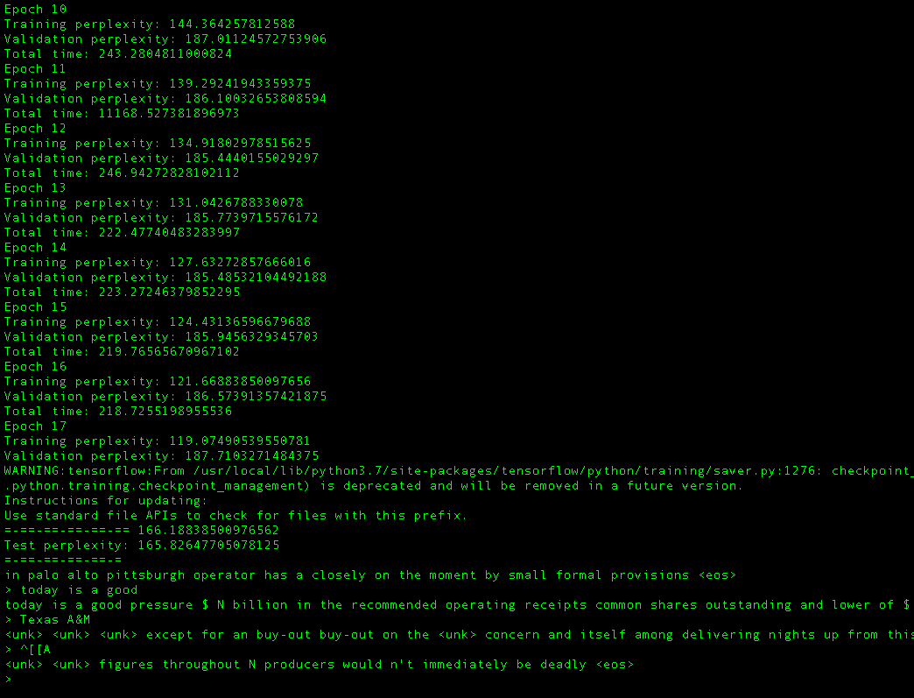

Since my computer is pretty slow with CPU, I only run for several times. I found the result is a bit random at beginning. However, after I tweet the parameters, it become better

### YOUR CODE HERE

batch_size = 32

embed_size = 100

hidden_size = 80

num_steps = 10 # RNN is unfolded into 'num_steps' time steps

max_epochs = 50

early_stopping = 2

dropout = 0.6

lr = 0.001

### END YOUR CODE

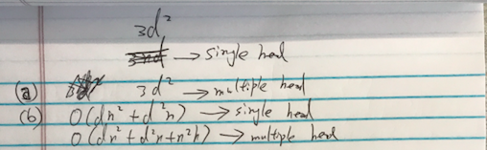

Below is the draft:



multiplication with A means that 🡪 for every node, we sum up all the feature vectors of all neighboring nodes but not the node itself, unless there are self-loops in the graph.

We can "fix" this by enforcing self-loops in the graph: we simply add the identity matrix to A.

1. Normalizing A such that all rows sum to one;