**CS5310.001/002, Fall 2020  
Computer Networks and Communication Systems Assignment 1**

**Issued: 09/23/2020 Due: 10/07/2020**

Name: Zebo Xiong A04907051

1. (15 pts) Briefly explain using your own words why the transport layer is a first end-to-end layer?

🡪 transport layer is the first layer which can accept data, and support point-to-point FIFO channel, provides a point-to-point connection.

🡪 At the sender side these protocols break the messages of application layer into segments and pass them to the network layer, and at the receiving end, these protocols reassemble the segments with the sequence numbers and pass them to the application layer.

2. (15+10=25pts)

1. (1)  Explain concisely using your own words why Internet is a connectionless packet switched network, and why it’s not designed to be a circuit switched network?

🡪 for example when you browse <https://www.harvard.edu> with any computer and any IP, you can read the website. The server in Harvard do not need to check your PC’s information before sending their data in sever. No connection needs to be established.

If internet is designed as a circuit switched network, then every visitor need to occupy a dedicated line/channel, and thus will make the network really cost inefficient.

For example, if only one car can run on one highway lane each time, then only few cars can arrive Austin from Houston in one day.

But if you allow multiple car run on one high way lane at the same time, as long as they do not bump, thousands and thousands cars can arrive Austin from Houston in one day.

1. (2)  Briefly explain using your own words the benefit and weakness of choosing a single frame format in ATM networks.

Good side:

🡪 Since all data are encoded into identical cells, data transmission is simple, uniform and predictable.

🡪 Uniform packet size ensures that mixed traffic is handled efficiently.

🡪 Small sized header reduces packet overload, thus ensuring effective bandwidth usage.

🡪 the fixed cell structure means that ATM can be readily switched by hardware without the inherent delays introduced by software switched and routed frames.

🡪 small data cells to reduce jitter in the multiplexing of data streams.

🡪 By using small cells, ATM can flexibly divide the bandwidth of a physical layer link among different users in fine slices

🡪 This ability is useful when, for example, sending both voice and data over one link without having long data packets that would cause large variations in the delay of the voice samples.

🡪 hardware switches will be fast and scalable

🡪 easy for voice data

🡪 Queue behavior can have fine-grained control.

Bad side:

🡪 overhead of cell header (5 bytes per cell)

🡪 Congestion may cause cell losses

🡪 the cell length is a compromise between American and Europe

🡪 Network devices are constrainted by the number of packets per second.

1. (10+10 = 20 pts) Assume that packet-switched network with a **500ms worst case jitter** is to be used for a number of application each of which involves constant bit rate information stream.

Determine the minimum amount of memory that is required at the destination and a suitable packet size for each of the following two input bit rates. It can be assumed that the mean packet transfer rate of the network exceeds the equivalent input bit rate in each case.

* + 100 Mbps

At 100 Mbps, 500ms will transmit 100*1000kbps * 0.5s = 50,000 KB

🡪 hence choose packet size 50,000KB with FIFO buffer of 100,000KB – two packets – and start playout of the bitstream after the first packet has been received.

* + 1000 Mbps

Packet size will be 500,000KB with FIFO butter of 1,000,000KB – to hold two packets.

4. (8+12=20pts)

1. (1)  Assume that the velocity of propagation of an electrical signal is equal to the speed of light (i.e. is 300,000km/s). Assume also that the distance S between two DTEs is 2,500 meters and the number of bits in a frame is 12,000 bits. At what data rate R is the transmission delay equal to the the propagation delay?





🡪 propagation delay: 2.5km / 300,000km = 0.833 / 100,000 s

🡪 12,000/R = 0.833 / 100,000

🡪 0.833R = 12,000 * 100,000 = 1200 MB = 0.833R

🡪 R = 1440Mbs

(2)  Assume that the velocity of propagation of an electrical signal is equal to 2/3 of the speed of light, determine the ratio of the signal propagation delay to the transmission delay, a, for the following types of data link and **12,000 bits** of data:

(a) 400 m of UTP wire and a transmission rate of 10 Mbps;

(b) 50.0 km of coaxial cable and a transmission rate of 40 Mbps;

(c) A satellite link of 60,000 km and a transmission rate of 200 Mbps.

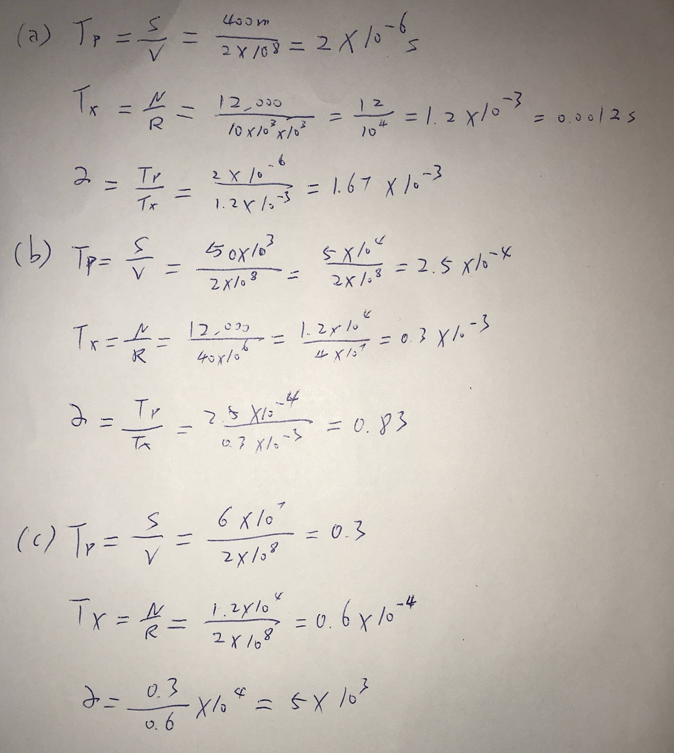

* + - 1. 🡪 let clock rate to be **C**, C/56000 = 8 🡪 C = 448 KHz
      2. 🡪 56/56 = 1 🡪 deviation = 1