The class will implement Internet information processing components, which are usually stationed at the servers, with four different software flavors. The software packages needed are the following:

The latest GNU C/C++ compiler

Apache HTTP Server 2 (the latest version), with PHP support

Perl (version 5.10 or higher)

Oracle database server (version 11g or 12c, plus Oracle Pro C/C++ component, JDBC support)

Apache TomCat web server (i.e. the servlet container), the latest version

PHP (version 5 or 7) + MySQL

Java SDK (the latest version), with Java Servlet and JDBC support

Python 3 (version 2 may also work, but the demo version tested under version 3)

eros.cs.txstate.edu

PuTTY login 🡪 eros.cs.txstate.edu

sqlplus Z_X3@CSDBORA

s

Oracle Account Id : Z_X3

Oracle Password : awdlrbme

s

sKZHzn234_A3

SQL>ALTER USER <YOUR TEXAS STATE USER ID> IDENTIFIED BY <YOUR NEW PWD>;

Example:

SQL> ALTER USER SK4567 IDENTIFIED BY SJASKJAL123;

cd $HOME , f然后 wget <http://newfirebird.cs.txstate.edu/~wp01/.bashrc>

newfirebird.cs.txstate.edu

cd $HOME , f然后 wget http://newfirebird.cs.txstate.edu/~wp01/.bashrc

imp Z_X3/sKZHzn234_A3@CSDBORA

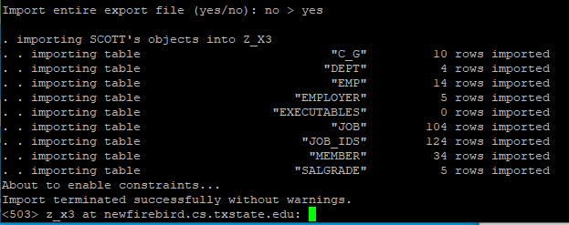

ls "$ORACLE_HOME"/precomp/demo/proc

cp "$ORACLE_HOME"/precomp/demo/proc/sample3.pc /home/Students/z_x3/public_html