<http://newfirebird.cs.txstate.edu/~z_x3/HW_2_Question_1.html>

1. Open the browser:

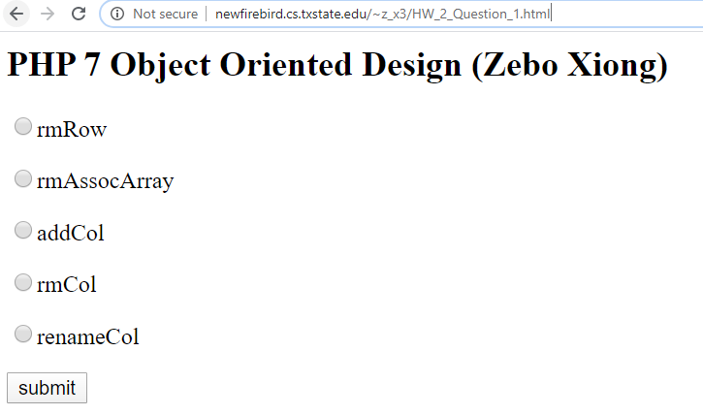

1. Submit the rmRow

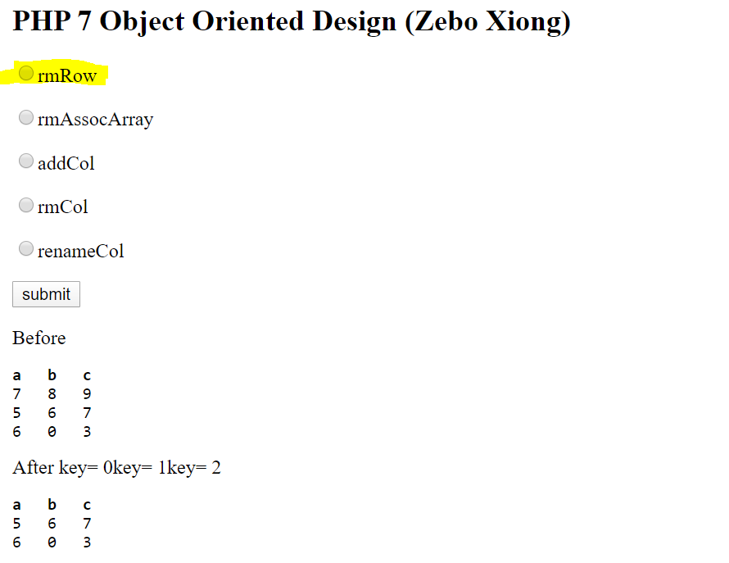

1. Submit the rmAssocArray

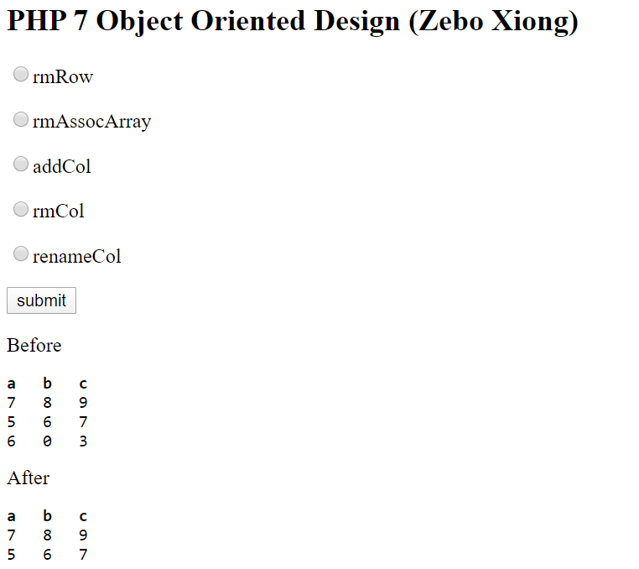

1. Submit the addCol

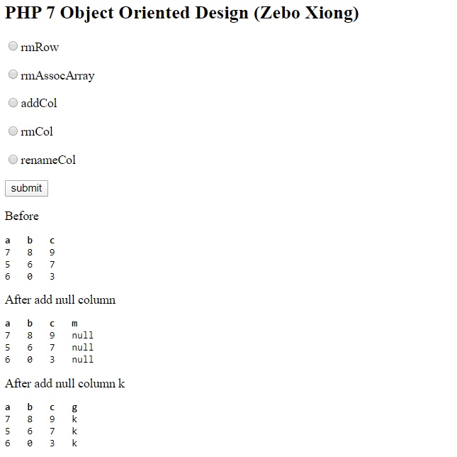

1. rmCol

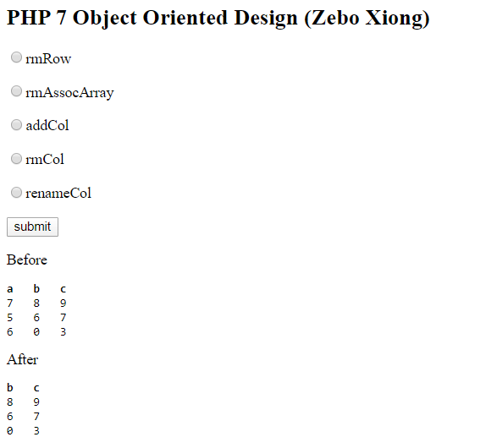

1. submit the renameCol field
2. 