Please check the page:

<http://newfirebird.cs.txstate.edu/~z_x3/demo/proc/unix-version/html/zebo/a_search.php>



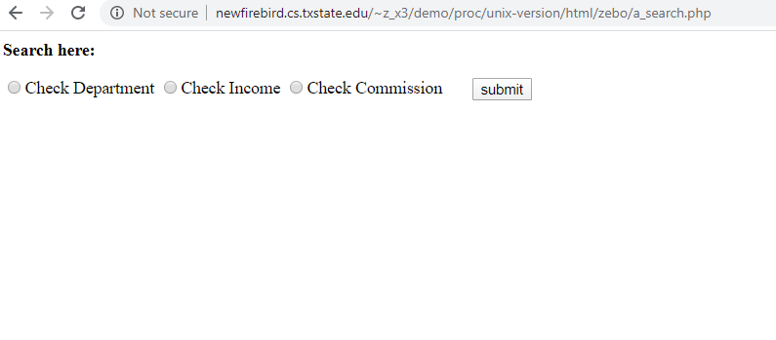



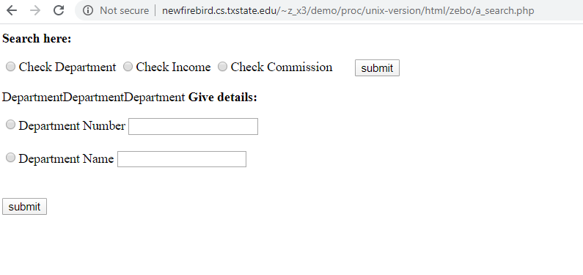

1. Successfully compile the sample3:

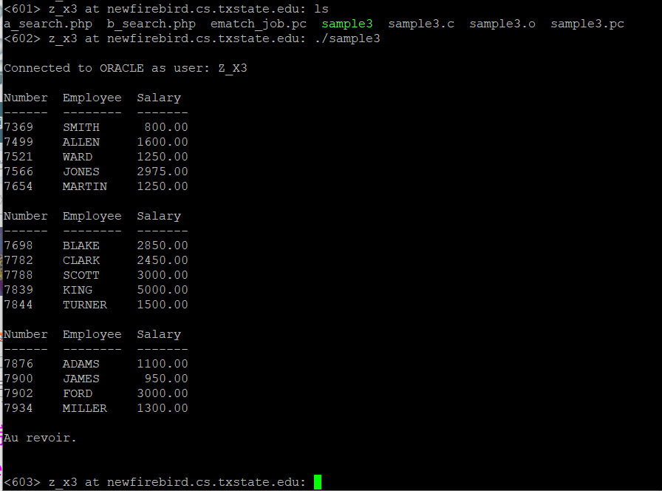

1. Revised the sample 3:

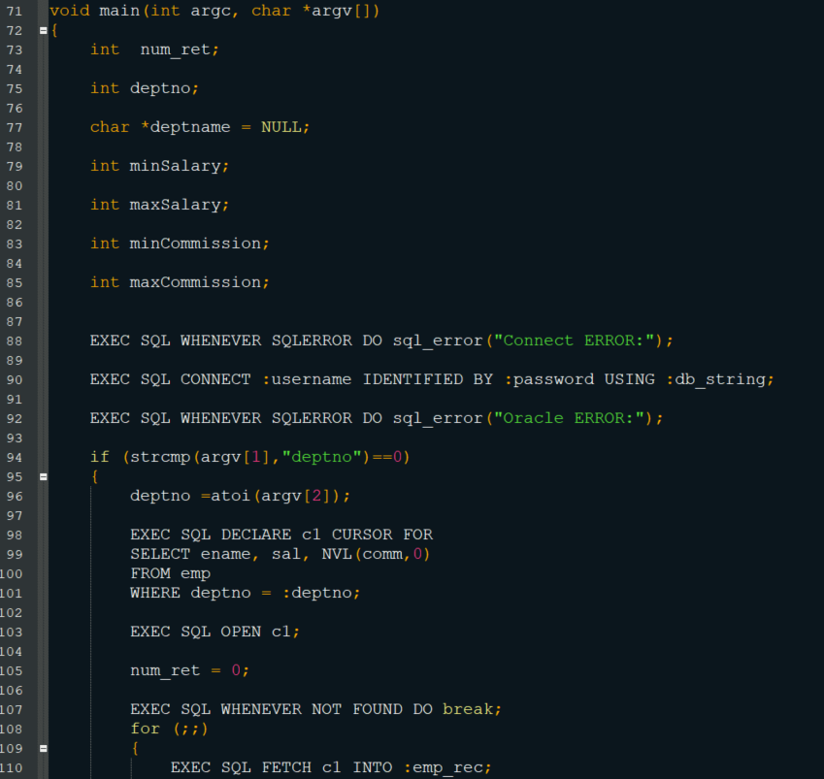

1. Successfully get data: 🡪 with conditions: 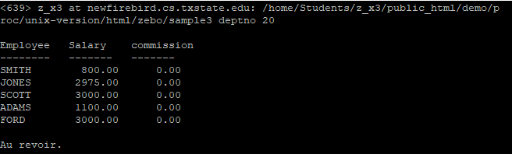
2. Updated the PHP code:

