1. Setup the VM with provided instance

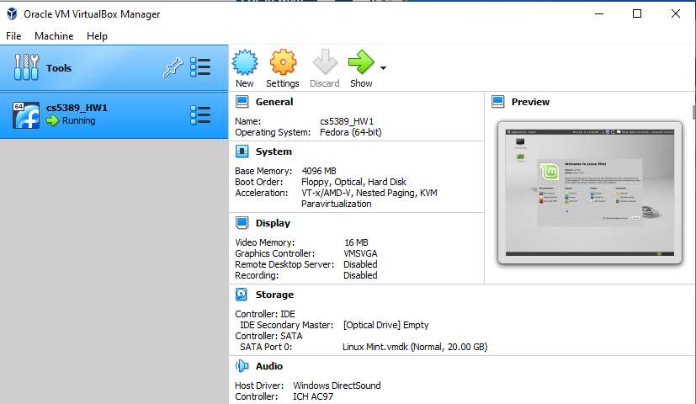



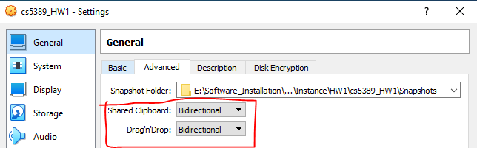

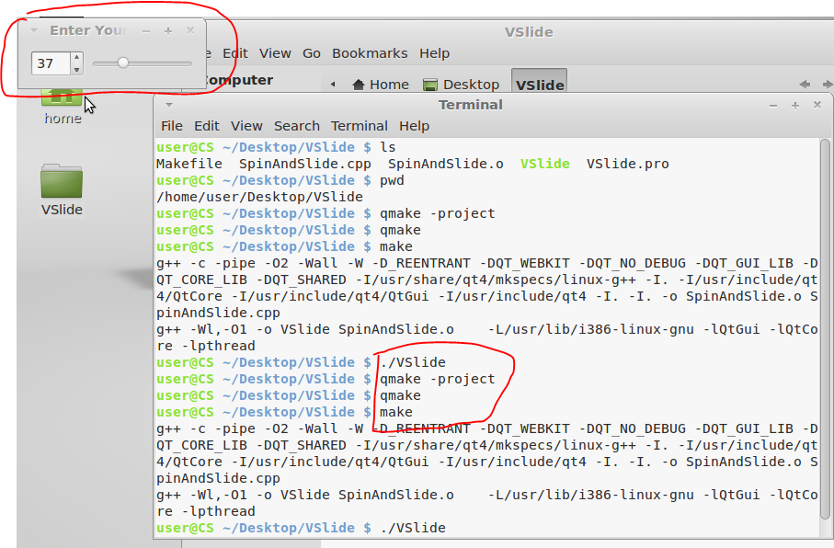

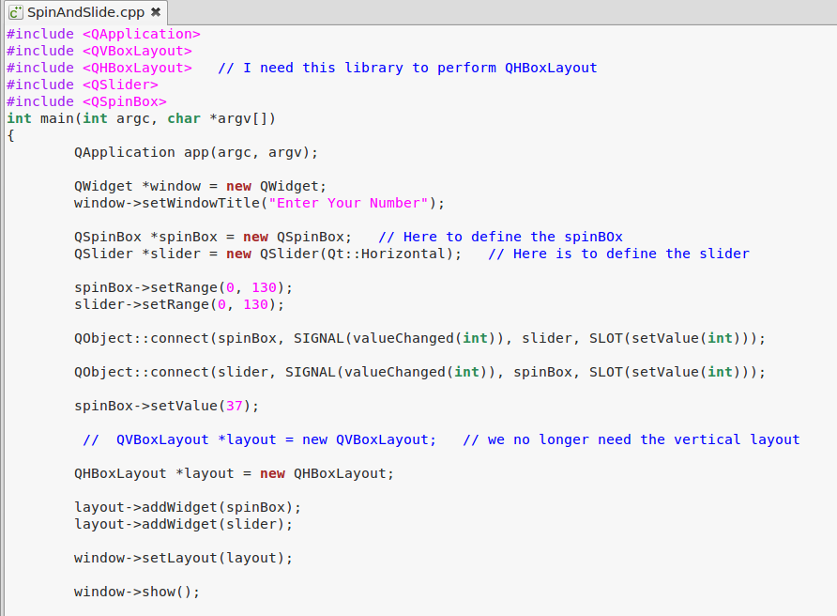

#include <QApplication>

#include <QVBoxLayout>

**#include <QHBoxLayout>** // I need this library to perform QHBoxLayout

#include <QSlider>

#include <QSpinBox>

int main(int argc, char *argv[])

{

QApplication app(argc, argv);

QWidget *window = new QWidget;

window->setWindowTitle("Enter Your Number");

QSpinBox *spinBox = new QSpinBox; // Here to define the spinBOx

QSlider *slider = new QSlider(Qt::Horizontal); // Here is to define the slider

spinBox->setRange(0, 130);

slider->setRange(0, 130);

QObject::connect(spinBox, SIGNAL(valueChanged(int)), slider, SLOT(setValue(int)));

QObject::connect(slider, SIGNAL(valueChanged(int)), spinBox, SLOT(setValue(int)));

spinBox->setValue(37);

// QVBoxLayout *layout = new QVBoxLayout; // we no longer need the vertical layout

**QHBoxLayout *layout = new QHBoxLayout;**

layout->addWidget(spinBox);

layout->addWidget(slider);

window->setLayout(layout);

window->show();

return app.exec();

}

