什么是找工作?

- Bug-Free

- OOD/System Design

- Concurrency

- 语言特性本身

- How to get interview opportunity in current situation

- 英文沟通描述能力

- Prepare yourself in every details (E.G., set-up your phont message box)

Communication: 面试英文口语

- Self-Introduction

- Project-Description

- Problem description

- Email communication

职业规划

- 选组

- Keep learning skills

- 工作之后如何发展自己

- etc.

题目讨论

1. Given an array stored in Stack 1, how to sort the numbers by using additional two stacks (will be discussed later in stack class)

2. Follow up, what if only 1 additional stack can be used?

Answer for 1:

Stack1|| 1 4 3 6

Stack2|| 来一个 global_min，每一轮更新 global_min

Stack3||

Answer for 2:

好的，我知道怎么做了，原理跟1一样，可能就是要多循环几次

**算法总共只有三种：**

Brute Force (DP all-path)

Divide and Conquer

Greedy (e.g. BFS)

**Common Data Structures**

* Array
* Stack
* Queue
* Linked List
* Tree
* Heap
* Graph
* Hash Table

**Sorting Algorithms**

* Selection sort
* Insertion sort
* Merge sort
* Quicksort
* Bubble sort
* Bucket sort
* Patient sort
* Smooth sort
* Cocktail sort

...

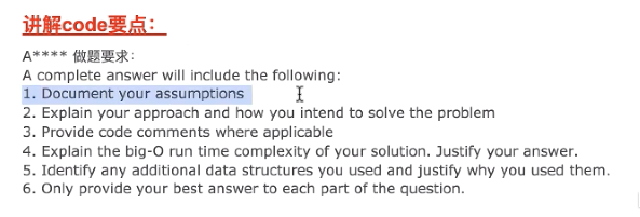

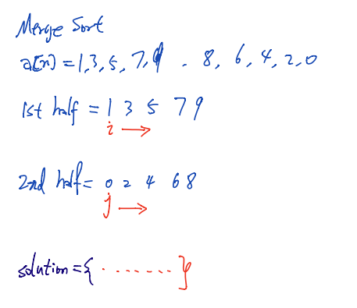

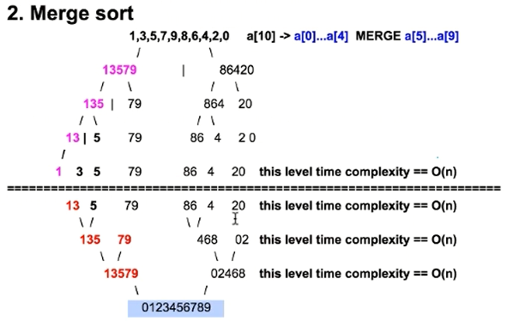

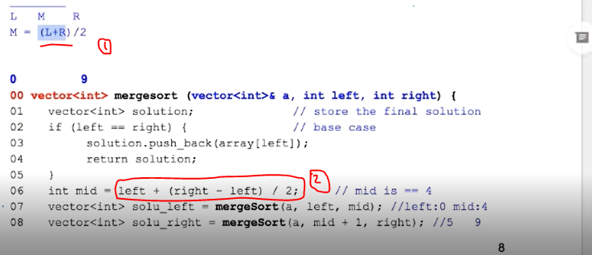

1. Point 1写成L+R很大，有越界的问题，所以
2. 写成point 2的方式

空间复杂的问题: 🡪 **看class1下视频** 🡪 时间点23:36

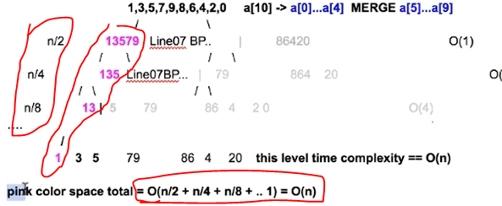

一头扎下去，每次用的**空间**，是粉红色的。

分析复杂度要画recursion tree一层一层分析

但是，如果input不是array，而是linkedlist，🡪 每一层的cost是O(N), 不变!!!

s