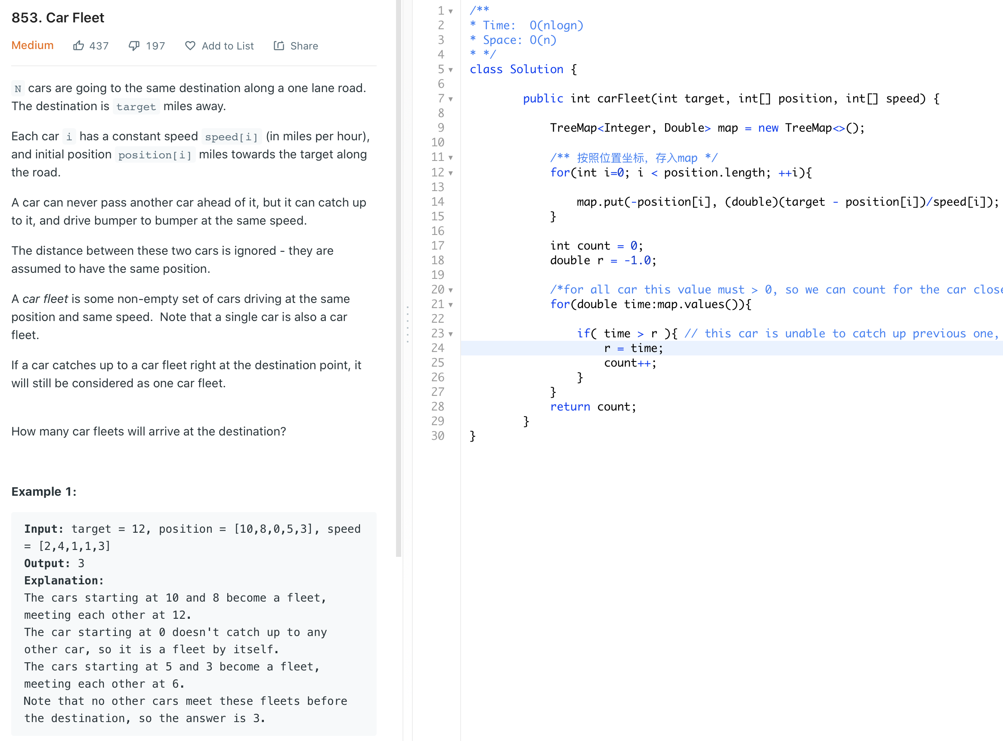

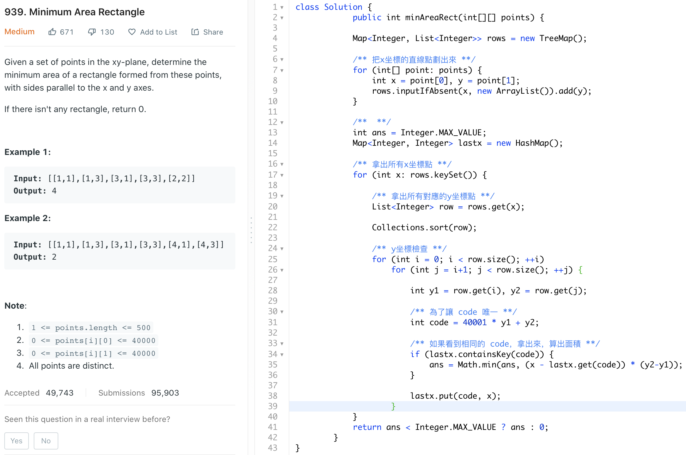

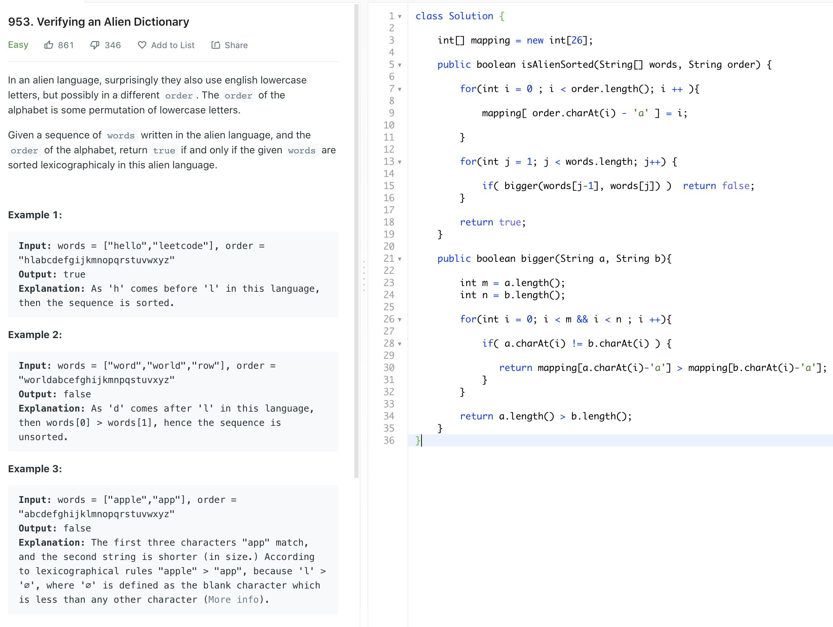

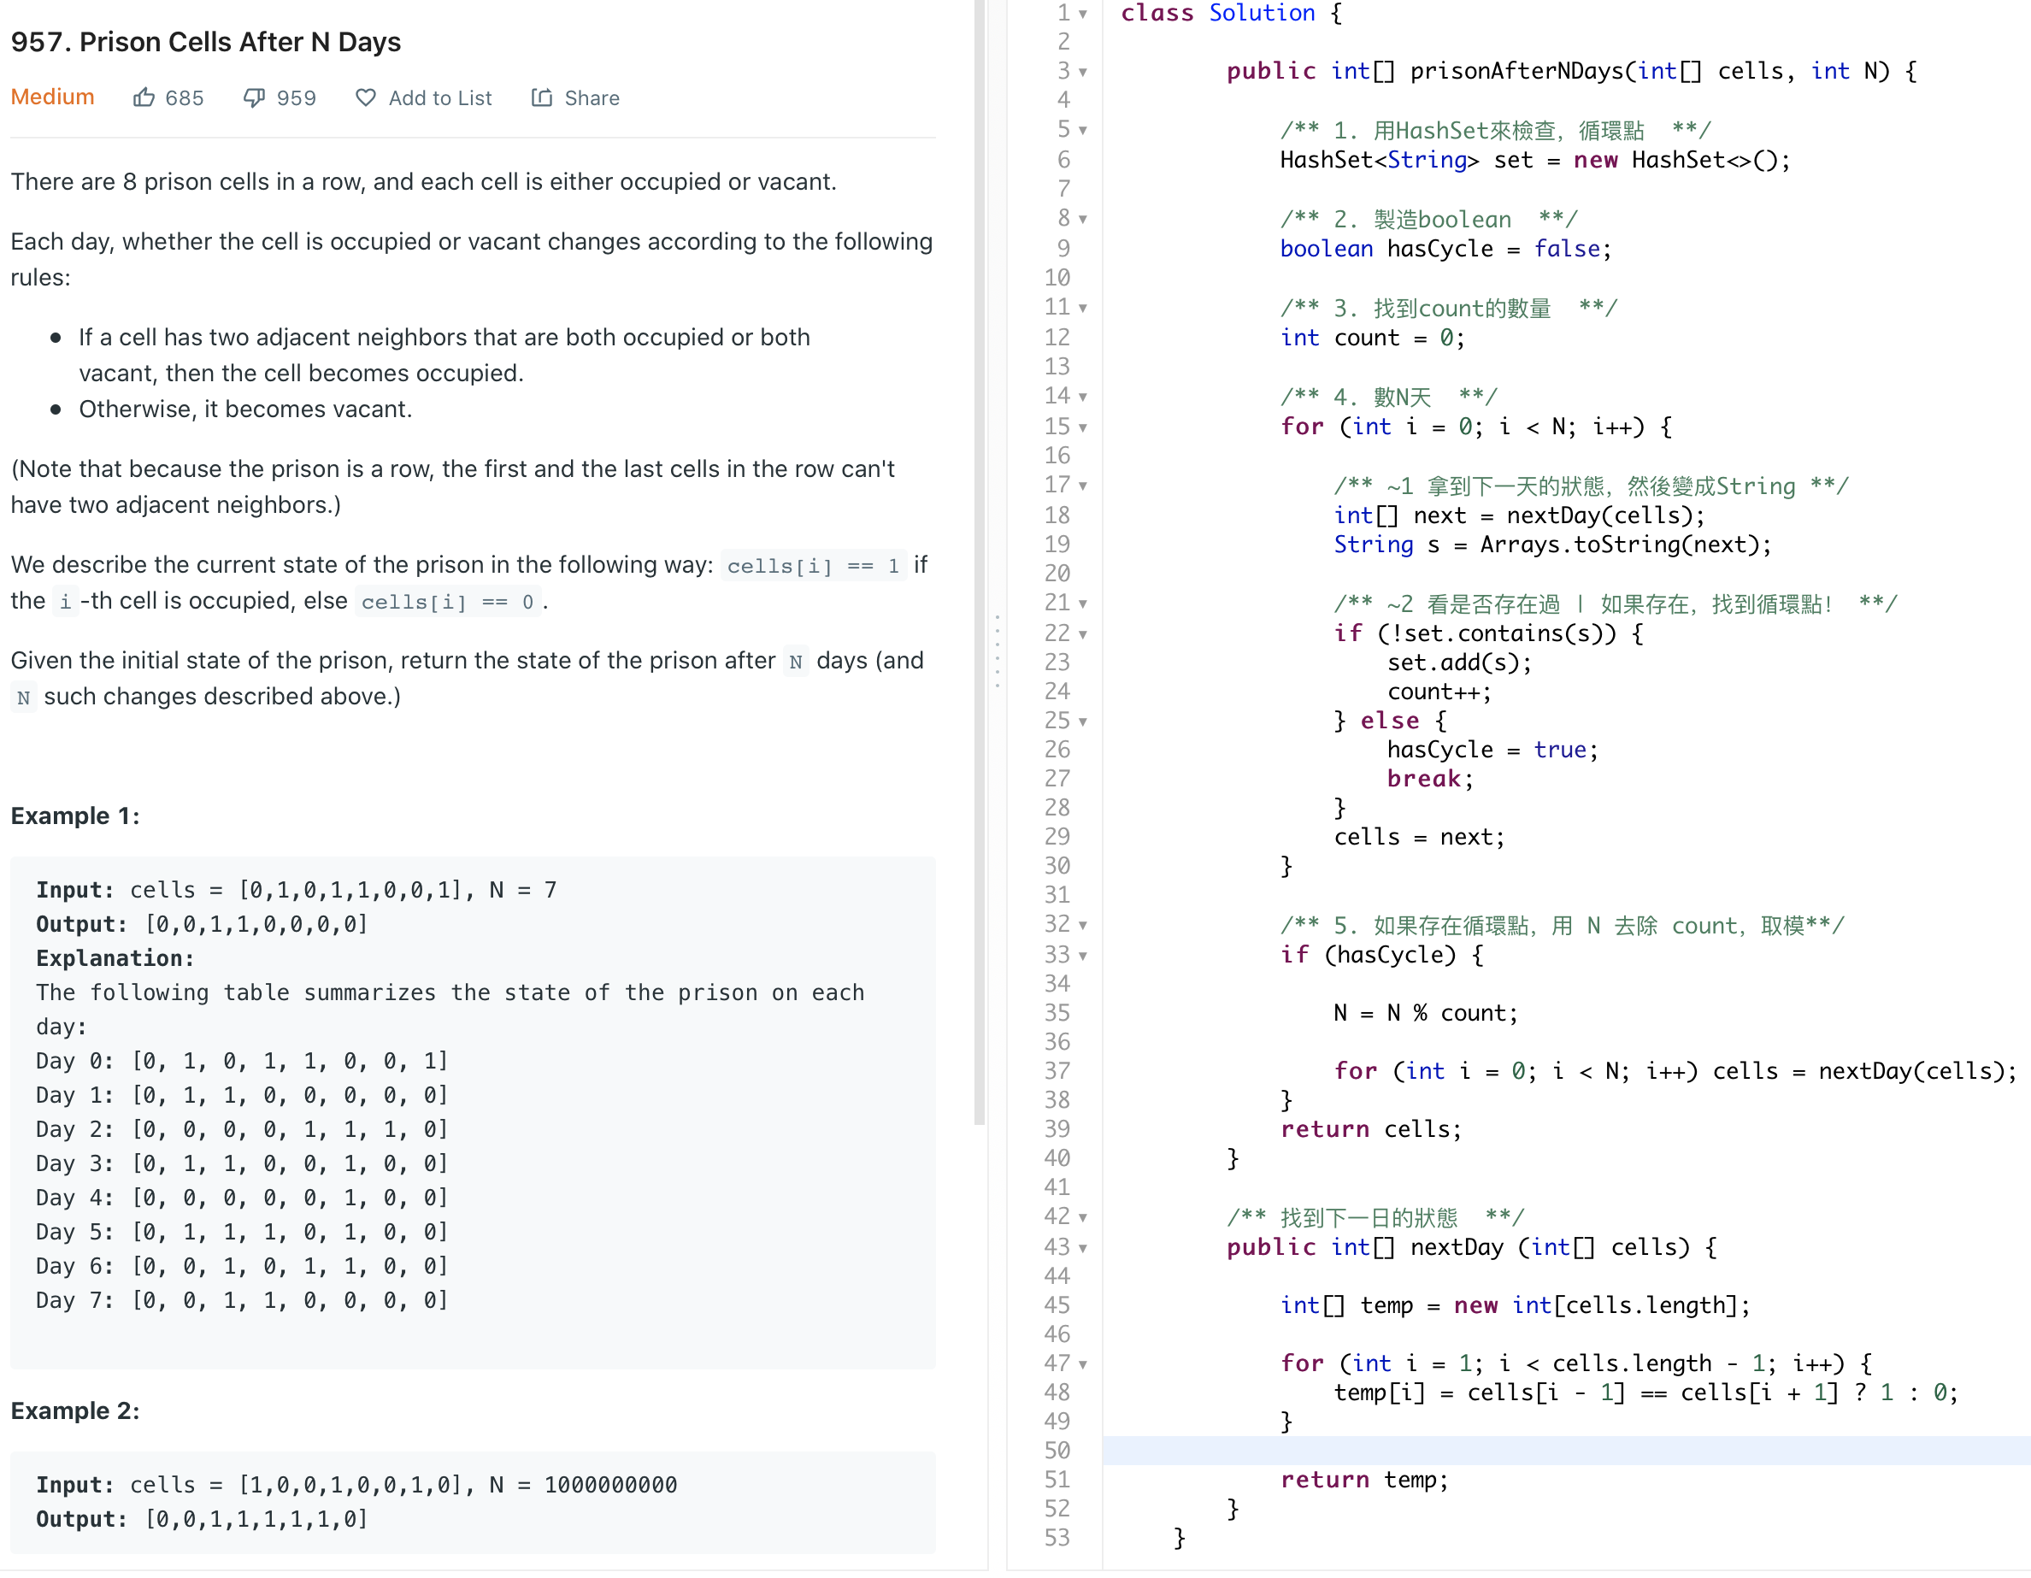

966

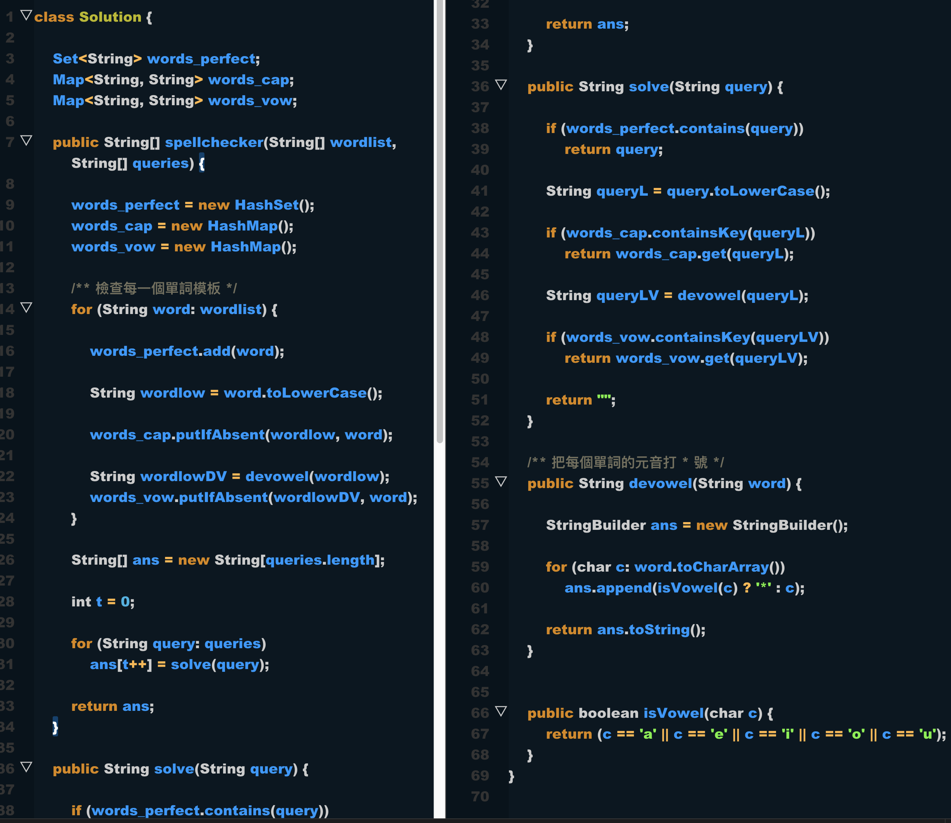

811

