Zebo Zhu

8/7/2022

IT FND 110

Assignment05

CD Inventory with Dictionaries

# Introduction

Based on the module 05 course material, the task for this assignment is to create a new version of our CD Inventory program where dictionaries are used as the inner data type (list of dictionaries). Also adding the functionality of loading existing data as well as functionality of deleting an entry. This week’s task also show retain all the rest of the functions created last week.

# Getting Started

To accomplish this task, I first read the material and watched the videos posted. From there, I acquired some basics about dictionaries and how to work with it.

Here are the steps I took in performing this assignment:

1. Based on the starter code included in this week’s assignment, I started by replacing the list of lists from last week with list of dictionaries. Details of the code can be seen in Figure 1 below:

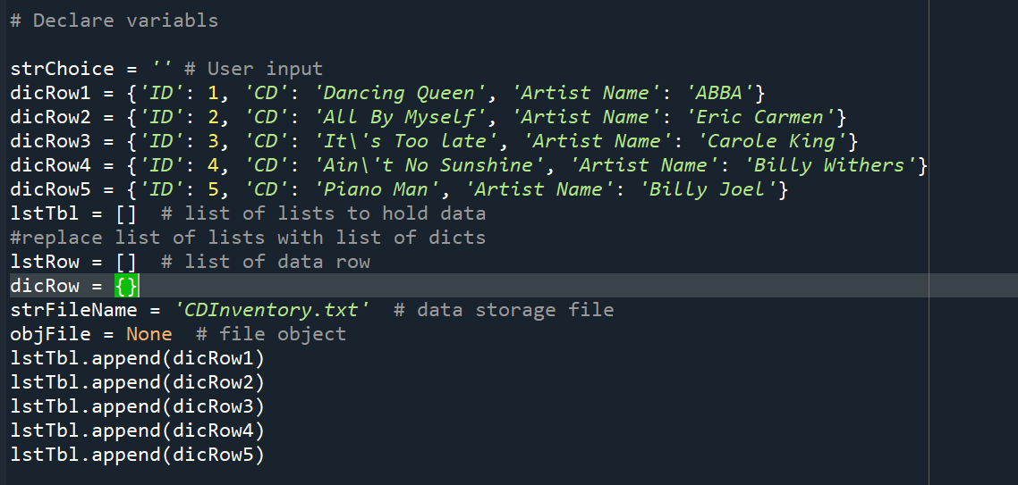

Figure 1 – Changing from list of lists to list of dictionaries

1. I then jumped to the “Display the current data” section of the code because I think this makes the most sense as the user most likely want to see what’s actually in the data before any other action. The only change I made was added .values() to the row so it adheres the rules of dictionaries. The code and the outputs from both Spyder and the terminal window are shown in Figure 2, 3, and 4 respectively.

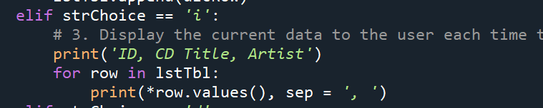

Figure 2 – Display the current data

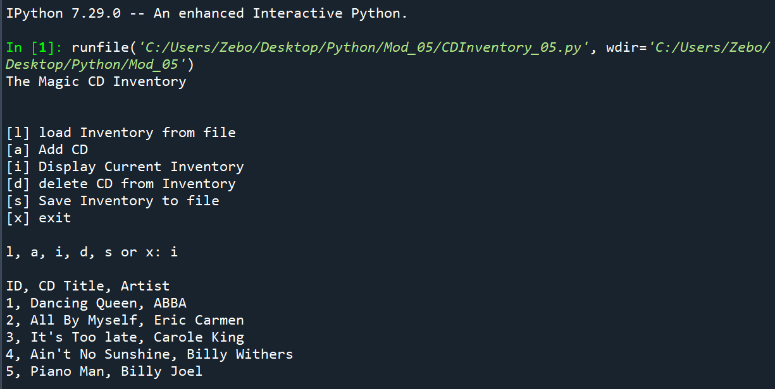

Figure 3 - Spyder results for displaying current data

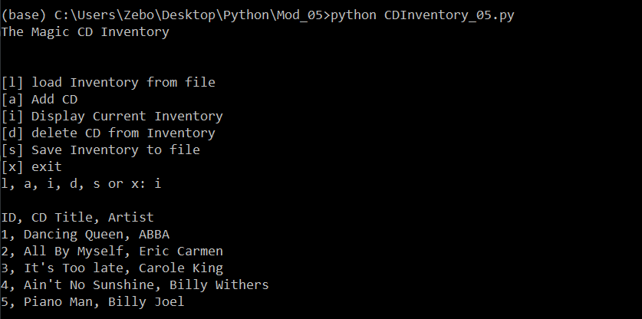

Figure 4 - Termial results for displaying current data

1. The next logical thing to do is to save data to file. I did the similar thing where I added .values() to the end of “row” as you can see it from the script shown in Figure 5 below, and the content of the text file is shown in Figure 6.

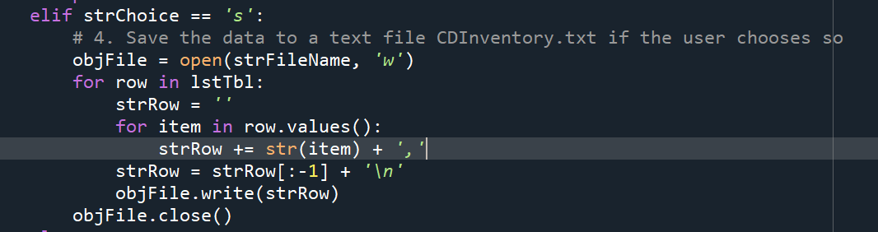

Figure – Display current data

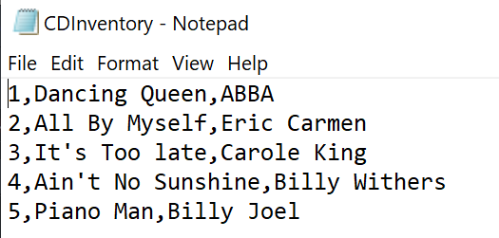

Figure 6 - Spyder results for option #2

1. After saving the file, it’s time for loading the existing data.

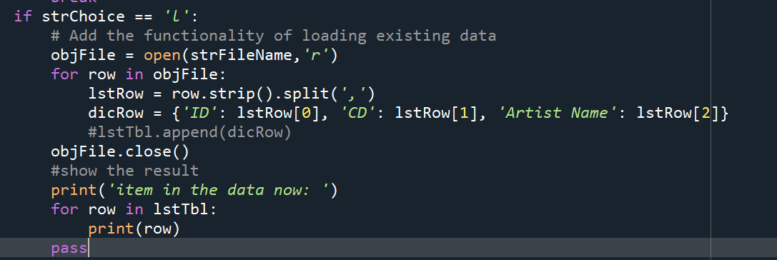

Figure – Loading the existing data

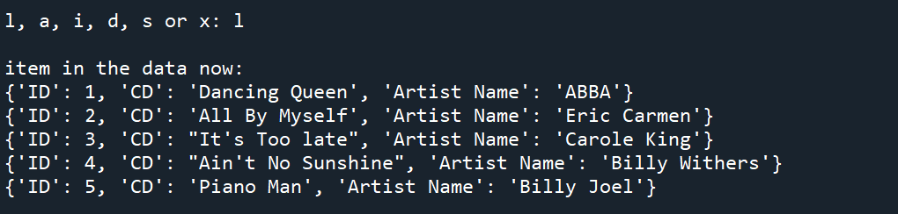

Figure 8 – Loading the existing data (Spyder result)

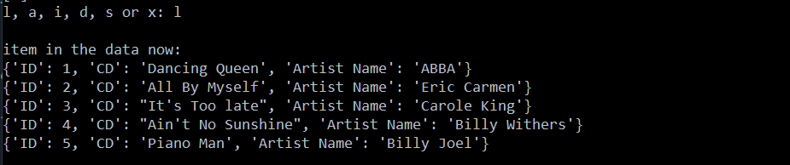

Figure 9 - Terminal results for loading the existing data

1. Next I edited and tested the “Add data” section of the code. The only part I added to the code is the addition of “dicRow” as shown in Figure 12 below. The result in both Syder and terminal window are shown in Figure 10 and 11. I tested this functionality by chose [a] and [i] so that I can know if I did it correctly or not.

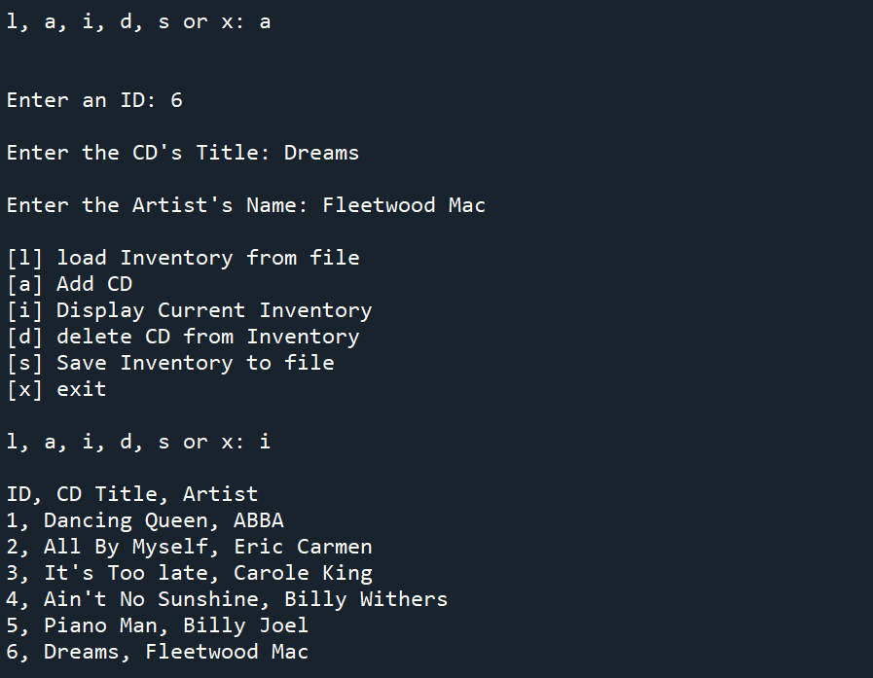

Figure 10 - Spyder Outputs

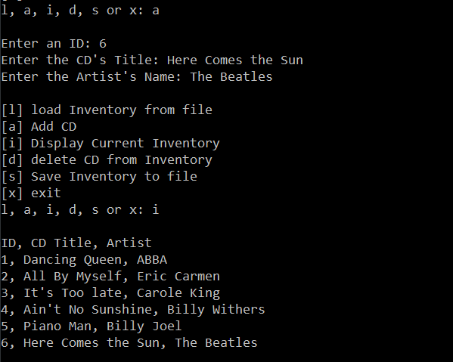

Figure 11 – Terminal Outputs

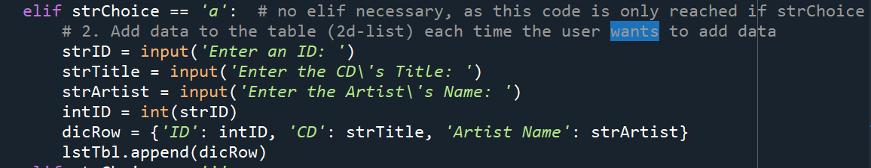

Figure 12 – Code for adding data entry

1. Now it’s time for deleting a data entry. After my research of all the methods of removing a data entry in Python documentation, I decided to use “del” as it is a simple and clean way of getting rid of an entry in the dictionary. The code and the outputs can be seen in the figures below:

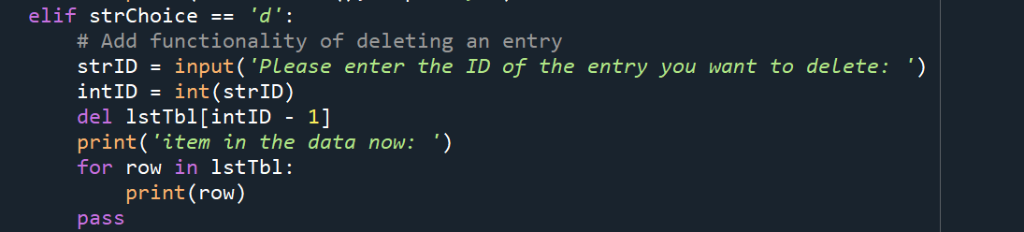

Figure - Deleting an entry

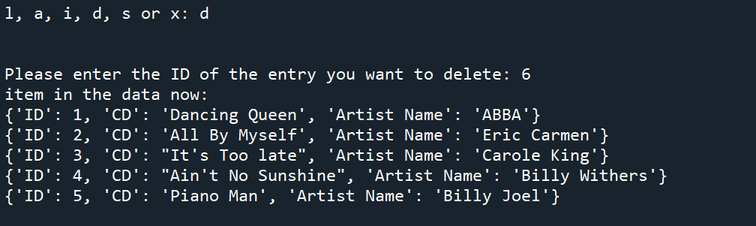

Figure - Spyder output

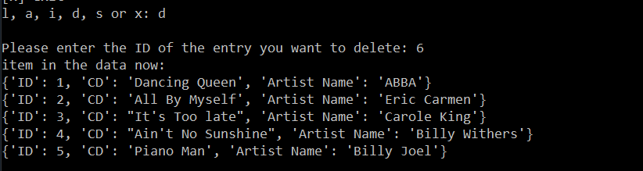

Figure - Terminal output

# Troubleshooting process

This week’s assignment is relatively straightforward compare to assignment last week. Mostly I think it’s because the study material last week was a really good foundation for this week. The lecture helped a lot as well. One of the main obstacle for this week is the use of “del” for deleting an entry. I took me a while to figure out the best (for now and for me) practice of doing such task.

# Summary

In this assignment I covered the entire process of how I created the CD inventory using dictionaries python script, which includes each step of the code and the troubleshooting part of my script. The task of creating a new version of our CD Inventory program where dictionaries are used as the inner data type (list of dictionaries). Also adding the functionality of loading existing data as well as functionality of deleting an entry is now complete.