Zebo Zhu

8/14/2022

IT FND 110

Assignment06

CD Inventory with Functions

# Introduction

Based on the module 06 course material, the task for this assignment is to modify create a new version of our CD Inventory program where functions are used for grouping statements and making groups available via programmer defined names. This week’s task also should retain all the rest of the functions created last week.

# Getting Started

To accomplish this task, I first read the material and watched the videos posted. From there, I acquired some basics about functions and how to work with it.

Here are the steps I took in performing this assignment:

1. Based on the starter code included in this week’s assignment, I started by moving parts of the starter codes into functions area. The code can be seen in CDInventory.py file. I have also attached a sample snippet of one of the functions I wrote for loading user input data to a dictionary in a table in Figure 1 below:

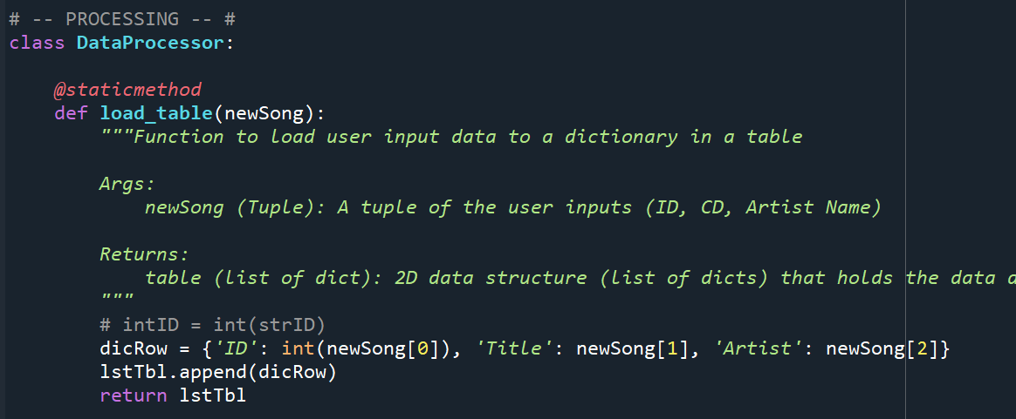

Figure 1 – Changing from list of lists to list of dictionaries

1. This assignment is fairly straightforward that after I moved all the codes to the function section, the results are shown below. Figure 2-8 are the results from Spyder and

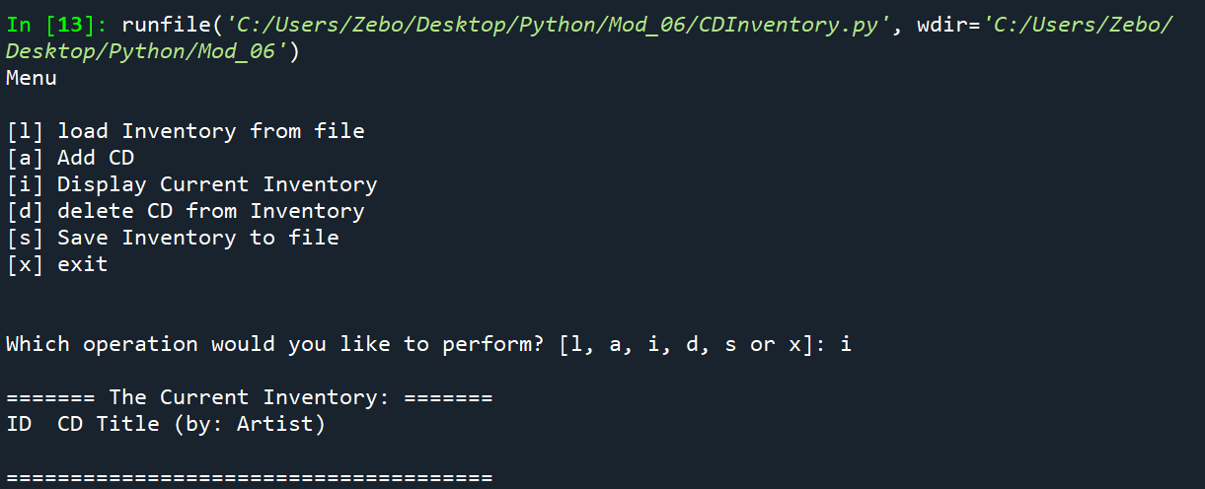

Figure 2 – Display the current data with nothing in the text file (Spyder)

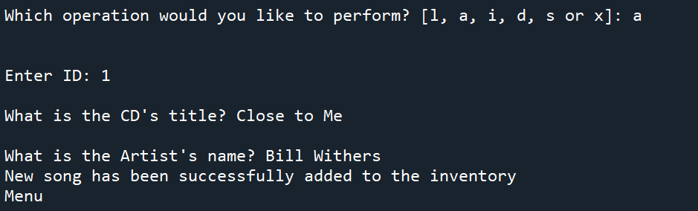

Figure 3 – Adding a new song (Spyder)

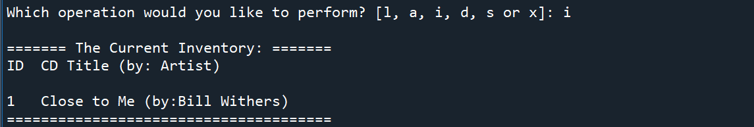

Figure 4 – Display the new CD Inventory (Spyder)

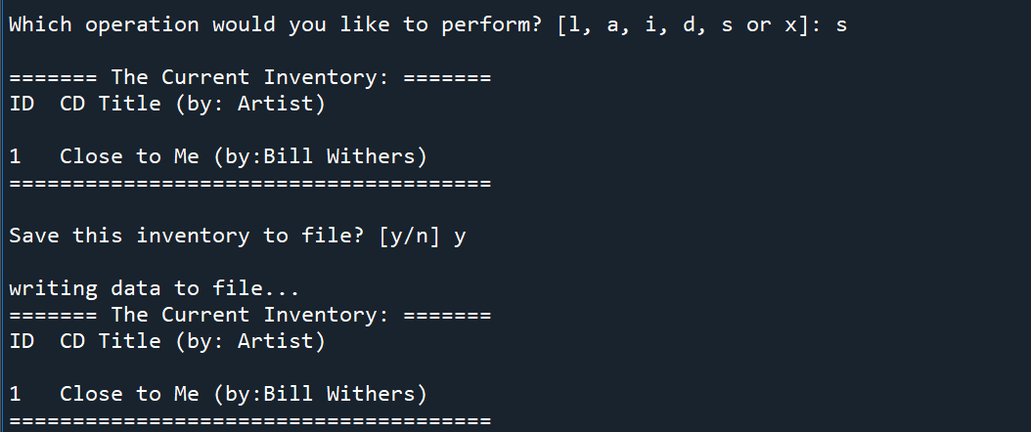

Figure 5 – Save data to a text file (Spyder)

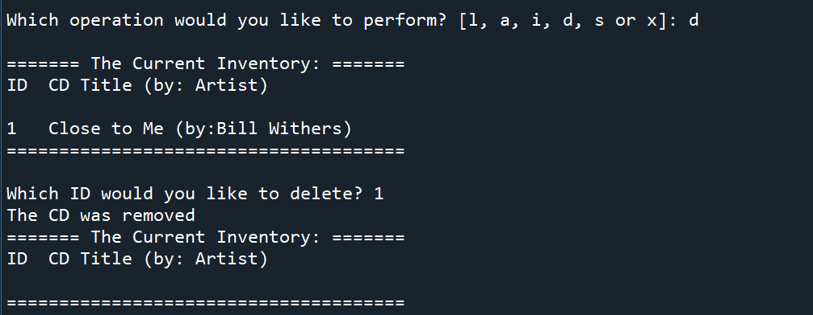

Figure 6 – Delete a song from CD Inventory (Spyder)

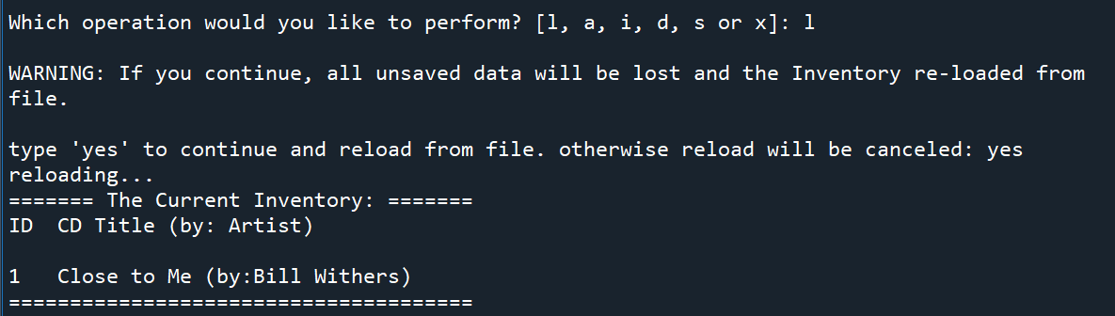

Figure 7 – reloading data from a text file to CD Inventory (Spyder)

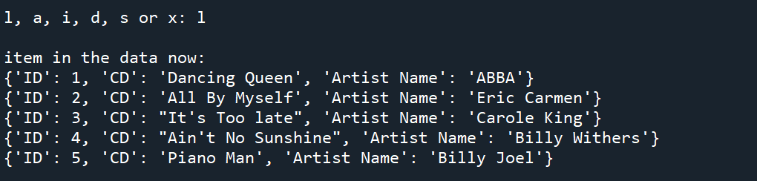

Figure 8 – Loading the existing data (Spyder result)

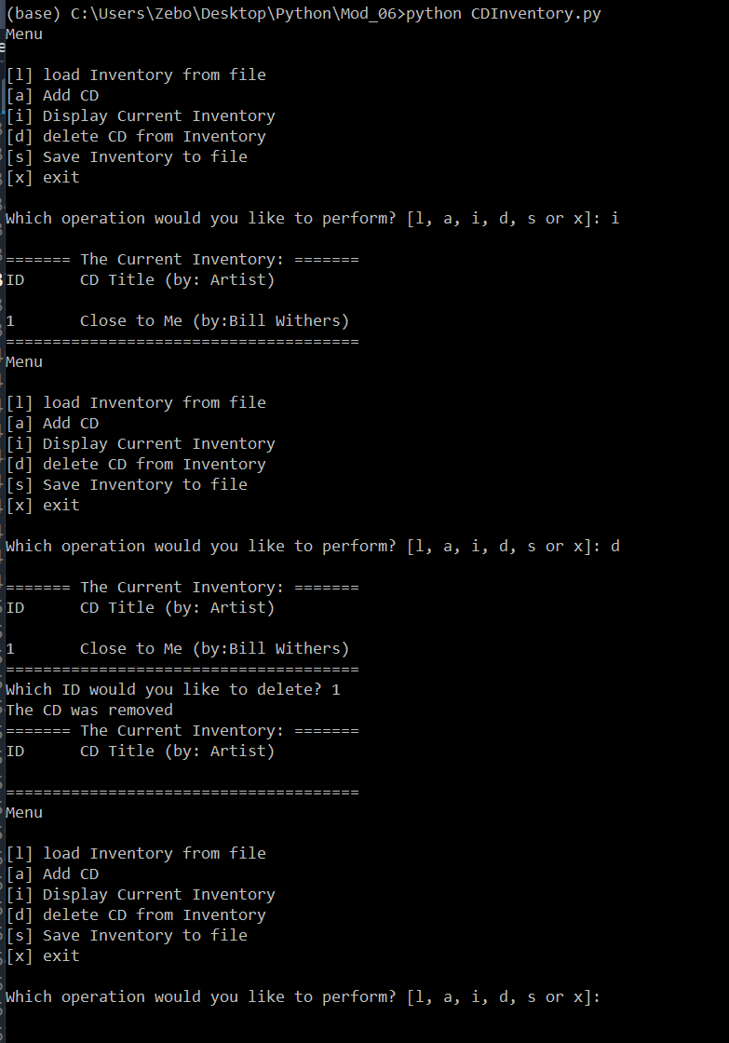

Figure 9 – Display current inventory and delete an item in the terminal window

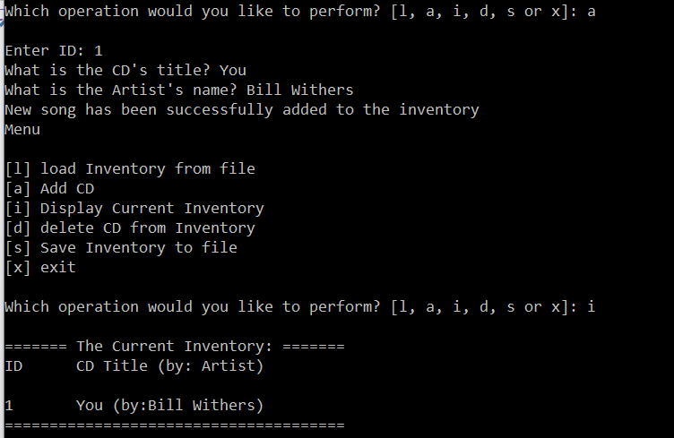

Figure 10 – Add a song to inventory and display in terminal window

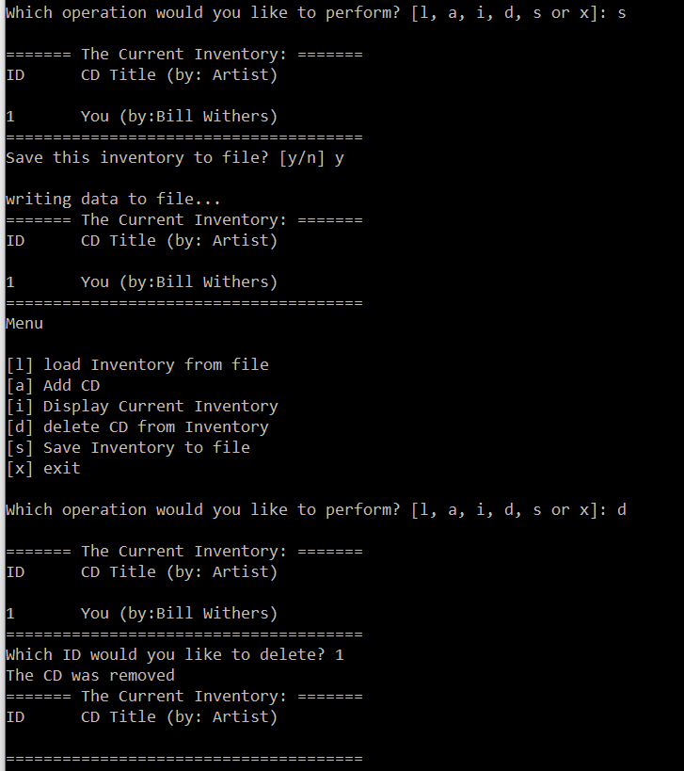

Figure 11 – Save to text file and display in the terminal window

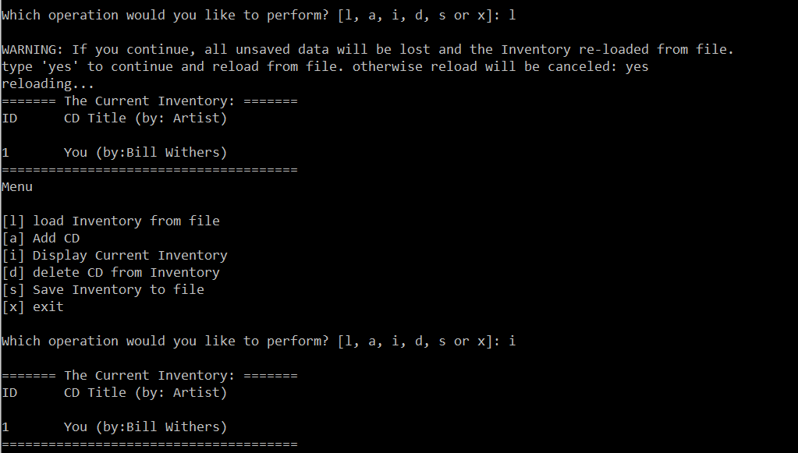

Figure 12 – Load data from an text file to inventory and display in the terminal window

This week’s assignment is relatively straightforward compare to assignment last week. Mostly I think it’s because the study material last week was a really good foundation for this week. The lecture helped a lot as well.

# Summary

In this assignment I covered the entire process of how I created the CD inventory using function python script, which includes each step of the code and the troubleshooting part of my script. The task of creating a new version of our CD Inventory program where functions are used is now complete.

The link to the Github page: <https://github.com/zebozhu/Assignment_05>