Zebo Zhu

8/21/2022

IT FND 110

Assignment07

CD Inventory with Error Handling

# Introduction

Based on the module 07 course material, the task for this assignment is to modify last week’s assignment to add structured error handling around the areas where there is user interaction, type casting (string to  
int) or file access operations. In addition, the permanent data store needs to be modified to use binary data.

# Getting Started

To accomplish this task, I first read the material and watched the videos posted. From there, I acquired some basics about error handling as well as working with binary data

Here are the steps I took in performing this assignment:

1. Based on last week’s assignment, I started by saving binary information. The pickle module takes the information associated with an object and serializes (or de-serializes) it in a way that it can easily be stored (or loaded) as binary information. The code can be seen in CDInventory.py file. I have also attached a sample snippet of the pickling from a binary file to a list of dictionary in a table in Figure 1 below, and write data from list of dictionaries to a binary file in Figure 2:

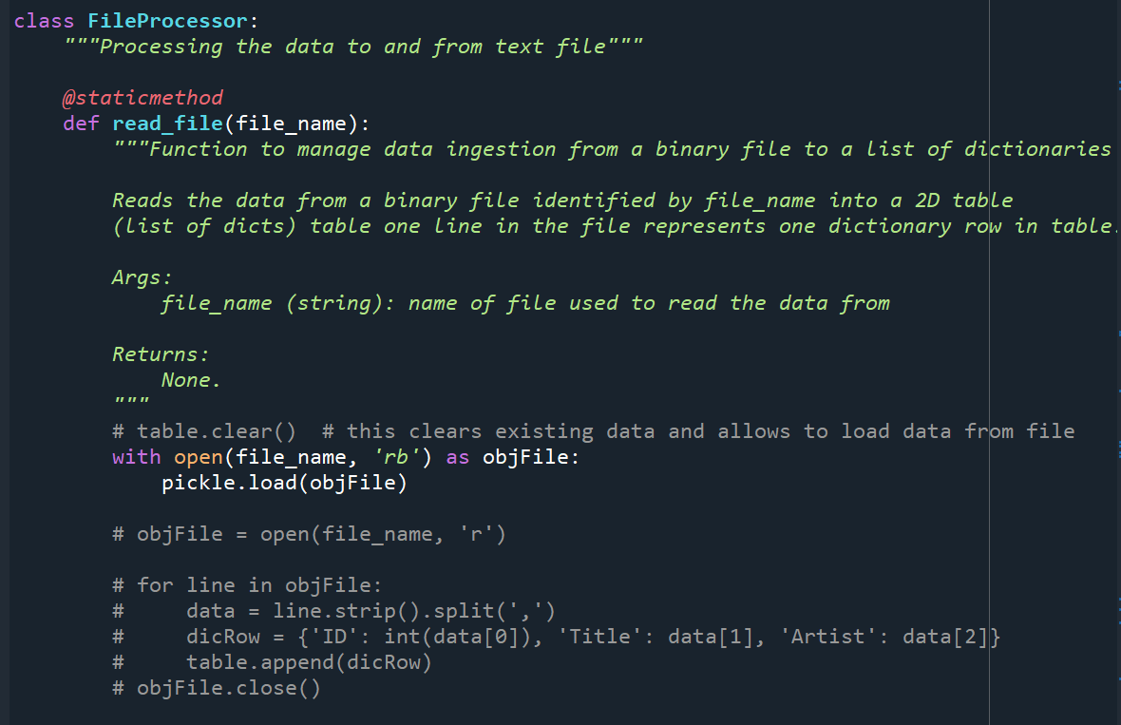

Figure – pickling from a binary file to a list of dictionary

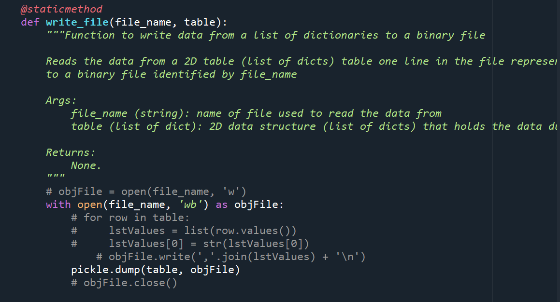

Figure - Writing data from a list of dictionaries to a binary file

1. Then I implemented a few try-except error handling around some user interactions, data type casting, as well as file accesses. The results are shown below. Figure 3-4 are the results from Spyder and 5-6 are results from the terminal window. Note: line 17 of the code needed to be uncommented to test the invalid file name error handling.

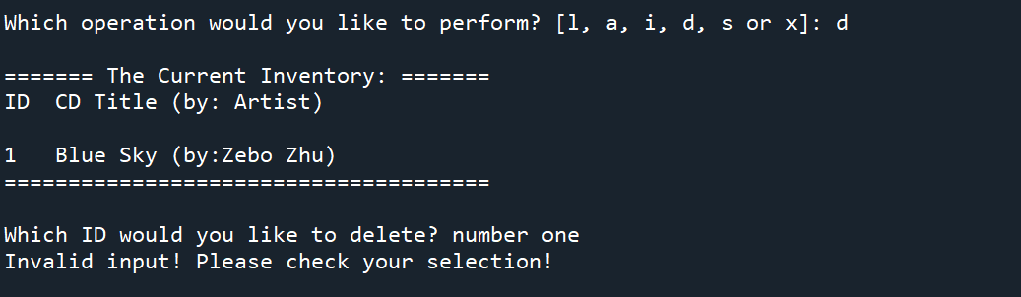

Figure – Error handling of incorrect user input data type (Spyder)

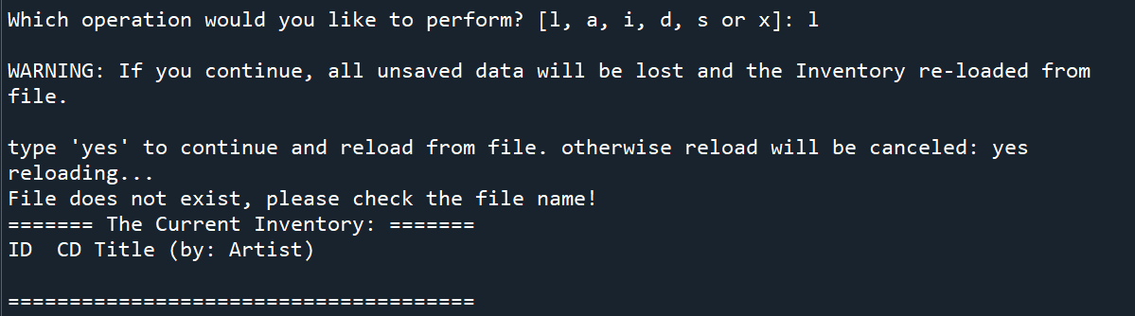

Figure – Error handling of wrong file name (Spyder)

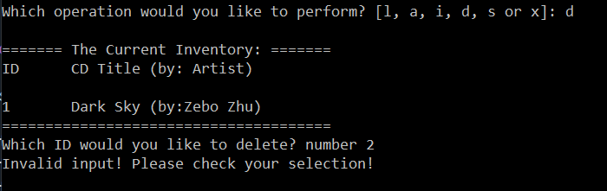

Figure – Error handling of incorrect user input data type (Terminal window)

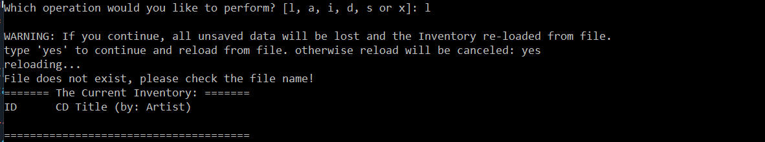

Figure – Error handling of wrong file name (Terminal window)

This week’s assignment is relatively straightforward compare to assignment last week. Mostly I think it’s because the study material last week was a really good foundation for this week. The lecture helped a lot as well.

# Summary

In this assignment I covered the entire process of how I modify last week’s assignment to add structured error handling around the areas where there is user interaction, type casting or file access operations. In addition, the permanent data store needs to be modified to use binary data.used is now complete.

The link to the Github page: <https://github.com/zebozhu/Assignment_05>