Zebo Zhu

8/27/2022

IT FND 110

Assignment08

CD Inventory with Objects

# Introduction

Based on the module 08 course material, the task for this assignment is to task is to read and understand the pseudocode provided in the starter script, then add code to make the application work with Object Oriented Programming.

# Getting Started

To accomplish this task, I first read the material and watched the videos posted. From there, I acquired some basics about Object Oriented Programming. It is a different way of thinking about programming. The basic and “new” concept is, that everything is an object. An object has attributes and methods. In terms of assignment structure, one of the menu option of deletion is no longer required.

Here are the steps I took in performing this assignment:

1. Based on the course material, I started by creating a class of CD objects. This involved creating Constructors, Attributes, and Properties of the objects. One thing I learned is that when defining getters and setters in Python, make sure to first define the getter property followed by the setter. The code can be seen in CD_Inventory.py file. Figure 1 shows the code for the CD class.

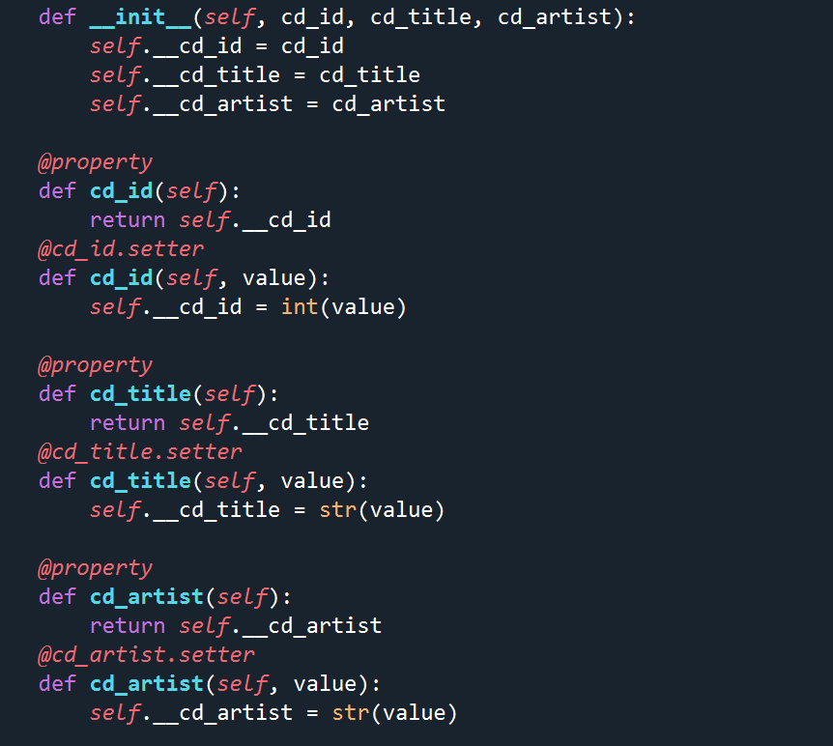

Figure – Class CD with Constructors, Attributes, and Properties

1. The results can be seen in Figure 2 (Spyder), and Figure 3 (windows terminal).

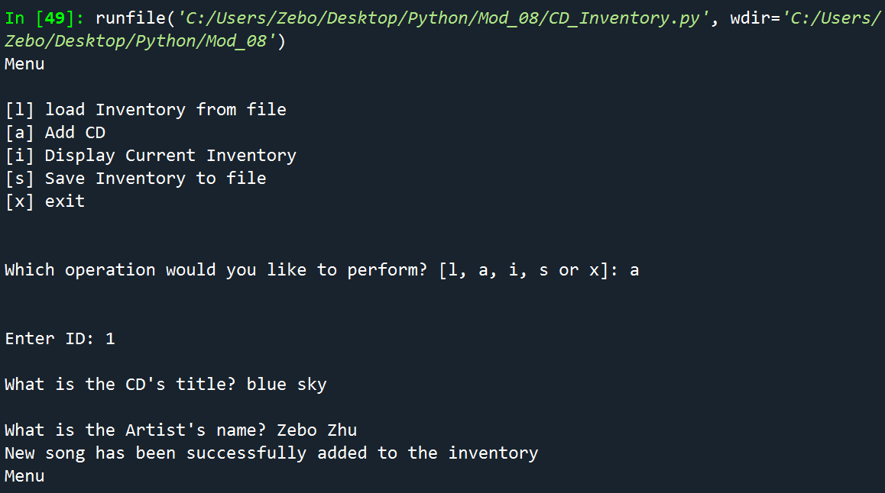

Figure – Results for add CD (Spyder)

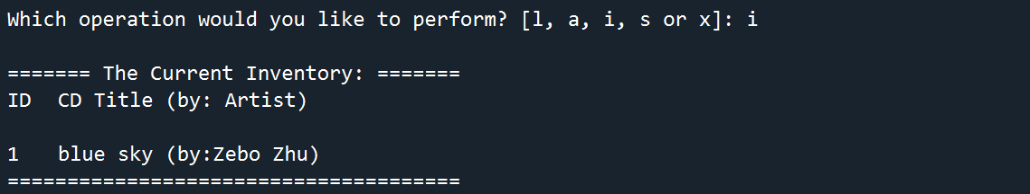

Figure - Results for displaying inventory (Spyder)

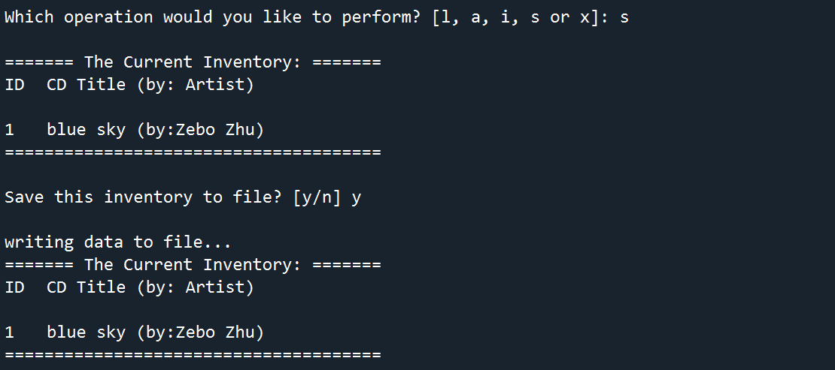

Figure - Results for saving inventory (Spyder)

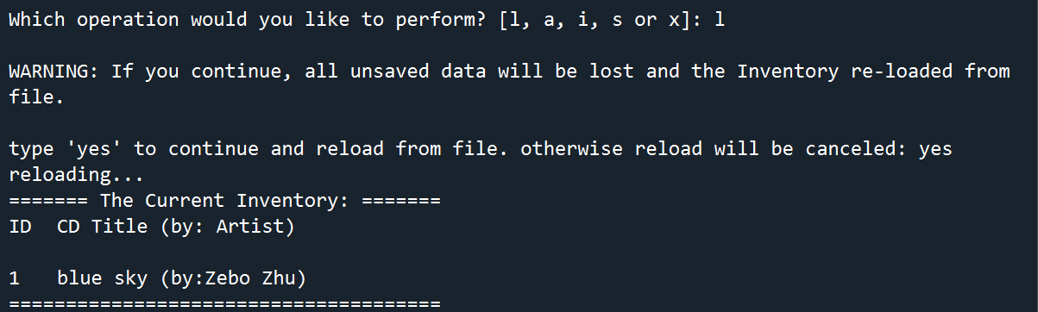

Figure - Results for loading data from file (Spyder)

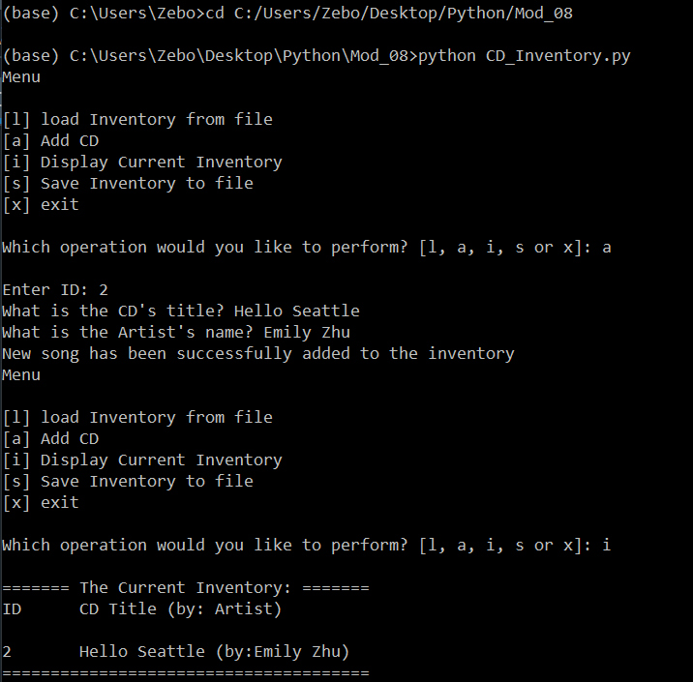

Figure - Results for adding CD and display current inventory (terminal)

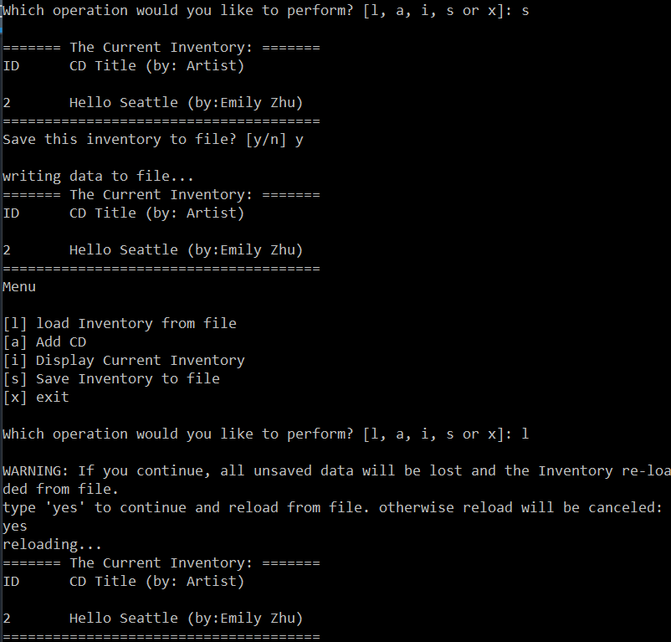

Figure - Results for saving inventory to a file and loading data from file (terminal)

# Summary

In this assignment I covered the entire process of how I read and understand the pseudocode provided in the starter script, then add code to make the application work with Object Oriented Programming and is now complete.

The link to the Github page: https://github.com/zebozhu/Assignment_08