Introduction
Out of the BOX when RFD40/90 is connected through USB, RFD40/90 barcode scanner is not available for Datawedge and can be accessed only through integrated RFID SDK. If users need to use RFD40/90 scanner for Datawedge along with integrated RFID applications, then user need to configure the device for new co-existence mode.
RFD40 barcode scanners are available for either SDK or Data wedge. Users cannot create Data wedge profile to access RFD40 scanner and associate to same application which initializes the same scanner interface through SDK.
Whenever a new RFD40 device is connected to terminal through USB. Scanning framework takes priority and enumerates the Scanning interface. During this period SDK will not be able to acquire the scanning interface until scanning framework finishes the enumeration which takes around 10 seconds. During this period scanner init API

sdkHandler.setSfCoexistenceModeInit(new SDKHandler.SfCoexistenceResultListener() {
@Override
public void onResult(SfCoexistenceResult sfCoexistenceResult) {
switch (sfCoexistenceResult){
case SF_COEXISTENCE_FAILURE:
//Failure case
break;
case SF_COEXISTENCE_SUCCESS:
//Success case
break;
case SF_COEXISTENCE_NOT_SUPPORTED:
//Reader not configured to SSI datawedge mode
break;
}
}
});
Note: User needs to call setSfCoexistenceModeInit as the first API call immediately after creating sdkhandler instance.

Callback listener will provide the result with success or failure. In case of failure user needs to retry after 10 seconds to set the operation mode again.

Co-existence mode has dependency on the following component version to function
- Android SDK 2.0.5.238 and above
- Android Application 2.0.5.238 and above
- Firmware version SAAFKS00-011-R01E0
- Scanning framework 2025 December LG release
- 123RFID Desktop 3.0.0.62
Note: Please refer to the component version section below to download corresponding components.

Users can also check or confirm if the RFID reader is in the data wedge mode supporting co-existence using the following API.
boolean isReaderInUsbDatawedgeMode = sdkHandler.isSSIDwInterfaceCDCScannerAvailable();

Please note Device needs to be configured for co-existence mode please refer to the details under firmware configuration.
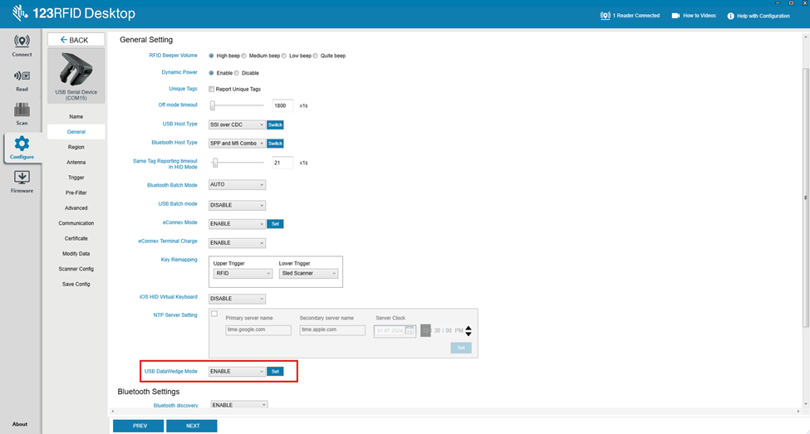
Component version
- Android SDK 2.0.5.238 Zebra 123RFID Mobile Support | Zebra
- Android APP 2.0.5.238 Zebra 123RFID Mobile Support | Zebra
- Firmware SAAFKS00-011-R01E0.DAT RFD40 UHF RFID Sled Support & Downloads | Zebra
- Scanning framework 2025 December LG release
- 123RFID Desktop 3.0.0.62 123RFID Desktop | Zebra
Firmware Configuration
Use the FW SAAFKS00-011-R01E0 to verify data wedge support
Steps to follow:
- Update the latest shared Firmware SAAFKS00-011-R01E0
- After successful update perform factory reset
- By default, out of the box/factory sled is not configured in data wedge mode. User needs to configure the same using below

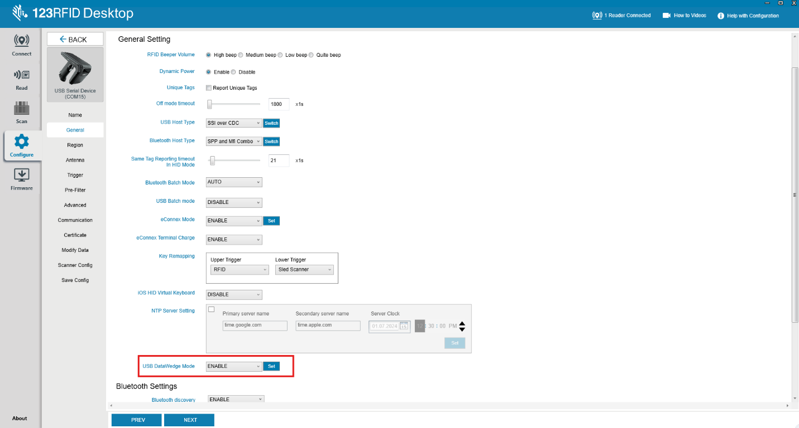

After above step USB will reset, that is connection to serial terminal will be lost

- Now users should be able to perform following actions
  - Switch to 123RFID sample app and perform barcode scan
  - Switch back to DW demo, and scan barcodes
  - Steps a & b can be repeated

Connection failure scenario
In scenario where RFDXX device is configured for USB Datawedge and when you try to connect using incompatible or the old BSP user will observe connection failures.
