**1.Introduction**

## Purpose

Existing Hanyang application is complicated, slow and UI is not good.

By developing light version of Hanyang application, it will be improved.

## Product Scope

New Hanyang application is only used by Hanyang university ERICA students. It helps students to give some information(restaurant menu, shuttle bus schedule, school class schedule, mobile student card, free board)

This application is responsive-web-based.

## Glossary

app. : application

univ. : university

* 1. **References**

IEEE Std 830-1998, IEEE Recommended Practice for Software Requirements Specifications. ISBN 0-7381-0332-2.

* 1. **Overview**

This document is laid out in a modified IEEE830-1998 style.

The following information is in this document:

* Section 2: General description of product, including user interface screen shots, dependency analysis, and enterprise requirements.
* Section 3: Functional & Non-functional requirements. Note that all non-functional requirements are grouped into one category
* Section 4 describes the requirements analysis process.

**2. Overall Description**

**2.1 Product Perspective**

**2.1.1 System interfaces**

* Responsive Web Design
* Database connection to the mySQL database containing user and schedule data

**2.1.2 User interfaces**

Font is 15px.

Menu button is on the top.

And so on… ( because we didn’t decide)

**2.1.3 Software interfaces**

**2.2 Product Functions**

1. Restaurant menu

2. Shuttle bus schedule

3. School class schedule

4. Mobile student card

5. Free board

## 2.3 User characteristics

The users are students in the university. The students are expected to be able to use in daily life of university. The main functions of Hanyang University Application will have the Restaurant menu, shuttle bus schedule, school class schedule, free board and QR code for mobile student card.

Most of users are expected to use this application. The application should facilitate the students’ school life.

The detailed look of these pages is discussed in section 3.2 below.

## 2.4 Constraints

Hanyang Univ. Application is developed by students and the team consists of 10 persons. Therefore, there are few limitations. Following are the limitations :

* Lack of professionalism
* Lack of reality database
* difficulty of Login system
* it must take contents in 4 touch

## 2.5 Assumptions and dependencies

To implementation of all functions, we must use Hayang univ. API.

It can support to fully function of mobile student card include QR code and personally notification.

## 2.6 Apportioning of requirements

We will adopt agile software development with Scrum. The new sprint will cycle every two weeks.

1. **Specific Requirements**

## 3.1 External interface requirements

The application of Hanyang Univ. is going to use the browsers in operating system. Moreover, the link to an external system is Database to verify the identity of students. The QR code use-case keeps the QR code for database.

## 3.2 Functional requirements

**3.2.1 Use-case Diagram**

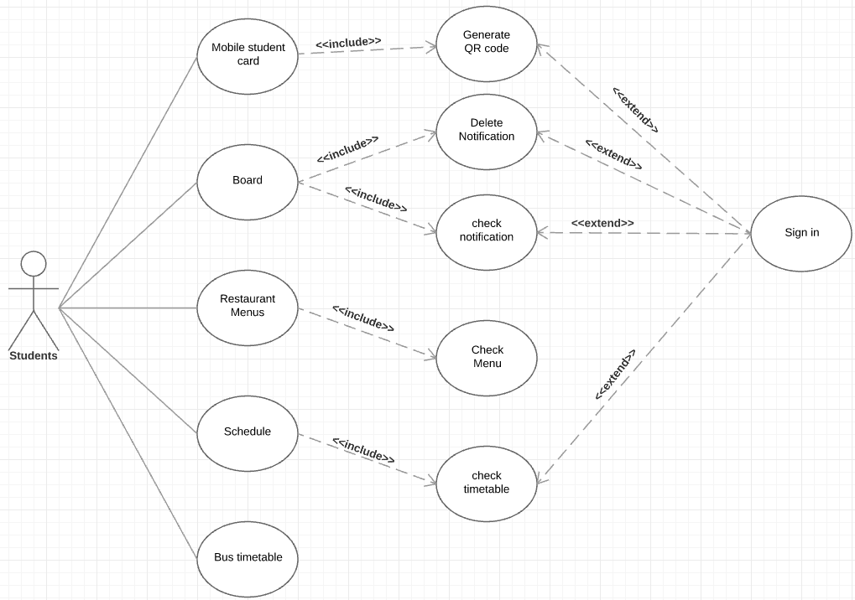

**3.2.2 Feature-Functionality Table**

|  |  |  |  |
| --- | --- | --- | --- |
| **Feature No.** | **Features** | **Functionality** | **Descriptions** |
| 1 | Mobile student card | This feature should provide a personally QR code for students | Generating the QR code by student number |
| Users will use it to enter the library or other entrance guard |

## 3.3 Design constraints

This application shall be a web application running in the windows or XOS. The system should be developed using technologies about web development.

## 3.4 Software system attributes

## 3.4.1 Availability

This system should available every time, so the web server is always working state.

## 3.4.2 Security

This software saves the students information into database when students sign in. There is no restriction on access. The use of QR code should be generated when user use it for getting into library.

## 3.4.3 Maintainability

Developed team updates web application, reflecting users’ feedback.