<Hanyang Application>

Software Requirements Specification

<1.0.0>

<2016. 4. 7.>

<SE project team>
Lead Software Engineer

Prepared for
WSU-TC CptS 322—Software Engineering Principles I
Instructor: A. David McKinnon, Ph.D.
Spring 2005

Revision History

Date | Description | Author | Comments
2016. 4. 7. | 1.0.0 | SungDaHae | SRS for a bulletin board

Document Approval

The following Software Requirements Specification has been accepted and approved by the following:
Signature | Printed Name | Title | Date

Table of Contents

Revision History ii
Document Approval ii
3. Specific Requirements 2
3.1 Functional Requirements 3
3.1.1 Functional Requirement 1 3
3.1.2 Functional Requirement 2 3
3.1.3 Functional Requirement 3 3
3.1.4 Functional Requirement 4 3
3.1.5 Functional Requirement 5 3
3.1.6 Functional Requirement 6 3
3.2 External Interface Requirements 3
3.2.1 User Interfaces 3
3.2.2 Software Interfaces 3

3. Specific requirements

3.1 Functional Requirements
A Bulletin board section help people related with hanyang univ. communicate each others. In this section, people can share their knowledge about a space around the univ., situation that is happened in the univ., or anything else. Also people ask others if they seek a partime job or have something need to use. To be able to do these requirements, functions of the bulletin board consist of writing, reading, editing, deleting contents by people and paging, searching for a content or a page.

3.1.1 Functional Requirement 1
3.1.1.1 Introduction
Writing content and saving.
3.1.1.2 Inputs
Name of title, content, save request.
3.1.1.3 Processing
Send request to server to save content.
3.1.1.4 Outputs
Popup alert identify saving.

3.1.2 Functional Requirement 2
3.1.2.1 Introduction
Reading content.
3.1.2.2 Inputs
Clicking the content.
3.1.2.3 Processing
Send request to server to give the content to browser and browser shows up the page.
3.1.2.4 Outputs
The page with reading content.

3.1.3 Functional Requirement 3
3.1.3.1 Introduction
Editing content.
3.1.3.2 Inputs
matching information between writer and editer, Name of title, content revised, save request.
3.1.3.3 Processing
Send request to server to update content.
3.1.3.4 Outputs
Popup alert identify updating.

3.1.4 Functional Requirement 4
3.1.4.1 Introduction
Deliting content.
3.1.4.2 Inputs
matching information between writer and requester, delting request.
3.1.4.3 Processing
Send request to server to delete content.
3.1.4.4 Outputs
Popup alert to identify deleting.

3.1.5 Functional Requirement 5
3.1.5.1 Introduction
Paging next list of page.
3.1.5.2 Inputs
Clicking paging index.
3.1.5.3 Processing
Send request to server to show up the list of next page.
3.1.5.4 Outputs
List page of wanted page by user

3.1.6 Functional Requirement 6
3.1.6.1 Introduction
Searching the content
3.1.6.2 Inputs
Name of title or writer or parts of contents.
3.1.6.3 Processing
Send request to server to make DB to find the content and take with content to browser showing up the content.
3.1.6.4 Outputs
list page of the contents consisting of searching hint.

3.2 External Interface Requirements

3.2.1 User Interfaces
The Interface of Bulletin Board must fulfill effectiveness of visual discrimination. The following is just an example for a possible interface to the bulletin board

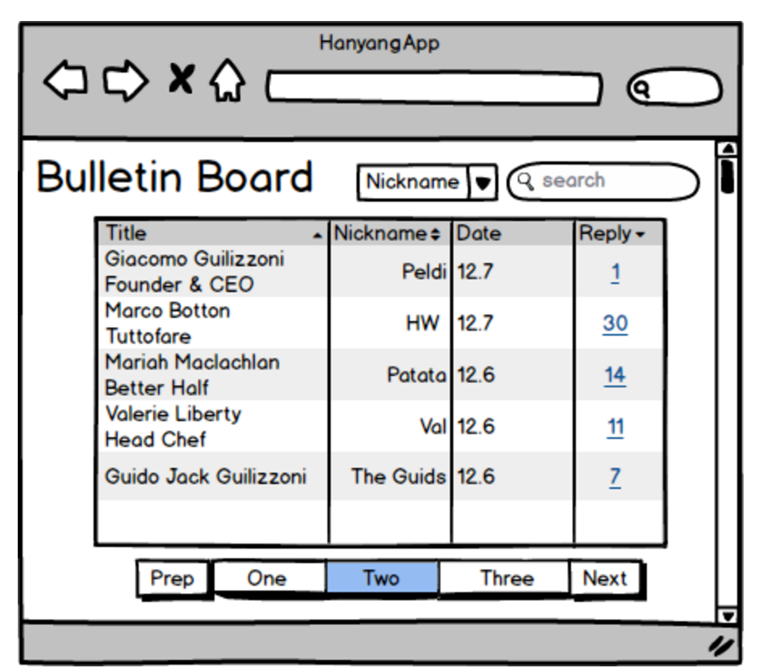
Figure 1: Bulletin Board List
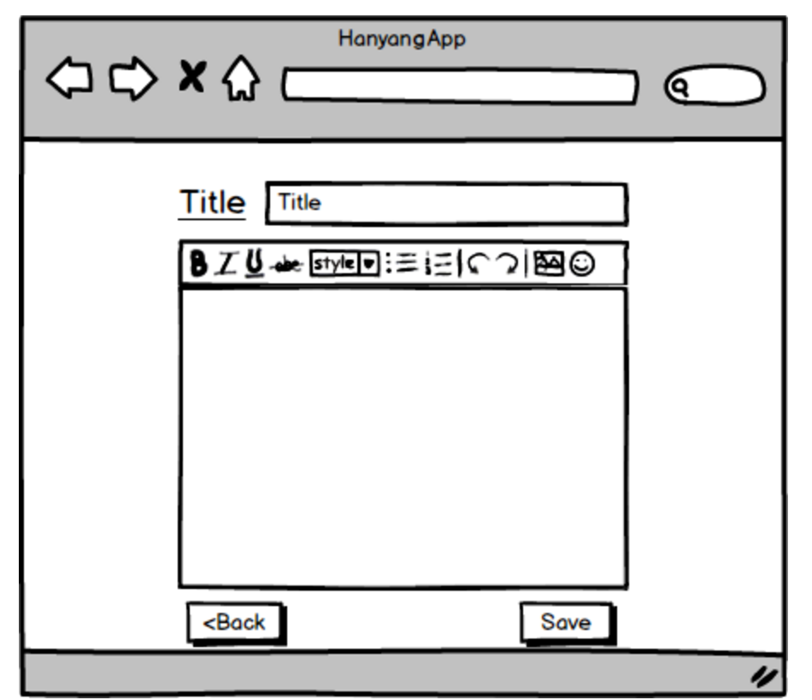
Figure 2: Bulletin Board Writing Page
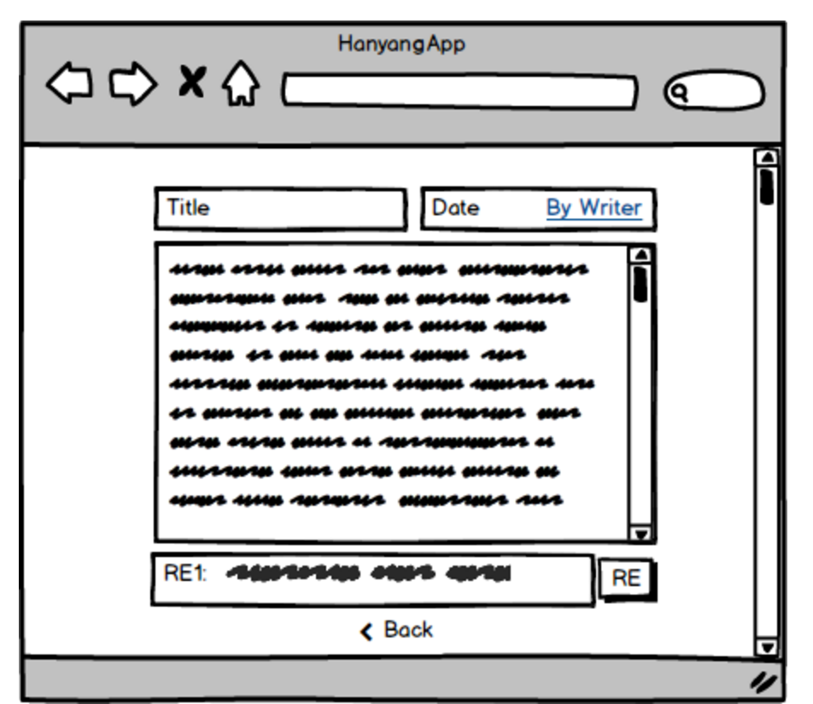
Figure3: Bulletin Board Reading Page

3.2.2 Software Interfaces
The bulletin board network has to provide software interface to:
● different network software
User maybe not operates the network software that server operates. So Interface with different software is needed.

