<HYUmini>

Software Requirements Specification

<draft for bus time function>

<04.07>

<SeungyeonWoo, HyeongseokSong>

1. Introduction

1.1 Purpose
The purpose of this document is to present a detailed description of the Mobile application based on Dynamic web and web application itself. It will explain the purpose and features of the application, the interfaces of the application, what the application will do, the constraints under which it operates and how the application will react to external inputs. This document is intended for both the stakeholders and the developers of the application.

1.2 Scope
This application will a compact version of currently using Hanyang University application. We will call this as a HYUmini. This application provides only key functions of current Hanyang University application. This application is more intuitive and lighter(uses less memory spaces and fast run time). By reducing functions, user can reduce overuse of time to search for wanted functions and that leads to remove inconvenience of using abundant application.
More specifically, this application is designed to provide users only a key function for Hanyang University students. Selected most required 5 functions are voted by Hanyang University students.
-Show HYU shuttle bus time table
-Show menus of cafeterias inside HYU
-Show individual’s time table
-Provide mobile student ID card function, so that students can use it as a student card.
-Provide anonymous free board.

1.3 Overview
The next chapter, the General Description section, of this document gives an overview of the functionality of the product. It describes the required functions of application and specifies the user. Then find some constraints and assumptions for further developing.
The third chapter, Requirement Specification section, of this document is written primarily for the developers and describe every details of the functionality of the application. It describes selected 5 key functions and shows use cases of each of them.

2. General Description

2.1 Product Perspective
Smaller version of current Hanyang University application. Remove abundant functions of current HYU application and select most used functions. Improve some inconvenience of selected function in using current HYU application.

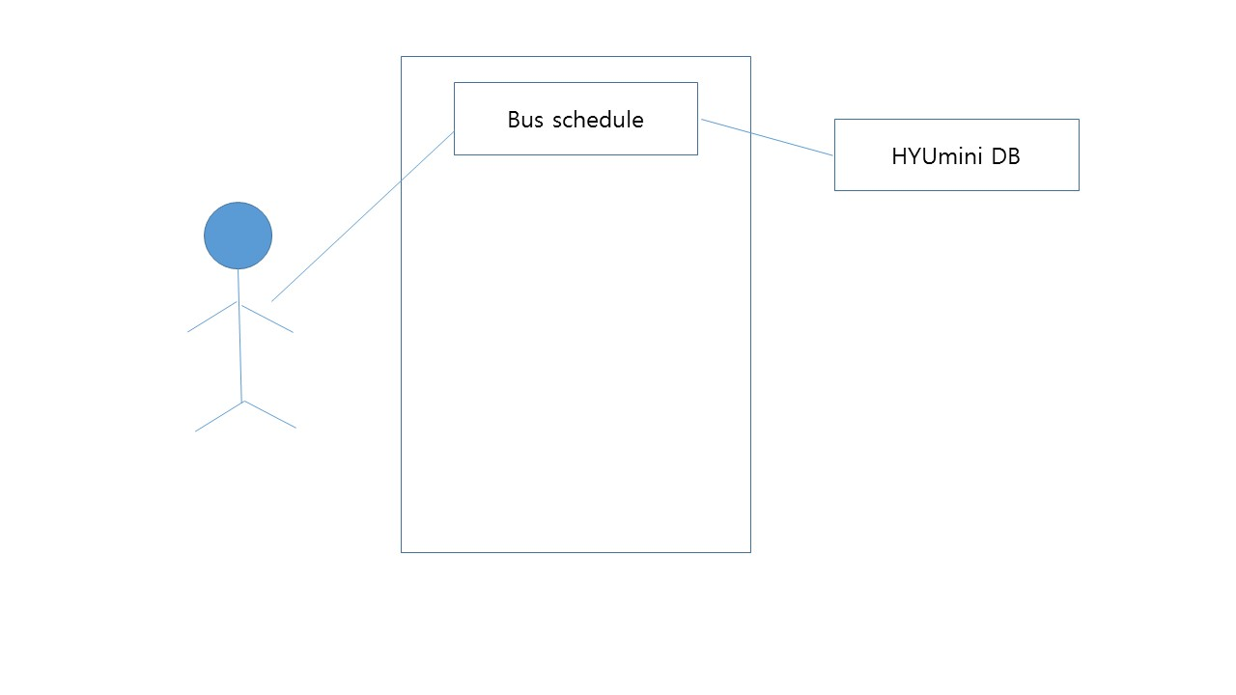

2.2 Product Functions
Provide simple functions for hanyang university students
-Show HYU shuttle bus time table
-Show menus of cafeterias inside HYU
-Show individual’s time table
-Provide mobile student ID card function, so that students can use it as a student card.
-Provide anonymous free board.

2.3 User Characteristics
Students of Hanyang University have been complained about too many functions that are not used at all in original Hanyang University application.
Students of Hanyang University who use only few functions in current application and want compact functionality.

2.4 General Constraints
Limits of API or user authority for access database system.

2.5 Assumptions and Dependencies
Have some functional or visual malfunctions, because of variety of web browsers.

3. Specific Requirements

3.1 External Interface Requirements
Maximum 3 clicks limitation (max 3 clicks are required to access every pages of application)

-Use tabs for access different categories in same function pool.3.2 Functional Requirements
This section describes specific features of the software project. If desired, some requirements may be specified in the use-case format and listed in the Use Cases Section.

3.2.1 Shuttle bus time table
3.2.1.1 Introduction
Showing shuttle/commute bus time table
3.2.1.2 Inputs
Current time
3.2.1.3 Processing
Using database, get shuttle bus time table and display up-coming bus schedule by checking current time.
3.2.1.4 Outputs
Show up-coming bus schedule. Display whole bus schedule and focus on up-coming bus schedule.
Divided into 2 tabs, one for shuttle bus schedule and other for commute bus schedule.
3.2.1.5 Error Handling
After the shuttle bus operation time, focusing on top of the bus schedule(earliest schedule).

3.3 Use Cases

3.3.1 Application User(Student of Hanyang University) Use Case

Use case : Find bus schedule
-Brief Description : The users click ‘bus schedule’ button, to check shuttle/commute bus schedule.
-Initial Step-By-Step Description

1. click ‘bus schedule’ button
-> Shuttle bus schedule displayed(among two tabs, shuttle bus tab is selected in default)
(in bus operation time : bus schedule displayed and up-coming bus schedule focused /not in bus operation time : bus schedule displayed and top of bus schedule focused)
2. Drag down to show other schedule
3. Click commute bus tab
->Display commute bus schedule
4.Click each line to check detail of commute bus route
->Display selected bus’s route
2. Click commute bus tab
->Display commute bus schedule
3.Click each line to check detail of commute bus route
->Display selected bus’s route

3.4 Non-Functional Requirements

3.4.1 Performance
Less than 3 clicks are needed to check all bus schedule.

3.4.2 Security
Secure login information

3.5 Design Constraints
- Don’t make horizontal scroll in any screen(display horizontal factor within given screen)
- Consistency in button design
- Consistency in text format

3.6 Logical Database Requirements

Bus schedule should have two attribute, shuttle bus and commute bus.
-Shuttle bus schedule categorized by school semester, week and weekend.
- Shuttle bus schedule with time information
- Texturized commute bus schedule

