Fashion and Apparel Career Evaluation - Group 7
  - Boston University MET AD 688 Professor Padalkar
Alyssa Quigley, Ankita Roy, Zechariah Schweitzer, Sara Scribner
2026-10-12
Project website: https://zechnschweitzer.github.io/ad688-fashion-apparel-evaluation-group7/
GitHub repository: https://github.com/zechnschweitzer/ad688-fashion-apparel-evaluation-group7

1. Product Framing
Our group developed a solution for students interested in entering the apparel and fashion industry and seeking analytics-related opportunities. Fashion retailers have leaned harder into data analytics in recent years (Oh, 2020), and the U.S. Bureau of Labor Statistics projects continued growth in analytics-related roles (U.S. Bureau of Labor Statistics, 2025). Job postings for these roles frequently call for SQL, Excel, and visualization tools like Tableau or Power BI, alongside analytical and communication skills (ZipRecruiter, 2026b), and the same postings show a fair amount of spread in pay and remote availability (ZipRecruiter, 2026a). A broader literature review on business analytics hiring shows a consistent pattern. Umamaheswaran et al. (2023) found business analytics postings ask for a mix of big data, business intelligence, and analytical technique alongside communication and stakeholder management (Umamaheswaran et al., 2023). Alshameri and Adhikari (2025) identified a similar mix of general tools and field-specific skills in business postings, describing a growing disconnect between what schools teach and what employers actually look for (Alshameri & Adhikari, 2025). Debortoli et al. (2014) found that business intelligence and big data postings separate technical tool skills from broader analytical thinking, with the strongest candidates showing both (Debortoli et al., 2014). Apparel retail is a fitting test case for that combination: IBISWorld (2025) backs forecasting, inventory, pricing, and supply chain decisions as recurring analytical needs in clothing and accessory retail (IBISWorld, 2025), and The Planet Group (2025) found retail hiring has grown more selective even as it leans harder into technology, analytics, and customer experience (The Planet Group, 2025). This project is aimed at BU MET students exploring analytics career paths in apparel retail, and asks which skills are most valued for business and data analyst roles in apparel retail, and how well our own team’s current skill set matches those demands. It helps them identify suitable job opportunities, assess skill gaps, and determine which skills to develop next. This analysis focuses on apparel and fashion employers under the North American Industry Classification System (NAICS) code 458, Clothing, Clothing Accessories, Shoes, and Jewelry Retailers.

2. Scope and Data
Although the dataset included 504,208 job postings extracted from 21 parquet parts, only 19 were usable for this evaluation after combining the NAICS 458 filter with a list of known apparel and fashion employers and a role-title match, making this analysis fashion analytics market-focused rather than an assessment of the broader analytics industry. The dataset uses the following columns in this evaluation: ID, TITLE_CLEAN, COMPANY_NAME, COMPANY_CLEAN, SALARY_FROM, SALARY_TO, MIN_YEARS_EXPERIENCE, MAX_YEARS_EXPERIENCE, CITY_NAME, STATE_NAME, REMOTE_TYPE_NAME, SKILLS_LIST, SOFTWARE_SKILLS_LIST, NAICS_2022_3.
Table 1: Filter funnel from raw dataset to final analytical sample
Step | Postings
Raw source (21 parquet parts) | 504,208
NAICS 458 only | 18
Known apparel/fashion employer only | 2,387
NAICS 458 OR known employer (industry match) | 2,405
Role title keyword match, any industry | 13,841
Final filtered set (industry match AND role match) | 19

3. Market Baseline
The market baseline examines the apparel and fashion industry demand, salary, location, working arrangement, and required experience for the selected analytics market. Job title, employer, and location are available for all 19 postings, but experience data is usable for only 9 postings and salary and work arrangement data are usable for only 4 postings each, so those smaller findings should be read with more caution. The 19 postings cover a fairly wide mix of roles, including analyst, business intelligence, ecommerce, merchandise, and senior analytics positions, and most titles appear only once.
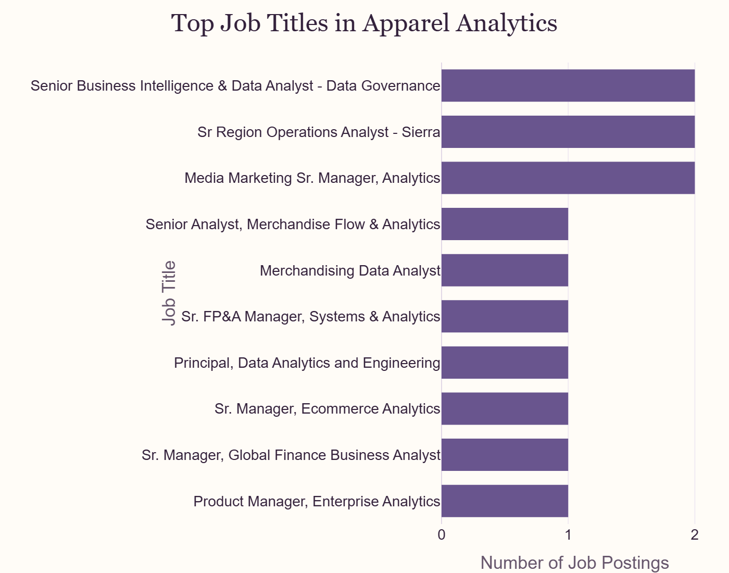
Market Baseline-Job Titles
Figure 1: Top job titles in the apparel analytics sample
Grouping the 19 postings by functional focus shows BI and data analytics roles make up the largest share at 6 postings, followed by marketing and customer analytics with 5, merchandising and ecommerce with 3, finance and strategy analytics and operations analytics with 2 each, and product or engineering analytics with 1. Job opportunities were also concentrated among a small number of employers: Vuori and TJX each account for 5 postings, Adidas accounts for 3, and Ralph Lauren accounts for 2, while Nordstrom, Foot Locker, Michaels, and Macy’s each contribute 1.
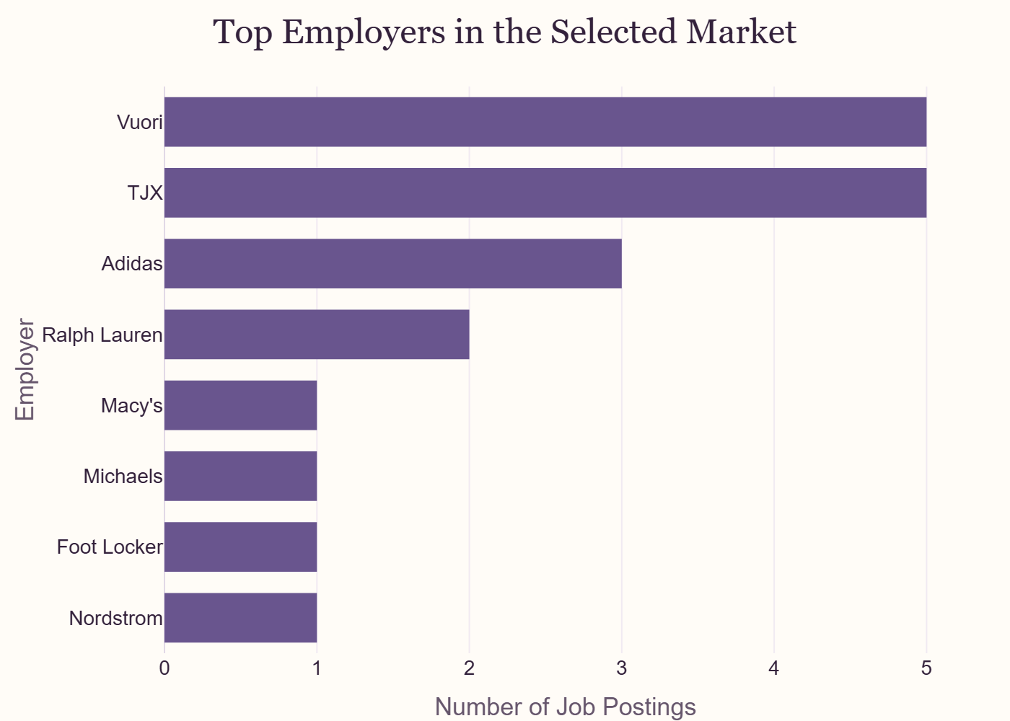
Market Baseline-Employers
Figure 2: Top employers in the selected market
Geographically, California and Massachusetts each account for 5 postings, followed by New York with 4 and Oregon with 3.
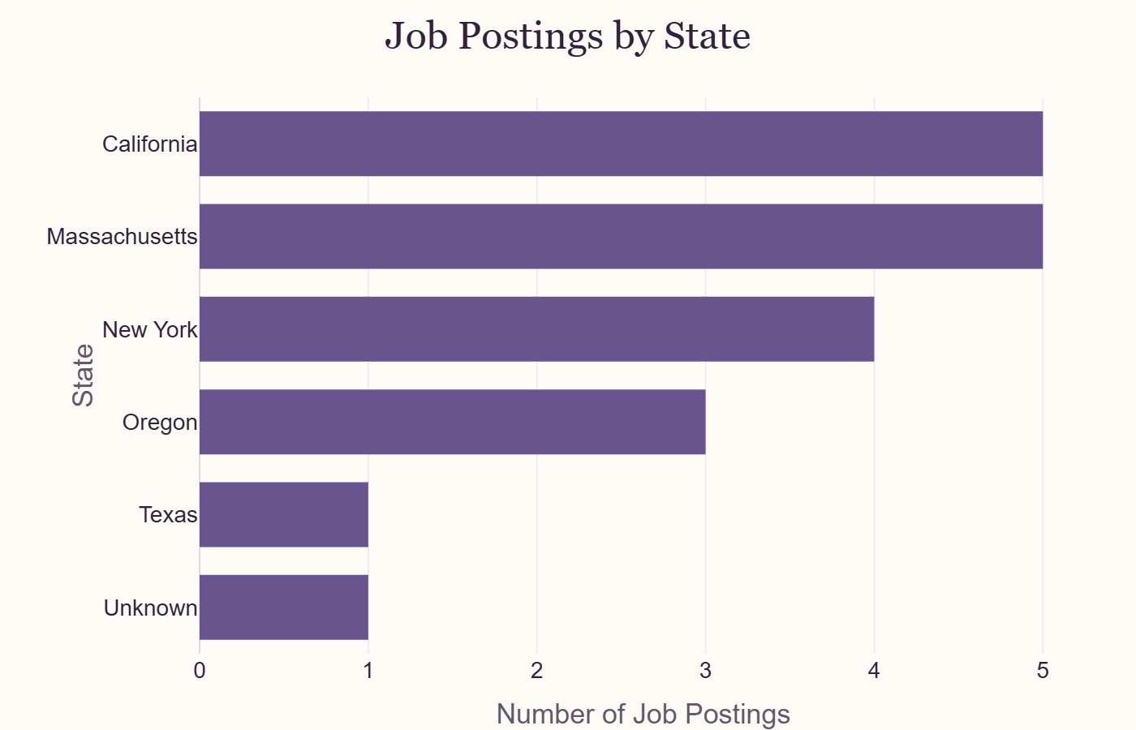
Market Baseline-Location
Figure 3: Job postings by state
Salary data was limited to 4 of the 19 postings, with a range of approximately $85,000 to $161,000. Work arrangement data was also limited to 4 postings: 3 are classified as hybrid and 1 as fully remote, and no posting in the sample is explicitly classified as onsite.
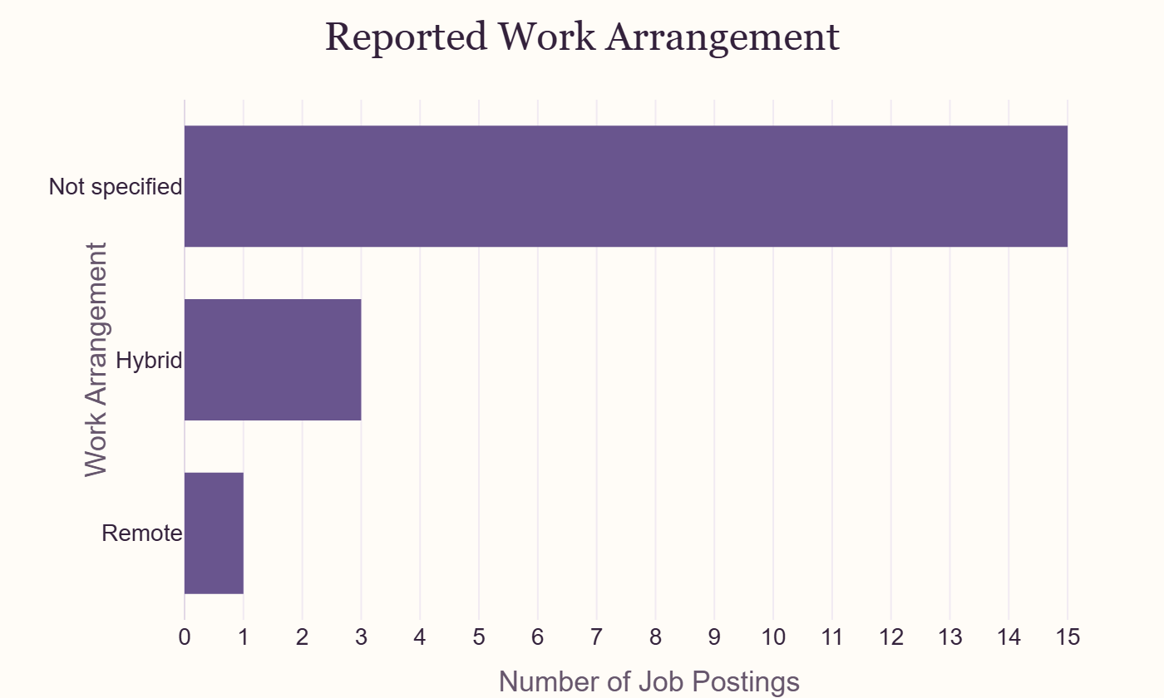
Market Baseline-Remote vs Onsite
Figure 4: Reported work arrangement
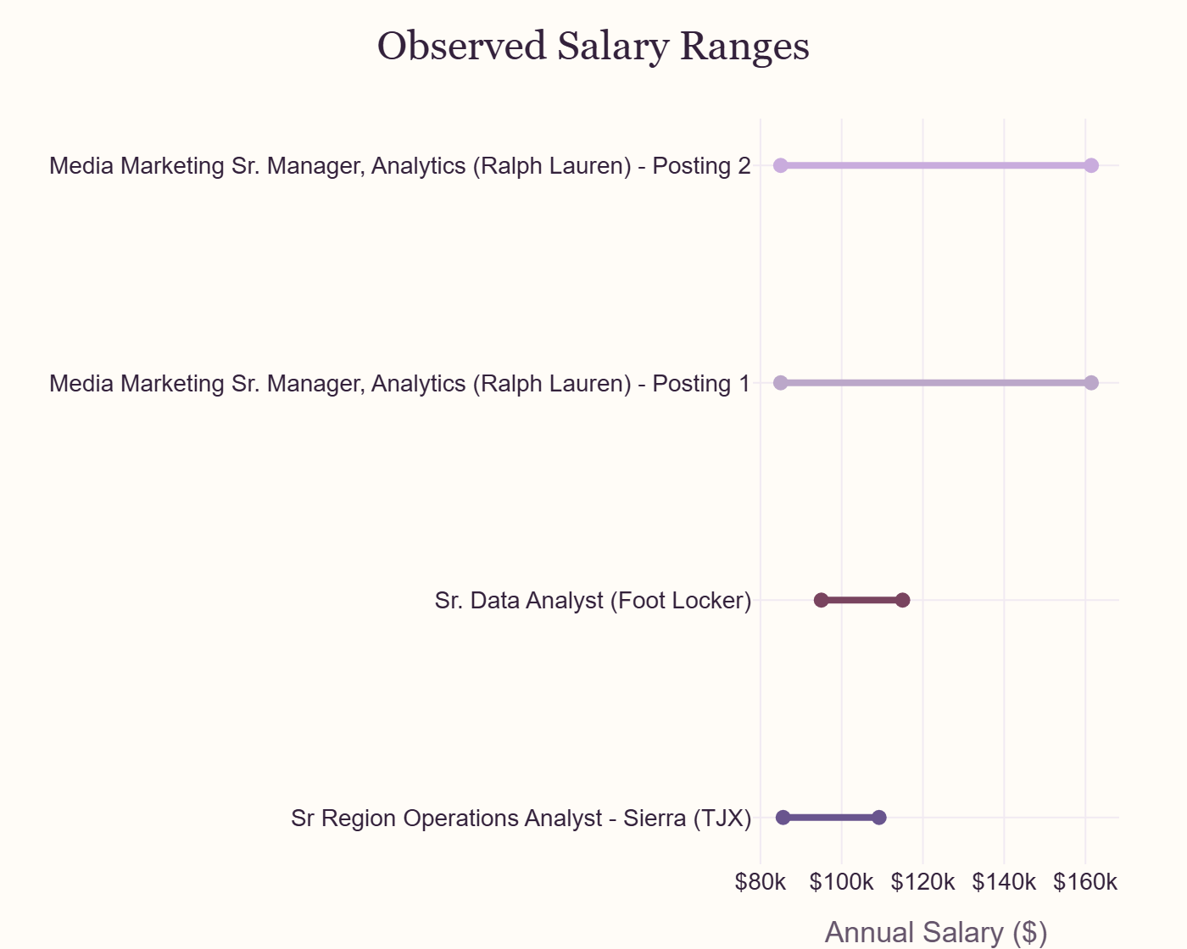
Market Baseline-Salary
Figure 5: Observed salary ranges
Minimum experience information is available for 9 of the 19 postings. Of those, 7 show a recorded minimum of 0 years and 2 show a minimum of 5 years, so most opportunities with a reported requirement do not require prior experience.
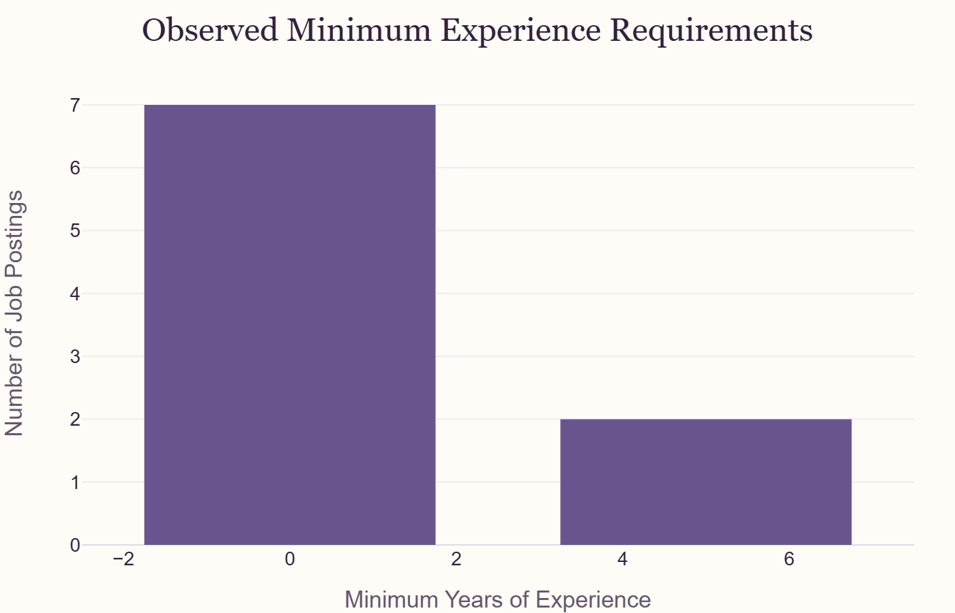
Market Baseline-Experience
Figure 6: Observed minimum experience requirements
Our findings suggest opportunities for analytics professionals across multiple areas within the fashion and apparel industry, while the dataset size and incomplete job posting information limit the ability to generalize these results to the broader fashion and apparel industry.

4. Skill-Gap Analysis
The Skill-Gap Analysis compares required employer skills with the current capabilities of the student, which our group used to test the model and assess our own skills. Skills are rated from 1 (Beginner) to 5 (Expert); each skill is then compared against market demand, which is used to set the “Target Level”. From there, the user can see the gap between their skill level and the target level, and is given a priority level for improvement. Power BI and SQL were the most frequently requested technical skills, each appearing in 7 of 19 postings, followed by Python and Microsoft Excel with 5 each and Digital Marketing with 4. The remaining skills, including Stakeholder Management, Project Management, and Data Analysis, each appeared in 2 to 3 postings.
Table 2: Skill gap summary: market demand, target level, team average, and priority
Skill | Market Demand | Target Level | Team Average | Gap | Priority
Power BI | 36.8% | 5 | 2.75 | 2.25 | High
SQL | 36.8% | 5 | 3.25 | 1.75 | High
Python | 26.3% | 4 | 2.75 | 1.25 | Moderate
Digital Marketing | 21.1% | 4 | 2.75 | 1.25 | Moderate
Excel | 26.3% | 4 | 4.25 | -0.25 | Low
Stakeholder Mgmt | 15.8% | 3 | 3.50 | -0.50 | Low
Project Mgmt | 15.8% | 3 | 3.50 | -0.50 | Low
Data Analysis | 15.8% | 3 | 4.00 | -1.00 | Low
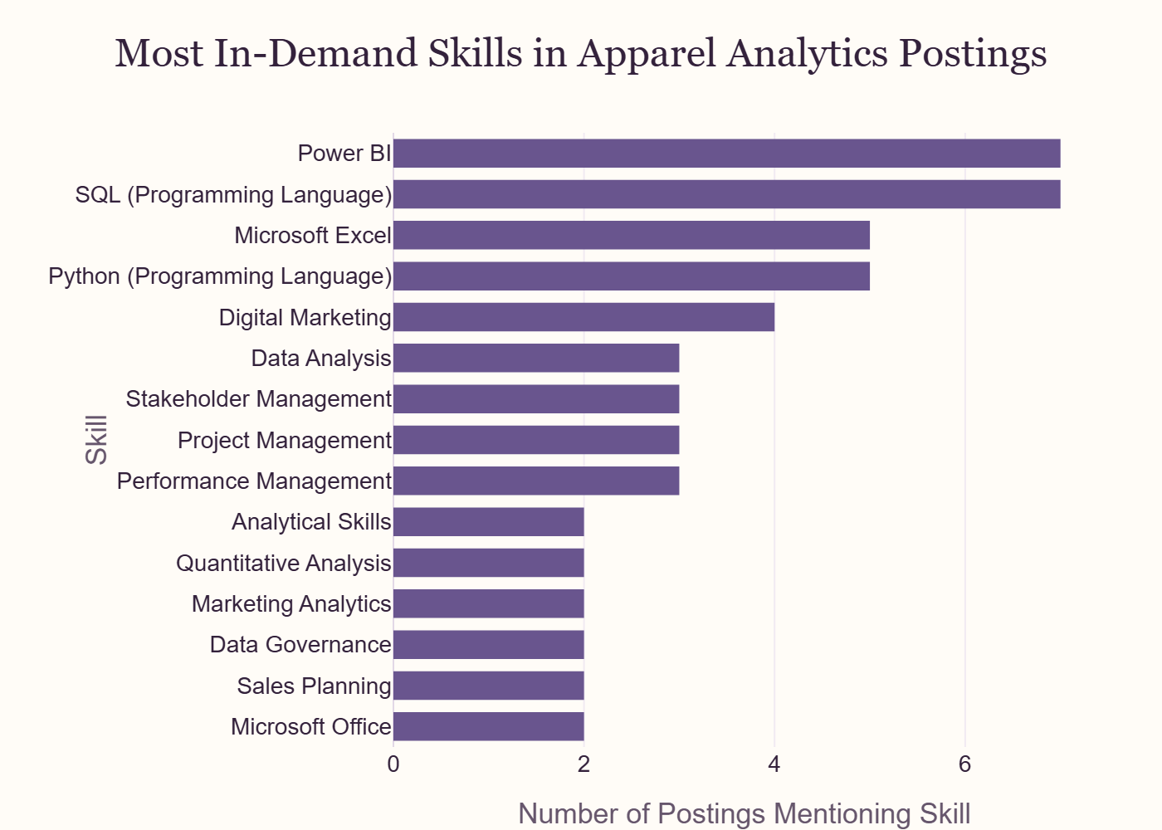
Skills Gap-Top Skills
Figure 7: Most in-demand skills in apparel analytics postings
The team rated itself strongest in Excel (4.25) and Data Analysis (4.0), and weakest in Power BI (2.75), Python (2.75), and Digital Marketing (2.75).
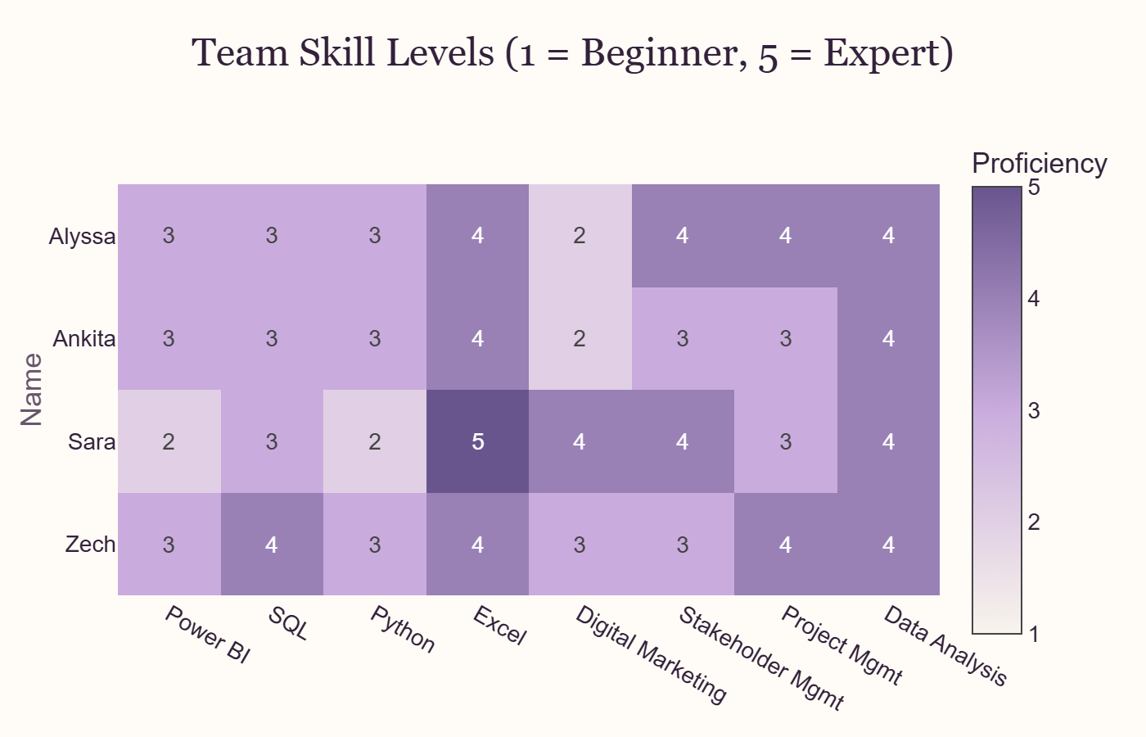
Skill Gap-Team Heatmap
Figure 8: Team skill levels (1 = Beginner, 5 = Expert)
Comparing these averages against market-based targets set Power BI (2.25 gap) and SQL (1.75 gap) as high priority, and Python and Digital Marketing as moderate priority. Excel, Stakeholder Management, Project Management, and Data Analysis all came back as low priority, since the team’s average proficiency already meets or exceeds the market-based target for each.
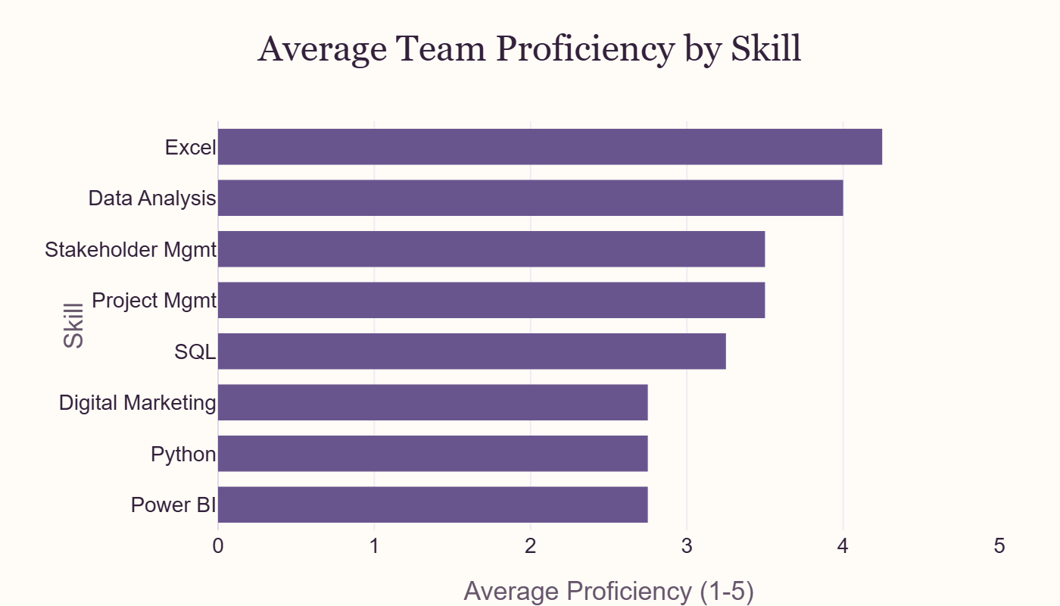
Skill Gap-Average Proficiency
Figure 9: Average team proficiency by skill
Power BI is the most consistent gap across the team: every member rated it at 3 or below despite it tying for the highest market demand.
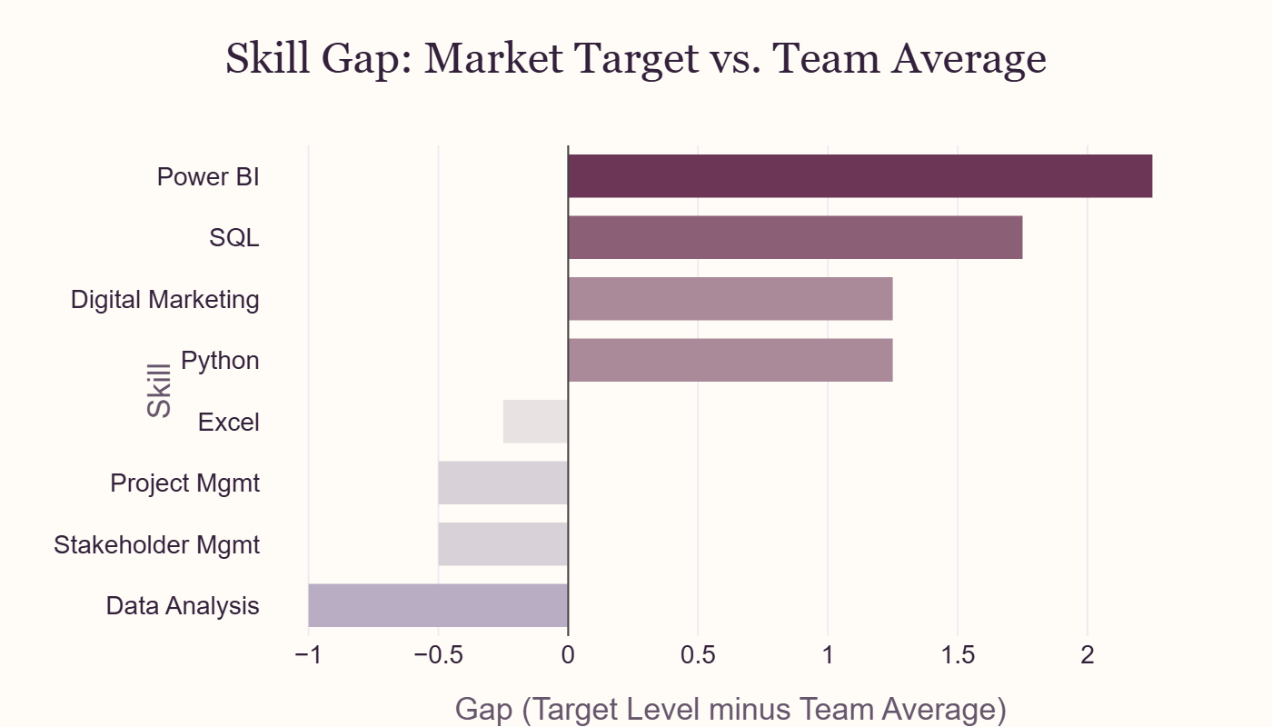
Skill Gap-Priority Diverging Chart
Figure 10: Skill gap, market target vs. team average

5. Career Evaluation
The 19 postings in our filtered dataset do not represent equally strong opportunities for this team, so we evaluate them on three factors: attainability, skill relevance, and employer signal. Experience requirements are not evenly spread: 17 of the 19 postings list a minimum of 0 years of experience, and only 2 list a 5-year minimum, so accessibility is mostly uniform with a couple of high-bar outliers. Skill relevance separates the postings more clearly. We counted how many of the team’s four strongest self-rated skills (Data Analysis, Microsoft Excel, Stakeholder Management, Project Management) show up in each posting’s listed skills, and found 8 of the 19 postings match none of them, 7 match exactly one, and 4 match two; not a single posting matches three or four. Employer signal is also concentrated: Vuori accounts for 5 of the 19 postings, TJX accounts for 5, and Adidas accounts for 3, so together those three employers make up 13 of 19 postings, or 68 percent, while the remaining six employers in the sample post once each. These three factors feed directly into the Opportunity Scorecard below.

6. Final Analytics
The final analysis uses a rule-based Opportunity Scorecard to rank job postings according to skill fit, experience accessibility, and employer signal score. A scorecard was selected over a predictive model because the final dataset had only 19 postings, making it more vulnerable to overfitting. We found the highest-ranked position was the Senior Manager, Ecommerce Analytics role at Vuori, with an opportunity score of 10. The second and third highly ranked positions were Sr. FP&A Manager, Systems & Analytics at Vuori and Director, Wholesale Sales Planning & Analytics at Adidas.
Table 3: Opportunity Scorecard, ranked by skill fit, accessibility, and employer signal
Title | Company | Skill Fit | Accessibility | Employer Signal | Opportunity Score
Sr. Manager, Ecommerce Analytics | Vuori | 2 | 3 | 5 | 10
Sr. FP&A Manager, Systems & Analytics | Vuori | 1 | 3 | 5 | 9
Director, Wholesale Sales Planning & Analytics | Vuori | 1 | 3 | 5 | 9
Manager, Digital Marketing Analytics | Adidas | 2 | 3 | 3 | 8
Sr. Manager, Global Finance Business Analyst | Vuori | 0 | 3 | 5 | 8
Product Manager, Enterprise Analytics | Vuori | 1 | 1 | 5 | 7
Sr Region Operations Analyst - Sierra | TJX | 0 | 3 | 3 | 6
Sr. Data Analyst | Foot Locker | 2 | 3 | 1 | 6
Senior Analyst, Merchandise Flow & Analytics | TJX | 0 | 3 | 3 | 6
Manager, Digital Consumer Analytics | Adidas | 2 | 1 | 3 | 6
Media Marketing Sr. Manager, Analytics | Ralph Lauren | 1 | 3 | 2 | 6
Sr Region Operations Analyst - Sierra | TJX | 0 | 3 | 3 | 6
Media Marketing Sr. Manager, Analytics | Ralph Lauren | 1 | 3 | 2 | 6
Manager, Digital Analytics | Adidas | 0 | 3 | 3 | 6
Senior Business Intelligence & Data Analyst - Data Governance | TJX | 0 | 3 | 2 | 5
Senior Business Intelligence & Data Analyst - Data Governance | TJX | 0 | 3 | 2 | 5
Merchandising Data Analyst | Michaels | 1 | 3 | 1 | 5
Data Analyst 3 - Store Operations | Nordstrom | 1 | 3 | 1 | 5
Principal, Data Analytics and Engineering | Macy’s | 0 | 3 | 1 | 4
The scorecard provides an intuitive method for prioritizing opportunities based on the student’s current skill levels and the characteristics found in the job postings. To check the model’s internal consistency, we computed the rank correlation between each component and the final Opportunity Score. Employer signal correlates most strongly (0.87), skill fit correlates moderately (0.42), and accessibility correlates essentially not at all (-0.11), confirming that employer signal currently has more influence on the ranking than the other two components, since it is an uncapped raw count rather than a capped 0-to-3 or 0-to-4 score. With this in mind, and considering this is not a predictive model, the scorecard is best interpreted as a career prioritization tool rather than a precise ranking.
Table 4: Scoring model diagnostics: component ranges and rank correlation with Opportunity Score
Component | Min | Max | Mean | Correlation with Opportunity Score
Skill Fit | 0.00 | 2.00 | 0.79 | 0.42
Accessibility | 1.00 | 3.00 | 2.79 | -0.11
Employer Signal | 1.00 | 5.00 | 2.89 | 0.87

6.1 Does the Score Predict Pay?
The correlations above show how each component relates to the final Opportunity Score. A separate question is whether those same components relate to actual advertised pay. We fit a simple linear regression predicting salary midpoint from the three scorecard components. Only 4 of our 19 postings listed an actual salary; the other 15 were filled with the sample median during data cleaning, so this regression does not have 19 independent salary observations, it has 4 real ones and 15 copies of the same imputed value. Treat the results below as illustrative of the method, not as a real pay-prediction signal.
Table 5: Linear regression of salary midpoint on scorecard components
Term | Coefficient | Std. Error | p-value
Intercept | 111,300 | 8,379 | <0.001
Skill Fit | 806 | 1,834 | 0.666
Accessibility | 226 | 2,366 | 0.925
Employer Signal | -238 | 954 | 0.806
The model explains about 2 percent of the variation in salary midpoint across our sample (R-squared = 0.017), a figure driven mostly by how the three predictors happen to relate to the repeated median value rather than genuine pay variation. None of the three components reach standard statistical significance at this sample size: skill fit and accessibility are both weakly positive, while employer signal is weakly negative, the opposite direction from its strong positive correlation with the Opportunity Score itself. That mismatch is further evidence the regression is reacting to noise from the imputed values rather than a real pay relationship. A real test of this question would need a larger sample with actual reported salaries, not an imputed one.

7. Recommendations
Given this dataset and our Opportunity Scorecard (Table 3), we recommend students focus their job search on Vuori and TJX, as they had multiple analytics-adjacent postings and dominate the top employers in Market Baseline (Figure 2), making them the most attainable by volume. Adidas ranked third in posting volume, with positions relying more on skill fit rather than application volume. For location, students have the best chance of finding opportunities in California, Massachusetts, and New York, consistent with the state-level concentration in Market Baseline (Figure 3). Students should also focus on developing their Power BI and SQL skills, as they are the most in-demand skills (Figure 7) and the two largest gaps in the Skill Gap Summary (Table 2) and gap chart (Figure 10). The third most important skill is Python, though less than half of these postings required it. By person, Alyssa and Ankita should complete a Power BI learning path before the Module 5 deadline, then move to SQL practice against our own filtered dataset. Sara should prioritize Power BI first given her lowest team rating on it, building on her existing Excel strength. Zech should focus on Power BI’s data modeling features, building on his existing SQL proficiency.

7.1 How to Use This Product Going Forward
- Re-run the Opportunity Scorecard as new postings come in, since employer signal and skill demand can shift as hiring continues.
- Treat the Opportunity Score as a starting point, not a verdict, since it has not been checked against real hiring outcomes. The diagnostics (Table 4) show employer signal drives the ranking more than skill fit or accessibility, and the salary regression (Table 5) found none of the three components reach statistical significance at this sample size, so its three components should be read individually rather than only as one combined number.
- Use the skill priorities above, Power BI, then SQL, then Python, to guide coursework and self-study for the rest of the semester, since those are the skills most likely to move a posting from low-scoring to high-scoring.

8. Limitations
As stated before, our working sample is 19 postings from a narrowly filtered search. These recommendations describe this specific sample, not the broader apparel analytics job market. Salary and remote work data were usable for only 4 of 19 postings each, so neither recommendation above can account for compensation or remote work preferences with much confidence. The salary regression in Final Analytics (Table 5) reflects this same limitation: with only 4 real salary values and 15 median-imputed ones, it is exploratory, not a reliable predictive tool. Lastly, the scorecard’s equal weighting of skill fit, accessibility, and employer signal is a modeling choice, not a validated weighting scheme.

9. Team Contributions
This project was built through close, ongoing collaboration rather than a strict division by task. The team met regularly throughout the semester to assign that week’s work, review each other’s pages before merging, and keep the site consistent in tone and structure from page to page. Work rotated across data preparation, analysis, and website development rather than being owned by a single person in any one area, so every team member can speak to the full product, not just one section.
Member | Contribution
Alyssa Quigley | Data preparation, analysis, and website development, rotating across sections with the team throughout the semester
Ankita Roy | Data preparation, analysis, and website development, rotating across sections with the team throughout the semester
Zechariah Schweitzer | Data preparation, analysis, and website development, rotating across sections with the team throughout the semester
Sara Scribner | Data preparation, analysis, and website development, rotating across sections with the team throughout the semester

References
Alshameri, F., & Adhikari, A. (2025). A content analysis of business job advertisements using data mining techniques. Journal of Information Systems Education, 36(3), 316–330. https://aisel.aisnet.org/cgi/viewcontent.cgi?article=2097&context=jise
Debortoli, S., Müller, O., & Brocke, J. vom. (2014). Comparing business intelligence and big data skills: A text mining study using job advertisements. Business and Information Systems Engineering. https://www.researchgate.net/publication/262150370_Comparing_Business_Intelligence_and_Big_Data_Skills_A_Text_Mining_Study_Using_Job_Advertisements
IBISWorld. (2025). Clothing and clothing accessory retailers in the US. https://www.ibisworld.com/united-states/industry/clothing-and-clothing-accessory-retailers/2048/
Oh, K. (2020). The roles of data analytics in the fashion industry. Journal of Textile Engineering and Fashion Technology, 6(3). https://medcraveonline.com/JTEFT/the-roles-of-data-analytics-in-the-fashion-industry.html
The Planet Group. (2025). Retail workforce report 2025. https://www.theplanetgroup.com/job-reports/retail-jobs-report-2025
Umamaheswaran, S., Fernandes, S., Venkatesh, V. G., Avula, N., & Shi, Y. (2023). What do employers look for in "business analytics" roles? – a skill mining analysis. Information Systems Frontiers. https://doi.org/10.1007/s10796-023-10437-y
U.S. Bureau of Labor Statistics. (2025). Market research analysts: Occupational outlook handbook. https://www.bls.gov/ooh/business-and-financial/market-research-analysts.htm
ZipRecruiter. (2026a). Retail data analyst remote jobs. https://www.ziprecruiter.com/Jobs/Retail-Data-Analyst-Remote
ZipRecruiter. (2026b). Work from home retail analyst jobs. https://www.ziprecruiter.com/Jobs/Work-From-Home-Retail-Analyst

10. Appendix: AI Use Disclosure
In compliance with course guidelines, our team discloses that we used generative AI tools, including Claude and ChatGPT, throughout this project. We used these tools as a tutor and collaborator: to explain unfamiliar functions and statistical concepts, help debug code, brainstorm approaches, draft and revise written sections, and review our analysis for errors and gaps. All final analysis, writing, and conclusions were reviewed and approved by the team.

