PostGreSQL Exercise 2

1. Add a date field in the existing table. Search the records where date is in current
year.

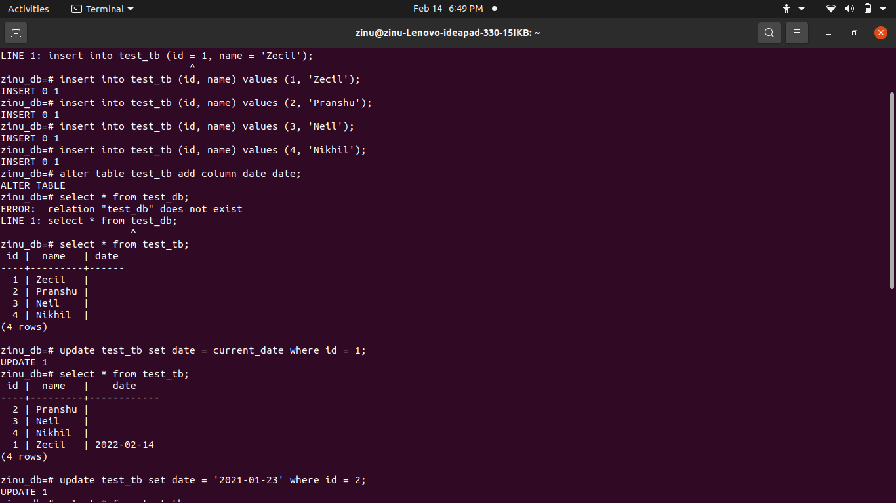

2.Fetch the quarter of the date field for all the records.

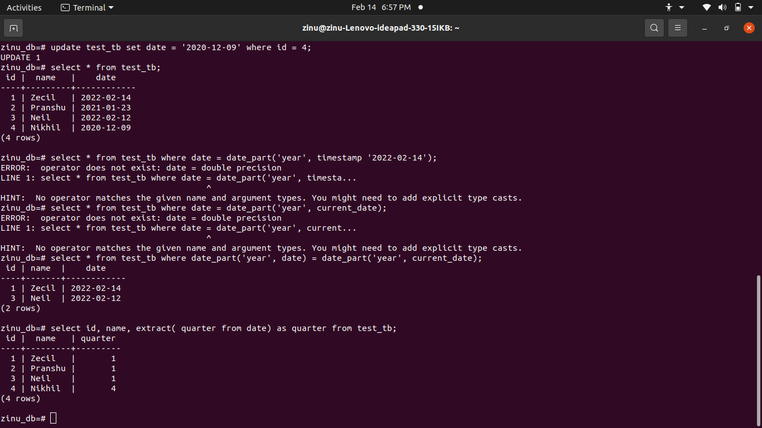

3-Fetch the year of the date field for all the records.

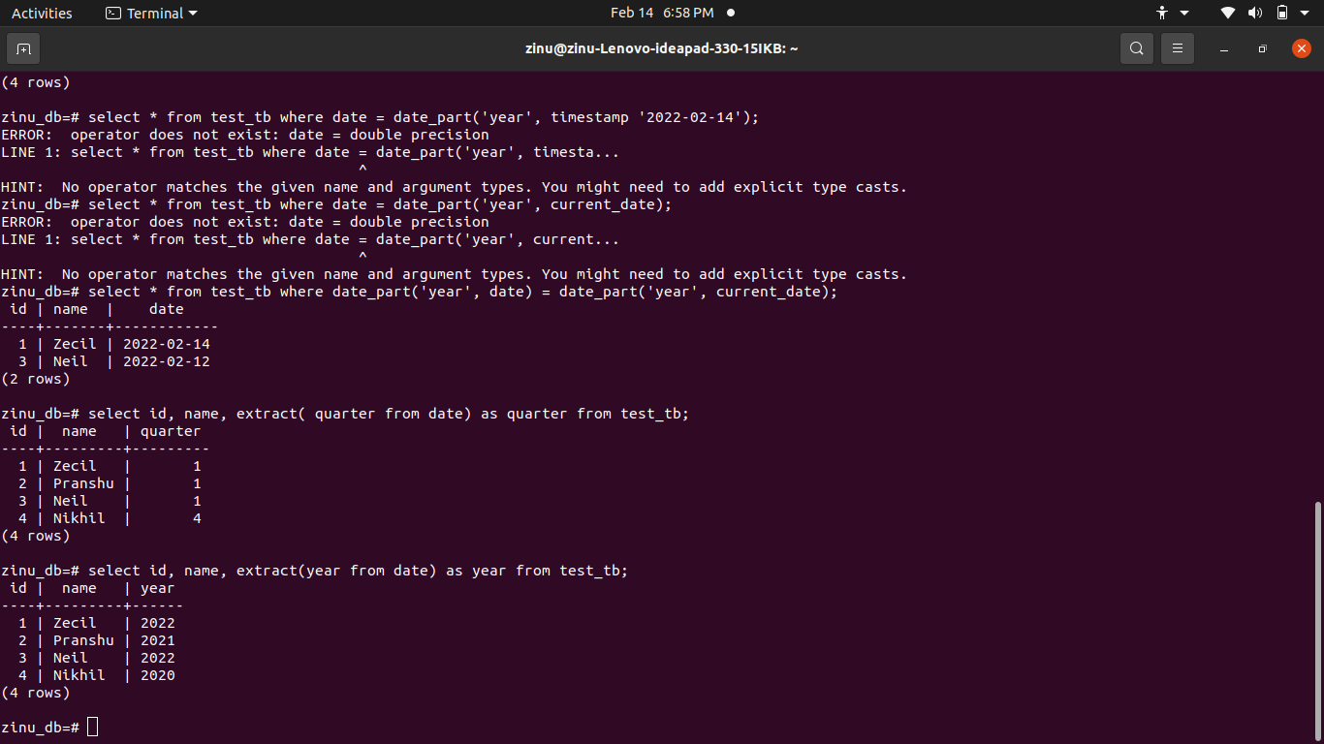

4. Fetch the weekday of the date field for all the records.
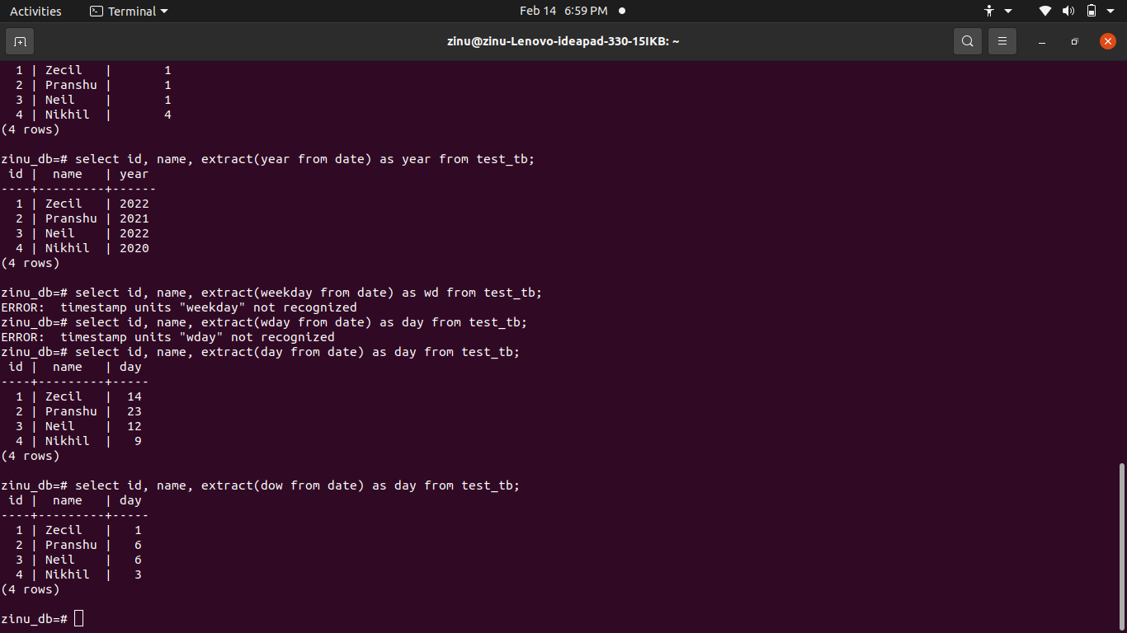

5. For all the records fetch whether it’s a new admission or old admission. If the date
is of current year it will be a new admission else it will be an old admission.
Display, id, name and new/old admission. NOTE: Admission field not to be added
in the table.
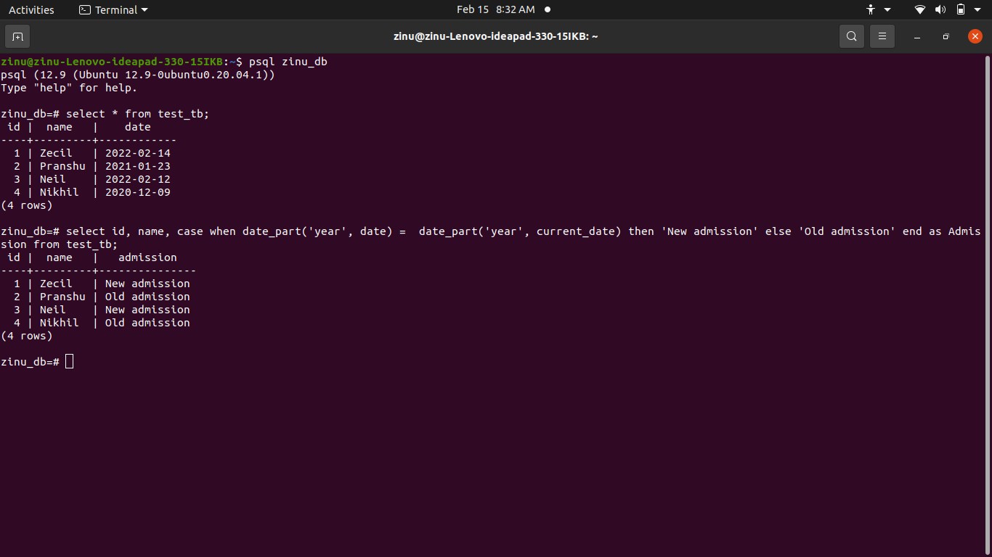

6. Add a primary key to the table as id.

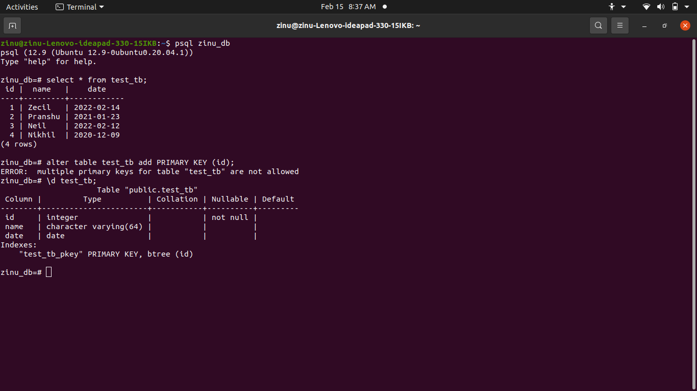

7. Create two tables one will be employee and another will be city. Add a primary
key id in both the tables. Add a foreign key of city in the employee table as
city_id.

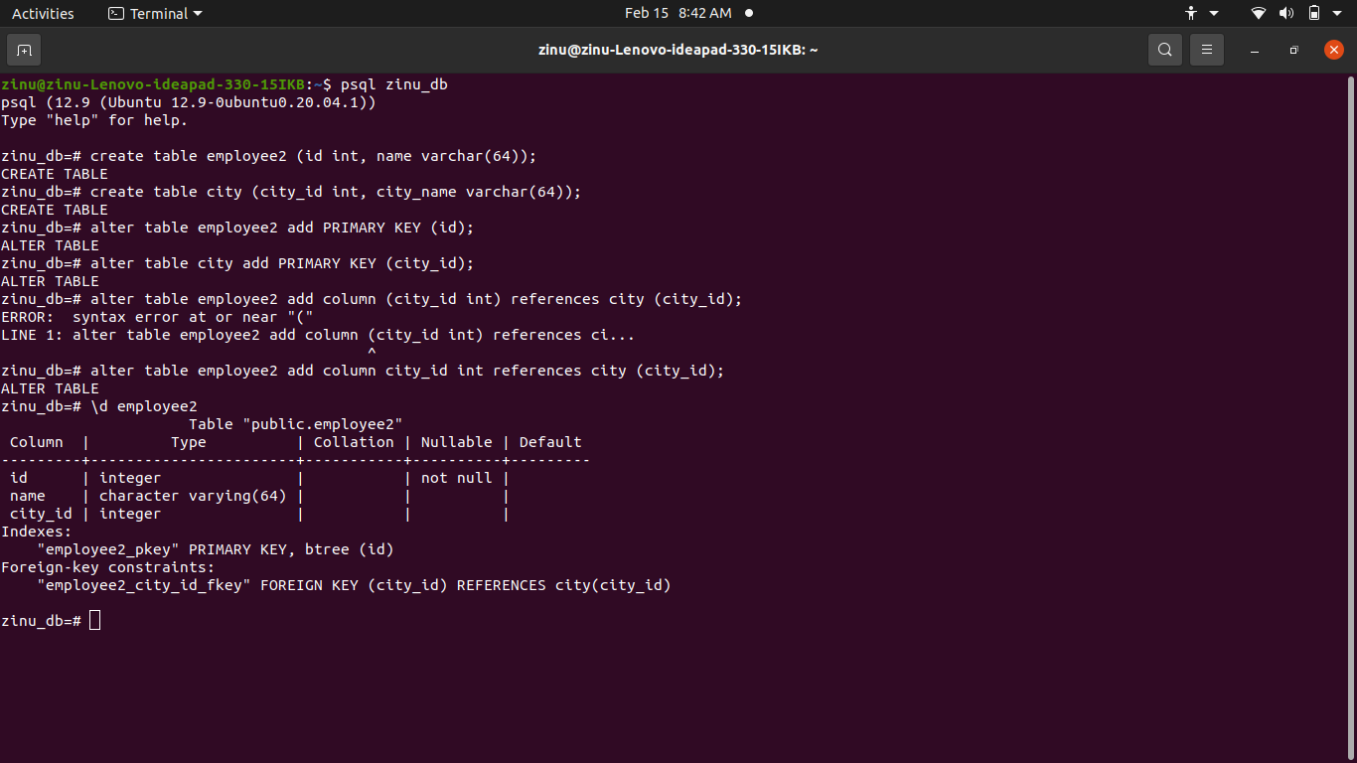

8. Add a not null constraint for name field in employee.
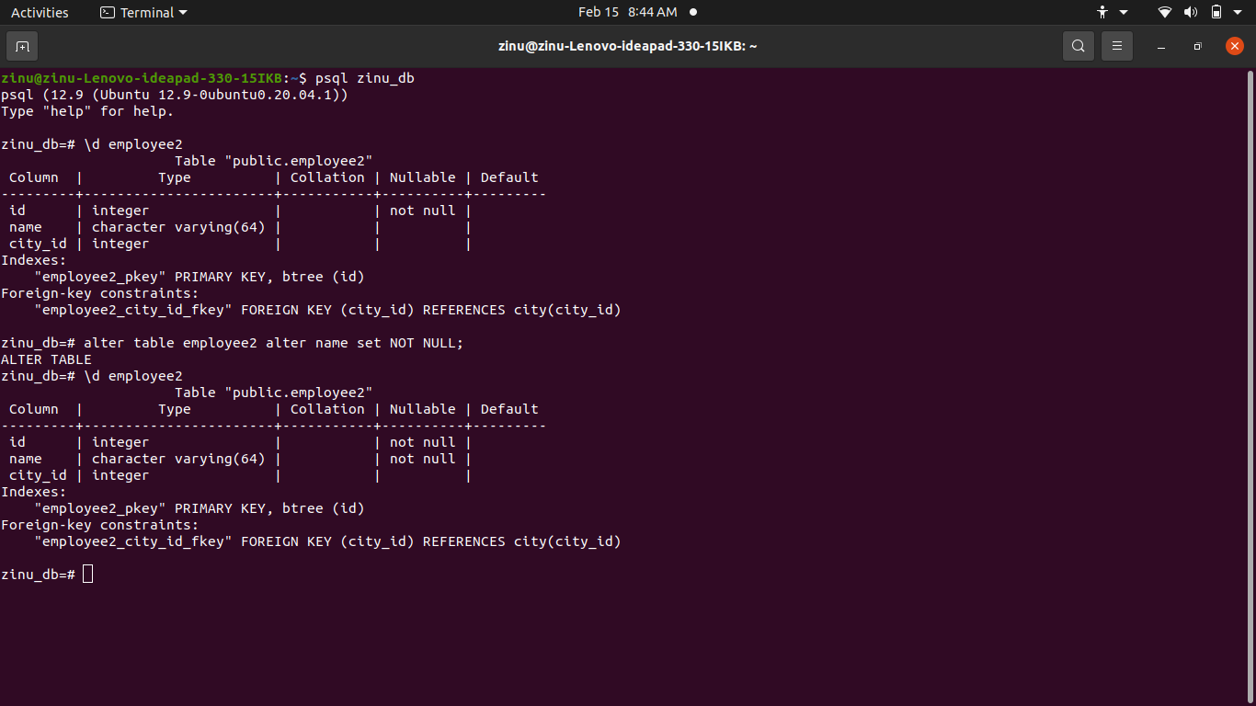

9. Add a new field in Code in the city table. Add a unique constraint on the code
field.

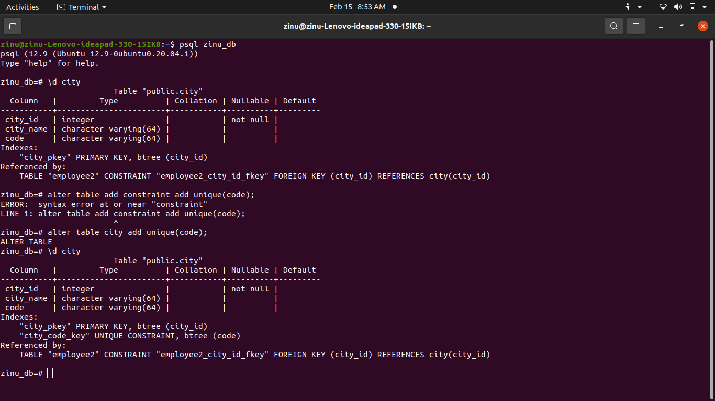

10. Add another table called Company and a primary key as id. Now add a foreign
key of company in city table. Add a unique constraint with combination of
company and code fields. Remove the old unique constraint with only code field.

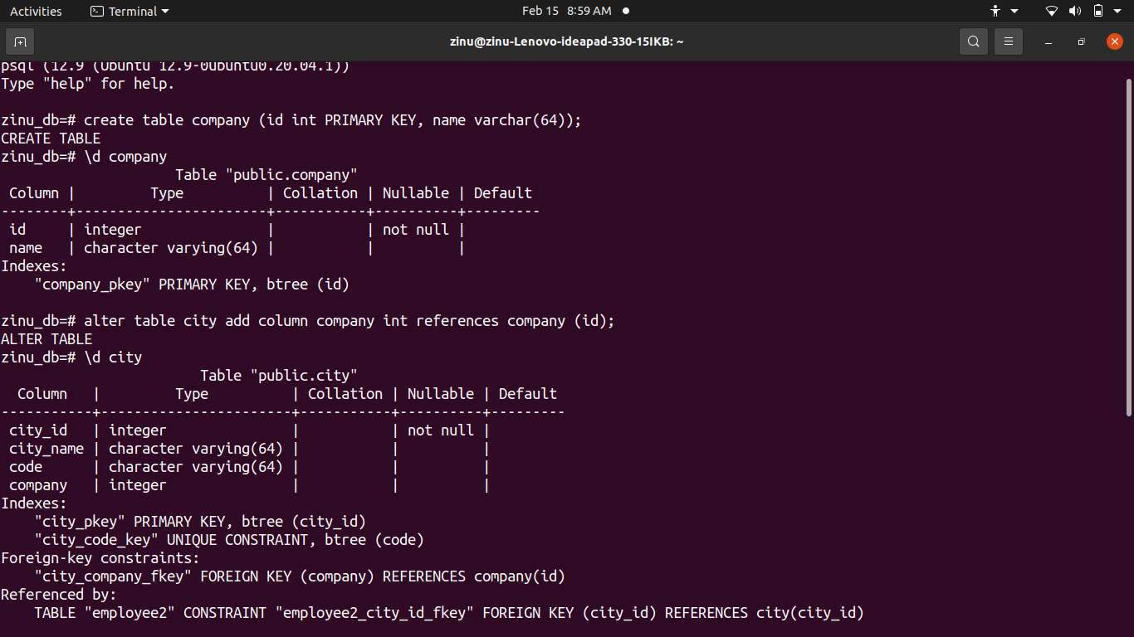

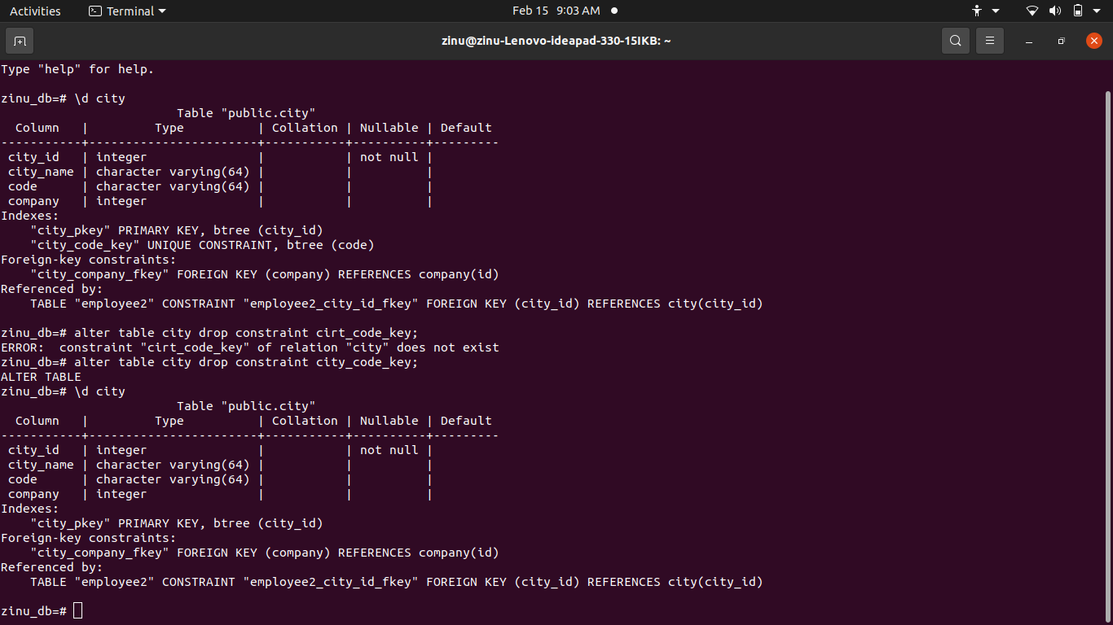

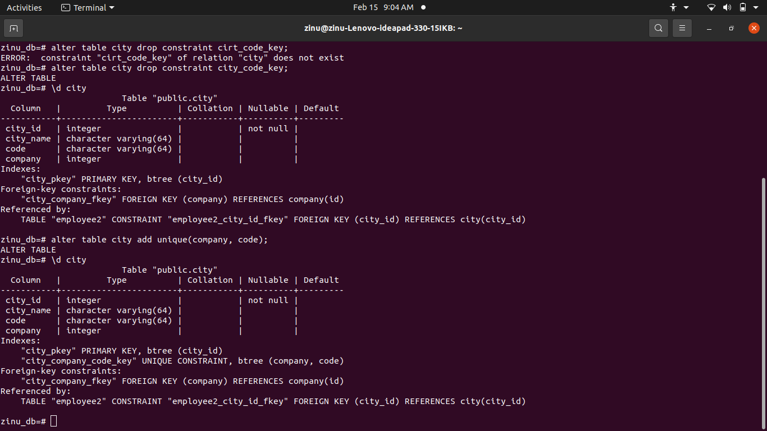

11. Check that the date is not before 2010-01-01 in the employee table using check
constraint.

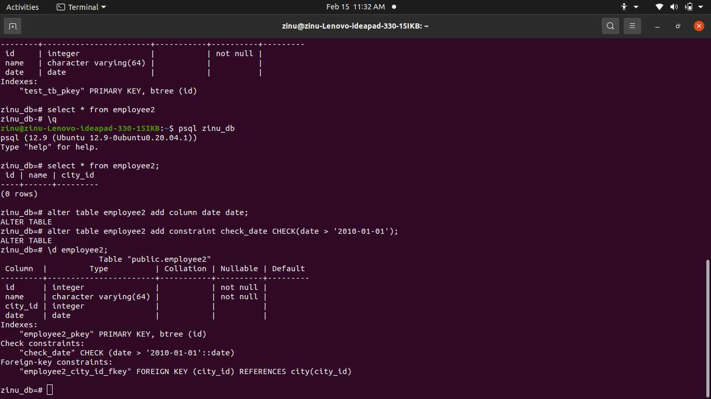

12. Create an index on the name field in City Table.

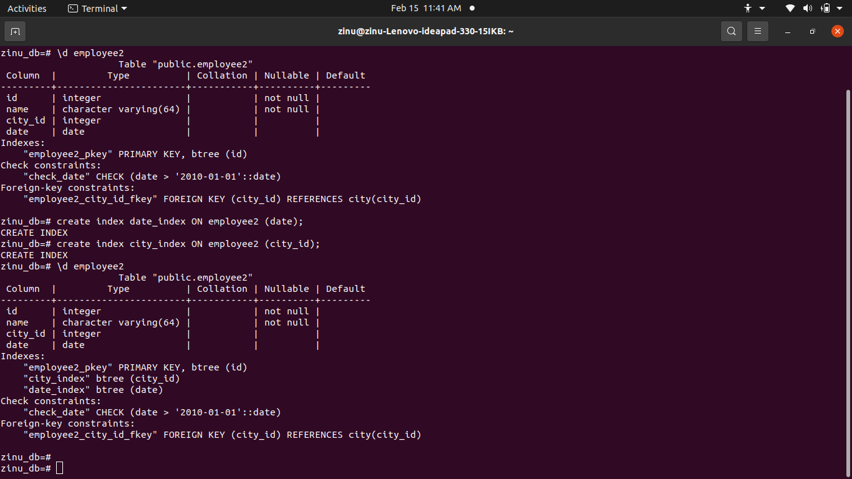

13. Create an index on the date and city fields in Employee Table

14. Create an index on the name field in Employee table.

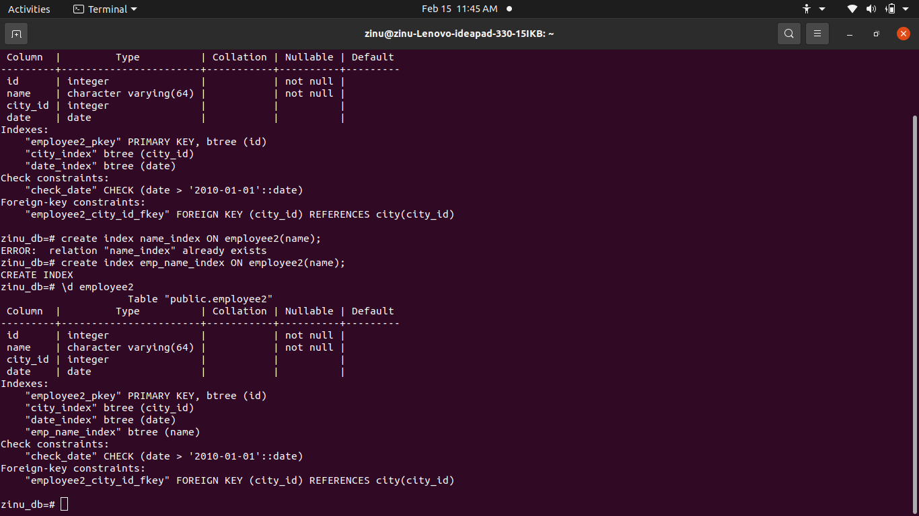

15. Create an index on the name field in Company table. Remove the index.

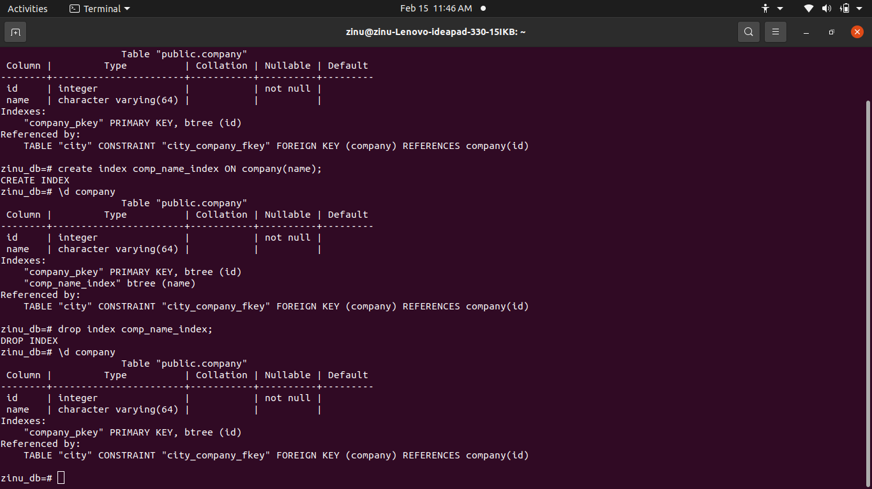

16.Create a primary key in a new table where there is an auto generated number
starting from 1 without creating a sequence.

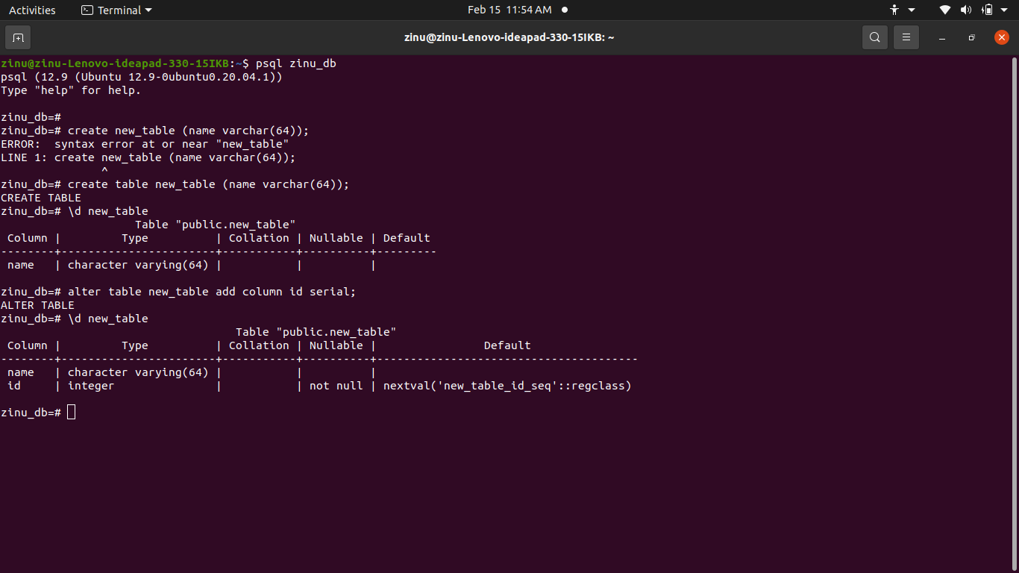

17. Create a sequence starting from 1000. Create a primary key in a new table. When
inserting records use this sequence.

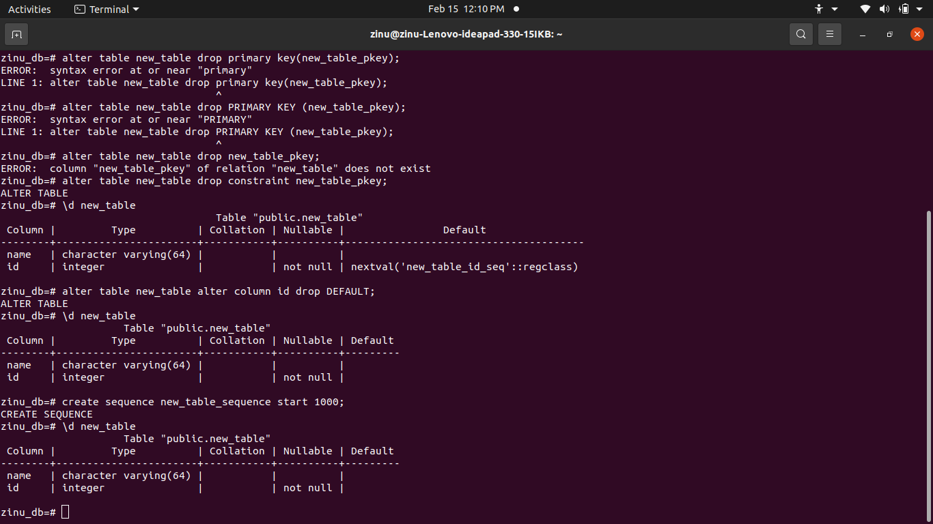

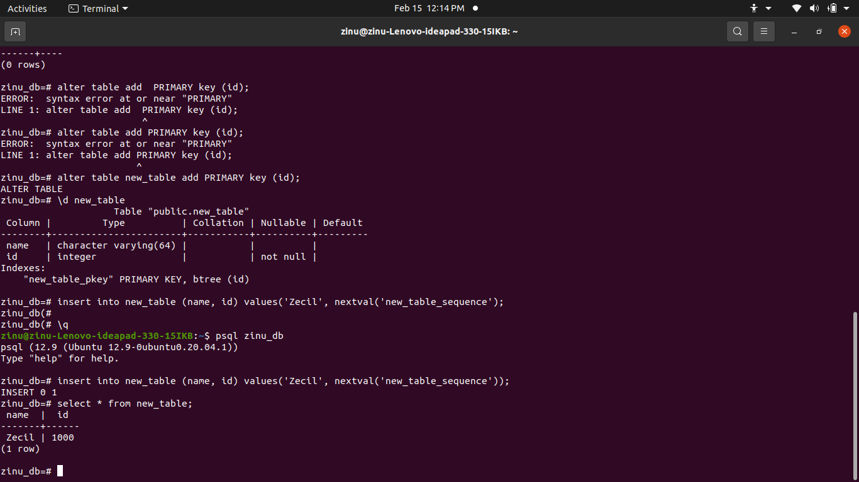

18. Create a sequence starting from 500. Create a primary key in a new table and
assign default value from this sequence.

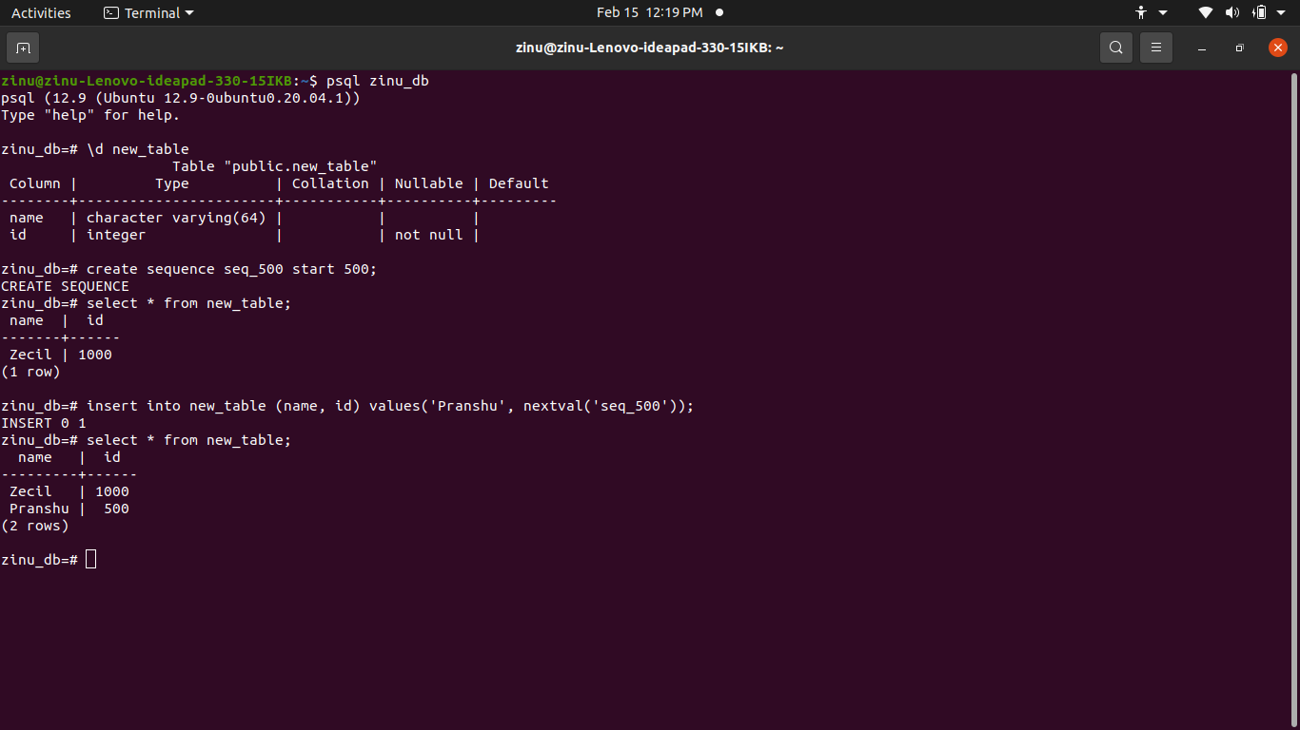

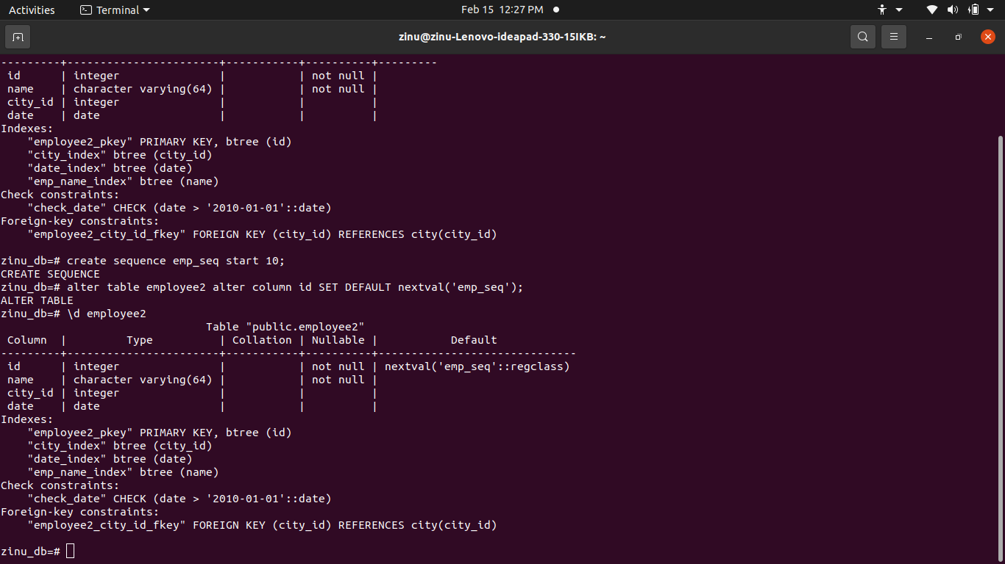

19.Delete the sequence which was created with 1000. Try to use the sequence to
insert records.

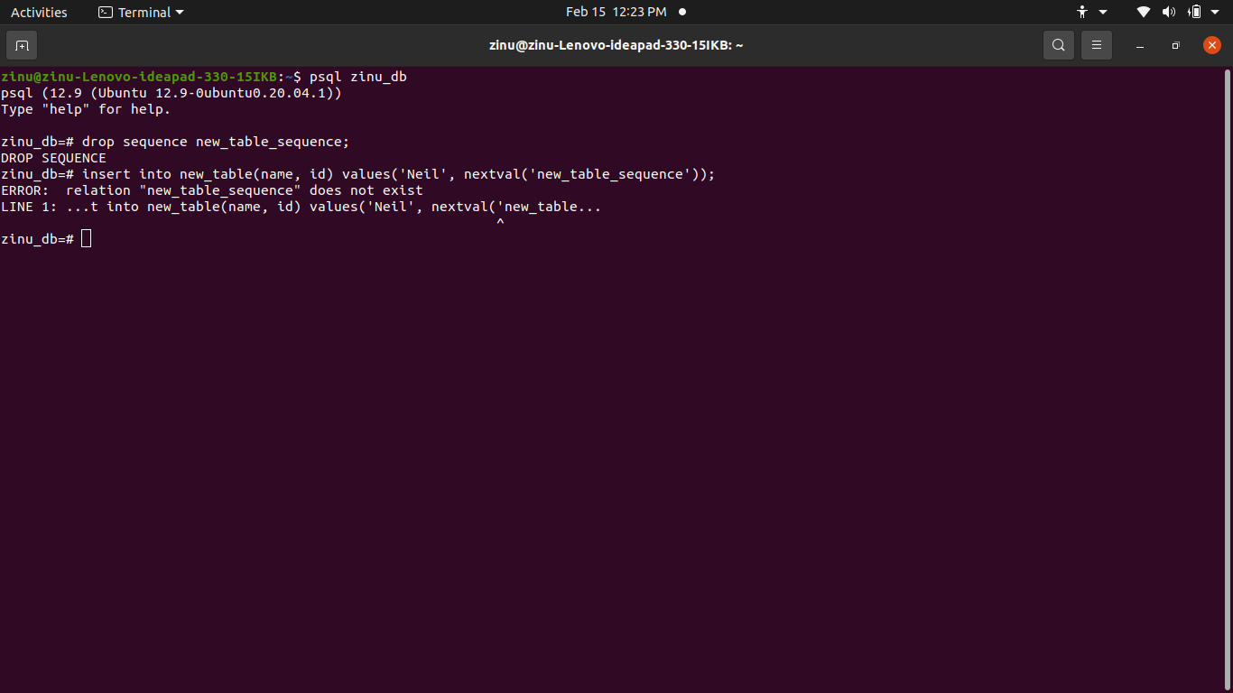

20.Create a sequence for an existing table and assign it in the default value.

21. Create a new table add a field with default value.

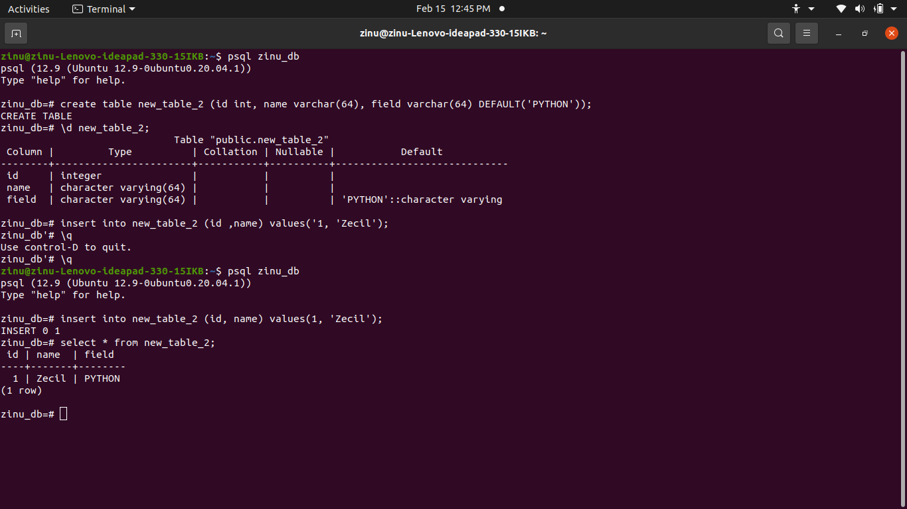

22.Add a gender field in Employee table which accepts only values male and female.
It must not be NULL. Perform this action without using a check or foreign key
constraint. However you can use other constraints

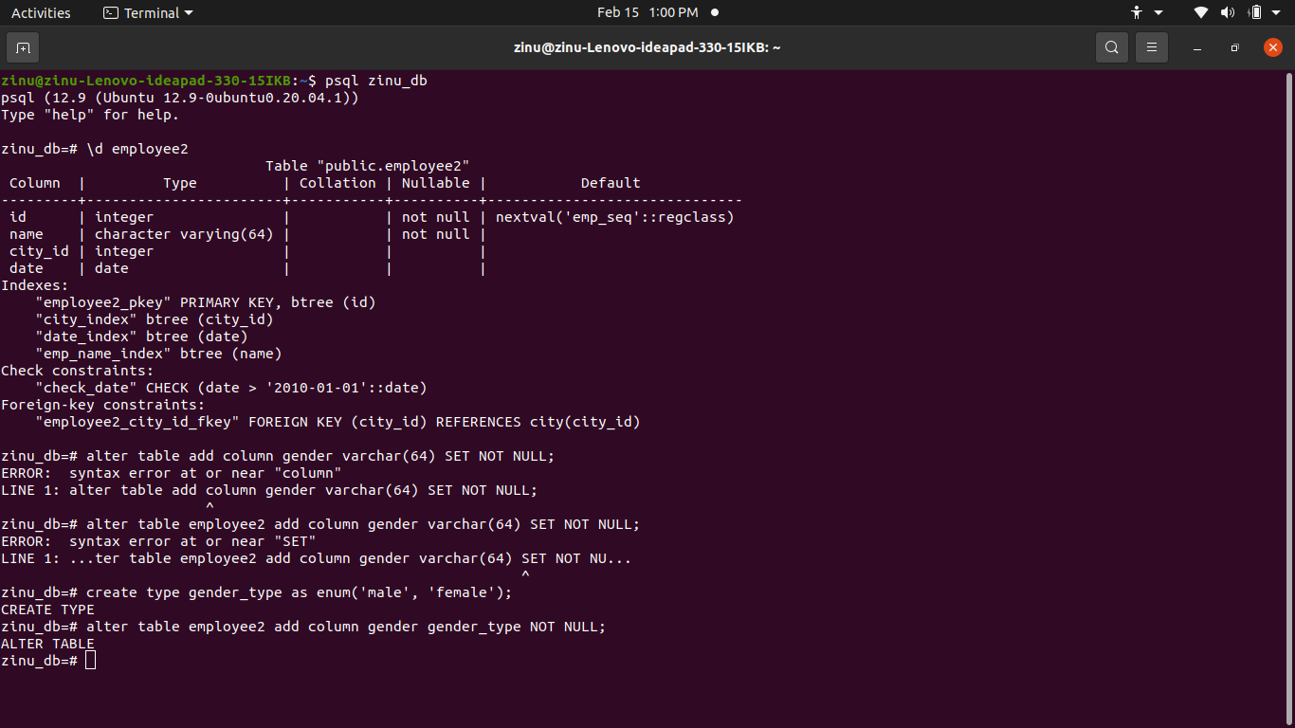

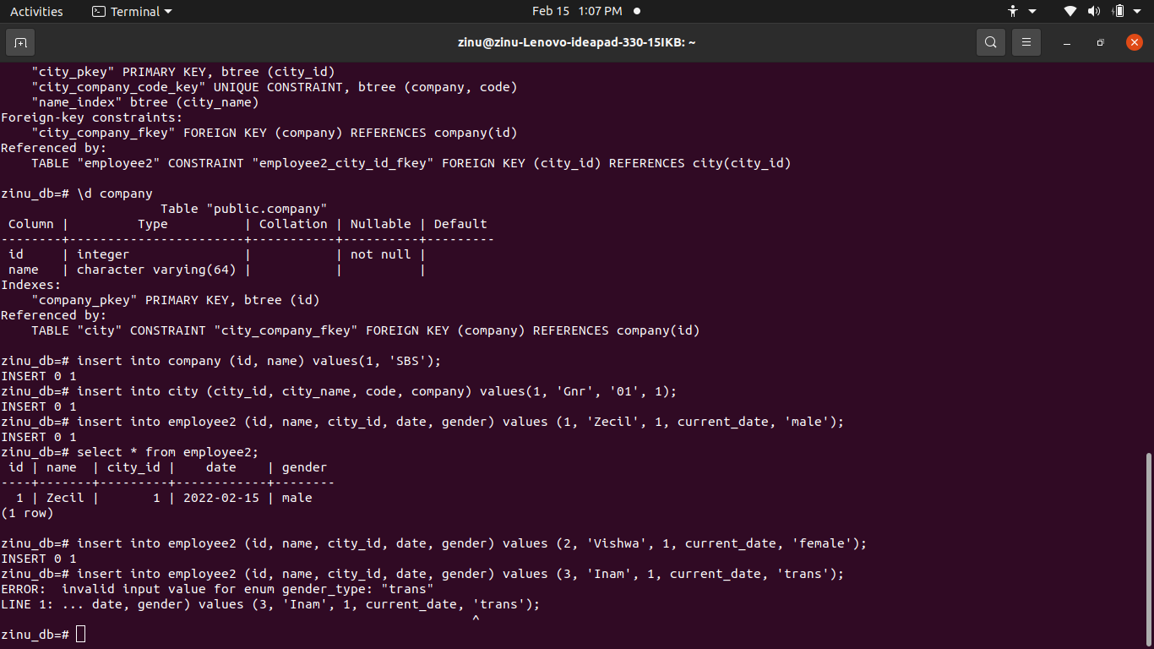

23.Display the fields id, name, city name from employee and city tables using inner
join and aliases.

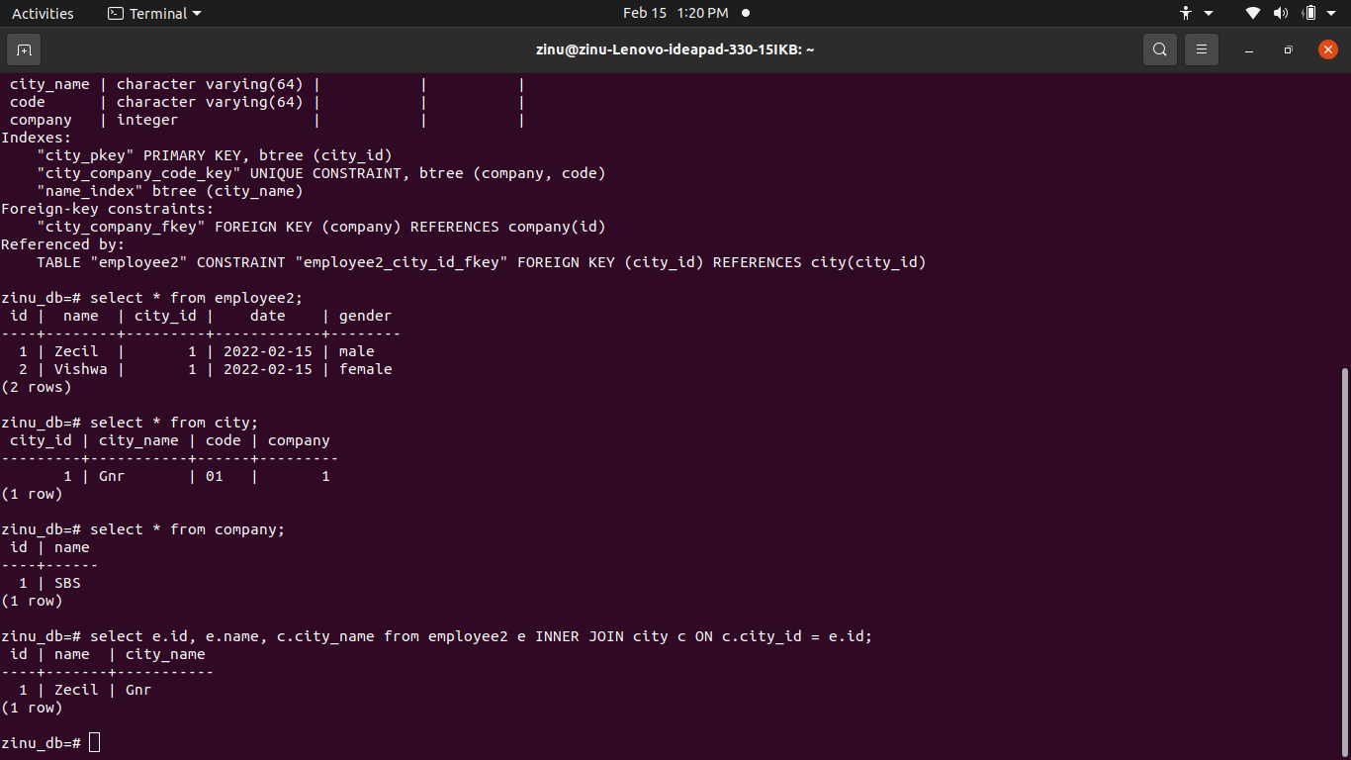

24. Display id, name, city name and company name from employee, city and
company tables.

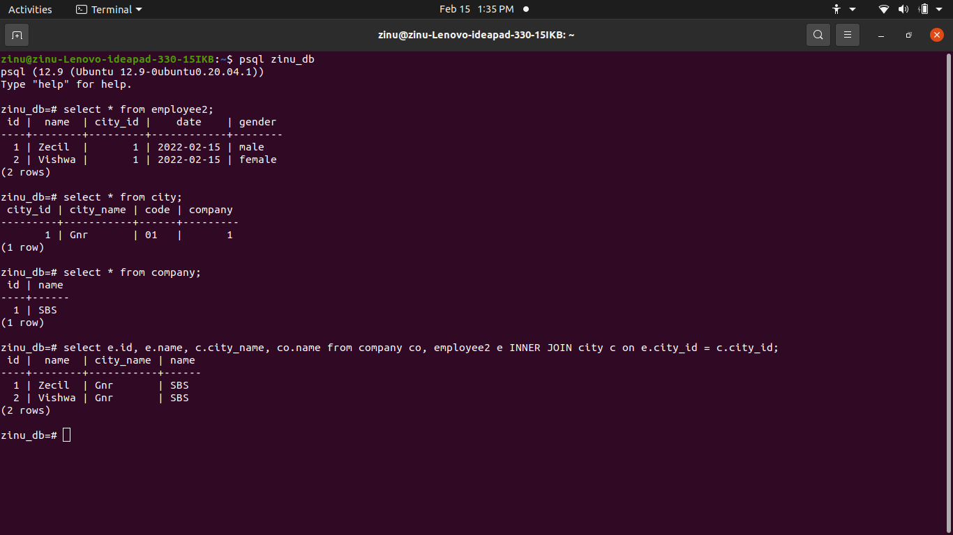

25. Update records using a subquery.

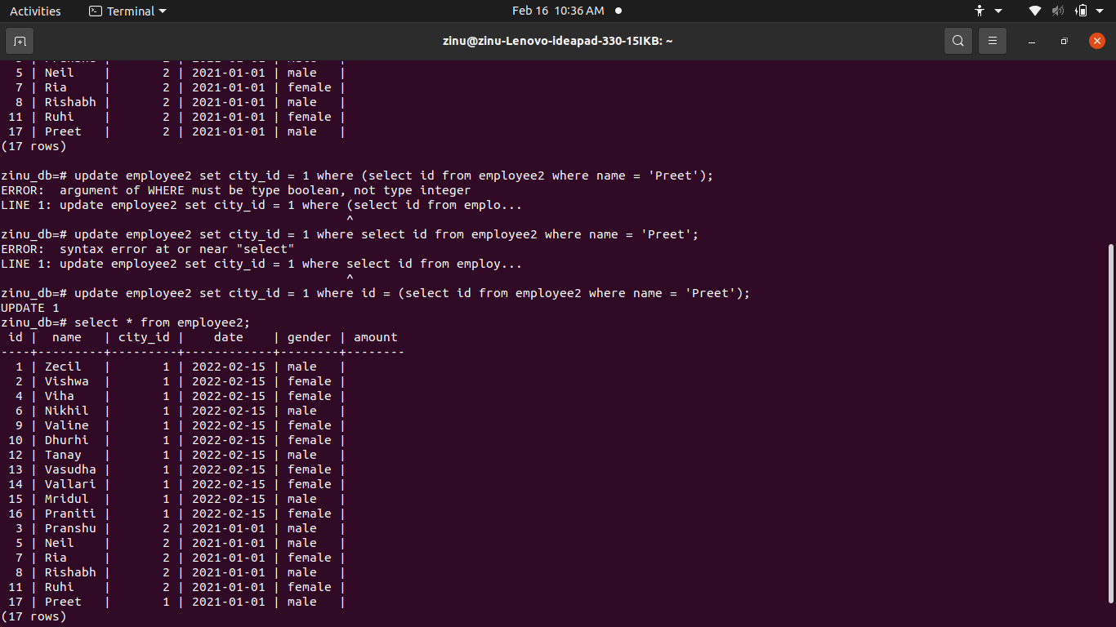

26.Create a view using the above select query result.

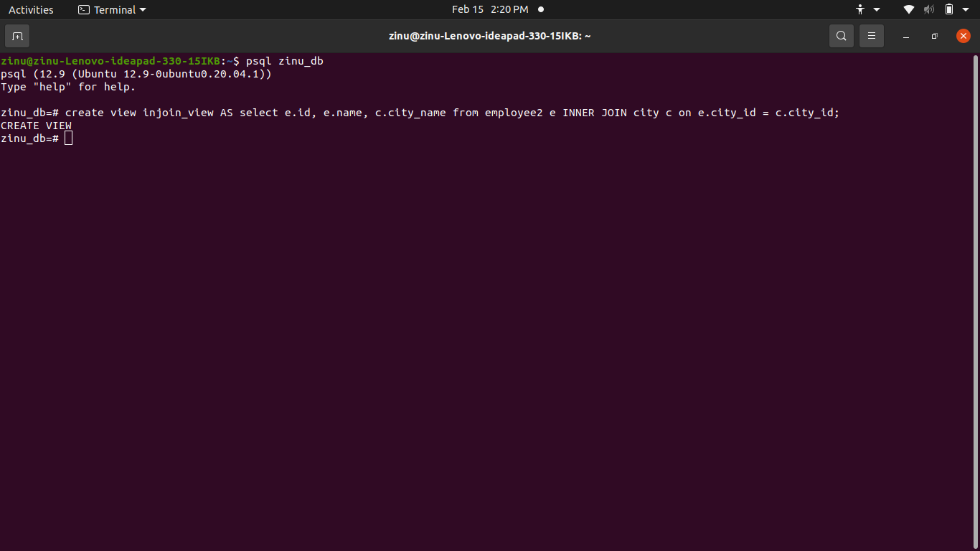

27. Delete the view and create a new view adding fields as id, name, amount, date,
city name , city code and company name.

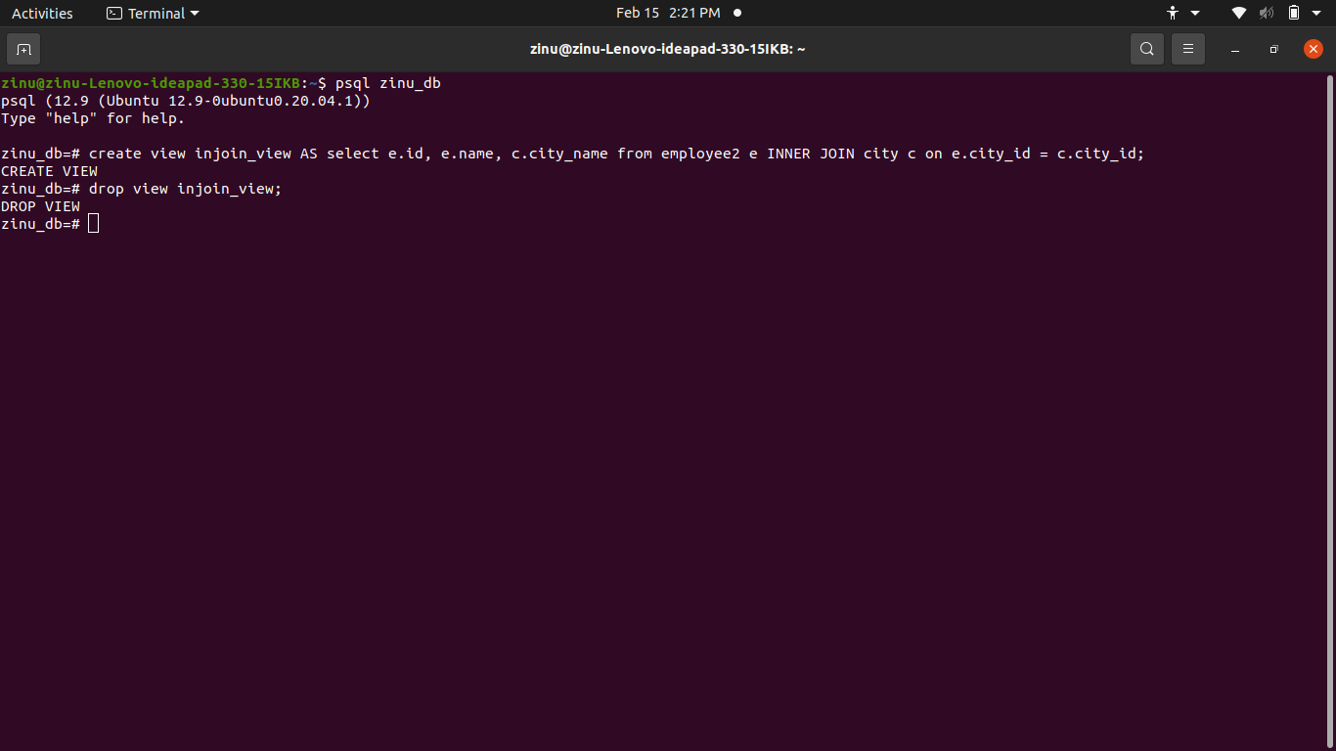

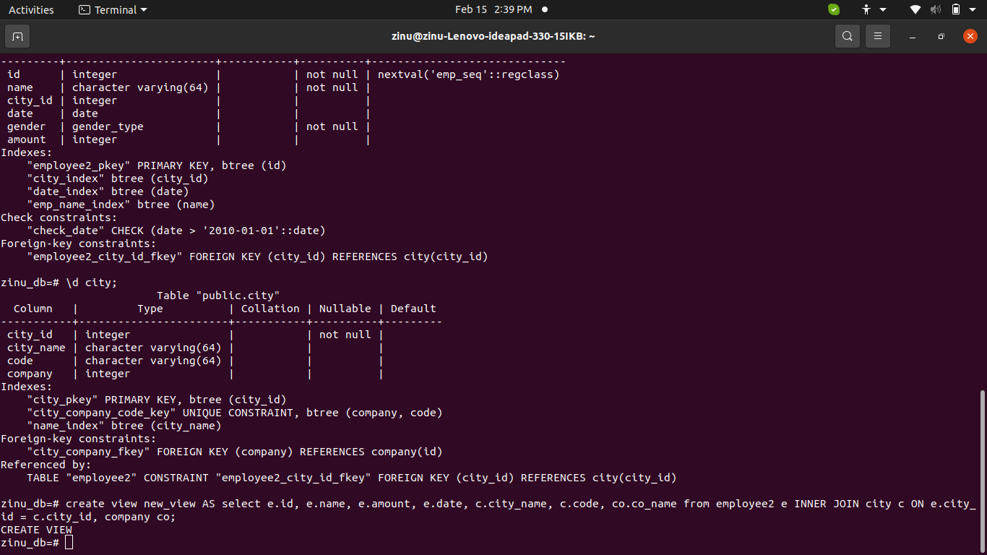

28. Insert 15 records using an sql file. In the same file update 5 records of the city
Mumbai increase the amount with 10.
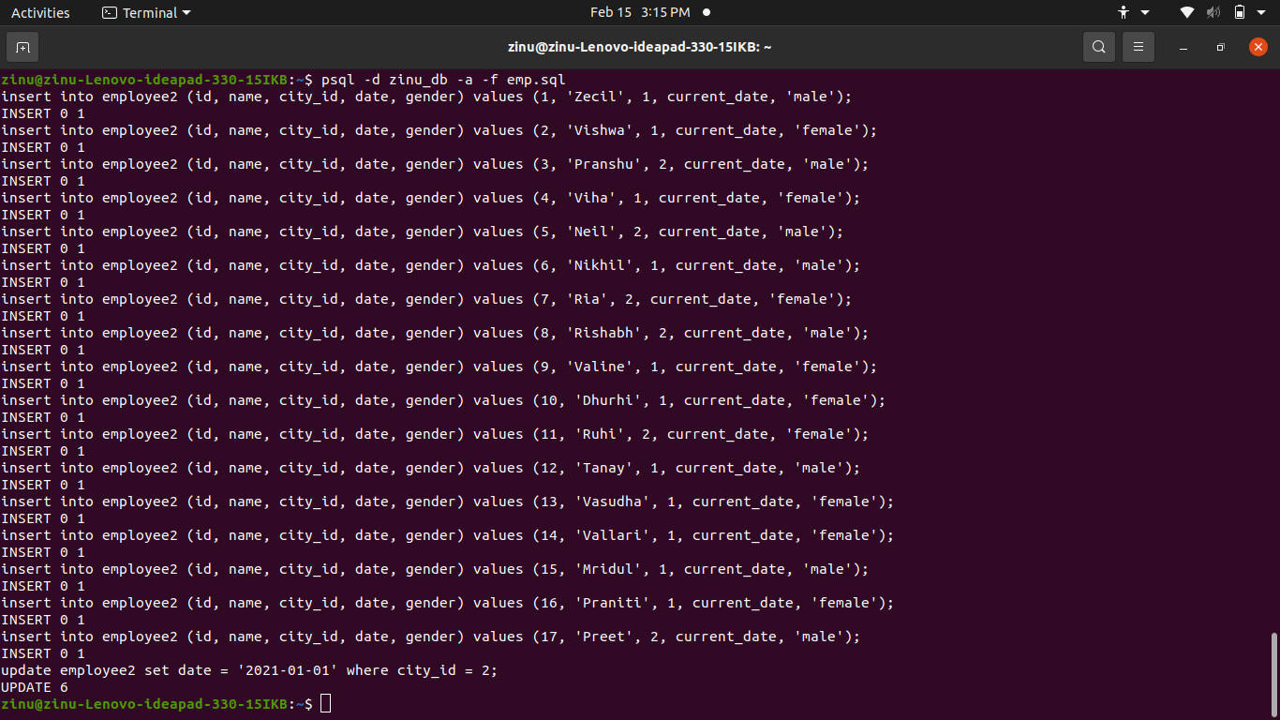

29. Create a backup of the database and restore it using psql.

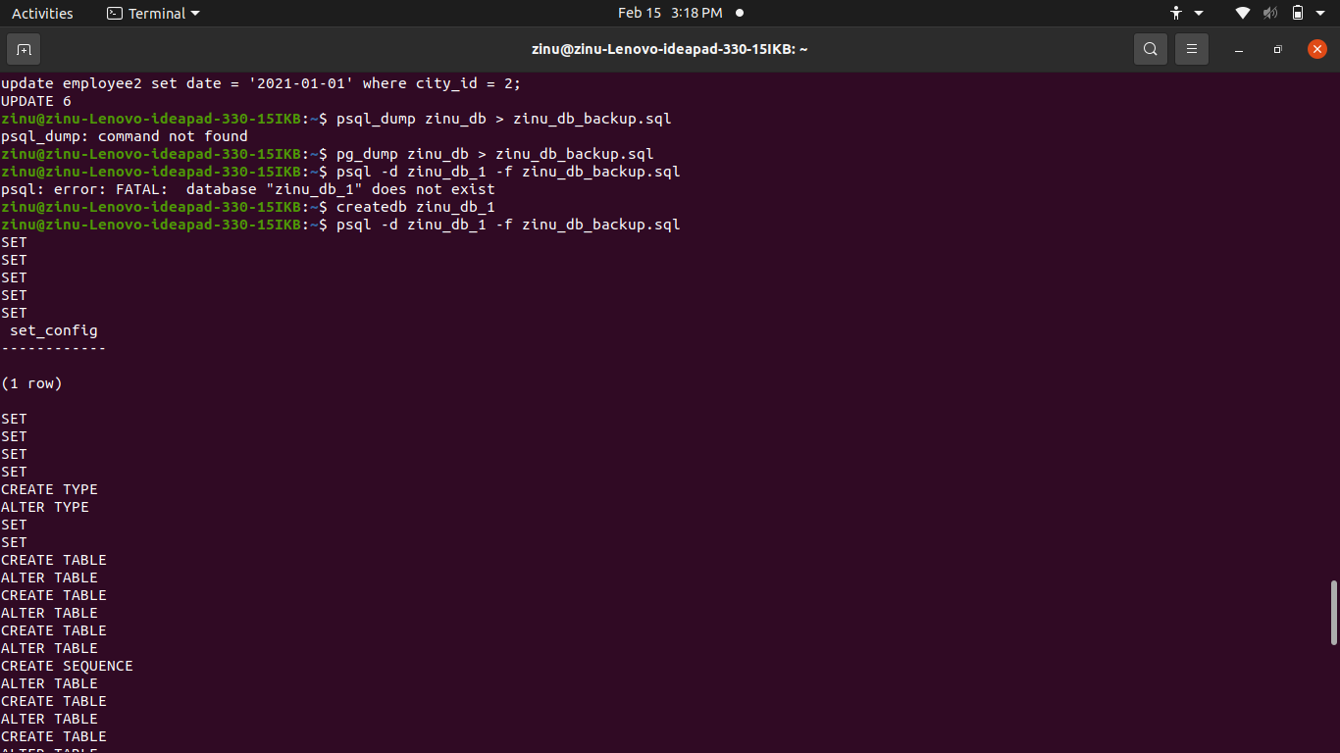

30. Create a backup of the database and restore using pg_restore

