Question 1: Analyse packet1.pcap and find the flag.
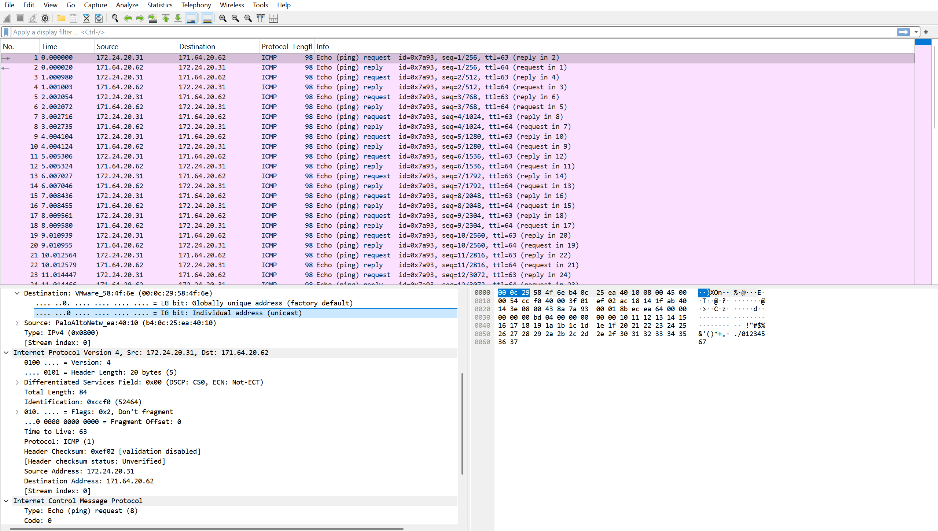
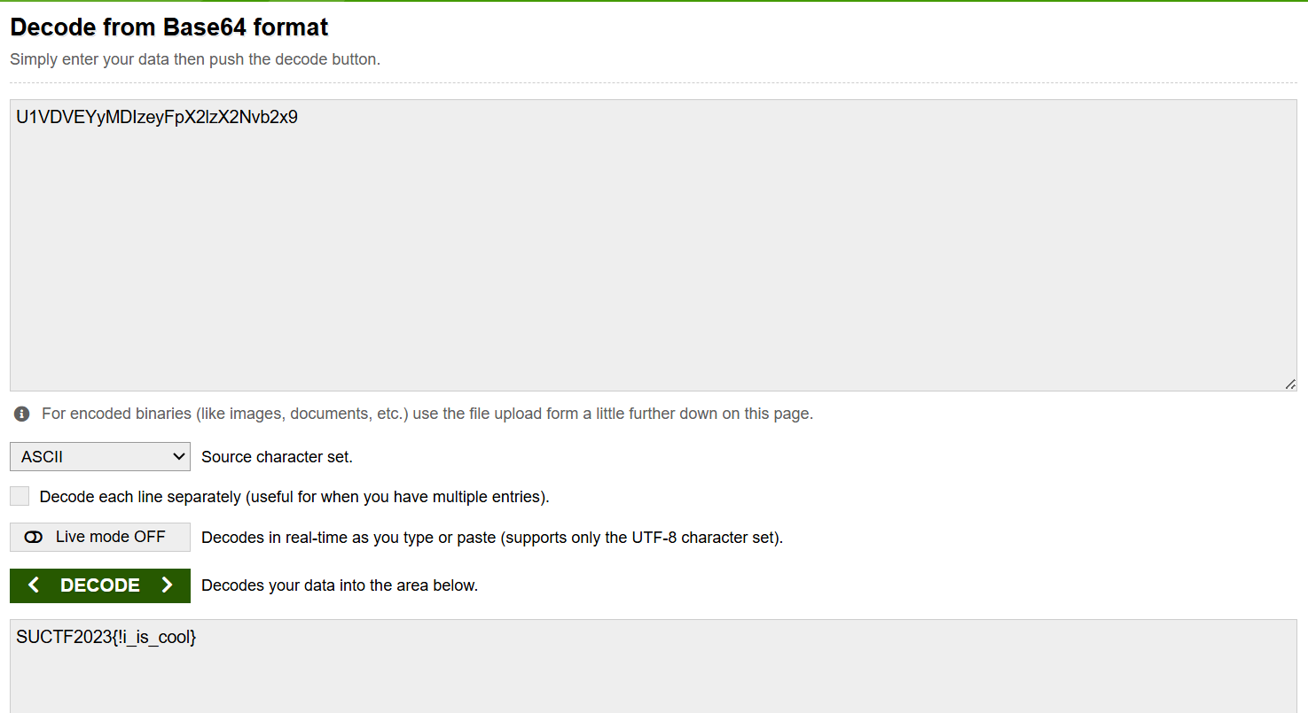

We already get the flag : SUCTF2023{ai_is_cool}

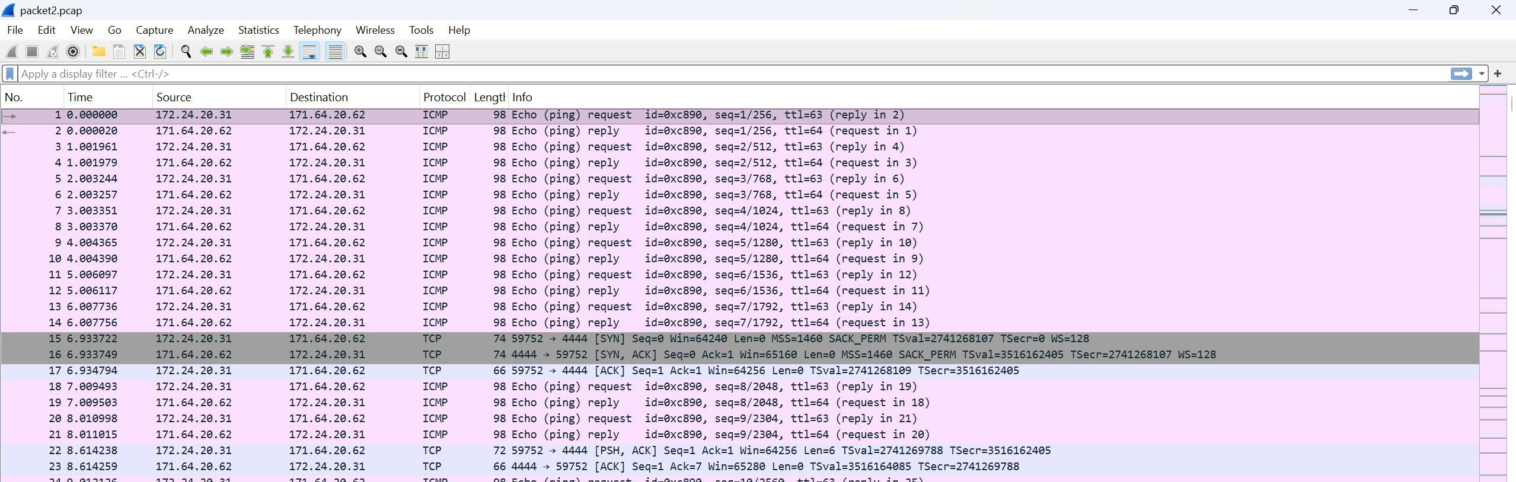
Searching tcp.port == 37697 to find the ftp
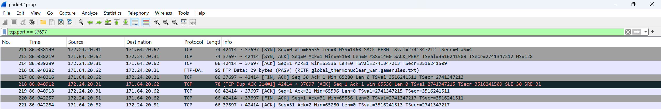

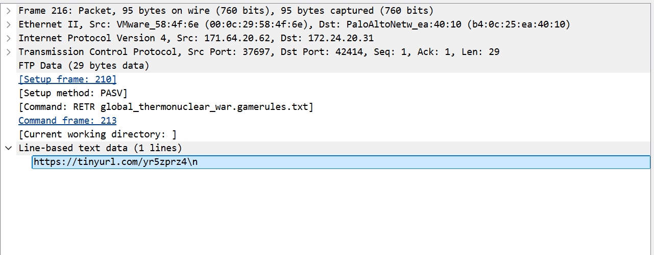
Paste the link into google

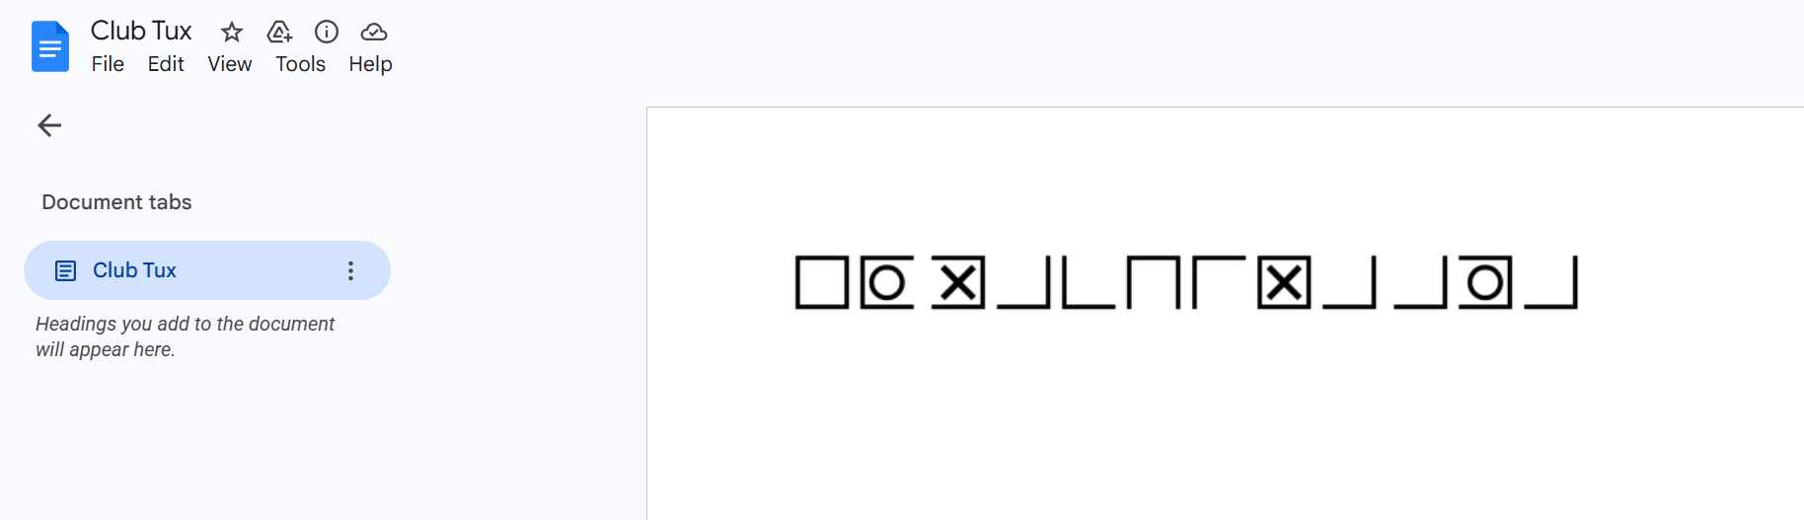

Question 3: Interpret an Nmap Output

1. What can an attacker do with each port?
Port 21 (FTP – vsftpd 2.3.4)
An attacker can try anonymous login or brute-force the FTP credentials. If successful, the attacker may upload or download files from the server. Since vsftpd 2.3.4 is an old version, it may also allow attackers to gain shell access through known exploits.
Port 22 (SSH – OpenSSH 5.3p1)
An attacker may try brute-force attacks to guess the username and password. If the credentials are weak, the attacker can get remote command-line access to the machine.
Port 80 (HTTP – Apache HTTP Server 2.2.8)
An attacker can access the website and look for web vulnerabilities such as outdated modules, file inclusion, or directory traversal. Sensitive files and hidden directories may also be exposed.
Port 139 (NetBIOS)
This port can allow attackers to gather information such as shared folders, usernames, and system details from the network.
Port 445 (SMB – Windows Sharing)
An attacker can attempt to access shared folders or exploit SMB vulnerabilities. SMB services are often targeted because they can give deeper access into the system.

2. What vulnerabilities are likely present based on the version?
FTP – vsftpd 2.3.4
This version is known to have a backdoor vulnerability which may allow remote shell access to attackers.
SSH – OpenSSH 5.3p1
This is an outdated version and may be vulnerable to brute-force attacks or weak SSH configurations.
HTTP – Apache HTTP Server 2.2.8
Apache 2.2.8 is outdated and may contain known vulnerabilities such as directory traversal or remote code execution depending on the server setup.
SMB – Windows 7 Professional SP1
Windows 7 SP1 is already end-of-life and vulnerable to SMB exploits like EternalBlue, which was used in WannaCry ransomware attacks.

3. Which one is the highest risk and why?
Port 445 (SMB – Windows 7 SP1) is the highest risk because SMB vulnerabilities such as EternalBlue are very dangerous. Attackers may exploit the system remotely and gain full access without needing valid credentials in some situations.

4. What attack path can be built from this?
An attacker may first scan the target and gather information from Port 80. Then, the attacker may exploit the FTP service on Port 21 to gain initial access. After entering the system, the attacker can enumerate SMB shares using Ports 139 and 445. Finally, the attacker may exploit SMB vulnerabilities such as EternalBlue to gain full control of the machine and maintain access through SSH if credentials are found.

5. What should be the remediation?
The best remediation is to update and patch all outdated services and operating systems, especially Windows 7 SP1, because most of the vulnerabilities come from old and unsupported software versions.

Question 4: Identify the OS (OS Fingerprinting) - TTL
Image 1
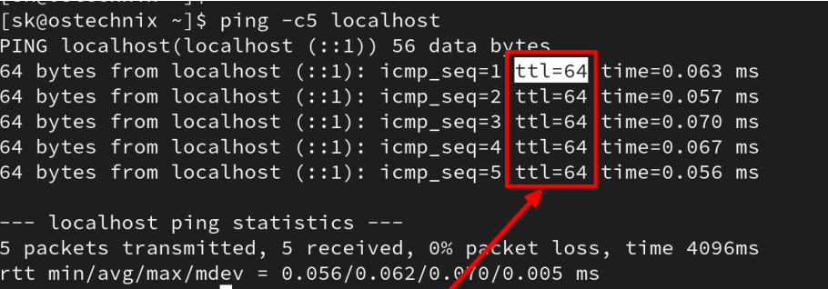
= The TTL value shown is 64, which commonly indicates that the operating system is Linux or Unix-based. Therefore, the detected OS is most likely Linux.
Image 2
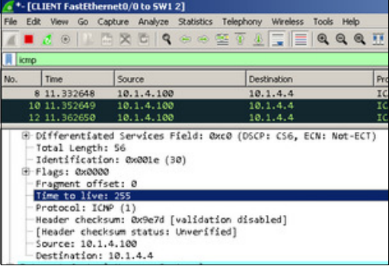

= The TTL value shown in the packet is 255. A TTL value of 255 usually indicates that the operating system is a network device such as a Cisco router or switch.

Image 3
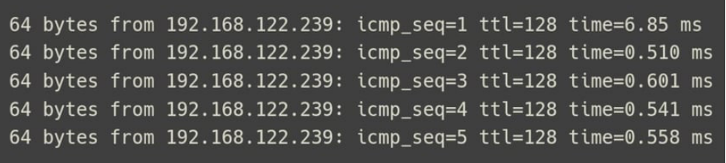

= The TTL value shown is 128, which commonly indicates that the operating system is Windows. Therefore, the detected OS is most likely Windows.

Question 5: Analyse the Nessus file
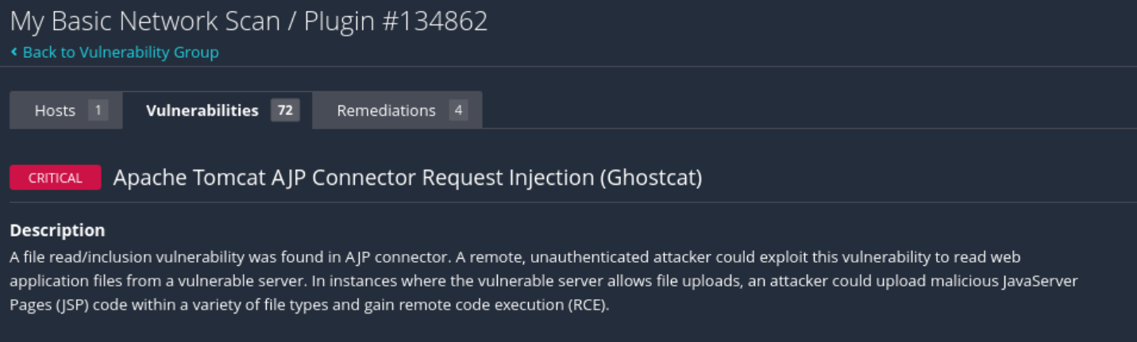
1. What is the affected Port number

2.What is the Affected protocol
Apache Tomcat AJP
3.What is the CVSS Score of vulnerability found


4.Can you find any exploit related to this vulnerability?
Yes, there are public exploits available for Ghostcat (CVE-2020-1938) that allow attackers to read sensitive files and potentially achieve remote code execution via the AJP port
5.Find CVE for this vulnerability.
CVE: CVE-2020-1938, CVE-2020-1745

