DNS

- What transport layer protocol does DNS use?
UDP
- Which port is used on client and server side?
Source Port: 59130, Destination Port: 53
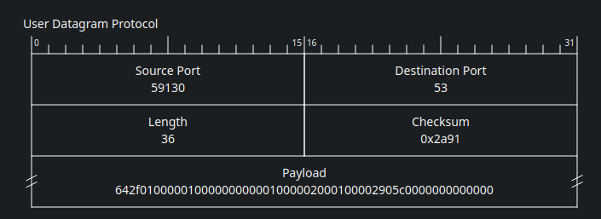
- What are the distinct IP addresses contacted during an iterative lookup?
. 7077 IN NS f.root-servers.net.
. 7077 IN NS h.root-servers.net.
. 7077 IN NS i.root-servers.net.
. 7077 IN NS d.root-servers.net.
. 7077 IN NS e.root-servers.net.
. 7077 IN NS k.root-servers.net.
. 7077 IN NS c.root-servers.net.
. 7077 IN NS m.root-servers.net.
. 7077 IN NS a.root-servers.net.
. 7077 IN NS l.root-servers.net.
. 7077 IN NS j.root-servers.net.
. 7077 IN NS g.root-servers.net.
. 7077 IN NS b.root-servers.net.

com. 172800 IN NS a.gtld-servers.net.
com. 172800 IN NS m.gtld-servers.net.
com. 172800 IN NS c.gtld-servers.net.
com. 172800 IN NS g.gtld-servers.net.
com. 172800 IN NS j.gtld-servers.net.
com. 172800 IN NS i.gtld-servers.net.
com. 172800 IN NS e.gtld-servers.net.
com. 172800 IN NS b.gtld-servers.net.
com. 172800 IN NS l.gtld-servers.net.
com. 172800 IN NS h.gtld-servers.net.
com. 172800 IN NS d.gtld-servers.net.
com. 172800 IN NS k.gtld-servers.net.
com. 172800 IN NS f.gtld-servers.net.

google.com. 172800 IN NS ns2.google.com.
google.com. 172800 IN NS ns1.google.com.
google.com. 172800 IN NS ns3.google.com.
google.com. 172800 IN NS ns4.google.com.

www.google.com. 300 IN A 142.251.10.99
www.google.com. 300 IN A 142.251.10.105
www.google.com. 300 IN A 142.251.10.147
www.google.com. 300 IN A 142.251.10.103
www.google.com. 300 IN A 142.251.10.104
www.google.com. 300 IN A 142.251.10.106

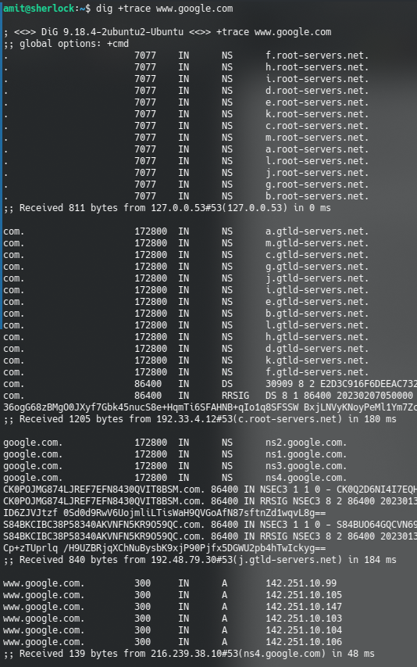
- Whose ip addresses are these?
root servers, .com servers, google.com servers
- How long does iterative lookup take? Compute it from wireshark.

- Run dig www.google.com; which IP address responds to DNS lookup when +trace is not used?
172.217.160.196
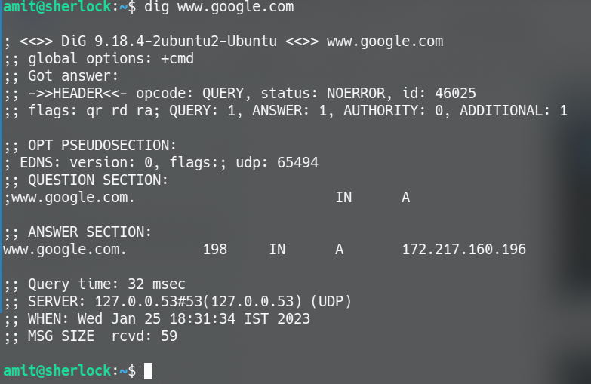
- Find out the location of the server using ip location service.
