wget

Run "wget http://mirror.pramati.com/ubuntureleases/18.04.1/ubuntu-18.04.1-desktop-amd64.iso -O /dev/null" for 20s duration. Answer the following questions

- What is /dev/null?
/dev/null refers to null device in Unix. Whatever you write to /dev/null will be discarded, forgotten into the void.
- What throughput range do you see when you run this experiment on your laptop?
Throughput:
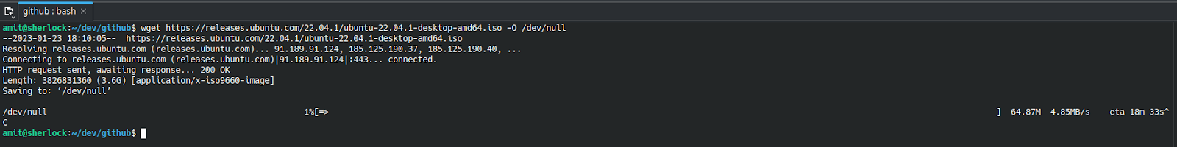

- What throughput do you see, when you use a wired connection?
Throughput:
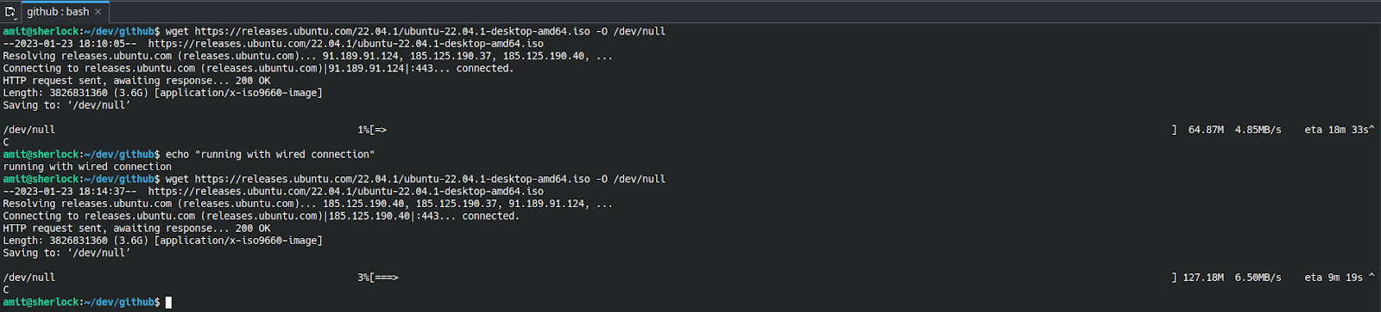

- Can you explain the difference in throughput between the first and second experiment?
Difference:
- Use Wondershaper (https://github.com/magnific0/wondershaper) to limit your network speed to 1 Mbps. What throughput do you see now?

- Run wireshark and compute the protocol overhead.
a) In wireshark session, look at packets downloaded to your machine corresponding to the ubuntu iso file. What is the size of each packet?

b) Compute the size of each header (Link layer, IP, and TCP). What is the protocol overhead i.e. the ratio of header bits to the actual data transmitted frame length=1514 byte
link layer header= 14 byte
ip packet total length=1500 byte
ip header=20 bytes
tcp header= 32 bytes
http header=1448-1400=48 bytes
data=1400 bytes

total header size = 14+20+32+48=114 bytes
overhead= 114/1400=0.08142

ping

Latency has 3 components, propagation delay, transmit delay and queueing delay.

- Write down the latencies for each case
  - ping 127.0.0.1
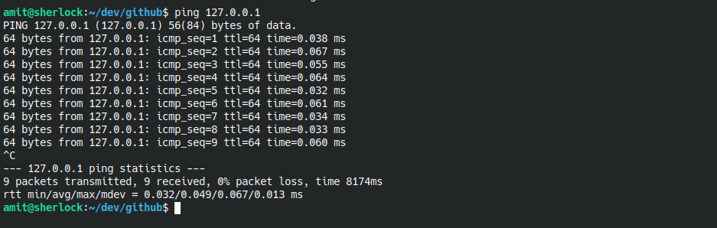
Latency: 0.049
  - ping nitw.ac.in
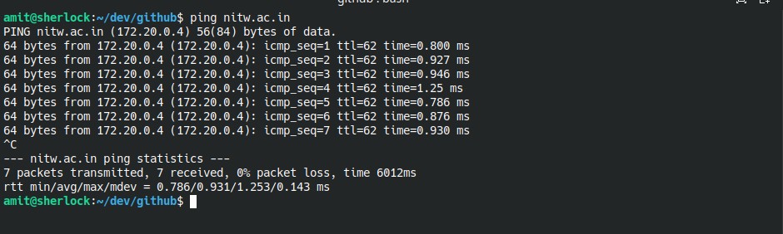
Latency: 0.931
  - ping www.google.com
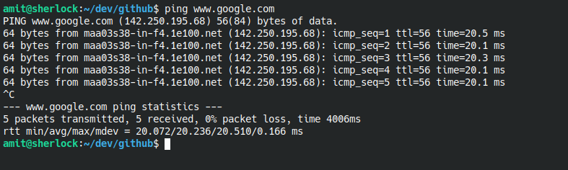
Latency: 20.236

  - ping www.iitmandi.ac.in
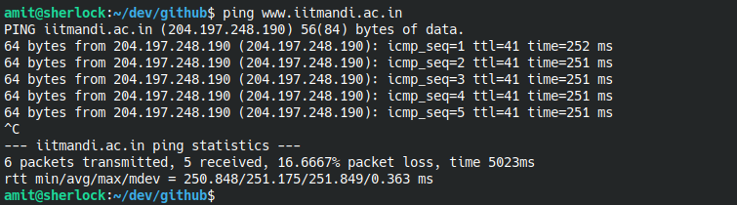
Latency: 251.175

- what is the relative ordering among the latencies? Why? Which component of latency majorly affects the observed results?
Latency Ordering: www.iitmandi.ac.in > www.google.com > nitw.ac.in > 127.0.0.1

