Design

Distributed System Components
The system is comprised of and distributed across four components: The Server, Controller Client, ESP32 and Arduino Mega. Figure 1 depicts the relation between these components. The system uses TCP/IP protocol to send requests between the server, controller clients and buggies. The TCP/IP protocol has been chosen due to features such as:
- Guarantee of delivery – ensures that data will be delivered as long as there is a connection.
- Order of delivery – Ensures that the data is delivered in the same order it was sent.
- Error Correction – Utilises checksums to ensure that the data was not corrupted during the transmission process.
Despite being slower than UDP due to the extra data the protocol transmits, it offers the reliability that that satisfies the communication reliability requirement of the system.
The requests only carry ‘ready to use’ data. This means that any processing of the data is done on the hardware platform the data originated from. This decision was made to utilise the computing power of all devices in order to distribute the workload and not overload any one component. Additionally, data that has already been processed before transmission is smaller in size and therefore latency between transmission and delivery of the information will be reduced.
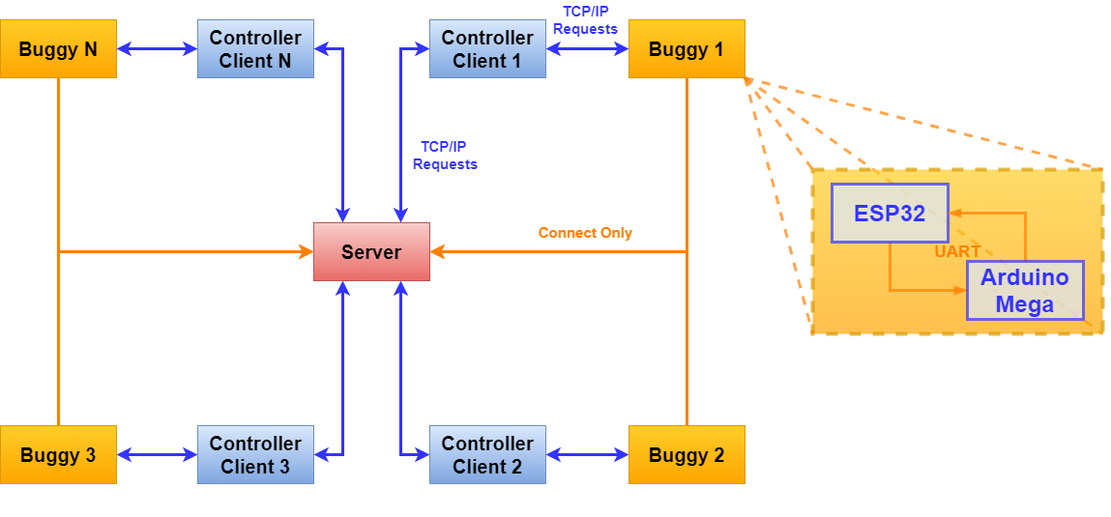
Figure 1:Connections between the components of the distributed system.

The Server
In order to allow multiple users and buggies to interact with each other, a server has been created for the controller clients and buggies to connect to. By having a server that all buggies and users connect to, awareness of all clients present on the network can be established. The server can then relay this information back to the controller clients which can then choose a buggy they would like to connect to.
Aside from maintain awareness of the connected clients, the server keeps track of the connections between controller clients and buggies and provides permission for controller clients to connect to a buggy. Because the server keeps track of the aforementioned information it prevents multiple client connections to a single buggy which prevents control contention.

Controller Client
The controller client is a graphical user interface utilised by the user of the system to connect and interact with the buggy and the server. The controller client provides the interface through which the user can control and interact with the buggy in three different modes. These are the ‘Manual’ mode, ‘Configuration’ mode, and ‘Autonomous’ mode.

Manual Mode
Manual mode allows the connected user to control the buggy. The user can move the buggy to a desired location and request environmental data from that location.

Configuration Mode
In this mode, the user can configure the following parameters to affect how the buggy operates.
Autonomous Mode Data Transmission Frequency – This configuration option allows the user to select how often the buggy sends data back to the user in Autonomous mode. A finer map of environmental conditions can be produced based on need.
Buggy Speed – Allows the user to select the speed at which the buggy can move. Finer motion can be achieved if the buggy moves slower.
Maximum Object Distance – Allows the user to set the maximum distance between the buggy and the obstacle before the buggy tries to avoid it in Autonomous mode. The slower the buggy speed, the larger the distance should be to allow the buggy space to avoid the obstacle.
Difference in Light Intensity – Allows the user to set the minimum difference between the readings of the Arduino LDRs before the buggy decides to move left or right. The LDRs are not perfect and there may be some differences in readings between the two even if the light intensity is identical. Allowing the configuration of the difference can prevent this effect from making the buggy turn if the intensity of light is the same. Additionally, setting this parameter can prevent the buggy turning at the smallest of changes in light intensity.

Autonomous Mode
In this mode the buggy moves around the greenhouse on its own, periodically relaying information about the conditions inside the greenhouse back to the user.

Buggy

ESP32
The ESP32 is a microcontroller that comes with integrated WiFi and is therefore used inside the buggy to allow connection to a network which in turn allows the buggy to connect to a server and a controller client to connect to the buggy.
The ESP32 also extracts data from the environment through the sensors interfaced to it and carries out appropriate computations on the data. Additionally, any information that the ESP32 receives from the controller client that is applicable to the Arduino Mega is relayed to the Arduino by the ESP32 using UART.
The ESP32 connects to the server to make it aware of the buggy’s presence. There is no communication between the server and the buggy after the connection is made.

Arduino Mega
The Arduino is equipped with an Arduino Motor shield which allows the buggy motors to be driven. The Arduino Mega is therefore responsible for driving the buggy. The Arduino is also equipped with two light dependent resistors (one to the right and one to the left of the buggy) and an ultrasonic module for use in the autonomous mode.
Any information that needs to be transmitted back to the controller client is first sent to the ESP32 over UART which then transmits the data back to the controller client. Because the ESP32 uses 3.3V logic level compared to the Arduino’s 5V logic level, a 3.3V-5V logic converter is used. Figure 2 depicts a detailed diagram of the hardware that comprise the buggy.
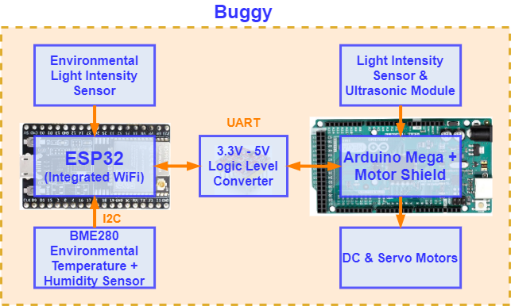
Figure 2: Hardware used in the buggy and hardware connections.

Choice of Sensors and Actuators
To provide the buggy with intended functionality and to ensure that the buggy is able to perform the intended tasks, the following sensors and actuators were chosen.
BME280 – Records temperature and humidity which are important parameters to monitor in a greenhouse to ensure optimal conditions.
LDR (Environmental) – Records the light intensity which is also an important parameter to monitor as light preferences of different plants vary.
LDR (Autonomous Mode) – The LDRs connected to the Arduino serve the purpose of guiding the robot through the greenhouse. Because there are no plants in the pathway, the light intensity would be higher than in places where plants are present. By comparing the light intensities from both, left and right LDRs that are attached to the Arduino, the buggy can make a distinction if it is straying from the correct path or not and correct its course. If a situation arises that the buggy cannot overcome, the user can always switch to manual mode and direct the buggy in the right direction.
Ultrasonic Module – The ultrasonic module serves the purpose of detecting nearby objects in front of the buggy in order to allow it to avoid collisions. The module is fitted to a servo motor to allow the buggy to move the module left and right to see and decide on which route to take depending on what the buggy detects to its left and right side.

