Implementation

Communication and Middleware
Because the mobile robot platform combined with sensors is akin to sensor networks, and the intended functionality does not require a vast variety of requests, a decision was made to implement 'primitive' (add reference) based middleware where functions, built into each hardware platform of the system, are used to fulfil requests sent between the nodes in the network. The requests that are sent carry request identification to allow the target to recognise the type of request. Any data associated with the request that is required by the primitive is also sent. Figure 1 shows the generalised form of the request. Appendix A contains a full list of requests used, their description, and data composition. Appendix B provides a more detailed description of the data sent with each request.
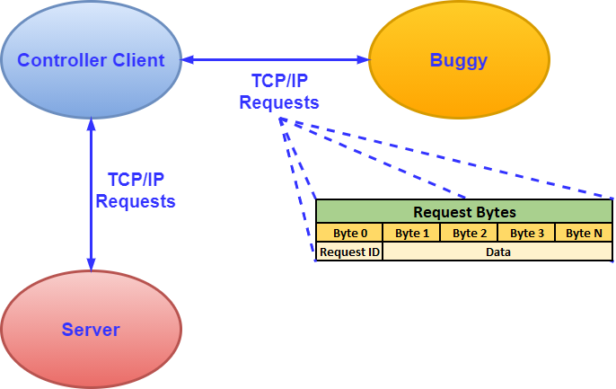
Figure 1: Generalised composition of a request used in the system.

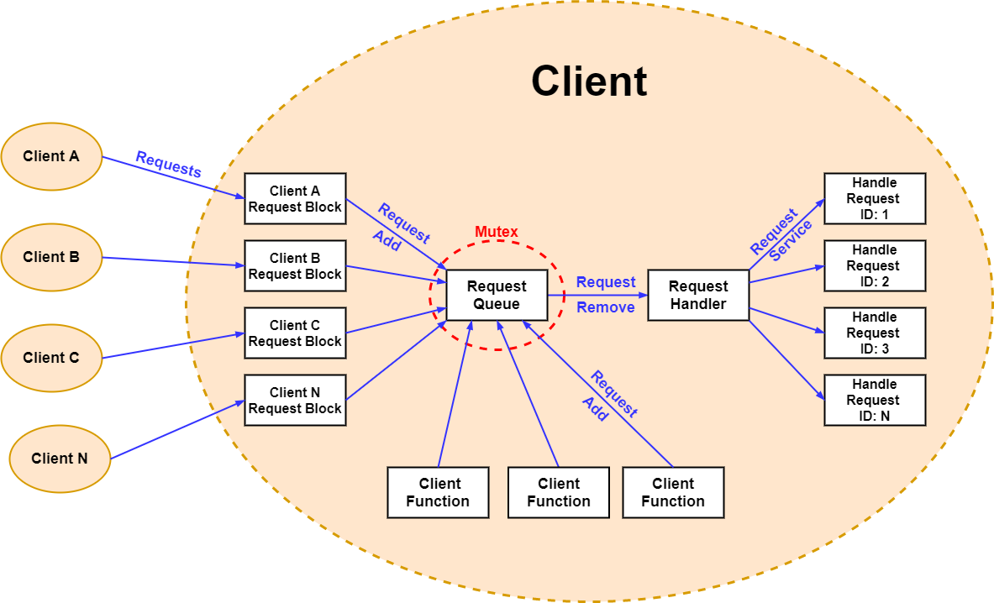

Appendix A
Complete list of requests used by the system and data composition of each request.
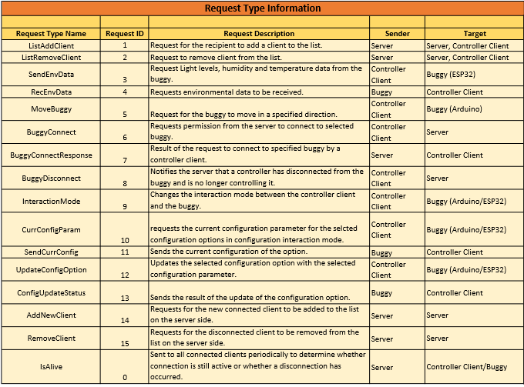
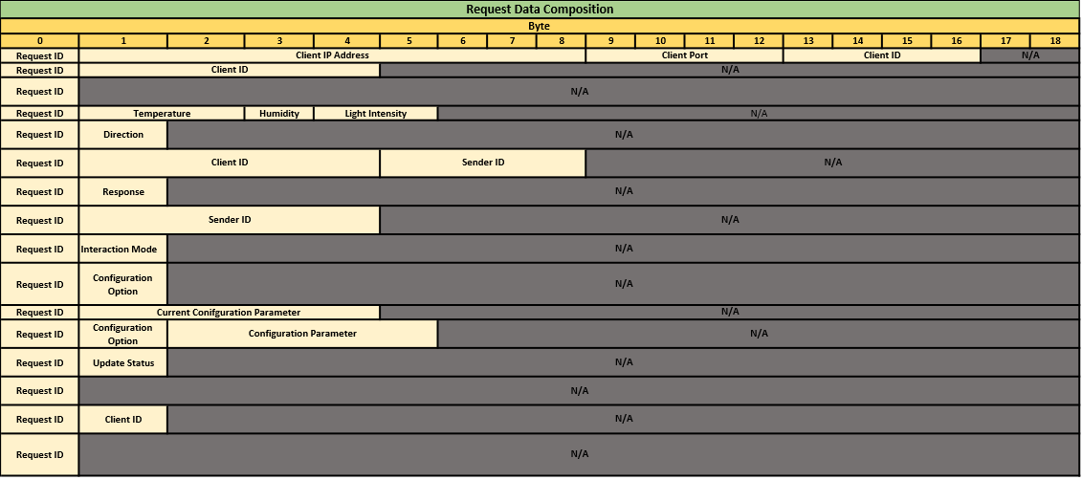

Appendix B
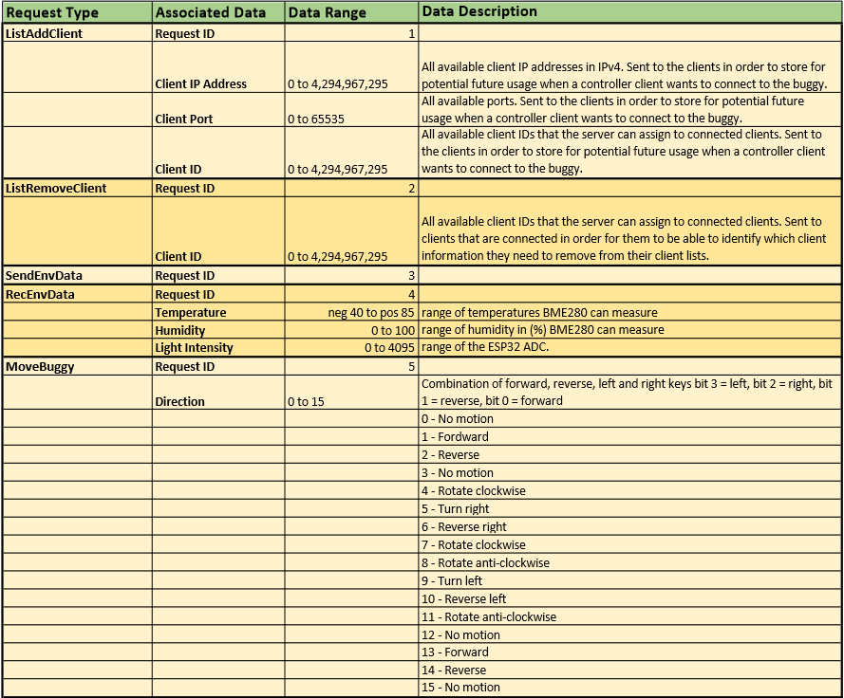
Detailed description of the data sent with each request.

