

[](https://steamcommunity.com/id/ze_das_skins/inventory/)[](https://zedasskins.000webhostapp.com/pistols.html)[](https://zedasskins.000webhostapp.com/smg.html)[](https://zedasskins.000webhostapp.com/pistols.html)[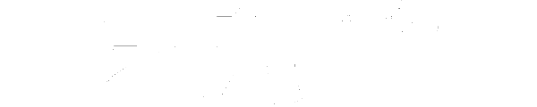](https://zedasskins.000webhostapp.com/rifles.html)[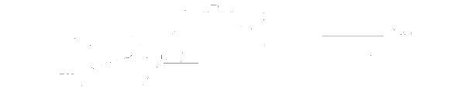](https://zedasskins.000webhostapp.com/awp.html)[](https://steamcommunity.com/id/ze_das_skins/inventory/)[](https://www.instagram.com/ze_das_skins/)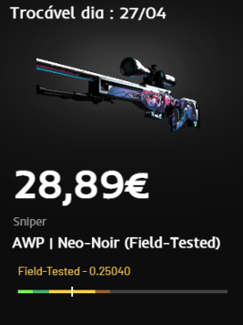

**Preçário**

**@ze_das_skins**