|  |  |
| --- | --- |
| Safilo Product Mix | |
| **Date:** 19/04/2022 | **Version:** 1.0 |
| **Course:** Managerial Decision Making & Modeling | |

|  |  |
| --- | --- |
| **Principal investigator(s)** | |
| **Name** | **email** |
| Regin Kaci | 873353@stud.unive.it |
| Federico Stragliotto | 893690@stud.unive.it |
| Elena Martarello | 872265@stud.unive.it |

|  |  |  |  |  |
| --- | --- | --- | --- | --- |
| **Document review** | | | | |
| **Version** | **Date** | **Modified pages /**  **sections** | **Description /**  **Modifications** | **Transmitted on date** |
| V1.0 | 2/07/2022 | All | First draft + First scenario | 13/07/2022 |
| V1.1 | 14/07/2022 | All | Second Scenario | 25/07/2022 |
| V1.2 | 15/07/2022 | All | Third Scenario | 25/07/2022 |

# Abstract

Safilo, an eyewear production company, is deciding on the product mix for its metal sunglasses for summer 2022.

Safilo has a given portfolio of Products P and a set of plant I. Each product provides a revenue, but consumes a given amount of a strategic resource T (=titanium) which is shared among the different plants. This strategic resource is scarce, so the company has to account for the limited availability of titanium.

Each product that the company makes must be built entirely in one plant. In fact, each plant has the capacity to complete each product but, due different technology available and other variables, the results are different costs and different usage of machine-hours. Each plant has available only a limited amount of machine-hours to complete the product that Safilo assigns to it.

The purpose of this project is to optimize the profit for Safilo by choosing what and where to produce the product.

FICO Xpress Workbench results show us that Safilo can only produce certain brands unless it increases its working hours.

# Acronyms and definitions

|  |  |
| --- | --- |
| **Safilo** | An eyewear production company |
| **PRODUCTS** | The final product is a complete pair of sunglasses |
| **PLANTS** | Safilo has two plants for production one in Longarone and one in Santa Maria Di Sala |
| **RESOURCE_T_AVAIL** | A limited resource necessary for for production,  in this case titanium |
| **MACHINE_TIME_BATCH** | The time necessary for the machine to produce the final lot of products |
| **MAN_HOURS_REQ** | The time necessary for the worker to assemble a unit |
| **MACHINE_TIME_AVAIL** | Total machine time available in each plant |
| **COST** | The cost of each product in each plant |
| **MAX_OVERTIME** | The maximum hours overtime available |
| **COST_PER_OVERTIME_HOUR** | The price of each overtime hour |
| **MAN_HOURS_AVAIL** | The man hours available |

Summary

Abstract 2

Acronyms and definitions 3

Summary 4

Problem statement 5

System 5

Elements 5

Agents/DMs 5

Entities 5

Relationships among elements 5

Other constituents of the system 5

Mathematical model(s) 6

Sets 6

Variables 6

Decision variables 6

Service variables 6

Parameters 6

Constraints 6

Objectives 7

Model 7

Data collection 8

Scenario analysis 9

Scenario 1 9

Scenario 29

Scenario 3 10

Attachments 10

# Problem statement

Safilo Group is a company specialized in eyewear, in Italy it has 2 assembly plants, one in Longarone and one in Santa Maria di Sala.

The products, in this case metal frames, are built using titanium which is the scarce resource, available only in limited quantities.

Each plant has different features, our job is to optimize the production according to each plant's production cost, machine time and other factors (Man Hours available)...

The aim is to decide where and what to produce in order to maximize the total profit.

# System

## Elements

### Agents/DMs

### The agents are Safilo Group and we, who are in charge of the optimization process.

### Entities

The main entities are the two plans of Longarone and Santa Maria di Sala.

Also we have a strategic resource constraint (T).

## Relationships among elements

The main constraints of our system are the availability of Titanium (strategic resource) and the different machine times to produce a batch of items in the two plants. There also is the man-hours constraint.

## Other constituents of the system

Other constituents of the system are the maximum overtime hours (360 hours) and the cost of those (15 €/h)

# Mathematical model(s)

## Sets

* Products
* Plants

## Variables

### Decision variables

* X (Products) = binary (1 = Produce, 0 = Don’t produce)
* Y(Products,Plants) = binary (1 = Longarone, 0 = Santa Maria di Sala)
* W = integer, the number of overtime-hours to use

## Parameters

* Parameters for the products: Sale price, quantity, number of resources necessary for production
* Parameters for the plants: Machine time available, and machine time needed for each batch
* Cost: considering both products and plants
* Parameters for the workers: man-hours, max-overtime and cost per overtime-hour

## Constraints

* MaterialConsumptionConstraint: constraint due to the strategic resource



* ProductCreationConstraint: Implies to produce the entire batch only in one plant

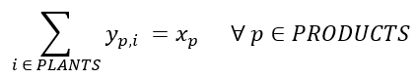

* MachineTimeUsage: Time necessary to produce one batch in the plants



* Man_hoursConstraint: Maximum time available to workers

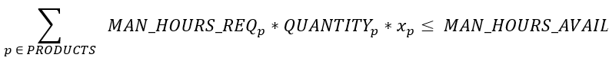

* MaxOvertimeHoursConstraint: the maximum number of overtime-hours available



* xBinaryContraint: X(PRODUCTS) if 1 = Produce the batch, if 0 = Do not produce



* yBinaryContraint: Y(PRODUCTS,PLANTS) if 1 = Produce batch “p” in plant “j”, 0 = otherwise



## Objectives

* Maximize the total profit



## 

## Model

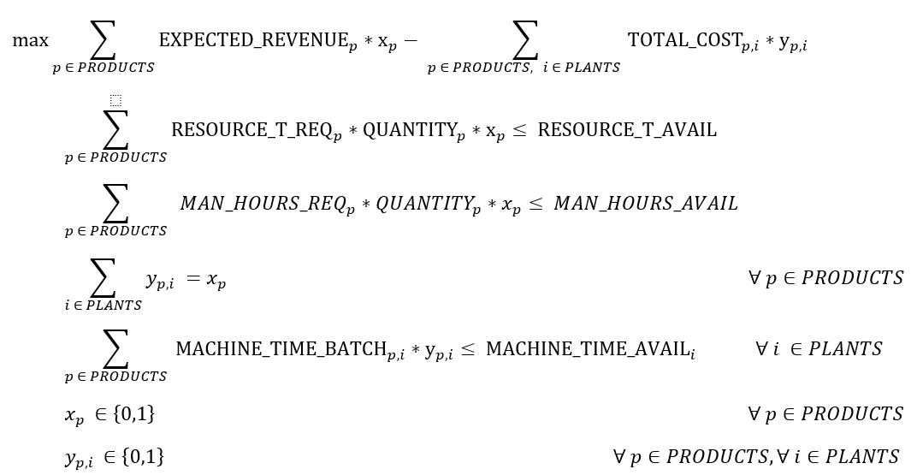

# Data collection

Safilo internal data for sale price, resource required, resource available and cost.

**Assumptions:**

- Quantities to be produced are defined randomly

- The time available in each plant is assumed while the time required to produce each batch is defined following this formula:

**32 days + 5(=days for ElectroPlating)*[(CEi – minCE)/ (maxCE-minCE)]**

*32 days generally required to produce a batch of metal sunglasses (Metal Component + Soldering + Polishing + Electro Plating + Coloring + Assembling).

**Customized ElectroPlating (CE) Table, from 1 to 7**

|  |  |
| --- | --- |
| Carrera | 4 |
| Boss | 3 |
| Jimmy Choo | 7 |
| Polaroid | 1 |
| Tommy | 2 |
| Dsquared | 6 |
| Moschino | 5 |

The SantaMaria Plant can produce the batch with a difference of one day less or more than the Longarone Plant (defined randomly).

All the measures are converted into hours by multiplying the days estimated by 8 hours (-> machines running for 8 hours a day).

- Man hours available calculated in this way:

**30gg*12h*5m=1800 h**

(5 month=assumed that the production start in January and finish May)

- Max Overtime defined as:

**12h*30gg=360h**

(additional month for the production)

- Cost per Overtime hours is assumed

- The Man hours required for each unit is defined following this formula:

**Machine Time Batch/Quantities to produce**

# Scenario analysis

## Scenario 1

In the first scenario we formulate (and solve) the product selection and assignment problem as linear programming to decide which product Safilo must produce, and which plant must carry them on to maximize the company profit. Determine: the maximum profit, the products to complete and the products assigned to each different plant.

From an operational point of view, we consider the costs and the machine time of each plant.

We take the plant with the lowest cost and production time and assign to it the items to be produced.

**Solution:**

total profit: 520000

CARRERA, expected revenue 68200, carried on in plant: SantaMaria, at cost 18600

JIMMYCHOO, expected revenue 99000, carried on in plant: Longarone, at cost 25200

TOMMY, expected revenue 105000, carried on in plant: SantaMaria, at cost 30000

DSQUARED, expected revenue 250000, carried on in plant: Longarone, at cost 50000

MOSCHINO, expected revenue 184300, carried on in plant: SantaMaria, at cost 62700

overtime hours: 0

## Scenario 2

In the second scenario in order to increase the profit we need to produce more products, so we need to ask our workforce to work overtime up to 360 extra man-hours. However, we will face additional payments of 15 euro per hour, which have to be considered as further costs for the company.

Having stated the conditions, we have to determine how many hours of overtime we should ask the employees.

**Solution:**

total profit: 583065

CARRERA, expected revenue 68200, carried on in plant: SantaMaria, at cost 18600

BOSS, expected revenue 104000, carried on in plant: SantaMaria, at cost 34320

JIMMYCHOO, expected revenue 99000, carried on in plant: Longarone, at cost 25200

TOMMY, expected revenue 105000, carried on in plant: Longarone, at cost 31500

DSQUARED, expected revenue 250000, carried on in plant: Longarone, at cost 50000

MOSCHINO, expected revenue 184300, carried on in plant: SantaMaria, at cost 62700

overtime hours: 341

## Scenario 3

In the 3rd scenario we assume additional constraints that could decrease our profit, yet we do not have overtime hours available as in first scenario case:

1. produce BOSS only if CARRERA is made
2. produce POLAROID under any circumstances
3. produce at least one of the following brand: JIMMYCHOO, DSQUARED and MOSCHINO

**Solution 1:**

total profit: 514380

CARRERA, expected revenue 68200, carried on in plant: SantaMaria, at cost 18600

BOSS, expected revenue 104000, carried on in plant: SantaMaria, at cost 34320

TOMMY, expected revenue 105000, carried on in plant: Longarone, at cost 31500

DSQUARED, expected revenue 250000, carried on in plant: Longarone, at cost 50000

MOSCHINO, expected revenue 184300, carried on in plant: SantaMaria, at cost 62700

overtime hours: 0

**Solution 2:**

total profit: 491940

JIMMYCHOO, expected revenue 99000, carried on in plant: SantaMaria, at cost 24660

POLAROID, expected revenue 31500, carried on in plant: Longarone, at cost 10500

TOMMY, expected revenue 105000, carried on in plant: SantaMaria, at cost 30000

DSQUARED, expected revenue 250000, carried on in plant: Longarone, at cost 50000

MOSCHINO, expected revenue 184300, carried on in plant: SantaMaria, at cost 62700

overtime hours: 0

**Solution 3:**

total profit: 415280

CARRERA, expected revenue 68200, carried on in plant: SantaMaria, at cost 18600

BOSS, expected revenue 104000, carried on in plant: SantaMaria, at cost 34320

POLAROID, expected revenue 31500, carried on in plant: Longarone, at cost 10500

TOMMY, expected revenue 105000, carried on in plant: SantaMaria, at cost 30000

DSQUARED, expected revenue 250000, carried on in plant: Longarone, at cost 50000

overtime hours: 0

# Attachments

- SafiloBest.mos: Mosel file that contains the model

- SafiloBest.dat: dat file that contains the values of the parameters of the models