Nicholas Boyd

IT-230: Software Development with C#.NET

Southern New Hampshire University

12 / 12 / 24

Final Project Part 2

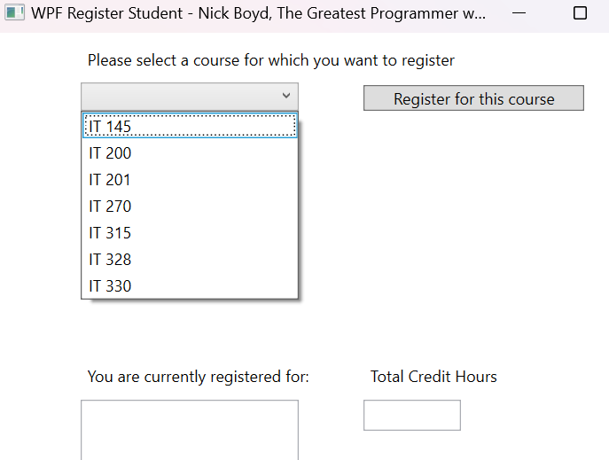

Output window.

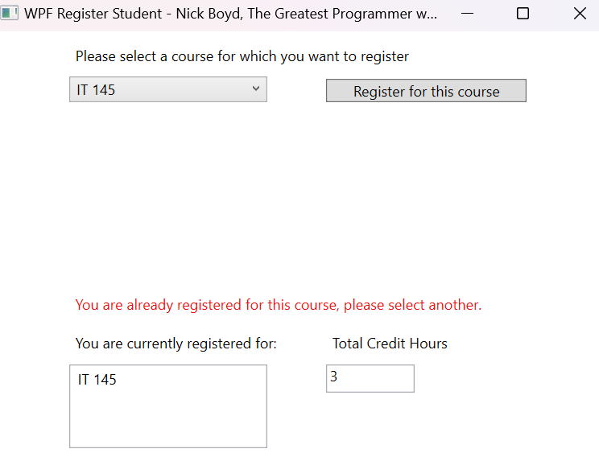

Displays input validation, error message for attempting to register for same course twice.

Displays input validation, error message for attempting to register when at 9 Credit Hours.

Successful registration for three courses.

Source Code

using System;

using System.Collections.Generic;

using System.Linq;

using System.Text;

using System.Threading.Tasks;

using System.Windows;

using System.Windows.Controls;

using System.Windows.Data;

using System.Windows.Documents;

using System.Windows.Input;

using System.Windows.Media;

using System.Windows.Media.Imaging;

using System.Windows.Navigation;

using System.Windows.Shapes;

namespace WPFRegisterStudent

{

/// <summary>

/// Interaction logic for MainWindow.xaml

/// </summary>

public partial class MainWindow : Window

{

Course choice;

int totalCreditHours = 0;

public MainWindow()

{

InitializeComponent();

}

private void Window_Loaded(object sender, RoutedEventArgs e)

{

Course course1 = new Course("IT 145");

Course course2 = new Course("IT 200");

Course course3 = new Course("IT 201");

Course course4 = new Course("IT 270");

Course course5 = new Course("IT 315");

Course course6 = new Course("IT 328");

Course course7 = new Course("IT 330");

this.comboBox.Items.Add(course1);

this.comboBox.Items.Add(course2);

this.comboBox.Items.Add(course3);

this.comboBox.Items.Add(course4);

this.comboBox.Items.Add(course5);

this.comboBox.Items.Add(course6);

this.comboBox.Items.Add(course7);

this.textBox.Text = "";

}

private void button_Click(object sender, RoutedEventArgs e)

{

choice = (Course)(this.comboBox.SelectedItem);

if (choice.IsRegisteredAlready() == true)

{

this.label3.Content = "You are already registered for this course, please select another.";

}

else if (totalCreditHours == 9)

{

this.label3.Content = "You have already selected the maximum of 9 credit hours.";

}

else

{

this.label3.Content = "";

choice.SetToRegistered();

totalCreditHours = totalCreditHours + 3;

this.listBox.Items.Add(choice);

this.textBox.Text = totalCreditHours.ToString();

}

}

}

}