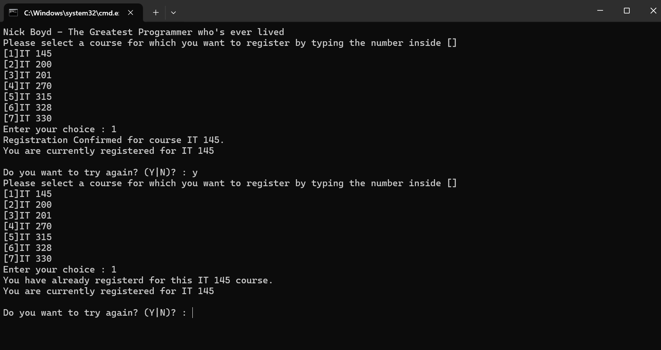

^^^Displays functionality of registration code

^^^Displays functionality of three courses registered

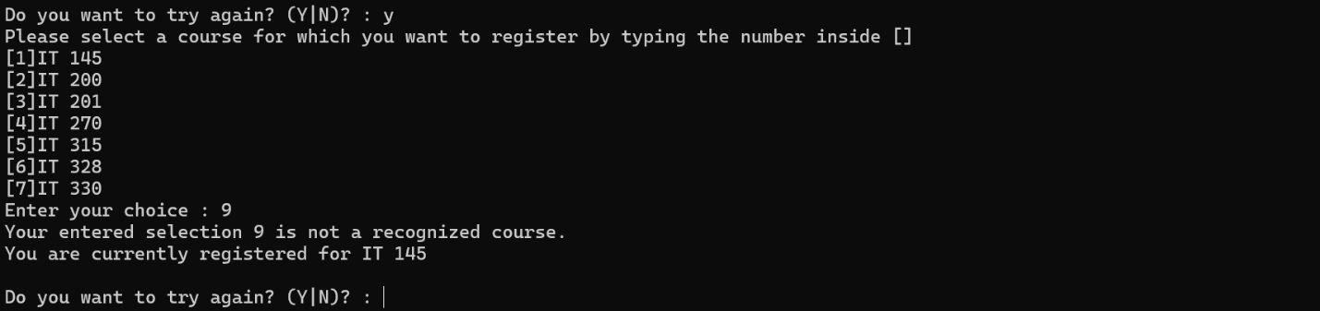

^^^Displays functionality of input validation

^^^Displays functionality of 9 credit hour limit

^^^Displays functionality of double registration detection



^^^Outro text

using System;

using System.Collections.Generic;

using System.Linq;

using System.Text;

using System.Threading.Tasks;

namespace ConsoleRegisterStudent

{

class Program

{

static void Main(string[] args)

{

(new Program()).run();

}

void run()

{

int choice;

int firstChoice = 0, secondChoice = 0, thirdChoice = 0;

int totalCredit = 0;

string yesOrNo = "";

System.Console.WriteLine("Nick Boyd - The Greatest Programmer who's ever lived");

do

{

WritePrompt();

choice = Convert.ToInt32(Console.ReadLine());

switch (ValidateChoice(choice, firstChoice, secondChoice, thirdChoice, totalCredit))

{

case -1:

Console.WriteLine("Your entered selection {0} is not a recognized course.", choice);

break;

case -2:

Console.WriteLine("You have already registerd for this {0} course.", ChoiceToCourse(choice));

break;

case -3:

Console.WriteLine("You can not register for more than 9 credit hours.");

break;

case -4: // changed case: 0 to case: -4

Console.WriteLine("Registration Confirmed for course {0}.", ChoiceToCourse(choice));

totalCredit += 3;

if (firstChoice == 0)

firstChoice = choice;

else if (secondChoice == 0)

secondChoice = choice;

else if (thirdChoice == 0)

thirdChoice = choice;

break;

}

WriteCurrentRegistration(firstChoice, secondChoice, thirdChoice);

Console.Write("\nDo you want to try again? (Y|N)? : ");

yesOrNo = (Console.ReadLine()).ToUpper();

} while (yesOrNo == "Y");

Console.WriteLine("Thank you for registering with us");

}

void WritePrompt()

{

Console.WriteLine("Please select a course for which you want to register by typing the number inside []");

Console.WriteLine("[1]IT 145\n[2]IT 200\n[3]IT 201\n[4]IT 270\n[5]IT 315\n[6]IT 328\n[7]IT 330");

Console.Write("Enter your choice : ");

}

int ValidateChoice(int choice, int firstChoice, int secondChoice, int thirdChoice, int totalCredit)

{

if (choice < 1 || choice > 7) // changed 70 to 7

return -1;

else if (choice == firstChoice || choice == secondChoice || choice == thirdChoice) //changed && to ||

return -2;

else if (totalCredit >= 9) // changed > to >=

return -3;

return -4;

}

void WriteCurrentRegistration(int firstChoice, int secondChoice, int thirdChoice)

{

if (secondChoice == 0)

Console.WriteLine("You are currently registered for {0}", ChoiceToCourse(firstChoice));

else if (thirdChoice == 0)

Console.WriteLine("You are currently registered for {0}, {1}", ChoiceToCourse(firstChoice), ChoiceToCourse(secondChoice));

else

Console.WriteLine("You are currently registered for {0}, {1}, {2}", ChoiceToCourse(firstChoice), ChoiceToCourse(secondChoice), ChoiceToCourse(thirdChoice));

}

string ChoiceToCourse(int choice)

{

string course = "";

switch (choice)

{

case 1:

course = "IT 145";

break;

case 2:

course = "IT 200";

break;

case 3:

course = "IT 201";

break;

case 4:

course = "IT 270";

break;

case 5:

course = "IT 315";

break;

case 6:

course = "IT 328";

break;

case 7:

course = "IT 330";

break;

default:

break;

}

return course;

}

}

}