Contents

I. Application of Interaction Design Theory and Principles of Interaction design 3

1. Interaction design 3

2. Five dimensions of Interaction Design 3

a) Dimension 1 (Words) 3

b) Dimension 2 (Visual Representations) 3

c) Dimension 3 (Physical Objects or Space) 3

d) Dimension 4 (Time) 4

e) Dimension 5 (Behavior) 4

3. Principles of Interaction Design 4

a) Visibility 4

b) Feedback 4

c) Constraints 5

d) Mapping 5

e) Consistency 5

d) Affordance 6

4. Interaction Design Process 6

a) Research 6

b) Analyze 6

c) Design 7

d) Launch 7

e) Implement 7

f) Application 8

II. Design Research 9

1. Theory of Design research 9

2. Activities of the design research 9

a) Primary research 9

b) Interviews 9

c) Survey 10

d) Observation 10

e) User groups 10

f) Contextual inquiry 10

g) Diary study 10

h) Usability testing 11

i) Secondary research 11

k) Generative or exploratory research 11

l) Evaluative research 11

m) Application activities of the design research 11

III. Prototyping 12

1. List of questions for the interview: 12

2. List of questions for the survey 13

Section 1 13

Section 2 13

Section 3 14

IV. Conclusion 14

V. Mid-fidelity prototype of an interaction device 15

Reference 18

# I. Application of Interaction Design Theory and Principles of Interaction design

## 1. Interaction design

Interaction design is products that interact with people to support in working and daily life. Besides, interaction design is designed to that help people enhance and develop the way to work, communicate and interact. For interactive systems, the structure and behavior are made out by designers. Designers try to create significant relationships of users with interaction design systems and their services from smart or other devices such as laptop, computer, and tablet of people. Compare to software engineering, interaction design has the exact opposite. While interaction design focus on defines structure and interaction behavior between the system and users, the main primary of software engineering is that create software solutions for given applications.

## 2. Five dimensions of Interaction Design

In interaction design, there are 5 fundamental principles which also called dimensions by people. The 5 dimensions of interaction design including 1D(Words), 2D(Visual Representations), 3D (Physical Objects or Space), 4D(Time), 5D(Behavior).

### a) Dimension 1 (Words)

In interaction design, words need to be considered carefully before use. They need to be used properly to bring about good interactions. Using words properly, there are elements that need to be focused. For example, the target audience, the context, the context and the purpose that words are used. Moreover, words are used not only simple and easy to understand, but also works can accurately convey much meaning (Smith, 2021).

### b) Dimension 2 (Visual Representations)

All things that are not words typography, photography, icons, diagrams and any graphical elements. Images have a very strong attraction to, helping the entire content become attractive and attractive. In addition, some images are illustrative to make it easier for users to understand or some important contents are highlighted or created different highlights to help people focus, remember that content for a long time and easier (Smith, 2021).

### c) Dimension 3 (Physical Objects or Space)

In interaction design, visuals don’t just need to be well designed. They need to be in right place to be effective. If visuals are in wrong place, they will not bring interactive positivity for the user or can have a negative impact. The website that have messy design can make difficult for users to interact with website elements and bring affect the interaction negatively. With interaction design, there are serious objects that people are used for example , devices such as lap top, smart phone, computer, that user use to interact with system. Moreover, the physical design of different devices is different than that, User interactions when using different devices will be different. Physical environment where user use devices to interact with system can affect to the way interact (Smith, 2021).

### d) Dimension 4 (Time)

Time dimension have important role in the way that user navigates and interacts with a product. People can interact with sound, animation, video and Factors can change over time. Besides, there are significant factors that need meticulous attention. They are the amount of time that a user takes to interact with the product and how they get feedback from the product (Smith, 2021).

### e) Dimension 5 (Behavior)

The way that people take actions on websites is focused attention. Different from 4 dimensions including time, physical objects or space, visual representations, words. The behavior dimension consider for emotional feedback from the users and base on feedbacks to create new recommendations and increase the experience of user, while the remaining 4 dimensions focus on work together to how to influence The interaction of user with the system (Smith, 2021).

## 3. Principles of Interaction Design

Interactive design principles are generalized abstract contents to orientate towards mind of designer in different aspects of designs. Design principles are came from the combination of knowledge, experience, and common sense. The primary purpose of design principles is recommendation about things that designer should provide and avoid in different aspects of designs. Recommendations intended to help designers explain and improve the design skills. However, actions just like reminders for designers to consolidate that certain things at the interface have provided by designers. Design principles have not purpose how to design an real interface. The design principles that know a lot are the way to make out things, which users should see and do during interaction with the product. For example, some design principles are popular such as visibility, feedback, constraints, mapping, consistency, and affordances. Moreover, there are the number of design principles are encouraged

### a) Visibility

The significance of visibility is very important and proven. There are more visible functions, the easier it will be for users to know what to do next, and the easier it will be to use. In contrast, users will find it difficult to use and interact with the system when there are few functions displayed. For example, Buttons on the dashboard of the car such as indicators, headlights, horn, and hazard warning lights. These dashboards are usually located near the driver's steering wheel and are easily visible so that the driver can easily use them. The dashboards on the car are really easy to use and each panel controls a different function of the vehicle.

### b) Feedback

Feedback is information of action has been handled, has been completed and then sent back users. After receiving feedback, users are allowed to continue with the activity. There are various kinds of feedback that are obtainable for interaction design-audio, tactile, verbal, visual, and combinations of feedback. The important of feedback decide combinations suitable for different kinds of activities and interactivities. The required visibility for user interaction is provided when using properly.

### c) Constraints

Constraints consult about make out the way that can take place to limit the types of user interaction at a given moment. Some constraints are commonly used. For example, Menu options are disabled from the user by shading the menu options so that the user cannot access, and then the user can only use the allowed options. Disabling options keeps users from making incorrect choices and reduces the risk of making mistakes. There are three kinds of constraints including physical, logical, and cultural.

Physical constraints is the way that physical objects are restricted the movement of things. For example, the physical constraints of a disk drive are shape and size. Therefore, an external disk should have fit shape and size and can only be inserted in one way

Logical constraints base on the knowledge of people about the way that everything around activate. Logical thinking allows people to reason about what will happen when people interact with the system. When people interact with something in the system, people tend to expect something different to happen.

Cultural constraints base on conventions learned such as using red to warning, using firm types of audio signals for danger and using icon to deputize emotions. Designers can arbitrary most cultural constraints in the sense that relationship among constraints are discrete and constraints could have equally improved to be represented in another form, for example yellow is used to instead of red for warning. Conventions became widely accepted after the cultural group study and admit. Among the many, there are two interface conventions that are universally made acceptance using window to display information and using icons on the desktop to deputize operations and documents.

### d) Mapping

Mapping adverts to the relationship among controls and their influences in the world. Most artifacts have the number of mapping among controls and influences such as flashlight, car, power plant, or cockpit. For example, the up and down arrows on a computer keyboard that used to deputize the up movement and down movement of the cursor respectively is a favorable mapping among control and effect. The position relatively of controls and their effects in mapping is also significant. For example, controlling different music players (such as MP3, CD player, tape recorder) playing, rewinding, and fast forward is based on a general convention. Based on common convention, the middle is the play button, on the left is the rewind button, and on the right is the fast-forward button

### e) Consistency

Especially, the interface is designed based on rules like using the similar operation to select all objects. For example, a consistent operation is the left mouse button click that always action is used to select all objects. Using the same input action at the interface help show up any graphical object. On the other hand, exception rules are used to inconsistent interface, for example, in presenting email messages in a table, the right mouse button is only used to have check, while all other operations are used to check by the left mouse button. Exception rules have usually not consistency, designer can develop quite arbitrarily, so that, user difficult to remember, use and easy prone to mistakes. As opposite to inconsistent interfaces, consistent interfaces help people easier to learn and use. With consistent interfaces, user needs to know only an individual mode of applicably operation to all objects. However, consistent rules only works well for simple interfaces with basically operation with a few of separate buttons are mapped operations. But complex interfaces with designing many different operations, User is difficult to learn and use. Users should learn, memorize the operations, symbolic buttons for operations and analysis to use and combine them properly. But each buttons mapped onto an individual operation .If an interface have a hundred, thousand buttons, it will not enough space for a thousand buttons. In case, there are enough space, user is extremely difficult and time-consuming to find, study all the desired operation and use. Besides, there is a more effectual design measure is to make categories of commands mapped into subsets of operations. For example, the word-processing application have the hundreds of operations available are divided into subsets other menus. Operations have with file operations such as new, save, open, close which are set together in the similar menu. The similar with file menu, format menu include operations concerned with formatting text.

### d) Affordance

Affordance that make mention of an attribute of an object helped people to know about the way to use it. For example, a mouse button need to push or click through physically constrained in plastic mouse shell. The way to interact with a physical object is easy to find when the affordances of obviously perception. For example, a door handle that can be pulling, a cup handle that can been grasping, a mouse button that can been pushing and a light switch can pushing. Affordance become widely popular and is used to represent the way that should design interface objects to they can make clearly things, which can be done to objects. For example, graphical elements such as buttons, icons, links, and scroll bar.

## 4. Interaction Design Process

The interaction design process is things that designers make out solutions focused on demand, goal and behavior of users during interacting with products. There are 4 stages including research, analyze, and design.

### a) Research

Researching request and demand of users that is a significant stage and basis of the interaction design process help designers to know about request, demand of users and relevance of context. There are many ways to collect request and demand of users such as observe, interview, focus groups and surveys. Designers ask interviewers questions about problems that designers want to research. Interview become popular because bring great effects because the designer can assess the emotions and reactions of the interviewees. Another common practice that is often used is surveys. Survey is a questionnaire that includes questions about the content the designer wants to explore. Survey is useful to find attitudes of user towards a particular topic and the information receive immediately when survey participants complete the survey (The Interaction Design Foundation. 2021).

### b) Analyze

The all data collect from research is analyzed, filtered to sort and order the most significant elements. The analysis through the steps including description or story about the way to use a product, task analysis, divide steps and sub-step of user (The Interaction Design Foundation. 2021).

### c) Design

Design is that create a potentially solution based on design guidelines and basic design principles. Using the best techniques to suitable with the way that users have interaction with system in terms of, such as navigation. Design is construction site map, user flow, mockups, images, icons, colors, wireframe. Design is an iterative process, Design will be difficult for designers to complete the design in one go, the design will be done over and over until it is completed. Designers may have to design, redesign, scrap it, and design it all again (The Interaction Design Foundation. 2021).

### d) Launch

When the design completed, the design make transformation into clickable prototypes. All things transfer for the development team to produce a high faith version of the user interface. After receiving and converting the design plan, there are some ways to check the quality of the product such as internal testing, user testing and start prototyping. Users are provided a basic idea of product and users test it. Besides, experts evaluate effective of product through heuristics (The Interaction Design Foundation. 2021).

### e) Implement

Based on all the data collected from the research and launch stages, the construction are carried out. For example, from user interview results, designers can develop a system based on user requirements and wishes. Or after the test versions have been tested by experts and users, and then they make assessments about the performance and problems of the system for the designers to rely on to change and improve the system (The Interaction Design Foundation. 2021.

### f) Application

### Apply theories of interaction design and conduct the design and implementation of an in-vehicle navigation and entertainment system. The system allows users to access a music library system to experience listening to music in the car and a navigation system that allows users to search for places to go and the fastest ways to get there. The navigation function works like Google map.

### The design of a performance system is carried out in steps to complete a system. Design starts with research, the designer collect data by interview, surveys and observe. Samples are selected by convenience sampling. Populations that are people using car entertainment and navigation systems. With entertainment systems everyone of different ages, genders, professions use it, for example, the whole family moves in the car and both parents and children listen to music so there are a lot of people using entertainment systems. With navigation system, people driving car frequent use it, but nowadays, with the prevalence of cars, the number of people using the car navigation system is relatively large. Population is too large making sample selection difficult so for the sake of interview, samples are selected by convenience sample method although this method selects weak samples but it is very convenient in case it is impossible to know obtain the main number of samples and the characteristics of samples in population, similar to the case in which it is applicable. with sets of questions for people to survey in an online form. The data after people complete the survey is sent back and the Google form provides statistics in the form of a table or a pie chart depending on the type of data. Nowadays, there are many navigation and entertainment system in car developed, observing users using similar software also helps to gather more information, user experiences to get more information and build your own system.

After research complete, all research data are synthesized and analyzed. But information such as about the functions that should be, the sharing of how to design the interface, what buttons should be, how the buttons work, where the buttons should be and how the interface should be arranged. The analyzed data will be broken down into appropriate parts to create a foundation document for the whole design process.

The next step is design, the design base on research information and follows five dimensions, principles of interaction design. Entertainment and navigation systems in cars need to have a home interface With a menu with 2 options, one is the navigation function, the other is the music function. Another important interface is the music player interface, the music player interface must have important buttons such as play, stop, skip to the previous song, go through the post behind. The design is followed principles of interaction design, so that play button in the middle, skip button in the right and previous button in the left. Besides, there is a button with other functions like listen again and randomize next song out of order arranged consecutively to the right of the skip button. Car music player interface, the interface screen needs a labels to display information such as song title, singer name, a bar showing the length of the song and the list of songs. For the navigation interface, the interface needs a large map for the driver to easily follow along with labels that display information about the route being moved such as distance, destination, and current route moving. Both the music and navigation interfaces have buttons to return to the main menu. In addition, the main operation of the system is to press the button, the color of the interface is also designed with deep colors that does not cause dazzle and are suitable for the diversity of the system users. The design can be changed and aligned until the design is considered to be the most demanding.

Once the blueprint is completed, a version of the system is built upon the blueprint. The product will be tested by a select number of users or experts, the testers and experts will give their comments and feelings about the system. From the considerations, the developers will change and improve the system for the better. Initial product as a trial version after being improved and upgraded a final version will be created and released to the public.

# II. Design Research

## 1. Theory of Design research

Research design is the framework of research methods and techniques that selected by a researcher. Researchers can improve knowledge about suitably research methods for the subject matter and set up successful research. The major kinds of research designs have three kinds that are data collection, measurement, and analysis. Besides, the design of a research topic illuminate the pattern of research such as experimental, survey, correlational, semi-experimental, review and also its sub-type like experimental design, research problem, descriptive case-study.

## 2. Activities of the design research

Design research is a crucial step that help user have the best experience. Design research helps designer understand about behavior of customers and transfer behavior of customers data into useful information to improve design. There are many ways to conduct design research, but some of commonly used are:

### a) Primary research

Primary research is a popular method. In most design research, primary research is a significant part. Primary research allows designers ask directly questions to user and collect information. The aim of primary research with design research is that help designers to clearly understand the actual end user and define design ideas. There are some activities to do primary research, for example:

### b) Interviews

Interview is a qualitative research technique that interviewer ask questions to the interviewees to gather data about a subject or The interviewees may be subject experts or may just be people who are knowledgeable about the topic and able to give good answers to prepared questions or questions that the interviewer comes up with during the interview depends on the interviewer's answers to the previous questions. There are many types of interviews, but three crucial types of interviews are directed, non-directed, and ethnographic. The most popular types of interviews is direct interviews. Other forms of interviews such as non-directed are often conducted when interviewees are unable to conduct face-to-face interviews because they are too far away, or do not feel confident to answer face-to-face interviews or special circumstances such as distancing because the effect of COVID-19. Besides, there is other way to do interview that is ethnographic interviews that have the similar performance with observe. Interviewers observe activities of people in daily habitat. Interview have many benefits that make it a popular research method, interviewers can be proactive about the order of questions, arising questions, location, date, time, and time during the interview. Moreover, the interview also gives high quality, detailed answers and the interviewer can observe the attitude and feelings of the interviewee when answering. Other forms of interviewing may not yield as good results as face-to-face interviews.

### c) Survey

A survey that is a research method is used to gather information from a predefined group of participants to achieve data and deep understanding into interested topics. There are multiple purposes so, researchers can perform following many ways based on the methodology chosen and purposes of research. Survey usually collect information through using method standardized to make sure that each participants can answer equally questions to avoid factors affecting choice of respondents leading to influence the result of the research or study. the development of technology Surveys are usually perform online through digital media such as social networks, email, QR codes, or URLs or survey can also be perform directly. The process of the survey implementation process starts from collecting data from participants through a questionnaire. Surveys have advantages. For example, high precision or nowadays, with the development of technology, researchers can easily create questionnaires for surveys and participants can participate in answering easily through many different forms

### d) Observation

Observation gathers data through witness events, action of people, or noting physical characteristics in natural habitat and recorded. Situations in observation research are non-experimental or experimental. Non-experimental are events and phenomena that occur unexpectedly, without control. The result of non-experimental of have both qualitative and quantitative in nature.

### e) User groups

User groups are the best research activity when researcher wants to gather data of a larger number of user in a short period of time. Groups are usually gathered from 3 to 6 people and though the exercises, group activities, researcher operate, guide, give verbal and write feedback.

### f) Contextual inquiry

Contextual inquiry is especially central type of design research in the early stages of the design process to study things that significant with users and the way to user interact with similar tools or services. Contextual inquiry is not just an interview or an observation, when conducting contextual inquiry, researcher provide a set of criterion questions, which is the first task, and then follow the process of people completing tasks and everyday tasks in natural environment of people. Events and phenomena occurring during monitoring are recorded and data analyzed.

### g) Diary study

Participants are requested to write and log detailed information about activities of participants during a long period of time such as some weeks, some months. The simplest way to gather information from diaries, participants log all details about the activities finished into diaries like report.

### h) Usability testing

When the design process is almost complete and a large prototype can be created to share users, experts. Usability testing helps that research give design into the wild to collect feedback. In usability testing, potential or current users and experts need to finish a list of using prototype tasks created by researchers.

### i) Secondary research

Secondary research is using existing data such as books, articles, the internet validated, support existing research. Secondary research can been use to make out a stronger case for design choices and provide additional detail datas for data of primary research. Secondary research is the quick and cheap research method, but secondary research has general difficulty for example, researchers cannot search the specific information, or outdated data, poor quality data. Some places that can collect data for secondary research are:

* Internal data such as company database, sales reports, or historical information
* Statistically information or data of government from government agencies
* Information from research centers of university
* Reputable magazines and reputable newspapers

### k) Generative or exploratory research

Generative research also called as exploratory research centre into a deeper knowledge to requirement and desire. In explorement process, researcher recognizes a design hypothesis and presents it with customers to confirm. The researcher is not sure that explore the result or answer of the discovery process, but generative research produces a strong base to give good design decisions going forward. Generative research has some similar point with primary research. Because both generative research and primary research have a way to gather data that is approach and talk with users. For example, form to conduct research data collection of primary research and generative research like interviews, user groups, surveys, and contextual inquiries.

### l) Evaluative research

Evaluative research is a process that researcher test a design solutions that prepared after finishing collection data from generative research. Besides, users can experience and evaluate prototype. Evaluative research help researcher get feedback from customer and experience from prototypes to gather information that is used to refine and improve the design solutions and prototypes. Customer using product or service and giving feedback is the most popular ways to carry out evaluative research. For example, a speciality method of evaluative research is usability studied. Additionally, there are two types of evaluative research are summative and formative. Compared to formative emphasizes, summative emphasizes has results better than the process and formative is used to test and consolidate idea.

### m) Application activities of the design research

Design research is an important stage, so it needs to reliably perform to get a good result. Design research conducted through activities such as primary research, secondary research, evaluative research, diary study and usability testing. With primary research, interviews, survey and observation.

Four people will participate in the interview. Since it is not possible to determine the number of samples in populations so that the interviewees will be selected by convenience sampling method. The selected samples are those most easily accessible to researchers to conduct interviews. The interviewees are those who have experienced the entertainment and directions in the car, each interviewee need to answer a set of questions about his experience and thoughts about the solution and directions system on the car. Interviewees will also be asked to participate in a diary study. In addition, the survey was also carried out to collect data for the study. A questionnaire created with Google form is created and sent to everyone, everyone participates in the survey by clicking on the link and answering the questions. The answers will be saved by Google form and arranged in different formats such as tables and charts so that researchers can easily study. Currently, there are many entertainment and navigation systems in cars that have been developed and used. Therefore, observing people using similar software to gain experience in designing and modifying to make their software better. To reinforce the research results, the researcher needs to conduct secondary research. The car music and navigation system is a system that has been researched and developed for a long time. So that, there are a lot of documents such as books, reputable articles, previous research papers on the design of music and navigation systems in cars. Moreover, designers can also learn design knowledge to apply to the design of entertainment and navigation systems in cars. After conducting data collection, the data will be analyzed and a design prototype will be created based on the analysis results. Design prototypes will be given to users to experience and give evaluations. Creating a prototype for users to experience is the process of performing evaluative research and usability testing. After a period of user experience or experts will make comments and feelings, based on those data, researchers will adjust and improve the system to have the best end product.

Based on the calculations outlined in the previous section. One set of survey questions and one set of interview questions will be prepared. Participants are selected to participate in the interviews and also participants in observation, diary study, usability testing and evaluative research. Populations are those who have developed entertainment and navigation systems in cars. The sample is selected by convenient sampling method, because with the popularity of cars and music and navigation systems that have been developed for a long time, so there are a lot of people used and it is difficult to know about the size of sample in populations. Therefore, samples are the ones that researchers can easily approach for research.

# III. Prototyping

## 1. List of questions for the interview:

* Question 1: Can you share your personal information? How old are you? What's your occupation?
* Question 2: Have you used software for listening to music and directions in the car before? How do you feel about designing them?
* Question 3: Do you think the color of the main menu is reasonable?
* Question 4: Do you think the menu layout is reasonable?
* Question 5: What buttons do you see a car music system need?
* Question 6: How do you feel the information about the song such as the song title should be displayed?
* Question 7: What color do you think is appropriate for the interface of a car music system?
* Question 8: In your opinion, what is the reasonable layout of the music player interface in the car?
* Question 9: What buttons do you see a car directions system need?
* Question 10: How do you feel the information about the multi-travel route?
* Question 11: What do you think is the best map to show people?
* Question 12: What color do you think is appropriate for the interface of a car directions system?
* Question 13: In your opinion, what is the reasonable layout of the directions interface in the car?

## 2. List of questions for the survey

The survey questionnaire consists of 3 sections including a general section, a section asking about the music system and a section about the navigation system.

### Section 1

* Question 1: What is your gender?
* Answer: A. Male B. Female
* Question 2: How old are you ?
* Question 3: Have you used car navigation and music systems?
* Answer: A. Yes B. Not yet
* Question 4: Which color tone do you think the main menu should be designed in?
* Answer: A. Very good B. Good C. Normal D. Bad
* Question 5: How do you think the menu layout should be designed?
* Answer: A. Very good B. Good C. Normal D. Bad

### Section 2

* Question 1: How do feel about the layout of the interface of navigation systems?
* Answer: A. Very good B. Good C. Normal D. Bad
* Question 2: How do you feel about the position of the in buttons in the interface of navigation systems?
* Answer: A. Very good B. Good C. Normal D. Bad
* Question 3: How do you feel about the color of the interface of navigation systems?
* Answer: A. Very good B. Good C. Normal D. Bad
* Question 4: How do you feel about the functions of the navigation systems?
* Answer: A. Very good B. Good C. Normal D. Bad
* Question 5: How do you feel about the image that illustrates the distance to go?
* Answer: A. Very good B. Good C. Normal D. Bad
* Question 6: How do you feel about the image that illustrates the distance to go?
* Answer: A. Very good B. Good C. Normal D. Bad
* Question 7: How do you feel about the information displayed?
* Answer: A. Very good B. Good C. Normal D. Bad
* Question 8: What are advantages of navigation system?
* Question 9: What are disadvantages of navigation system?
* Question 10: Rate the design of the navigation system from 1 to 5 points (from very bad to very good)?

### Section 3

* Question 1: How do feel about the layout of the interface of music systems?
* Answer: A. Very good B. Good C. Normal D. Bad
* Question 2: How do you feel about the position of the in buttons in the interface of music systems?
* Answer: A. Very good B. Good C. Normal D. Bad
* Question 3: How do you feel about the color of the interface of music systems?
* Answer: A. Very good B. Good C. Normal D. Bad
* Question 4: How do you feel about the functions of the music player system?
* Answer: A. Very good B. Good C. Normal D. Bad
* Question 5: How do you feel about the information of the song displayed on the interface of music systems ?
* Answer: A. Very good B. Good C. Normal D. Bad
* Question 6: What are advantages of music player system?
* Question 7: What are disadvantages of music player system?
* Question 8: What do you think the music system needs to improve?
* Question 9: Rate the design of the music system from 1 to 5 points (from very bad to very good)?

**https://docs.google.com/forms/d/e/1FAIpQLScFffxUCdJjKDdVNh-SLDjQUjHpeN6k49AMhTKaJrlJWQwXxg/viewform?usp=sf_link**

The following data were obtained from the research field. The data will be analyzed qualitatively and quantitatively, with the data from the survey being statistics by Google form in the form of a table or a chart, so it will be analyzed quantitatively. The data from the survey will be mostly numbers or few words. For the rest of the forms, the data are mostly textual. The analysis results will be used to develop a sample design in accordance with customer comments such as color, polarity, position of buttons. Prototypes will be sent to customers to review for comments and experiences. Based on the comments and experiences, the designer will proceed to improve the system to have the best end product.

# IV. Conclusion

In conclusion, the report presents interaction design theories, processes of interaction design and principles of interaction design. In addition, understanding of design research and activities of design research is presented. Based on the theories stated, a plan to conduct a design research plan includes the preparation of interview questions, survey questionnaires and the selecting way participants to research. Moreover, the research implementations are also presented. However, the report still has a lot of errors such as the presentation, lack of some information about the theory and plans or the application of the shortcomings in a design is still not good and there are many shortcomings. Things that can be improved, such as how to select research participants, interviewees can be selected more carefully to achieve better results or the principles of interaction design are applied more fully and rigorously. Additionally, The theories of interaction design speak out better.

# V. Mid-fidelity prototype of an interaction device

An in-car navigation and music player interface has been designed using Axure 10. The design includes a main menu interface, a music player interface, a navigation interface, and descriptions of the way that the functions working. The interface will be changed when the user clicks the buttons. The interface is designed based on five dimensions of interaction design such as words, visual representations, physical objects or space, time and behavior.

The first interface is the main menu of the system designed according to the size of 740x380 that is suitable for the entire system. The main menu of 3 main buttons in which the music button is used to enter the music player function. When the user clicks on the music icon, the system will be redirected to the music player interface. Similar to the direction icon, when the user clicks on the direction icon, the system will automatically switch to the interface of the direction icon. Because it is a car music and navigation system, the Bluetooth icon is for illustrative purposes only. In addition, the interface also has some icons in the right corner of the screen indicating the time, the Bluetooth feature is turned on and the system is in sound.

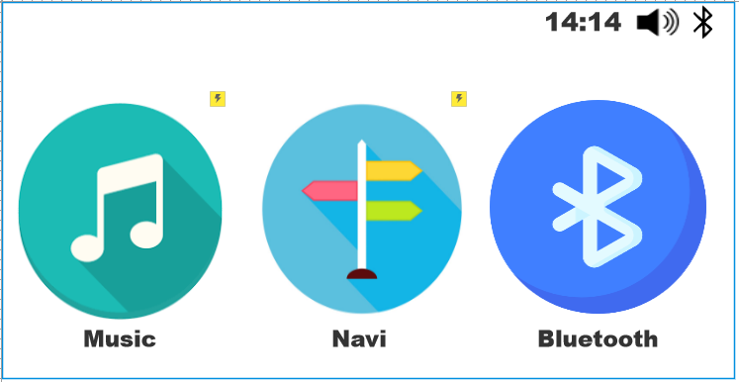

The music player interface includes buttons for functions such as play/pause, next, back, replay and random play. The functions are corresponding to the illustrated icon in an easy to understand manner. In addition, the system also has a list of existing songs on the right for users to easily track and jump to the song they want. Moreover, information about the song such as the number of minutes, the artist's name is also displayed. There is a button in the left corner for the user to return to the main menu.

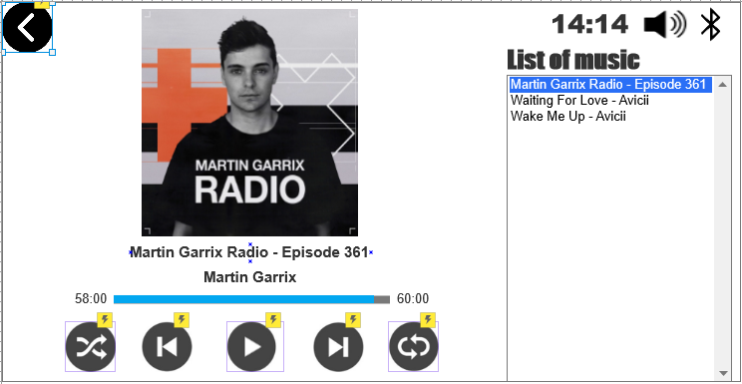

The interface of the navigation feature includes a map with the location of the vehicle indicated by a blue dot, A button for the user to return to his current location when moving the map to other points, Button above of the 2 buttons in the bottom right corner. The remaining button is used to start the route after the user has entered the address and found the destination. A textbox is also used to let people enter the desired destination and search for it. . A button used to return to the main menu

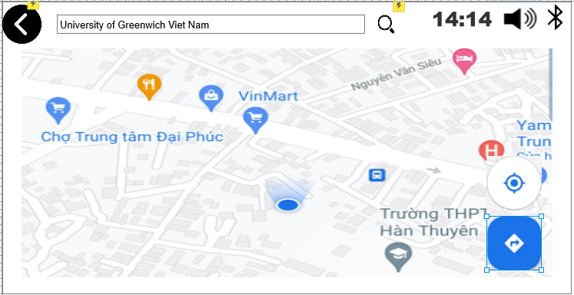

Once the user starts the route, the user can cancel the journey with the X button in the lower left corner and view the route information in the upper left and upper right corner. A button used to return to the main menu

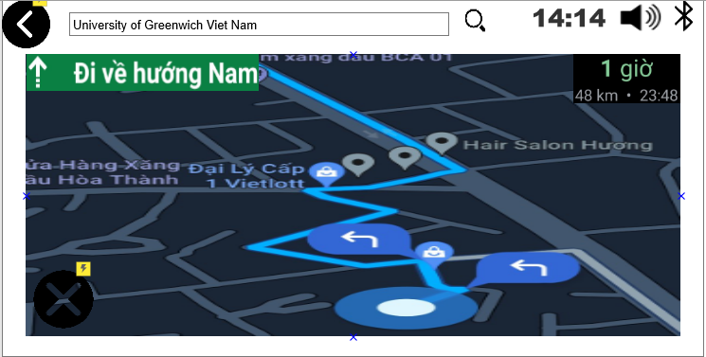

# Reference

Smith, A., 2021. A Brief Introduction To Interaction Design - Usability Geek. [online] Usability Geek. Available at: <https://usabilitygeek.com/introduction-interaction-design/> [Accessed 19 September 2021].

The Interaction Design Foundation. 2021. What is Interaction Design Process?. [online] Available at: <https://www.interaction-design.org/literature/topics/interaction-design-process> [Accessed 27 September 2021].

Esposito, E., 2018. 4 types of research methods all designers should know | Inside Design Blog. [online] Invisionapp.com. Available at: <https://www.invisionapp.com/inside-design/research-methods-designers/> [Accessed 3 October 2021].