**Digitalising Mining In South Africa**

According to Accenture’s research, it shows that the mining industry can create ZAR213 billion in value through 2026 by investing in the right digital initiatives. That's where we tap in as Ore Tech, to provide Access, Preservation, Integration of documentation

* Access - Information available to audiences
* Preservation - Valuable information preserved
* Integration - Important information summed categorically in one software

**Problem (Contextualizing the problem)**

* Extensive research in the grounds of mining was last done in the 1980s
* Legacy of valuable information was not properly saved or updated between the years and other important records still in hardcopy which are vulnerable to many risks and permanent damage caused by handling.
* Investors and entrepreneurs find it hard to find integrated information in one place about information regarding mining in SA

**Possible solution (Competitors)**

- Siemens

- CSIR

- 4Sight Asset Simulation

- Anglo American

Why are their solutions not good enough?

**Prototype**

* Sums organized and verified mining documentation and information from different sources in one app.
* Digitalisation of information to make it easier for **entrepreneurs** to access information if they venture into the mining space
* Allow **investors** to know exactly which location to tap into for specific resources to generate income
* Present valuable data and trends of environment for correct decision making
* Offers recommendation links to connect customers to clients for mining machines/components
* Access, Preservation, Integration

**Functionality of prototype**

* Know it. Set.

**Impact and sustainability**

* Optimize time and processes involved in finding/researching information
* Improve productivity
* Increase competitiveness of mines
* Sustains valuable information and allows information update, information remains retrievable
* Mining businesses venture into explored areas to reduce inaccurate mining in non or few minerals areas
* Digitalised documentation that contains commercial value for correct audiences
* Sustainability reports, sustainable mining plan and impact on communities
* Track performance of companies and ensure safety and health

**Market size in SA**

* South African mining companies are pouring millions of Rands into digital technologies. But their gains from these investments have been muted.
* Accenture’s research shows that the mining industry can create ZAR213 billion in value through 2026 by investing in the right digital initiatives.
* Local mines could miss out on over a third of this value ZAR213 billion if they do not invest in key foundational technologies—e.g., analytics, integrated platforms.
* A lack of focus on key foundational technologies—e.g., advanced analytics and integrated platforms—means mines cannot fully tap the gains (ZAR51 billion) from current digital technology investments

//(Leveraging the entire ecosystem and forge unique collaborations to create value with foundational technologies.)

**Constraints**

* App used in the South African context

**Income**

* Advertisement

**Recommendations**

**Conclusion**

**Constraint**

* More accurate data could not be obtained due to this error below

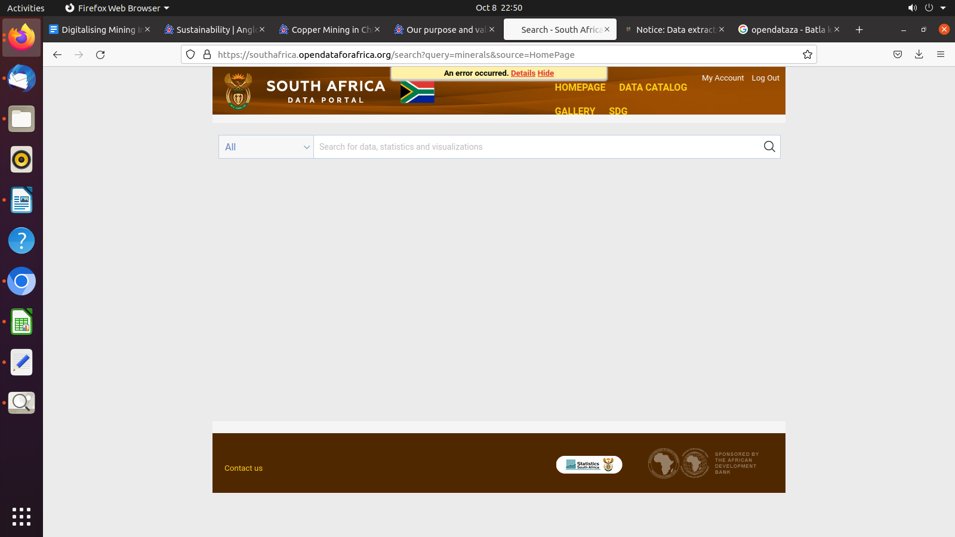

**Reference**

<https://www.accenture.com/za-en/insights/natural-resources/data-mining-in-south-africa>

https://www.africanmining.co.za/2022/07/01/digitalisation-in-mining-part-2-the-digital-twin/

<https://www.miningreview.com/base-metals/digitalisation-key-to-unlocking-mineral-wealth/>

<https://www.nationalarchives.gov.uk/about/commercial-opportunities/digitisation-services/benefits-of-digitisation/>

<https://www.nsenergybusiness.com/features/south-africa-mining-digital-transformation/>