1. Html

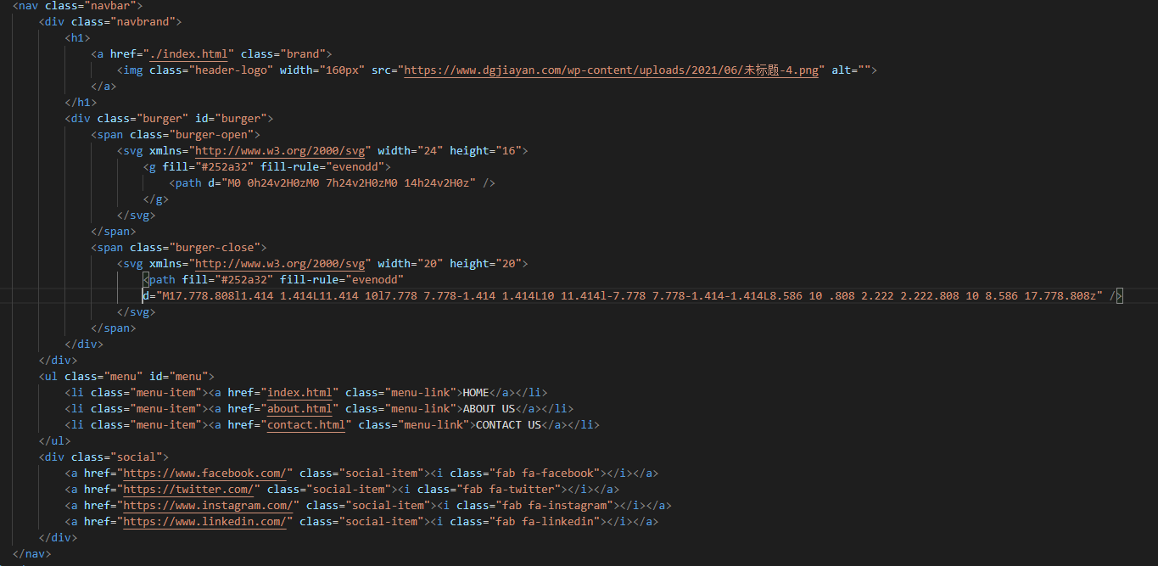

This is the html code for nav bar

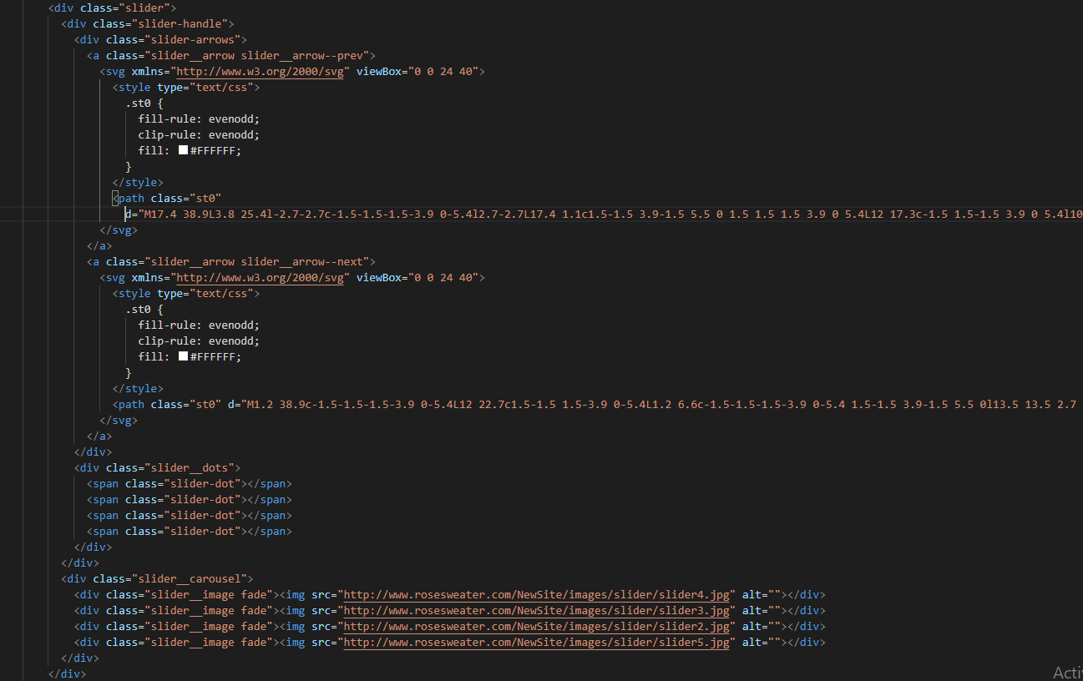

This the html code for carousel

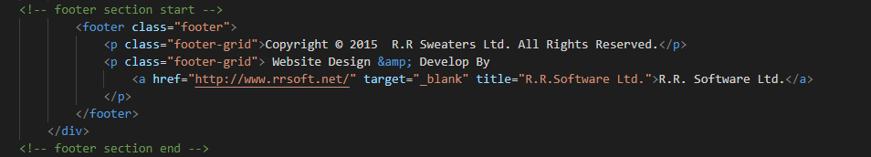

This is the html code for footer section

1. Css

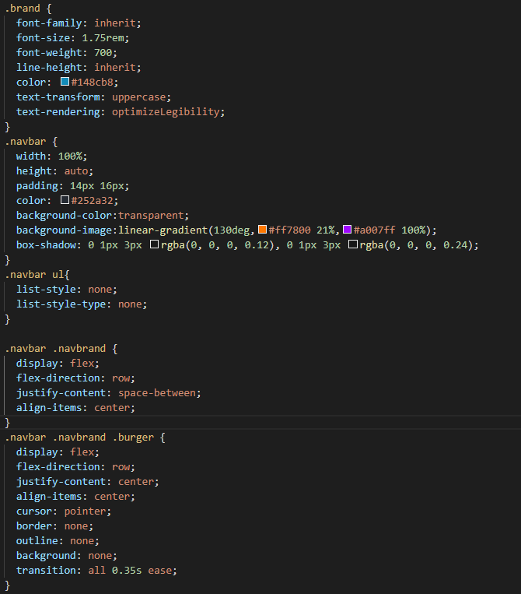

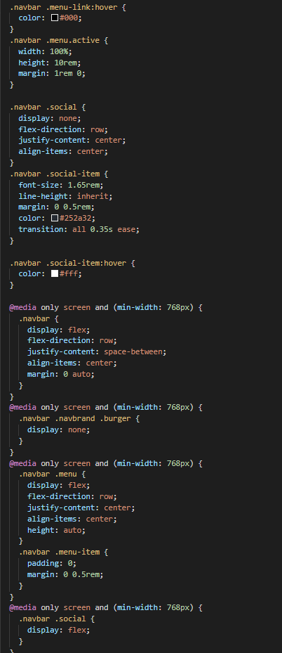

This is the css code for nav bar

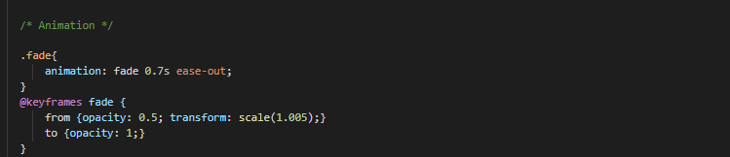This is the fade animation for slides

1. javascript

* RESPONSIVE NAV BAR SCRIPT

var burgerMenu = document.getElementById("burger");

Get html element which id is “burger” and input in variable burgerMenu.

Here is html code

<div class="burger" id="burger">

            z            <span class="burger-open">

                            <svg xmlns="http://www.w3.org/2000/svg" width="24" height="16">

                                <g fill="#252a32" fill-rule="evenodd">

                                    <path d="M0 0h24v2H0zM0 7h24v2H0zM0 14h24v2H0z" />

                                </g>

                            </svg>

                        </span>

                        <span class="burger-close">

                            <svg xmlns="http://www.w3.org/2000/svg" width="20" height="20">

                                <path fill="#252a32" fill-rule="evenodd" d="M17.778.808l1.414 1.414L11.414 10l7.778 7.778-1.414 1.414L10 11.414l-7.778 7.778-1.414-1.414L8.586 10 .808 2.222 2.222.808 10 8.586 17.778.808z" />

                            </svg>

                        </span>

 </div>

var navbarMenu = document.getElementById("menu");

Get html element which id is “menu” and input in variable navbarMenu.

Here is html code

<ul class="menu" id="menu">

   <li class="menu-item"><a href="index.html" class="menu-link">HOME</a></li>

  <li class="menu-item"><a href="about.html" class="menu-link">ABOUT US</a></li>

   <li class="menu-item"><a href="contact.html" class="menu-link">CONTACTUS</a></li>

</ul>

burgerMenu.addEventListener("click", function () {

    navbarMenu.classList.toggle("active");

    burgerMenu.classList.toggle("active");

});

When I click hamburger or close button, call this function

function () {

    navbarMenu.classList.toggle("active");

    burgerMenu.classList.toggle("active");

}

navbarMenu.classList.toggle("active");

when I click burgerMenu element, this add or remove class “active” in the class list of navbarMenu element.  
The class of html element which id is “menu”

burgerMenu.classList.toggle("active");

when I click burgerMenu element, this add or remove class “active” in the class list of burgerMenu element.  
The class of html element which id is “menu”

-CAROUSEL SCRIPT

var prev = document.querySelector('.slider__arrow--prev');

var next = document.querySelector('.slider__arrow--next');

var slides = document.getElementsByClassName('slider__image');

var dots = document.querySelectorAll('.slider-dot')

Get html element which class is “slider__arrow--prev” and input in variable prev.

Get html element which class is “slider__arrow--next” and input in variable next.

Get html element which class is “'slider__image” and input in variable slides.

Get html element which class is “slider-dot” and input in variable dots.



Let variable slideIndex initialize as 0

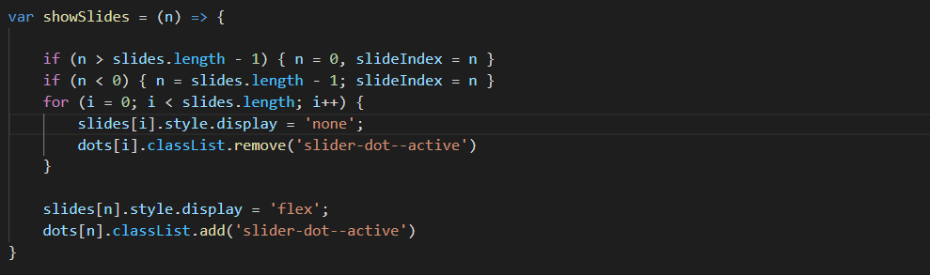

Create showSlides function  
This function controls each slides in carousel.



Calling showSlides function

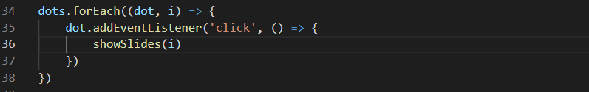

When I click each dot icon, call showSlides



When I click left arrow img button, call showSlides function decreasing slideIndex one by one.



When I click left arrow img button, call showSlides function increasing slideIndex one by one.



This function calls showSlides per every 3 seconds