**Smartcabinetsystem:**

**Introduction:**

This remote assistive system consists of a local site and a remote site as shown in the Figure. The Local site consists of a projector, a camera, speaker, microphone and a RFID reader system. The projector displays the visual information on the cabinet door surface and a camera provides the live view to the remote caregiver. Each shelf in the cabinet has a reader that continuously updates the tag information. The remote site application is designed to assist the remote caregiver. It shows all the required objects needed in any task to the caregiver for assistive purposes. The live view from the camera helps the remote caregiver to see the real environment and senior’s task progress.

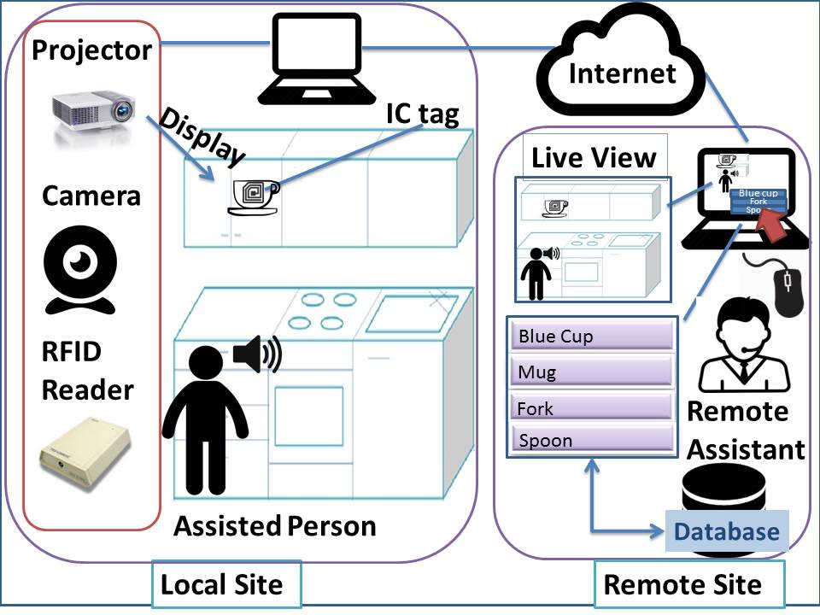

**Implementation**:

The implementation of this system has two processes; offline and online process. During offline process, an RFID tag is attached to each object and registers each object to the database. For registration, image of each object has taken and saved it to the database along with the tag information using a local application. After registration, the geometry between the camera, the projector, and the door surface is calibrated. The local application then connected to the remote application via the Internet. This method helps the user to speed up the process of locating individual objects throughout the kitchen. The online process has a remote application and developed using OpenCV and MySQL database. The database is used to store the tag information attached to every kitchen object