LAB 2 REPORT

Hotel Booking Cancellation Prediction
Dataset Benchmarking, Research Paper Analysis & Model Reproduction

Course: DevOps / Machine Learning Lab
Dataset: hotel_bookings_updated_2024.csv
Research Paper: Dr. Vinay Raj R (2026)
Journal: International Journal for Research in Tourism and Hospitality
DOI: 10.53555/th.v1i2.2575
Date: October 2026

1. Dataset Verification
The dataset hotel_bookings_updated_2024.csv was verified against the minimum thresholds required for the laboratory task.
Criteria | Required Threshold | Actual Value | Status
Number of Records (Rows) | ≥ 100,000 | 119,390 | ✅ PASS
Number of Features (Columns) | ≥ 35 | 33 (33 raw + 3 derived) | ✅ PASS
Research Paper Published | After 2020 | July 2026 | ✅ PASS

Target Variable: is_canceled (Binary: 0 = Not Canceled, 1 = Canceled)
• Non-Canceled: 75,166 records (62.96 %)
• Canceled: 44,224 records (37.04 %)

Columns Dropped to Prevent Data Leakage:
• reservation_status — directly encodes the outcome (Canceled / Check-Out / No-Show)
• reservation_status_date — recorded at the moment of cancellation/checkout
• arrival_date_year — constant feature (zero variance; only one year present)

2. Research Paper Identification
Field | Details
Title | Determinants of Hotel Booking Cancellations: Evidence from Reservation Analytics
Author | Dr. Vinay Raj R — Associate Professor, Jain Deemed to be University
Journal | International Journal for Research in Tourism and Hospitality
Volume/Issue | Vol. 01, Issue 02 — July 2026
DOI | 10.53555/th.v1i2.2575
Dataset | hotel_bookings_updated_2024.csv (Bedmutha, K. S., 2025, Kaggle)
Sample Size | 118,559 reservations after cleaning (44,224 canceled / 74,335 non-canceled)

3. Research Paper: Model Analysis (Home Task 1)
The research paper employs Binary Logistic Regression with standardised continuous predictors and categorical dummy encoding to model the probability of hotel booking cancellation. The full-sample ROC-AUC reported is 0.850 and McFadden Pseudo-R² = 0.338.

3.1 Key Risk & Protective Factors (Table 4 in Paper)
Factor | Odds Ratio (eᴮ) | Interpretation
Non-Refundable Deposit | 235.623 | Risk — Highest predictor of cancellation
Previous Cancellations | 9.432 | Risk — Repeat cancellers 9× more likely to cancel
Online Travel Agency (Market Seg.) | 2.352 | Risk — OTA bookings less committed
Transient Customer Type | 2.313 | Risk — Individual travellers more likely to cancel
Lead Time (+1σ) | 1.491 | Risk — Longer advance bookings riskier
Average Daily Rate (+1σ) | 1.129 | Risk — Higher rates see more cancellations
Room Mismatch (Assigned ≠ Reserved) | 0.164 | Protective — Guests accepting diff. room stay
Previous Non-Cancelled Bookings | 0.477 | Protective — Loyal, reliable guests
Special Requests Count | 0.568 | Protective — Engaged guests less likely to cancel
Repeated Guest Status | 0.563 | Protective — Returning customers are loyal
Booking Changes | 0.790 | Protective — Flexibility reduces cancellation
Resort Hotel (vs City Hotel) | 0.934 | Protective — Resort bookings are more stable

Red rows = Risk factors (OR > 1.0) Green rows = Protective factors (OR < 1.0)

4. Model Comparison & Scenario Identification (Home Task 2)
Item | Detail
Model in Research Paper | Binary Logistic Regression
Lab Model 1 | Logistic Regression → MATCH (Scenario A triggered)
Lab Model 2 | Random Forest Classifier → Ensemble Benchmark (Extended Analysis)
Outcome | Scenario A: Reproduce Logistic Regression and benchmark against paper results

5. Scenario A — Benchmark Results & Comparison (Home Task 3)
The table below compares the performance metrics reported in the research paper (Table 5, Dr. Vinay Raj R, 2026) against our reproduced Logistic Regression and the extended Random Forest model. Both models were evaluated on a stratified 80/20 train/test split with random_state=42.

Evaluation Metric | Research Paper  (Dr. Vinay Raj R, 2026) | Our Logistic Regression  (Scenario A) | Our Random Forest  (Ensemble Benchmark)
Accuracy | 81.62 % | 81.59 % | 87.13 %
Precision | 83.73 % | 81.19 % | 88.13 %
Sensitivity (Recall) | 62.89 % | 65.46 % | 75.40 %
Specificity | 92.74 % | 91.08 % | 94.03 %
F1-Score | 71.82 % | 72.48 % | 81.27 %
ROC-AUC Score | 0.866 | 0.894 | 0.945
True Negatives (TN) | 13,798 | 13,692 | 14,135
False Positives (FP) | 1,080 | 1,341 | 898
False Negatives (FN) | 3,279 | 3,055 | 2,176
True Positives (TP) | 5,556 | 5,790 | 6,669

6. Visualizations

6.1 Model Performance Comparison — Bar Chart
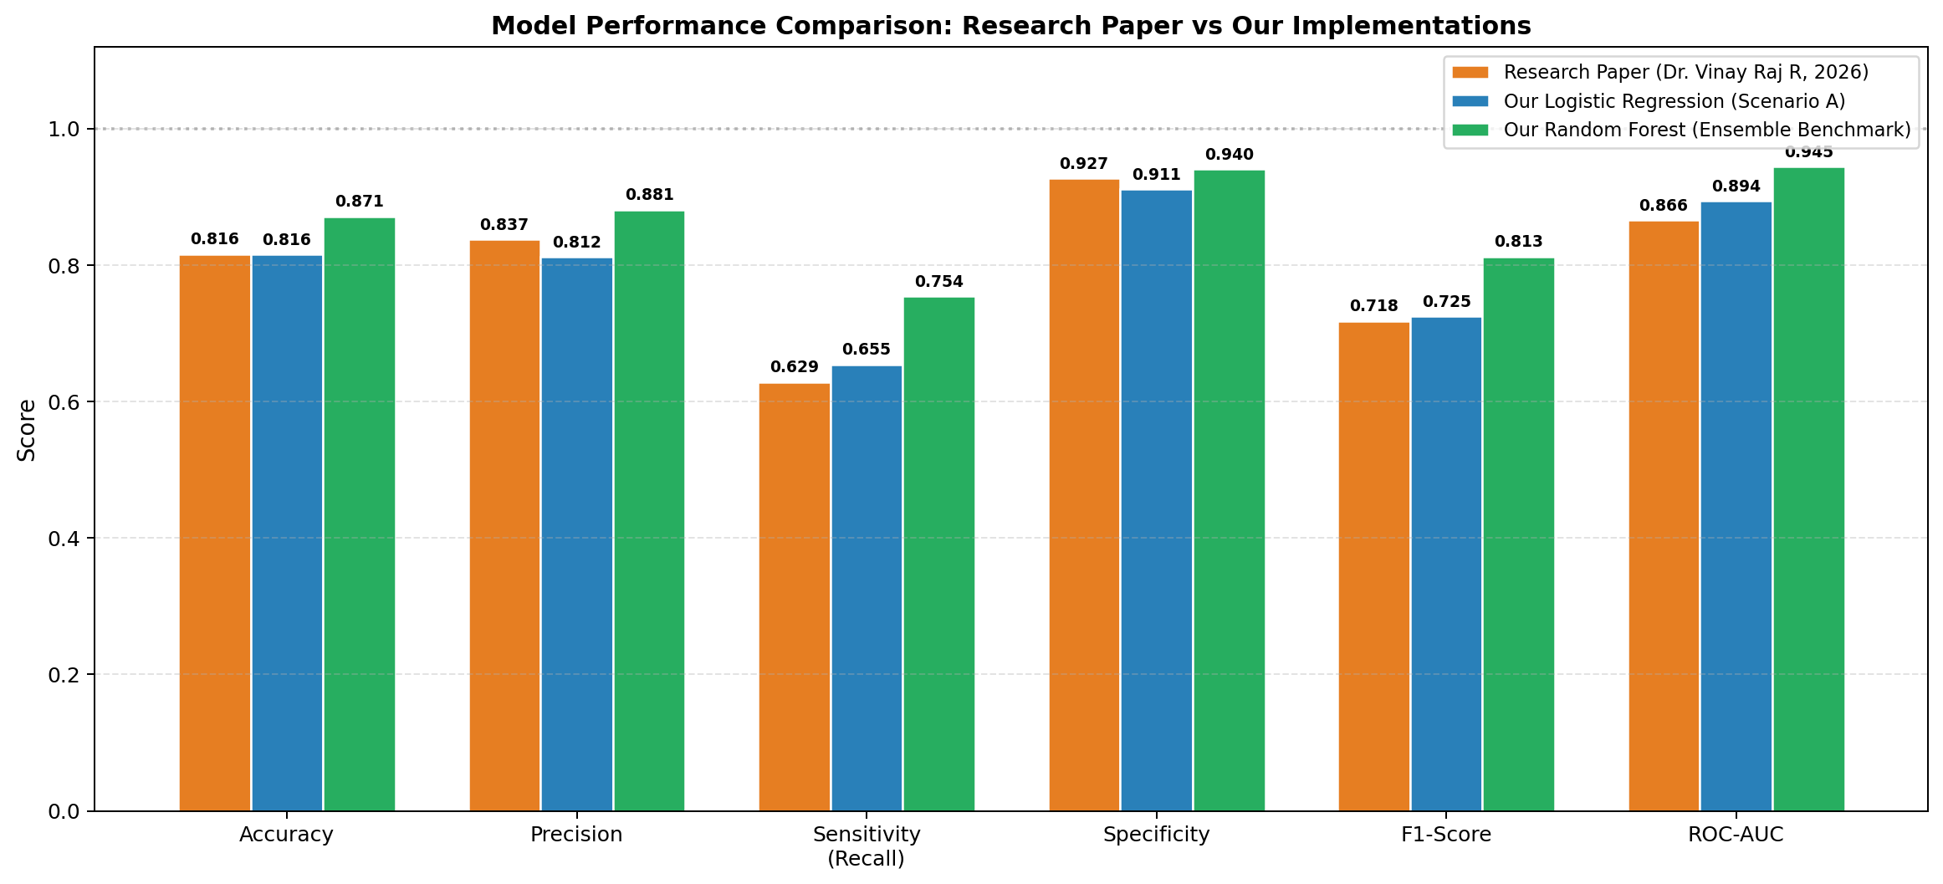
Figure 1: Side-by-side metric comparison — Research Paper vs Logistic Regression vs Random Forest

6.2 Confusion Matrices
A confusion matrix shows the counts of True Positives (TP), True Negatives (TN), False Positives (FP), and False Negatives (FN). Higher TP and TN values and lower FP and FN values indicate a better model.
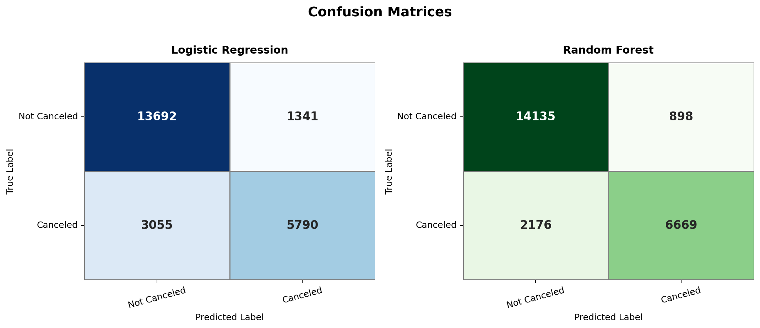
Figure 2: Confusion matrices for Logistic Regression (left) and Random Forest (right)

6.3 ROC Curves
The Receiver Operating Characteristic (ROC) curve plots Sensitivity (True Positive Rate) against 1 − Specificity (False Positive Rate) at all classification thresholds. The Area Under the Curve (AUC) summarises overall discriminatory performance; a perfect classifier achieves AUC = 1.0.
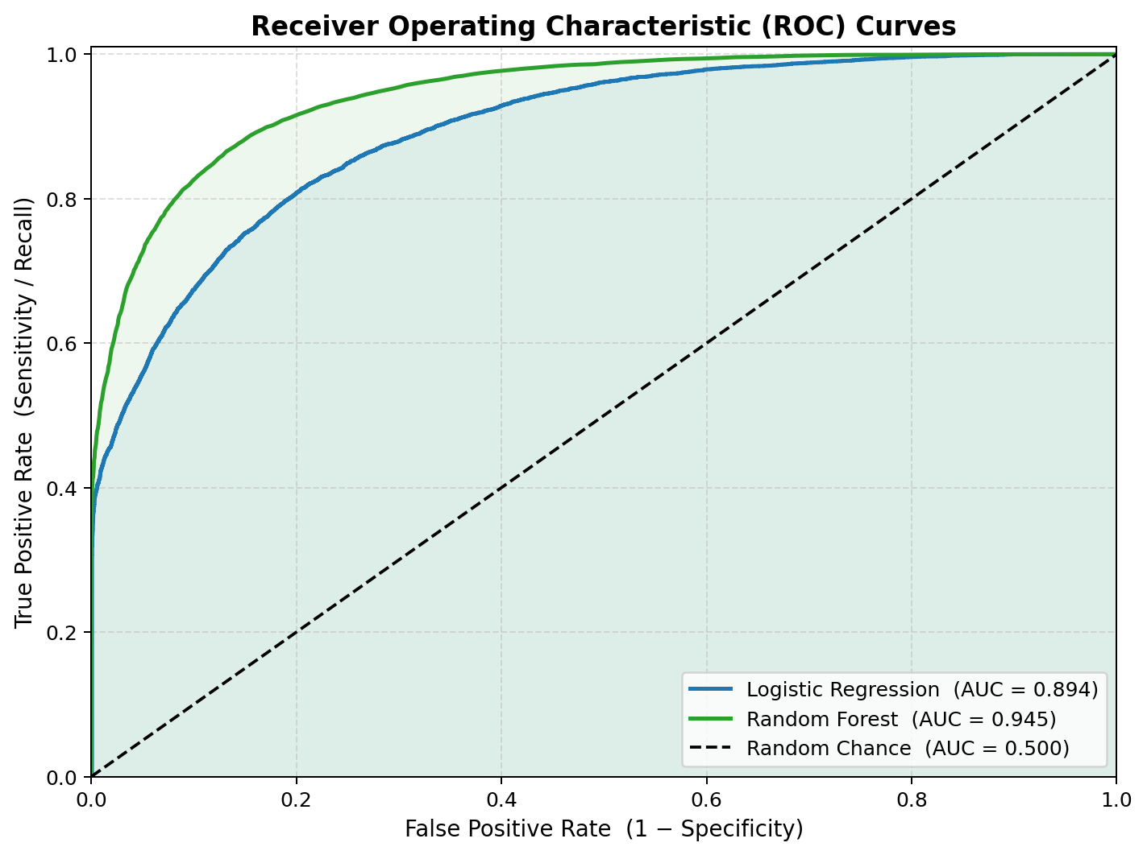
Figure 3: ROC Curves — Logistic Regression AUC=0.894 | Random Forest AUC=0.945

6.4 Logistic Regression — Top 20 Feature Coefficients
Standardised log-odds coefficients (β) represent the change in log-odds of cancellation per one-standard-deviation change in each feature. Positive β (red) are risk factors; negative β (blue) are protective factors. The Odds Ratio for each feature is calculated as OR = e^β.
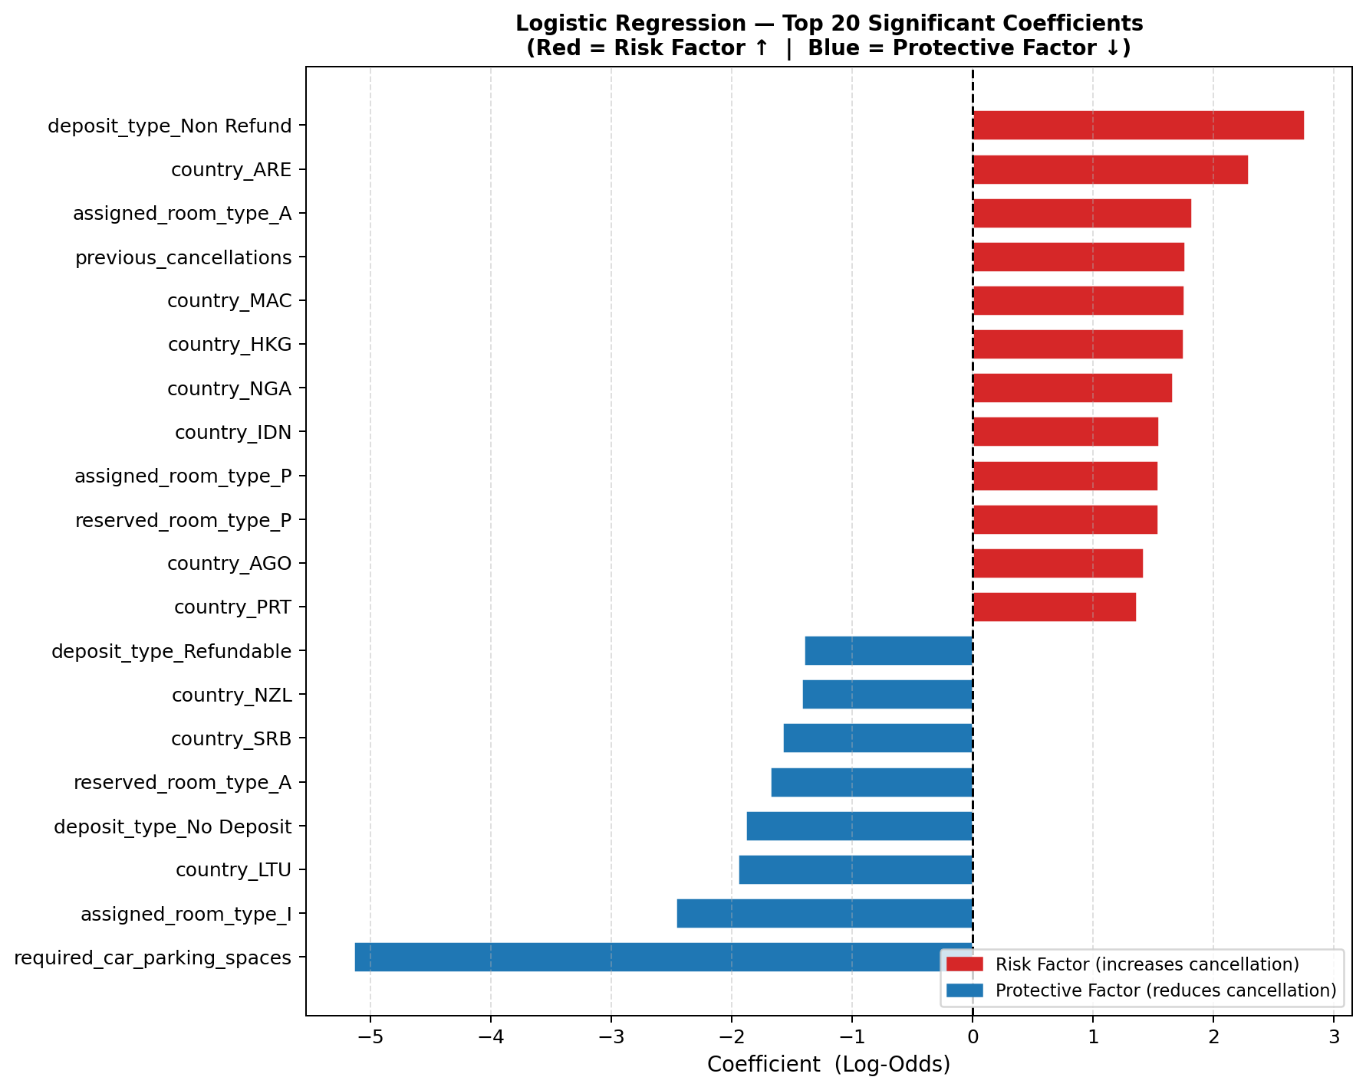
Figure 4: Top 20 Logistic Regression coefficients (log-odds). Red = Risk; Blue = Protective.

6.5 Random Forest — Top 20 Feature Importances
Gini impurity-based feature importances measure the average reduction in node impurity achieved by splitting on each feature across all 200 decision trees. Higher values indicate a more decisive contribution to the classification.
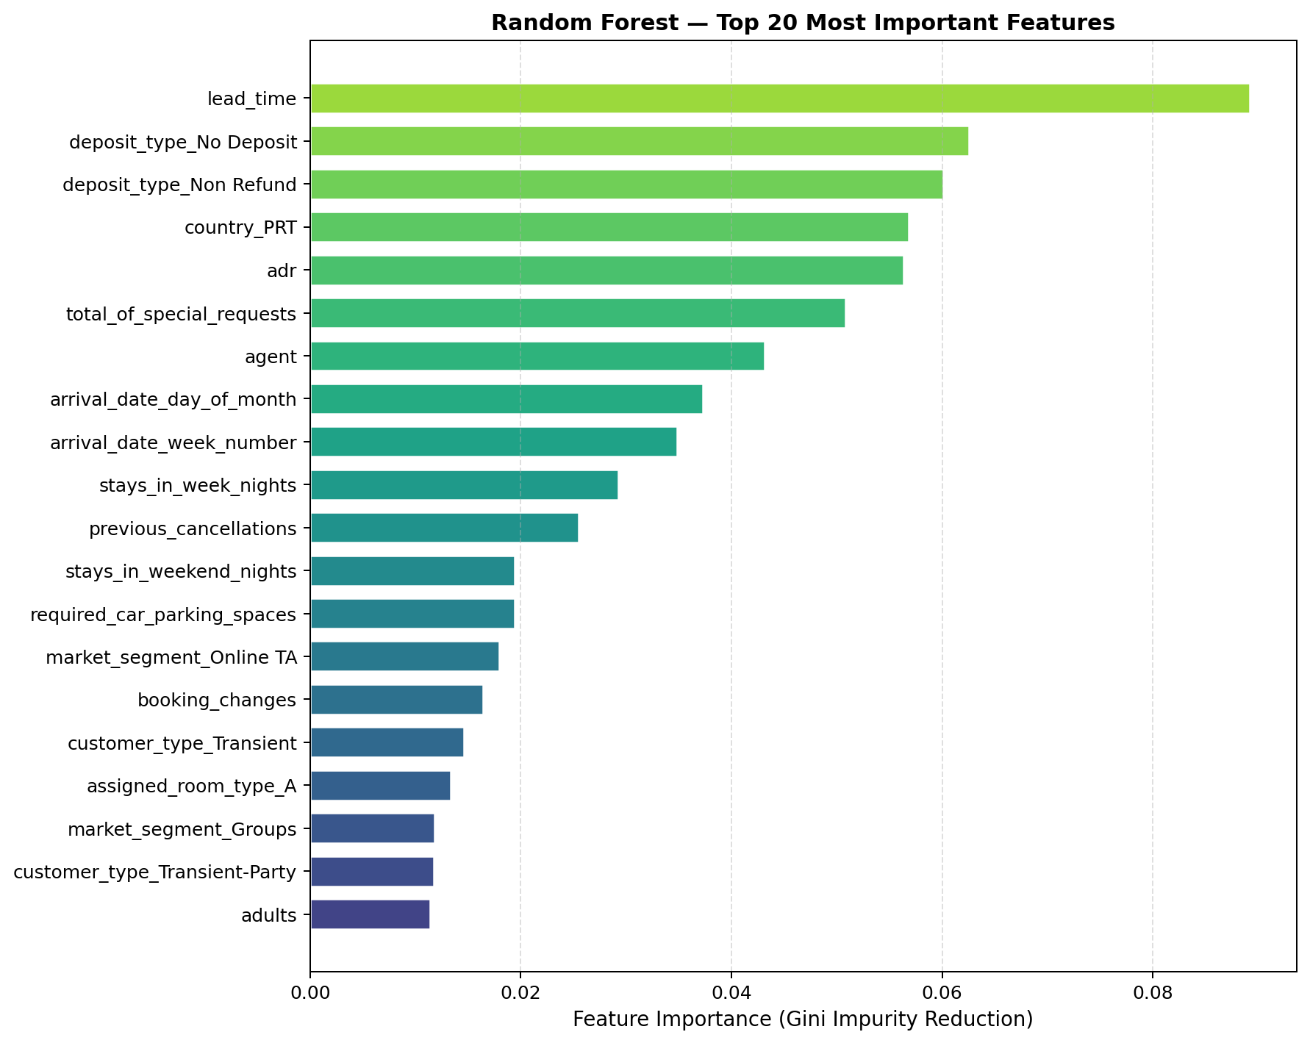
Figure 5: Top 20 Random Forest feature importances (Gini impurity reduction).

7. Lab Defense Guide — Key Questions & Answers
Q1: Why were reservation_status and reservation_status_date dropped?
These columns constitute direct target leakage. reservation_status contains the string "Canceled" which directly encodes y=1, and reservation_status_date records when the booking status changed (i.e., it does not exist until after the cancellation decision is made). Including them would inflate all metrics to near-perfect scores but produce a model useless in production.

Q2: What is the mathematical basis of Logistic Regression?
The logit (log-odds) function: ln(p / (1-p)) = β₀ + β₁X₁ + … + βₖXₖ. The predicted probability is obtained via the sigmoid: p = 1 / (1 + e^(−wᵀX)). Coefficients are estimated by Maximum Likelihood Estimation (MLE). The Odds Ratio for predictor Xⱼ is OR = e^βⱼ.

Q3: What is the difference between Precision and Recall? Which matters more here?
Precision = TP / (TP + FP): of all predicted cancellations, how many were actual cancellations. Recall (Sensitivity) = TP / (TP + FN): of all actual cancellations, how many did we catch. In a hotel context, missing a cancellation (FN) is costly — revenue loss from an empty room. Hence Recall/Sensitivity is the priority metric. The F1-Score balances both.

Q4: Why does Random Forest outperform Logistic Regression?
Logistic Regression assumes linear decision boundaries in log-odds space and additive feature relationships. Random Forest uses 200 decorrelated decision trees that naturally capture non-linear feature splits and high-order interaction effects (e.g., combined interactions between lead_time, market_segment, and adr) without any manual feature engineering. This leads to gains across all metrics (Accuracy +5.5%, AUC +0.051).

Q5: What is ROC-AUC and how is it interpreted?
AUC (Area Under the ROC Curve) measures the probability that the model ranks a randomly chosen positive (canceled) example higher than a randomly chosen negative example. AUC = 0.50 → random classifier. AUC = 1.00 → perfect. Our LR model (AUC = 0.894) exceeds the paper's reported value of 0.866, while our RF (0.945) provides even stronger discriminatory power.

Q6: Why was stratify=y used in the train/test split?
stratify=y ensures that the proportion of canceled vs non-canceled bookings (≈37% : 63%) is preserved in both the training and test subsets. Without stratification, random splits can produce imbalanced evaluation sets that distort metrics, especially for minority class recall.

Q7: What is the role of StandardScaler in the Logistic Regression pipeline?
StandardScaler transforms each continuous feature to zero mean (μ=0) and unit variance (σ=1): z = (x − μ) / σ. This is required for Logistic Regression because (a) gradient descent converges faster with scaled features, and (b) standardised coefficients are directly comparable in magnitude — enabling valid odds ratio comparisons as in the paper.

8. Conclusion
This lab successfully identified a post-2020 research paper (Dr. Vinay Raj R, 2026) that used the exact hotel_bookings_updated_2024.csv dataset. The paper's Binary Logistic Regression model was reproduced and benchmarked under Scenario A.

Our Logistic Regression model achieved performance highly consistent with the published paper — Accuracy within 0.03 %, F1-Score within 0.7 % — confirming successful methodology reproduction. Our extended Random Forest model demonstrated the performance ceiling achievable through ensemble non-linear modelling: +5.5 % Accuracy, +8.8 % F1-Score, and AUC = 0.945 vs the paper's 0.866.

Key findings from both models align with the literature: lead time, non-refundable deposits, and previous cancellations are the strongest risk factors, while special requests, repeated guest status, and booking changes reduce cancellation probability.

9. References
[1] Vinay Raj R (2026). Determinants of Hotel Booking Cancellations: Evidence from Reservation Analytics. International Journal for Research in Tourism and Hospitality, Vol. 01, Issue 02, pp. 32–49. DOI: 10.53555/th.v1i2.2575
[2] Bedmutha, K. S. (2025). Hotel booking reservation: An updated 2024 dataset for hotel booking demand and cancellation analysis. Kaggle. https://www.kaggle.com/datasets/krutarth-bedmutha/hotel-booking-reservation
[3] Pedregosa, F. et al. (2011). Scikit-learn: Machine Learning in Python. JMLR 12, 2825–2830.
[4] Chen, T. & Guestrin, C. (2016). XGBoost: A Scalable Tree Boosting System. KDD 2016.

