[12/1/2016 6:39:03 PM] Client: Look at the tabs though

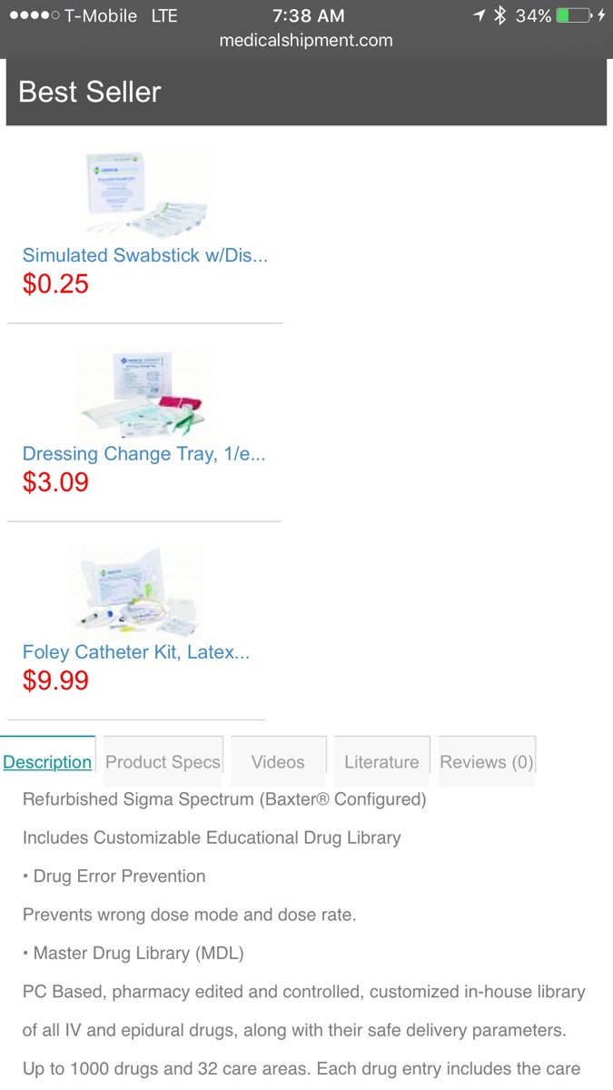

[12/1/2016 6:39:31 PM] Client: The add to cart buttons are fixed 👍

[12/1/2016 6:39:38 PM] Client: Thanks!

[12/1/2016 6:41:07 PM] Client: The space between the tabs

[12/1/2016 6:41:27 PM] Client: Looks on the desktop and it's perfect

[12/1/2016 6:41:37 PM] Client: That's the screenshot for mobile

[12/1/2016 6:41:41 PM] Mansoor Mahmood: ok

[12/1/2016 6:41:45 PM] Client: 👍

[12/1/2016 6:41:46 PM] Mansoor Mahmood: let me ask my dev to check this

[1:57:34 AM] Client: Admin is not uploading images properly

[1:57:46 AM] Client: When I add an image to the admin, it doesn't show on the site

[1:57:56 AM] Client: I even reduced the image quality significantly

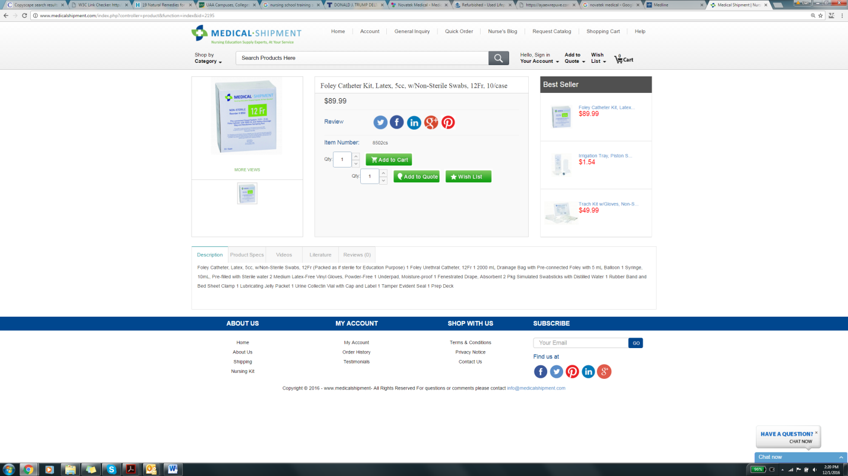

[2:12:28 AM] Client: Guys, Please fix this for tomorrow

[2:12:34 AM] Client: We need the correct images on the site