Jarvis Handbook
Version 1.0. Product, installation, user, administration and technical documentation.

1. Product overview

What Jarvis is
Jarvis is a voice and text assistant for a Windows computer. You talk to it (or type) in English or Hindi, and it does the work: it answers questions, opens websites and programs, sets timers, keeps tasks and notes, writes and sends email, makes Word, Excel and PowerPoint files, builds full documents with pictures, and answers questions from your own files.
It runs on your own computer. Your documents, contacts, notes and tasks stay in a folder on that computer. It works without any API key or subscription. An optional Claude API key makes its written answers fuller, but nothing depends on it.
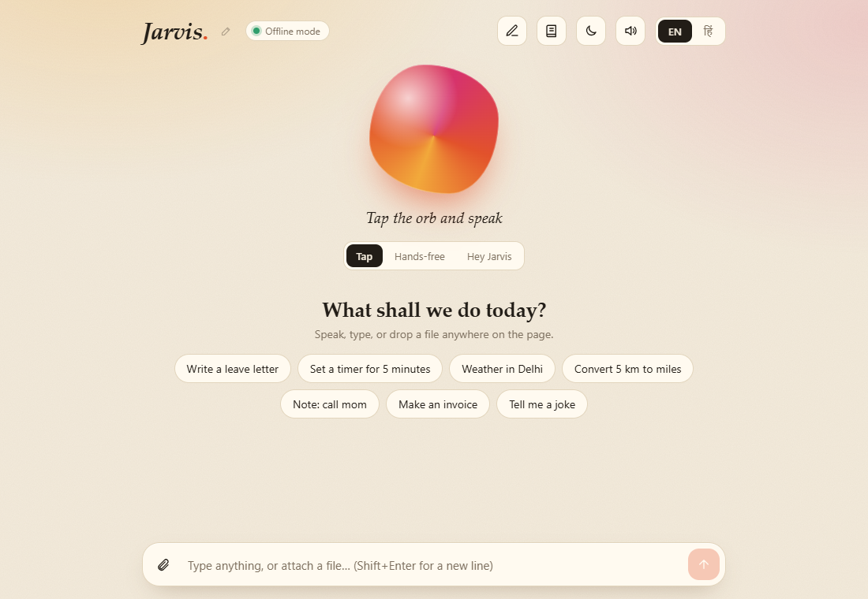
Jarvis home screen

Who it is for
- Offices and small businesses that want a private assistant for documents, email and reminders without sending files to a cloud service.
- Hindi and English speakers who want one assistant for both languages.
- Schools, colleges and training centres that want a voice-assistant project to teach with, with source code they can read and extend.
- Developers who want a working base for their own assistant (FastAPI backend, Next.js front end, documented API).

What you get
Area | What it does
Voice and text | Tap to talk, hands-free listening, or a wake word ("Hey Jarvis"). You can interrupt it while it speaks. Everything also works by typing.
Two languages | English and Hindi for commands, replies and speech.
Your own assistant name | Say "call yourself Friday" and the wake word, title and replies change.
Everyday help | Time, date, maths, unit and currency conversion, weather, jokes, coin and dice.
Organiser | Timers and reminders, to-do tasks, notes. Saved on your computer.
Open and search | Websites, Notepad, Calculator, Chrome, Command Prompt, Google, YouTube and image search.
Music | Plays songs from your own music folder (it asks for the folder once, then remembers). Or plays the first matching YouTube video.
Email by talking | "Send an email to Ravi": Jarvis asks for CC, BCC, subject and message, shows an editable draft, and sends only after you confirm. It keeps an address book of everyone you mention.
Documents from forms | Leave letter, resignation letter, invoice, budget, meeting minutes, checklist, resume, or your own text as Word, Excel, PowerPoint, CSV, text, Markdown or HTML.
Document studio | Write whole documents with headings, bold and italic, lists, tables, pictures with captions, quotes and page breaks. Save as Word or PDF.
Your files | Attach a PDF, Word, Excel, PowerPoint or text file: summarise it, list key words, count words, find a word, read it aloud, or convert it.
Chat with your documents | Point it at a folder or upload files. It indexes them on your computer (ChromaDB) and answers questions with the source file shown.
Safety | Shutdown and sending email always ask for a yes first.

The full list of what you can say, with the real replies, is in the command reference.

Two ways to run it
 | Offline mode (default) | With a Claude API key (optional)
Cost | No running cost | You pay Anthropic for what you use
Questions it does not know | Wikipedia, then Google | Written answers from Claude
Chat with your documents | Quotes the best sentences from your files, with sources | Writes a proper answer from the same passages, with citations
Writing new content | Not available (templates and your own text only) | Available
Attached images and scanned PDFs | Cannot read them | Can read them

Everything else is identical in both modes.

System requirements
 | Requirement
Operating system | Windows 10 or 11. Developed and tested on Windows 11. Opening programs and starting songs use Windows features; other systems are not tested.
Browser | Google Chrome or Microsoft Edge (needed for voice)
Python | Tested with 3.14. Other versions are not tested.
Node.js | Tested with 24. Other versions are not tested.
Memory and disk | Not measured. Plan for about 8 GB of memory and 3 GB of free disk (the document-search model alone is about 170 MB).
Internet | Not needed for most features. Needed for weather, currency, Wikipedia, YouTube, Gmail, and the first download of the document-search model.
Microphone | Needed only for voice

What Jarvis does not do
Being clear about this up front avoids disappointment:
- It does not write new content by itself (essays, long answers) unless you add a Claude API key. Without one it fills templates and arranges the text you give it.
- It cannot read scanned PDFs or photos without the optional Claude key.
- It cannot control any installed program. It opens a fixed list (Notepad, Calculator, Chrome, Command Prompt) and websites.
- It cannot stop or pause a song once your music player has started it.
- PDF files made in the Document studio cannot contain Hindi text (Word files can).
- It is built for one person on one computer. It has no user accounts or login.
- Voice recognition uses the browser. In Chrome this is done by Google's speech service, so spoken words leave the computer (see Security and privacy).
More detail is in Roadmap, limits and release notes.

How well it works
193 command checks across 18 areas passed, and 83 automated tests pass. See Test results for every line. Voice input and speech output need a real microphone and speakers, so those parts are not covered by the automated checks.

2. Installation guide
This guide installs Jarvis on one Windows computer. It takes about 15 minutes, most of it downloading.

Before you start
Install these once:
1. Python from python.org. During setup tick "Add python.exe to PATH". Check: open Command Prompt and run python --version.
2. Node.js (LTS) from nodejs.org. Check: node --version and npm --version.
3. Google Chrome or Microsoft Edge.
Copy the Jarvis folder to the computer (for example D:\JARVIS). Do not put it in a folder that needs administrator rights.

Quick start (recommended)
Double-click start.bat.
The first time it:
1. creates a Python environment in backend\.venv and installs the backend packages,
2. installs the front-end packages (npm install),
3. builds the front end (npm run build),
4. starts the backend (port 8000) and the front end (port 3000),
5. opens http://127.0.0.1:3000 in your browser.
The first start takes several minutes. Later starts take a few seconds. Two black windows stay open, Jarvis backend and Jarvis frontend. Close both to stop Jarvis.

Manual start
Open two Command Prompt windows.
Backend:
cd backend
python -m venv .venv
.venv\Scripts\pip install -r requirements.txt
.venv\Scripts\python -m uvicorn main:app --host 127.0.0.1 --port 8000
Front end (development mode):
cd frontend
npm install
npm run dev
Front end (production mode, what start.bat uses):
cd frontend
npm run build
npm start
Do not run npm run build while npm run dev is running. They share the .next folder and the running page breaks. If that happens, stop the dev server, delete frontend\.next, and start again.

First run checklist
1. Open http://127.0.0.1:3000 in Chrome or Edge. Use 127.0.0.1, not localhost.
2. The header shows Offline mode next to the name. That is normal: no API key is set.
3. Type what is the time and press Enter. You should get the time.
4. To use the microphone, tap the orb. Chrome asks for permission once: choose Allow. If you blocked it by mistake, click the padlock in the address bar and allow the microphone for 127.0.0.1.
5. The first time you use Chat with my documents, a search model of about 80 MB is downloaded once. After that it works without internet.

Optional settings
Copy backend\.env.example to backend\.env and fill in only what you need. Every setting is explained in Configuration and administration. Restart the backend after changing it.

Updating
1. Stop Jarvis (close both black windows).
2. Keep a copy of backend\data (your contacts, notes, tasks, settings and indexed documents) and backend\.env.
3. Replace the program files with the new version, but keep those two.
4. Run start.bat. If the package lists changed, delete backend\.venv and frontend\node_modules first so they are installed again.

Uninstalling
Close Jarvis and delete the Jarvis folder. Nothing is installed anywhere else, except the optional search model cache in C:\Users\<you>\.cache\chroma (about 170 MB), which you can delete too.

Ports
Port | Used by
8000 | Backend (API)
3000 | Front end (the page you open)

Both listen only on 127.0.0.1, so other computers on the network cannot reach them. If a port is busy, the program that uses it must be closed first. To find it: netstat -ano | findstr :8000.

Installation problems
What you see | What to do
python is not recognised | Reinstall Python and tick "Add python.exe to PATH", then open a new Command Prompt.
Unable to copy ... venvlauncher.exe | The backend is still running and locks the environment. Close the Jarvis backend window, then try again.
error while attempting to bind on address ('127.0.0.1', 8000) | Something is already using port 8000, usually an old Jarvis backend. Close it, or find it with `netstat -ano | findstr :8000` and end that process.
Header says Offline (and nothing answers) | The backend window is closed or crashed. Start it again (start.bat).
Blank page or i is not a function | A build ran while the dev server was running. Stop it, delete frontend\.next, start again.
Voice does nothing | Use Chrome or Edge, open http://127.0.0.1:3000, and allow the microphone.

More answers are in the FAQ and troubleshooting.

3. User guide
This guide shows how to use Jarvis day to day. For the complete list of things you can say, see the command reference.

The screen
Jarvis home screen
Part | What it does
Name (top left) with the pencil | The assistant's name. Click the pencil to rename it.
Offline mode label | Shows that no AI key is set. Everything still works. It says the model name when a key is set.
Pen icon | Opens the Document studio.
Book icon | Opens Documents, where you add files or a folder to chat with.
Moon icon | Switches between light and dark. Your choice is remembered.
Speaker icon | Turns Jarvis's spoken replies on or off.
EN / हिं | Switches the language of commands, replies and speech.
The orb | Tap it and speak. It changes while Jarvis listens, thinks and speaks.
Tap / Hands-free / Hey Jarvis | How Jarvis listens (see below).
Text box | Type any command. Enter sends, Shift+Enter starts a new line.
Paperclip | Attach a file. You can also drop a file anywhere on the page.
Suggestion buttons | Ready-made examples on an empty screen. When Jarvis asks a question, short answer buttons appear (for example Yes / No, or numbered choices).

Dark theme:
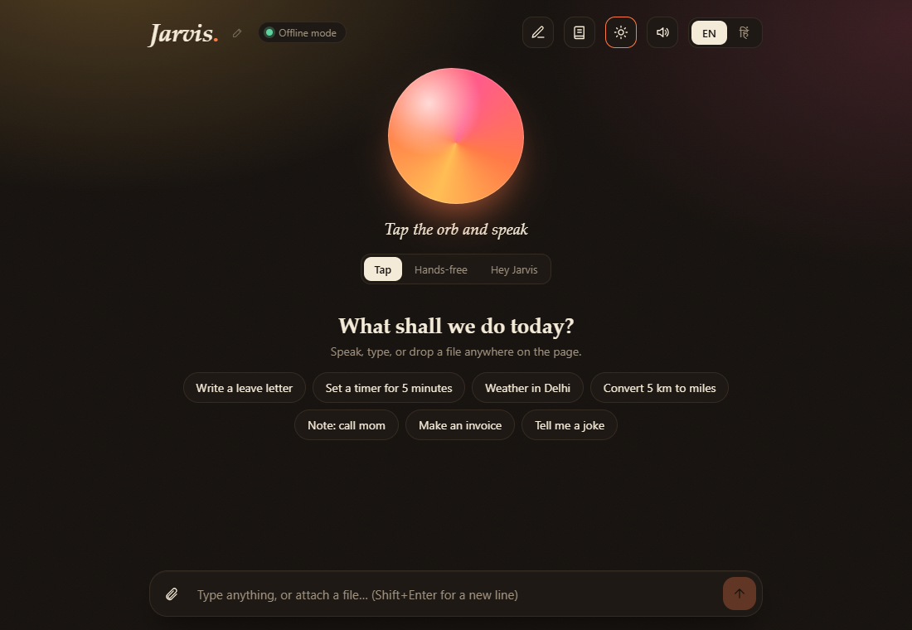
Dark theme

Three ways to talk
Mode | How it works | Best for
Tap | Tap the orb, speak, Jarvis answers. | Occasional use.
Hands-free | Jarvis keeps listening and answers everything it hears. You can talk over it to interrupt. | A quiet room.
Hey Jarvis | Jarvis waits quietly and reacts only when you say its name. | Like the film: "Hey Jarvis, good morning" or "Send an email, Jarvis".

In Hey Jarvis mode, Jarvis stays awake for about 12 seconds after it answers (25 seconds while it waits for a yes or no), so you can reply without saying the name again. Say "bye" or "sleep" to send it back to waiting. Say only "Jarvis" and it answers "Yes? I'm listening."
Your chosen mode is remembered.

Change its name
Click the pencil, or say "call yourself Friday" or "change your name to Nova". Hindi: "अपना नाम फ्राइडे रखो". Names can be up to 20 letters or digits. The wake word, the title and the replies all change.

Everyday help
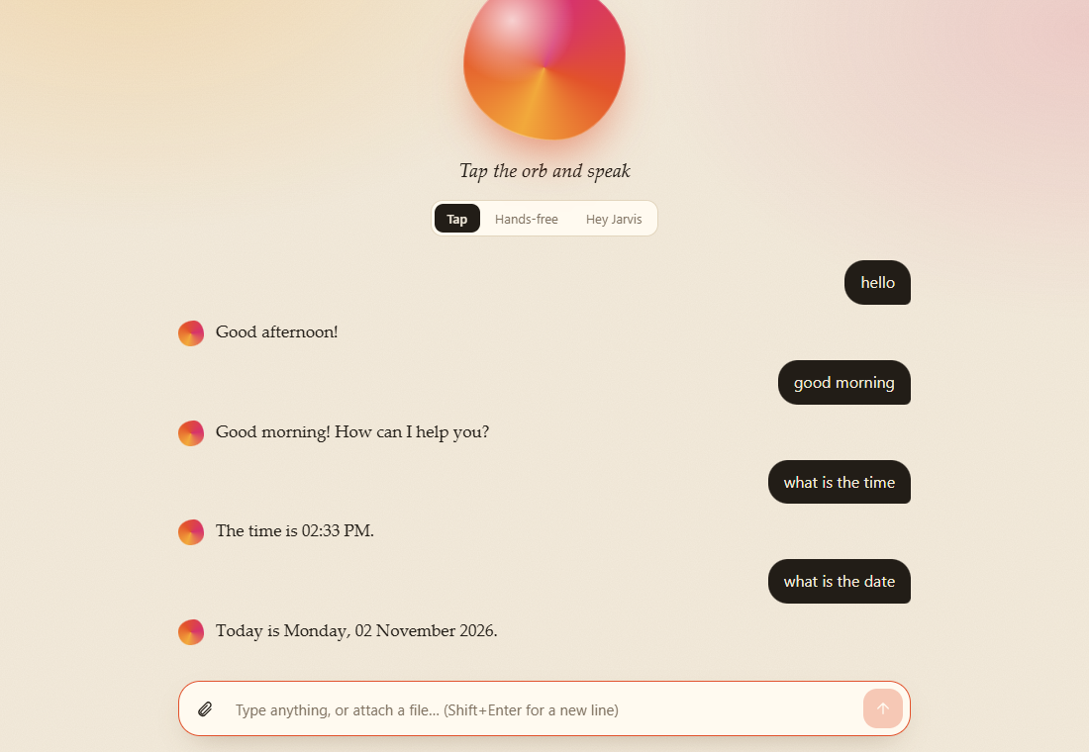
Greetings, time and date
Ask for the time, date, weather in any city, a maths sum, or a conversion ("convert 5 km to miles", "convert 50 usd to inr"). Set timers and reminders ("remind me in 10 minutes to drink water"). Keep tasks and notes ("add task buy milk", "take a note meeting at 5 pm"). They are saved on your computer.

Open things and play music
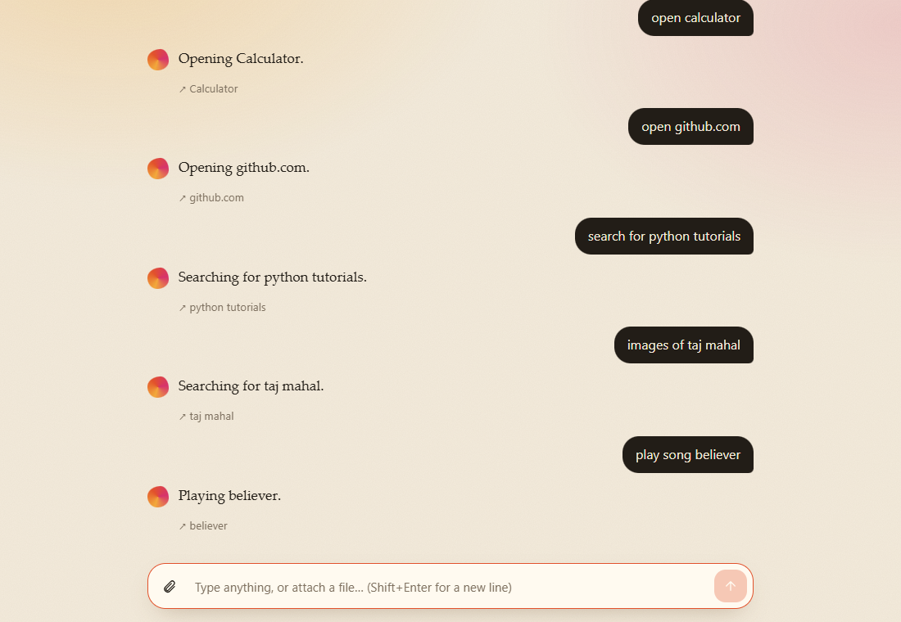
Open, search and play
"Open youtube", "open notepad", "open github.com", "search for python tutorials", "images of taj mahal".
Music from your own folder. Say "play believer". The first time, Jarvis asks "Where are your songs?" Type the folder, for example D:\Music. It saves the folder, finds the song (also inside sub-folders) and starts it in your music player. From then on "play believer" plays straight away. If several songs match, it lists them and you say the number. If the song is not in your folder, it plays the first matching YouTube video instead. Say "skip" at the question to use YouTube always. "Play online believer" always uses YouTube.

Send an email by talking
Say "send an email to Ravi saying the team meeting is moved to Friday", or just "send an email".
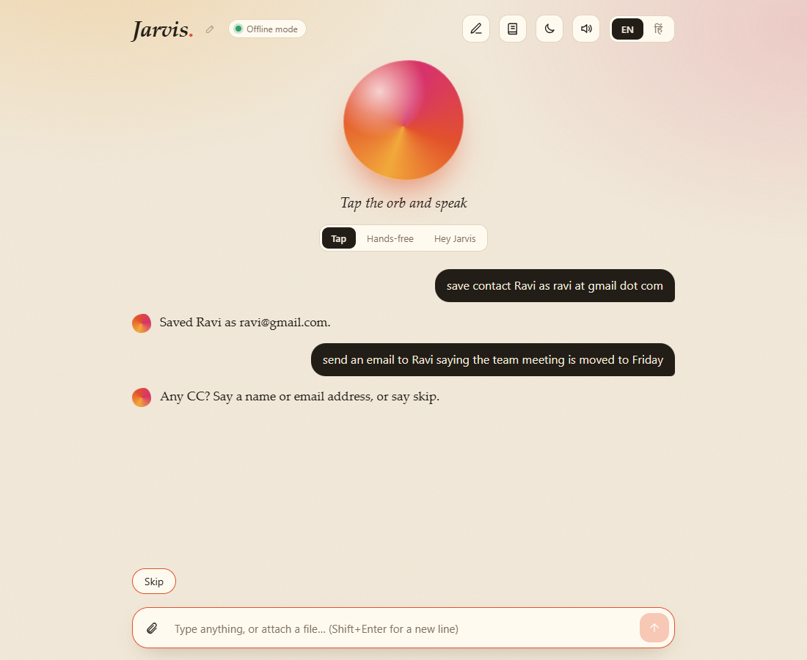
Jarvis asks for CC
Jarvis asks only for what is missing: who it goes to, then CC, BCC, subject and message. Say "skip" for CC, BCC or subject (a skipped subject is written from the first words of your message).
- Say addresses like "ravi at gmail dot com".
- Every address you say is saved to the address book. Next time a name is enough.
- If two saved addresses match a name, Jarvis lists them ("1 ravi@gmail.com, 2 ravi.k@yahoo.com") and you say the number.
- The finished draft appears as a card where every field can be edited, then you confirm.
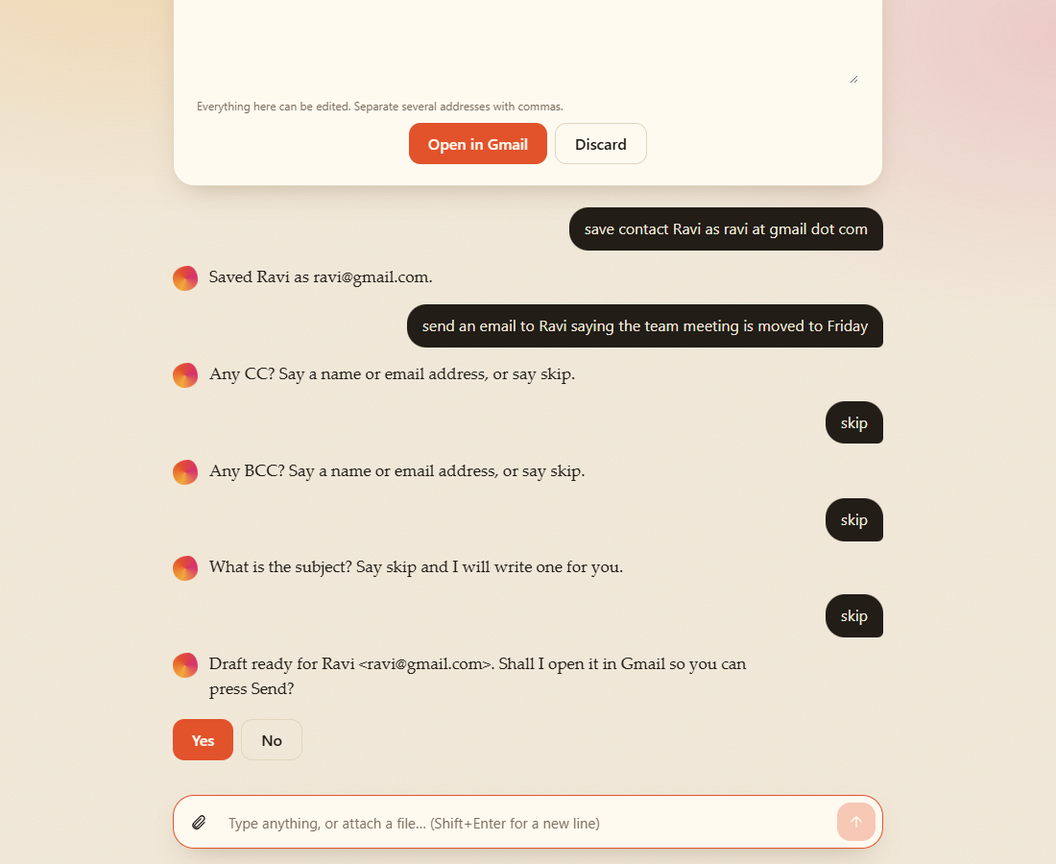
Email draft
Nothing is sent without your yes. If email is not set up (see Configuration), Jarvis opens a ready-filled Gmail draft and you press Send there.

Make documents
Say "make a word document", "write a leave letter", "make an invoice", "make a resume", and so on. A form opens. Fill it in and press Create. A download button appears.
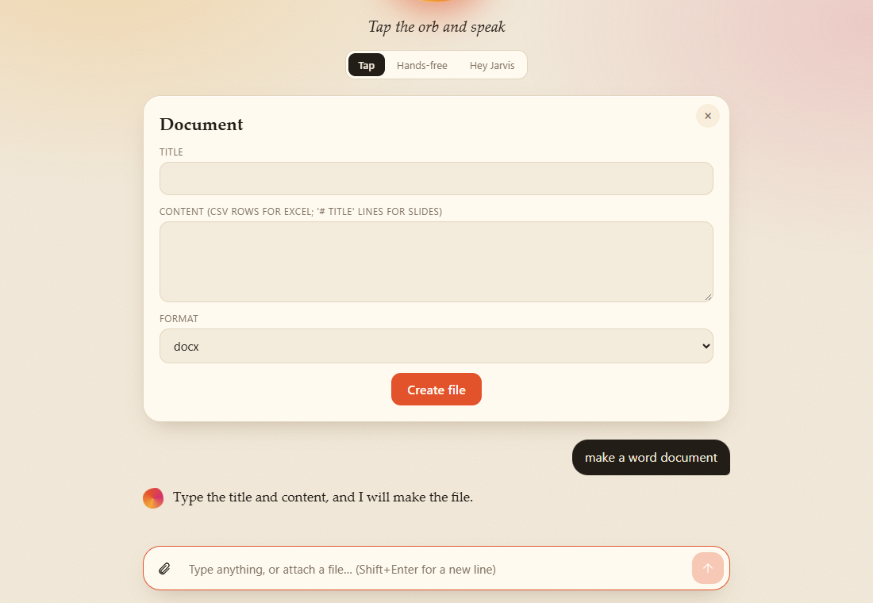
Blank document form
Templates: leave application, resignation letter, invoice (Excel, with totals), budget (Excel), meeting minutes, checklist, resume. Or choose your own text and a format: Word, Excel, PowerPoint, CSV, text, Markdown, HTML.

Document studio: write a whole document with pictures
Click the pen icon, or say "open document studio" or "write a report with images".
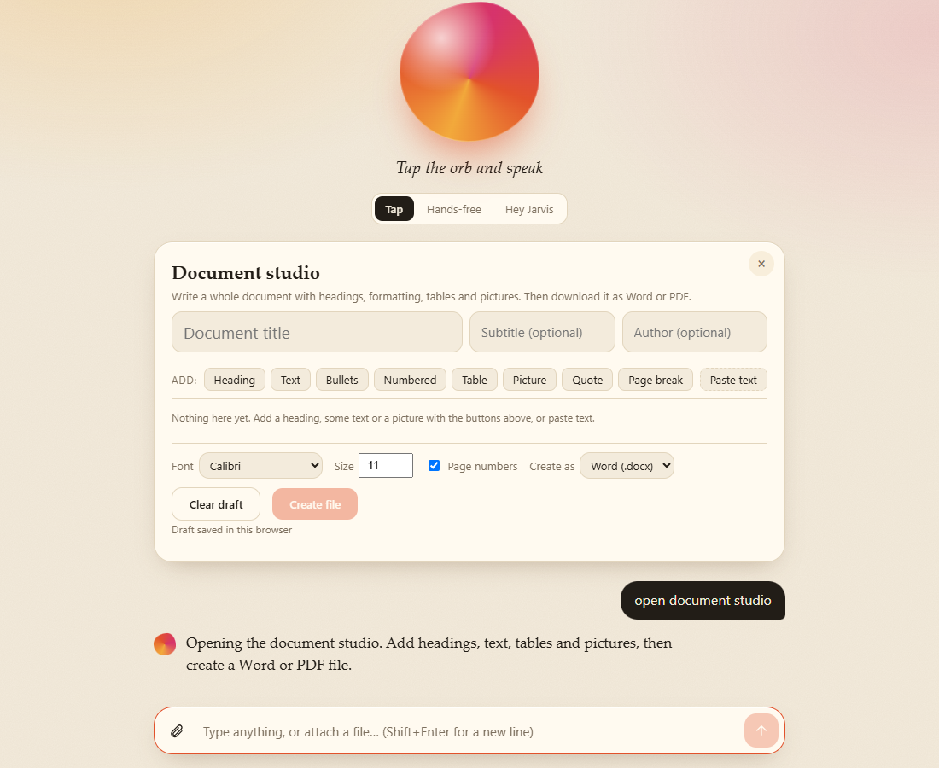
Studio, empty
The fastest way to start is Paste text. Paste your text using these simple marks and press Add to document:
Write | You get
# Title, ## Heading | Headings
bold, italic | Bold, italic
- item | Bullets
1. item | A numbered list
| a | b | on each row | A table
> text | A quote
--- | A page break

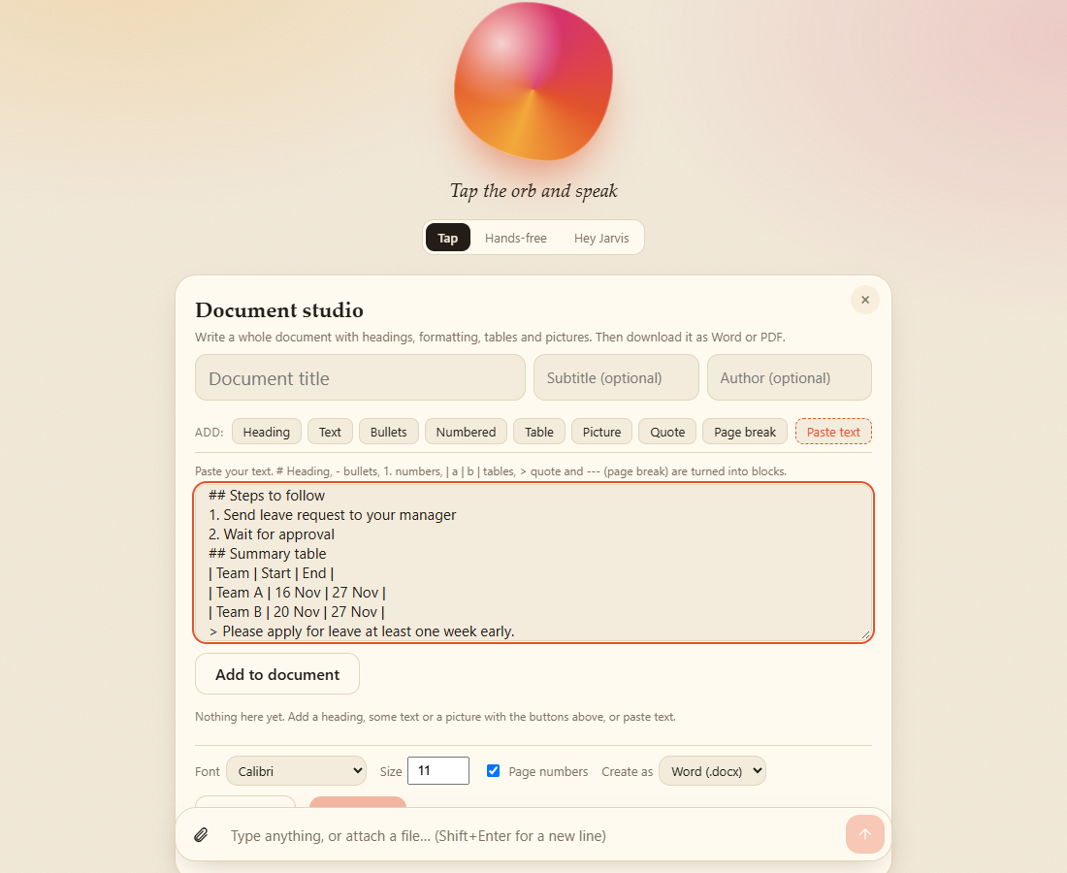
Paste text
Each block can be edited, moved up or down, or deleted. Add Picture blocks with any image file (they are resized automatically, and you set width, alignment and caption).
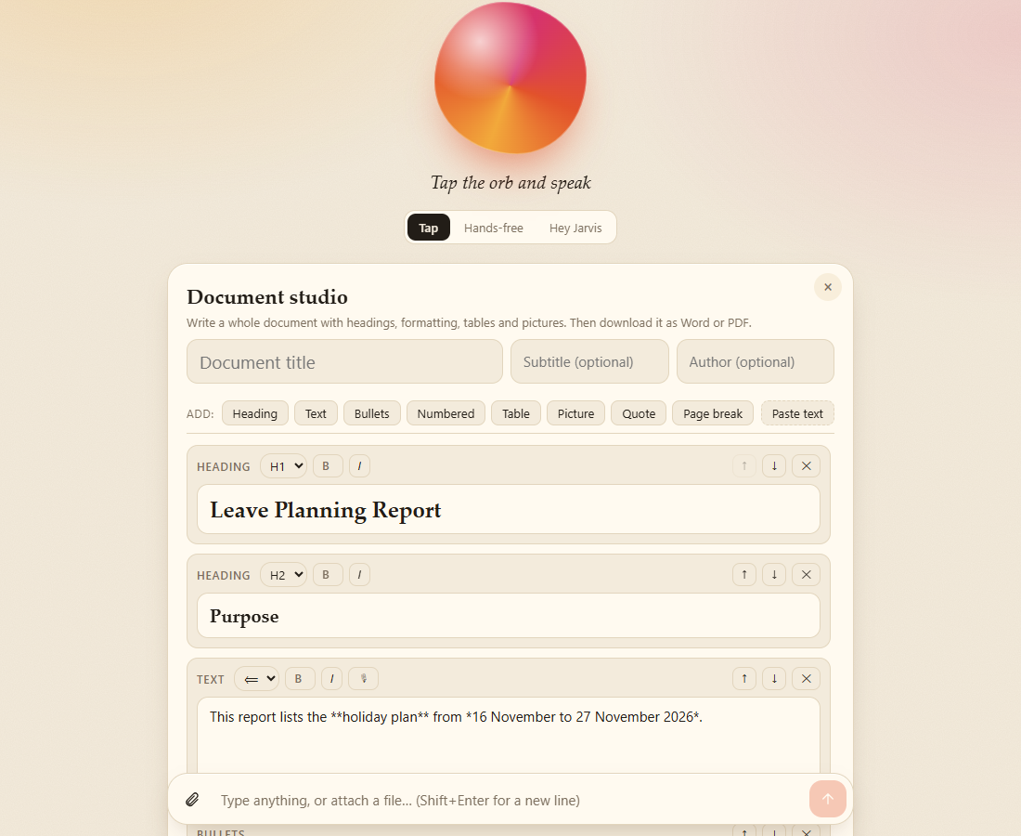
Blocks made from the pasted text
Choose font, size and page numbers, then Create file as Word (.docx) or PDF.
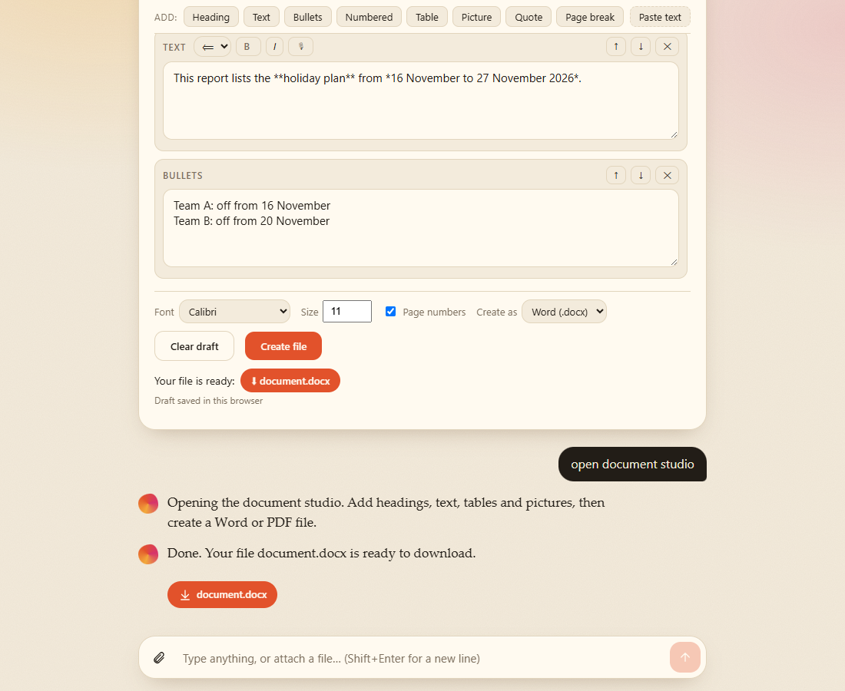
File created
Your draft is saved in the browser, so you can close the panel and come back. Files are also saved in backend\outputs. Hindi works in Word. PDF is English only.

Work on a file you attach
Attach or drop a PDF (with text), Word, Excel, PowerPoint or text file. Then say "summarize it", "key words", "word count", "find budget in the file", "read it", or "convert to Word" (also Excel, CSV, PowerPoint, Markdown, text). The summary picks the most important sentences from the file. It does not rewrite them.

Chat with your documents
Click the book icon. Add files, or type a folder path (for example D:\Company\Policies) and press Index folder. Jarvis reads every PDF, Word, Excel, PowerPoint, text and code file in it, including sub-folders, and stores the searchable index on your computer.
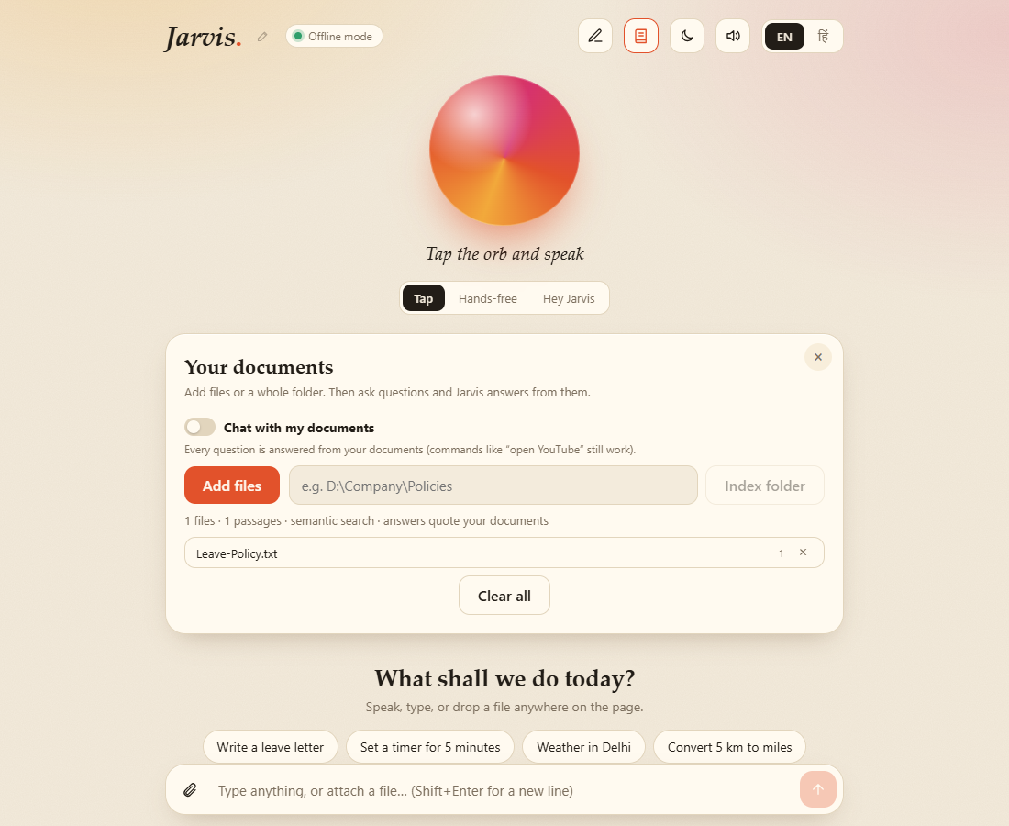
Documents panel
Then say "chat with my documents" and ask anything. Jarvis answers from your files and shows which file each sentence came from.
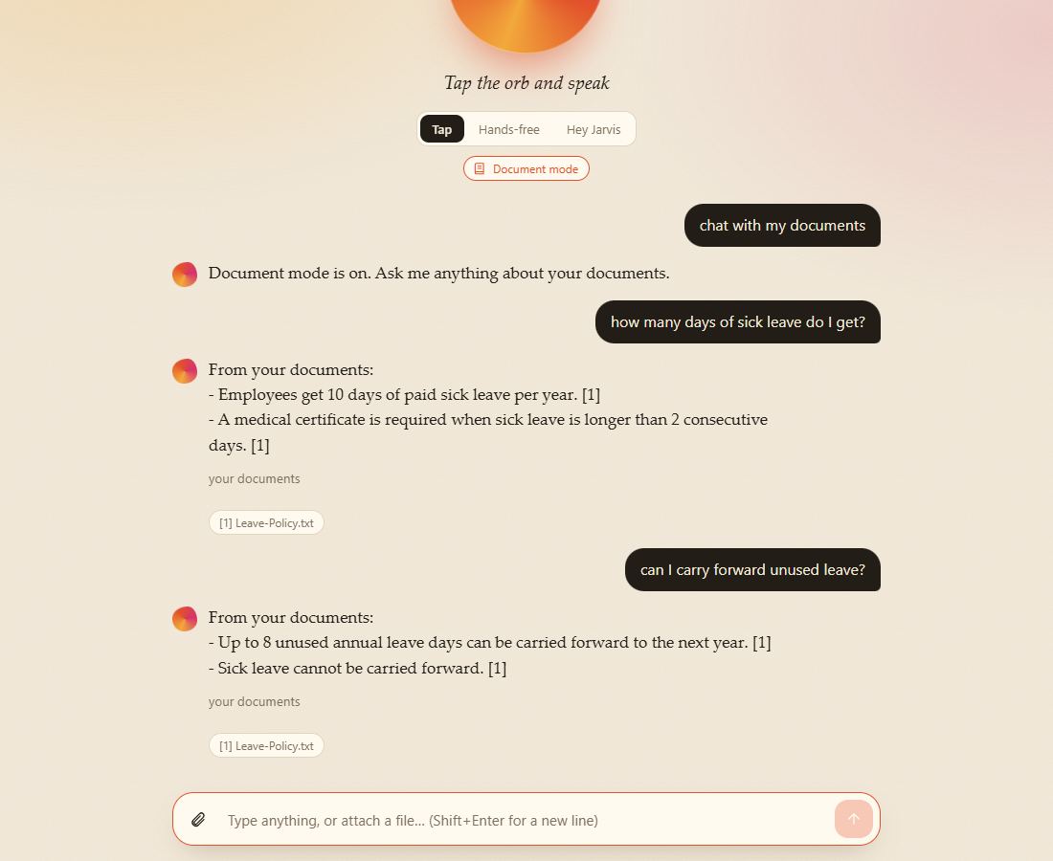
Chatting with documents
- One question without changing mode: "from my documents, what is the notice period".
- Ask about a topic for a short overview: "explain the leave policy".
- Turn it off: "turn off document mode" or "normal mode".
- Normal commands such as "open youtube" and "what is the time" still work in this mode.
Without an AI key the answer is made of the best matching sentences from your files. It is not rewritten. Scanned PDFs and photos contain no text, so they are skipped.

Safety
- "Shut down the computer" asks "Do you really want to shut down?" and does nothing until you say yes. After yes you have 30 seconds to say "cancel shutdown".
- Email is never sent without your confirmation.
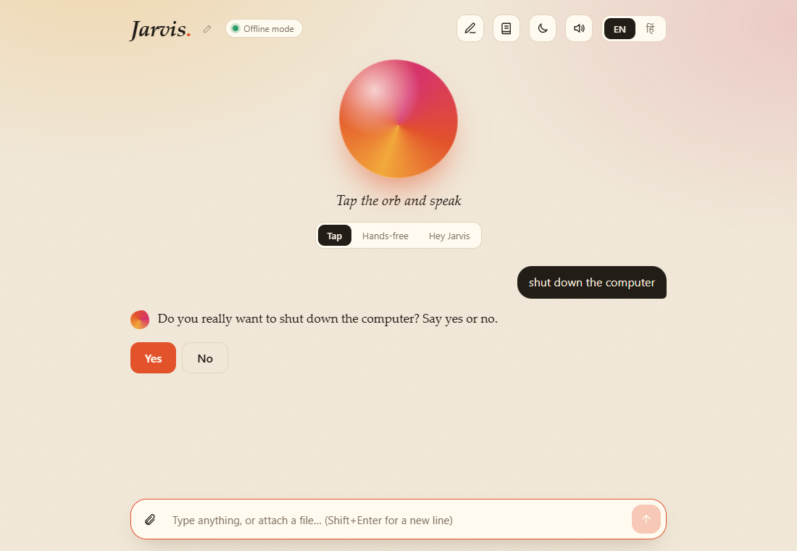
Asks before shutdown

Hindi
Switch to हिं and speak or type Hindi: "नमस्ते", "समय क्या है", "वाराणसी का मौसम", "5 मिनट का टाइमर लगाओ", "यूट्यूब खोलो", "डॉक्यूमेंट स्टूडियो खोलो".
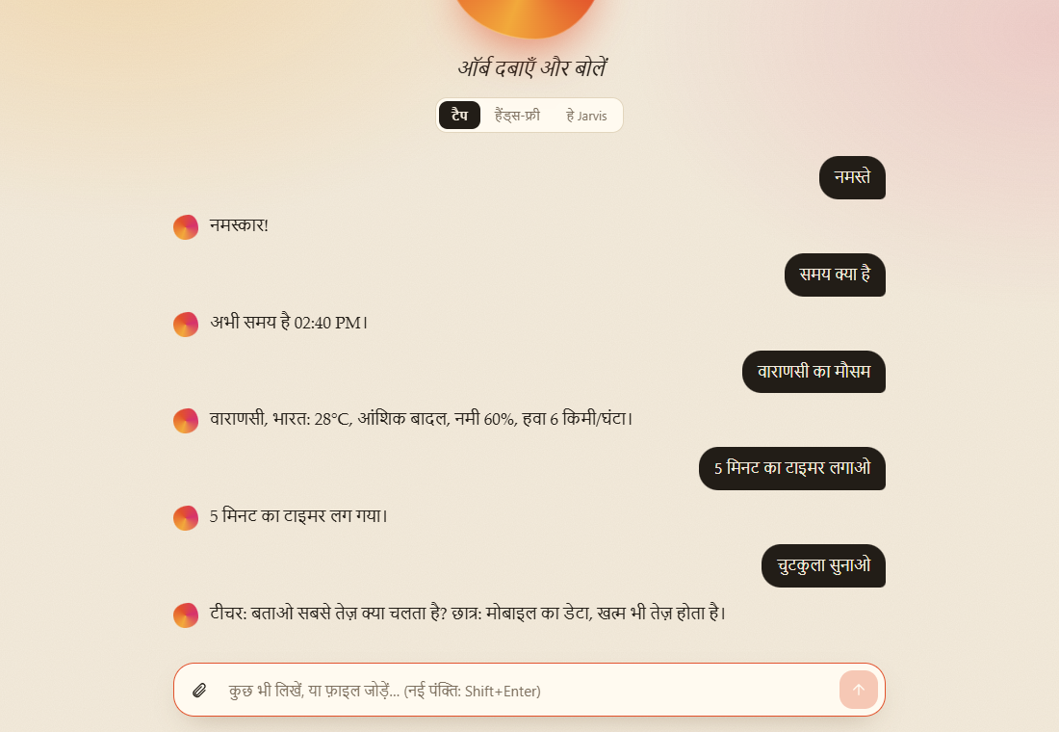
Hindi

On a phone-sized screen
The page adapts to narrow screens.
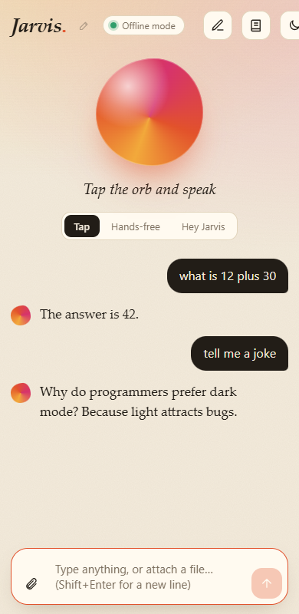
Mobile view

Jarvis: everything you can do
Everything here works without any API key. Jarvis understands English and Hindi. Switch language with the EN / हिं button at the top right.
Every reply listed below was produced by the real backend while writing this guide. The pictures are real screenshots of the running app (in docs/images/).

0. How to talk to Jarvis
Way | How
Type | Write in the box at the bottom and press Enter (Shift+Enter = new line).
Tap mode | Tap the orb, speak, Jarvis answers.
Hands-free | Jarvis keeps listening. You can interrupt it while it is talking.
Hey Jarvis (wake word) | Say "Hey Jarvis, good morning" or "Jarvis, send an email". It wakes up and runs the command.
Rename it | Say "call yourself Friday". After that you say "Hey Friday".
Drop a file | Drag a file onto the page, or use the paperclip.
Header buttons | Pen = Document studio · Book = Documents (chat with your files) · Moon = light/dark · Speaker = voice on/off.

Home, light theme
Home, dark theme

1. Talk and small talk
Say | Jarvis replies
hello / hi / hey | A greeting for the time of day
good morning / good afternoon / good evening / good night | "Good morning! How can I help you?"
how are you | "I am doing great and ready to assist you."
what is your name / who are you | "I am Jarvis, your voice assistant."
bye / goodbye / exit / sleep | "Okay, bye!" and Jarvis goes to sleep

2. Time, date, computer info
Say | Jarvis replies
what is the time | "The time is 02:20 PM."
what is the date | "Today is Monday, 02 November 2026."
what is my IP address | Your IP address
what is my MAC address | Your MAC address

Greetings, time and date

3. Maths and conversions
Say | Jarvis replies
what is 12 plus 30 | "The answer is 42."
25 multiplied by 4 | "The answer is 100."
100 divided by 8 | "The answer is 12.5."
convert 5 km to miles | "5 km = 3.11 miles"
100 c to f | "100 c = 212 f"
10 kg to pounds | "10 kg = 22.05 pounds"
convert 50 usd to inr | Live currency rate (needs internet)

Maths words: plus, minus, times / multiplied by, divided by, power. Units: length, weight, volume, temperature, and 16 currencies.
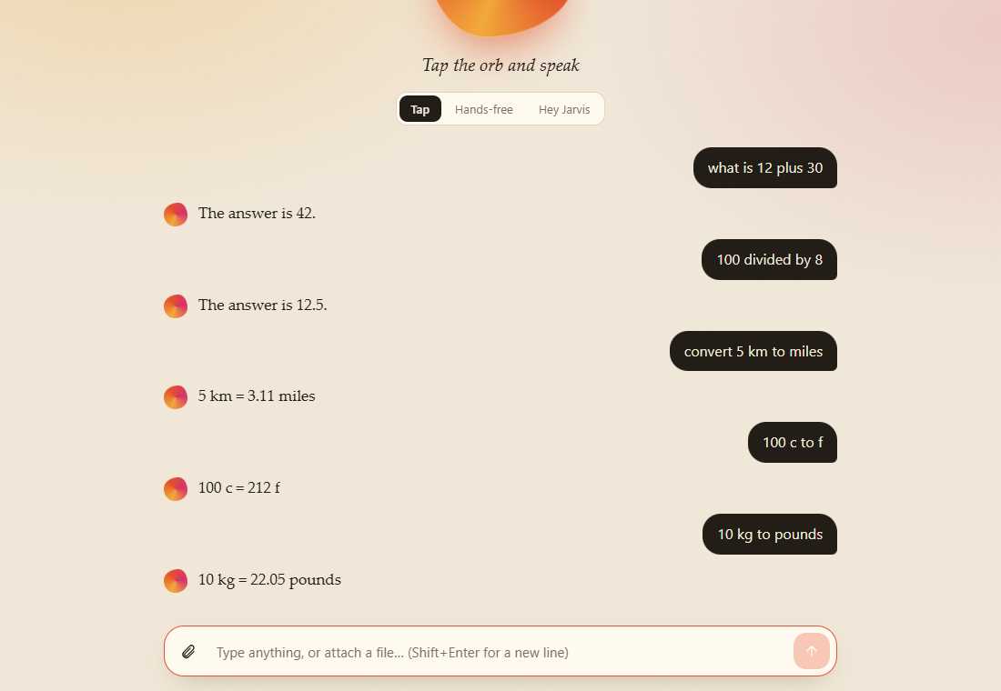
Maths and conversions

4. Weather (needs internet, no key)
Say | Jarvis replies
weather in Varanasi | "Varanasi, India: 28°C, partly cloudy, humidity 60%, wind 6 km/h."
weather | Asks "Which city?"

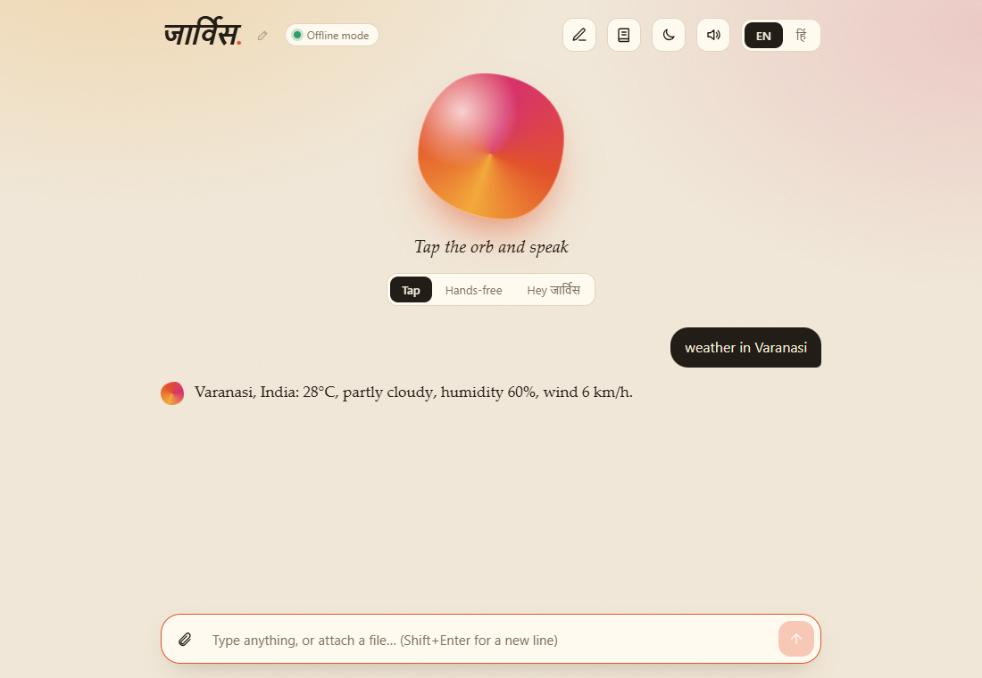
Weather

5. Timers and reminders
Say | Jarvis replies
set a timer for 5 minutes | "Timer set for 5 minutes."
remind me in 10 minutes to drink water | "Okay, I will remind you to drink water in 10 minutes."

When time is up, Jarvis shows and speaks the reminder. (Timers are lost if you reload the page.)
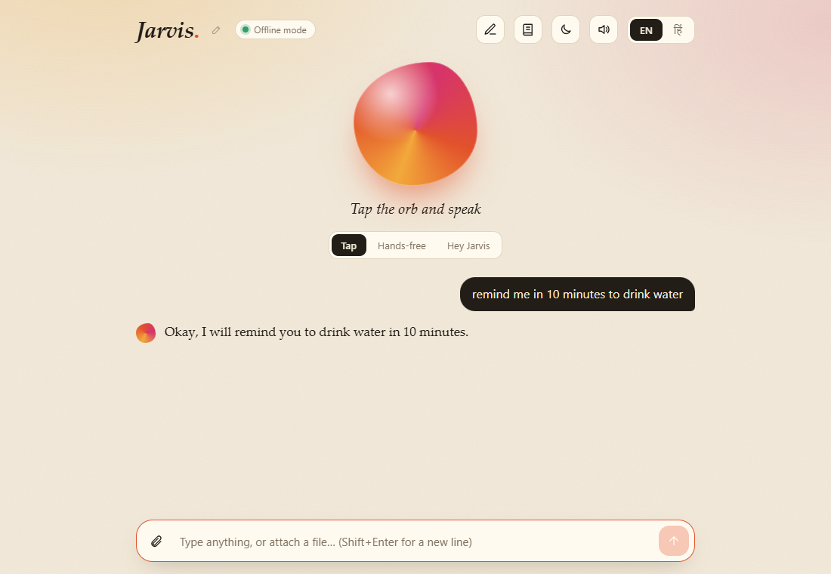
Timer

6. Tasks and notes (saved on your computer)
Say | Jarvis replies
add task buy milk | "Task added. You have 1 task(s)."
show my tasks | "1. [ ] buy milk 2. [ ] call ravi"
done 1 | "Marked done: buy milk"
clear my tasks | "All tasks cleared."
take a note meeting at 5 pm | "Noted. You have 1 note(s)."
show my notes | "1. meeting at 5 pm (02 Nov 14:20)"
clear my notes | "All notes cleared."

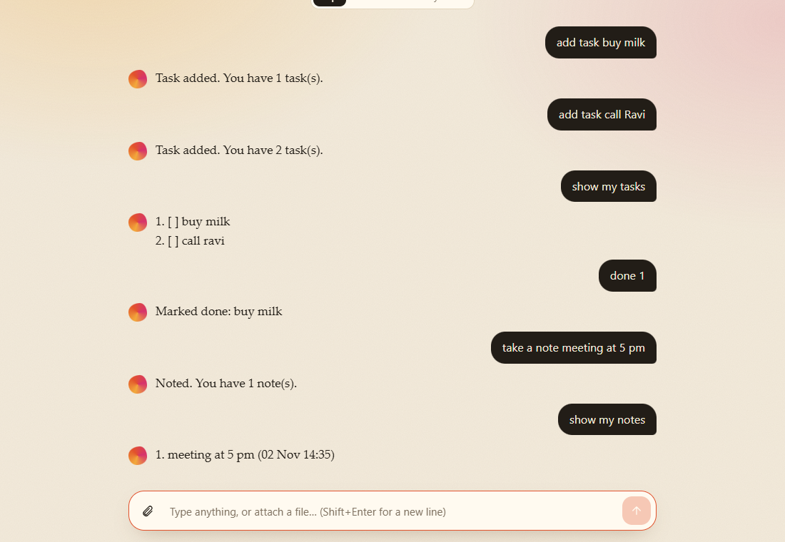
Tasks and notes

7. Fun
Say | Jarvis replies
tell me a joke | A random joke
flip a coin | "Heads." / "Tails."
roll a dice | "You rolled a 6."
random number between 1 and 50 | "Your number is 22."

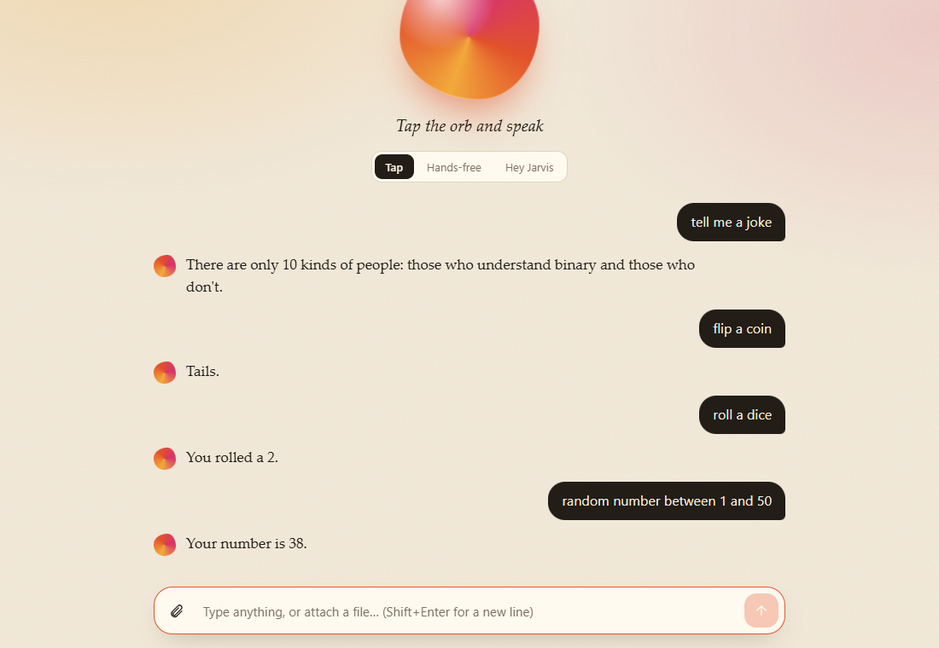
Fun

8. Open websites and apps
Say | What happens
open youtube / google / gmail | Opens the site
open tutorialspoint / geeksforgeeks / javatpoint | Opens the site
open github.com (any name.com, .in, .org ...) | Opens that website
open notepad / calculator / chrome / command prompt | Starts the program
search for python tutorials | Google search
youtube videos of cricket | YouTube search
images of taj mahal | Google Images search
play believer | Plays it from your music folder. The first time, Jarvis asks where your songs are
play online believer | Plays it on YouTube
set music folder to D:\Music | Saves a new music folder (also: "my songs are in D:\Music")
where is my music folder | Tells you the saved folder
use youtube for songs | Always use YouTube instead of a folder

First time you say "play believer": Jarvis asks "Where are your songs?". Type the folder path (for example D:\Music), or say it ("d colon backslash music"). It saves the folder, finds the song in it (also inside sub-folders) and starts it in your default player. Next time it plays straight away. Say "skip" to use YouTube instead. If the song is not in the folder, Jarvis tells you and searches YouTube. If several songs match, it lists them and you say the number.
Open, search, play

9. Charts and drawings
Say | What happens
show pie chart | A pie chart appears in the page
show bar graph | A bar graph appears
make a pattern | A colourful pattern is drawn

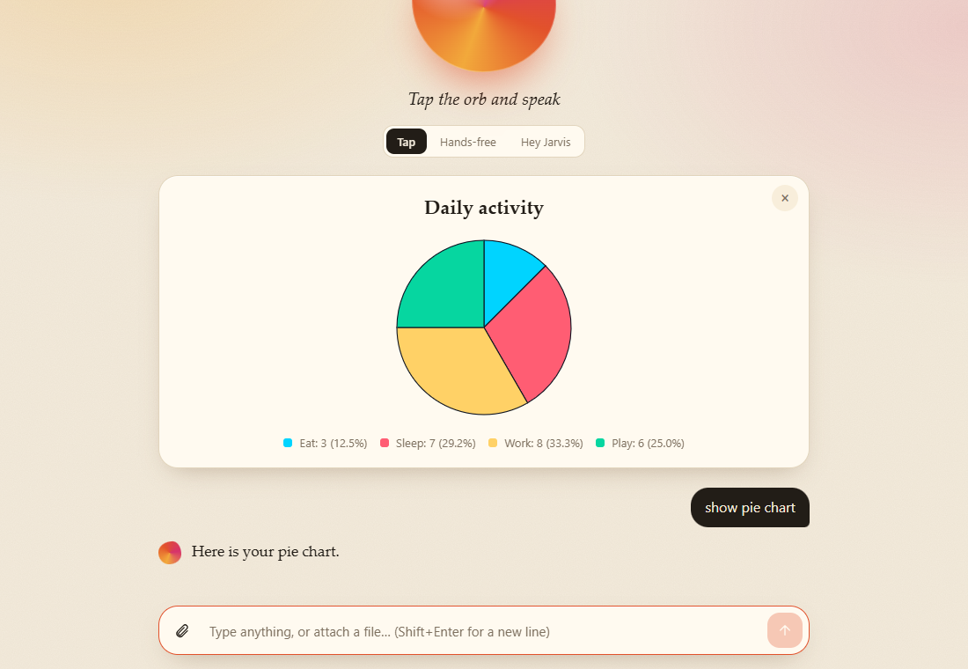
Pie chart
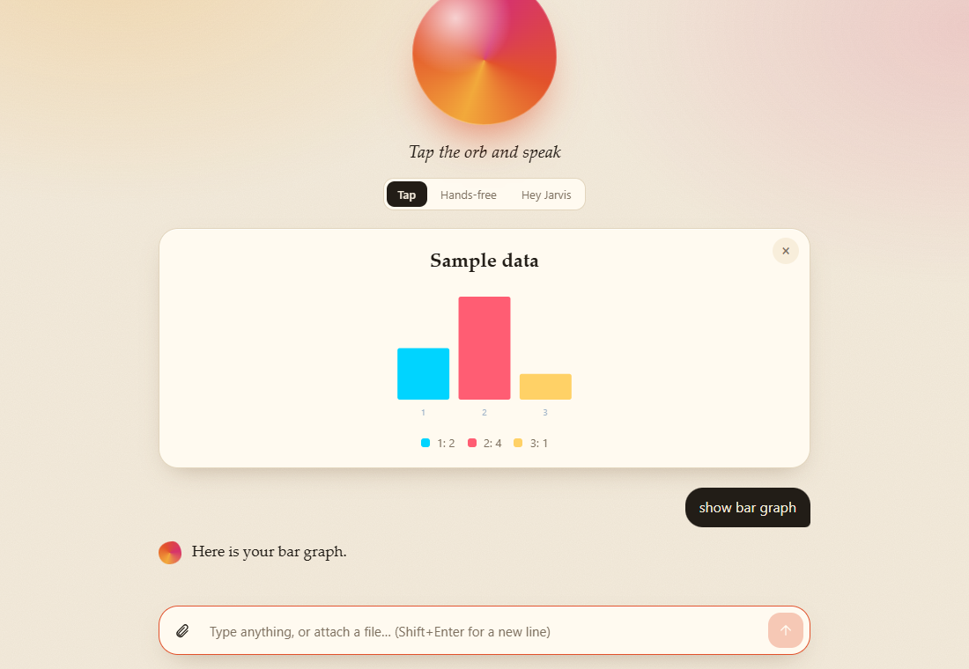
Bar graph
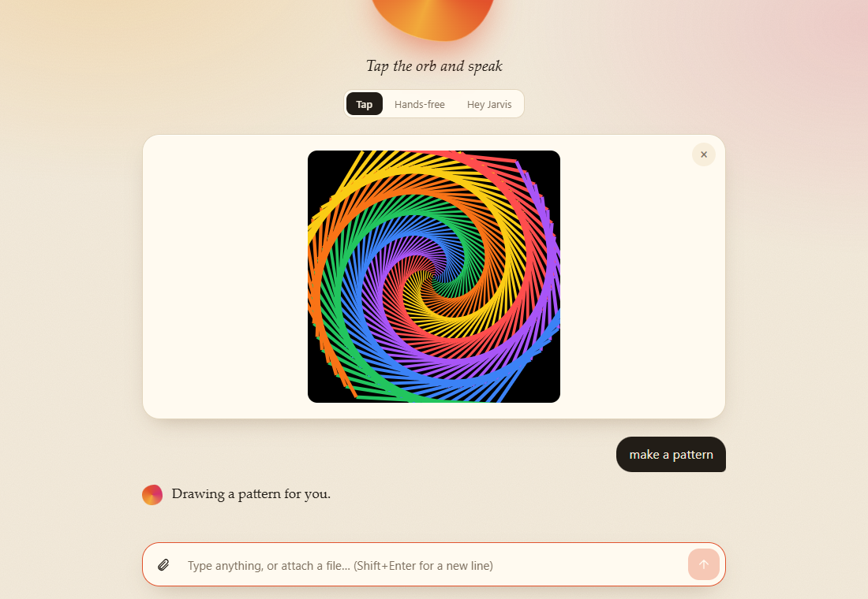
Pattern

10. Camera
Say | What happens
take my photo / click my picture / selfie | Opens the camera panel (the browser asks for permission)

11. Make documents from a form
Say "make / create / write" plus the document. A small form opens, you fill it in, and the file is created and ready to download.
Say | You get
make a word document | Blank document form (Word, text, Markdown, Excel, CSV, PowerPoint, HTML)
make an excel sheet / powerpoint / csv | The same form, with that format chosen
write a leave letter | Leave application (Word)
write a resignation letter | Resignation letter
make an invoice | Invoice (Excel, with totals)
make a budget | Budget (Excel)
make meeting minutes | Meeting minutes
make a checklist | Checklist
make a resume | Resume

Blank document form
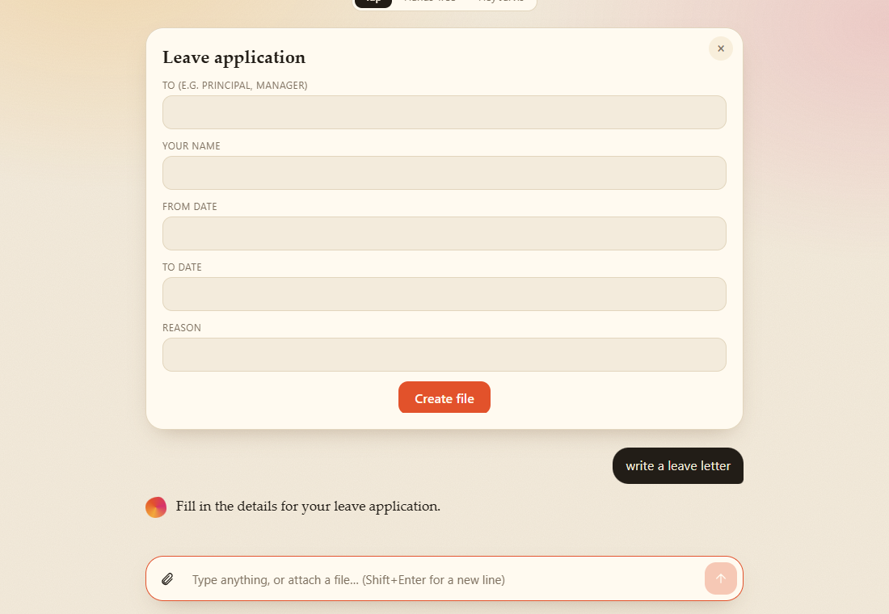
Leave letter form
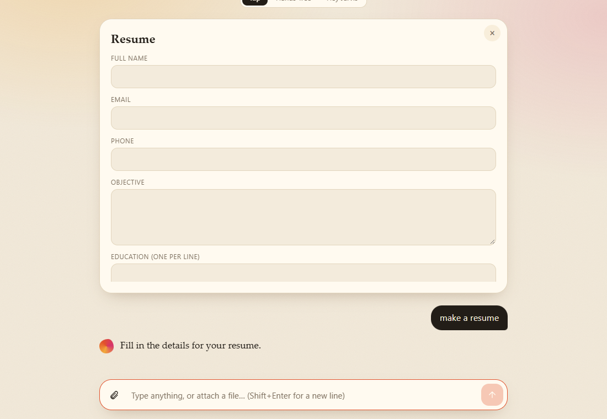
Resume form

12. Document studio (write a whole document with pictures)
Say "open document studio" or "write a report with images", or click the pen icon. Add headings, text (bold / italic), bullets, numbered lists, tables, pictures, quotes and page breaks, then create a Word or PDF file. Use Paste text to build a whole document at once.
Write this in Paste text | It becomes
# Title / ## Heading | Headings
bold / italic | Bold / italic
- item | Bullets
1. item | Numbered list
` | a | b | ` | Table
> text | Quote
--- | Page break

Studio, empty
Paste text
Blocks made from the pasted text
Word file created
Notes: Hindi text works in Word. PDF is English only. Files are saved in backend/outputs/.

13. Work on a file you attach
Attach a PDF (with text), Word, Excel, PowerPoint or text file, then say:
Say | Jarvis does
summarize it | Picks the key sentences
key words | Lists the main words
word count | Words, sentences, reading time
find budget in the file | Shows every place the word appears
read it | Reads it aloud
convert to word / excel / csv / powerpoint / markdown / txt | Makes a new file in that format (a text file cannot become a spreadsheet)

14. Email by talking
Say "send an email to Ravi saying the team meeting is moved to Friday" (or just "send an email"). Jarvis asks only for what is missing, in this order: To → CC → BCC → Subject → Message. (If you already said the message, it skips that question.) Say "skip" for CC, BCC or Subject (it writes the subject for you). Every address you say is saved. If a name has more than one address, Jarvis lists them and you say the number. The draft appears in an editable card. You can change anything, then send it (or open it in Gmail if SMTP is not set up).
Say addresses like: "ravi at gmail dot com" (also "at the rate").
Say | What happens
send an email | Starts the flow
show contacts | Lists saved contacts
save contact Ravi as ravi at gmail dot com | "Saved Ravi as ravi@gmail.com."
cancel / never mind | Stops the email

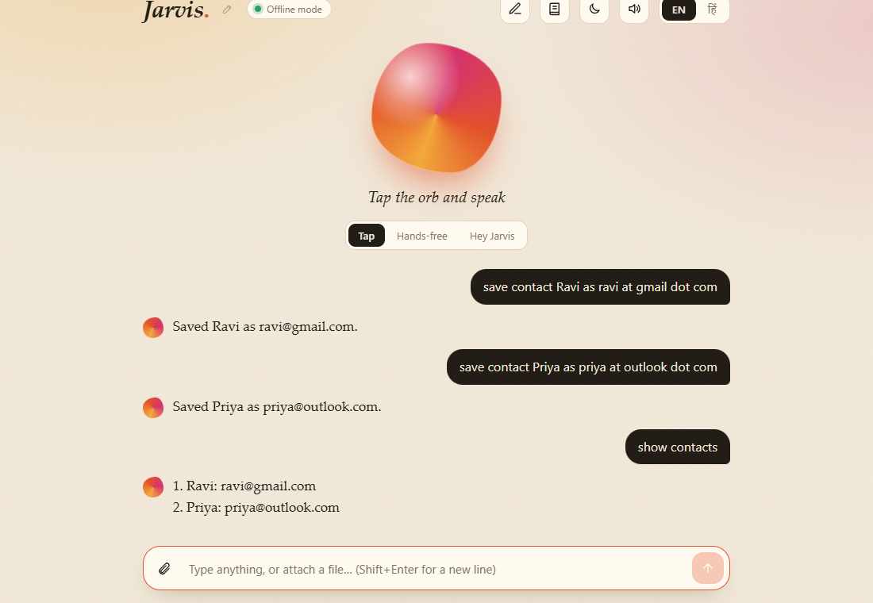
Contacts
Jarvis asks for CC
Email draft

15. Chat with your documents (RAG)
Click the book icon, upload files or give a folder path. Jarvis indexes them on your computer (ChromaDB, no key needed).
Say | What happens
chat with my documents | Document mode ON: every question is answered from your files
how many days of sick leave do I get? | Answer with the sources it used
from my documents, what is the leave policy | One question from your files, without changing mode
explain the leave policy / tell me about the leave policy | A short overview of that topic from your files (say the topic; "summarize my documents" with no topic finds nothing)
turn off document mode / normal mode / stop chat with my documents | Back to normal

Documents panel
Chatting with documents
Without an AI key, answers are taken from your files (extractive) with their sources. They are not rewritten in new words.

16. Change Jarvis's name
Say | What happens
call yourself Friday | "Okay, from now on I am Friday. Say Hey Friday to wake me up."
change your name to Nova | Same
call yourself Jarvis | Back to the default

You can also click the small pencil next to the name.
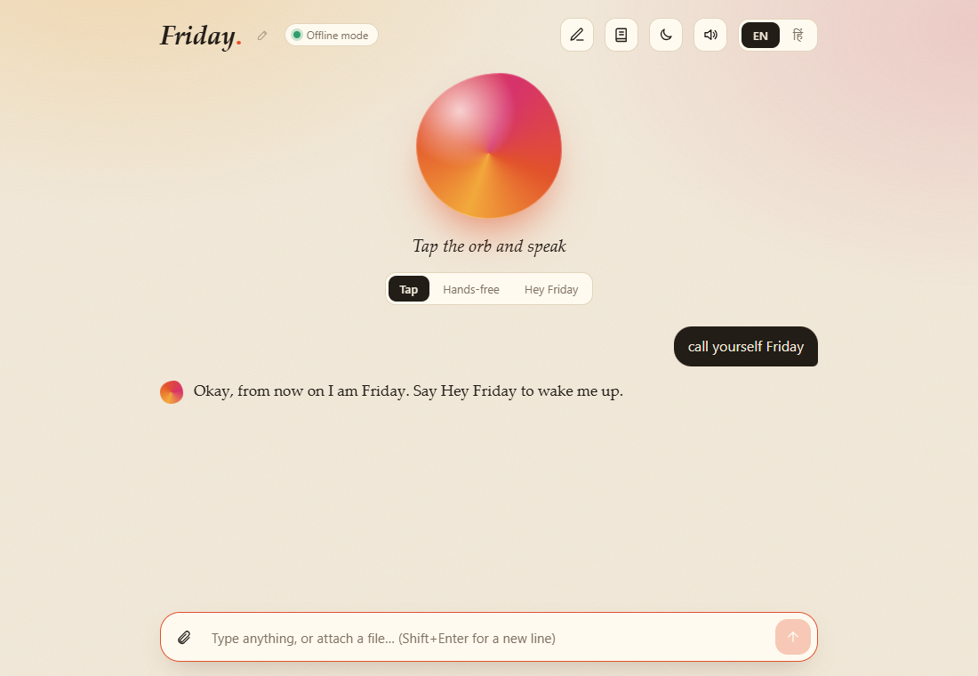
Rename

17. Safety: dangerous actions always ask first
Say | What happens
shut down the computer | "Do you really want to shut down the computer? Say yes or no." Nothing happens until you say yes
cancel shutdown | Stops a shutdown that was started
send the email | Always asks for confirmation before sending

Asks before shutdown
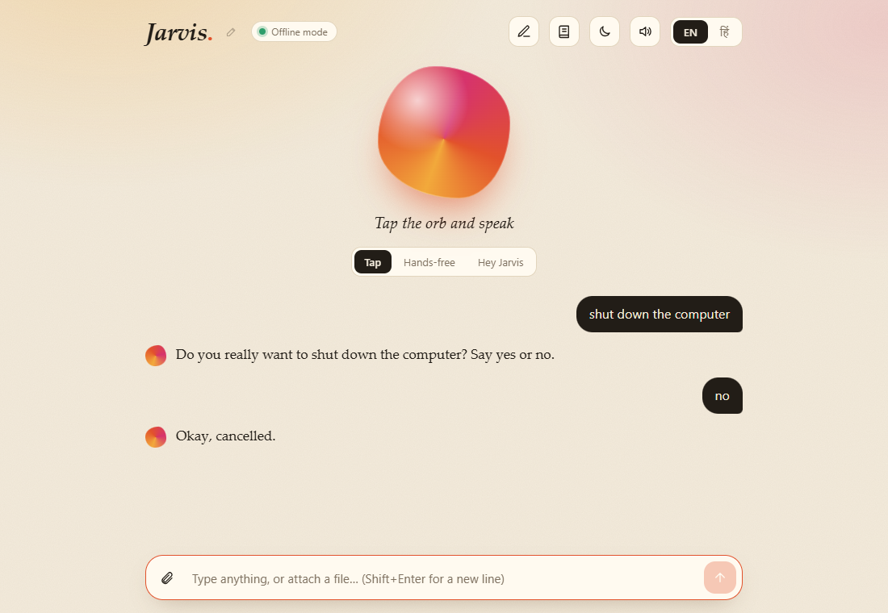
Cancelled

18. Hindi examples
बोलिए | जवाब
नमस्ते | नमस्कार!
समय क्या है | अभी समय है …
वाराणसी का मौसम | वाराणसी, भारत: 28°C, आंशिक बादल …
5 मिनट का टाइमर लगाओ | 5 मिनट का टाइमर लग गया।
चुटकुला सुनाओ | एक चुटकुला
यूट्यूब खोलो | YouTube खोल रहा हूँ।
डॉक्यूमेंट स्टूडियो खोलो | स्टूडियो खुलता है
अपना नाम फ्राइडे रखो | नाम बदल जाता है

Hindi

19. On a phone-sized screen
Mobile view

What Jarvis cannot do (no AI key)
- It does not write new content by itself (essays, long answers). It fills templates, arranges what you type, and answers from your own files.
- Answers in "Chat with my documents" are quoted from your files, not rewritten.
- Scanned PDFs and photos have no text to read.
- PDF files from the studio cannot contain Hindi (use Word).
- It cannot yet open or control any installed app. Only the ones listed in section 8.
With a Claude API key in backend/.env (ANTHROPIC_API_KEY=...), open-ended questions and document answers are written in full sentences.

4. Configuration and administration

Settings file
Settings live in backend\.env (copy it from backend\.env.example). The file is not shared or committed. Restart the backend after you change it.
Setting | Default | What it does
ANTHROPIC_API_KEY | empty | Optional. Turns on Claude for open-ended questions, longer requests, attached images and written document answers. Leave empty for offline mode.
JARVIS_MODEL | claude-haiku-5-5 | Model for quick chat (only used with a key).
JARVIS_AGENT_MODEL | claude-sonnet-5-5 | Model for files and long requests (only used with a key).
SMTP_HOST | smtp.gmail.com | Mail server used to send email directly.
SMTP_PORT | 587 | Mail server port (STARTTLS).
SMTP_USER | empty | Your email address. With SMTP_PASSWORD it turns on direct sending.
SMTP_PASSWORD | empty | An app password (not your normal password).
SENDER_NAME | empty | Name printed at the end of emails ("Regards, ...").
MUSIC_DIR | empty | Optional default music folder. Normally Jarvis asks for the folder the first time and saves it, so you can leave this empty.
RAG_EMBEDDER | auto | Document-search method. auto uses the local MiniLM model and falls back to keyword matching if it cannot be loaded. default forces the model. hash forces keyword matching (no download).
OUTPUT_DIR | backend\outputs | Where generated files are saved.
DATA_DIR | backend\data | Where contacts, notes, tasks, settings and the document index are saved.
ALLOWED_ORIGINS | http://localhost:3000,http://127.0.0.1:3000 | Pages allowed to call the backend. Change only if you serve the front end from another address.

Turning on email sending
Without these settings Jarvis opens a ready-filled Gmail draft and you press Send. To send directly:
1. In your Google account turn on 2-step verification.
2. Create an App password (Google account, Security, App passwords).
3. Put it in backend\.env:
SMTP_USER=you@gmail.com
SMTP_PASSWORD=your-16-letter-app-password
SENDER_NAME=Your Name
1. Restart the backend. The email draft card now says it will send directly. Check: open http://127.0.0.1:8000/api/health; it shows "email": true.
Never use your normal password and never share the .env file.

Turning on Claude (optional)
1. Create a key at console.anthropic.com.
2. Put it in backend\.env: ANTHROPIC_API_KEY=your-key.
3. Restart the backend. The header changes from Offline mode to Claude · the model name.
Costs are billed by Anthropic to the key's owner. With a key, any message longer than six words, any message with an attached file, and requests that start with words like "write", "explain" or "translate" go to Claude. Short known commands such as "what is the time" still run locally.

Where your data is stored
What | Where | Notes
Address book | backend\data\contacts.json | Every email address Jarvis hears.
Notes | backend\data\notes.json
Tasks | backend\data\tasks.json
Assistant name, music folder | backend\data\settings.json
Document index (search) | backend\data\chroma\ | ChromaDB. Contains the text of your indexed files in small pieces.
Generated files | backend\outputs\ | Word, Excel, PDF and other files Jarvis made. Never deleted automatically.
Search model | C:\Users\<you>\.cache\chroma\ | Downloaded once, about 170 MB.
Page preferences | Browser storage | Theme, language, listening mode, voice on or off, studio draft.

Pending timers, the conversation and attached files live in memory only and are lost when the backend stops.

Backup and restore
Close Jarvis, then copy backend\data, backend\outputs and backend\.env to a safe place. To restore, copy them back before starting. Treat the backup as private: it contains your contacts and the text of your documents.

Reset
To reset | Do this
Notes or tasks | Say "clear my notes" or "clear my tasks".
Address book | Delete backend\data\contacts.json.
Assistant name and music folder | Delete backend\data\settings.json.
All indexed documents | Open the Documents panel and press Clear all, or delete backend\data\chroma.
Everything | Delete the whole backend\data folder.
Page preferences | Clear the site data for 127.0.0.1:3000 in the browser.

Limits
Limit | Value
Size of one uploaded file | 20 MB
Files indexed from one folder | 2,000
Studio: one picture | 10 MB (larger pictures are shrunk in the browser first)
Studio: all pictures together | 40 MB
Studio: blocks per document | 600
Text read from one attached file | first 80,000 characters
Message length | 20,000 characters

Running more than one copy
Each copy needs its own DATA_DIR, and the ports in start.bat changed (and ALLOWED_ORIGINS updated). The page is built to call the backend at http://127.0.0.1:8000, so a second copy also needs NEXT_PUBLIC_API_URL set before the front end is built.

5. Architecture
For developers who will maintain or extend Jarvis.

Overview
Browser (Chrome / Edge) Your computer
┌──────────────────────────────┐ HTTP/JSON ┌───────────────────────────────────────────┐
│ Next.js 16 + React 19 (3000) │ ────────────► │ FastAPI backend (8000) │
│ • orb UI, chat, panels │ │ main.py endpoints │
│ • Web Speech API: listen │ ◄──────────── │ engine.py sessions, order of rules │
│ and speak │ reply+action │ mail / music / rag / commands / offline │
│ • wake word, barge-in │ │ docbuilder, documents, templates, tools │
└──────────────────────────────┘ │ settings, i18n, brain, agent (optional) │
└───────────────┬───────────────────────────┘
│ files
backend/data (JSON + ChromaDB) · backend/outputs (generated files)
The browser does all speech work (listening and speaking). The backend only sees text. It returns a reply (text to show and speak) and an optional action (a small JSON object telling the page to draw a chart, open a panel, start a timer and so on).

Technology
Layer | Technology
Front end | Next.js 16 (App Router), React 19, TypeScript, plain CSS (no UI library)
Speech | Browser Web Speech API (SpeechRecognition for input, speechSynthesis for output)
Backend | Python, FastAPI, Uvicorn, Pydantic
Document search | ChromaDB (persistent), local MiniLM embeddings through ONNX, keyword fallback
Office files | python-docx, openpyxl, python-pptx, pypdf, reportlab, Pillow
Optional AI | Anthropic Claude (Messages API)
Free web data | Open-Meteo (weather), Frankfurter (currency), Wikipedia (summaries)

Request lifecycle
1. The page sends POST /api/command with {text, lang, session}.
2. engine.handle() looks up the session (an in-memory object for that browser tab).
3. The wake word is removed from the start or end of the text ("Hey Jarvis ...").
4. If a yes/no confirmation is pending (shutdown, email send), the answer is handled first.
5. The text goes through the rules in this order. The first one that answers wins:
Order | Module | Handles
1 | mail.handle | Email conversation, contacts ("save contact ...")
2 | music.handle | Playing songs, music-folder questions
3 | rag.handle | "Chat with my documents" switch, "from my documents, ..."
4 | document mode | When on: commands.route, else rag.answer
5 | commands.route | Exit, shutdown, then offline.route, then fixed commands
6 | offline.route | Rename, studio, timers, tasks, notes, units, weather, fun, file commands, templates, web search
7 | fallback | Claude (if a key is set), else Wikipedia, else a Google search

1. The result {reply, action, needs_confirm, dictate} is returned and the page speaks and shows it.
Long requests, attached files, and requests starting with words like "write" or "explain" skip steps 5 and 6 and go straight to Claude only when a key is set.

Backend modules (backend/jarvis/)
File | Responsibility
engine.py | Session state (pending confirmation, history, attachments, email draft, document mode, music question) and the order above
commands.py | Result type, fixed commands (sites, apps, date and time, IP and MAC, maths, charts, camera, shutdown, YouTube)
offline.py | Everything that works without an API key (see table above)
mail.py | Spoken email as a step-by-step conversation, address book, spoken-address cleanup, Gmail link, SMTP send
music.py | Music folder question, file search, picking among matches, playing
rag.py | Reading files, splitting into passages, ChromaDB index, hybrid search, answers, folder indexing jobs
docbuilder.py | Studio blocks to Word or PDF
documents.py | Reading uploads (text extraction), converting files, saving generated files
templates.py | The form templates (leave, invoice, resume, ...)
tools.py | Timers parsing, tasks, notes, unit and currency conversion, weather, jokes
textutils.py | Summary, key words, word statistics, find
settings.py | settings.json (name, music folder), wake-word matching
i18n.py | Every user-facing string in English and Hindi. {a} is replaced by the assistant name
brain.py, agent.py | Optional Claude calls and Wikipedia lookup
config.py | Reads .env

backend/main.py holds the HTTP endpoints only. See the API reference.

Front end (frontend/)
File | Responsibility
app/page.tsx | The whole screen: listening modes, wake word and awake window, barge-in, messages, panels, theme, language
app/globals.css | All styling (light and dark themes, panels, studio)
lib/api.ts | Typed calls to the backend and the Action type
lib/speech.ts | Recognition (silence timer, long pauses), speaking, stop words, echo filter
lib/wake.ts | Wake-word matching
components/Panels.tsx | Chart, camera, email draft card, forms
components/DocStudio.tsx | The document studio
components/Knowledge.tsx | The documents panel

Data
Store | Format
Contacts, notes, tasks, settings | JSON files in backend/data/
Document index | ChromaDB in backend/data/chroma/ (passages of about 900 characters with 150 overlap; ranking is 65% meaning and 35% keywords)
Generated files | backend/outputs/
Sessions, history, attachments, timers | Memory only

Design rules the code follows
- No key needed. Every feature has an offline path. Claude only improves answers.
- Dangerous actions confirm. Shutdown and sending email return Result(on_confirm=...). They never run directly.
- Two languages everywhere. A new command needs strings for both languages in i18n.py.
- Data is not instructions. Text from files, Wikipedia or tools is treated as data.
- Secrets stay in .env. Never in code, logs or replies.

Adding a command
1. Add a rule in backend/jarvis/commands.py (fixed commands) or a step in offline.py (anything richer). First match wins, so place it carefully.
2. Add its strings for English and Hindi in backend/jarvis/i18n.py.
3. Add a test in backend/tests/. Tests must replace webbrowser.open, subprocess.Popen and any file-opening function so no real program or page opens.
4. If the page must react (a panel, a chart), return an action and handle its type in frontend/app/page.tsx and add it to the Action type in frontend/lib/api.ts.
5. Run cd backend && .venv\Scripts\python -m pytest and cd frontend && npx tsc --noEmit.

Testing
What | How
Backend tests | cd backend && .venv\Scripts\python -m pytest (83 tests, about 10 seconds)
Front end types | cd frontend && npx tsc --noEmit
Full command check | See Test results for the 193 checks that were run

Do not run next build while next dev is running; they share .next.

Known design limits
- One user, one machine. Sessions are identified by an id the page invents. There is no login.
- Timers are kept by the page and are lost on reload.
- The backend starts programs and music players on the machine it runs on. It must therefore run on the user's own computer.

6. API reference
Base address: http://127.0.0.1:8000. All bodies are JSON unless stated. Interactive documentation, generated automatically, is at http://127.0.0.1:8000/docs while the backend runs.
There is no login. The API is meant to be called only from the Jarvis page on the same computer (see Security and privacy). Every example below was produced by running the real code.

Health

GET /api/health
{ "ok": true, "brain": "offline", "model": null, "email": false, "name": "Jarvis" }
brain is "claude" when an API key is set. email is true when SMTP is configured.

Talking to Jarvis

POST /api/command
Field | Type | Notes
text | string, 1 to 20,000 characters | What the user said or typed
lang | "en" or "hi" | Default en
session | string, up to 64 characters | Identifies one conversation (confirmations, email draft and attachments are kept per session)

{ "text": "set a timer for 5 minutes", "lang": "en", "session": "s1" }
Response:
{
"reply": "Timer set for 5 minutes.",
"action": { "type": "timer", "seconds": 300, "label": "Timer finished" },
"needs_confirm": false,
"dictate": false
}
Field | Meaning
reply | Text to show and speak
action | null, or an object with a type (below)
needs_confirm | true when Jarvis is waiting for yes or no (for example shutdown). The next message in the same session is read as the answer
dictate | true when the next message is a long dictated sentence (email subject or message), so the page should wait longer for pauses

Example of a confirmation:
{ "reply": "Do you really want to shut down the computer? Say yes or no.", "action": null, "needs_confirm": true, "dictate": false }
Action types
type | Extra fields | The page should
sleep |  | Go back to waiting
opened | name, url? | Show that a site, program or song was opened
chart | kind (pie or bar), title, data | Draw the chart
camera |  | Open the camera panel
spiral |  | Draw the pattern
compose_email |  | Open the email composer
files | files: [{name, url}] | Show download buttons
form | template, title, fields | Show a form (submit it to /api/make)
timer | seconds, label | Start a timer
mail_draft | draft | Show the editable email card (send with /api/mail/send)
rename | name | Update the displayed name
rag | sources, mode | Show the sources under the answer
kb_mode | on | Show or hide the Document mode badge
studio |  | Open the Document studio
reply_options | options: [{label, send}] | Show quick-answer buttons
read |  | Read the reply aloud
ai, wiki |  | Mark the answer source

POST /api/name
Body { "name": "Friday" } returns { "name": "Friday" }. A bad name returns status 400:
{ "detail": "Pick a short name (up to 20 letters or digits)." }

Files you attach

POST /api/upload (multipart form)
Fields: file, session, lang. Maximum 20 MB. Allowed: PDF, images, Word, Excel, PowerPoint, text and code files.
{ "name": "n.txt", "kind": "text", "size": 26, "truncated": false, "reply": "Got n.txt. Tell me what to do with it." }
Then send commands such as summarize it to /api/command with the same session.

DELETE /api/attachments/{name}?session=...
Removes an attached file from the session. Returns { "ok": true }.

GET /api/files/{name}
Downloads a file from the output folder. Returns 404 {"detail":"File not found"} if it does not exist. Names that contain path characters are refused.

Making files

POST /api/make
Builds a file from a template form. Body: template, values (text fields), lang.
Templates: leave, resignation, invoice, budget, minutes, todo, resume, blank.
{ "template": "todo", "values": { "title": "Trip", "items": "Pack\nBook" }, "lang": "en" }
{ "reply": "Done. Your file Checklist-Trip.docx is ready to download.",
"files": [ { "name": "Checklist-Trip.docx", "url": "/api/files/Checklist-Trip.docx" } ] }
A missing required field returns 400, for example {"detail":"Please fill in: To (e.g. Principal, Manager)"}.
The blank template takes title, body and format (docx, txt, md, xlsx, csv, pptx or html).

POST /api/doc/build
Builds a Word or PDF file from Document studio blocks.
Field | Notes
title, subtitle, author | Optional text
font, font_size | Default Calibri, 11 (range 8 to 20)
page_numbers | Default true
format | docx or pdf
blocks | Up to 600 blocks, each with a type: heading, paragraph, quote, bullets, numbered, table, image, pagebreak
lang | en or hi

Block fields: text, level (1 to 3), items, rows, header, data (base64 image, up to 10 MB each, 40 MB in total), width (10 to 100 percent), caption, align (left, center, right, justify).
{ "title": "Report", "format": "docx", "blocks": [ { "type": "heading", "level": 1, "text": "Hello" } ] }
{ "reply": "Done. Your file Report.docx is ready to download.",
"files": [ { "name": "Report.docx", "url": "/api/files/Report.docx" } ] }
A PDF that contains Hindi text returns 400 with an explanation. Use docx for Hindi.

Email

POST /api/mail/send
Used by the editable draft card. Body: to, cc, bcc (lists of up to 20 addresses), subject, body, lang, session. It also clears any pending voice confirmation so a later "yes" cannot send the same email twice.
With SMTP configured it sends and replies { "reply": "Email sent.", "url": null }. Without SMTP it returns a Gmail link and opens it on the computer:
{ "reply": "Gmail draft opened. Press Send there to finish.",
"url": "https://mail.google.com/mail/?view=cm&fs=1&to=a%40b.com&su=Hi&body=Hello" }
A bad address returns 400. A mail-server failure returns 502.

POST /api/email
Simple single-recipient send. Body to, subject, body, lang. Returns 400 if SMTP is not configured.

Chat with your documents

GET /api/kb
{ "embedder": "minilm", "chunks": 1,
"sources": [ { "name": "a.txt", "chunks": 1, "origin": "upload" } ],
"answers": "extractive" }
embedder is minilm (local model) or hash (keyword fallback). answers is claude when a key is set.

POST /api/kb/upload (multipart form)
Field files (up to 50 files). Returns { "results": [{ "name", "chunks" }], ...same fields as GET /api/kb }.

POST /api/kb/folder
Body { "path": "D:\\Company\\Policies" }. Starts indexing in the background (up to 2,000 files, sub-folders included). Returns { "job": "<id>" }. A path that does not exist returns 400.

GET /api/kb/jobs/{job_id}
Progress of a folder job. Returns 404 for an unknown id.
{ "state": "running", "done": 12, "total": 40, "current": "Policies\\leave.docx" }
state is running, done or error (with an error message). When done it also reports indexed, unchanged and chunks. Poll it every second or so.

DELETE /api/kb/source?name=...
Removes one source from the index. Returns the same fields as GET /api/kb.

POST /api/kb/clear
Empties the index. Returns the same fields as GET /api/kb.

POST /api/kb/mode
Body { "on": true, "session": "s1" } turns document mode on or off for that session. Returns { "on": true }.

Status codes
Code | Meaning
200 | Done
400 | The request was understood but cannot be done (bad name, missing field, unreadable file, PDF with Hindi)
404 | File or job not found
422 | The request body has the wrong shape (for example an unknown block type)
502 | An outside service failed (mail server)

7. Security and privacy
This document says plainly what Jarvis keeps, what leaves the computer, and where the limits are.

Summary
- Jarvis runs on the user's own computer. The backend and the page listen only on 127.0.0.1, so other computers on the network cannot reach them.
- Documents, contacts, notes, tasks and the search index are stored in a folder on that computer (backend\data).
- It needs no account and no API key. Jarvis itself sends no usage data to anyone. The document-search database has its anonymous telemetry switched off, and start.bat switches off the Next.js build tool's telemetry (NEXT_TELEMETRY_DISABLED=1). If you start the front end by hand, run npx next telemetry disable once.
- Some features contact outside services by design (listed below). Each one is used only when you ask for it.
- There is no login. It is a single-user program. See "Limits" before putting it on a shared or public machine.

What leaves the computer, and when
Feature | What is sent | To whom | When
Voice input | Your spoken audio | The browser's speech service. Chrome uses Google's speech recognition; Edge uses Microsoft's. | Only while the microphone is listening (Tap, Hands-free or Hey Jarvis mode). Typing sends no audio.
Weather | The city name | Open-Meteo (geocoding and forecast) | When you ask for weather
Currency conversion | The two currency codes | Frankfurter | When you ask to convert money
Unknown questions | The question text | Wikipedia; if nothing is found, a Google search opens in your browser | When no other command matches and no AI key is set
Play a song online | The song name | youtube.com (the page is read to find the first video, then the video opens in your browser) | When you play from YouTube
Email | The message and addresses | Gmail (opened in your browser), or your mail server if SMTP is set | Only after you confirm
Claude (optional) | The conversation, attached files, and the passages found in your documents | Anthropic | Only if you set ANTHROPIC_API_KEY. Leave it empty and nothing is sent
Search model download | A request for the model file | The model host used by ChromaDB | Once, the first time you use Chat with my documents

Everything else (documents, contacts, notes, tasks, timers, generated files, the document index, the music folder) never leaves the computer.

What is stored
See Configuration and administration for the exact files. The files are not encrypted. Anyone who can open the Jarvis folder can read the address book and the text of indexed documents. Protect the computer (Windows account, disk encryption such as BitLocker) as you would for any other work files.

Secrets
- The API key and the mail password live only in backend\.env. Jarvis never prints them, never puts them in replies and never sends them to the page.
- The page can only see whether email is on ("email": true) and whether Claude is on, not the values.
- Use a Gmail app password, never the normal password.
- Do not share or copy .env with a customer's installation. Each customer fills in their own.

Safety built into the commands
Risk | Protection
Shutting the computer down by mistake | Always asks yes or no. After yes there are 30 seconds to cancel.
Sending email by mistake or by a misheard sentence | Always shows the draft and asks first. The draft can be edited. A pending "yes" is cleared when the email is sent from the card, so it cannot send twice.
Maths input running code | Maths uses a restricted expression reader (numbers and + - * / % ** only), not eval.
Bad file names or paths when downloading | Download names are cleaned and only files inside the output folder can be fetched.
Hidden instructions inside documents, web pages or Wikipedia text | Text from files, tools and websites is handled as data, never as instructions to Jarvis.
Oversized or malformed uploads | Uploads are limited to 20 MB, pictures in the studio to 10 MB, and unreadable files are refused with a message.
Other websites calling the backend from your browser | The backend only accepts calls from localhost:3000 and 127.0.0.1:3000.
Programs started by commands | Only a fixed list (Notepad, Command Prompt, Chrome, Calculator) and music files from the folder you chose. No command text is run in a shell.

Limits you should know about
These are not bugs. They follow from the design, and matter if you plan to use Jarvis differently from "one person, one computer".
1. No login or user separation. Anyone who can reach port 8000 can use every endpoint. Because the program listens only on the same computer, that means anyone using that computer. Do not expose the ports to a network or the internet. If you want a shared or hosted version, add authentication and per-user storage first.
2. The backend can read any folder you point it at. "Index folder" reads the folder path that is typed in the Documents panel. This is the feature, and it is safe on a personal computer. It is not safe on a shared server.
3. It can start programs and music players on the computer it runs on. It must run on the user's own machine.
4. Sessions are identified by an id the page makes up. There is no protection against someone else on the same computer using the same id.
5. Data at rest is not encrypted (see above).
6. Voice goes through the browser vendor. If your customers cannot send speech to Google or Microsoft, use typing, or choose the Tap mode only when needed.
7. Outside services can change. Weather, currency, Wikipedia and YouTube are used without keys. They can change or stop at any time. See Licences and compliance.

Recommendations for a customer's installation
- Run it under a normal Windows account, not an administrator account.
- Keep Windows, Chrome and the Jarvis dependencies updated.
- Turn on disk encryption.
- Keep backend\.env readable only by the user (right-click, Properties, Security).
- Back up backend\data and backend\outputs to a private place.
- Do not put customer data in the Jarvis folder on a shared drive.

Reporting a security problem
The seller should publish a contact address for security reports here before release: [SECURITY CONTACT ADDRESS].

8. FAQ and troubleshooting

Questions
Do I need an API key or a subscription? No. Everything in the command reference works without one. A Claude key is optional and only improves written answers.
Does it need the internet? Not for most things. Needed for: weather, currency, Wikipedia answers, YouTube, Gmail, and voice recognition in Chrome (it is done by the browser vendor's service). The document-search model is downloaded once and then works offline.
Is my data sent anywhere? Documents, contacts, notes and tasks stay on your computer. See Security and privacy for the short list of features that contact outside services.
Which languages? English and Hindi, for commands, replies, and speech. Switch with EN / हिं.
Can I change the name "Jarvis"? Yes. Say "call yourself Friday". The wake word and replies change with it.
Can two people use it at the same time? It is built for one person on one computer. See the limits in Security and privacy.
Can it control any program on my computer? No. It opens Notepad, Calculator, Chrome and Command Prompt, websites, and plays music files from your folder.
Why does it say "I can't write new content without AI"? Writing new text needs an AI model. Without a key, Jarvis fills templates and arranges the text you give it. Add a Claude key to enable writing.
Why are document answers quotes from my files and not a written answer? Without an AI key the answer is built from the best matching sentences, with the source file shown. A Claude key makes it write a full answer with citations.
Can it read scanned PDFs or photos? Not without a Claude key. Scanned pages have no text for it to read.
Can the PDF files contain Hindi? No. Make a Word file and use Save as PDF in Word.

Voice problems
Problem | Fix
Nothing happens when I tap the orb | Use Chrome or Edge. Open http://127.0.0.1:3000 (not localhost). Allow the microphone: click the padlock beside the address, set Microphone to Allow, reload.
The browser says the microphone is blocked | Same as above. Also check Windows Settings, Privacy, Microphone, and allow desktop apps.
It hears me but gets the words wrong | Check the language button (EN or हिं) matches what you are speaking. Speak at normal speed, closer to the microphone.
It cuts me off in the middle of a sentence | It waits about 1.8 seconds of silence, and longer (4.5 seconds) when dictating an email subject or message. Pause less, or type long text.
It answers itself or loops (hears its own voice) | Use a headset, or lower the speaker volume. Hands-free mode works best with a headset.
Hey Jarvis mode does not react | Say the name clearly at the start or the end of the sentence ("Hey Jarvis, ..." or "..., Jarvis"). If you renamed it, use the new name.
I hear no spoken replies | Check the speaker icon is on (not crossed out) and that Windows has a voice installed for the language. Hindi speech needs a Hindi voice (Windows Settings, Time and language, Speech).

Things that did not work as expected
Problem | Fix
"Play believer" opens YouTube, not my folder | No music folder is saved, or you chose "skip" before. Say "set music folder to D:\Music".
Song search says "I couldn't find ... in your music folder" | The file name must contain the words you said. Rename the file, or say the title as it appears in the file name. Sub-folders are searched. Only .mp3 .m4a .wav .flac .ogg .aac .wma .opus files count.
The YouTube video opens but does not play | Chrome may block sound that starts without a click. Click once on the YouTube tab.
Email opens Gmail instead of sending | SMTP is not set. See Configuration.
"Could not send email: ..." | Check SMTP_USER and the app password, and that 2-step verification is on.
"I couldn't find that in your documents" | Nothing in your files matches. Rephrase using words that appear in the files. A request like "summarize my documents" needs a topic: "explain the leave policy".
"There are no documents in my library yet" | Add files or a folder in the Documents panel (book icon).
Weather or currency says it could not fetch | No internet, or the free service is busy. Try again later.
Timer did not ring | Timers live in the open page. If the page was closed or reloaded, the timer is lost.
Attached file: "I can't read text from ..." | It is an image or a scanned PDF. Attach a PDF with real text, Word, Excel, PowerPoint or a text file.
Studio PDF refuses my text | It contains Hindi. Create a Word file instead.
Documents panel is slow the first time | The search model (about 80 MB) is downloading once.

Page problems
Problem | Fix
Header says Offline and nothing answers | The backend is not running. Run start.bat, or start it as in the installation guide.
Port 8000 or 3000 already in use | Close the other Jarvis window. Find the program with netstat -ano | findstr :8000.
Blank page, or i is not a function | A build was run while the dev server was running. Stop the front end, delete frontend\.next, start again.
The page looks old after an update | Hard refresh (Ctrl+Shift+R).
Dark or light theme resets | Browser storage is blocked or cleared. Allow site data for 127.0.0.1.

Still stuck?
Collect these three things before asking for support: what you said or typed, what Jarvis answered, and the text in the black Jarvis backend window. Never send your .env file.

Jarvis test results
Run on 02 November 2026. 193 of 193 command checks passed, and the 83 automated backend tests passed (cd backend && .venv\Scripts\python -m pytest). The frontend type check (npx tsc --noEmit) is clean.
Every line below is one thing you can say or do. It was run against the real Jarvis code in a sandbox: temporary data, and no real browser tab, program, music player, shutdown or email was started. Weather and currency used the real internet.
Area | Passed
Talk | 16 / 16
Time and computer | 6 / 6
Maths and conversion | 11 / 11
Weather | 3 / 3
Timers | 5 / 5
Tasks and notes | 12 / 12
Fun | 5 / 5
Open, search, play online | 15 / 15
Charts, drawing, camera | 5 / 5
Music from your folder | 18 / 18
Contacts and email | 22 / 22
Make documents (forms) | 28 / 28
Document studio | 6 / 6
Work on an attached file | 9 / 9
Chat with your documents | 13 / 13
Assistant name | 8 / 8
Safety | 8 / 8
Anything else | 3 / 3
All | 193 / 193

Talk
Result | You say / do | Expected | What Jarvis answered
PASS | hello | a greeting | Good afternoon!
PASS | how are you | says it is fine | I am doing great and ready to assist you.
PASS | what is your name | says its name | I am Jarvis, your voice assistant.
PASS | who are you | says its name | I am Jarvis, your voice assistant.
PASS | good morning | greets back | Good morning! How can I help you?
PASS | good afternoon | greets back | Good afternoon! How can I help you?
PASS | good evening | greets back | Good evening! How can I help you?
PASS | good night | greets back | Good night! How can I help you?
PASS | Hey Jarvis good morning | wake word, then greets | Good morning! How can I help you?
PASS | Jarvis | wake word alone: 'I'm listening' | Yes? I'm listening.
PASS | bye | goes to sleep | [sleep] Okay, bye!
PASS | goodbye | goes to sleep | [sleep] Okay, bye!
PASS | नमस्ते | Hindi greeting | नमस्कार!
PASS | सुप्रभात | Hindi good morning | शुभ प्रभात! मैं आपकी क्या मदद करूँ?
PASS | आप कैसे हैं | Hindi how are you | मैं ठीक हूँ और आपकी सहायता के लिए तैयार हूँ।
PASS | अलविदा | Hindi bye, sleeps | [sleep] ठीक है, अलविदा!

Time and computer
Result | You say / do | Expected | What Jarvis answered
PASS | what is the time | the time | The time is 03:16 PM.
PASS | what is the date | today's date | Today is Monday, 02 November 2026.
PASS | what is my ip address | an IP address | Your IP address is 192.168.1.106.
PASS | what is my mac address | a MAC address | Your MAC address is 87:40:ba:35:73:61.
PASS | समय क्या है | Hindi time | अभी समय है 03:16 PM।
PASS | आज की तारीख क्या है | Hindi date | आज की तारीख है Monday, 02 November 2026।

Maths and conversion
Result | You say / do | Expected | What Jarvis answered
PASS | what is 12 plus 30 | 42 | The answer is 42.
PASS | 25 multiplied by 4 | 100 | The answer is 100.
PASS | 100 divided by 8 | 12.5 | The answer is 12.5.
PASS | what is 50 minus 8 | 42 | The answer is 42.
PASS | what is 2 power 5 | 32 | The answer is 32.
PASS | convert 5 km to miles | 3.11 miles | 5 km = 3.11 miles
PASS | 100 c to f | 212 f | 100 c = 212 f
PASS | 10 kg to pounds | 22.05 pounds | 10 kg = 22.05 pounds
PASS | convert 5 liters to gallons | about 1.32 gallons | 5 liters = 1.32 gallons
PASS | convert 50 usd to inr | a live rate (needs internet) | 50 USD = 4,747.5 INR
PASS | 12 जोड़ 30 | Hindi maths: 42 | उत्तर है 42।

Weather
Result | You say / do | Expected | What Jarvis answered
PASS | weather in Varanasi | weather of Varanasi (needs internet) | Varanasi, India: 28°C, clear sky, humidity 60%, wind 6 km/h.
PASS | weather | asks which city | Which city? Say, for example: weather in Varanasi.
PASS | वाराणसी का मौसम | Hindi weather | वाराणसी, भारत: 28°C, साफ आसमान, नमी 60%, हवा 6 किमी/घंटा।

Timers
Result | You say / do | Expected | What Jarvis answered
PASS | set a timer for 5 minutes | timer of 300 seconds | [timer] Timer set for 5 minutes.
PASS | remind me in 10 minutes to drink water | reminder with label | [timer] Okay, I will remind you to drink water in 10 minutes.
PASS | set an alarm for 2 minutes | timer of 120 seconds | [timer] Timer set for 2 minutes.
PASS | set a timer | asks for how long | For how long? Say, for example: set a timer for 5 minutes.
PASS | 5 मिनट का टाइमर लगाओ | Hindi timer | [timer] 5 मिनट का टाइमर लग गया।

Tasks and notes
Result | You say / do | Expected | What Jarvis answered
PASS | add task buy milk | adds task 1 | Task added. You have 1 task(s).
PASS | add task call Ravi | adds task 2 | Task added. You have 2 task(s).
PASS | show my tasks | lists both | 1. [ ] buy milk / 2. [ ] call ravi
PASS | done 1 | marks task 1 done | Marked done: buy milk
PASS | clear my tasks | clears all | All tasks cleared.
PASS | show my tasks | none left | You have no tasks.
PASS | take a note meeting at 5 pm | saves a note | Noted. You have 1 note(s).
PASS | show my notes | lists the note | 1. meeting at 5 pm (02 Nov 15:16)
PASS | clear my notes | clears all | All notes cleared.
PASS | नया काम जोड़ो दूध लाना | Hindi: adds task | काम जोड़ दिया। अब 1 काम हैं।
PASS | मेरे काम | Hindi: lists tasks | 1. [ ] दूध लाना
PASS | सभी काम हटाओ | Hindi: clears tasks | सभी काम हटा दिए।

Fun
Result | You say / do | Expected | What Jarvis answered
PASS | tell me a joke | a joke | A SQL query walks into a bar, walks up to two tables and asks: can I join you?
PASS | flip a coin | heads or tails | Tails.
PASS | roll a dice | number 1-6 | You rolled a 6.
PASS | random number between 1 and 50 | number 1-50 | Your number is 7.
PASS | चुटकुला सुनाओ | Hindi joke | टीचर: बताओ सबसे तेज़ क्या चलता है? छात्र: मोबाइल का डेटा, खत्म भी तेज़ होता है।

Open, search, play online
Result | You say / do | Expected | What Jarvis answered
PASS | open youtube | opens YouTube | [opened] Opening YouTube.
PASS | open google | opens Google | [opened] Opening Google.
PASS | open gmail | opens Gmail | [opened] Opening Gmail.
PASS | open github.com | opens github.com | [opened] Opening github.com.
PASS | open geeksforgeeks | opens the site | [opened] Opening GeeksforGeeks.
PASS | open notepad | starts Notepad | [opened] Opening Notepad.
PASS | open calculator | starts Calculator | [opened] Opening Calculator.
PASS | open chrome | starts Chrome | [opened] Opening Chrome.
PASS | open command prompt | starts Command Prompt | [opened] Opening Command Prompt.
PASS | search for python tutorials | Google search | [opened] Searching for python tutorials.
PASS | youtube videos of cricket | YouTube search | [opened] Searching for cricket.
PASS | images of taj mahal | Google Images | [opened] Searching for taj mahal.
PASS | play online believer | opens the video itself (starts playing) | [opened] Playing believer.
PASS | यूट्यूब खोलो | Hindi: opens YouTube | [opened] YouTube खोल रहा हूँ।
PASS | play song | asks which song | Which song should I play? Say, play song, followed by the name.

Charts, drawing, camera
Result | You say / do | Expected | What Jarvis answered
PASS | show pie chart | pie chart | [chart] Here is your pie chart.
PASS | show bar graph | bar graph | [chart] Here is your bar graph.
PASS | make a pattern | drawing | [spiral] Drawing a pattern for you.
PASS | take my photo | opens camera | [camera] Opening the camera.
PASS | selfie | opens camera | [camera] Opening the camera.

Music from your folder
Result | You say / do | Expected | What Jarvis answered
PASS | play believer | no folder saved: asks where your songs are | Where are your songs? Type the folder path, for example D:\Music. Or say skip to use YouTube instead.
PASS | relative\path | refuses a non-absolute path | I can't find the folder relative\path. Type the full path, like D:\Music, or say skip to use YouTube.
PASS | C:\Users\Zeeshan\AppData\Local\Temp\jarvis-check-6viuzpx7\Music | saves the folder and plays Believer.mp3 | [opened] Saved C:\Users\Zeeshan\AppData\Local\Temp\jarvis-check-6viuzpx7\Music as your music folder. Playing Believer.
PASS | play shape of you | next time: plays at once, no question | [opened] Playing Shape of You.
PASS | play shape | 2 matches: asks for a number | I found 2 matching songs: 1. Shape of You, 2. Shape of Water. Say the number you want.
PASS | seven | bad number: asks again | Please say a number from 1 to 2.
PASS | 2 | plays Shape of Water | [opened] Playing Shape of Water.
PASS | play thunderstruck | not in folder: says so and plays from YouTube | [opened] I couldn't find thunderstruck in your music folder. Playing thunderstruck.
PASS | where is my music folder | tells the saved folder | Your music folder is C:\Users\Zeeshan\AppData\Local\Temp\jarvis-check-6viuzpx7\Music.
PASS | use youtube for songs | switches to YouTube | Okay, I will play songs from YouTube. Say set music folder to use a folder again.
PASS | play believer | now goes to YouTube | [opened] Playing believer.
PASS | set music folder to C:\Users\Zeeshan\AppData\Local\Temp\jarvis-check-6viuzpx7\Music | back to the folder | Saved C:\Users\Zeeshan\AppData\Local\Temp\jarvis-check-6viuzpx7\Music as your music folder.
PASS | play believer | plays from the folder again | [opened] Playing Believer.
PASS | set music folder | asks for the path | Where are your songs? Type the folder path, for example D:\Music. Or say skip to use YouTube instead.
PASS | cancel | cancels | Okay, cancelled.
PASS | गाना बजाओ shape of you | Hindi: plays from the folder | [opened] Shape of You चला रहा हूँ।
PASS | गाना बजाओ believer | Hindi: asks where songs are | आपके गाने कहाँ हैं? फ़ोल्डर का पाथ लिखें, जैसे D:\Music। या स्किप कहें, मैं YouTube पर चला दूँगा।
PASS | skip | skip: uses YouTube and remembers | [opened] Playing believer.

Contacts and email
Result | You say / do | Expected | What Jarvis answered
PASS | show contacts | none yet | You have no saved contacts yet. Say: save contact Ravi as ravi at gmail dot com.
PASS | save contact Ravi as ravi at gmail dot com | saves it | Saved Ravi as ravi@gmail.com.
PASS | save contact Ravi as ravi.k at yahoo dot com | saves a second Ravi | Saved Ravi as ravi.k@yahoo.com.
PASS | show contacts | lists both | 1. Ravi: ravi@gmail.com / 2. Ravi: ravi.k@yahoo.com
PASS | send an email to Ravi | two Ravis: lists them and asks for a number | [reply_options] I found 2 matches for Ravi: 1. ravi@gmail.com; 2. ravi.k@yahoo.com. Say the number you want.
PASS | seven | bad number: asks again | [reply_options] Please say a number from 1 to 2.
PASS | 2 | picks #2, asks CC | [reply_options] Any CC? Say a name or email address, or say skip.
PASS | skip | asks BCC | [reply_options] Any BCC? Say a name or email address, or say skip.
PASS | skip | asks subject | [reply_options] What is the subject? Say skip and I will write one for you.
PASS | skip | asks the message | What should the mail to Ravi say?
PASS | the meeting is moved to Friday | builds the draft, auto subject | [asks yes/no] [mail_draft] Draft ready for Ravi <ravi.k@yahoo.com>. Shall I open it in Gmail so you can press Send?
PASS | no | does not send; cancelled | Okay, cancelled.
PASS | send an email to a@b.com saying hello there | goes straight to CC | [reply_options] Any CC? Say a name or email address, or say skip.
PASS | cancel | cancels the email | Okay, cancelled.
PASS | send an email to sam at finance dot com | spoken address understood, asks CC | [reply_options] Any CC? Say a name or email address, or say skip.
PASS | sam at finance dot com | CC to the same address is accepted | [reply_options] Any BCC? Say a name or email address, or say skip.
PASS | skip | asks subject | [reply_options] What is the subject? Say skip and I will write one for you.
PASS | holiday plan | subject accepted, asks the message | What should the mail to sam@finance.com say?
PASS | regarding holiday from 16 November to 27 November 2026 | the whole long sentence reaches the draft | [asks yes/no] [mail_draft] Draft ready for sam@finance.com. Shall I open it in Gmail so you can press Send?
PASS | send mail | asks who to send to | Who should I send it to? Say a name or an email address.
PASS | cancel | cancels | Okay, cancelled.
PASS | ईमेल भेजो ravi@gmail.com को | Hindi email flow starts | [reply_options] कोई CC? नाम या ईमेल पता बोलें, या कहें स्किप।

Make documents (forms)
Result | You say / do | Expected | What Jarvis answered
PASS | make a word document | opens the blank form | [form] Type the title and content, and I will make the file.
PASS | make an excel sheet | opens the blank form | [form] Type the title and content, and I will make the file.
PASS | make a powerpoint | opens the blank form | [form] Type the title and content, and I will make the file.
PASS | write a leave letter | opens the leave form | [form] Fill in the details for your leave application.
PASS | write a resignation letter | opens the resignation form | [form] Fill in the details for your resignation letter.
PASS | make an invoice | opens the invoice form | [form] Fill in the details for your invoice (excel).
PASS | make a budget | opens the budget form | [form] Fill in the details for your budget (excel).
PASS | make meeting minutes | opens the minutes form | [form] Fill in the details for your meeting minutes.
PASS | make a checklist | opens the todo form | [form] Fill in the details for your checklist.
PASS | make a resume | opens the resume form | [form] Fill in the details for your resume.
PASS | make a word document | format preset to docx | [form] Type the title and content, and I will make the file.
PASS | make an excel sheet | format preset to xlsx | [form] Type the title and content, and I will make the file.
PASS | make a powerpoint | format preset to pptx | [form] Type the title and content, and I will make the file.
PASS | छुट्टी का आवेदन बनाओ | Hindi: leave form | [form] छुट्टी का आवेदन के विवरण भरें।
PASS | [fill the leave form and press Create] | a real file is created | Leave-application-Zeeshan.docx
PASS | [fill the resignation form and press Create] | a real file is created | Resignation-Zeeshan.docx
PASS | [fill the invoice form and press Create] | a real file is created | Invoice-INV-1.xlsx
PASS | [fill the budget form and press Create] | a real file is created | Budget-Monthly.xlsx
PASS | [fill the minutes form and press Create] | a real file is created | Minutes-Weekly.docx
PASS | [fill the todo form and press Create] | a real file is created | Checklist-Trip.docx
PASS | [fill the resume form and press Create] | a real file is created | Resume-Zeeshan.docx
PASS | [blank document as .docx] | a .docx file is created | Test.docx
PASS | [blank document as .xlsx] | a .xlsx file is created | Test.xlsx
PASS | [blank document as .pptx] | a .pptx file is created | Test.pptx
PASS | [blank document as .csv] | a .csv file is created | Test.csv
PASS | [blank document as .txt] | a .txt file is created | Test.txt
PASS | [blank document as .md] | a .md file is created | Test.md
PASS | [blank document as .html] | a .html file is created | Test.html

Document studio
Result | You say / do | Expected | What Jarvis answered
PASS | open document studio | opens the studio | [studio] Opening the document studio. Add headings, text, tables and pictures, then create a Word or PDF file.
PASS | write a report with images | opens the studio | [studio] Opening the document studio. Add headings, text, tables and pictures, then create a Word or PDF file.
PASS | डॉक्यूमेंट स्टूडियो खोलो | Hindi: opens the studio | [studio] डॉक्यूमेंट स्टूडियो खोल रहा हूँ। हेडिंग, टेक्स्ट, टेबल और तस्वीरें जोड़ें, फिर Word या PDF फ़ाइल बनाएँ।
PASS | [studio: headings, bold, lists, table, picture, quote, page break -> docx] | a .docx file you can download | Studio-test.docx
PASS | [studio: headings, bold, lists, table, picture, quote, page break -> pdf] | a .pdf file you can download | Studio-test.pdf
PASS | [studio: Hindi text to PDF] | refused with a clear message | {"detail":"Hindi text cannot be written to PDF here. Create the Word file, then use Save as PDF in W

Work on an attached file
Result | You say / do | Expected | What Jarvis answered
PASS | [attach notes.txt] | file accepted | {"name":"notes.txt","kind":"text","size":214,"truncated":false,"reply":"Got notes.txt. Tell me what
PASS | summarize it | key sentences | Summary of notes.txt (key sentences picked from the text): / • Jarvis is a voice assistant. / • It can make documents, send email and play songs. / •
PASS | key words | lists key words | Key words: assistant, budget, jarvis, voice, works, english, hindi, make
PASS | word count | words and sentences | notes.txt: 39 words, 6 sentences, about 1 min to read.
PASS | find budget in the file | finds 'budget' twice | Found “budget” 2 time(s) in notes.txt: / • …documents, send email and play songs. The assistant needs no API key. Budget planning is done every month.
PASS | read it | reads aloud | [read] Jarvis is a voice assistant. It works in English and Hindi. It can make documents, send email and play songs. The assistant needs no API key. B
PASS | convert to word | makes notes.docx | [files] Converted to DOCX: notes.docx
PASS | convert to excel | text file cannot become a spreadsheet: says so clearly | I can't do that conversion: Only CSV or Excel files can become spreadsheets.
PASS | convert to markdown | makes notes.md | [files] Converted to MD: notes.md

Chat with your documents
Result | You say / do | Expected | What Jarvis answered
PASS | chat with my documents | mode on, library empty hint | [kb_mode] Document mode is on. Ask me anything about your documents. There are no documents in my library yet. Open the Documents panel to add files o
PASS | [upload Leave-Policy.txt in the Documents panel] | indexed | [{"name": "Leave-Policy.txt", "chunks": 1, "origin": "upload"}]
PASS | how many days of sick leave do I get? | answers 10 days with a source | [rag] From your documents: / - Employees get 10 days of paid sick leave per year. [1]
PASS | can I carry forward unused leave? | answers 8 days | [rag] From your documents: / - Up to 8 unused annual leave days can be carried forward. [1] / - Sick leave cannot be carried forward. [1]
PASS | explain the leave policy | overview of the topic | [rag] Here is an overview from your documents: / - Leave-Policy.txt: Every employee gets 24 days of paid annual leave each year. Employees get 10 days
PASS | what is the time | normal commands still work | The time is 03:16 PM.
PASS | turn off document mode | mode off | [kb_mode] Document mode is off.
PASS | from my documents, how many days of annual leave | one-off question answered | [rag] From your documents: / - Every employee gets 24 days of paid annual leave each year. [1] / - Employees get 10 days of paid sick leave per year.
PASS | chat with my documents | mode on again | [kb_mode] Document mode is on. Ask me anything about your documents.
PASS | normal mode | mode off | [kb_mode] Document mode is off.
PASS | chat with my documents | mode on again | [kb_mode] Document mode is on. Ask me anything about your documents.
PASS | stop chat with my documents | mode off | [kb_mode] Document mode is off.
PASS | मेरे दस्तावेज़ों से कितनी बीमारी की छुट्टी मिलती है | Hindi one-off question | यह जानकारी मुझे आपके दस्तावेज़ों में नहीं मिली।

Assistant name
Result | You say / do | Expected | What Jarvis answered
PASS | call yourself Friday | renamed to Friday | [rename] Okay, from now on I am Friday. Say Hey Friday to wake me up.
PASS | Hey Friday what is the time | new name wakes it | The time is 03:16 PM.
PASS | Hey Jarvis what is the time | old name no longer a wake word (still answers the time) | The time is 03:16 PM.
PASS | change your name to Nova | renamed to Nova | [rename] Okay, from now on I am Nova. Say Hey Nova to wake me up.
PASS | call yourself Jarvis | back to Jarvis | [rename] Okay, from now on I am Jarvis. Say Hey Jarvis to wake me up.
PASS | call yourself a very very very long name that is not allowed | too long: refused | That name won't work. Pick a short name, up to 20 letters or digits.
PASS | अपना नाम फ्राइडे रखो | Hindi rename | [rename] ठीक है, अब से मेरा नाम फ्राइडे है। मुझे जगाने के लिए कहें: हे फ्राइडे।
PASS | call yourself Jarvis | back to Jarvis | [rename] Okay, from now on I am Jarvis. Say Hey Jarvis to wake me up.

Safety
Result | You say / do | Expected | What Jarvis answered
PASS | shut down the computer | asks yes/no, does nothing yet | [asks yes/no] Do you really want to shut down the computer? Say yes or no.
PASS | no | cancelled, nothing ran | Okay, cancelled.
PASS | shut down the computer | asks again | [asks yes/no] Do you really want to shut down the computer? Say yes or no.
PASS | yes | only now it starts the 30 s shutdown | [sleep] Shutting down in 30 seconds. Say cancel shutdown to stop it.
PASS | cancel shutdown | stops it | Shutdown cancelled.
PASS | शटडाउन | Hindi: asks yes/no | [asks yes/no] क्या आप सच में कंप्यूटर बंद करना चाहते हैं? हाँ या नहीं कहिए।
PASS | नहीं | Hindi: cancelled | ठीक है, रद्द कर दिया।
PASS | send mail to a@b.com | never sends without asking: flow asks first | [reply_options] Any CC? Say a name or email address, or say skip.

Anything else
Result | You say / do | Expected | What Jarvis answered
PASS | who is the president of france | no AI key: looks it up on Wikipedia | [wiki] According to Wikipedia: Wikipedia says something about it.
PASS | write an essay about rivers | no AI key: says it needs AI | I can't write new content without AI, but I can fill templates (leave letter, resignation, invoice, budget, resume, minutes, checklist) or make a file
PASS | asdf qwer zxcv | unknown: falls back to Google | [opened] I could not find that, so I searched Google.

Not covered by these tests
- Speaking into a microphone, the spoken answers (text to speech), barge-in and wake-word listening: these need a real microphone and speakers.
- Sending a real email (SMTP is not set up here; Jarvis opens a Gmail draft instead).
- A real song file starting in your music player (the check confirms Jarvis picks the right file and starts it).
- YouTube autoplay in your own Chrome (Jarvis opens the first video; Chrome may still ask for one click before sound).
- Answers written by an AI (Claude): no key is set, so these use the built-in offline answers.

Problems found and fixed while testing
- Hindi: गाना बजाओ shape of you left a stray letter in the song name. Fixed, with a regression test.
- The guide said "convert to PDF" was possible for an attached file. It is not: attached files convert to Word, Excel, CSV, PowerPoint, Markdown and text (a text file cannot become a spreadsheet). The guide is corrected.

9. Third-party licences and compliance
This is a technical inventory, not legal advice. Have a lawyer review it before you sell. Check each licence and each service's terms again at the time of sale, because they change.

Jarvis's own code
The Jarvis code in this folder has no licence file yet. Without one, nobody except the owner has any right to use it. Before you give a copy to a customer, decide the terms (for example a commercial end-user licence agreement) and add them as LICENSE. See the selling checklist.

Software packages included or installed
All of these allow commercial use and redistribution under the conditions of their licence (mostly: keep the copyright notice and the licence text with the product). Versions are the ones the tests were run with.

Backend (Python)
Package | Version | Licence | Used for
FastAPI | 0.162.0 | MIT | The API
Starlette | 1.10.0 | BSD-3-Clause | Web layer under FastAPI
Pydantic | 2.14.2 | MIT | Request checking
Uvicorn | 0.54.0 | BSD-3-Clause | Web server
python-dotenv | 1.2.4 | BSD-3-Clause | Reads .env
python-multipart | 0.0.32 | Apache-2.0 | File uploads
Anthropic SDK | 2.3.0 | Apache-2.0 | Optional Claude calls
ChromaDB | 1.5.9 | Apache-2.0 | Document search database
ONNX Runtime | 1.31.1 | MIT | Runs the search model
python-docx | 1.2.0 | MIT | Word files
openpyxl | 3.1.5 | MIT | Excel files
python-pptx | 1.0.2 | MIT | PowerPoint files
pypdf | 6.21.4 | BSD-3-Clause | Reading PDFs
ReportLab | 5.1.0 | BSD | Making PDFs
Pillow | 13.0.0 | MIT-CMU (HPND) | Pictures

Their own dependencies bring more packages. The full pinned list is backend/requirements.lock.txt. Before shipping, generate a full licence report (for example with pip-licenses) and include it.

Front end (JavaScript)
Package | Version | Licence
Next.js | 16.4.3 | MIT
React and React DOM | 19.3.1 | MIT
TypeScript (build only) | 7.0.2 | Apache-2.0

The Node packages that these install also carry licences (mostly MIT, ISC, BSD, Apache-2.0). Generate a report with npx license-checker --summary in frontend before shipping.

Model and fonts
Item | Licence or terms | Note
MiniLM sentence model (all-MiniLM-L6-v2, downloaded by ChromaDB on first use) | Apache-2.0 | About 80 MB, downloaded by the customer's computer, not shipped by you
Arial (Windows) | Microsoft font licence | Used when the studio makes a PDF. The font file is read from the customer's own Windows installation and is not redistributed with Jarvis
Calibri and other Word fonts | Microsoft | Only named in the Word file. The customer's Word supplies them

Outside services Jarvis contacts
These are used without keys because Jarvis is meant to cost nothing to run. Free access is a favour and not a contract, so each one needs a decision before you sell.
Service | Used for | Terms to check | Risk for a paid product
Open-Meteo (api.open-meteo.com, geocoding-api.open-meteo.com) | Weather | Free use is offered for non-commercial use. Commercial use needs a paid plan and API key | High. Selling a product that calls the free endpoint is likely a breach. Buy a plan, let each customer enter their own key, or use another weather source
Frankfurter (api.frankfurter.dev) | Currency rates | Free, open-source service | Low. Check current terms; add a fallback because there is no guarantee of service
Wikipedia (wikipedia.org) | Answers to unknown questions | Text is licensed CC BY-SA 4.0 and the Wikimedia user-agent policy applies. Jarvis identifies itself as JarvisAssistant/1.0 | Medium. Show attribution ("Source: Wikipedia") with answers, and keep the identifying user-agent. Add a contact address to it
YouTube (youtube.com) | Finding the first video for "play online ..." | YouTube's terms do not allow automated reading of its pages. The official way is the YouTube Data API with a key | High. The first-video lookup reads the search page. For a commercial release use the official API with the customer's key, or only open the search page, or remove the feature
Google / Gmail | Gmail draft link; SMTP sending | Using Gmail through a normal link, or SMTP with the customer's own account, is allowed | Low. Each customer uses their own account and app password
Browser speech service (Chrome: Google, Edge: Microsoft) | Voice recognition | A browser feature used by the page. The customer's browser vendor sets the terms | Medium. It sends audio to that vendor, so say so in your privacy notice. It is not available in every browser
Anthropic (Claude) | Optional written answers | Anthropic's commercial terms and usage policy apply to the key's owner | Low if each customer uses their own key. Never ship your own key inside the product
Model download host | MiniLM model, once | Terms of the host used by ChromaDB | Low. If your customers are offline, ship the model in the installer instead (Apache-2.0 allows it)

Name and branding
- "Jarvis" (and "J.A.R.V.I.S.", "Hey Jarvis") is the name of a fictional assistant owned by Marvel (Disney). Selling a product under that name, or using it in marketing, risks a trademark complaint. Choose your own product name before selling. The assistant's spoken name inside the program is changeable by the user, so you can keep "Jarvis" as an optional default only for private use.
- The word "Claude" and the Anthropic name belong to Anthropic. Mention them only to say the program can be connected to the service.
- The in-app icon and look are original to this project.

Content you must not ship
Remove everything that is not the product and everything that contains secrets. Details in the selling checklist.

Attributions to include with the product
Include (for example in a NOTICE file or an "About" page): the licences of the packages above, "Weather data by Open-Meteo.com" if you keep that service, "Contains text from Wikipedia, available under CC BY-SA 4.0" next to Wikipedia answers, and the Apache-2.0 notice for ChromaDB, the Anthropic SDK, python-multipart, TypeScript and the MiniLM model.

Data protection
Jarvis keeps personal data (contacts, notes, documents) on the customer's own computer, and you (the seller) never receive it. That makes you a software supplier, not a processor of the customer's data, as long as you do not add features that send data to your own servers. If you add accounts, cloud sync, analytics or support uploads, privacy laws such as GDPR or India's DPDP Act will apply and you will need a privacy policy and consent screens.

10. Roadmap, limits and release notes

Release notes

Version 1.0
Voice and screen
- English and Hindi, by voice or typing.
- Three listening modes: Tap, Hands-free, and the "Hey Jarvis" wake word. Talk over Jarvis to interrupt it.
- Renamable assistant (wake word, title and replies follow the name).
- Light and dark themes. Works on phone-sized screens.
Everyday help
- Time, date, IP and MAC address, maths, unit and currency conversion, weather, jokes, coin, dice, random numbers.
- Timers and reminders, tasks, notes.
- Open websites, Notepad, Calculator, Chrome, Command Prompt. Google, YouTube and image search.
- Play songs from your own music folder (asks for the folder once and remembers it), or the first matching YouTube video.
- Pie chart, bar graph, pattern drawing, camera.
Email by talking
- Step-by-step spoken email: who, CC, BCC, subject, message, with "skip".
- Address book saved automatically, name search, numbered choice when a name has several addresses.
- Editable draft card, confirmation before sending, Gmail draft or direct SMTP.
Documents
- Form templates: leave letter, resignation letter, invoice, budget, meeting minutes, checklist, resume, and free documents in seven formats.
- Document studio: headings, bold and italic, lists, tables, pictures with captions, quotes and page breaks, saved as Word or PDF.
- Work on attached files: summary, key words, word count, find, read aloud, convert.
- Chat with your documents: ChromaDB index of uploaded files or a whole folder, answers with sources.
Safety and quality
- Shutdown and email always ask first.
- 83 automated tests and 193 command checks pass. See Test results.

Known limits
Limit | Why | Workaround
Does not write new content without AI | No model is built in | Add a Claude key, or use templates and the studio
Cannot read scanned PDFs or photos | No text layer, no OCR | Add a Claude key, or attach a text PDF
Chat-with-documents answers are quoted, not rewritten | Offline mode extracts sentences | Add a Claude key
"Summarize my documents" needs a topic | The search is topic-based | Say "explain the leave policy"
No follow-up memory in document chat | Each question is searched on its own | Ask complete questions
Cannot stop or pause a song | The song plays in your own music player | Use the player
Cannot control other programs | Only a fixed list is supported | See the roadmap
Timers are lost if the page reloads | Timers live in the page | Keep the page open
Studio PDFs cannot contain Hindi | PDF font support | Create Word, then Save as PDF
Studio has no live page preview | Blocks are shown, not the page | Open the downloaded file to check
Windows only | Program launching and music use Windows features | Other systems are not tested
One user per computer, no login | Built as a personal assistant | Add authentication before any shared use
Needs Chrome or Edge for voice | Uses the browser's speech feature | Use typing in other browsers

Not yet tested
- A full install on a clean computer that has never had Python or Node installed.
- Speaking into a real microphone for every command (the automated checks send text).
- Spoken replies and talking over Jarvis on other computers, headsets and Windows versions.
- A real SMTP send and a real song file starting in a player.
- Scanned documents, very large folders (thousands of files) and very long documents.

Roadmap ideas
These are suggestions, not promises.
Idea | Value
Open and control installed programs (find programs from the Start Menu; ask before typing or clicking in them) | The most requested "assistant" feature
Installer (one setup file that includes Python and Node, offline model, desktop shortcut) | Makes selling and supporting much easier
Official weather, YouTube and speech services behind each customer's own key | Removes the main licence risks
Login and per-user data, HTTPS | Allows shared or hosted versions
Ollama or other local AI model support | Written answers with no cloud and no key
Built-in music player with pause and stop | "Stop the song"
Calendar and reminders that survive a restart | Reliable reminders
OCR for scanned documents | Reads scans and photos offline
Live page preview in the studio, PDF with Hindi | Better document writing
Follow-up questions in document chat | Natural conversation
More languages | Wider market

