Analysis of Poverty & Population of Two Top Poorest Countries

|  |  |
| --- | --- |
| **ID** | 22001928 |
| **Name** | Zarak Khan |
| **Course ID** | 7PAM2000 |
| **Course Name** | Applied Data Science 1 |
| **Assignment No** | 2 |
| **Assignment Title** | Statistics and trends |
| **Dataset Link** | <https://data.worldbank.org/topic/climate-change> |
| **GitHub Repository Link** | <https://github.com/zeekokhan/ADS1-Assignment2-Statistics-and-trends> |

# Abstract

This report analyses the poverty situation in the top two poorest countries, Burundi and the Central African Republic, using World Bank data. The poverty headcount ratio at different thresholds, population trends, and gender percentage were analysed. Statistical values show high poverty rates and little variation between poverty headcount ratios. The population is predominantly female, and both countries have a population of around 6 million, with Burundi having a slightly larger population. The poverty headcount ratios were found to be extremely high, indicating the urgent need for action to address poverty in these countries.

# Introduction

Poverty is one of the most pressing issues facing the world today. According to the World Bank, more than 700 million people live in extreme poverty, surviving on less than $1.90 per day. Poverty is a complex problem that affects people in different ways, and it has far-reaching consequences for individuals, families, and societies. Poverty has a direct impact on health, education, and economic growth, and it also contributes to climate change. In this report, we will analyze top two poorest countries, using data from the World Bank.

# Dataset

I downloaded data for 4 different indicators in four files from World Bank site. Those indicators were…

* Population, Total
* Population, female (% of total population)
* Population, male (% of total population)
* Poverty headcount ratio at $2.15 a day (2017 PPP) (% of population)
* Poverty headcount ratio at $8.85 a day (2017 PPP) (% of population)

I selected top two poorest countries by determining the Poverty Headcount. Burundi & Central African Republic are the countries having highest percentage of population with Poverty Headcount ratio at 2.15.

# Data Analysis

First of all, I checked the statistical values of all indicators for both countries.

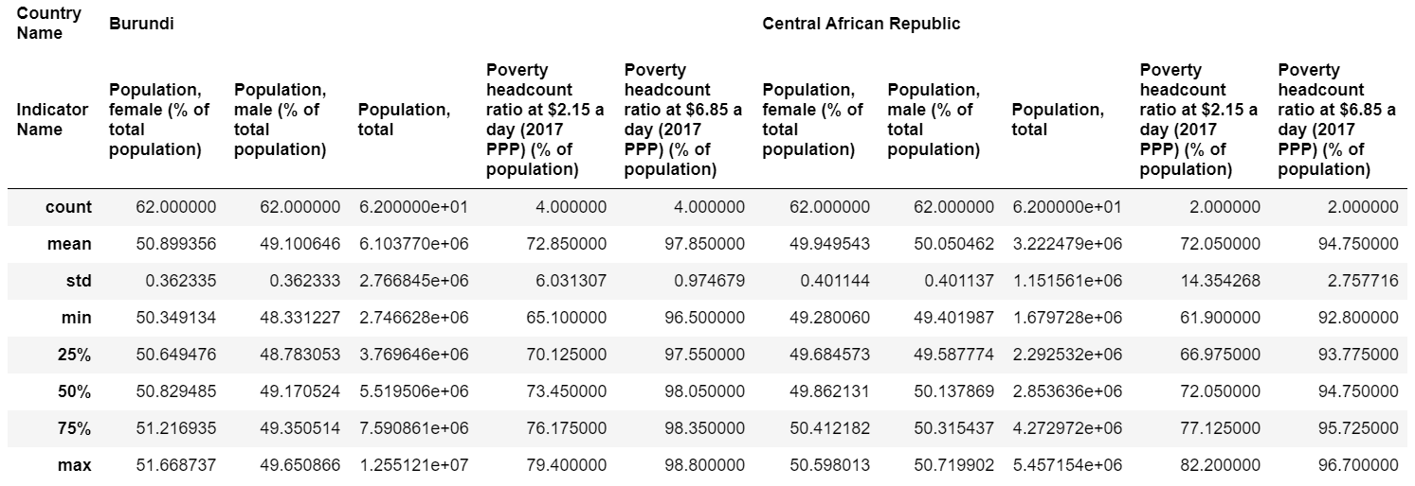

Statistical values indicate that both countries have high poverty rates, with a poverty headcount ratio at $2.15 a day of around 73% and a poverty headcount ratio at $6.85 a day of around 95%. The population is predominantly female, with a female percentage of around 50% and a male percentage of around 50%. The total population of both countries is around 6 million, with Burundi having a slightly larger population than the Central African Republic. The statistical properties of the poverty indicators show that there is very little variation between the poverty headcount ratio at $2.15 a day and $6.85 a day for both countries, with a small standard deviation of around 1%.

Then after that I analyzed the population trend in both countries from 1960 to 2020 and came to know that the population in both countries is increasing year by year. After 2000, there is abrupt change in the population growth of Burundi country. More can be visualized in following graphs.

|  |  |
| --- | --- |
| C:\Users\autom\AppData\Local\Microsoft\Windows\INetCache\Content.MSO\E281653E.tmp  Figure : Population Trend | C:\Users\autom\AppData\Local\Microsoft\Windows\INetCache\Content.MSO\BF7783FC.tmp  Figure : Population by 2021 |

One more thing can be seen from graph two that Burundi has 50% higher population than Central Africa. Then I checked the percentage of females in the population of both countries that can be visualized in the following graph.

|  |  |
| --- | --- |
| C:\Users\autom\AppData\Local\Microsoft\Windows\INetCache\Content.MSO\DC8E176A.tmp  Figure : Female Percentage | C:\Users\autom\AppData\Local\Microsoft\Windows\INetCache\Content.MSO\4F80F308.tmp  Figure : Male Percentage |

It can be seen that the percentage of female in total population decreasing continuously year by year. One more thing to notice is that there was a 0.5 percent decline in the percentage of female from 1980 to 1990 in Central Africa but after that it was again back to its original value by 2020.

Then I performed analysis on the poverty indicators of both countries and for that images are below.

|  |  |
| --- | --- |
| C:\Users\autom\AppData\Local\Microsoft\Windows\INetCache\Content.MSO\50B8ACD4.tmp  Figure : Poverty rate at 2.15$ | C:\Users\autom\AppData\Local\Microsoft\Windows\INetCache\Content.MSO\827FAE02.tmp  Figure : Poverty Rate at 6.85 |

The poverty headcount ratios at different thresholds for Burundi and the Central African Republic are shown in two tables. In 2017, 73.45% of the population in Burundi and 72.05% in the Central African Republic lived below the poverty line of $2.15 per day. For the poverty line set at $6.85 per day, 98.05% in Burundi and 94.75% in the Central African lived below this threshold, indicating a high level of poverty in both countries that requires urgent action.

# Conclusion

The analysis of poverty indicators in Burundi and the Central African Republic reveals extremely high poverty rates at different poverty headcount thresholds. Both countries have a predominantly female population, and the total population is around 6 million, with Burundi having a slightly larger population. The poverty indicators show very little variation, indicating a persistent issue that needs to be urgently addressed. This report highlights the importance of acting to alleviate poverty in these countries, as it has a direct impact on health, education, economic growth, and climate change.