**Book Bank**

**BY 3RD YEAR M.Sc. (CA&IT) (2016-2017)**

**Student name Roll NO**

Gadariya jay 3098

Patoliya Rahul 3129

Shah Purvesh 3148

Group Id:- 18

**Name of company**



REPORT SUBMITTED TO

K.S.SCHOOL OF BUSINESS MANAGEMENT

### **ACKNOWLADGEMENTACKNOWLEDGEMENT**

It was a great experience working on the project of “Book Bank”.We express our gratitude towards those who were constantly involved with us during our project. We will always occupies a special place in our heart, throughout our career, for both personal and professional reason. The phenomenon remains same that no project ever can be executed proficiently and efficiently without sharing the meticulous ideas, technical expertise and innovative thoughts put forwarded by technical and no-technical veterans. Whenever a technical project is developed, eventually it requires conductive technical environment and technical guidance to get involved in the assigned project enthusiastically. We also grateful to “Frux InfoTech” for being extremely friendly and co-operative during entire course of our project. Their continuous help and support made the project much easy. There is no exact word to express our regards and legitimate gratitude to one of our esteemed techno personality, without him this project could not get an entrance towards the execution.Our project manager is pioneer who availed this magnificent to us to move ahead. He is always inspired and guided us for the right track to be followed for all the system analysis section of this project.

**List Of Figures**

1. Use Case
2. Class Diagram
3. sequence Diagram
4. Activity Diagram
5. Deployment Diagram

**List Of Tables**

1. Admin Table
2. Book Table
3. Add User Table
4. Book Request Table
5. Complaint Table
6. Feedback Table
7. Return Book Table
8. Issue Book Table

**INDEX**

|  |  |  |
| --- | --- | --- |
| **NO** | **Table Of Content** | **Page**  **No** |
| **1** | **Introduction** | 06 |
|  | |  |  | | --- | --- | | 1.1 | Company Profile | | 1.2 | Project Detail | |  | |  |  | | --- | --- | | 1.2.1 | Current System | | 1.2.2 | Proposed System | | | 1.3 | Scope | | 1.4 | Objective | | 06  06  06  07  07  08 |
| **2** | **Requirement**   |  |  | | --- | --- | | 2.1 | Stack holder System | | 2.2 | Requirement gathering technique used | | 2.3 | Consolidated List of Requirement | | 2.4 | Project Definition | | 09  09  10  11  11 |
| **3** | **Project Management and Planning**   |  |  |  |  |  |  |  |  | | --- | --- | --- | --- | --- | --- | --- | --- | | 3.1 | Feasibility Study   |  |  | | --- | --- | | 3.1.1 | Technical | | 3.1.2 | Economic | | 3.1.3 | Operational | | | 3.2 | H/W and S/W Requirements | | 3.3 | Project Planning   |  |  | | --- | --- | | 3.3.1 | Work breakdown Structure | | 3.3.2 | Gantt chart | | | 3.4 | Process Model | | 12  12  12  13  13  14  15  15  16  17 |
| **4** | **Analysis and Design**   |  |  | | --- | --- | | 4.1 | UML Diagram | | 4.2 | System Flow Diagram | | 4.3 | System Navigation | | 4.4 | Data Dictionary | | 4.5 | User Interface | | 19  19  26  27  30  34 |
| **5** | **Summary**   |  |  | | --- | --- | | 5.1 | Assumption | | 5.2 | Limitation | | 5.3 | Conclusion | | 5.4 | Future Scope | | 39  39  39  39  40 |

**Chapter-1**

**Introduction:-**

* 1. **Organization / Company profile:-**

Name of organization: -Frux InfoTech

Organization Address: - E-1102 Titanum City Centre,

OppSeema Hall,

Near Shyamal Cross Road,

Ahmedabad.

Contact No : -07940345050

Owner of Organization:-KarshanZala

Email ID :-[mba_zala@yahoo.com](mailto:mba_zala@yahoo.com)

* 1. **Project Details:-**

**1.2.1Current System:-**

In current system person supposed to go to the library and first he needs to take membership of library. If he get the membership then and only Then he is able to get book from library for reading in library or take Book at home.

**1.2.1Proposed System:-**

In our system we are providing facility user to get membership of

library . Not only membership but he can choose his choice

package whichever he wants or his needs. He can choose package and then get online pdf books easily from our library We are providing a “free book package “ means user can read books only in our library he not suppose to issue a book.

**1.2.3Howto Solve Problem?:-**

A Book Bank lends books and magazines to member, who is registered in the system. Also it handles the purchase of new titles for the Book Bank. Popular titles are brought into multiple copies. Old books and magazines are removed when they are out or date or poor in condition. A member can reserve a book or magazine that is not currently available in the book bank, so that when it is returned or purchased by the book bank, that person is notified. The book bank can easily create, replace and delete information about the tiles, members, loans and reservations from the system.

**1.3 Scope:-**

**Purpose:**

In today’s world education is more important. And there is uncertainty in book so there is not a specified place to go and get needed books.

**Benefits:**

So, in solution of that problem we are making an offline library system with physical library,so that people can come at that specific place and get the Books.

* 1. **Objective**

**Objective from Admin side:-**

* + Maintain or manages Books Easily.
  + Manage the books and users.
  + Delete and update the records.
  + Manage the packages.

**Objective of User:-**

* Search Books.
* View Book.
* Make Complain.
* Easily Give the Feedback of the books.

**Chapter-2**

**2.1 Aboutstockholder:-**

1. Admin
2. User
3. Librarian
4. **Admin**:-

Owner can manage all the features provide in the system such as to manage the users, manage the librarian and also manage the Books. Manage feedback of Users managePackage, manage Complaint.

1. **User**:-

They are the people who desire to obtain the books and submit theinformation to the databaseand also user make complain, view related book, give feedback.

C.) **Librarian**:-

He has the certain privileges to add the books and to approval of the reservation of books, add user and remove user.

**2.2 Requirement Gathering Technique**

1.) **Questionnaire**:-

Questionnaires are much more informal, and they are good tool, together requirement, from stakeholders in remote locations. In this are create the form of questions and give it to the owner of the organization to complete it. So that are easily get the requirement for the system. The questionnaires are as follows:

* + - How do you handle current system?
    - What’s the requirement to build the computerized system?
    - How does the book bank communicate with the user?

1. Telephone

2. Computer

3. Cell phone

4.Others

* Is there any web based system for your organization?

a.Yes

b.No

* How do you manage the book detail?

a.In files

b.In computes

**2.3 List of Requirement:-**

* The system should maintain the stock of Books.
* The system should provide facility to User to Search a book, View the Book and Request for Books.
* The system should also allow User to Share Reviews.

**2.4 Project Definition:-**

**“Book Bank”**

We are developing a System Where User can Read Book in the Library or they can take the book at home for reading purpose. But for that user have to register them self in the system and then they can search book for Reading and take it at home.

**Chapter-3**

**3.1 Feasibility Study:-**

The main aim of the feasibility study is to determine that it would be financially and technically feasible to develop the System. The purpose of feasibility study is not to solve the problem, but to determine whether the problem is worth solving.

**3.1.1 Technical Feasibility:-**

* + - The project entitles "book bank” is technically feasibility because of the below mentioned feature. The project was developed in Java which Graphical User Interface.
    - It provides the high level of reliability, availability and compatibility. All these make Java an appropriate language for this project. Thus the existing software Java is a powerful language.
    - We can strongly say that it is technically feasible, since there will not be much difficulty in getting required resources for the development and maintaining the system as well.

**3.1.2 Operational Feasibility:-**

Operational feasibility study tests the operational scope of the System to be developed. It is checked that if the system is actually can be useful when implemented.

Our system is operationally feasible in the following ways:

* An effective catalyst for customer feedback is a portion of an operational system.
* It is operate very easily so that the admin can easily use it.
* Our system is very easy so user use it without any training.

**3.1.2 Economical Feasibility:-**

The economic feasibility study evaluates the cost of the software development against the ultimate income or benefits gets from the developed system. There must be scope for profit after the successful completion of the project.

The system is economical because:

* In economic feasibility, the most important is [cost-benefit analysis](http://www.freetutes.com/systemanalysis/sa3-cost-benefit-analysis.html).
* Additional investment is needed in developing tools because of java platform.
* Due to economic feasibility we can estimate and make changes according to the budget.

**3.2 Hardware & Software Specification:-**

* **Software Specification:-**

Front-end Technology:-CSS3, HTML5, J query, Java script, Bootstrap.

Back-end Technology:-Net Beans, MySQL.

Operating System:- Windows xp,Windows 7,Windows 8,Windows 10.

* **Hardware Specification:-**

Ram: - 1GB or More

Hard-Disk: - 400GB. Or more

Processor: -Core to duo

**3.3 Project Planning:-**

**3.3.1Project breakdown structure:-**

**3.3.2 Gantt Chart:-**

|  |  |  |  |  |  |  |
| --- | --- | --- | --- | --- | --- | --- |
| **Activities** | **July** | **Aug** | **Sep** | **Oct** | **Nov** |  |
| Project Scope |  |  |  |  |  |  |
| Research |  |  |  |  |  |  |
| Requirement Gathering |  |  |  |  |  |  |
| Analysis |  |  |  |  |  |  |
| Designing |  |  |  |  |  |  |

**3.4 Process model:-**

As new requirements can arise in future incremental models are used. With the help of it we can fulfil maximum user requirements. Many features can be added after the development of the system that serves the main purpose.If there are less number of employees to work on the project Incremental development model is very useful to complete the project before the deadline.

Incremental model:-

* This model is more flexible – less costly to change scope and requirements.
* It is easier to test and debug during a smaller iteration.
* In this model customer can respond to each built.
* Lowers initial delivery cost.

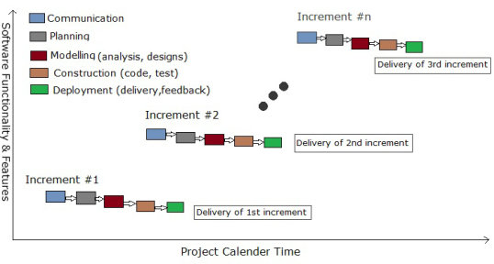

**Chapter-4**

**4. Analysis & Diagram:-**

**4.1 UML Diagram:**







**4.2 System Flow Diagram**



**4.3 System Navigation Diagram:-**







**4.4 Data Dictionary:-**

ADMIN TABLE:-

|  |  |  |  |  |
| --- | --- | --- | --- | --- |
| SERIAL NO | FIELD_NO | DATA_TYPE | CONSTRAINTS | DESCRIPTION |
| 1 | EMAIL | VARCHAR(25) | PRIMARY KEY | TO FIND ADMIN EMAIL |
| 2 | FIRST_NAME | VARCHAR(10) | NOTNULL | TO STORE NAME |
| 3 | PASSWORD | VARCHAR(15) | NOTNULL | TO VARIFY  ADMIN |
| 4 | MOBILE_NO | FLOAT(10) | NOT NULL | TO VERIFY NO |
| 5 | IMAGE | VARCHAR(20) | NOT NULL | VERIFY ADMIN |

BOOK TABLE:-

|  |  |  |  |  |
| --- | --- | --- | --- | --- |
| SERIAL NO | FIELD_NO | DATA_TYPE | CONSTRAINTS | DESCRIPTION |
| 1 | BOOK_TITLE | VARCHAR(15) | NOT NULL | TO FIND BOOK |
| 3 | AUTHOR_NAME | VARCHAR(20) | NOT NULL | TO SHOW AUTHOR OF BOOK |
| 4 | PUBLISHER | VARCHAR(30) | NOT NULL | TO SHOW PUBLISHER OF BOOK |
| 5 | ISBN NUMBER | FLOAT(13) | PRIMARY KEY | TO UNIFY BOOK |
| 6 | EDITION | VARCHAR(4) | NOT NULL | TO SHOW BOOK EDITION |
| 7 | AVAILABLE | INT(1) | NOT NULL | TO FIND AVAILABILITY |
| 8 | PDF | VARCHAR(26) | NOT NULL | TO SHOW A PDF |
| 9 | PRICE | INT(4) | NOT NULL | TO SHOW BOOK PRICE |
| 10 | IMAGE | VARCHAR(20) | NOT NULL | TO SHOW A  IMAGE |

ADD USER TABLE:-

|  |  |  |  |  |
| --- | --- | --- | --- | --- |
| SERIAL NO | FIELD NO | DATATYPE | CONSTRAINTS | DESCRIPTION |
| 1 | USER_NAME | VARCHAR(10) | NOTNULL | TO FIND USER |
| 2 | USER_EMAIL | VARCHAR(25) | PRIMARY KEY | TO SHOW E-MAIL |
| 3 | PASSWORD | VARCHAR(15) | NOTNULL | TO VARIFY USER |
| 4 | ADDRESS | BOOLEAN | NOTNULL | TO SHOW ADDRESS |
| 5 | MOBILE_NO | FLOAT(10) | NOTNULL | TO SHOW CONTACT NO |
| 6 | IMAGE | VARCHAR(20) | NOT NULL | TO SHOW USER |
| 7 | DATE | DATETIME | NOT NULL | TO SHOW ACTIVE |
| 8 | ACTIVE | INT(1) | NOT NULL | TO SHOW AVAILABILITY |

BOOK REQUEST TABLE:-

|  |  |  |  |  |
| --- | --- | --- | --- | --- |
| SERIAL NO | FIELD NO | DATATYPE | CONSTRAINTS | DESCRIPTION |
| 1 | USER_EMAIL | VARCHAR(25) | FOREIGN KEY | IDENTIFY USER |
| 2 | BOOK_TITLE | VARCHAR(25) | NOTNULL | FIND BOOK |
| 3 | AUTHOR_NAME | VARCHAR(20) | NOTNULL | SHOW AUTHOR NAME |
| 4 | PUBLISHER | VARCHHAR(30) | NOTNULL | SHOW BOOK PUBLISHER |
| 5 | EDDITION | VARCHAR(4) | NOTNULL | SHOW BOOK EDITION |

ISSUE BOOK TABLE

|  |  |  |  |  |
| --- | --- | --- | --- | --- |
| SERIAL NO | FIELD NO | DATATYPE | CONSTRAINTS | DESCRIPTION |
| 1 | USER_EMAIL | VARCHAR(25) | FOREIGN KEY | IDENTIFY USER |
| 2 | BOOK_TITLE | VARCHAR(25) | NOTNULL | FIND BOOK |
| 3 | AUTHOR_NAME | VARCHAR(20) | NOTNULL | SHOW AUTHOR NAME |
| 4 | PUBLISHER | VARCHHAR(30) | NOTNULL | SHOW BOOK PUBLISHER |
| 5 | EDDITION | VARCHAR(4) | NOTNULL | SHOW BOOK EDITION |
| 6 | TIME | TIME | NOTNULL | SHOW USER TIME |
| 7 | ISBN | INT(7) | FOREIGN KEY | IDENTIFY BOOK |

COMPLAINT TABLE:-

|  |  |  |  |  |
| --- | --- | --- | --- | --- |
| SERIAL NO | FIELD NO | DATATYPE | CONSTRAINTS | DESCRIPTION |
| 1 | USER_EMAIL | VARCHAR(25) | FOREIGN KEY | TO IDENTIFY USER |
| 2 | USER_NAME | VARCHAR(15) | NOT NULL | SHOW USER NAME |
| 3 | SUB | VARCHAR(25) | NOT NULL | SHOW SUBJECT COMPLAINT |
| 4 | COMPLAIN | VARCHAR(100) | NOT NULL | SHOW USER COMPLAIN |

FEEDBACK TABLE:-

|  |  |  |  |  |
| --- | --- | --- | --- | --- |
| SERIAL NO | FIELD NO | DATATYPE | CONSTRAINTS | DESCRIPTION |
| 1 | TIME | DATE | NOTNULL | IDENTIFY USER TIME |
| 2 | USER_EMAIL | VARCHAR(25) | FOREIGN KEY | IDENTIFY USER E,EMAIL |
| 3 | USER_NAME | VARCHAR(15) | NOTNULL | SHOW USERNAME |
| 4 | SUB | VARCHAR(25) | NOTNULL | SHOW A SUB |
| 5 | MESSAGE | VARCHAR(100) | NOTNULL | SHOW USER FEEDBACK |

CONTACT US

|  |  |  |  |  |
| --- | --- | --- | --- | --- |
| SERIAL NO | FIELD NO | DATATYPE | CONSTRAINTS | DESCRIPTION |
| 1 | USER_EMAIL | VARCHAR(25) | FOREIGN KEY | TO IDENTIFY USER |
| 3 | SUB | VARCHAR(25) | NOT NULL | SHOW SUBJECT COMPLAINT |
| 3 | MESSAGE | VARCHAR(100) | NOT NULL | SHOW USER COMPLAIN |
| 4 | DATE | DATE | NOT NULL | SHOW A MESSASGE DATE |

FAVOURITE BOOK

|  |  |  |  |  |
| --- | --- | --- | --- | --- |
| SERIAL NO | FIELD NO | DATATYPE | CONSTRAINTS | DESCRIPTION |
| 1 | USER_EMAIL | VARCHAR(25) | FOREIGN KEY | IDENTIFY USER |
| 2 | BOOK_TITLE | VARCHAR(100) | NOTNULL | FIND BOOK |
| 3 | AUTHOR_NAME | VARCHAR(20) | NOTNULL | SHOW AUTHOR NAME |
| 4 | PUBLISHER | VARCHHAR(30) | NOTNULL | SHOW BOOK PUBLISHER |
| 5 | EDDITION | VARCHAR(12) | NOTNULL | SHOW BOOK EDITION |
| 6 | TIME | TIME | NOTNULL | SHOW USER TIME |
| 7 | ISBN | INT(7) | FOREIGN KEY | IDENTIFY BOOK |
| 8 | IMAGE | VARCHAR(20) | NOTNULL | SHOW USER TIME |
| 9 | PDF | VARCHAR(26) | FOREIGN KEY | IDENTIFY BOOK |

4.5User Interface:-

Home Page:-

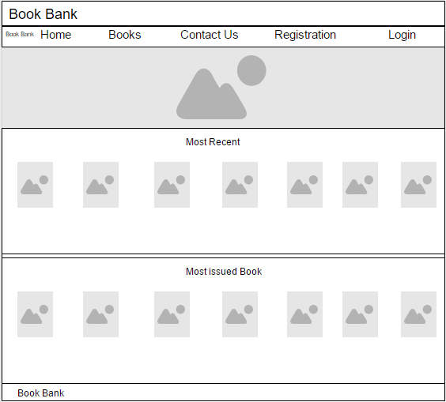

Search Book Page:-

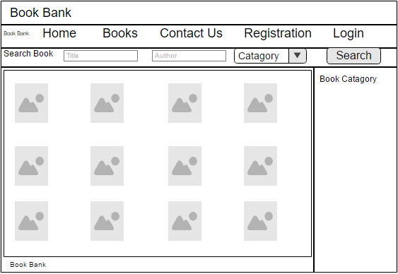

Contact Us Page:-

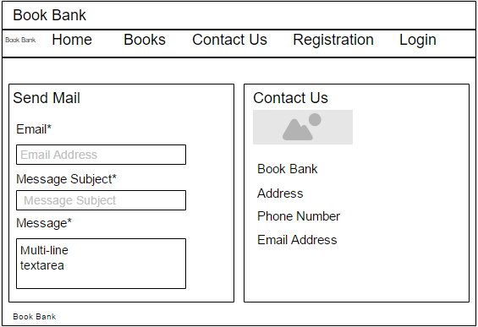

Registration page:-

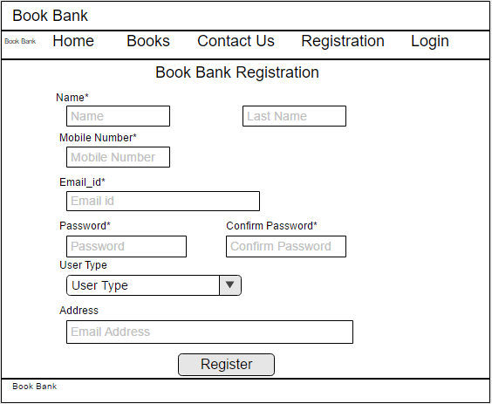

`

Login Page:-

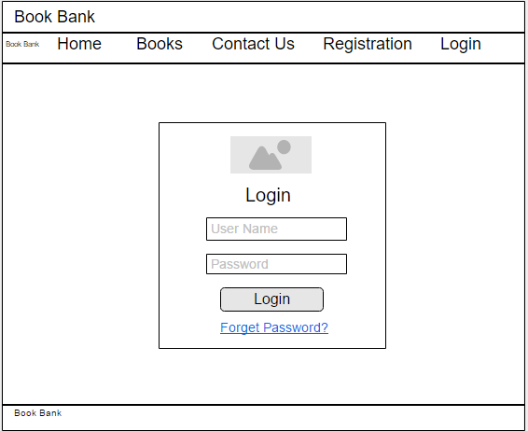

**Chapter-5**

**5.1Assumption:-**

* + The Users and Librarian must have basic knowledge of computers ,English Language and

About books.

* + The Admin know about the User requirement for books.

**5.2 Limitation:-**

* The system is not hosted at Internet.
* Without internet we will not able to login from other ways like login with Google, login with Facebook, etc.
  1. **Conclusion:-**

There may be some defects or errors. We have taken enough care to make the project user friendly and more interactive. Major focus is to provide books easily without any conflicts or any ambiguity

**5.4 Future scope:-**

• Our current system is desktop based system. But we will providing you a web based application.

• We will provide a facility to visit a library online.

• Using this application user can get his books according to his requirement easily compare to existing system or libraries.

• We will make an admin panel to handle all the functionality of system/application.