A Project Report On

EVENT MANAGEMENT

Submitted By:

Mayur .A.Ghunkikar
Roll #7920

MMS II

Second Year Masters In Management Studies

(IV–Semester)

Oriental Institute Of Management Studies

To the University of Mumbai In Partial Fulfilment
Of MMS

Academic Year:

2008-2009
CERTIFICATE
This is to certify that, the project assigned on ‘Event Management’ has been successfully completed by Mr. Mayur .A. Ghunkikar of Oriental Institute of Management Studies, Vashi.
The project is being completed as a part of the syllabus and also in partial fulfillment of the two year full time degree of Master Of Management Studies conducted by University of Mumbai.

Signature of examiner |  | Prof. Rupali Mohite  (Course coordinator)
Dr. Shiridharan Menon
(Director)

CERTIFICATE

I.Mr. Ravi Vaidee hereby certify that Mayur . A.Ghunkikar student of MMS II Oriental Institute Of Management Studies has completed the Project on Event Management for the Academic Year 2008-09. This information is true to the best of my knowledge

Place :____________ ________________
Date :____________ Mr Ravi Vaidee.

(Project guide

DECLARATION

I, Mayur .A. Ghunkikar student of MMS II Oriental Institute Of Management Studies have completed the Project on Event Management for the Academic Year 2008-09.The information given in this project is true to the best of my knowledge.

_________________
Place :_______________
Mayur .A. Ghunkikar

Date :_________________

ACKNOWLEDGEMENT

First of all I would like to take this opportunity to thank the Mumbai University for having projects as a part of the MMS curriculum.

Many people have influenced the shape and content of this project, and many supported me through it. I express my sincere gratitude to Prof. Ravi.Vaidee for assigning me a project on Event Management, which is an interesting and exhaustive subject.

He has been an inspiration and role model for this topic. His guidance and active support has made it possible to complete the assignment.

I also would like to thank my sister and my parents who have helped and encouraged me throughout the working of the project.

Last but not the least I would like to thank the Almighty for always helping me.

PREFACE

This project is undertaken to fulfil the project work component of the M.M.S program in the IV Semester. My project guide from Oriental Institute Of Management is Mr . Ravi Vaidee .

This project gives idea about what are the things which are to be taken in consideration while handling an event and what sort of challenges are faced by an event manager.

This project specifically talks about two events handled by our college during the academic year.

TOPIC | Pg.no
- Executive summary | 2
- Introduction | 3
- Meaning of word event and management | 4
- Event management and its types | 6
- Event management industry | 11
- Meaning of event manager | 13
- Event management process  A)Event planning B)Event control | 14
- Industry player - Niem | 32
- Case study 1 industrial visit | 45
- Case study 2 Nova inter college event | 75
- Conclusion | 89

EXECUTIVE SUMMARY

Event management, the very topic looks challenging. A concept which gained importance in India only after the late 90’s. Commitment, leadership and mental & physical devotion are the core factors needed to manage any type of event. Irrespective of the type or the scale of the event, the mental and physical hard work that is to be put in, differs by only a negligible degree of difference.

This terminology is comparatively very new to India, though Indians have been arranging for wedding ceremonies, naming & threading ceremonies even much before independence. But due to the lack of proper forecasting, proper material handling they used to end up in problems like wastage of the food due to less people coming in or fire in the pandal or food poisoning .These problems many a times used to put the families into financial trouble after the wedding.

It is very easy for the audiences to make the event a hit or a flop. It takes just the 5 minutes for the audiences to judge the event resulting in the efforts of nearly 3-4 months and the hard work 70-80 people either turning productive or waste. Thus the efforts they have put in always remains at stake till the date of the event.

There are innumerable activities that have to be carried out. First of all forming committees, then allotting different jobs to each committee is the very first step. Here all the theoretical concepts learnt up till now in subjects like public relations, human resource planning, logistics, human skills, controlling, accounts, organizing, and others come into actual use.

As an event manager one must have a lot of flexibility in terms of working pattern. Be free to do all sorts of jobs irrespective of your position.

INTRODUCTION

Every time when you saw a programme like 'Filmfare' awards or those pop concerts and beauty pageants you would have wondered how people managed to set up such brilliant shows. Every tiny detail from your entering the venue to your going out is a result of rigorous planning. Well…that's event management for you.
One of the fastest and the most glamorous upcoming professions today, it means rubbing shoulders with who's who of the crème-de-la crème layer of the city. Event management, the most profound form of advertising and marketing, is a glamorous and thrilling profession. It provides an opportunity for unleashing one's creative potential to a very high degree. It demands a lot of hark work and effort but at the same time offers enormous scope.
Event management is a process of organizing a professional and focused event, for a particular target audience. It involves visualizing concepts, planning, budgeting, organizing and executing events such as fashion shows, musical concerts, corporate seminars, exhibitions, wedding celebrations, theme parties, product launching etc.
Event Management is a multi-million dollar industry, growing rapidly, with mega shows and events hosted regularly. Surprisingly, there is no formalized research conducted to access the growth of this industry. The industry includes fields such as the MICE (Meetings, Incentives and Events), exhibitions, conferences and seminars as well as live music and sporting events.
On the profession side, event management is a glamorous and exciting profession that demands a lot of hard work and dynamism.
The logistics side of the industry is paid less than the sales/sponsorship side, though some may say that these are two different industries.

MEANING OF THE WORD ‘EVENT’

“The use of unconventional media / method involving people witnessing a happening within a capsule of time, for the purpose of communication of a message”
An event is a live multimedia package carried out with preconceived concept, customized or modified to achieve the clients’ objectives of reaching out and suitably influencing the sharply defined, specially gathered target audience by providing at complete experience and an avenue for two way interaction.

Event in terms of Cultural and social life
In cultural and social life, an event refers to a social gathering or activity, such as:
- A festival, for example a musical festival
- A ceremony, for example a marriage
- A party, for example a birthday party

Event in terms of science
In science, an event is something that takes place at a particular place and time. Specifically, event may refer to:
- Phenomenon, something observable at a given time
- A point in space time , a concept of the theory of relativity
- Event (particle physics), a set of elementary particle interactions
- Event (probability theory), a possible outcome of an experiment
- Extinction event, when a large number of biological species die out in a relatively short period of time.

Programming
In programming, an event is a software message that indicates something has happened, such as a keystroke or mouse click.

Common usage
In common usage, an event (as opposed to a special event) has a connotation of an occurrence which is more common than a phenomenon (due perhaps to the difference between a two syllable word and a four syllable word). Thus, in common usage, a keystroke is an event, where the Big Bang might be connoted a phenomenon (a special event which denotes the beginning of the universe). For example, portal:current events denotes “events” rather than “phenomena”.

Meaning of the Word ‘Management’
The term "management" characterizes the process of and the personnel leading and directing all or part of an organization through the deployment and manipulation of resources (human, financial, material, intellectual or intangible).
According to the Oxford English Dictionary, the word "manage" comes from the Italian maneggiare (to handle). Management has to do with power by position, whereas leadership involves power by influence.

Functions of management
Management operates through various functions, often classified as planning, organizing, leading/motivating and controlling.
- Planning: Deciding what has to happen in the future (today, next week, next month, next year, over the next five years, etc.) and generating plans for action.
- Organizing: Making optimum use of the resources required to enable the successful carrying out of plans.
- Leading/Motivating: Exhibiting skills in these areas for getting others to play an effective part in achieving plans.
- Controlling: Monitoring — checking progress against plans, which may need modification based on feedback.
- Staffing: Appointing skill and unskilled workers, and efficient personnel.

EVENT MANAGEMENT
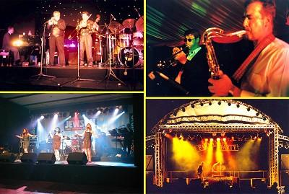
Event management is the application of the management science of project management to the creation and development of festivals and events.

Event Management involves studying the intricacies of the brand, identifying the target audience, devising the event concept, planning the logistics, coordinating the technical aspects before getting down to actually executing the modalities of the proposed event.

The recent growth of festivals and events as an industry around the world, means that the management can no longer be ad hoc. Events and festivals, such as the Asian Games or the Dubai Shopping Festival, have a large impact on their communities and, in some cases, the whole country.

The industry now includes events of all sizes from the Olympics down to a breakfast meeting for ten business people. Every industry, charity, society and group will hold events of some type/size in order to market themselves, raise money or celebrate.

Types Of Event Management

There are mainly 3 types of event management,
- Corporate Event Management
- Product Launch Event Management
- Special Event Management
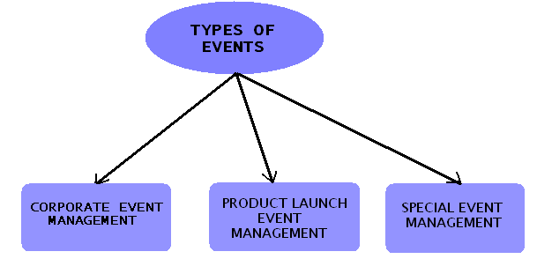

- Corporate Event Management

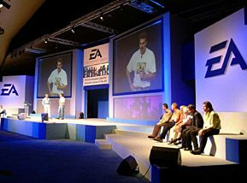
A product launch, the company anniversary, sales target achieved or any special event could mark the onset of a corporate event. It demands pure professionalism as you are interacting with people from the high-end category.
Not surprising, that event management companies are spurring up to provide these professional services. They attend meetings, hold dialogues with the bosses to realize the objective of the event. They then take it off with creative ideas to arrive at a theme for the event. A corporate event demands a little corporate look. The food and the style need to blend with the corporates and make the bosses comfortable. Hence it ought to be prepared and presented with ultimate efficiency. But that is if the top-notches are involved. A corporate event could also be a product-launch. That would involve a media conference. So the event management company would get a list of prospective venues. Decide on the dinner and the cocktail party that will follow. Arrange for the conference, the speakers, and microphones. Make sure everyone get a seat. Car parking is made available, etc. For a product launch in the market, the event management team gets their grey cells working as to the creative ways to make the samples of the product reach the end consumers. They have to be innovative so that consumers are attracted to try it out.
Corporate management is a sub-category of event management. Mega companies usually have an in-house event management team to organize their events on a regular basis.

- Product Launch Event Management
A company wants to launch a product in the market. So how should it get to its customers? How does the company make sure that the products gain awareness? The feel and touch reasoning still remains strong in the mind of the consumer. So although you have advertised in other channels, how do you explain product usage to the audience?
Call in the event management team. They innovate new styles so that the product can make its way to the consumer. They ensure that the samples reach the desired households. For instance: when coca cola launched Vanilla Coke, two men dressed in the 70s attire would enter retail grocery shops and dance to the designed tune. This was the strategy used to launch vanilla coke and make its entry memorable.
Some event management companies even professionalize in a particular target audience. For example if you have a particular target audience in mind, the event management team will devise ideas and strike places that will give you maximum reach.
Road shows, promotions, contests, set designing, stage shows and audiovisual films are all interesting methods to invite public participation. Some event management companies go a step ahead to analyze the customer reaction and provide relevant feedback.
Among the available platforms road shows are known to be economical. It gives more visibility and allows the customer to directly relate to the product. And the touch and feel concept is satisfied. Road shows with innovative themes organized at a national level give your product high reach and coverage. These road shows arrest the customer's attention and persuade the customers to try out the product. If impressed then the product receives a warm welcome.

- Special Event Management

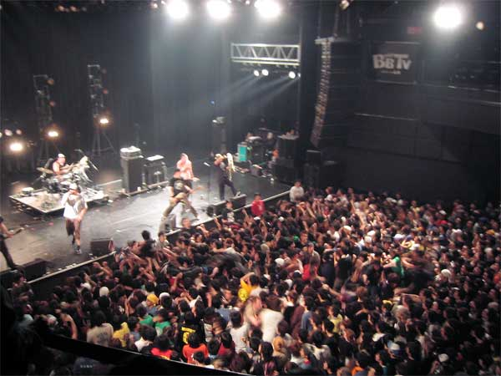

'Special Events' is the term given to events with a difference. Charity shows, marathons, cycling races, street festivals etc. are a few of the many special events organized. As the event has an unusual theme, the event management company has to double up its speed to think on lines with the theme. More resources and creativity are put to the task.
For instance consider the organization of Athens 2004. It was a special event. The opening ceremony, the event and the closing ceremony, had to be meticulously organized. A race kicked off the event. Runners passed the baton. This earmarked the tradition that running was the only sport at the first Olympic Games held in Athens. Then 400 percussionists and 50 bouzouki players welcomed the audience. From 400 it dropped to just one percussionist who played the rhythm of a heartbeat. This was the symbol of the theme of Athens 2004 'unique games on a human scale'. This should give you an idea how a special event is organized.
Event management companies arrange the entire event on a theme. It could be a wedding or a charity show, a children's event etc. these events demand creativity. Something that will make them stand out of the clutter firstly, as it is a different event and secondly that the feedback should be encouraging for an encore. The recent marathon that Mumbai witnessed was one of the specialized events. Foreign nationals, corporate personnel, etc. everybody was seen to take part in it. More than winning it was the spirit of participation that was encouraged. And it received an overwhelming response.

EVENT MANAGEMENT AS AN INDUSTRY

‘Event management’ is catching the attention of companies and graduates alike. It does not have a textbook definition and to try and define it would mean to borrow heavily from mainstream management and media concepts. It usually consists of conceptualization, planning, budgeting, and execution of below-the-line activities such as exhibitions, stage shows, fashion or rock shows, music concerts, celebrity appearances, fashion or charity shows, conferences, weddings, product or brand launches, and sports shows to name few.
Events begin where the glamour ends. EM is the most intimate form of marketing. It is a controlled activity aimed at the target audience. Events have always been there. In the past meeting, organizing and project planning were the form of event management as a profession. Today it is much more professional and more organized a sector than, a decade ago. Event management was started, the moment multinationals started pouring in, when our markets liberalized in the 80s. It is difficult to pinpoint exactly when event management broke away from mainstream course and started carving a niche for itself in the industry. Maybe it was around 1996 that it rapidly gained importance as a professionally managed niche of marketing.
Companies realize that through events they can reach out to customers more closely, more intimately and it is cheaper than mainstream or conventional forms of communication, say television or print. It can be called as 'experiential marketing', or niche marketing, where the environment is controlled to suit the needs of the product or
The show being showcased and the output being far tangible that that of the conventional media. An event is a niche communication medium that allows companies to reach their target audience directly with tangible outcomes, which are not possible through conventional forms of advertisement. Through events, we can select and reach out directly to our target audience, we can control our budgets and at the end of the event tangibly analyze if the event was a success or not. This is quite difficult, in mainstream communications, where the results are intangible and we are not sure who is seeing it and whom the communication reaches out to.

Event Management as a Marketing Tool

Event management is considered one of the strategic marketing and communication tools by companies of all sizes. From product launches to press conferences, companies create promotional events to help them communicate with clients (and potential clients). They might target their audience by using the news media, hoping to generate media coverage which will reach thousands or millions of people. They can also invite their audience to their events and reach them at the actual event.

Providing A Plethora Of Services

Companies approach event managers with a vague idea and a budget in mind. It is then entirely up to the event manager to develop and improvise and turn the idea into a success. Once the idea and the budget are settled, event managers begin coordinating with sponsors and performers, arranging travel, security, and accommodation for the stars if there is a show. They also have to supervise ticket and stage design, arrange music, sound and lights, and look into those numerous details that go into making an event successful. Security is another big issue that is dealt with by event managers. In India, shows usually have to end before midnight at the latest, even earlier in some places. Event managers have to ensure that events conclude on time, and in case they stretch beyond the permitted hours, they have to handle the police and the local bureaucracy

Bad security could ruin an otherwise well-organized event. Unwanted guests, stampedes, fights, and harassment of performers are a few things event managers have to tackle during public events. Event management companies service a variety of areas including corporate events (product launches, press conferences, corporate meetings and conferences), marketing programs (road shows, grand opening events), and special events like concerts, award ceremonies, film premieres, launch/release parties, fashion shows, private (personal) events such as weddings and bar mitzvahs. Clients hire event management companies to handle a specific scope of services for the given event, which at its maximum may include all creative, technical and logistical elements of the event. (Or just a subset of these, depending on the client’s needs, expertise and budget).

Meaning of Event Manager

The Event Manager is the person who plans and executes the event. Event managers and their teams are often behind-the-scenes running the event. Event managers may also be involved in more than just the planning and execution of the event, but also brand building, marketing and communication strategy. The event manager is an expert at the creative, technical and logistical elements that help an event succeed. This includes event design, audiovisual production, scriptwriting, logistics, budgeting, negotiation and, of course, client service. It is a multidimensional profession.

Educational Support

There are an increasing number of universities which offer Graduate Degree/ Diploma in Event Management, especially in the UK where they have been quick to catch on to the new interest and many are now offering certificate, diploma, degree and masters courses.

In addition to these academic courses, there are many associations and societies that provide courses on the various aspects of the industry. These courses though not official, are still useful additions to your resume.

Study includes organizational skills, technical knowledge, P.R., marketing, advertising, catering, logistics, decor, glamour identity, human relations, study of law and licenses, risk management, budgeting, study of allied industries like television and other medias and several other areas.

EVENT MANAGEMENT PROCESS

There are 2 stages of event management process namely, Event planning and Event control.

- Event Planning
To plan an event we must consider the following areas of an event, viz, feasibility, promotion, site choice/design, staging, shutdown, site map, event proposal.

- Event Control
To control an event we must look on the following areas logistics, negotiations, costing & cash flow, event manual, I.T., decision making and change, risk management.
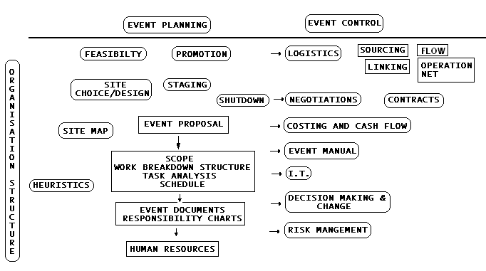

- Planning The Event
A significant part of event project management is the planning. It is a process of mentally fitting all the components together. It includes foreseeing any problems and solutions. However, to see all the problems is impossibility.

It is more realistic to regard event planning as a method of reducing the number of problems.
In this sense the aim of event planning is to plan all the tasks that can be planned so that changes and unforeseen problems can be dealt with in a focused way. Although most aspects of the event can be organized, the fluidity of event preparation means there is always the unexpected.

- Event Project Life Cycle
The basic tenet of event planning is that there will be changes as the event is organized. The staff will grow as the event nears. Some event companies go from 2 people during the early concept stages to over a thousand staff and volunteers on the day of the event. The concept that the event has a life cycle is a metaphor for the growth and change of the planning and implementation. The diagram below shows the event project life cycle.
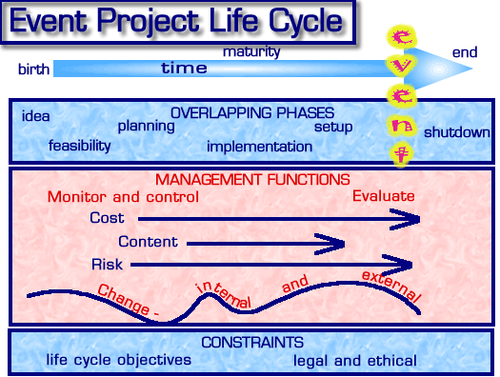

The event starts with an idea or concept, the first question to ask is “Is it feasible?” The feasibility is fed back into the concept (iteration) and the concept may need to develop. Once it looks feasible, the event planning can start. This is not a mechanical or linear model. The planning may uncover opportunities or risks that need to modify the event concept. Aspects of the plan may be implemented while other areas are still in the planning phase. For example promoting the event may start well before site planning. All these processes feed into each other.

There are some aspects of shutdown that may well begin during set up.

The areas of risk, content and cost as well as the schedule have to be managed along the life cycle. A risk may be very different over the event project life cycle. This means that event plan is not a static document. The only certainty is that there will be change. Internal change includes the increase in event staff, the increase in contract management as more suppliers are involved. Internal change may also be unexpected. The event company may take on other events while the one event is being planned. External change could be the all-too-common change of venue or it could be on a grand scale with the change in overseas currency exchange rate. No matter what change occurs the event will need to work within constraints set by the client - such as making a profit - or by legal and ethical issues. The former form the event life cycle objective functions. There may be far more subtle constraints implied by the client’s working culture - such as the corporate culture.
- Scale
The written event plan can be as short as one page or as long as a book. It depends on the level of detail or scale in the planning. This level of detail will depend on such factors as:
- Complexity of the event
- Scale of the event
- Familiarity of the event management, staff and suppliers with the type of event
- Legal and stakeholder requirements
- Time and other resources allocated to the task of planning

The process of writing a plan assists in the structuring of the event. It is also a communication tool and a project baseline from which the event can be measured. It is not ‘written in stone’ and will need revising as the organization of the event life cycle proceeds.
Risk
There is a risk that a written plan will become the master of the event rather than a method of obtaining a successful event. The Assessment -> Plan -> Implement -> Evaluate procedure is an oversimplification of a complex series of overlapping processes. This explains the reticence of event managers to create mission statements and objectives. In the volatile environment of event organization, these can easily become milestones around the neck of the event management. There is enough to do without having to revisit and rework all the objectives. As well, there is a tendency in academic writings on event management to see planning as the panacea of all event problems. They stress that the major failures of events are a result of poor planning. This is a tautology and a result of 20 20 hindsight. If planning is defined as foreseeing all problems before they arise then ipso facto there has not been enough planning. A good example of turning an historical description into a prescription. In the real world of event organizing, change (and problems) can come from anywhere. A local Prince may dislike the event and cancel it.

The result of any change in a complex system made up of a fixed number of related variables can not be predicted. For example, if there are 200 tasks to set up an event and one of these tasks changes or a new one is introduced, the relationship between all the tasks may change i.e. 200x 199 relationships, which may well change all the relationships again and so on ad infinitum. In other words a small change can easily have unforeseen results.
Feasibility Study
A major element in a feasibility study is to provide a choice of various models for the event and discuss the implication of these models.
- Setting out the aims of the study
- Choice of time and place
  - Factors in Site Choice
  - Draft of Suggested Places
  - Factors in the Choice of Date
- Logistics
  - Sourcing
  - Transport
- Costing
- Revenue
  - Ticket scaling
  - Ticket distribution
  - Funding sources - sponsorship, foundations, grants
- Event Content
- Event Options or Models
- Comparison of Event Models
- Administration including contracting and organization structure
- Risk issues -including possible insurance
- Assessment of similar events
- Recommended Option
The most important section of the event feasibility study is the comparison of the choices - options or models. The comparison must use the same aspects of the event.
Event Promotion
In the world of marketing 'promotion' generally refers to a one-off event that provides a stimulus for the public to buy a service or product. A special event can be part of a more general promotion campaign of a company wanting to draw attention to their product. The Absolute Vodka venue at the Opera House during the Sydney Festival was an example of this. A local council may create a festival as a way of promoting their region. As used by the event industry the word promotion has come the full circle. It uses all the marketing techniques. As it is project based it has a definite life span. The risks involved in one off or first time events mean that the event manager has to be acutely aware of the tools of promotion. The audience does not have a reference point for the event other than that created by the promotion. With repeat events and festivals the audience and suppliers have at least an idea of the type of event, venue and scale. For special one off events, the promotion is strongly linked to the reputation of the organizing company, sponsors and other stakeholders as well as the actual program or event content.
As with all areas of event management, event promotion must be dynamic and able to respond to opportunities as they arise. Other areas of the event planning should also be able to respond to the unforeseen products of promotion. A good bit of PR can result in a surge of interest in the event and the event company needs to be able turn the response to the advantage of the event.
The promotion schedule is only a tool to assist the planning of the event - not the event's master.
Tools of Promotion
- Advertising
- Public Relations
- Direct marketing
- Word of mouth
Site Choice And Design
While selecting a site/venue for an event, we have to look into for following considerations,
- Size of the event – Large scale or on a Medium or for a shorter scale event has to be carried out.
- Location – Distance, accessibility, neighbours, history of other events, suitability to the event, etc. are the factors to be considered under locating a venue for an event.
- Design of the site – Site/venue design is an essential part of event management. The temporary nature of events means there is limited time for corrections to the design. Therefore the event manager can not forget that any element of design has an aesthetic as well as logistical - or practical - function.
- Layout of the venue – points to be considered are facilities to be provided, size and shape of the room, viewing potential, flow of men and material, etc. while deciding a site.
- Flow of people and equipment - Although it seems obvious, the flow of people and equipment around a site is often not considered over the whole event. In particular there are different flow patterns at deferent times. As well the event manager must be aware of the 'flow' during an emergency.
Staging
The staging of an event involves bringing together all the event elements around a theme. It is where the 'action' takes place at an event - where the audience looks. Staging is the heart of event management- it is basically the 'show'. All other aspects of event management surround it.
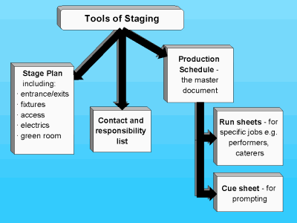
The elements of staging revolve around a theme. It could be Children's Circus, the Blues tent or a corporate dinner party theme. However the theme has to work within constraints - available resources, what the client expects....
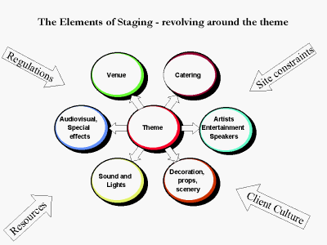

The efficient management of events is dependent on deciding what is most important in the given time span- i.e. priority. Different types of events place different emphasis on the staging elements. The staging is all about the guest/audience experience of the show- whether the 'show' is a sports competition, fun run or performance. An event manager doesn't need to know all about lights, sounds, audio-visual effects, special effects, etc. - but it is imperative that the manager at least knows the special terms used.

The Event Proposal
A response to a request for tender is a common way for an event company to obtain work. In some cases it is the only way a new event company can enter the field. Government and semi government companies are required by law to put their needed supplies and services out to tender. Most private companies will do this as a matter of good business to make certain they are receiving competitive quotes. The event industry is no different. An event company will put together tender documents in much the same way as any other supplier. Depending on the quality of their work they may be placed on a preferred supplier list and regularly asked to put in a tender. This can be an arduous task as the event company does not want to be dropped from the preferred supplier list but may not want the work.
Below is a checklist of what could be contained in the event proposal.
- Cover Letter
- Title Page
- Proprietary Notice - cautions about unauthorized disclosure
- Table of Contents (TOC)
- List of Abbreviations
- Executive Summary
- Body of Proposal:
  - Profile of the Event Company:
    - General: including mission, background, credentials
    - Specific: including previous similar events and resources available
  - Project partners and their profiles
  - Event Specific information:
    - Objectives
    - Scope of Work
    - Stakeholders
    - Themes, design and ideas
    - Site/venue assessment
    - Resources required: AV, entertainment, catering, staff, suppliers...
    - Marketing and promotional services needed
    - Possible sponsorship
    - Budget - corresponding to functional areas of program elements
    - Control management - reporting processes, organization structure responsibilities
    - Schedules - planning, transport, running order, promotion
    - Environmental impact - natural environment, traffic, transport.
    - Risk issues including insurance.
Venue /Site Map
With the exception of cyber events, all events have to exist in 3D space. It sounds obvious but it can be easily overlooked. The place of the event can create so many problems and provide so many opportunities. All the event managers place the site of the event as their highest priority. Most event mangers will not bid on an event unless they have carefully looked at the site. Professional conference organizers will stay a few days in the conference hotel venue just to make sure that nothing is overlooked.
The map can be used in these areas:
- Communication
- Planning - event design and logistics
- Promotion
- History and evaluation
However the map is only effective if it can be understood.
Planning and Control Documentation
It is one thing to plan the event it is another to communicate this plan to the various stakeholders. Correct event documentation is vital to effective management. The advantages are:
- It communicates the plan of the event to the staff and volunteers
- The documents provide an ongoing record of the event's progress
- They provide a history of the event planning which may be used in any liability issues
- They provide a written basis on which to improve the methods of event management
- By standardizing the documents, different events can be compared

- The production of the documents creates a discipline in the planning
- The documents impersonalize the plan - that is it takes it out of the hands of any one person and it becomes separate from any individual.
- The documents proved a link to other departments within a corporation such as finance and with the sponsors.
One of the most common fears in event management is what happens if the event manager falls ill (‘run over by a bus' is the colloquial saying). As long as the details of any event are in the head of one person there is this risk. The results of the project management process are documented as various schedules, responsibility and action sheets. Each event company has evolved their own style of sheets.

They are called by various names : production schedules, task lists, output matrix, timelines, run sheets, critical paths, checklists, event order, milestone lists, show schedule, show sequence ... The terms used generally reflect the past work experience of the event manager. However they all converge into six planning and control documents:
- Contact Sheet
- Responsibility Chart
- Task or Action Sheet
- Work Package
- Checklist
- Run Sheet or Production Schedule - (the implementation schedule) which concerns the program of task at the actual event and can be further subdivided into specific Run Sheets - such as Rehearsal, Technical, Shut down ...
- EVENT CONTROL
- Logistics
Logistics is both a science and an art. It is also a convenient way of classifying an aspect of event management.
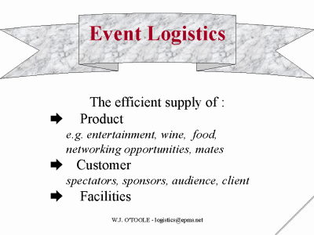
In logistics the areas of importance to the events are supply, transport, linking, flow control, and information network.
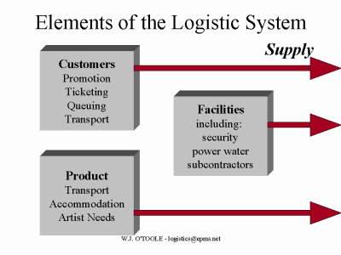
Each of these elements can be thought of as contributing to the sourcing and flow of the customers. They all require a checklist. The event product can be intangible as well as tangible items. However they all need to be supplied efficiently to the event. The facilities are the third element that needs to be analyzed in logistical terms. Supply - sourcing and flow - both to the event, around the event and out of the site.
- Negotiation
It seems obvious but it is often forgotten - an event is a one-time occurrence. Every year the annual festival is different. Change is fundamental to event management. Change will mean entering into different business relationships for every event. The result is that negotiation skills are fundamental to event management. Negotiation does not mean tricky dealings - it means coming to a mutually satisfying business arrangement.

A large part of event negotiation concerns the resources used to create the event. They can be divided in to:
- Standard resources - the negotiation for standard resources is fairly straightforward as most of the constraints and parameters are already known. For example in hiring a venue there will be a standard contract. The event manager needs to know the contract terms and the history of the use of these resources at events.
- Customized resources - these are specialist resources created for the specific event. There may not be a standard contract or process. In this case the negotiation has to be well researched with risk and contingencies thought out. An example of this is the harbour floats for the Sydney's New Year's Eve event.
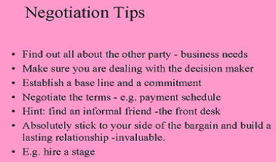

- The Event Manual
- The Generic Manual
The manual can serve as both a list of procedures to successfully plan and implement the event, and a record of the procedures. It is part of the intellectual capital of an event organisation. The discipline involved in creating a manual can assist in the systematic planning of event operations. Many large companies have a generic operation and logistic manual that can be used in similar events organized around the world. Of all the areas of event management, the exhibition industry has created the most comprehensive event operation manuals. These manuals can take the event manager from the idea of an exhibition through the suggested marketing schedule to sourcing venues and creating floor plans. As they are going to be used with different operation teams, such areas as common terms and definitions and a plan for the filing system (both digital and paper) become an important section of the manual. These manuals can be set up on the web or the company intranet and become part of their knowledge management system.

In general the manual is the document outcome of the project management process. The event operation manual can vary in its content. It is the result of the project management process combined with experience and advice- no matter how informal or unstated. This process is illustrated below.

The checklist below is for a specific event operation manual - it is the manual to be used on the day of the event.
- Design
- Strongly bound, colorful, and plastic cover so it can be used and found on the day
- Tabs with program elements (stages) for quick reference
- Cover with logo
- Contents page also show tab list
- Index
- Contacts
- Event coordinator mobiles
- Emergency Services - police/ambulance/fire numbers
- Lost children procedure
- Lost property
- Headquarters - where and when open
- Police - where on site
- First Aid - where on site
- 'On the Day' Event Contact List (one page)
- Road and Traffic Authority
- Venue Management
- Defence forces
- Infolines for event
- Performer contact list - listed by stage, parade
- Radio channel list
- Two-way radio operation guide
- Production
- Event summary - time/action/location
- Map of event site
- Production Schedule by locations (stage)
- Set up schedule - date, action, supplier, crew number, option
- Crew (backstage) schedule - bump in and bump out times
- Crew catering requirements
- Crew accommodation
- Information booths and map of their location
- Security information
- Security
- Information Technology for Events
Information Technology is rapidly changing the way events are both planned and controlled.
Areas of event planning and control that can benefit from IT:
- Scheduling
- Financial control and Budgeting
- Promotion
- Distribution
- Control and reporting
- Risk management and scenario building
- Contact management
- Site/venue layout
- Staffing and volunteer management

Possible limitations of IT for events:
- Financial costs
- Retraining staff
- Limited access, passwords and computer security
- Information loss
- Refocusing the event
- Software compatibility
- Restructuring the event company - particularly corporate culture problems and power shifts as a result of knowledge and skill ownership.
Use of information software in
a. Design stage
- Presentation software such as PowerPoint
- Spreadsheet software to establish budget scenarios such as Excel and Lotus CAD
- Graphics software in the creation of themes and logos
b. Planning process and basic business support:
- Word processing packages such as MS Word and Word Perfect
- Accounting software packages such as Quicken and MYOB and spreadsheets
- Project Management software including MS Project
- Data Management software including Dbase and Outlook
- Communication software including Eudora and MS Outlook
c. Marketing of the event:
- Ticketing and Smart card use
- Tracking
- Internet Marketing and Web sites
d. Implementation:
- Registration in both sport and conference software
- Audio visual software
- Video production and editing software
- CDROM production
- Digital broadcast
- Scoring and scoreboard display
- Risk Management
In the event field as in so many project based industries the identification and management of risks is a high priority for management. There are special circumstances at events that add to the importance of risk management such as
- Large crowds
- Use of Volunteers and inadequately trained staff
- Untried venues and sites
- Quick decisions and inadequate time, particularly as the event gets closer
- Complex and specialist activity
- Thrills and Spills - i.e. activity that is meant to seem like it is a risk.
- Need for good community relations
- Untried communications
- New event company
- Little 'continuing work' control over subcontractors and suppliers
When combined the above points provide a very good reason to identify and control as many problems as possible.

Risk Identification
Part of the knowledge gained by event experience is the ability to identify risks. It would then make sense to ask those people with the most experience. In many cases this is the subcontractors and suppliers. Although the event may take a year to plan and be over in a day, the suppliers are continually working at various events and their knowledge is invaluable to the event manager.

Other methods of identifying risk are:
- Meetings with stakeholders
- Employing risk management experts
- Raising the issue at staff and volunteer meetings
- Through the local councils and police
- Asking the emergency service suppliers
Brainstorming is a common method of identifying risk. The brainstorming meeting can apply itself to the whole event or to particular sections.

The use of test events, event modeling and 'event incubating' are methods for risk identification. The Olympic Organizing Committee carries out a detailed schedule of smaller events that test aspects of their overall plan. As yet there is little computer modelling of events. However, simple financial scenarios, using spreadsheets and project management software, are used as a method of risk identification. On a larger and more scientific scale, events can be 'incubated' in a controlled environment or on a small scale and the finished plan is used as the basis of a larger event or franchised to other regions.
National Institute Of Event Management
The institute
Event Management is done at a very huge scale in India. We have the greatest stage and television shows in the world. The growth of sophisticated and mega companies have brought forth a spurt of Meetings, Seminars, Exhibitions, Conferences, Product launches and all have to be a matter of class and style. Then come the celebrity shows, international artist shows, shows for a cause, road shows, competitions and you name it and India has it. In India even personal functions like Marriages and Birthday parties have become such important social matters, that they have to be managed professionally.

Research showed that there was no formalized education to teach Event Management. Event Management Companies found that they had to spend a lot of time in training personnel and they will lose a perfectly trained person to a competitor for better bait. Companies found that their executives lacked expertise to handle events, and hence a growing need was felt, to have a formalized training in Event Management. If it could be done in Advertising, Marketing, Communications and Public Relations, Than Why not Event Management? But it was not so easy because Event Management encompasses all; it includes Organizational skills, Technical and Production Knowledge, P.R. Marketing, Advertising, Catering Logistics, Décor, Glamour Industry, Human Relations, Study of Law Licenses, Risk Management, Budgeting Study to Allied lines like Television and other Medias, and the list just does not end here. So it took a painstaking three years research to start a course on Event Management. National Institute of Event Management was formed to cater to the growing needs of the huge multi-dimensioned Event Management Industry in India.

Mission & Vision
NIEM believe that creation and dissemination of knowledge is essential for any effective management. NIEM’s mission is to create future leaders, managers and professionals in the Global Event Management field by offering superior learning opportunities, engaging in research and scholarly activities along with a perfect blend of practical training on some of the most awesome and glittering sets of the worlds biggest events.
NIEM are guided by their commitment to achieve excellence in research and knowledge on event management and promote entrepreneurial spirit by encouraging the intellectual and diversified development of their faculty and students.

Through their distinctive curriculum and post graduate program they challenge the students to think and communicate and with a supportive climate of civility and freedom of expression their students become ethical, informed, wide spectrum med and articulate participants in society.
NIEM aims to
- To create a new generation of Event Personnel and groom them to become Event Organizers of the future. NIEM has already done it. It has created the largest number of event personnel in the world.
- To professionalize the field of event management.
- To organize the event sector and bring Indian events to the class of global events.\

Various Projects Undertaken By NIEM & Its Students
NIEM students have worked on various projects and come out with credit and flying colours.
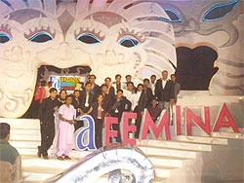
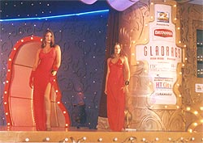
- Ceat Cricket Ratings
- Lata Mangeshkar Night
- Deep Purple Concert
- Zee Cine Awards
- Mahindra Scorpio Launch
- Sir Elton John Concert
- Sansui Awards
- Alpha Gaurav Awards
- Tele Awards
- Mata Sanman
- Pune Festival
- V. Shantaram Awards
- Miss Pune
- International Film Festival Pune
- Movie Premiers
- Alpha Mumbai Gaurav Puraskar
- Drishti - Indian Express
- Bryan Adams Concert
- Manikchand Dandiya
- Priti - Pinky Dandiya
- Times Utsav Dandiya
- Falguni Pathak Dandiya ‘Sankalp’
- Miss Mumbai
The Way, Niem Manages Events
NIEM is an institute which manages and organizes events by working in the teams. These teams are defined on the basis of the type of events they manage and organize. Normally, NIEM handles 2 types of events, viz. In-house Events and Out-house Events.

Events
The events managed by NIEM are basically classified into two types, viz, In-House Events and Out-House Events.

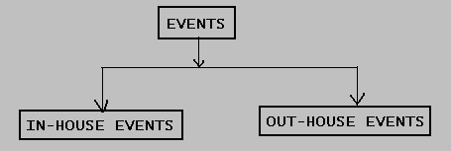

- In-House Events

In-House Events are the events that are totally managed and organized by the NIEM. These events are normally managed and organized by the students of NIEM. Various events organize by the NIEM are
  - MR AND MS UNIVERSITY
  - ALL INDIA RADIO FM
And many more…………………..

- Out-House Events

Out-House Events are the events that are manages by the NIEM students but are organized and controlled by the event management companies or event managers other than that of NIEM. Various events handled by the NIEM students but organized by the others are
  - ZEE CINE AWARDS
  - SANSUI AWARDS
  - BRYAN ADAMS CONCERT
  - STAR SCREEN AWARDS
  - MTV LYCRA AWARDS – 2003
  - MTV IMMIES – 2003
And many more………………

Teams
A team comprises of any group of people linked in a common purpose. Teams are especially appropriate for conducting tasks that are high in complexity and have many interdependent subtasks. No significant task can be accomplished without the help of essentially all team members, team members typically specialize in different tasks, and the success of every individual is inextricably bound to the success of the whole team.

NIEM manages all its events by working in teams. These teams depend upon the type of events which NIEM handles. Generally, these teams are named after the event types. i.e. In-House Team for managing In-House Events and an Out-House Team for managing Out-House Events. These teams are decided by the Principal of NIEM. These teams are further sub-divided into sub-teams and committees depending upon the nature of events.

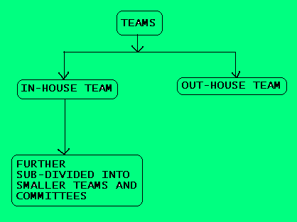

- Out-House Team

Out-House Team is formed for managing the Out-House Events. These events are organized by the event managers and the event management companies other than NIEM. Hence, we can say that the events which are not managed by the NIEM are said to be the Out-House Events. This Out-House Team is completely managed by the event managers and event management companies. The head of this team is not a NIEM member. The student who has first worked with the In-House Team is only given the opportunity to work in the Out-House Team. Here, also, there is no restriction on the no. of members that should be present in the team. The nature of working of Out-House Team completely depends on the nature of the event management company.

- In-House Team
In-House Team is formed for managing and organizing In-House Events. In-House Events are the events that are totally managed and organized by the NIEM students. This In-House Team is further sub-divided into smaller teams and committees. This team is responsible for the whole event. There is no limitation on the no. of members to be present. Any no. of members can form the In-House Team. The Principal allocates the work to the sub-teams and committees. In-House Team is completely managed and organized by the students of NIEM. And at the top level of these teams students only handle the work and responsibilities.
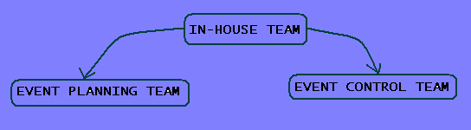
This In-House Team is further subdivided into Event Planning Team and Event Control Team. As the name suggests, that Event Planning Team would be looking after the work of planning the whole event and the Event Control Team has to control the whole event.

Event Planning Team
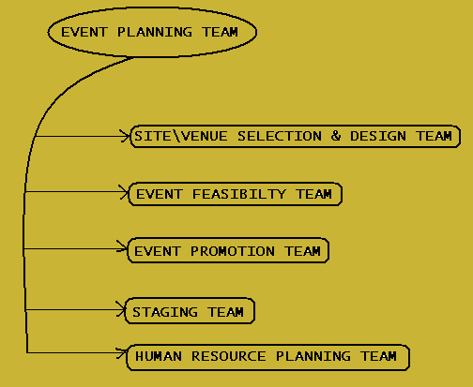
The aim of Event Planning Team is to plan all the tasks so that changes and unforeseen problems can be dealt with in a focused way. This team deals with the planning of the site/venue selection or design, preparing the feasibility report, promoting the event, designing the stage for the event, and planning the human resources. The above functions of event planning are divided into further sub-teams based on the area of responsibility.
- Site/Venue Selection & Design Team
This is a team which decides the venue or site where the event has to take place. The team is totally responsible for the venue designing and selection. They have to prepare a report on the site selection that why they are selecting this venue, what are advantages of the venue, and more related queries on the venue location. They also have to design the venue that means how the location should be, which object should be present where, and many others.
- Event Feasibility Team
Event Feasibility Team has a very important task to do. That is, the team has to prepare a feasibility report about the whole event. The team has to make a research that whether organizing that event would be profitable or not and what are the implications of that event on the reputation of the organization or whether the transportation/logistics cost would not be high by organizing event at a particular place or are their any risk that would arise out of the event and more related aspects.
- Event Promotion Team
Event promotion team, as the name suggests, is responsible for promoting the event to the target audience. This team has to plan a perfect combination of 5 areas i.e. advertising, public relations, direct marketing, word of mouth and hospitality for promoting the event. This team has a control over the tools of promoting an event. We can say that the team is the one which creates a stimulus in the minds of the people.

- Staging Team
Staging team is responsible for designing the stage. Staging is the heart of event management. This team has to decide particularly about a stage that how the stage should be looking or where the sound system should be kept or how the cameras would be placed or how the décor should be maintained and many other related areas. This team has the work to be done well in advance but their work is seen and felt only at the time of the actual event.
- Human Resource Planning Team
The Human Resource Team is able to decide that what number of staff is required during the event, before the event and after the event. This helps the event management organization to hire the staff for the actual event as per the need.

Event Control Team
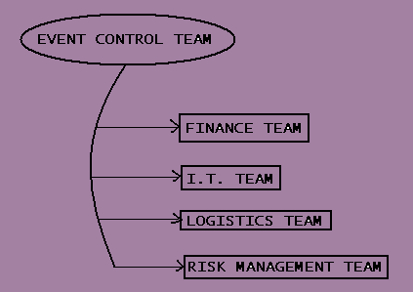

The aim of Event Control Team is to control the various factors for organizing an event. The whole event is controlled with the help of factors such as finance, logistics, I.T., etc. The Event Control Team is further sub-divided into finance team, I.T. team, logistics team and risk management team.
- Finance Team
As the name suggests, finance team deals with the financial implications of the event on the organization. The finance team estimates the event costs, cost for promotion, logistical costs, human resource cost, etc. That means the finance team has to look after the various factors that affects the profitability of the event management organization.
- I.T. Team
I.T. team deals with technological aspects of the event. It deals with the areas where the technology is used for managing the events. Those areas could be promotion of the event, designing the event, controlling the technical areas on the stage, etc. Hence the team is responsible for all these areas.

- Logistics Team
This team mainly deals with the logistics and transportation factors of the event. The team has to identify the risks and benefits arising out of the transportation of various equipments, etc.
- Risk Management Team
The team has to identify the various risks arising during and before the actual event. The organization has to control those risks by identifying them earlier and finding appropriate solutions to avoid those. The various risks can arise out of large crowds, using inadequately trained staff, negative publicity, and many more.

Niem’s View About Event Management As An Industry

Event Management is a multi-crore industry with mega shows and events hosted regularly. In India personal functions like marriages and birthday parties have become important social matters, and have to be professionally managed. The growth of sophisticated and mega companies have brought forth a spurt of meetings, seminars, exhibitions, conferences, product launches with everything being a matter of class and style. Then comes the innumerable celebrity shows, international artists shows, shows for a cause, road shows, competitions, that India has seen of late.
More than 200 companies have forayed into events. The early 90s has seen events spend at a mere 20 crores but now it has increased to over 500 crores. Growth is therefore 200% annually. The FICCI has estimated event management to be a 3500 crore industry by 2009. But surprisingly, research showed that there was no formalized education to teach event management and Companies found their executives not up to the mark to handle events. It was not so easy to train because event management includes organizational skills, technical knowledge, P.R., marketing, advertising, catering, logistics, decor, glamour identity, human relations, study of law and licenses, risk managements, budgeting, study of allied like television and other Medias and several other areas. The Present Scenario is extremely positive and this is the right time to open small & medium sized Event Companies. NIEM students are taught how to form an Event Company and many of them have successfully done it.

Factor that distinguishes NIEM from its competitors in the Industry

Regency International Institute of Tafe is situated at Adelaide – South Australia, and it is a world class Institute wholly owned by the Government of South Australia. It specializes in Food, Leisure and Event studies and has a very high name in Australian study circles.
Impressed with NIEM’s excellent track record in the field of events and its 5th position in the world and first in Asia, Regency chose NIEM as its INTERNATIONAL PARTNER and gave an opportunity to NIEM students to get an additional elite diploma called DIEM (Diploma in International Event Management) from this coveted Institute. NIEM students are the ONLY PRIVILIGED STUDENTS IN INDIA to get this elite International Diploma which no other Indian students of any University, Institute or college can get, i.e. the DIEM. The advantages of holding the DIEM are:-
- Its exclusivity that you are the only few Indian students holding an International Diploma.
- The power it adds to your C.V as an additional world class diploma.
- You get it with the regular NIEM’s DEM & PGDEM, so no waste of extra study time.
- You learn two subjects in International Event Management.
Your Diplomas will also carry the rare honor of having the logo of the Government of South Australia along with the Regency logo. The cost and procedure is kept simple to be of great use to NIEM students and you can do it without sparing extra time or efforts.

Media Opinion About Niem
- 'No Body can organize like National Institute of Event Management'- Bombay Times
- 'And rest assures, the institute isn't one of the many that springs up in every street corner, it has come in to existence as an autonomous body only after painstaking and detailed research in the field'-Bombay Times
- 'Said the Events Manager of ZEE the students of NIEM were so good that its like ZEE-NIEM marriage and we will definitely work together in future'-Bombay Times
- 'A programme that adds Power to your CV- Head Start'- Indian Express
- 'According to a study, DEM Graduates will draw 50 percent higher salary compared to a Management graduate'-Kaleidoscope- New Woman
- 'In April 2000 NIEM was set up. It is considered to be on par with Event Management Institutes around the world'. 'It is very different from other courses It is very interactive and a lot of emphasis is given on practical training. You learn a lot more than in other management courses'. The response entertainment industry has given NIEM is very encouraging'.-Mid Day
- 'Dr Hoshi Bhiwandiwalla rightly called the Father of Event Management in India'-Mid Day
- 'NIEM was the only institute to speak on Event Management on All India Radio- FM

Case study : Industrial visit to Goa

As a part of curriculum each and every B school take there students for the industrial visit .The industrial visit is a good way to learn the practical aspect of the industries. In which students can practically see the process and learn form it. Each B school take there students for this study tour. The primary objective of such a type of tour is learning because of which such study tour are organized. But as all study and no play makes Jack a dull boy so students are also taken for site seeing so that they can also learn from it. These tours are mainly long tour wherein students travel to far flung areas just to get the feel of the actual industry. The knowledge which they gain from such kind off tour is much more practical and help them understand the intricacies of he industry .
These tours are handled by professional tour operator who looks after everything right from traveling to stay and food arrangement.

As our college OIM also conducts such type of tours, as part of curriculum our college visited Goa for its tour. I going to study this industrial visit and will critically review it. So that as a part of my event management project I can very well learn how such type of event are handled and also I will get practical knowledge of it.

I am taking this case to study an industrial visit which was arranged by our college OIM for students in early November for which all the 220 students of OIM were taken for a study tour to Goa which included al the 1st year MMS , second year MMS and students from PG .

This was a four day trip which included a traveling by train traveling was during day time and it was for over 5 days, in which two days where for traveling to and fro goa and Mumbai . This tour was arranged by a tour operator called as Khusi holidays Pvt ltd which are in to educational tours and travels. They took care of all the arrangements for the tour which included traveling food and hotel arrangement.

According to students they had tough time while on this visit . Especially with the arrangements, like they were provided with the food while traveling in train which most the students were not happy with. Same company looked after the arrangement of intercity traveling. The hotel arrangement was fair enough but some students had some or other problems even with hotel arrangements, the food provided by the hotel was not satisfactory according to students. While traveling from different sites people had problem with arrangements as well. Students were also taken for the site seeing where in they where shown some sites in Goa . I am trying to study what went wrong in tour so that I can find it out and analyze the problem so that I can draft a better plan for the future so that such kind off events can be better handled next time. For which I prepared a questionnaire for students and management of the college .

Appendix

Questionnaire for participants

    - Which is your area of specialization?

    - Do you prefer one day industrial visit or industrial visit with stay ?

    - Have you ever been to industrial visit?

    - What do you prefer one day industrial visit or industrial visit with stay?

    - What do you hope to gain from industrial visit ??

    - Along with learning what else do you expect from industrial visit ?

    - Do you want industrial visit as per your area of specialization?

    - What is that you liked most about last industrial visit ?

    - Which specific area your industrial visit should highlight? ( eg. Specific area in marketing like packaging /finance)

    - Were you happy with the traveling arrangement?

    - If yes why?

    - If no why?

    - Which mode of transport do you prefer?

    - How was your hotel arrangement?

    - If good why ?

    - If bad why?

    - Do you think site seeing is important aspect of industrial visit?

    - Are you ready to pay more for traveling if better service is provided?

    - According to you, what is included in ideal industrial visit ?

    - Do you want management to consult you before industrial visit?

    - What flaws did you find with the tour operator?

    - What did you like most about your tour operator?

    - Was your tour operator easily accessible?

    - Do you think lack of tour plan was major constrain ?

    - What kind of problems did you face?

    - Were your problems sorted out?

    - Which place would you like to visit next?

    - What is that one thing which you would like to see in such type of tour?

    - Do you find industrial visit. important part of your curriculum or just waste of time, ? give reason .

Questionnaire for management

1 .Do you think industrial visit. is important for students?

2. Do you think students’ orientation is important before industrial visit.?

If yes why?

If no why?

3. What do you expect from students during industrial visit?

4. What are your responsibilities in arranging tour ?

5. What was the reason behind selecting Goa as destination ?

6. Was safety one of the criteria will arranging the tour ?

7. What precautionary measures did you take to avoid any discrepancies ?

8. Why did you select that particular tour operator?

9 .What difficulties did you face during arrangements ?

10 .Which activity did you find toughest to handle in terms of arrangement ?

11. Where you happy with arrangements done by tour operator?

Research methodology

Problem: Participants dissatisfaction towards the industrial visit to Goa
conducted by the college .

Objective: Identify exact problem and its causes and give recommendations
to rectify the same.

Source of data: For the purpose of the project primary data was collected this
primary data was collected from students and the management of the
college.. For this a questionnaire was prepared with the help of this
questionnaire the data was collected. Questionnaire shown in the
appendix was used .questionnaire contains open ended questions.

Sampling method : Random sampling was used in which sample size for students is
70 and for the management it was 4
.

Research analysis

Analysis of participants

Question : Do you want industrial visit as per your area of specialization?

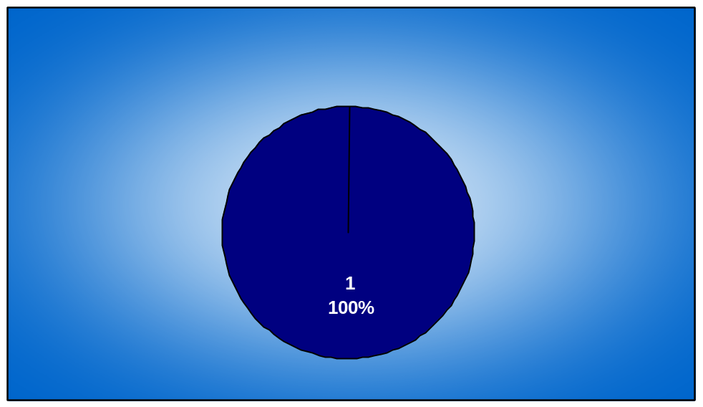

Analysis : most of the students want the industrial visit as per there area of the specialization like there are different students who are from marketing , finance and HR so they all wanted to learn as per there area even though they knew, its not possible two fulfill every bodies desire, but they wanted little beat idea about there area.

Question : Do you prefer one day industrial visit or visit with overnight stay ?

Analysis : 100% students want industrial visit with stay because they feel it is not easy to manage it in a day as it becomes very exhaustive if its a day industrial visit and also they don get proper time to observe the industries.

Question: What do you hope to gain from industrial visit ?

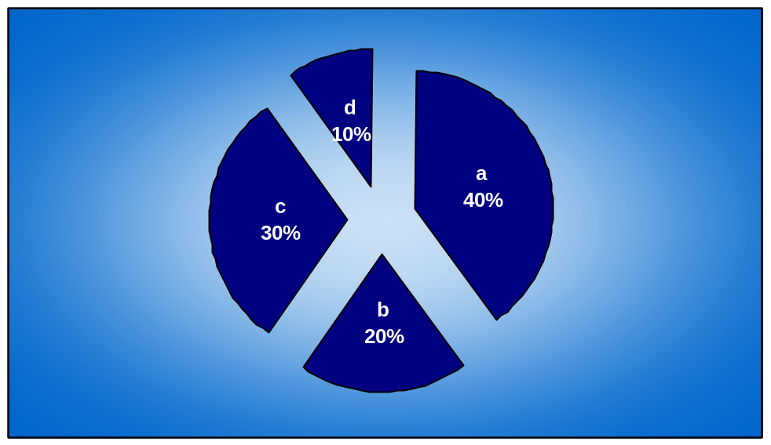

Analysis : students wanted things like
a .Practical knowledge of the industry
b company detail
c learning and recreation
d guide to explain the tour

Question: Along with learning what else do you expect from industrial visit?

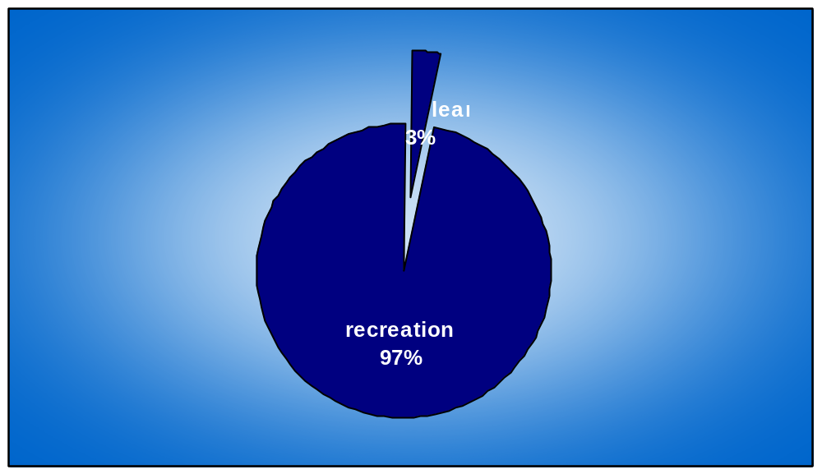

Analysis: There is only one student who says that he wants only learning rest all want enjoyment in terms of site seeing.

Question :Are you satisfied with the industrial visit you visited ?

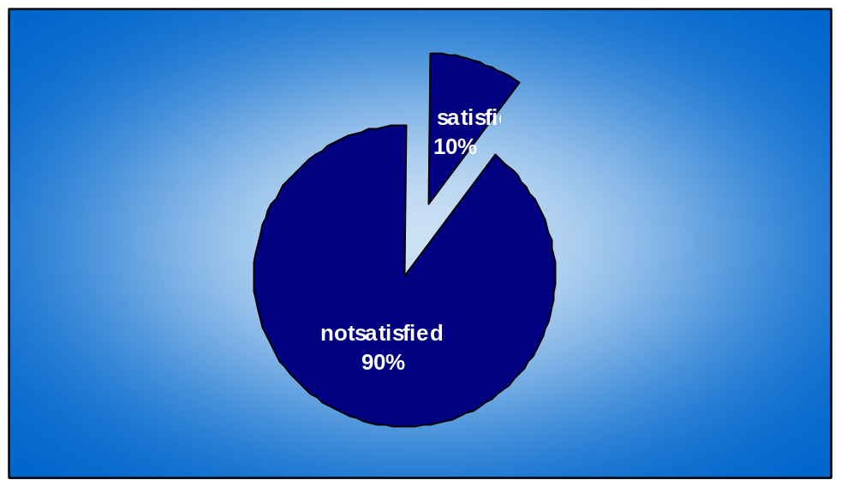

Analysis : 90 % of students were not happy with the industrial visit which was last visited and only 10 % were happy with it .As they say it was not very well organized .

Question: what is that you liked most about the last industrial visit ?

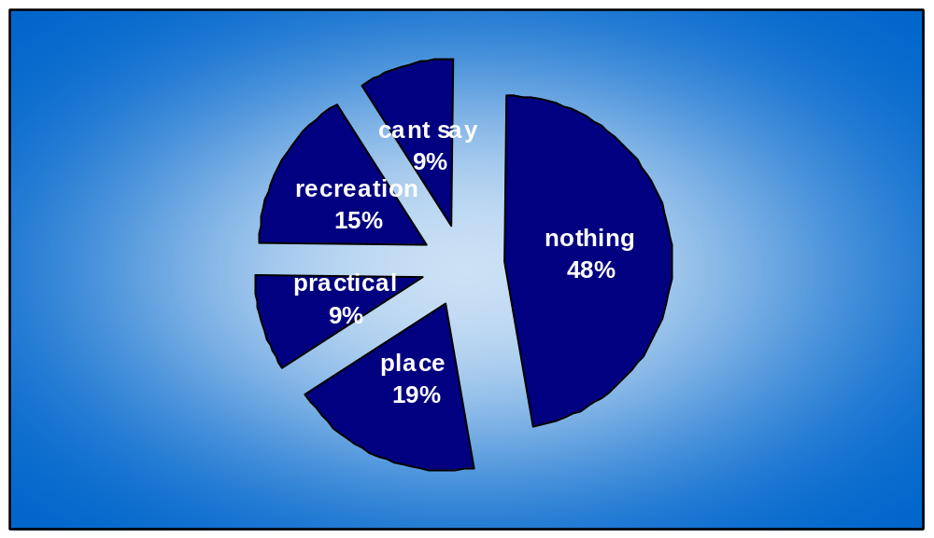

Analysis:
Nothing: 46 % students did not like anything about the industrial visit

Place: 18 % of the students liked the place which is Goa

Practical knowledge: 9 % of the students where happy with practical
it provided.

Recreation: 15% of the students like the fun element of the industrial visit
like site seeing

Can’t say: 9% of the students where not able to figure out what they liked
about the industrial visit
.

Question: Were you happy with traveling arrangement?

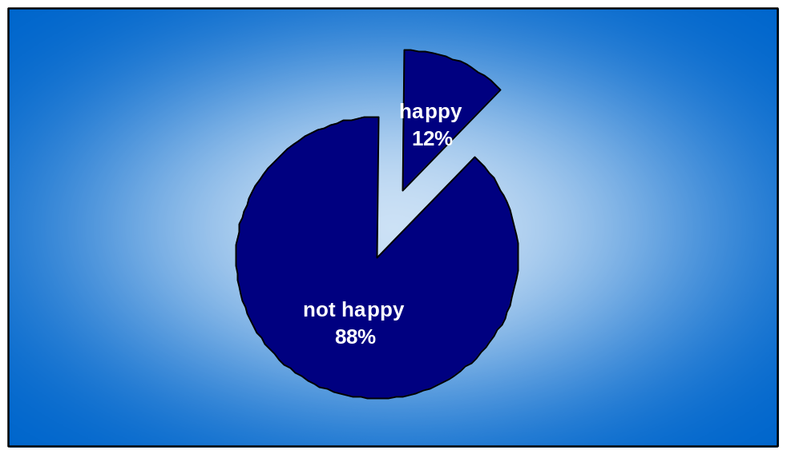

Analysis: Only 12 % of the students were happy with the traveling arrangements
Because they found it safe to travel in train and also thought that at least it
was on time . On the other hand 88 % of the students were not happy with the . arrangements done. because they found it was having following
flaws.:

1. Improper arrangement

2. Bad schedule

3. Bad behavior by drivers in busses

4. Uncomfortable seating arrangements

5. Charges were high .

6. Cleanliness was not up to the mark

7. No proper time management

8. Changing compartments

Question: Which mode of transport do you prefer?

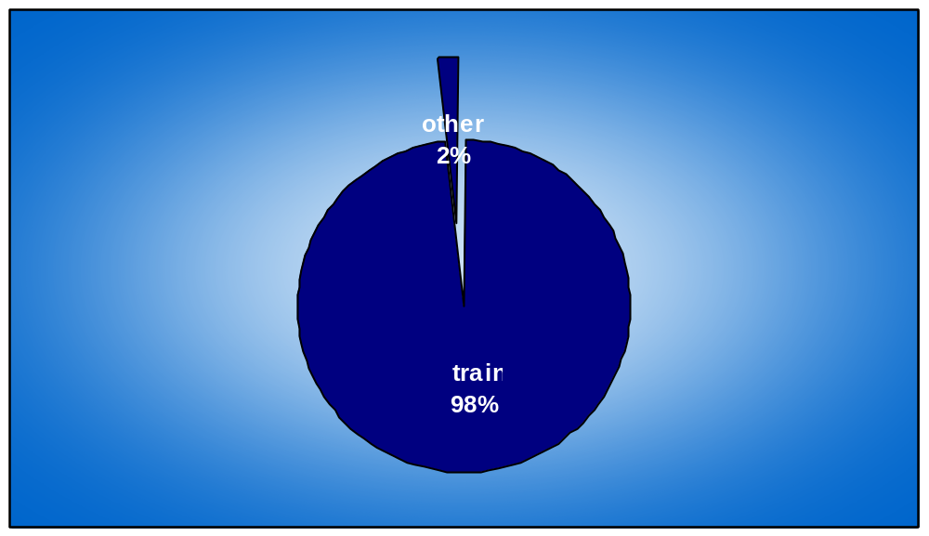

Analysis:

Train: 98% of people prefer train as they feel its very safe and affordable.

Question : How was your hotel arrangement ?

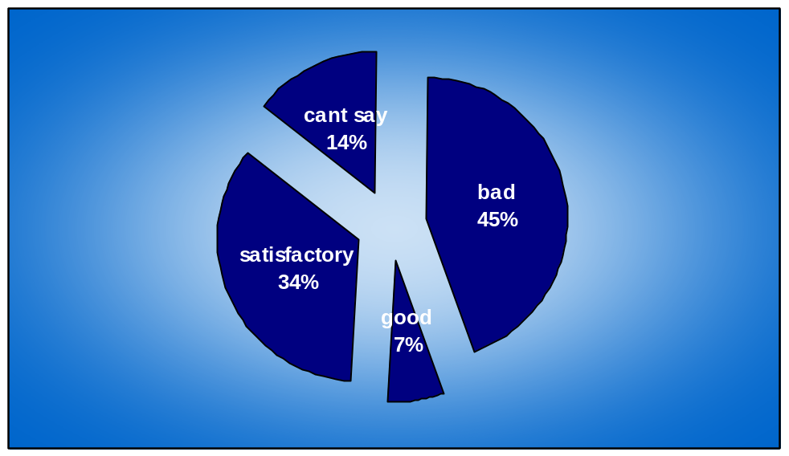

Analysis :40 % of the people found hotel arrangement was not that good
as infrastructures of the hotel was not good and there was no proper
security provided as theft broke and students lost there belongings. The
food of the hotel was the biggest disappointment .and also they found
that it was in remote area.

Only 6% of the students found it to be good as they say it was spacious
and clean ,and had TV, AC and fridge in the room .

And 31% of the students were satisfied with hotel arrangements.

Rest were not able to figure out how it was .

Question : Do you think site seeing is important aspect of the industrial visit?

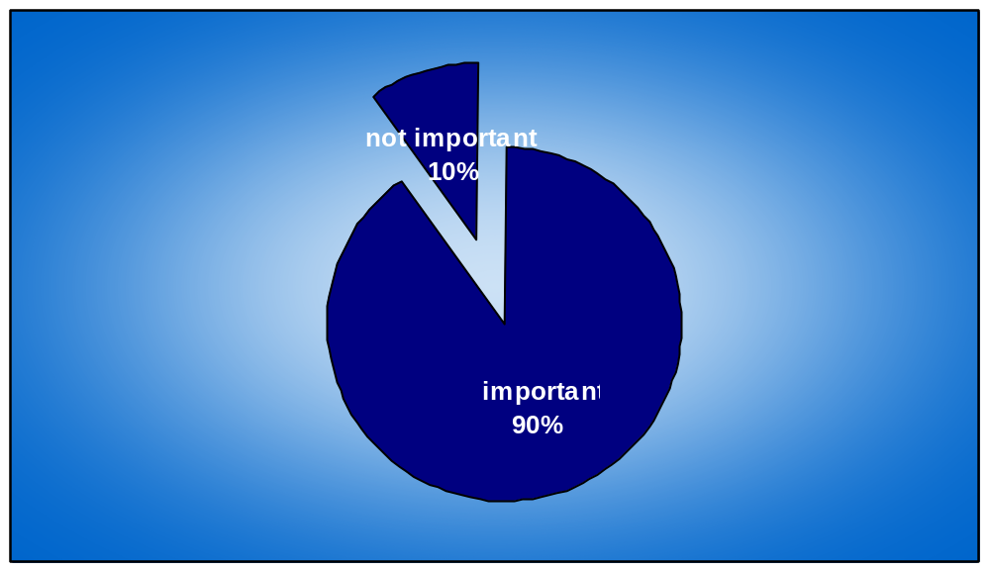

Analysis:

Yes :90 % of the students think that site seeing is very important apart of
industrial visit as it helps them to refresh and helps them to see new sites.
No: 10 % of the students think that it is not that important , and should be done
only if time permits.

Question : Are you ready to pay more for traveling if better service is provided ?

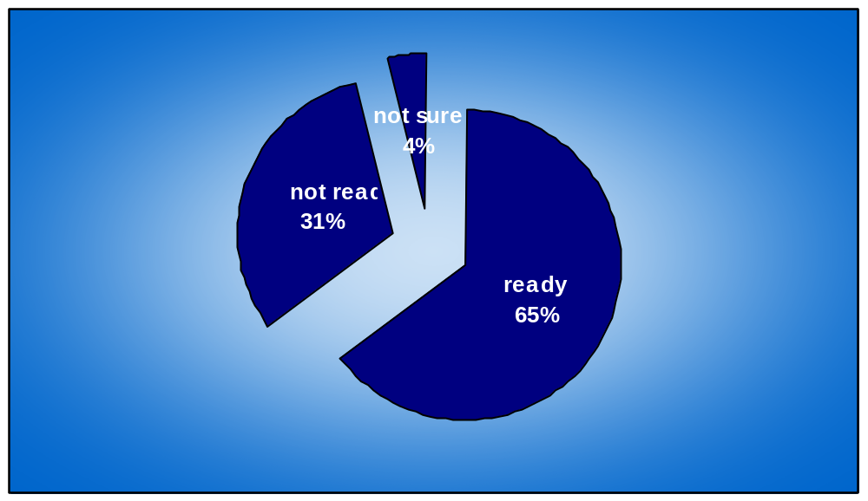

Analysis : Yes :65% of people are ready to pay more if better service is provided for
traveling purpose as they are not happy with the traveling arrangement
done

No : 31 % of people are not ready to pay more for traveling .

Cant say : 4 % of people are not sure if they want to or they don’t want to.

Question : According to you what is included in an ideal industrial visit?

Analysis :

- Good traveling arrangement
- Thorough planning
- Practical knowledge about the industry.
- Value for money.
- Meeting top company executives
- Entertainment
- Knowledgeable guide
- More than 5 companies to visit

Question : Do you want management to consult you before industrial visit?
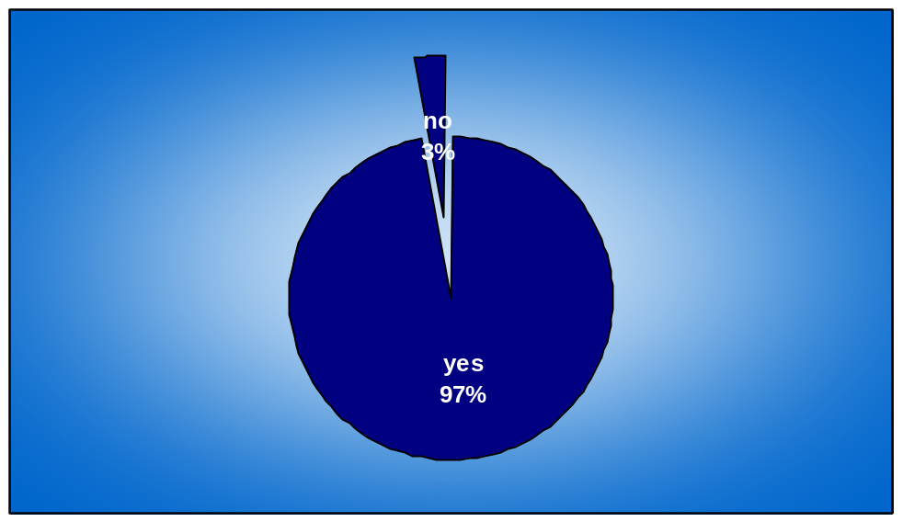

Analysis :

Yes : 97 % of the students want management to consult them
before deciding over industrial visit

No : 3 % of the students feel that its not necessary for the management
to consult them .

Question : What flaws did you find with the tour operator ?
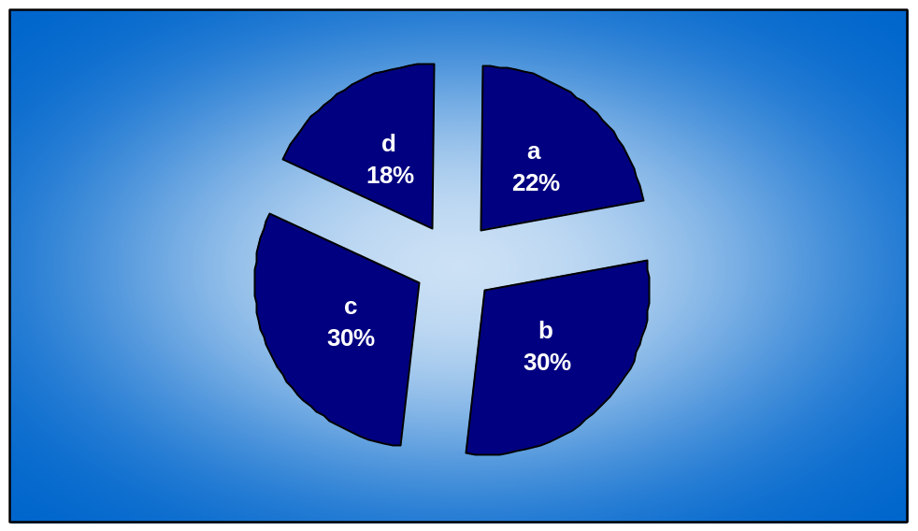

Analysis : students found following flaws with tour operator .
- Not organized
- No proper communication with students
- Very bad in managing time
- He was not clear about the industries

However some students found no flaws with him.

Question: what did you like most about your tour operator?

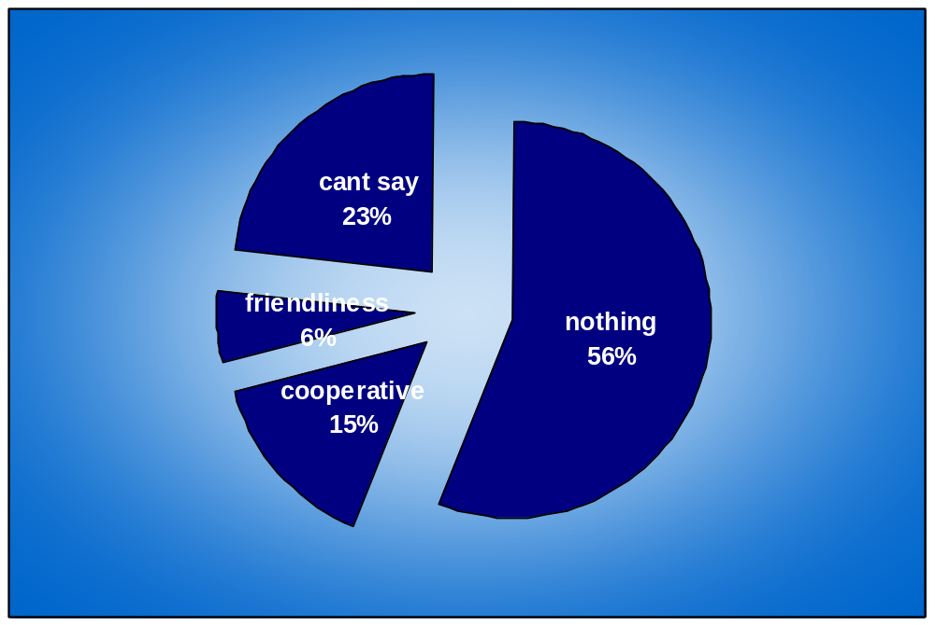

Analysis :
Nothing : 56 % of students found nothing good in him

Cooperative : 15 % of the students found him cooperative

Friendliness :6 % found him friendly .

Rests were not sure about how he is as they never approached him.

Question : Do you find lack of tour planning as a major constrain ?

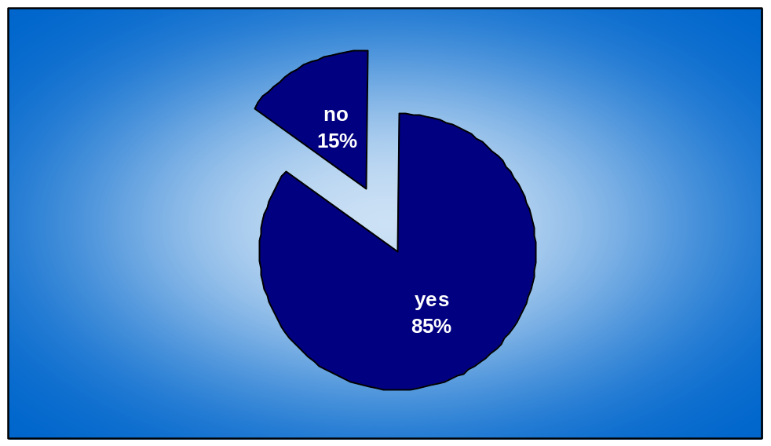

Analysis :

Yes :15 % of the students feel that there was no problem with tour planning

No : 85% of the students found out that there was no tour planning
.

Question : What kind of problems did u face ?

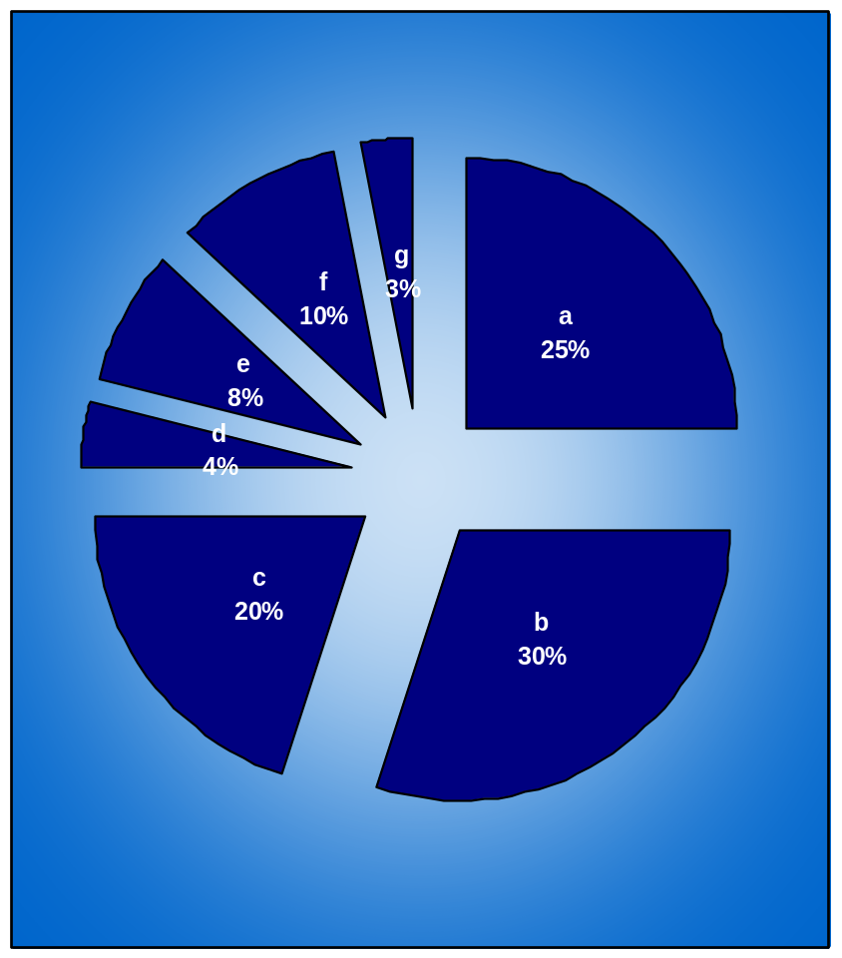

Analysis : Problems faced by the students were :

a. No coordination
b. No proper infrastructure
c .Didn’t serve the purpose of industrial visit

d Tour operator had no idea about industries

e No proper schedule

f Wastage of time

g No proper security

Question : What is that one thing which you would like to see in such type of tour ?

Analysis : students wanted to see things like , good time management , better
coordination, , better food, hotel ,planning .

Question : Do you find industrial visit important part of your curriculum, or just waste of
time give reason ?

.

Analysis : Students feel that industrial visit is not waste of time and it is important
as it gives them practical knowledge, clear picture about industries and also
they get chance to refresh there mind.

Analysis for management

1 .Do you think industrial visit is important for students?

Analysis: Management thinks that its important part of the students curriculum because as it gives them good practical knowledge about the industries and its working.

2 Do you think students’ orientation is important before industrial visit ?

Analysis: Management wants that students should be given clear idea about the visit
as it will help in smooth completion of the industrial visit.

3.What do you expect from students during industrial visit?

Analysis: Management wants students to be flexible so that they can adjust to the situation

4.What are your responsibilities in arranging tour ?

Analysis: To make sure that all the facilities are provided to students.

5.What was the reason behind selecting Goa as destination

Analysis: Goa, because it gave better exposure in terms of industries and also it had

and is also combination of recreation with business

6. Was safety one of the criteria will arranging the tour

Analysis: Safety was most important because journey should be safe and students

students should enjoy the journey

7 What precautionary measures did you take to avoid any discrepancies?

Analysis: Committees were formed and insurance cover was taken by the travel operator

8. Why did u select the particular tour operator?

Analysis: They had good track record.

9. What difficulties did you face during arrangements?

Analysis: Shortage of time .

10. Which activity did you find toughest to handle in terms of arrangement?

Analysis: Shortage of time and getting students at one place

11. Where you happy with arrangements done by tour operator?

Analysis : Management was happy but felt that there was room improvement

Recommendations

The industrial visit to Goa which organized by college was analyzed n plenty of things came out of it if these things are taken in to considerations, next industrial visit will be a far more better as the analyses was done on basis of students and the managementAfter conducting the survey and discussing with them I have come up with some recommendations.

First of all whenever there is plan to take for the industrial visit , the management must take closer look at which are the places they could visit and should discuss about it with the students. Students should discuss the whole thing among themselves and should take a decision for that the event committee of the college should take the initiative and should try and should act as a channel between management and the students. The students view and managements view should not clash about which place to visit , and also they should decide over which industries to visit, because place is not important it’s the industries which they visit is important , because at the end of the day learning should happen which is the main objective of such exercises .

The industrial visit should be at least for because last trip was too short and students lost there most of the time in traveling so it should be made sure that the traveling is done during the nigh time and so that day time is used for the visiting industries.

The traveling is the most important aspect of visit wherein last visit students lost there most of the time, the schedule of traveling was not very well planned. the first mistake which was done was traveling was of day both while going and coming back from Goa so it took a lot of time which should have been utilized for visiting some more industries and also traveling in a day is beat tough as most of the students were exhausted by traveling in day that too for 8 hours at a stretch, and as it was day traveling they had to seat and travel which made the journey far more difficult. The first thing which management should sort out with tour operator is that he is making it sure that traveling schedule is as per students comfort , because if students are not comfortable during journey then the whole event is very exhaustive exercise because students will spend most of the time while traveling so it should be with comfort .in survey most of the students preferred train over any other means of transport so it was good that college arranged for train as mode of transport because they feel train is much more comfortable and it was much more safer . Students wanted that schedule should be properly managed and well planned .it should be made sure that students don’t need to change there compartments while traveling it becomes to difficult to carry there luggage and change there place.

The next thing which need to be looked after is the time management in last visit there was too much of time management because of which students lost the opportunity to visit the industries for longer time .It went wrong right from the moment everybody reached Goa , like there were no busses ready for the students to take them to hotel and even inside the buss the students had to wait which was really frustrating. As traveling was during day time that day was lost which could have been used for other purpose. And even during other day when students were supposed to go for visit there was wastage of time and wherein students and tour operator ended up blaming each other for the delay . so students should be given idea about the schedule and it should be strictly followed . and it should not happen that next days schedule is told on day prior to it .

The hotel arrangement during visit was good enough but most the people again dissatisfied with the arrangement though some students said it was good enough, but students said that there rooms were not good enough and the food especially was not at all good.. Some students who pure veg found non veg stuff in there food which they found very insulting , and also they were not happy with taste of the food which was below average and they said each and every thing tasted the same and had never tasted such worst food. The hotel was situated in a remote area so commuting from hotel to different places use to consume time So the hotel which is selected should be situated in a place which is easily accessible . and which provides the basic facilities of food and water on time as many students complained that there was no water in there rooms and had to wait for it for longer time. And most important thing which should be seen while selecting the hotel was whether they provide pooper security as some students lost there belongings for which hotel did not take any responsibility. Such irresponsible behavior is not at all expected from the hotel management.

Site seeing I also considered by the students as important aspect as it is not the main objective. But as students want it , they should be taken for site seeing but only after the industrial visit that too when time permits as it will help them to refresh themselves.

Students as I suggested, should be consulted before visit, because after the survey I got to know that many students are ready to pay more if they are provided with good traveling arrangements, better seating facilities and better hotel arrangement with good food.

The tour operator which was been hired by he college was not very well appreciated by students because according to them he was not at all properly organized , and was not communicating well because which people were confused about schedule, and especially he was not good in managing time which was the main problem in whole of tour. And also he himself was not sure about the place and industries to visit .So college management should make sure that tour operator is the one who has good experience and has thorough knowledge about the place to be visited .And even as students are ready to pay more for better facilities then that should be taken in to consideration and next time a better tour operator should be hired even though he charges more but provides better service.

Information forms an important party in any event, same things hold true over here but unfortunately thee was whole lot of miscommunication as information instead of leading the students mislead them for example students had no idea about which station they are supposed to get down and because of which when station arrived they were still sitting in side the compartments .And then they had to rush to get down at the station. And also they had no idea which place they are visiting and some students were too confused about it. There should be proper dissemination of information wherein students should be given some responsibility so that information is passed on to each and every student and they get exact idea of the programmer which is scheduled.

Students find this exercise of industrial visit very important part of curriculum and look forward to it and they felt that last visit did not surve the purpose of industrial visit and they felt that it could have been much better. They feel that it is very important for them to know how industries work and to get an real life experience of the industry. Even though 90% of students found site seeing is important part of visit but they feel it is secondary to main objective and feel it gives them clear picture of the industries .

So following points should be taken into consideration:
- Consult students as students are the actual beneficiary of this tour and it should be decided with respect to there likes and dislikes.
- Tour operator must be efficient one check if he is experienced or not.
- As students are ready to pay ask them and make arrangements accordingly
- Make proper schedule about the things to be done
- Make sure that schedule is followed
- Long distance traveling should be done during night time as it becomes to exhaustive and tiring during daytime
- Make sure there is proper dissemination of information or else it creates confusion
- Give responsibility to students as well
- Select a hotel which is easily accessible as if it is in remote area it consumes lots of time in traveling.
- Check out the hotel infrastructure and there food especially as students are very touchy about the food
- Security should be checked as students might loose there belongings.
- Make sure the place visited had maximum industries
- Make sure maximum industries are visited as it is main purpose of visit.
- Give students exact idea and perfect schedule about which places to visit
- Give responsibilities to class representatives to provide with the information to students
- Proper time management so that there no wastage of time
- there should be proper coordination between tour operator , management and the class representatives
- A proper guide who has good idea bout the place to visit and has good idea bout the industries
- And if time permits take students out for site seeing

NOVA

Annual inter college event of oriental institute of management

Back ground :

Nova an inter college event organized by OIM Vashi was held in month of march for the first time in the history of oriental institute of management .Since this was the first time such type of event at such a large scale was held it had its own importance , because as college is new college it need an image to stand out and also it needs to be promoted in front of other colleges , so this event was seen as an manifestation of the same .As there are many MBA colleges coming up so to fight with competition and to stand different , this was seen as an opportunity . The initiative was taken up by the management of the college. And all the activities of the event fight from the scratch were carried down by the students.

Objective:
The main objective of such type of event was to create an image of the college. Wherein people from outside college will recognize the college which is a relatively new college. Make this event a foundation stone on which future events can be held.

Challenges :

Nova faced many challenges since the idea of holding it took place. The first and fore most challenge was with the budget as it’s a new college nobody had any idea about the college so getting sponsor was big deal. So the team working on nova had great challenge in getting sponsors .And getting the team together for common purpose was also difficult .It was a great challenge for them to lay the foundation on which college will hold future events, so it was very important for them to make sure that event was great success , so that next year people will respond to it . They not only had challenge to start it but also had challenge to convince other colleges to participate in an event which was relatively new.

Strategy:
First of all plan of event was jotted down like what will be event and what will be the name of the event and about different types of events which will be held under it .For each and every sub event a team was created on which the whole responsibility of the that particular event was given. Then these teams were given some time to come up with the ideas about how they will conduct the events. The name Nova was decided because it means a rising star since this is new college so this name was chosen. The various event which were decided for the event were like :

Vision 2020 fossil fuel free India (Paper presentation)
Shodh (equity research paper presentation)
Mkatta (management game)
Nextmanager
Marketing midas
Quiz
Cultural event

Vision 2020 fossil fuel free India:
This was the flagship event . This event was all about a paper presentation in which participants had to present on various ways through which India can ensure sustainable development. For this participants have to submit a business plan. Which had prize money of around Rs. 5000.It had a registration fees of rs 100.

Marketing midas:
In this participants had to launch a product and making it a brand. In which two members for each team were allowed. Registration fees of Rs 100 was charged.

Shodh :
Its a equity research paper competition in which participants have to make paper presentation they have to come with reports for companies in various sectors of the economy. Winner will get prize money of rs 5000 . Registration fee of rs100.

Quizt craft :
It is a business quiz event . Winner gets rs 5000. registration fees rs 100

M katta ::
It included various events like:
Role-play , ad mad, mandavli, mock stock, radio jingle, skit , dpower
Prize was in cash and kind, registration fee of rs 50.

Next manager:
Has various sports events like chess, table tennis, carom , and face painting .
Registration fee of around rs 50.

Cultural events
Which has events like dance and ramp .and was conducted on last day of all event.

Each team handled there own event and had total responsibility for the same.
There was an event coordination team which was handling which was handling all these events.

Sponsorship team:
This was the most important team as this was the team. As this is the first time such type of event will be held in new college so its is very difficult to get sponsors as college is new nobody knew it so people were very skeptical about sponsoring the event. Unlike some old colleges like sydenham were the college is very well known by every one out side so they don’t have that much of problem in getting the sponsors. After trying there luck many a times and having meetings with various companies. The sponsorship team at last succeeded in getting some sponsors. But the money which they got was way to less with respect to target they had. But never the less as a starter they succeeded in getting some amount. The sponsorers were Axis bank , Edelweiss, crompton greaves ,Busssiness standard ,big 92.7 ,pagal guy.etc.

Promotional team and promotional activities:
After getting the sponsorship this team had to pull up there socks and had to work
hard to make sure that people are aware of this event . These teams visited maximum colleges in Mumbai right from colleges in vashi to colleges in western side. They distributed brochures in these colleges and talked with students in different colleges.For promotion purpose a brochure was made which gave full idea about the event to be held with numbers of the event heads .And also postures were given in various colleges so that it can be put on notice boards of the colleges . Advertisement in the business standard was also given .Media used was mostly mouth to mouth publicity and postures .

Event coordinator team:
This team worked along with all other team and coordinated between them and made sure that all the teams were working on there respective teams. They were a link between various teams . This team was also responsible for the logistic aspect of the event right from picking up the guest to dropping him. They had to look at various aspects like building a stage for performance and getting DJ for the cultural event.

Analysis of the event:
Event as it was the first time held was great thing to start because some where down the line they had to start the event . The event which was supposed to be took place in September took place very late in March as there were no sponsors coming up and they had no money to start the event . The event was very well designed but it had its own flaws. The event was mainly centralized between only two people where in they took all the decisions about the event and had behaved very autocratically because of which many people lost there interest and gave up the event . there was no coordination between the people who were working on the different teams as they themselves had no idea about the what other teams are doing . event management team did not bother to disseminate the information to the other students who were not part of the event team, because of which loads of confusion was created. Students in college were not at all sure about whether Nova will take place or not.. There was no proper communication and proper dissemination of the information. When decision to take such a event was taken the teams which were formed at that time were different , and when the nova took place the teams where totally different with different members in it. This was prime reason for the event to be not so successful.
The decision making was always in the hands of few people who never bothered about others and there views , this event was great opportunity for students to come together and make it happen . There was no delegation of authority to other students, so that they can take decisions and implement there thoughts.
The teams working on the various sub events made a good contribution. But the major problem occurred was that there was no response for some events which took place . That means promotional team though visited many colleges were not able to promote the event convincingly.
The brochure was very nicely designed but it was not glamorous enough to make it look outstanding but considering the tight budget I feel it was an great effort.

The names of the some events like mkatta and next manger are confusing and were not serving the purpose. In mkatta there were various event like Hatke ,ad mad, role play ,Radio jingle but these event except for ad mad and mock stock had no response , that means people were not able to recognize with the name . And also events like next manager , the name of this event depicts that its about some management related game wherein next manager will be found .But this event was a sport event where different events like carrom and table tennis took place, some sport events like chess did not take place at all.

The Event
The event day occurred but there was no crowd for the event, many in-house students were missing, college looked very much empty which was bad impression from the outsiders point of view. And also one of the event had no participants except for one team , college should have made sure at least there was some other team to compete with that team, the purpose of the event is lost when there is no competitors, this shows that the promotional team was not upto the mark .

Same thing happened with various events like quiz where only in house students participated and they had no competitors from outside. There was no infrastructure for the participants coming from outside , as some students from outside where seen looking for basic things like water for which they had to travel all the way to canteen .

The events like mock stock and admad got response as such kind off events are seen in most of the colleges and students understand them pretty easily. So response to them was good enough and this event were conducted very nicely . But events like quiz where in only in house students participated was not at all planned well. It had various rounds but hey were not properly designed. Some participants got unfair advantage of such bad planning. But at the end of the show a tie occurred but the event team had no idea that such kind off stuff can happen and were not ready for it so they decided that tie breaker will be held on next day during cultural event which displayed there lack of vision and they had no contingency planning. The host had no idea about the rules of the game, the crowd was not at all well managed.

Cultural event was the event which was very much awaited but same thing happened with the event only one team participated from outside college and all others were college participants. Such type of event needs host who knows which events are going to happen and they should know how to hold on to crowd. But whole event was very shabbily handled where in participants were not aware when is there turn going to be. Th ere was too much of pause in between the show as participants were not ready with there performance. There were no fillers which can engage the crowd and also host had no idea about the plan of the event. This event ended up with prize distribution but the host had no idea whom to call for the prize . The trophies and certificates were no ready which created much of the delay .Participants from

outside where not happy as they reacted that there was no coordination even though they won price they did not get it in there hand .Some people who had not participated there name was taken as winners which was the physical evidence of lack of coordination.

Suggestions
Developing the event concept.
Key steps : It is important when staging an event to be clear about WHY the event is being held.
What is this event for?
When and where it will be held?
How it will benefit participants?
What could be barriers?

All this questions are basic questions but while holding the event like Nova there was problem with this basic questions because first the time of event got delayed and it got delayed by more than 5 months. And there was no thought given to barriers it might face during the event as many events went hay wire with hosts goofing up during the event.

Determine the feasibility of the event

Key questions to ask are:

What physical resources are available (facilities and equipment)
or accessible to support the event?

What are the costs (time, personnel, money)?

How can any potential barriers be overcome?
Is there sufficient time for planning ?

While the event was on participants where not happy with the basic facilities for eg. they did not get water and even complained about other facilities and said that there is lack of coordination .the time was not at all managed the events were running late .Planning of event was big problem with everyone going with the flow and taking decisions hap hazardly which proved bad for the event .

Event planning and preparation

It's a good idea to establish a formal event committee consisting of committed members who are clear about their skills and what they are pre p a red to contribute. One person should lead the pro j e c t as the Event Coordinator. As early as possible, outline the responsibilities of each member-their tasks, deadlines, reliance on other members for support and any interdependency of tasks.

When decision of conducting the event was taken the teams which were formed earlier were not to be seen again and there was change in members of team and infact teams changed completely with only two members remaining form the earlier team. Set realistic dates, times, deadlines.

Identify Tasks and Responsibilities

Main tasks for the event must be identified, and individuals in the event committee appointed against each task. Such tasks include catering, competition, facilities and equipment, finance, marketing and communications, pro g r a m s / re s u l t s / a wards, security, support services, transport, sponsorship relations and volunteers.

Prepare a blue print

It may be useful to prepare a blueprint which outlines your project timelines and the people responsible for tasks. This will help keep track of your progress.

Progress of the event was not tracked as event was held way out of its dead line and many of the teams where not ready with the plan on the time this was very much evidently seen during the quiz event were the plan of action was seen absolutely missing. Such charts will give you exact idea about what each and every team is doing. And there progress can be tracked down .

Event Marketing Plan
Successful marketing of the event will take into account your event objectives (to raise awareness of a cause) and your target audience (their habits, the media they watch or listen to, hobbies).

Publicity of the event should be done very vigorously with students contacting the main
people in other colleges like students general secretary or the professors . unconventional media like internet can be used for promotion , social networking sites are used very much by the students even this can be used for creating awareness about the event.

Monitor event progress
The Event Coordinators role is to monitor the teams progress against milestones and ensure the event runs smoothly. Regular meeting dates for progress reports are advisable, to keep members feeling connected with each other, report on progress or problems, and map out next steps for the project and address contingencies.

Event delivery

Event delivery day requires a clear understanding at the event of each member’s responsibilities. It’s good to have back up plans in case of changes A script sheet for the day distributed to all involved is an excellent guide for a smooth event. It also provides context for an individuals tasks. Information on this schedule should include person, task, timing, those involved, location and contact information to reach the relevant people.All activities, no matter how small, should be included in the script (greetings at the door, set microphone up and test, present gifts). Throughout the planning and event delivery stages, it is important to keep records of all activities, promotional material, media coverage, transactions and sponsorship agreements.

Post event

Although the event is over, a number of wrap up tasks still need to be done. These include:
- Obtain feedback from participants.
- Thank and recognize all involved in the event including volunteers, sponsors,
- Media and participant
- Send out event reports to all sponsors and key organizations
- Ensure records are kept in a central place for running the event in the future
.

TROUBLE SPOTS
- Not maintaining accurate written records.

- Not monitoring progress closely

- Allowing insufficient planning time

- Failing to communicate and coordinate fully with committee members

- Insufficient staff

- No contingency plans

- Program running over time

- Lack of hospitality for participants

- Lack of colour or glamour.

- Team members not having sufficient knowledge

- No decentralization of authority

- Confusion

CONCLUSION
Event management is a glamorous and exciting profession which demands a lot of hard work and dynamism. As the name suggests, it means conceptualizing, planning, organizing and finally executing an event. The event could be of any type - musical show, concert, exhibition, product launching etc. This industry is just eight years old in India, but holds a lot of promise for expansion. It offers enormous scope for ambitious young people.
Event management is the planning and implementation of events, large and small that meet the marketing goals of an organization. Event management is an area that is growing rapidly, and is expected to have a better growth rate in the next decade. Typical events organized by professional event managers include product launches, parties, sponsored events, sporting events, competitions, concerts and festivals, fundraisers, trade shows, corporate open days, seminars and tours.

WEBLIOGRAPHY
www.wikipedia.com
www.niem.com
www.eventmanagement.org
www.google.com

