Meetup helps people do more of what they love by finding and create communities based around the ideas and activities that matter to them. Meetups are formed around a common interest, goal, or cause, and they are made up of regular, face-to-face gatherings.  
  
Meetups help people:  
  
- Do what they love  
- Find others and make friends  
- Get involved in  local communities  
- Learn, teach, and share   
- Rise up, stand up, unite, and make a difference  
- Be part of something bigger - both locally and globally

Event Management System is software that is a great innovation in Management field. EMS have made new way of organizing & managing events. EMS software covers all major functions in event planning life cycle. It offers facilities of online registration, budgeting, booking, events history, exhibitors/sponsors/speakers management.

The product market-driven approach is deliberately designed for the events industry. Event Management System is all about covering a function online, that’s included the advertisement of the event, registration, coverage of event & after execution survey and feedback about the event. The Event Management System software is fully outfitted with all the features & sub modules that make it extraordinary. Their single databases for gathering all core actions make its accuracy in reports generations.

[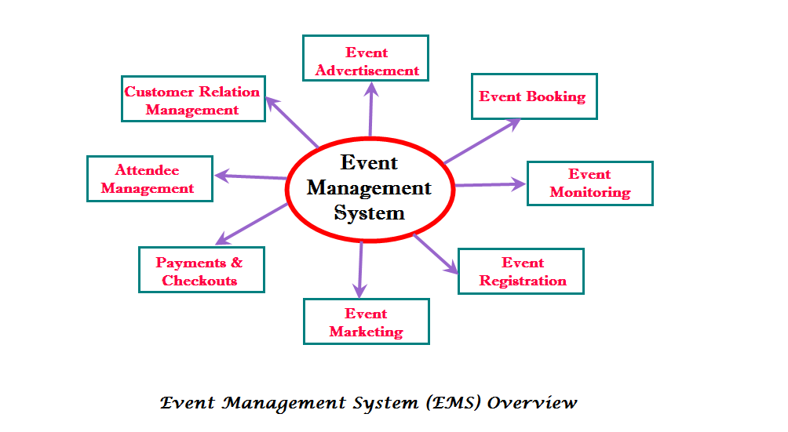](https://solutiondots.com/wp-content/uploads/2015/01/EMSImage.png)

**Sub-Modules of Event Management System**

Event Management System is structured with lots of sub modules & some of them are listed here:

* **Attendee Management System**
* **Events Booking System**
* **Events Management**
* **Payment & Checkouts System**
* **Customer Relationship Management (CRM)**
* **Event History Records**
* **Social Advertisement of events**
* **Events Online Registration**
* **Events Marketing**

**Features of Event Management System**

Event Management System has provided ease in the large as well as smaller organizations to market in a better way & manages all complex workflows associated with event management. There is a huge list of Event Management System features. Here are some of them:

* Secure payment process
* Powerful integration among sub modules
* Marketing of events on all social media site
* Scheduling of resources utilized in event
* Online registration of Attendee
* Online selling of tickets of events
* Single database system provide centralized access to all resources
* Streamline workflow of all events
* Online payments collection provide ease to attendees & visitors to get register from all over the world
* Keep records of events history
* After events successful execution survey & feedbacks to make improvements for next time
* Management of wait list about over sold events
* Automation of notifications about events
* No extra charges of transaction& invoices
* Customized setting features about events notifications
* Improve visiting experience of attendees

Event Management System provides you user friendly & cost effective properties for events managements. Because of a large number of sub module’s integration in EMS, organizations can customize these sub modules as per their demands.

**Conclusion**

So we can conclude that [Event Management System](http://solutiondots.com/products/event-management-system) has customized lots of activities related to the event life cycle in a single database system. These technology advancements in management, industry are appreciated able. And the companies that are adopting these changes are making their survival un-extinct. At last we can say that EMS application is best in its own way of providing a new edge to management industry. These changes are not only recommendable in their features, but also booming new traditions of raising income growth.

Project Details
➢ eTL system manages all the events which are conducted in
college/University.
➢ This system automatically...

Propose
➢Manual hours that need to spend in record keeping and generating
reports.
➢The data in a centralized way which is...

Scope
➢This web application includes the IT fields.
➢ Secure Administrative panel.
➢ Normal users are the participants.
➢ ...

Feasibility Study
Product : eTL is a event management system. By using this system various users can login
and participate...

Technical Feasibility : eTL is a web-application which avoids more manual
hours that need to spend in record keeping and g...

Economic feasibility : As no papers required so it
reduce cost. It would be beneficial because only one time
development e...

Modules
1.Registration – Participants can register online for any event.
2. Event – Event manager can generate event by th...

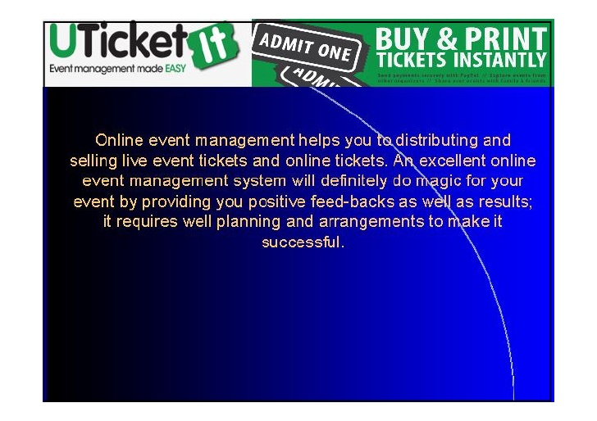

**Project Management: Tools & Techniques**

Sean Maserang

MSIS 488: Systems Analysis & Design

Fall 2002

[**Introduction**](http://www.umsl.edu/~s1011155/#introduction) | [**Projects**](http://www.umsl.edu/~s1011155/#projects) | [**Project Management**](http://www.umsl.edu/~s1011155/#project_management) | [**Tools**](http://www.umsl.edu/~s1011155/#tools) | [**The Future**](http://www.umsl.edu/~s1011155/#the_future) | [**References**](http://www.umsl.edu/~s1011155/#references)

**Introduction**

Problems arise in every organization. Such problems as what products/systems to develop, should capacity be expanded, or should a computer be purchased are just a few of an endless number of continuing problems about which management must concern itself if the firm is to survive. These problems and their alternative solutions establish some elements of change around which the organization must adapt. Projects are generally established to carry out these changes and someone is always responsible for each project's successful completion.[[11](http://www.umsl.edu/~s1011155/" \l "eleven)]

Every project is unique in terms of the problems that arise, the priorities and resources assigned it, the environment in which it operates, and the project manager's attitude and style used to guide and control project activities. Therefore, the organizational structure for the project must be designed to fit within that project's operating constraints. The organizational structure implemented may not be the same structure used throughout the life cycle of the project due to changes in priorities, available resource, project personnel, laws, and other contingencies. Regardless of the project management structure chosen, management must realize that a dynamic state of equilibrium between limited personnel and financial resources and the objectives of the project will be necessary if project management is to be successful in their particular organization.[[11](http://www.umsl.edu/~s1011155/" \l "eleven)] Before touching on the major tools and techniques of project management, let's get to the bottom of what project management truly is. Later, I will list the benefits that the tools and techniques of project management bring to the systems analysis process.

**Projects**

Nearly every activity within an organization could be labeled as a project possessing unique characteristics and varying levels of importance to the organization. A project is defined as a planned undertaking of related activities to reach an objective that has a beginning and an end.[[16](http://www.umsl.edu/~s1011155/" \l "sixteen)] All projects solve some type of problem, but projects may also be established simply to determine and define feasible alternative solutions to problems. Seven primary characteristics of a project include:[[11](http://www.umsl.edu/~s1011155/" \l "eleven)]

1. Objective: Each has a specific goal to reach.
2. Schedule: Point in time in which they must be accomplished.
3. Complexity: Does the technology exist to achieve the project objectives?
4. Size and Nature of Task: Step-by-step plan of action.
5. Resources: Labor, personnel, equipment, materials, facilities, etc.
6. Organizational Structure: The 'meshing' of project requirements into the existing organization.
7. Information and Control Systems: These must be structured to handle problems through the typical lines of authority (Prin. of Project Mgmt).

**Project Management**

In the past, a company typically decided to undertake a project effort, assigned the project and the "necessary" resources to a carefully selected individual and assumed they were using some form of project management. Organizational implications were of little importance. Although the basic concepts of project management are simple, applying these concepts to an existing organization is not. Richard P. Olsen, in his article "Can Project Management Be Defined?" defined project management as "…the application of a collection of tools and techniques…to direct the use of diverse resources toward the accomplishment of a unique, complex, one-time task within time, cost, and quality constraints. Each task requires a particular mix of these tools and techniques structured to fit the task environment and life cycle (from conception to completion) of the task." [[11](http://www.umsl.edu/~s1011155/#eleven)]

Employing project management technologies minimizes the disruption of routine business activities in many cases by placing under a single command all of the skills, technologies, and resources needed to realize the project. The skills required depend on each specific project and the resources available at that time. The greater the amount of adjustments a parent organization must make to fulfill project objectives, the greater chance exists for project failure. The form of project management will be unique for every project endeavor and will change throughout the project.[[11](http://www.umsl.edu/~s1011155/" \l "eleven)]

The project management process typically includes four key phases: initiating the project, planning the project, executing the project, and closing the project. An outline of each phase is provided below.

Initiating the Project  
The project management techniques related to the project initiation phase include: [[16](http://www.umsl.edu/~s1011155/#sixteen)]

1. *Establishing the project initiation team.* This involves organizing team members to assist in carrying out the project initiation activities.
2. *Establishing a relationship with the customer.* The understanding of your customer's organization will foster a stronger relationship between the two of you.
3. *Establishing the project initiation plan.* Defines the activities required to organize the team while working to define the goals and scope of the project.
4. *Establishing management procedures.* Concerned with developing team communication and reporting procedures, job assignments and roles, project change procedure, and how project funding and billing will be handled.
5. *Establishing the project management environment and workbook.* Focuses on the collection and organization of the tools that you will use while managing the project.

Planning the Project  
The project management techniques related to the project planning phase include:[[16](http://www.umsl.edu/~s1011155/" \l "sixteen)]

1. *Describing project scope, alternatives, and feasibility.* The understanding of the content and complexity of the project. Some relevant questions that should be answered include:
   * What problem/opportunity does the project address?
   * What results are to be achieved?
   * What needs to be done?
   * How will success be measured?
   * How will we know when we are finished?
2. *Divide the project into tasks.* This technique is also known as the work breakdown structure. This step is done to ensure an easy progression between tasks.
3. *Estimating resources and creating a resource plan.* This helps to gather and arrange resources in the most effective manner.
4. *Developing a preliminary schedule.* In this step, you are to assign time estimates to each activity in the work breakdown structure. From here, you will be able to create the target start and end dates for the project.
5. *Developing a communication plan.* The idea here is to outline the communication procedures between management, team members, and the customer.
6. *Determining project standards and procedures.* The specification of how various deliverables are produced and tested by the project team.
7. *Identifying and assessing risk.* The goal here is to identify potential sources of risk and the consequences of those risks.
8. *Creating a preliminary budget.* The budget should summarize the planned expenses and revenues related to the project.
9. *Developing a statement of work.* This document will list the work to be done and the expected outcome of the project.
10. *Setting a baseline project plan.* This should provide an estimate of the project's tasks and resource requirements.

Executing the Project  
The project management techniques related to the project execution phase include:[[16](http://www.umsl.edu/~s1011155/" \l "sixteen)]

1. *Executing the baseline project plan.* The job of the project manager is to initiate the execution of project activities, acquire and assign resources, orient and train new team members, keep the project on schedule, and assure the quality of project deliverables.
2. *Monitoring project progress against the baseline project plan.* Using Gantt and PERT charts, which will be discussed in detail further on in this paper, can assist the project manager in doing this.
3. *Managing changes to the baseline project plan.*
4. *Maintaining the project workbook.* Maintaining complete records of all project events is necessary. The project workbook is the primary source of information for producing all project reports.
5. *Communicating the project status.* This means that the entire project plan should be shard with the entire project team and any revisions to the plan should be communicated to all interested parties so that everyone understands how the plan is evolving.

Closing Down the Project  
The project management techniques related to the project closedown phase include:[[16](http://www.umsl.edu/~s1011155/" \l "sixteen)]

1. *Closing down the project.* In this stage, it is important to notify all interested parties of the completion of the project. Also, all project documentation and records should be finalized so that the final review of the project can be conducted.
2. *Conducting post project reviews.* This is done to determine the strengths and weaknesses of project deliverables, the processes used to create them, and the project management process.
3. *Closing the customer contract.* The final activity is to ensure that all contractual terms of the project have been met.

The techniques listed above in the four key phases of project management enable a project team to:[[3](http://www.umsl.edu/~s1011155/" \l "three)]

* Link project goals and objectives to stakeholder needs.
* Focus on customer needs.
* Build high-performance project teams.
* Work across functional boundaries.
* Develop work breakdown structures.
* Estimate project costs and schedules.
* Meet time constraints.
* Calculate risks.
* Establish a dependable project control and monitoring system.

**Tools**

Project management is a challenging task with many complex responsibilities. Fortunately, there are many tools available to assist with accomplishing the tasks and executing the responsibilities. Some require a computer with supporting software, while others can be used manually. Project managers should choose a project management tool that best suits their management style. No one tool addresses all project management needs. Program Evaluation Review Technique (PERT) and Gantt Charts are two of the most commonly used project management tools and are described below. Both of these project management tools can be produced manually or with commercially available project management software.[[4](http://www.umsl.edu/~s1011155/" \l "four)]

PERT is a planning and control tool used for defining and controlling the tasks necessary to complete a project. PERT charts and Critical Path Method (CPM) charts are often used interchangeably; the only difference is how task times are computed. Both charts display the total project with all scheduled tasks shown in sequence. The displayed tasks show which ones are in parallel, those tasks that can be performed at the same time.[[3](http://www.umsl.edu/~s1011155/#three)] A graphic representation called a "Project Network" or "CPM Diagram" is used to portray graphically the interrelationships of the elements of a project and to show the order in which the activities must be performed.[[2](http://www.umsl.edu/~s1011155/#two)]

PERT planning involves the following steps:[[7](http://www.umsl.edu/~s1011155/" \l "seven)]

1. *Identify the specific activities and milestones.* The activities are the tasks of the project. The milestones are the events that mark the beginning and the end of one or more activities.
2. *Determine the proper sequence of activities.* This step may be combined with #1 above since the activity sequence is evident for some tasks. Other tasks may require some analysis to determine the exact order in which they should be performed.
3. *Construct a network diagram.* Using the activity sequence information, a network diagram can be drawn showing the sequence of the successive and parallel activities. Arrowed lines represent the activities and circles or "bubbles" represent milestones.
4. *Estimate the time required for each activity.* Weeks are a commonly used unit of time for activity completion, but any consistent unit of time can be used. A distinguishing feature of PERT is it's ability to deal with uncertainty in activity completion times. For each activity, the model usually includes three time estimates:
   * Optimistic time - the shortest time in which the activity can be completed.
   * Most likely time - the completion time having the highest probability.
   * Pessimistic time - the longest time that an activity may take.

From this, the expected time for each activity can be calculated using the following weighted average:

Expected Time = (Optimistic + 4 x Most Likely + Pessimistic) / 6

This helps to bias time estimates away from the unrealistically short timescales normally assumed.

1. *Determine the critical path.* The critical path is determined by adding the times for the activities in each sequence and determining the longest path in the project. The critical path determines the total calendar time required for the project. The amount of time that a non-critical path activity can be delayed without delaying the project is referred to as slack time.

If the critical path is not immediately obvious, it may be helpful to determine the following four times for each activity:

* + ES - Earliest Start time
  + EF - Earliest Finish time
  + LS - Latest Start time
  + LF - Latest Finish time

These times are calculated using the expected time for the relevant activities. The earliest start and finish times of each activity are determined by working forward through the network and determining the earliest time at which an activity can start and finish considering its predecessor activities. The latest start and finish times are the latest times that an activity can start and finish without delaying the project. LS and LF are found by working backward through the network. The difference in the latest and earliest finish of each activity is that activity's slack. The critical path then is the path through the network in which none of the activities have slack.

The variance in the project completion time can be calculated by summing the variances in the completion times of the activities in the critical path. Given this variance, one can calculate the probability that the project will be completed by a certain date assuming a normal probability distribution for the critical path. The normal distribution assumption holds if the number of activities in the path is large enough for the central limit theorem to be applied.

1. *Update the PERT chart as the project progresses.* As the project unfolds, the estimated times can be replaced with actual times. In cases where there are delays, additional resources may be needed to stay on schedule and the PERT chart may be modified to reflect the new situation. An example of a PERT chart is provided below:

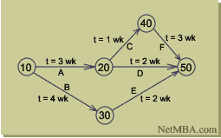<="">

Benefits to using a PERT chart or the Critical Path Method include:[[6](http://www.umsl.edu/~s1011155/" \l "six)],[[7](http://www.umsl.edu/~s1011155/#seven)]

* Improved planning and scheduling of activities.
* Improved forecasting of resource requirements.
* Identification of repetitive planning patterns which can be followed in other projects, thus simplifying the planning process.
* Ability to see and thus reschedule activities to reflect interproject dependencies and resource limitations following know priority rules.
* It also provides the following: expected project completion time, probability of completion before a specified date, the critical path activities that impact completion time, the activities that have slack time and that can lend resources to critical path activities, and activity start and end dates.

Gantt charts are used to show calendar time task assignments in days, weeks or months. The tool uses graphic representations to show start, elapsed, and completion times of each task within a project. Gantt charts are ideal for tracking progress. The number of days actually required to complete a task that reaches a milestone can be compared with the planned or estimated number. The actual workdays, from actual start to actual finish, are plotted below the scheduled days. This information helps target potential timeline slippage or failure points. These charts serve as a valuable budgeting tool and can show dollars allocated versus dollars spent.[[4](http://www.umsl.edu/~s1011155/" \l "four)]

To draw up a Gantt chart, follow these steps:[[1](http://www.umsl.edu/~s1011155/" \l "one)]

1. *List all activities in the plan.* For each task, show the earliest start date, estimated length of time it will take, and whether it is parallel or sequential. If tasks are sequential, show which stages they depend on.
2. *Head up graph paper with the days or weeks through completion.*
3. *Plot tasks onto graph paper.* Show each task starting on the earliest possible date. Draw it as a bar, with the length of the bar being the length of the task. Above the task bars, mark the time taken to complete them.
4. *Schedule activities.* Schedule them in such a way that sequential actions are carried out in the required sequence. Ensure that dependent activities do not start until the activities they depend on have been completed. Where possible, schedule parallel tasks so that they do not interfere with sequential actions on the critical path. While scheduling, ensure that you make best use of the resources you have available, and do not over-commit resources. Also, allow some slack time in the schedule for holdups, overruns, failures, etc.
5. *Presenting the analysis.* In the final version of your Gantt chart, combine your draft analysis (#3 above) with your scheduling and analysis of resources (#4 above). This chart will show when you anticipate that jobs should start and finish. An example of a Gantt chart is provided below:

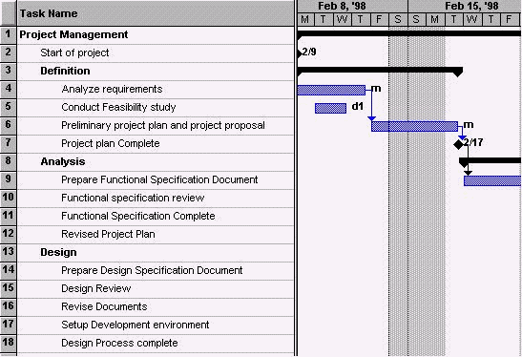<="">

Benefits of using a Gantt chart include:[[8](http://www.umsl.edu/~s1011155/" \l "eight)]

* Gives an easy to understand visual display of the scheduled time of a task or activity.
* Makes it easy to develop "what if" scenarios.
* Enables better project control by promoting clearer communication.
* Becomes a tool for negotiations.
* Shows the actual progress against the planned schedule.
* Can report results at appropriate levels.
* Allows comparison of multiple projects to determine risk or resource allocation.
* Rewards the project manager with more visibility and control over the project.

**The Future**

Project management tools have evolved from simple spreadsheet products to sophisticated, Web-based project information portals. The obvious trend in project management software, as with almost everything in information technology, is a move toward Web-based systems. Most project management tools can be accessed via browsers and those that do not currently have this capability are moving in that direction.[[17](http://www.umsl.edu/~s1011155/" \l "seventeen)] One product that allows users to take non-Web-based project management tools and to then bring the data to a Web browser is mesaVista from Mesa Systems Guild, Warwick, R.I. The product acts as a portal development tool that allows firms to view information from products such as Microsoft Project over the Web. These project management portals are becoming more common as the collaboration capabilities of project management tools improve.[[9](http://www.umsl.edu/~s1011155/" \l "nine)]

Another trend is the move toward hosted project management applications. For example, users can outsource project management to product/service offerings such as onProject.com from onProject.com Inc., Morristown, N.J., or WorkLenz from Metier Ltd., Washington D.C. onProject.com is an Internet workspace that allows users to share and mange information associated with projects and their related tasks. WorkLenz is a software application that serves as a virtual project manager with intelligent agent features. Offered via the ASP model, WorkLenz manages a customer's project and provides real-time alerts of issues, inefficiencies and problems, and even recommends solutions.[[9](http://www.umsl.edu/~s1011155/" \l "nine)]

Project management tools continue to evolve in terms of capabilities and user interface. The general direction is toward more integrated process and knowledge management systems, and user interfaces with a "Web" look.[[17](http://www.umsl.edu/~s1011155/" \l "seventeen)] Project management tools are gradually becoming integrated project information portals with capabilities far beyond simple project tracking and reporting.[[9](http://www.umsl.edu/~s1011155/#nine)]

As the sophistication of these products continues to grow, however, so too does their complexity. It is important for project management software vendors to keep things simple and easy to use. Project management tools should not become the focus of a project manager's life or add time to project activities. If a project manager has to spend too much time learning a product's features, their ability to actively manage the project process diminishes, totally defeating the purpose of the tool.[[9](http://www.umsl.edu/~s1011155/" \l "nine)]

**References:**

1. "Introduction to Project Management Skills". <http://www.mindtools.com/pages/main/newMN_PPM.htm>. Last update time unknown. Accessed Nov. 2, 2002.
2. The Numbers Group. "Project Management". <http://www.snc.edu/socsci/chair/333/numbers.html>. Last update time unknown. Accessed Nov. 4, 2002.
3. "What is Project Management?". <http://www.esi_intl.com/Public/projectmanagement/whypm.asp>. Last update time unknown. Accessed Nov. 4, 2002.
4. "Project Management Techniques". <http://www.tifb.state.tx.us/Handbooks/Project_Management.htm>. Last update time unknown. Accessed Nov. 4, 2002.
5. "Project Management Tools". <http://www.dbm.state.md.us/mdplan/apdx-bt.htm>. Last update time unknown. Accessed Nov. 6, 2002.
6. Georgia State University - CIS 330. "Project Management". <http://www.cis.gsu.edu/~dtruex/courses/cis330/cis330PDF/wk7/ProjMgtp.pdf>. Last update time unknown. Accessed Nov. 6, 2002.
7. NetMBA. "PERT". <http://www.netmba.com/operations/project/pert>. Last update time unknown. Accessed Nov. 6, 2002.
8. The Gantt Group. "Using Gantt Charts". <http://204.144.189.70/index.htm>. Last update time unknown. Accessed Nov. 6, 2002.
9. Trepper, Charles H. "A Project Management Primer". <http://www.aisc.com/us/lang_en/press_room/in_the_news/adtMag_August01.pdf>. Last update August 2000. Accessed Nov. 6, 2002.
10. Vanhooren, Axel. "Project Management". <http://itprojmngt.8m.net/projman/pm_what.html>. Last update time unknown. Accessed Oct. 31, 2002.
11. Adams, John R. "Principles of Project Management". (c)1997 by the Project Management Institute.
12. Craig, H Kent. "PM 101: Assess Your Aptitude, Mindset, Potential." *Contractor*. Sep. 2002. Vol. 49. Issue 9.
13. Crawford, J Kent; Pennypacker, James S. "Put an End to Project Management". *Optimize*. Oct. 2002. Pages 73-78.
14. Friedlein, Ashley. "Web Project Management". (c)2001 by the Presentation Company Limited. Morgan Kaufmann Publishers.
15. Hartman, Francis; Ashrafi, Rafi A. "Project Management in the Information Systems and Information Technologies Industries." *Project Management Journal*. Sep 2002. Vol. 33. Issue 3. Pages 5-15.
16. Hoffer, Jeffrey A; George, Joey F; Valacich, Joseph S. "Modern Systems Analysis & Design". (c)2002 by Pearson Education, Inc. Prentice Hall.
17. Kioppenborg, Timothy J; Opfer, Warren A. "The Current State of Project Management Research: Trends, Interpretations, and Predictions." *Project Management Journal*. June 2002. Vol. 33. Issue 2. Pages 5-18.
18. Payne, John & Shirley. "Management Basics". (c)1998 by the Adams Media Corporation.
19. Quick, James Aaron; New, Cheryl Carter. "Grant Winner's Toolkit: Project Management and Evaluation". (c)2000 by Cheryl Carter New and James Aaron Quick. Published by John Wiley & Sons, Inc.
20. Schimmoller, Brian K. "The Changing Face of Project Management." *Power Engineering*. May 2001. Vol. 105. Issue 5. Pages 28-30.