Let’s Meet

3005 – Jaishil Bhavsar

3036 – Zeel Modi

3186 – Bhargavi Jansari

**Test Cases**

**Create Event**

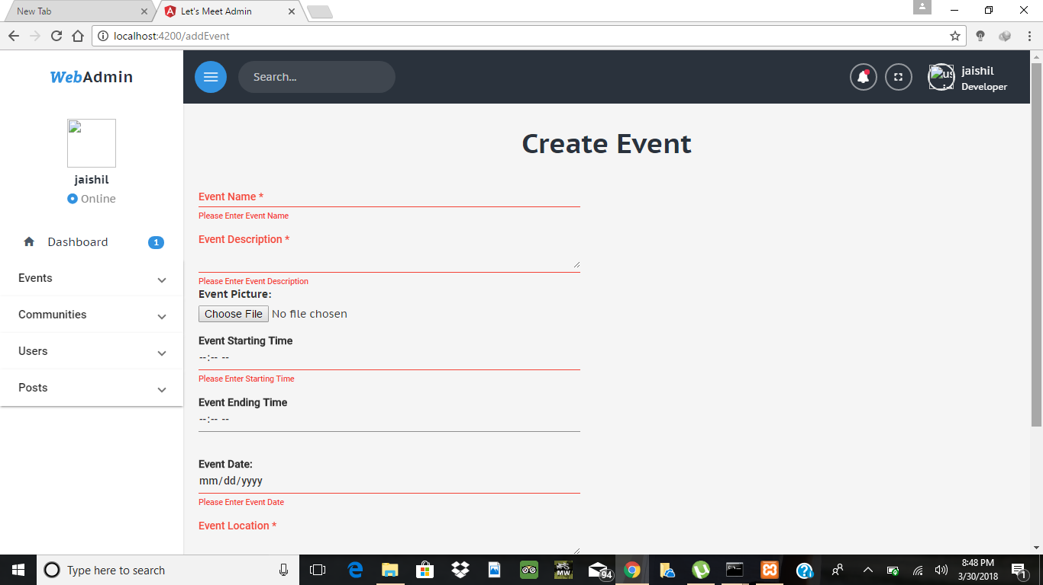

**Create Community**

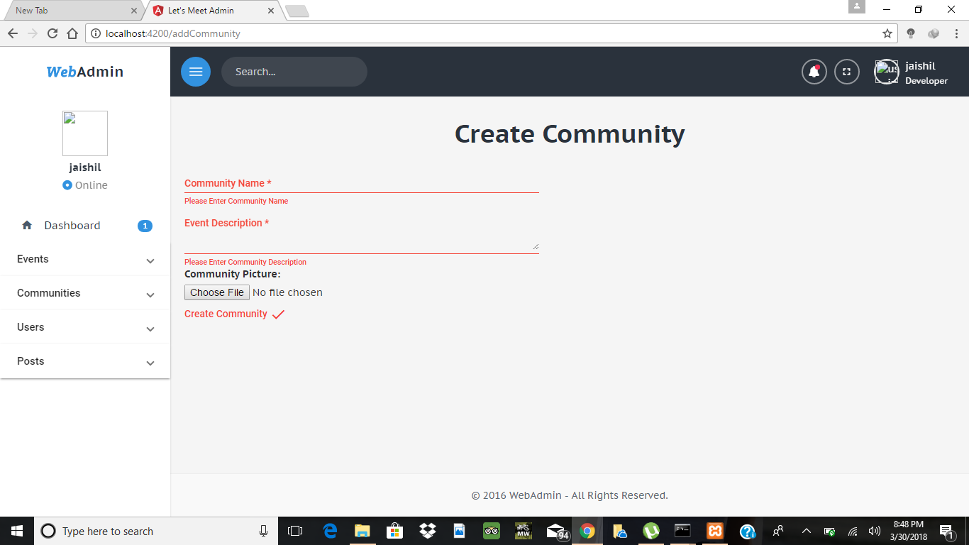

**Create Post**

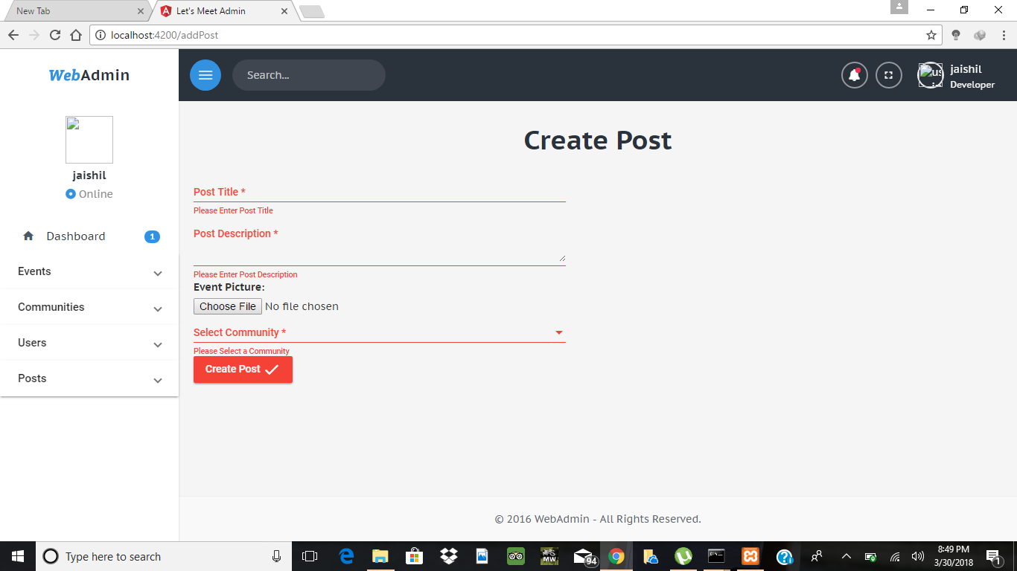

**Login**

