Container to Kubernetes
Hands-On Assignment: deploying the CampusConnect Flask app on Kubernetes
Name | Zeel Dadhaniya
Student ID | 202303010
Assignment | Container to Kubernetes: Hands-On Assignment (Kubernetes, Hands-On lab)
Lab | https://k8slabs.learnwithdutta.com/ (app from https://labs.docker.learnwithdutta.com/)
Date performed | 25 October 2026 (16:44 – 16:48 UTC)
Environment | Linux VM · Docker Engine 29.9.2 · kind v0.30.0 · kubectl v1.34.0 · Kubernetes v1.34.0 (kindest/node) · Chromium for the browser checks
Submission | 27 screenshots with the commands, an explanation of each command, and an observation for each screenshot

Contents
1. Objective
2. Environment and notes
3. Part A — Prerequisites
4. Part B — Rebuild the CampusConnect image (assignment tasks 1 and 2)
5. Part C — Build the cluster and make the image available to it (assignment task 3)
6. Part D — Deploy the app (assignment tasks 4 and 5)
7. Part E — Test the app and confirm the Service is reachable (assignment task 6)
8. Part F — Going further: scaling, a rolling update to v2, and self-healing
9. Part G — Cleanup
10. What I learned
Appendix A: Commands in order
Appendix B: Files
Figures
Figure 1. Checking Docker, kubectl and kind
Figure 2. Creating the assignment folder
Figure 3. Recreating the CampusConnect Flask app
Figure 4. Dockerfile.v1, the Dockerfile from the Docker practical
Figure 5. Building the image campusconnect:v1
Figure 6. Testing the image with plain Docker first
Figure 7. Writing the kind cluster configuration
Figure 8. Creating the 3-node cluster
Figure 9. Checking the nodes
Figure 10. Loading campusconnect:v1 into the cluster nodes
Figure 11. Writing deployment.yaml
Figure 12. Validating, deploying and checking the rollout
Figure 13. One file, three kinds of objects
Figure 14. Reading the app's logs in the Pods
Figure 15. Creating a NodePort Service
Figure 16. Calling the app through the NodePort
Figure 17. Calling the app from inside the cluster by its Service name
Figure 18. Reaching the app through kubectl port-forward
Figure 19. Browser: http://localhost:30080/
Figure 20. Scaling up to 5 replicas
Figure 21. Scaling back to 3 replicas
Figure 22. Building and loading version 2 of the image
Figure 23. Declarative rolling update from v1 to v2
Figure 24. Checking the new version
Figure 25. Browser: version 2 served through the NodePort
Figure 26. Self-healing: deleting a running Pod on purpose
Figure 27. Removing the app and deleting the cluster

1. Objective
In the Docker practical I packaged the CampusConnect Flask app (a visit-counter web service) as a Docker image. The goal of this assignment is to take that same image and run it on Kubernetes as a Deployment, the way it is done in production: Docker builds the image, and Kubernetes runs it at scale.
The table maps each task in the assignment to the part of this report and the screenshots that show it.
# | Assignment task | Where it is shown
1 | Identify the Flask app from the Docker practical (FROM python:3.12-slim, EXPOSE 8000, python app.py) | Part B, Figures 3–4
2 | Build or retag the image: docker build -t campusconnect:v1 -f Dockerfile.v1 . | Part B, Figures 5–6
3 | Make the image available to the Kubernetes cluster | Part C, Figures 7–10 (kind load docker-image)
4 | Create deployment.yaml with the correct image and port | Part D, Figure 11
5 | kubectl apply -f deployment.yaml and kubectl rollout status deployment/<name> | Part D, Figures 12–14
6 | Test the app from the cluster and confirm the Service is reachable | Part E, Figures 15–19
+ | Extra: scaling, rolling update v1 → v2, self-healing, cleanup | Parts F and G, Figures 20–27

2. Environment and notes
Everything was done in one terminal session on a Linux VM, in the folder ~/k8s-assignment. Each screenshot caption gives the time it was captured (UTC). The screenshots appear in the order the commands were run.
Architecture. Host → localhost:30080 → control-plane container (extraPortMappings) → NodePort Service campusconnect (port 80) → one of 3 Pods on the two worker nodes → Flask in the container on port 8000.
Getting the image into the cluster. kind nodes have their own containerd image store. Instead of pushing to a registry, I used kind load docker-image to copy campusconnect:v1 (and later v2) into every node. The Deployment sets imagePullPolicy: IfNotPresent, so the nodes use that local copy.
Two small environment fixes. These do not change anything the assignment teaches:
- kind-config.yaml contains a containerdConfigPatches block (restrict_oom_score_adj = true). On this VM a container is not allowed to lower its OOM score, and without this line kind create cluster fails with "failed to update /proc/self/oom_score_adj: Permission denied". This is the same fix I used in the Kubernetes lab.
- The VM reaches the internet through an HTTPS-inspecting proxy, so pip inside the build could not verify pypi.org. I added the proxy's CA certificate to the local python:3.12-slim base image once, before the assignment. Dockerfile.v1 and Dockerfile.v2 are exactly as in the Docker practical.

3. Part A — Prerequisites
Before starting, I checked that the three tools needed for the lab are installed and created a working folder for the assignment.

Figure 1. Checking Docker, kubectl and kind
Command | Explanation
docker ps | Confirms the Docker daemon is running. The empty table means no containers are running yet.
kubectl version --client | Prints the version of kubectl, the Kubernetes command-line client.
kind version | Prints the version of kind (Kubernetes IN Docker), which builds the cluster out of Docker containers.
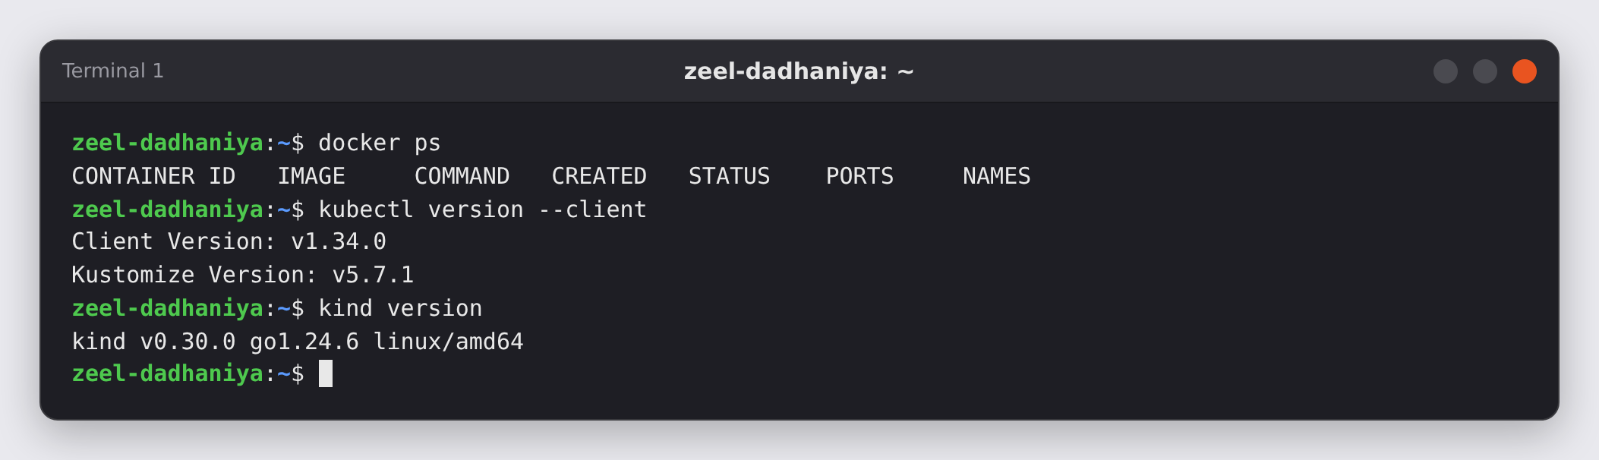
Figure 1: Checking Docker, kubectl and kind · Terminal 1 · captured 2026-10-25 16:44:59 UTC
Observation: All three tools respond: Docker is running, kubectl is v1.34.0 and kind is v0.30.0.

Figure 2. Creating the assignment folder
Command | Explanation
mkdir -p ~/k8s-assignment && cd ~/k8s-assignment | Creates the folder (if it does not exist) and moves into it. Every file of the assignment is kept here.
pwd | Prints the current directory to confirm the location.
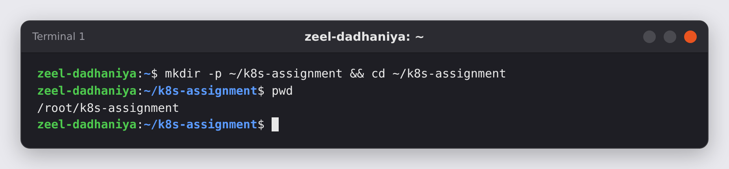
Figure 2: Creating the assignment folder · Terminal 1 · captured 2026-10-25 16:45:00 UTC
Observation: The working directory is ~/k8s-assignment (the home directory on this machine is /root).

4. Part B — Rebuild the CampusConnect image (assignment tasks 1 and 2)
Task 1 asks for the Flask app from the Docker practical: the project that uses FROM python:3.12-slim, EXPOSE 8000 and runs python app.py. I recreated the same three files from the Docker lab (requirements.txt, app.py and Dockerfile.v1), then built and tested the image campusconnect:v1 exactly as task 2 shows.

Figure 3. Recreating the CampusConnect Flask app
Command | Explanation
echo "flask==3.0.3" > requirements.txt | Writes the only Python dependency of the app (Flask 3.0.3).
cat > app.py <<'EOF' … EOF | Writes the Flask app from the Docker lab. GET / adds 1 to a visit counter in /data/visits.txt and returns JSON with the message, visit count, hostname, PID and version. GET /health returns {"status":"ok"}. It handles SIGTERM to shut down gracefully.
ls -l | Lists the files to confirm both were created.
cat requirements.txt | Shows the content of requirements.txt.
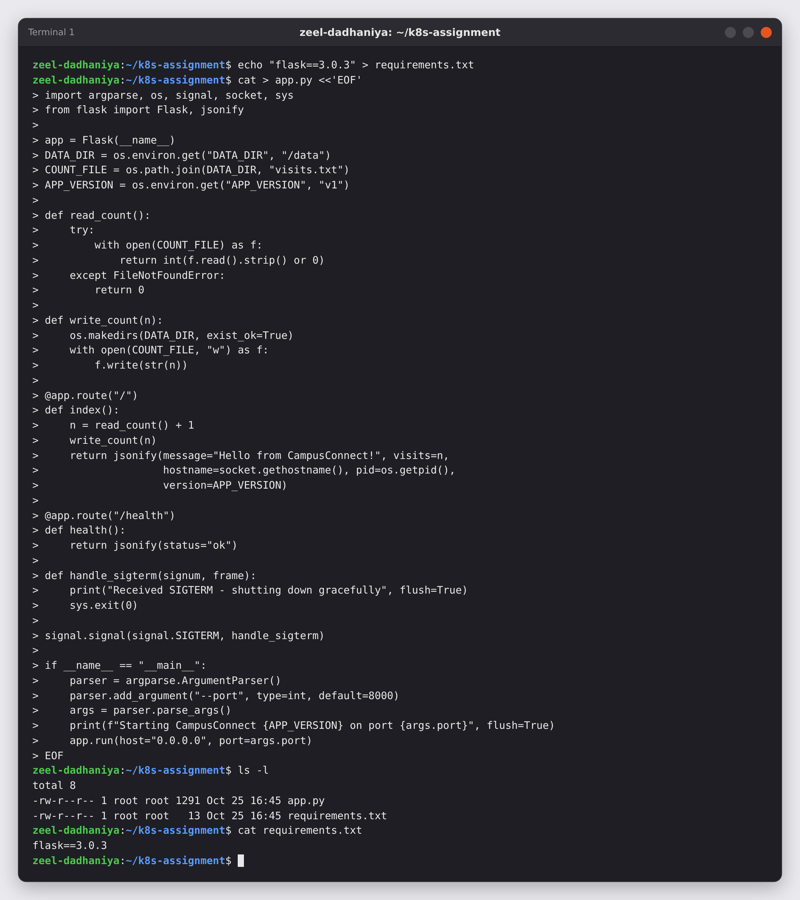
Figure 3: Recreating the CampusConnect Flask app · Terminal 1 · captured 2026-10-25 16:45:00 UTC
Observation: app.py (1291 bytes) and requirements.txt are in the folder. The app listens on port 8000 by default.

Figure 4. Dockerfile.v1, the Dockerfile from the Docker practical
Command | Explanation
cat > Dockerfile.v1 <<'EOF' … EOF | Writes the Dockerfile: start FROM python:3.12-slim, work in /app, copy the code, pip install the requirements, document port 8000 with EXPOSE and start the app with python app.py.
cat Dockerfile.v1 | Prints the file to check it.
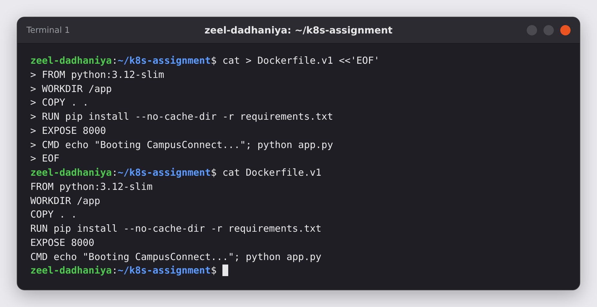
Figure 4: Dockerfile.v1, the Dockerfile from the Docker practical · Terminal 1 · captured 2026-10-25 16:45:00 UTC
Observation: This is the same Dockerfile.v1 as in the Docker lab: FROM python:3.12-slim, EXPOSE 8000, and CMD runs python app.py.

Figure 5. Building the image campusconnect:v1
Command | Explanation
docker build -t campusconnect:v1 -f Dockerfile.v1 . | Builds an image from Dockerfile.v1 using the current folder (.) as build context and tags it campusconnect:v1.
docker images campusconnect | Lists the local images in the campusconnect repository.
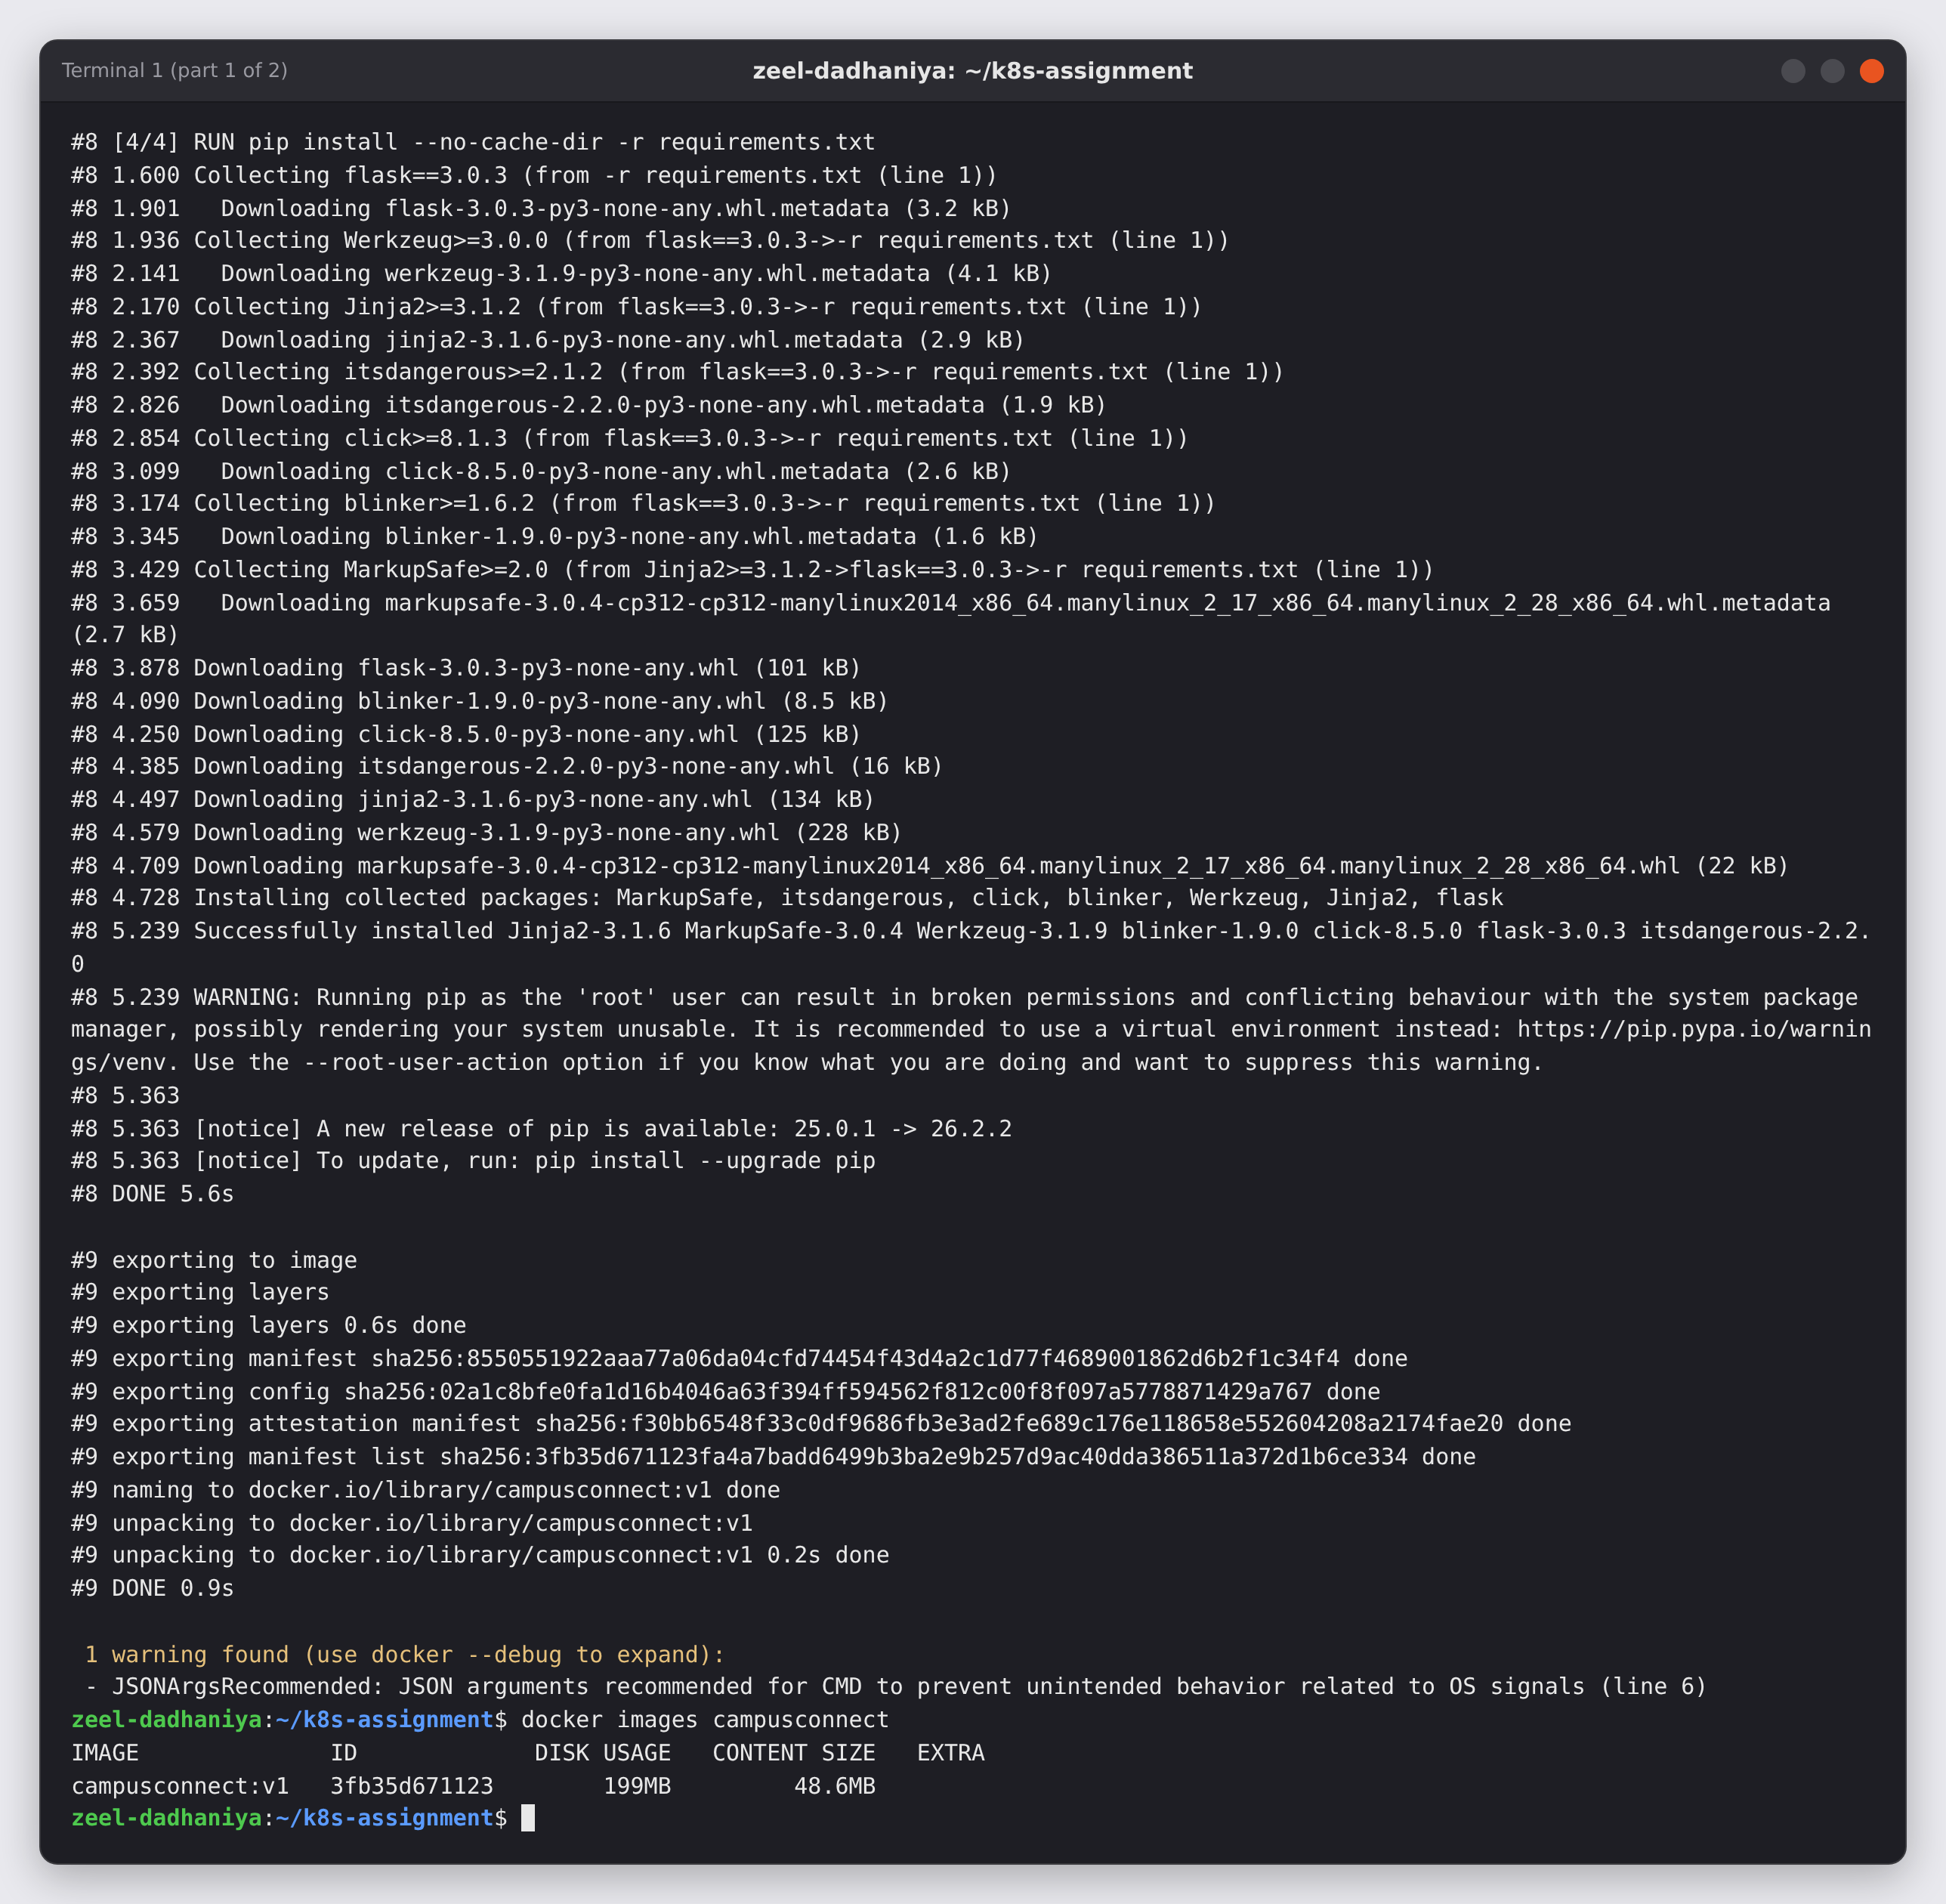
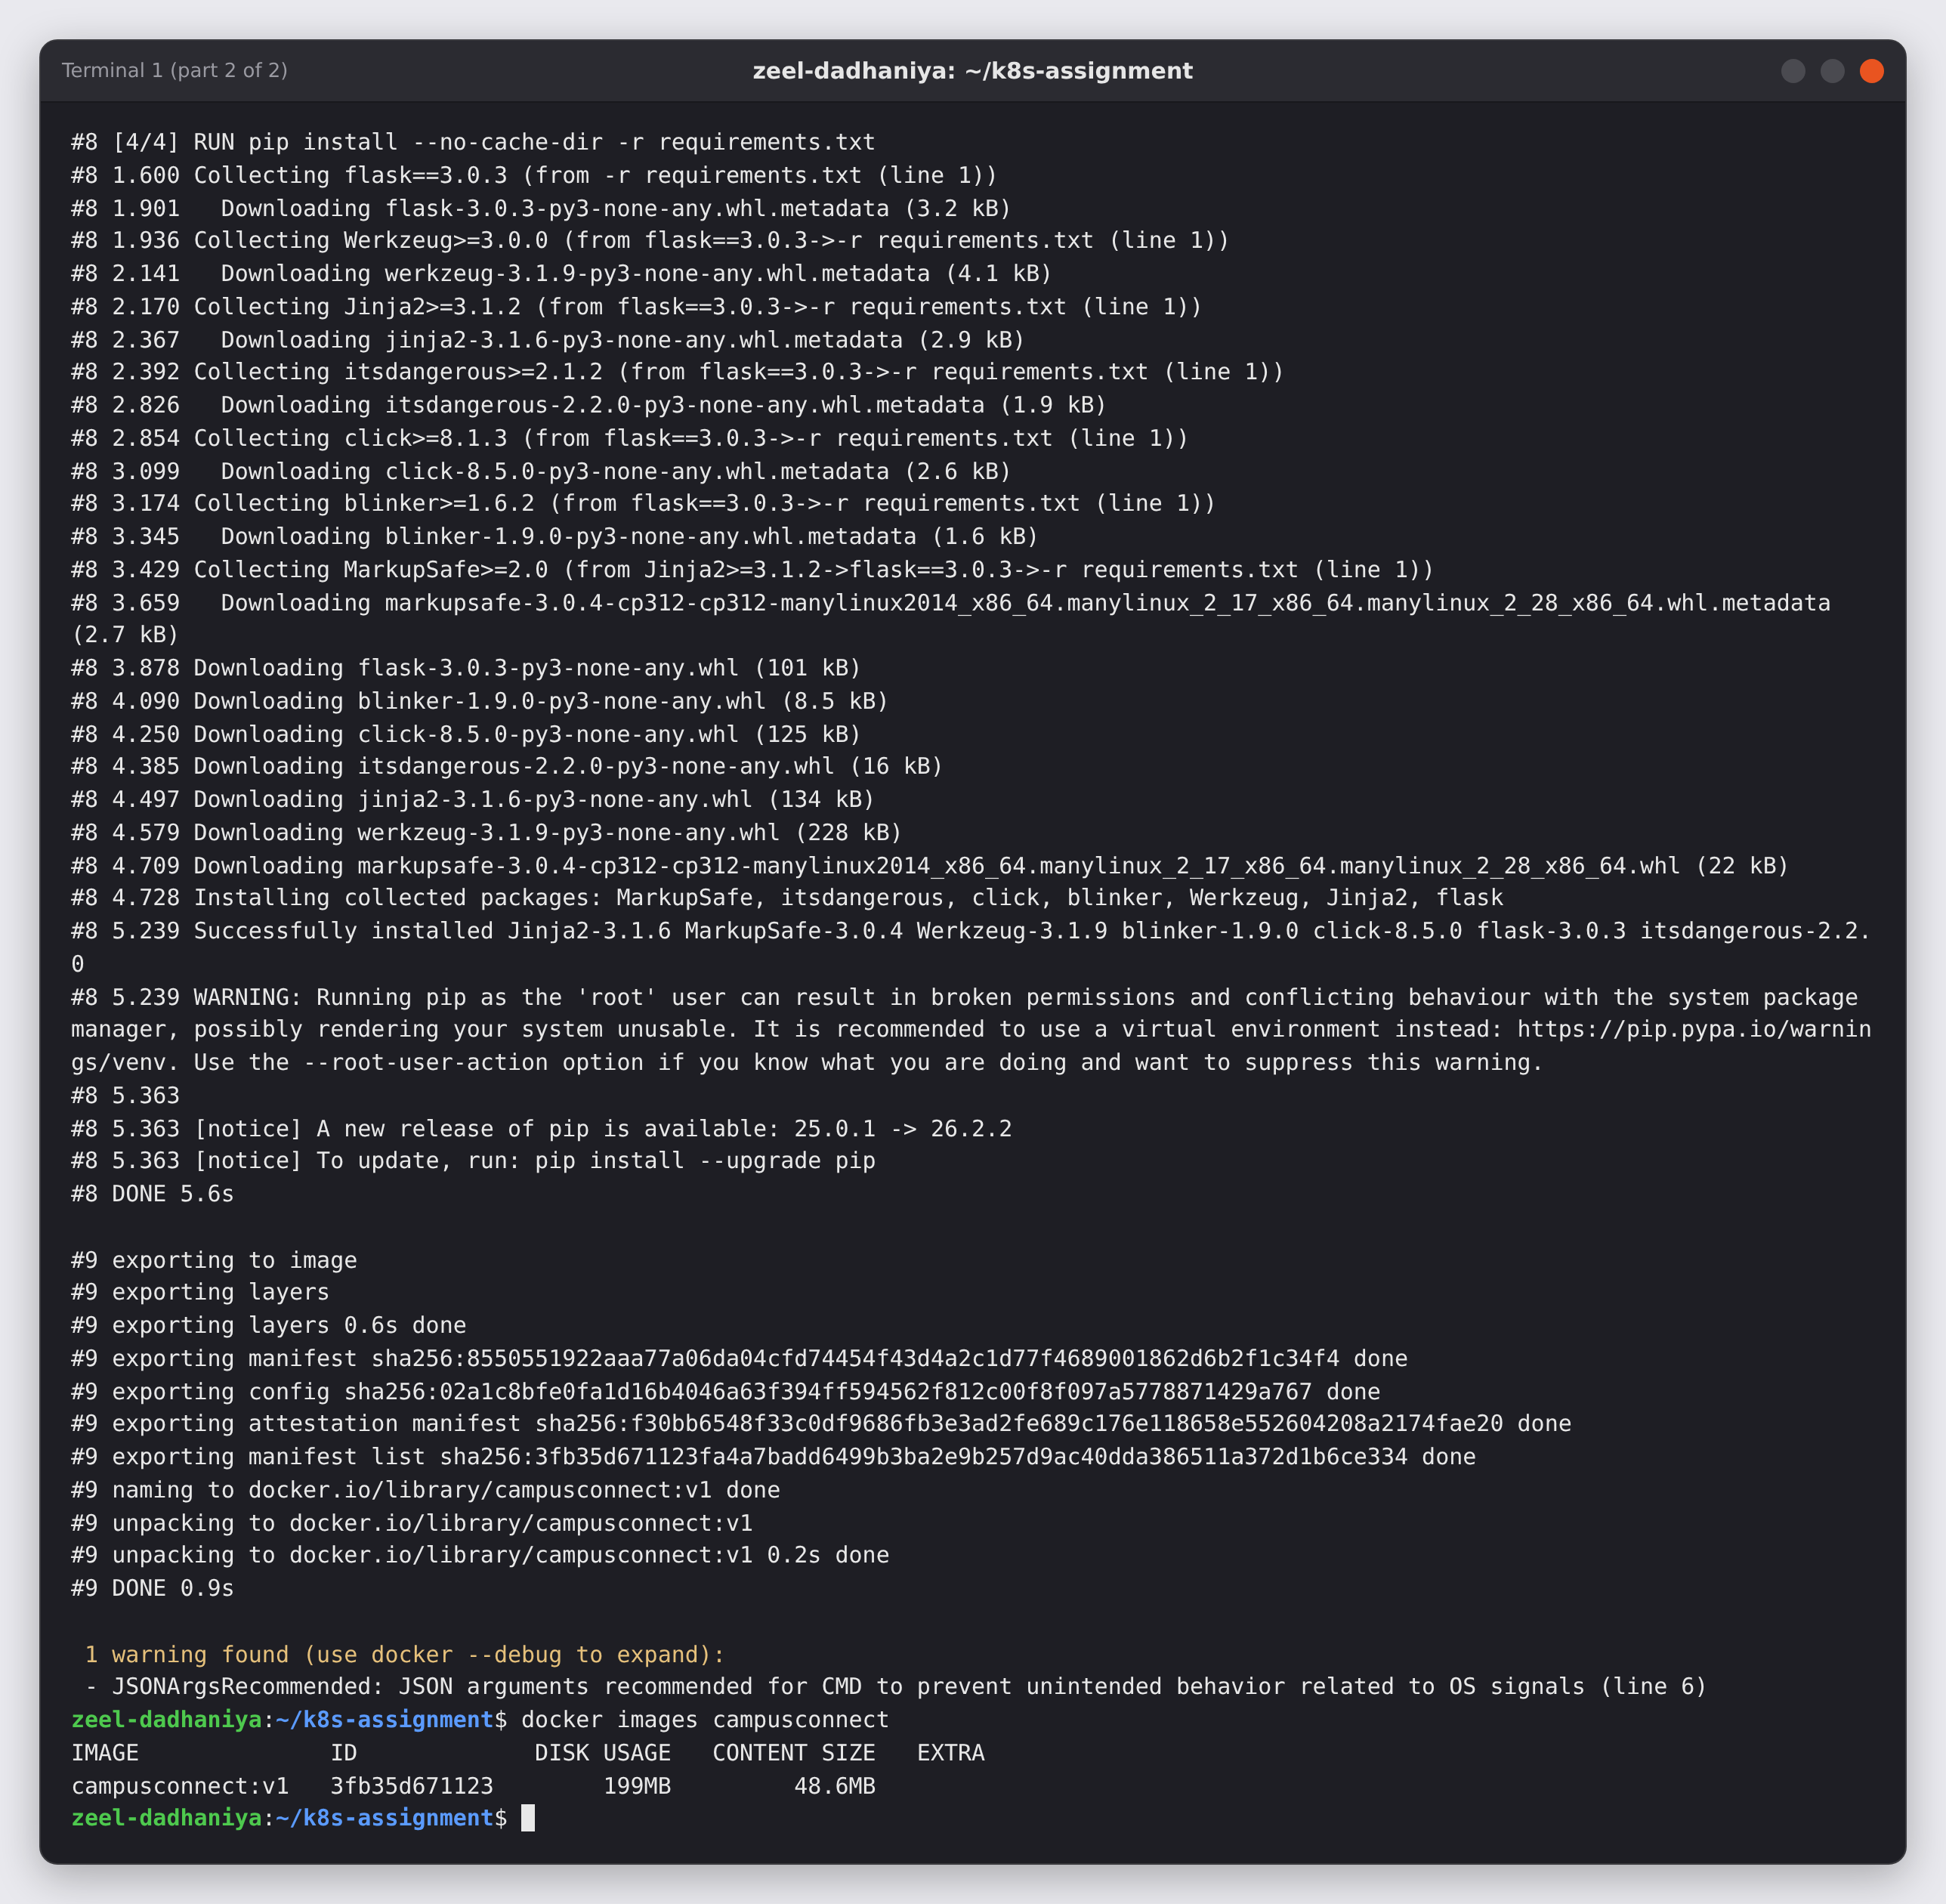
Figure 5: Building the image campusconnect:v1 · Terminal 1 · captured 2026-10-25 16:45:00 UTC
Observation: All 4 build steps finished. pip installed Flask 3.0.3 and its dependencies, and the image campusconnect:v1 (199 MB on disk) now exists locally. Docker shows a JSONArgsRecommended warning for the shell-form CMD. The Docker lab points out the same issue, and it shows up again in Figure 24.

Figure 6. Testing the image with plain Docker first
Command | Explanation
docker run -d --name cc-test -p 8080:8000 campusconnect:v1 | Starts one container in the background and maps host port 8080 to container port 8000.
sleep 2 | Gives Flask two seconds to start.
curl -s http://localhost:8080/; echo | Calls the main endpoint of the app.
curl -s http://localhost:8080/health; echo | Calls the health-check endpoint.
docker logs cc-test | Shows what the container printed: the start message and the two requests.
docker rm -f cc-test | Stops and removes the test container. From now on, Kubernetes runs the app.
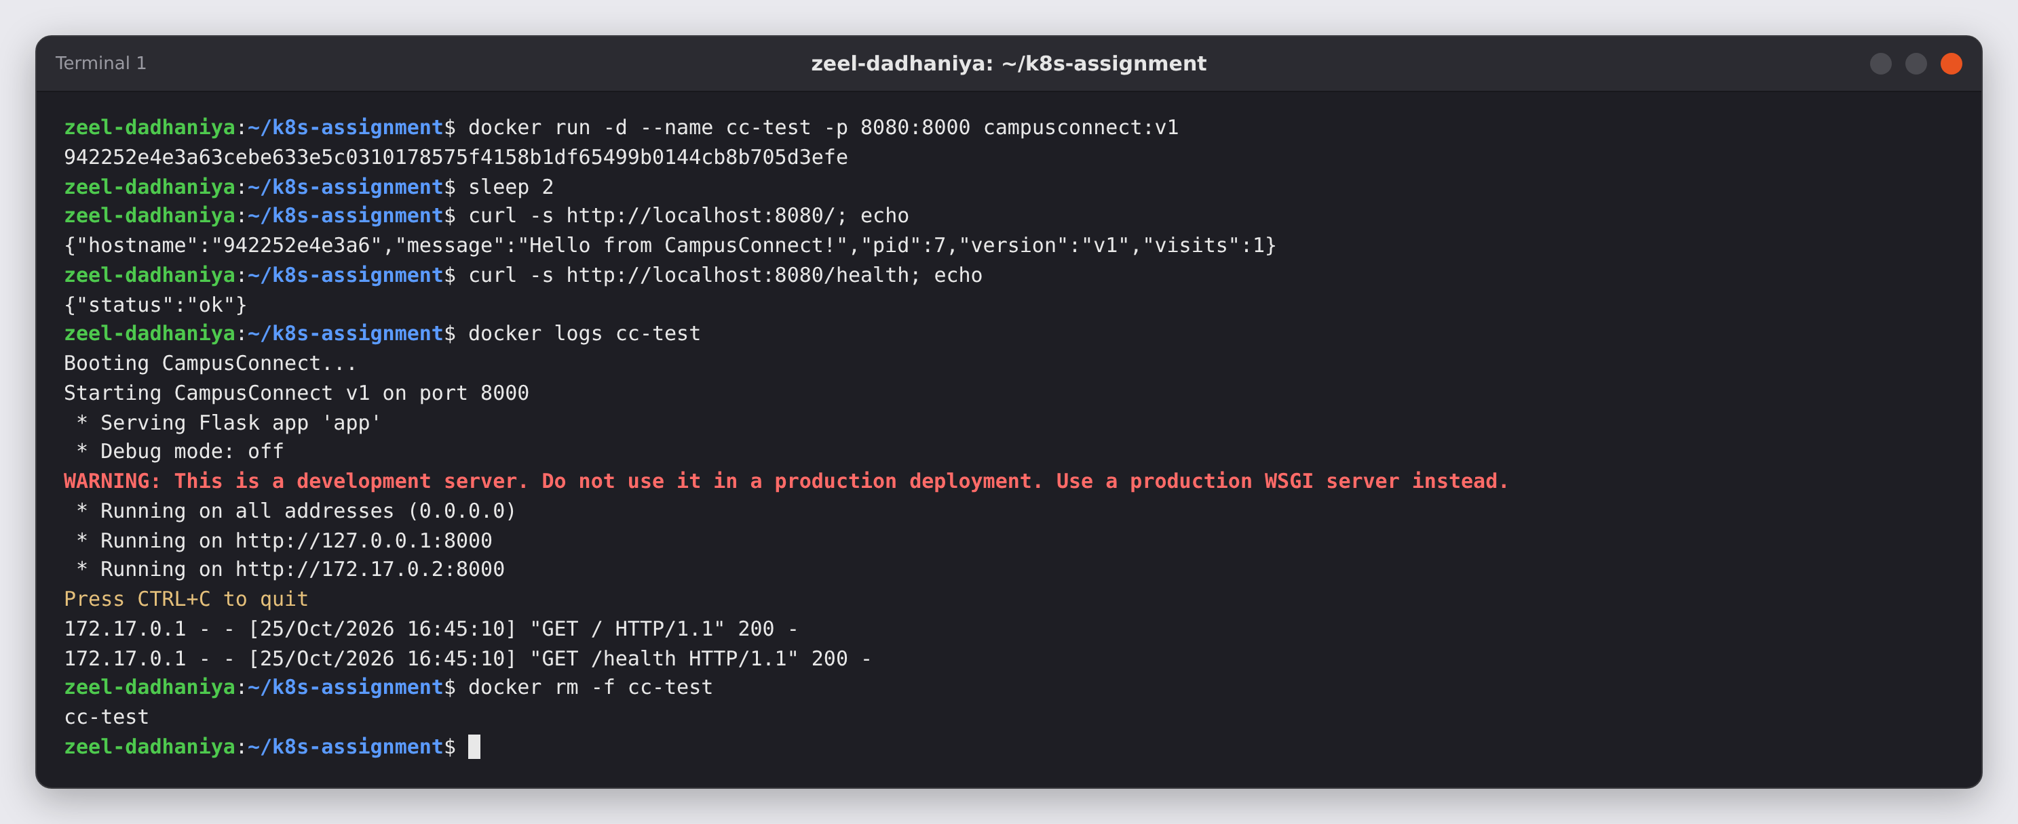
Figure 6: Testing the image with plain Docker first · Terminal 1 · captured 2026-10-25 16:45:08 UTC
Observation: The image works: it answers "Hello from CampusConnect!" with visits 1 and version v1, and /health returns ok. The log shows "Booting CampusConnect..." and two HTTP 200 requests.

5. Part C — Build the cluster and make the image available to it (assignment task 3)
Kubernetes nodes have their own container runtime (containerd) and do not see the images in my local Docker. I built a 3-node kind cluster and then copied the local image into every node with kind load docker-image, so no registry is needed.

Figure 7. Writing the kind cluster configuration
Command | Explanation
cat > kind-config.yaml <<'EOF' … EOF | Describes the cluster: one control-plane node and two worker nodes. extraPortMappings opens port 30080 of the control-plane container on the host, so the NodePort Service can be reached at localhost:30080.
cat kind-config.yaml | Prints the file to check it.
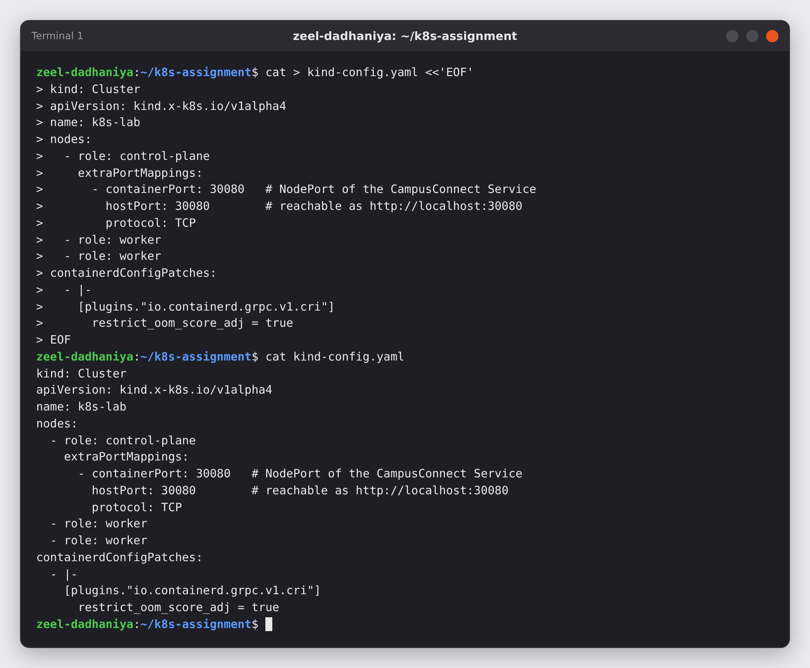
Figure 7: Writing the kind cluster configuration · Terminal 1 · captured 2026-10-25 16:45:11 UTC
Observation: The cluster is named k8s-lab, as in the Kubernetes lab. The containerdConfigPatches block is an environment fix for my VM; see the note in section 2.

Figure 8. Creating the 3-node cluster
Command | Explanation
kind create cluster --config kind-config.yaml | Creates three Docker containers that act as Kubernetes nodes. It starts the control plane, installs networking (CNI) and storage, and joins the two workers.
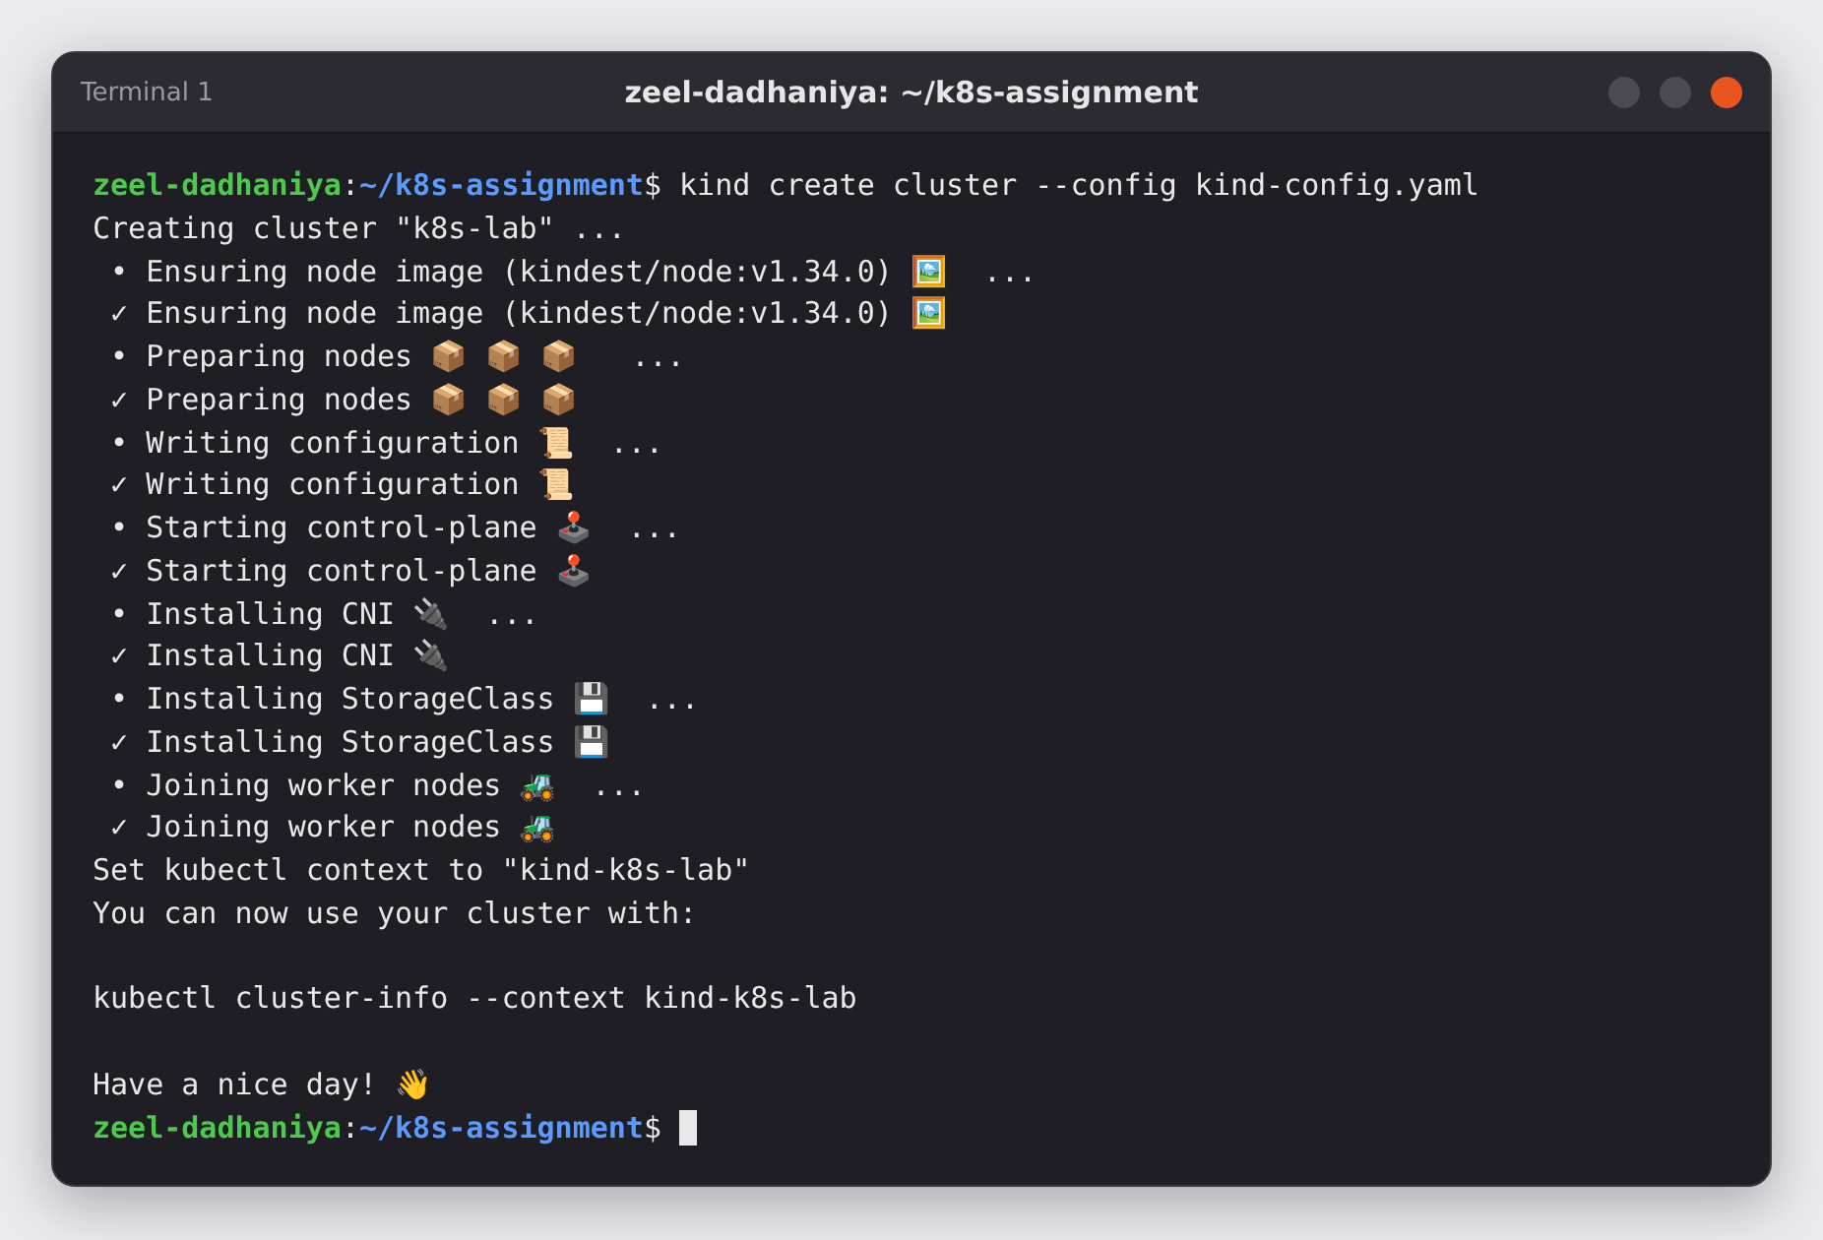
Figure 8: Creating the 3-node cluster · Terminal 1 · captured 2026-10-25 16:45:11 UTC
Observation: Every stage completed with a tick, and kubectl was switched to the new context kind-k8s-lab.

Figure 9. Checking the nodes
Command | Explanation
kubectl wait --for=condition=Ready nodes --all --timeout=180s | Waits until all nodes report Ready instead of guessing.
kubectl config current-context | Shows which cluster kubectl is talking to.
kubectl get nodes -o wide | Lists the nodes with their role, version, internal IP and container runtime.
docker ps --format "{{.Names}}\t{{.Ports}}" | Lists the Docker containers behind the nodes and their published ports.
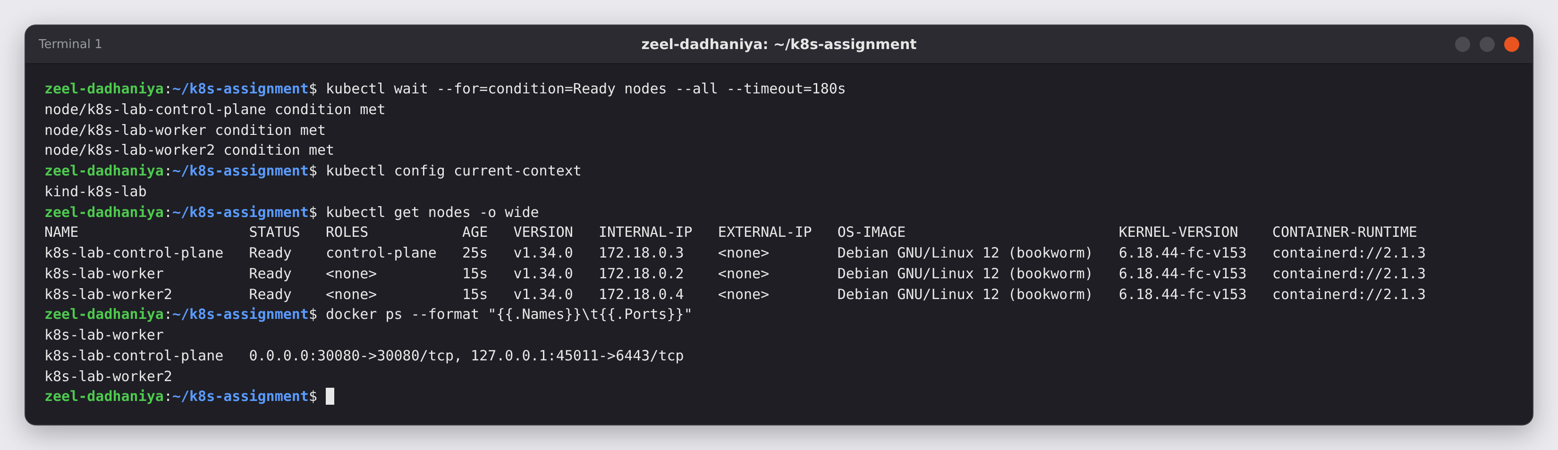
Figure 9: Checking the nodes · Terminal 1 · captured 2026-10-25 16:45:35 UTC
Observation: k8s-lab-control-plane, k8s-lab-worker and k8s-lab-worker2 are Ready (Kubernetes v1.34.0, containerd 2.1.3). Docker shows the same three names. Port 0.0.0.0:30080 is published on the control-plane container.

Figure 10. Loading campusconnect:v1 into the cluster nodes
Command | Explanation
kind load docker-image campusconnect:v1 --name k8s-lab | Exports the image from local Docker and imports it into the containerd store of every node in the k8s-lab cluster.
docker exec k8s-lab-worker crictl images | grep campusconnect | Lists the images inside the first worker's container runtime to prove the image arrived.
docker exec k8s-lab-worker2 crictl images | grep campusconnect | Same check on the second worker.
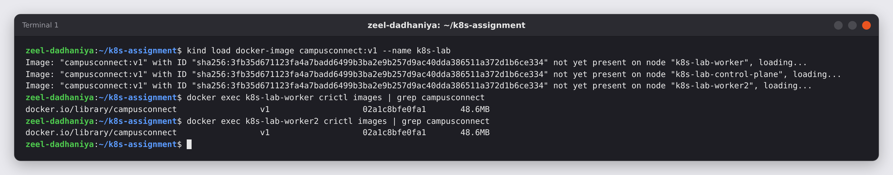
Figure 10: Loading campusconnect:v1 into the cluster nodes · Terminal 1 · captured 2026-10-25 16:45:49 UTC
Observation: kind loaded the image on all three nodes, and both workers now list docker.io/library/campusconnect:v1 (48.6 MB). Pods can start from this local image without contacting any registry.

6. Part D — Deploy the app (assignment tasks 4 and 5)
I wrote a Deployment for the Python app with the correct image (campusconnect:v1) and container port (8000). Then I applied it and checked the rollout.

Figure 11. Writing deployment.yaml
Command | Explanation
cat > deployment.yaml <<'EOF' … EOF | Creates the Deployment manifest. The main fields are explained below.
replicas: 3 / selector / labels | Keeps 3 copies of the app running. The label app: campusconnect links the Deployment to its Pods, and later the Service.
image: campusconnect:v1, imagePullPolicy: IfNotPresent | Runs the image built in Part B. IfNotPresent uses the copy loaded into the nodes instead of trying to download it from Docker Hub.
containerPort: 8000 | The port Flask listens on, the same port as EXPOSE 8000 in the Dockerfile.
readinessProbe / livenessProbe on /health | The readiness probe sends traffic to a Pod only after /health answers. The liveness probe restarts the container if /health stops answering.
resources: requests / limits | Reserves 50m CPU and 64Mi memory per Pod and caps each Pod at 250m CPU and 128Mi memory.
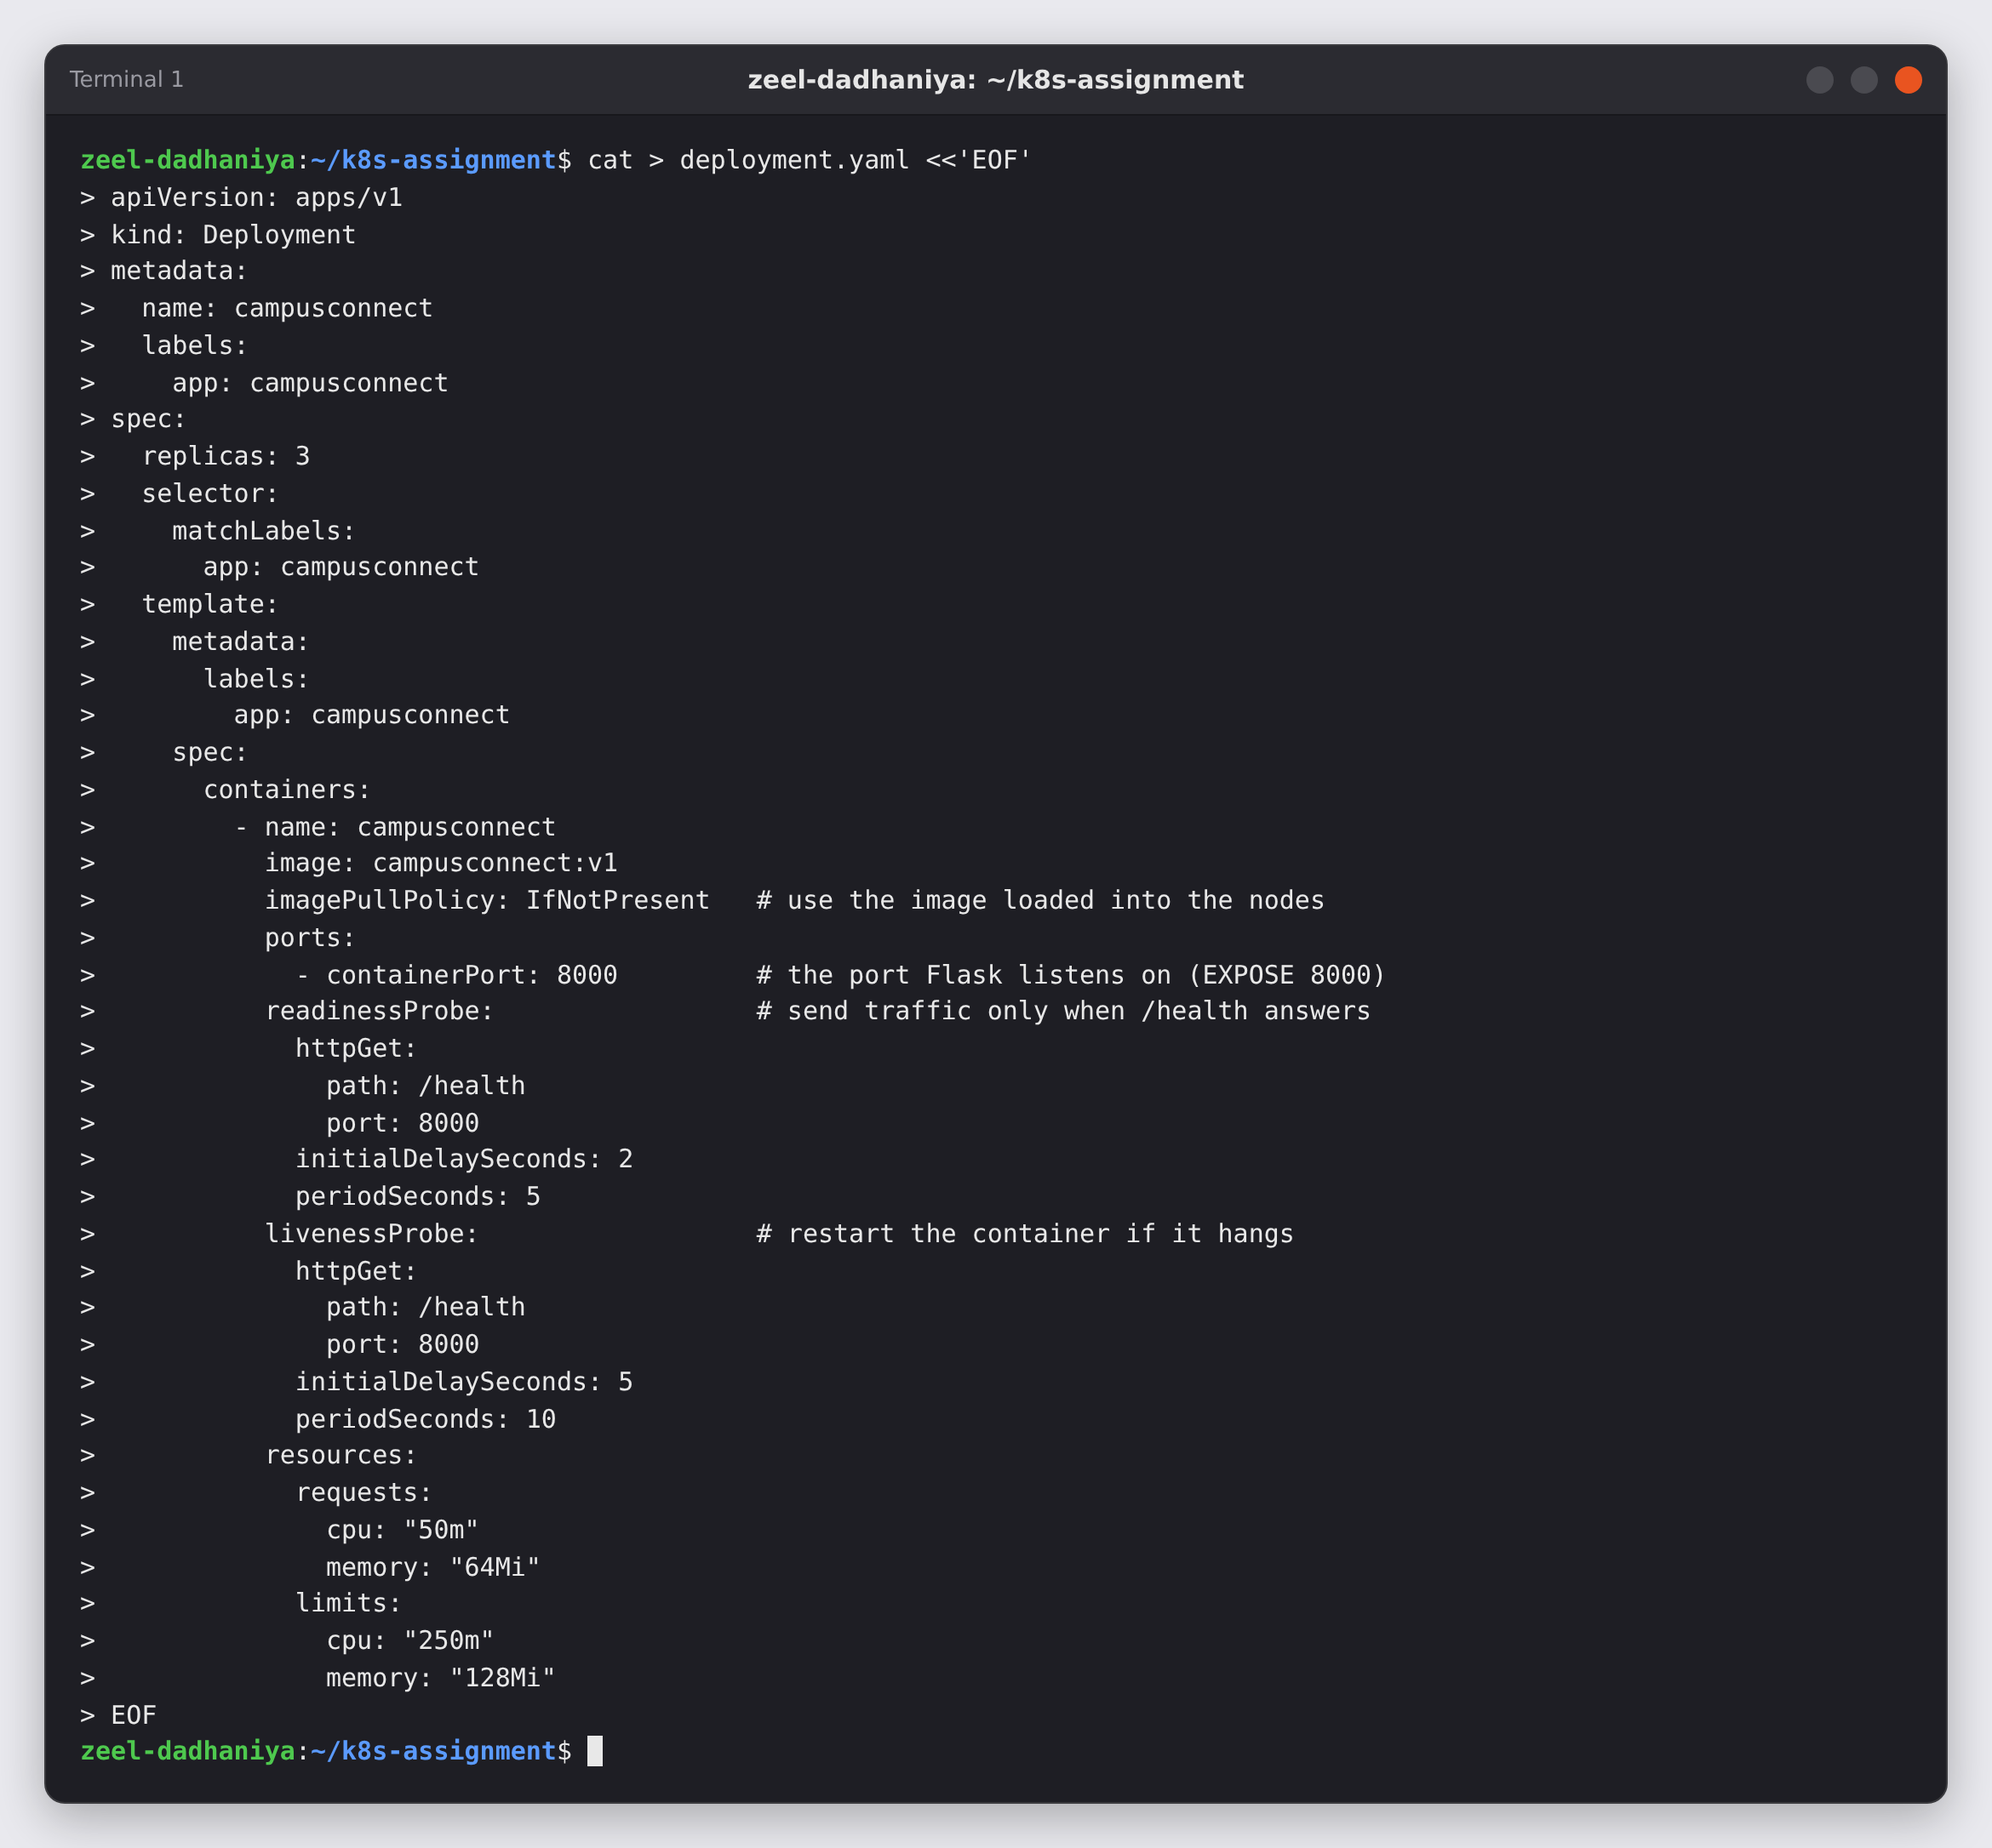
Figure 11: Writing deployment.yaml · Terminal 1 · captured 2026-10-25 16:45:57 UTC
Observation: The file is written with spaces only (two per level). The full file is in Appendix B.

Figure 12. Validating, deploying and checking the rollout
Command | Explanation
kubectl apply --dry-run=client -f deployment.yaml | Validates the file locally without creating anything.
kubectl apply -f deployment.yaml | Sends the desired state to the API server.
kubectl rollout status deployment/campusconnect --timeout=120s | Follows the rollout until every replica is available (task 5).
kubectl get pods -o wide | Shows the Pods with their IP addresses and the node each one runs on.
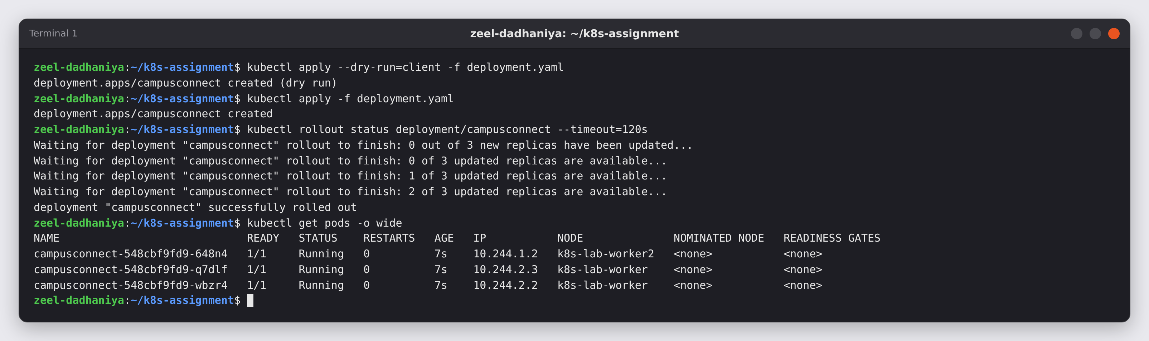
Figure 12: Validating, deploying and checking the rollout · Terminal 1 · captured 2026-10-25 16:45:57 UTC
Observation: The rollout went from 0 to 3 available replicas and printed "successfully rolled out". All 3 Pods are Running (1/1) and are spread over k8s-lab-worker and k8s-lab-worker2. The scheduler placed them; I never named a node.

Figure 13. One file, three kinds of objects
Command | Explanation
kubectl get deployments | Shows the Deployment I wrote: 3/3 ready.
kubectl get replicasets | Shows the ReplicaSet the Deployment created to keep exactly 3 Pods.
kubectl get pods -l app=campusconnect | Lists only the Pods carrying the label app=campusconnect.
kubectl describe deployment campusconnect | tail -n 6 | Shows the end of the description: the active ReplicaSet and the Events.
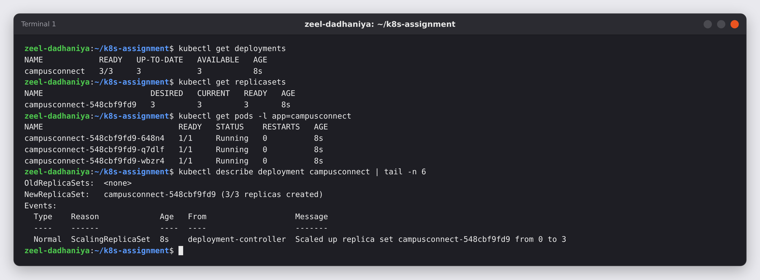
Figure 13: One file, three kinds of objects · Terminal 1 · captured 2026-10-25 16:46:04 UTC
Observation: The names show the chain: Deployment campusconnect → ReplicaSet campusconnect-548cbf9fd9 → Pods campusconnect-548cbf9fd9-xxxxx. The event "Scaled up replica set campusconnect-548cbf9fd9 from 0 to 3" is the hand-over from the Deployment to its ReplicaSet.

Figure 14. Reading the app's logs in the Pods
Command | Explanation
kubectl logs -l app=campusconnect --prefix --tail=4 | Prints the last 4 log lines of every Pod with the label. --prefix shows which Pod each line comes from.
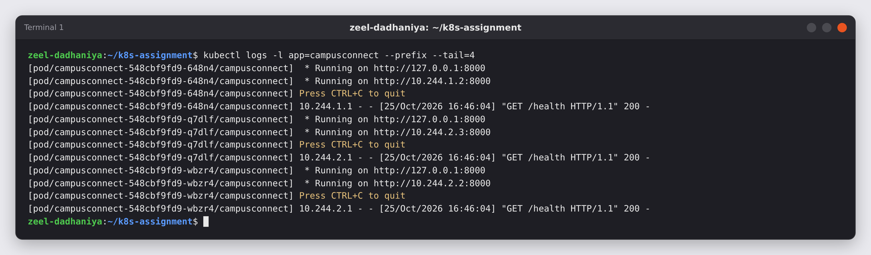
Figure 14: Reading the app's logs in the Pods · Terminal 1 · captured 2026-10-25 16:46:05 UTC
Observation: Each Pod runs Flask on its own Pod IP, port 8000. The GET /health 200 lines are the kubelet's readiness and liveness probes, which shows the probes work.

7. Part E — Test the app and confirm the Service is reachable (assignment task 6)
Pod IPs change every time a Pod is replaced, so I put a Service in front of the Pods. I then tested it three ways: from my machine through the NodePort, from inside the cluster through the Service's DNS name, and through a port-forward tunnel. I finished with a browser check.

Figure 15. Creating a NodePort Service
Command | Explanation
cat > service.yaml <<'EOF' … EOF | Creates a Service of type NodePort. The selector app: campusconnect picks the Pods. port 80 is the Service port, targetPort 8000 is the container port and nodePort 30080 is the port opened on the nodes.
kubectl apply -f service.yaml | Creates the Service.
kubectl get services | Lists the Services with their cluster IP and ports.
kubectl get endpoints campusconnect | Shows which Pod IP:port pairs the Service sends traffic to.
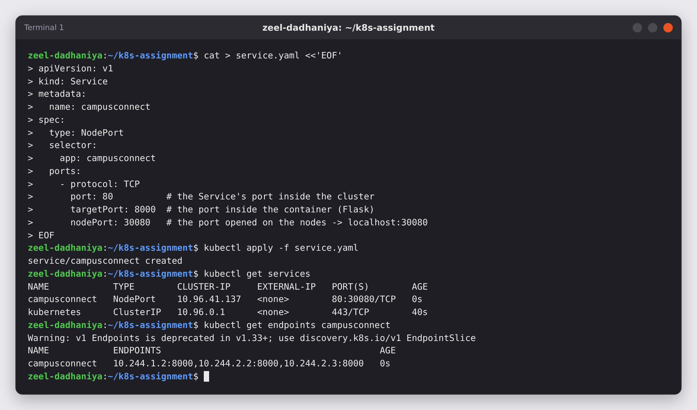
Figure 15: Creating a NodePort Service · Terminal 1 · captured 2026-10-25 16:46:05 UTC
Observation: campusconnect is a NodePort Service (80:30080/TCP) with cluster IP 10.96.41.137. ENDPOINTS lists exactly the 3 Pod IPs on port 8000, which proves the labels match. (Kubernetes 1.33+ prints a deprecation warning for v1 Endpoints; the command still works.)

Figure 16. Calling the app through the NodePort
Command | Explanation
sleep 5 | Gives kube-proxy a few seconds to program the new NodePort on the nodes.
for i in 1 2 3 4 5 6; do curl -s http://localhost:30080/; echo; done | Sends 6 requests to the Service through localhost:30080 (host → control-plane container → kube-proxy → a Pod).
curl -s http://localhost:30080/health; echo | Calls the health endpoint through the Service.
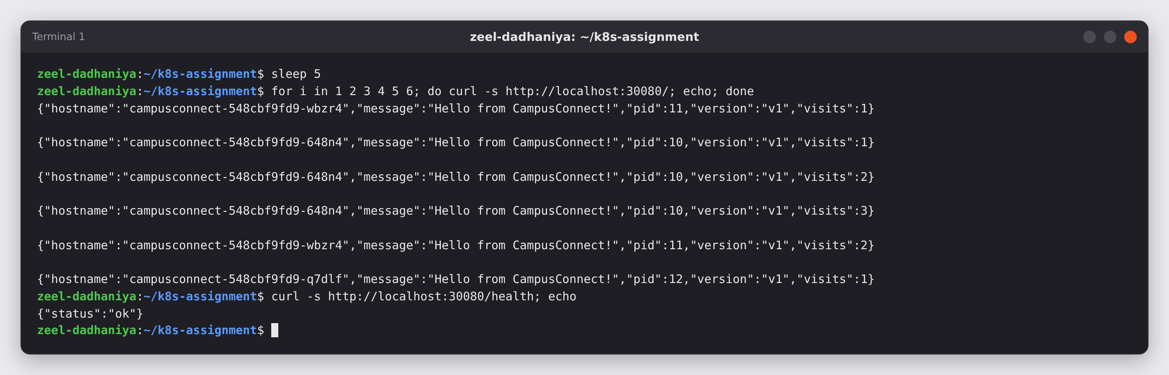
Figure 16: Calling the app through the NodePort · Terminal 1 · captured 2026-10-25 16:46:05 UTC
Observation: Every request succeeded. The hostname changes between campusconnect-548cbf9fd9-wbzr4, -648n4 and -q7dlf, so the Service spreads requests over all 3 Pods (load balancing). Each Pod keeps its own visit counter because /data is inside each container.

Figure 17. Calling the app from inside the cluster by its Service name
Command | Explanation
kubectl exec deploy/campusconnect -- python -c "import urllib.request as u; print(u.urlopen('http://campusconnect').read().decode())" | Runs a small Python HTTP request inside one of the Pods against http://campusconnect. This shows that other Pods find the app by its Service name through cluster DNS (CoreDNS) on port 80.
kubectl get service campusconnect -o wide | Shows the Service again with its SELECTOR column.
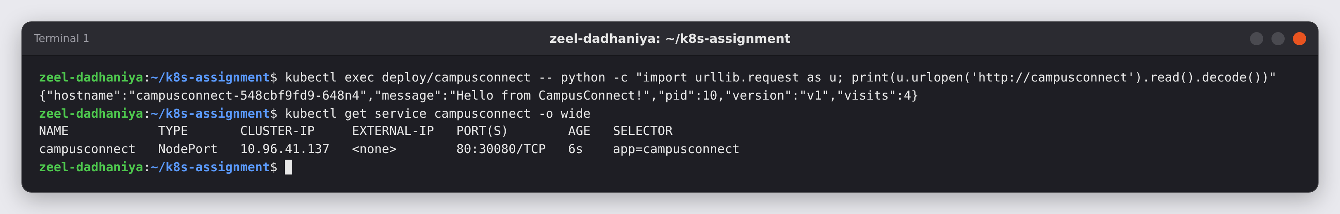
Figure 17: Calling the app from inside the cluster by its Service name · Terminal 1 · captured 2026-10-25 16:46:10 UTC
Observation: The in-cluster request returned the CampusConnect JSON, so the Service is reachable inside the cluster by name. The selector is app=campusconnect.

Figure 18. Reaching the app through kubectl port-forward
Command | Explanation
kubectl port-forward service/campusconnect 8081:80 > pf.log 2>&1 & | Opens a temporary tunnel from localhost:8081 to port 80 of the Service. It runs in the background and writes its messages to pf.log.
sleep 2 | Waits for the tunnel to open.
curl -s http://localhost:8081/; echo | Calls the app through the tunnel.
cat pf.log | Shows the messages port-forward printed.
kill %1; rm pf.log | Stops the background tunnel (job 1) and removes the log file.
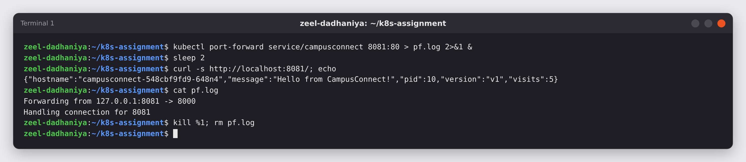
Figure 18: Reaching the app through kubectl port-forward · Terminal 1 · captured 2026-10-25 16:46:11 UTC
Observation: "Forwarding from 127.0.0.1:8081 -> 8000" and "Handling connection for 8081" show the request went through the tunnel to container port 8000. port-forward is useful for a quick private check; the NodePort keeps working without it.

Figure 19. Browser: http://localhost:30080/
Action | Purpose
Open http://localhost:30080/ in Chromium | Loads the app through the NodePort, the same way a user would.
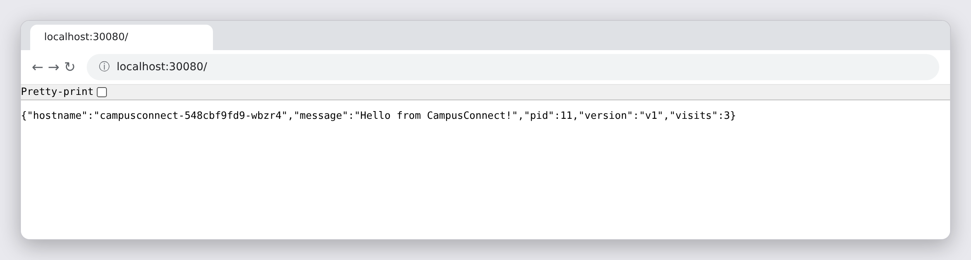
Figure 19: Browser: http://localhost:30080/ · Browser (Chromium) · captured 2026-10-25 16:46:13 UTC
Observation: The browser shows the CampusConnect JSON from Pod campusconnect-548cbf9fd9-wbzr4 (version v1). The app deployed from the Docker image is reachable from outside the cluster.

8. Part F — Going further: scaling, a rolling update to v2, and self-healing
To show the production workflow the assignment asks for, I also scaled the Deployment, shipped a new version of the image (campusconnect:v2 from the Docker lab's Dockerfile.v2) with a declarative rolling update, and checked that Kubernetes replaces a deleted Pod.

Figure 20. Scaling up to 5 replicas
Command | Explanation
kubectl scale deployment campusconnect --replicas=5 | Changes the desired number of Pods from 3 to 5.
kubectl rollout status deployment/campusconnect | Waits until all 5 are available.
kubectl get pods -o wide | Shows the old and the new Pods.
kubectl get endpoints campusconnect | Shows that the Service picked up the new Pods automatically.
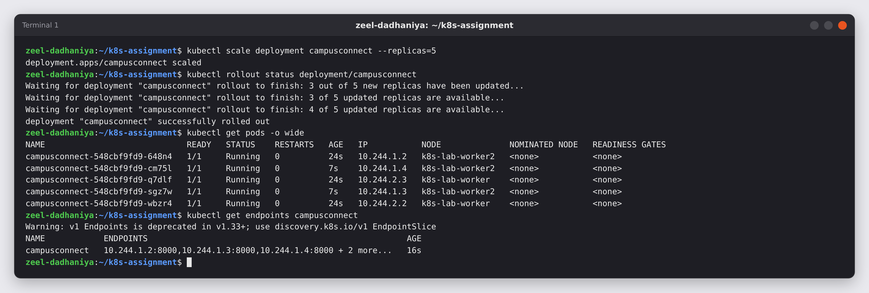
Figure 20: Scaling up to 5 replicas · Terminal 1 · captured 2026-10-25 16:46:14 UTC
Observation: Two new Pods (AGE 7s) were added and the original three (AGE 24s) were not touched. The endpoints grew to 5 ("+ 2 more...") without editing service.yaml, because the Service selects Pods by label.

Figure 21. Scaling back to 3 replicas
Command | Explanation
kubectl scale deployment campusconnect --replicas=3 | Sets the desired count back to 3.
sleep 35 | Waits for the two extra Pods to finish shutting down (the default grace period is 30 s).
kubectl get pods -o wide | Checks the result.
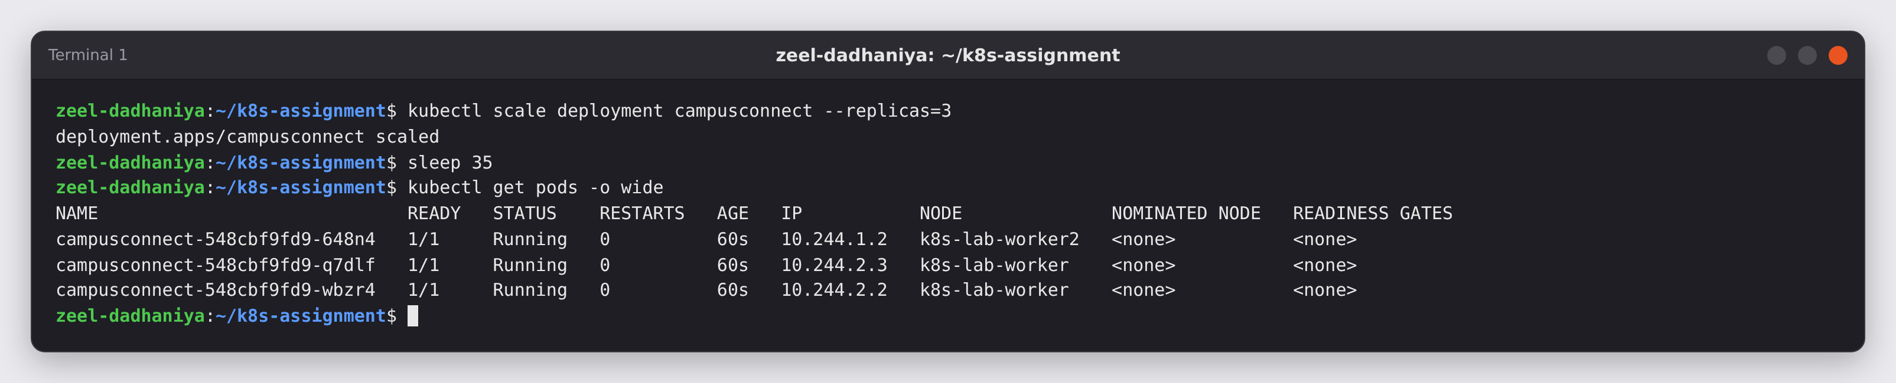
Figure 21: Scaling back to 3 replicas · Terminal 1 · captured 2026-10-25 16:46:21 UTC
Observation: Exactly the original 3 Pods remain. Kubernetes removed only the extra ones.

Figure 22. Building and loading version 2 of the image
Command | Explanation
cat > Dockerfile.v2 <<'EOF' … EOF | Writes the improved Dockerfile from the Docker lab. It copies requirements.txt and installs dependencies before the code, so the layer cache works. It sets APP_VERSION=v2 and uses the exec form ENTRYPOINT ["python", "app.py"], so Python runs as PID 1 and receives SIGTERM.
docker build -t campusconnect:v2 -f Dockerfile.v2 . | Builds the new image with the tag v2.
kind load docker-image campusconnect:v2 --name k8s-lab | Makes the v2 image available on all cluster nodes.
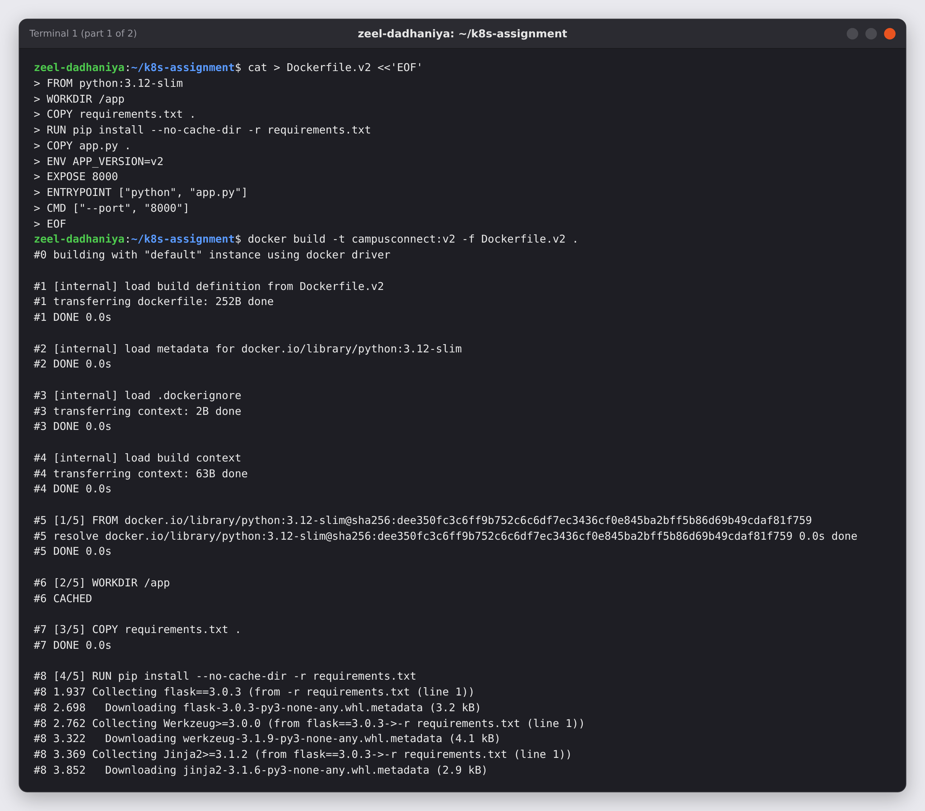
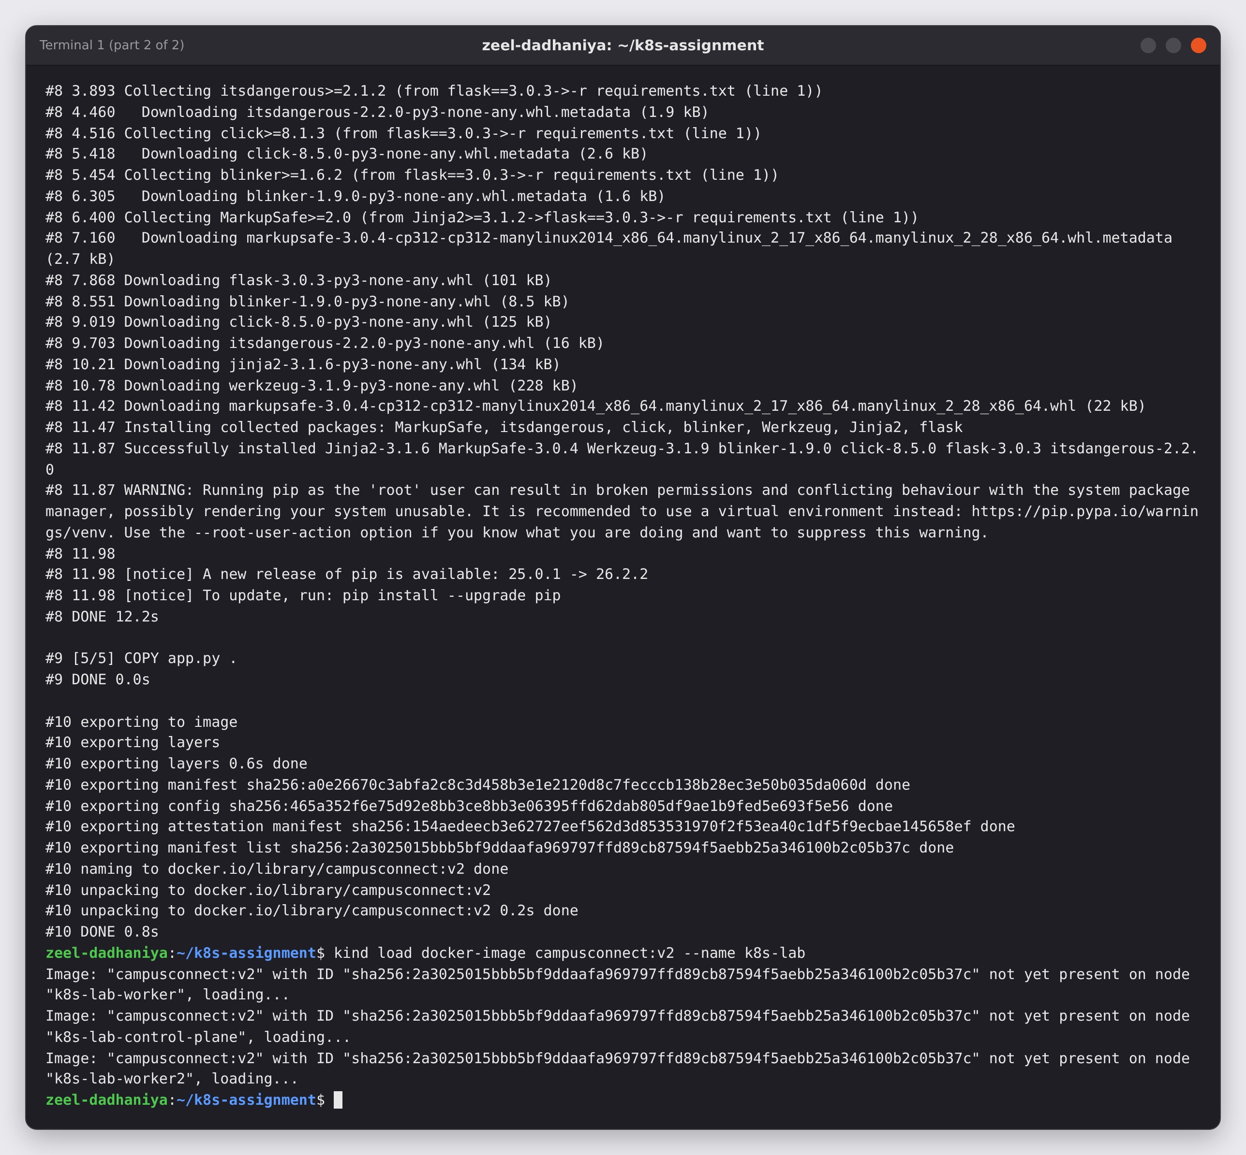
Figure 22: Building and loading version 2 of the image · Terminal 1 · captured 2026-10-25 16:46:57 UTC
Observation: campusconnect:v2 was built (5 steps) and loaded on all three nodes.

Figure 23. Declarative rolling update from v1 to v2
Command | Explanation
sed -i 's/campusconnect:v1/campusconnect:v2/' deployment.yaml | Changes the image tag in the YAML file. The file stays the single source of truth and could be committed to Git.
grep -n 'image:' deployment.yaml | Confirms that line 19 now says campusconnect:v2.
kubectl apply -f deployment.yaml | Applies the changed file. kubectl reports "configured" because only the image changed.
kubectl rollout status deployment/campusconnect --timeout=180s | Follows the rolling update: a new Pod becomes ready before an old one is removed, one at a time.
kubectl get replicasets | Shows one ReplicaSet per version.
kubectl rollout history deployment/campusconnect | Lists the recorded revisions.
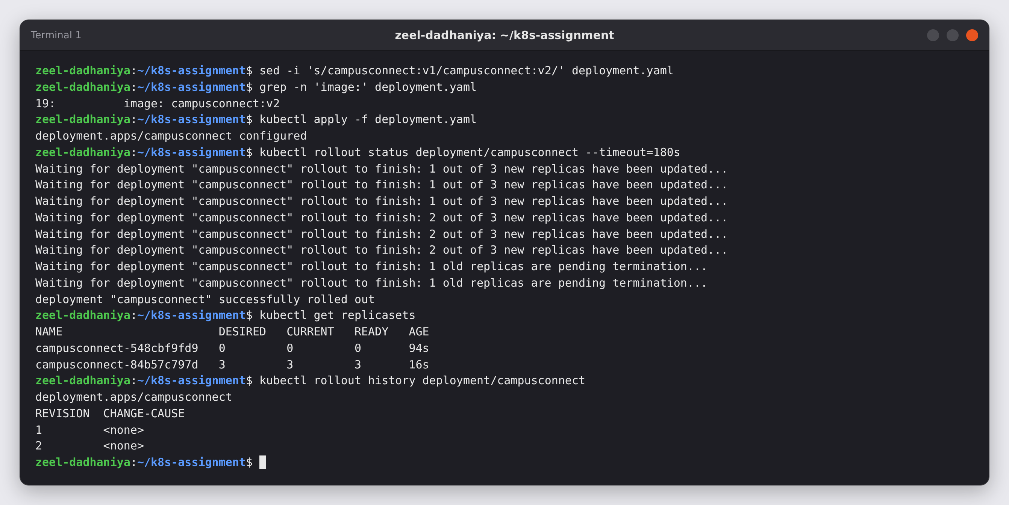
Figure 23: Declarative rolling update from v1 to v2 · Terminal 1 · captured 2026-10-25 16:47:14 UTC
Observation: The rollout replaced the Pods one by one and finished successfully. The new ReplicaSet campusconnect-84b57c797d (v2) runs 3 Pods. The old one, 548cbf9fd9 (v1), is kept at 0 so that kubectl rollout undo can return to it. History shows revisions 1 and 2.

Figure 24. Checking the new version
Command | Explanation
sleep 30 | Waits for the old v1 Pods to finish terminating.
kubectl get pods -o wide | Lists the Pods after the update.
for i in 1 2 3; do curl -s http://localhost:30080/; echo; done | Calls the app through the NodePort three times.
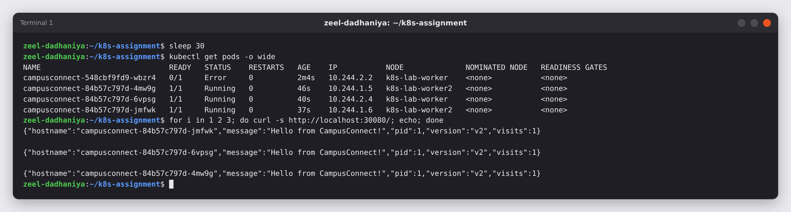
Figure 24: Checking the new version · Terminal 1 · captured 2026-10-25 16:47:31 UTC
Observation: All three v2 Pods are Running, and every response now says "version":"v2" and "pid":1. One old v1 Pod still shows Error. Its CMD used shell form, so /bin/sh was PID 1 and did not pass SIGTERM to Python. Kubernetes waited the full 30 s grace period and then killed it, the same "exit 137" problem as in the Docker lab. Version 2 fixes this with the exec-form ENTRYPOINT, and Python is now PID 1.

Figure 25. Browser: version 2 served through the NodePort
Action | Purpose
Reload http://localhost:30080/ in Chromium | Checks the update the way a user would see it.
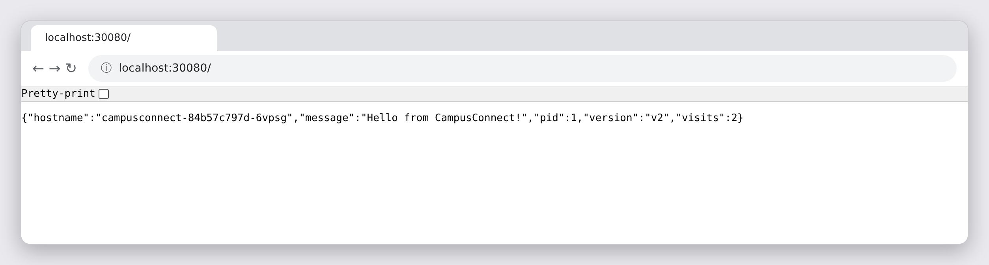
Figure 25: Browser: version 2 served through the NodePort · Browser (Chromium) · captured 2026-10-25 16:48:01 UTC
Observation: The page now shows version v2 from a campusconnect-84b57c797d Pod. The Service URL did not change during the update.

Figure 26. Self-healing: deleting a running Pod on purpose
Command | Explanation
kubectl get pods | Lists the Pod names so a real one can be chosen.
kubectl delete pod campusconnect-84b57c797d-4mw9g | Deletes one running Pod.
kubectl get pods -o wide | Checks the Pods immediately.
sleep 5 ; kubectl get pods -o wide | Checks again a few seconds later.
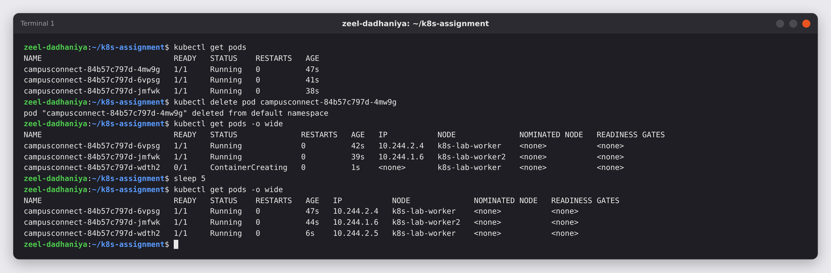
Figure 26: Self-healing: deleting a running Pod on purpose · Terminal 1 · captured 2026-10-25 16:48:02 UTC
Observation: The ReplicaSet saw 2 Pods instead of the desired 3 and immediately created a replacement, campusconnect-84b57c797d-wdth2. The replacement was ContainerCreating and became Running 1/1 within about 6 seconds, with a new name and a new IP (10.244.2.5). The other two Pods kept serving requests the whole time.

9. Part G — Cleanup
Finally I removed the app and the cluster. The files on disk are kept, because they are the real result of the assignment.

Figure 27. Removing the app and deleting the cluster
Command | Explanation
kubectl delete -f service.yaml -f deployment.yaml | Deletes the Service and the Deployment described by the two files. The ReplicaSets and Pods are owned by the Deployment, so they are removed too.
kubectl wait --for=delete pod -l app=campusconnect --timeout=90s | Waits until every CampusConnect Pod is gone.
kubectl get all | Shows what is left in the default namespace.
kind delete cluster --name k8s-lab | Deletes the three node containers and the cluster.
kind get clusters | Confirms that no kind cluster remains.
ls | Shows the files that remain in the assignment folder.
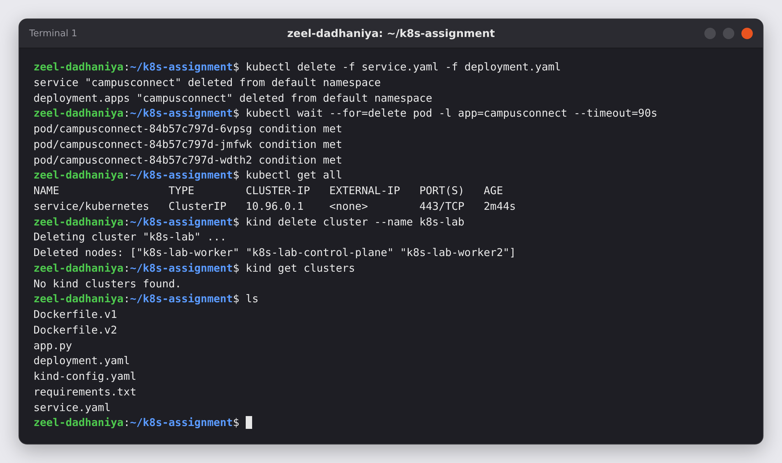
Figure 27: Removing the app and deleting the cluster · Terminal 1 · captured 2026-10-25 16:48:08 UTC
Observation: Only the built-in kubernetes Service was left before the cluster was deleted, and kind reports "No kind clusters found." The Dockerfiles, app.py, kind-config.yaml, deployment.yaml and service.yaml remain, so the whole deployment can be rebuilt from these files.

10. What I learned
- Docker builds the image and Kubernetes runs it. The same campusconnect:v1 image ran unchanged with docker run and in a Kubernetes Deployment.
- A local image has to be made available to the cluster. kind load docker-image copies it into the nodes, and imagePullPolicy: IfNotPresent stops Kubernetes from looking for it on Docker Hub. A real cluster would use a registry instead.
- The containerPort in the Deployment and the targetPort in the Service must match the port the app listens on (EXPOSE 8000). The Service can use a different port (80) and nodePort (30080).
- A Service finds its Pods by label, and kubectl get endpoints proves it. Scaling to 5 Pods updated the endpoints automatically.
- Readiness and liveness probes on /health make Kubernetes send traffic only to healthy Pods and restart a container that hangs.
- A declarative rolling update (edit the YAML, then kubectl apply) shipped v2 with no downtime and kept the old ReplicaSet for rollback.
- Exec-form ENTRYPOINT matters on Kubernetes too. The v1 Pods (shell-form CMD) ignored SIGTERM and were killed after 30 s. The v2 Pods run Python as PID 1 and shut down cleanly.
- Pods are disposable. A deleted Pod was replaced within seconds by a new Pod with a new name and IP, and the app stayed available.

Appendix A: Commands in order
docker ps
kubectl version --client
kind version
mkdir -p ~/k8s-assignment && cd ~/k8s-assignment
pwd
echo "flask==3.0.3" > requirements.txt
cat > app.py <<'EOF' … EOF
ls -l
cat requirements.txt
cat > Dockerfile.v1 <<'EOF' … EOF
cat Dockerfile.v1
docker build -t campusconnect:v1 -f Dockerfile.v1 .
docker images campusconnect
docker run -d --name cc-test -p 8080:8000 campusconnect:v1
sleep 2
curl -s http://localhost:8080/; echo
curl -s http://localhost:8080/health; echo
docker logs cc-test
docker rm -f cc-test
cat > kind-config.yaml <<'EOF' … EOF
cat kind-config.yaml
kind create cluster --config kind-config.yaml
kubectl wait --for=condition=Ready nodes --all --timeout=180s
kubectl config current-context
kubectl get nodes -o wide
docker ps --format "{{.Names}}\t{{.Ports}}"
kind load docker-image campusconnect:v1 --name k8s-lab
docker exec k8s-lab-worker crictl images | grep campusconnect
docker exec k8s-lab-worker2 crictl images | grep campusconnect
cat > deployment.yaml <<'EOF' … EOF
kubectl apply --dry-run=client -f deployment.yaml
kubectl apply -f deployment.yaml
kubectl rollout status deployment/campusconnect --timeout=120s
kubectl get pods -o wide
kubectl get deployments
kubectl get replicasets
kubectl get pods -l app=campusconnect
kubectl describe deployment campusconnect | tail -n 6
kubectl logs -l app=campusconnect --prefix --tail=4
cat > service.yaml <<'EOF' … EOF
kubectl apply -f service.yaml
kubectl get services
kubectl get endpoints campusconnect
sleep 5
for i in 1 2 3 4 5 6; do curl -s http://localhost:30080/; echo; done
curl -s http://localhost:30080/health; echo
kubectl exec deploy/campusconnect -- python -c "import urllib.request as u; print(u.urlopen('http://campusconnect').read().decode())"
kubectl get service campusconnect -o wide
kubectl port-forward service/campusconnect 8081:80 > pf.log 2>&1 &
sleep 2
curl -s http://localhost:8081/; echo
cat pf.log
kill %1; rm pf.log
kubectl scale deployment campusconnect --replicas=5
kubectl rollout status deployment/campusconnect
kubectl get pods -o wide
kubectl get endpoints campusconnect
kubectl scale deployment campusconnect --replicas=3
sleep 35
kubectl get pods -o wide
cat > Dockerfile.v2 <<'EOF' … EOF
docker build -t campusconnect:v2 -f Dockerfile.v2 .
kind load docker-image campusconnect:v2 --name k8s-lab
sed -i 's/campusconnect:v1/campusconnect:v2/' deployment.yaml
grep -n 'image:' deployment.yaml
kubectl apply -f deployment.yaml
kubectl rollout status deployment/campusconnect --timeout=180s
kubectl get replicasets
kubectl rollout history deployment/campusconnect
sleep 30
kubectl get pods -o wide
for i in 1 2 3; do curl -s http://localhost:30080/; echo; done
kubectl get pods
kubectl delete pod campusconnect-84b57c797d-4mw9g
kubectl get pods -o wide
sleep 5
kubectl get pods -o wide
kubectl delete -f service.yaml -f deployment.yaml
kubectl wait --for=delete pod -l app=campusconnect --timeout=90s
kubectl get all
kind delete cluster --name k8s-lab
kind get clusters
ls

Appendix B: Files

app.py
import argparse, os, signal, socket, sys
from flask import Flask, jsonify

app = Flask(__name__)
DATA_DIR = os.environ.get("DATA_DIR", "/data")
COUNT_FILE = os.path.join(DATA_DIR, "visits.txt")
APP_VERSION = os.environ.get("APP_VERSION", "v1")

def read_count():
try:
with open(COUNT_FILE) as f:
return int(f.read().strip() or 0)
except FileNotFoundError:
return 0

def write_count(n):
os.makedirs(DATA_DIR, exist_ok=True)
with open(COUNT_FILE, "w") as f:
f.write(str(n))

@app.route("/")
def index():
n = read_count() + 1
write_count(n)
return jsonify(message="Hello from CampusConnect!", visits=n,
hostname=socket.gethostname(), pid=os.getpid(),
version=APP_VERSION)

@app.route("/health")
def health():
return jsonify(status="ok")

def handle_sigterm(signum, frame):
print("Received SIGTERM - shutting down gracefully", flush=True)
sys.exit(0)

signal.signal(signal.SIGTERM, handle_sigterm)

if __name__ == "__main__":
parser = argparse.ArgumentParser()
parser.add_argument("--port", type=int, default=8000)
args = parser.parse_args()
print(f"Starting CampusConnect {APP_VERSION} on port {args.port}", flush=True)
app.run(host="0.0.0.0", port=args.port)

requirements.txt
flask==3.0.3

Dockerfile.v1
FROM python:3.12-slim
WORKDIR /app
COPY . .
RUN pip install --no-cache-dir -r requirements.txt
EXPOSE 8000
CMD echo "Booting CampusConnect..."; python app.py

Dockerfile.v2
FROM python:3.12-slim
WORKDIR /app
COPY requirements.txt .
RUN pip install --no-cache-dir -r requirements.txt
COPY app.py .
ENV APP_VERSION=v2
EXPOSE 8000
ENTRYPOINT ["python", "app.py"]
CMD ["--port", "8000"]

kind-config.yaml
kind: Cluster
apiVersion: kind.x-k8s.io/v1alpha4
name: k8s-lab
nodes:
- role: control-plane
extraPortMappings:
- containerPort: 30080 # NodePort of the CampusConnect Service
hostPort: 30080 # reachable as http://localhost:30080
protocol: TCP
- role: worker
- role: worker
containerdConfigPatches:
- |-
[plugins."io.containerd.grpc.v1.cri"]
restrict_oom_score_adj = true

deployment.yaml (as first applied, image campusconnect:v1)
apiVersion: apps/v1
kind: Deployment
metadata:
name: campusconnect
labels:
app: campusconnect
spec:
replicas: 3
selector:
matchLabels:
app: campusconnect
template:
metadata:
labels:
app: campusconnect
spec:
containers:
- name: campusconnect
image: campusconnect:v1
imagePullPolicy: IfNotPresent # use the image loaded into the nodes
ports:
- containerPort: 8000 # the port Flask listens on (EXPOSE 8000)
readinessProbe: # send traffic only when /health answers
httpGet:
path: /health
port: 8000
initialDelaySeconds: 2
periodSeconds: 5
livenessProbe: # restart the container if it hangs
httpGet:
path: /health
port: 8000
initialDelaySeconds: 5
periodSeconds: 10
resources:
requests:
cpu: "50m"
memory: "64Mi"
limits:
cpu: "250m"
memory: "128Mi"

service.yaml
apiVersion: v1
kind: Service
metadata:
name: campusconnect
spec:
type: NodePort
selector:
app: campusconnect
ports:
- protocol: TCP
port: 80 # the Service's port inside the cluster
targetPort: 8000 # the port inside the container (Flask)
nodePort: 30080 # the port opened on the nodes -> localhost:30080
In Figure 23, the only change made to deployment.yaml was the image line, from campusconnect:v1 to campusconnect:v2.

