**GUJARAT TECHNOLOGICAL UNIVERSITY, Ahmedabad**



**C. K. Pithawala College of Engg. & Technology, Surat Computer Engineering Department**

**A detailed report on Web Development Under the Subject of**

**Summer Internship (3170001) BE – IV, VIIth Semester Academic Year: 2023-2024**

**Submitted By:**

**ZEEL H. KAKLOTAR**

**210090107505**

**Guided By**

**PROF. SUPRIYA PATI**

**INDEX**

**Certificate 04 Joining Letter 05 Certificate of Joining 06 Certificate of Completion 07 Student’s Declaration 08 Acknowledgement 09 Abstract 10 Company Brief 11**

1. **Introduction 12**
   1. **Internship Objective 12**
   2. **Scope Of Work 12**
2. **Internship Work 13 2.1Technology Stack 13**
   1. **Knowledge Gained 13**
   2. **Description Of Sample Task 13**
   3. **Implementation Detail 14**
3. **Conclusion 17 Reference 18**
   1. **Training Schuedule 18**
   2. **Reference Link 18**

**C K Pithawala College of Engg. & Technology, Surat**



CERTIFICATE

This is to certify that the report entitled “ **Web Development** ” has been carried out by

**Zeel kaklotar**, Enrollment No: **210090107505** under the subject of “Summer Internship”(3170001) for the degree of Bachelor of Engineering in Computer Engineering in 7th Semester and presented the report as per guidelines of Gujarat Technological University, Ahmedabad during the academic year 2023-2024.

Place: Surat Date:

**Guide Internal Examiner External Examiner Head of Department**

**JOINING LETTER**

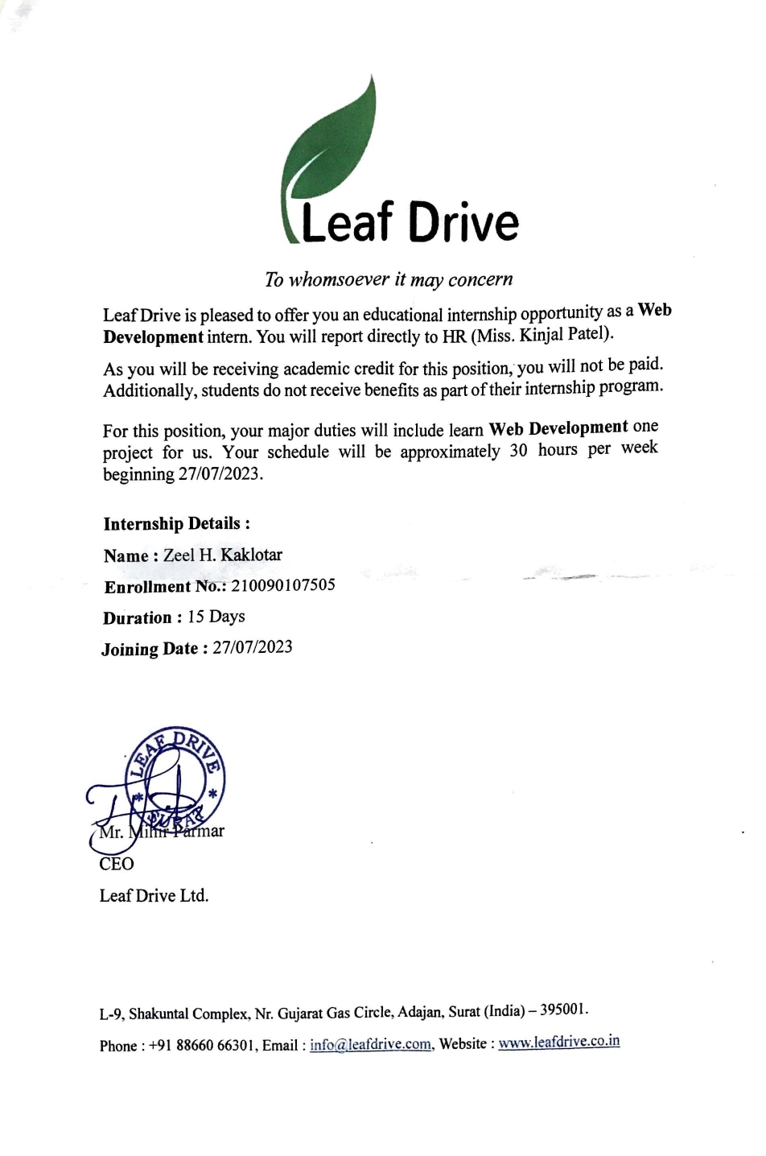

## Certificate of Completion

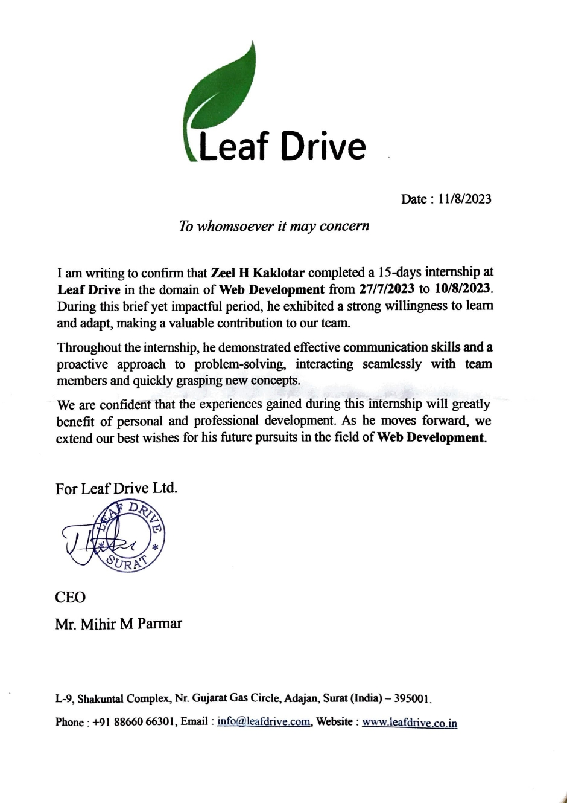

**Student’s Declaration**

I, under signed, **Zeel H. Kaklotar** a student of 7th semester, COMPUTER ENGINEERING, CKPCET, declare that Summer Internship report titled “**Web Development**” is a result of my own work and my indebtedness to other work publications, references, if any, have been duly acknowledged. If I am found guilty of copying any other report or published information and showing as my original work, I understand that I shall be liable and punishable by Institute or University, which may include ‘Fail’ in examination, ‘Repeat study & re-submission of the report’ or any other punishment that Institute or University may decide.

Name of Student: Zeel H. Kaklotar

Enrollment Number: 210090107505 Signature:

# Acknowledgement

First and foremost, I would like to thank Mihir Parmar, my internship supervisor, for providing me with the opportunity to work at Leaf Drive IT Solution. Your guidance, mentorship, and unwavering support throughout the internship have been invaluable. I have learned an immense amount under your leadership, and I am grateful for the knowledge and skills I have gained during this period.

I also would like all the people that worked along with me Leaf Drive It solution with their patience and openness they created an enjoyable working environment.

I would like to thank my Head of the Department Prof. Saurabh Tandel for his constructive criticism throughout my internship, I would like to thank my Internal Guide Prof. Supriya Pati, Assistant Professor, Computer Engineering Department, C. K. Pithawala College of Engineering and Technology, Surat, for mentoring and giving me continuous guidance and support from beginning to ending of my internship.

I would also like to extend my thanks to the entire team at Leaf Drive It solution. Your warm welcome, willingness to share knowledge, and collaborative spirit made my internship experience both enjoyable and educational. I am indebted to each team member for their patience and assistance.

Lastly, I am deeply grateful to my family and friends for their unwavering encouragement and belief in me. Your moral support has been a source of strength throughout this journey. This internship has been a significant milestone in my academic and professional development, and I am thankful to all those who have played a role in making it a success.

# ABSTRACT

This Report describes the full stack web development Internship that I did at **Leaf Drive IT Solution. Leaf Drive IT Solution** is known for its proficient and client-centric Mobile application development services, Web Design and Web Development services, E-Commerce services and Flutter development. I describe motivation and scope of work behind WebApp Development, explain what technology I learnt in this internship and how much knowledge I gained by working in professional environment. I also explain how the task or projects are made in HTML, CSS and JS Language and provide screenshots of the work that I have done in this internship.

The duration of this internship was from 27th July 2023 to 10th August 2023. In conclusion, this was an opportunity to develop and enhance skills and competencies in my career field which I actually achieved.

## COMPANY BRIEF

Leaf Drive Software is an IT solutions company that provides a wide range of services to businesses of all sizes. We specialize in custom software development, cloud migration and DevOps services, enterprise resource planning (ERP) solutions, customer relationship management (CRM) solutions, business intelligence and analytics solutions, data warehousing and data mining solutions, mobile app development, website development and design, and IT consulting and managed services.

Our team of experienced and qualified professionals is passionate about helping our clients succeed. We are committed to providing the highest level of customer service and satisfaction.

#### Mission :

Our mission is to provide our clients with the IT solutions they need to grow and succeed. We believe that technology can be a powerful tool for businesses, and we are committed to helping our clients use technology to their advantage.

#### Services:

* Web Development
* App Development
* PHP Development
* Flutter Development
* UI/UX Design
* Digital Marketing

# INTRODUCTION :

Internships are generally thought of to be reserved for college students looking to gain experience in a particular field. However, a wide area of people can benefit from Training Internships in order to receive real world experience and develop their skills. An objective for this position should emphasize the skills you already possess in the area and your interest in learning more. Internships are utilized in a number of different career fields, including architecture, engineering, healthcare, economics, advertising and many more. Some internship is used to allow individuals to perform scientific research while others are specifically designed to allow people to gain first-hand experience working. Utilizing internships is a great way to build your resume and develop skills that can be emphasized in your resume for future jobs. When you are applying for a Training Internship, make sure to highlight any special skills or talents that can make you stand apart from the rest of the applicants so that you have an improved chance of landing the position.

#### INTERNSHIP OBJECTIVE :

The primary objective of my 15-day internship in web development is to gain a comprehensive understanding of web technologies, encompassing both front-end and back-end development aspects. During this internship, I aim to cultivate hands-on coding experience, enhance my proficiency in HTML, CSS, and JavaScript, and explore server-side scripting languages like Node.js. Additionally, I plan to learn about database integration, version control systems like Git, web security practices, and performance optimization techniques. This internship will provide me with valuable insights into real-world project management and collaboration within a development team. Throughout the experience, I intend to document my progress, improve my skills, and foster a mindset of continuous learning to keep pace with the dynamic field of web development.

#### SCOPE OF WORK :

The scope of work for this 15-day web development internship encompasses a range of responsibilities, including front-end and back-end development tasks, version control using Git, web security, testing, debugging, documentation, and collaboration within a development team. The intern is expected to complete assigned coding projects, actively participate in meetings, and demonstrate progress in technical skills. The primary goal is to provide the intern with a well-rounded experience, fostering practical skills, teamwork, and effective communication while

contributing to the completion of real-world web development projects.

# INTERNSHIP WORK :

### Technology Stack :

* + - * **HTML :** Understanding of the structure and semantics of web content. Proficiency in creating web page structures, forms, tables, and multimedia elements.
      * **CSS :** Mastery of styling web pages, including layout, typography, color schemes, and responsive design. Knowledge of CSS Animation etc.
      * **JavaScript :** Proficiency in client-side scripting, enabling dynamic web interactivity and functionality. Understanding of JavaScript libraries and frameworks like jQuery, React, or Angular.
      * **Front-End Fremework(ReactJS) :** In-depth knowledge of the chosen framework, including component-based architecture, state management, and routing. Skills in building modern, responsive web applications.

### DICRPTION OF SAMPLE TASK :

First, I learn the basic knowledge of HTML and CSS after then I start learning fundamentals of JavaScript(variables, data types, function, DOM manipulation, event listener etc). Along with creating a web pages for each main topic. After this learn Git and Github.

After then start a framework and start building a project with use of ReactJS and NodeJS and MongoDB.

* + **IMPLEMENTATION DETAILS : Project : 1 – My Portfolio**

In this project, I make a static web site of my own portfolio in which I add the main page and footer and this page use with HTML and CSS and with Media query concept use. In website having navigation with nevbar to that content.

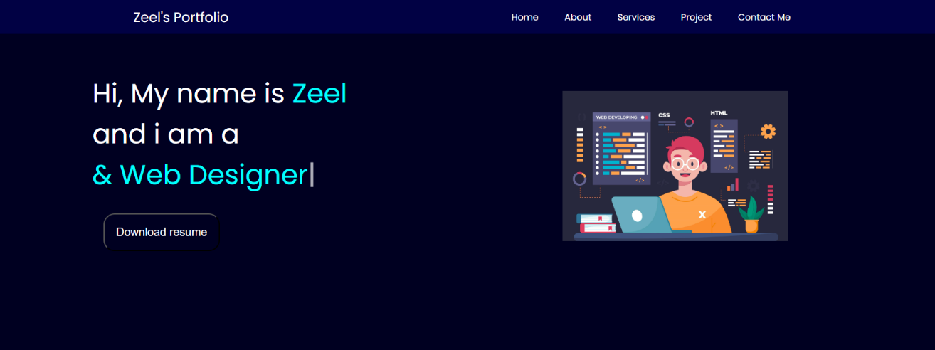

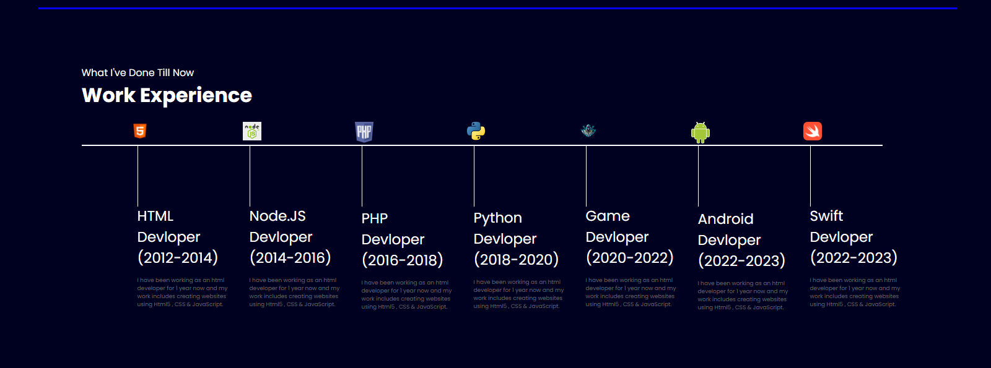

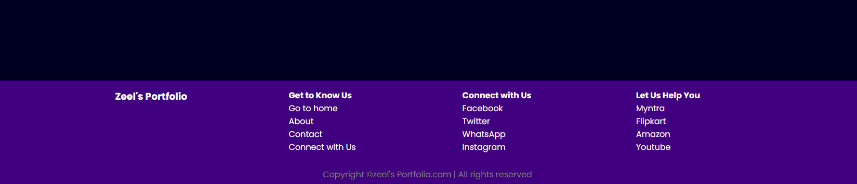

### CONCLUSION :

On the whole, this internship was a useful experience. I have gained new knowledge, skills and met many new people. I achieved several of my learning goals, however for some the conditions did not permit. I got insight into professional practice. I learned the different facets of working within a company. I experienced that financing, as in many organizations, is an important factor for the progress of projects. Related to my study I learned more about how to make project with MERN stack. There is lot more to discover and learn to improve.

The internship was also good to find out what my strengths and weaknesses are. This helped me to define what skills and knowledge I have to improve in the coming time. It would be better that the knowledge level of the language is sufficient to contribute fully to projects. I think that I could start my working career. However, I could perform certain tasks in research better if I practice/know more then I learn new thing in my subject. It would also be better if I can present and express myself more confidently.

**Training Schedule**

**Training Schedule at Leaf Drive IT Solution :**

|  |  |  |  |
| --- | --- | --- | --- |
| **Date** | **Time** | **Working Hours** | **Daily/Periodic Work Details** |
| **27/07/20**  **23 to 29/07/20**  **23** | **10:00 am**  **to 3:00 pm** | **5 hours** | **Learn about HTML and CSS and those functionality and create a web page from those concept.** |
| **30/07/20**  **23 to 05/08/20**  **23** | **10:00 am**  **to 3:00 pm** | **5 hours** | **Learn all the concept of Java script and his functionality and use on the web site. And learn to use API and learn basic of node.** |
| **06/08/20**  **23 to 10/08/20**  **23** | **10:00 am**  **to 3:00 pm** | **5 hours** | **Learn th java script framework and build a project and learn about version control and database and learn software cycle.** |
| **Total Hours =** | | **75 hour** |  |

★ **Reference Link :** [**https://www.w3schools.com/html/default.asp**](https://www.w3schools.com/html/default.asp) **https://**[**www.w3schools.com/css/default.asp**](http://www.w3schools.com/css/default.asp)[**https://getbootstrap.com/**](https://getbootstrap.com/)

[**https://www.youtube.com/watch?v=ER9SspLe4Hg&list=PLu0W_9**](https://www.youtube.com/watch?v=ER9SspLe4Hg&list=PLu0W_9lII9ahR1blWXxgSlL4y9iQBnLpR)[**lII9ahR1blWXxgSlL4y9iQBnLpR**](https://www.youtube.com/watch?v=ER9SspLe4Hg&list=PLu0W_9lII9ahR1blWXxgSlL4y9iQBnLpR)

[**https://react.dev/**](https://react.dev/)[**https://nodejs.org/en**](https://nodejs.org/en) **https://expressjs.com/**