**Dijkstra’s Algorithm**

**Goal: To Implement Dijkstra’s Algorithm using adjacency list, to make it efficiently run for large number of nodes.**

This program assumes that nodes.txt and edges.txt is already present in the folder.

For instance, consider following graph:

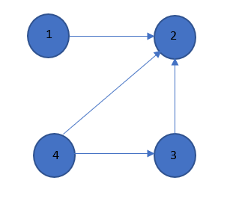

6

3 5

1

For above graph nodes.txt contains:

1

2

3

4

For above graph edges.txt contains:

1,2,6

4,2,3

4,3,1

3,2,5

After executing the program for above graph output generated is:

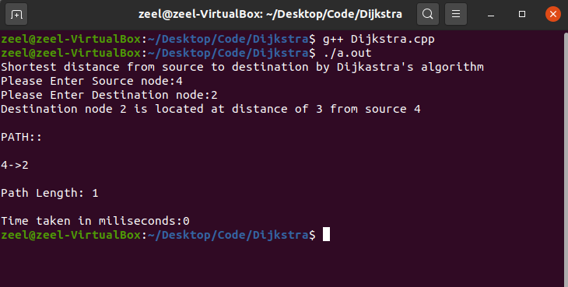

Implementation Details:

Programming language: C++

* This program uses adjacency list; hence it runs efficiently for large number of nodes
* Asks user to input source node and destination node and finds shortest path between both the nodes.
* Prints path and path length and time taken to find the path.
* ‘list_of_nodes’ is an adjacency list containing Node name, connected Node name and distance between them.
* ‘route’ contains path of nodes