CLIENT OPERATIONS GUIDE
Client Evaluation and Guided Tour Manual
One-click setup and a safe 15-minute tour through every clinic role
WHO THIS IS FOR | Clinic owners, project evaluators, and first-time users
SYSTEM VERSION | 1.0
SUPPORT NOTE | Keep this guide beside the clinic host computer or server records.

1. What this evaluation edition is
This separate Windows package lets the client explore the complete clinic workflow without entering real patient data. It uses its own Docker project and database volume, so its demonstration records do not mix with either production delivery.
STEP 1  Install | STEP 2  Read credentials | STEP 3  Explore roles | STEP 4  Reset demo
- Use demonstration information only. The amber banner remains visible while evaluation mode is active.
- The installer creates a different random password on each computer and writes it to DEMO-CREDENTIALS.txt.
- The reset command replaces only the named demonstration accounts and their related workflow records.

2. Install in three actions
- Extract the ZIP. Extract the complete evaluation package to a normal folder; do not run it inside the ZIP
- Start Docker Desktop. Wait until Docker Desktop reports that its engine is running
- Double-click the installer. Open deploy\evaluation and run INSTALL-EVALUATION.cmd. The first build may take several minutes
When installation finishes, the browser opens http://localhost:8081. Open DEMO-CREDENTIALS.txt in the deploy folder to see the four account emails and generated shared demonstration password.

3. Recognize evaluation mode
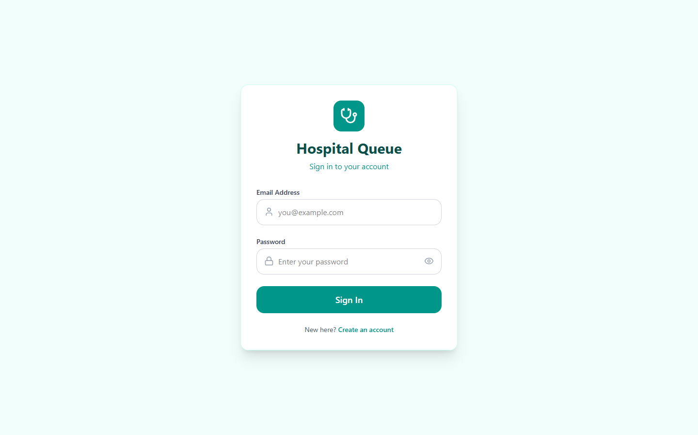
Sign-in page. The evaluation build also shows an amber safety banner and Guided Tour button.
Select Guided Tour at any time for role-specific next steps.

4. Administrator - about 3 minutes
- Sign in. Use admin.demo@clinic.local and the password in DEMO-CREDENTIALS.txt
- Review Accounts. Create reception staff, control access, or issue replacement passwords
- Review setup. Open Departments and Doctors to see starter departments and the assigned Demo Doctor
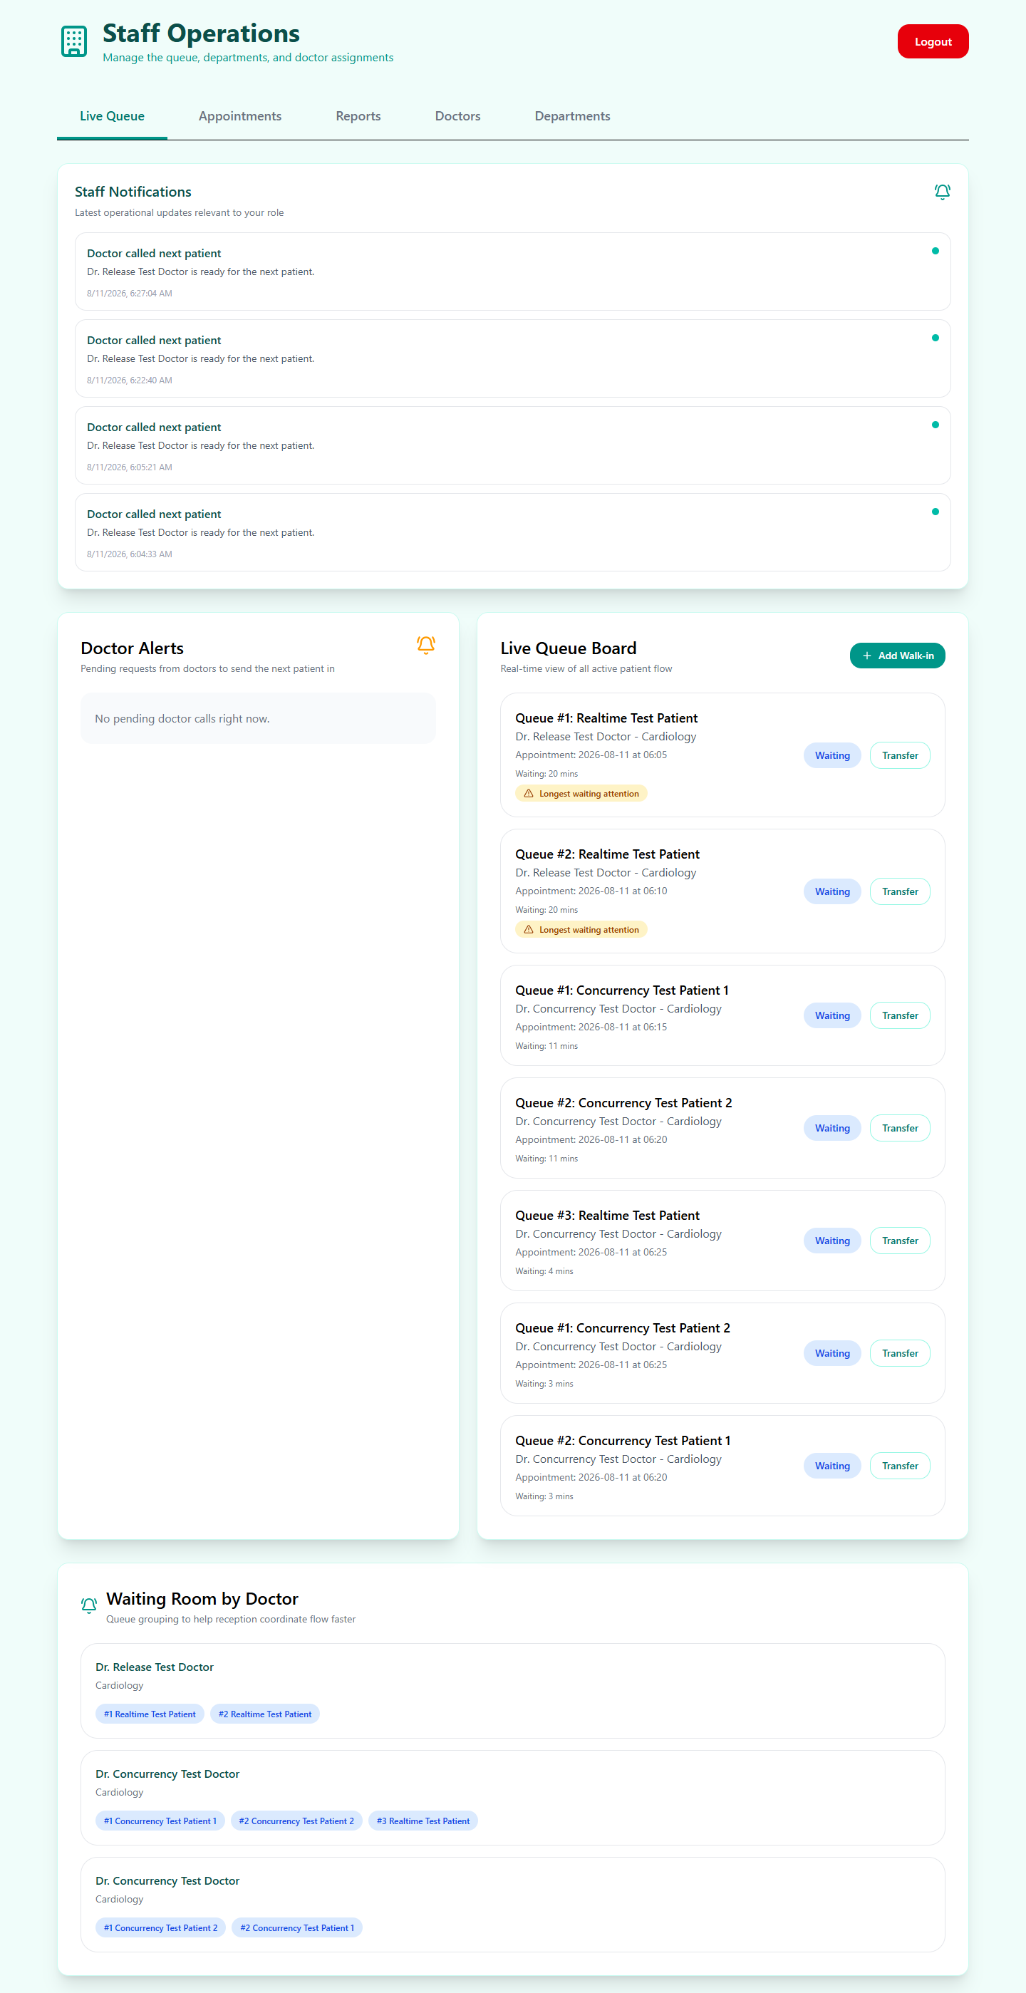
Staff operations: live queue, appointments, reports, doctors, departments, and administrator account controls.

5. Doctor - about 4 minutes
- Sign in. Use doctor.demo@clinic.local
- Review availability. Availability is prepared for every day so booking can be explored
- Call the patient. Select Call Next Patient; the staff view receives a real-time alert
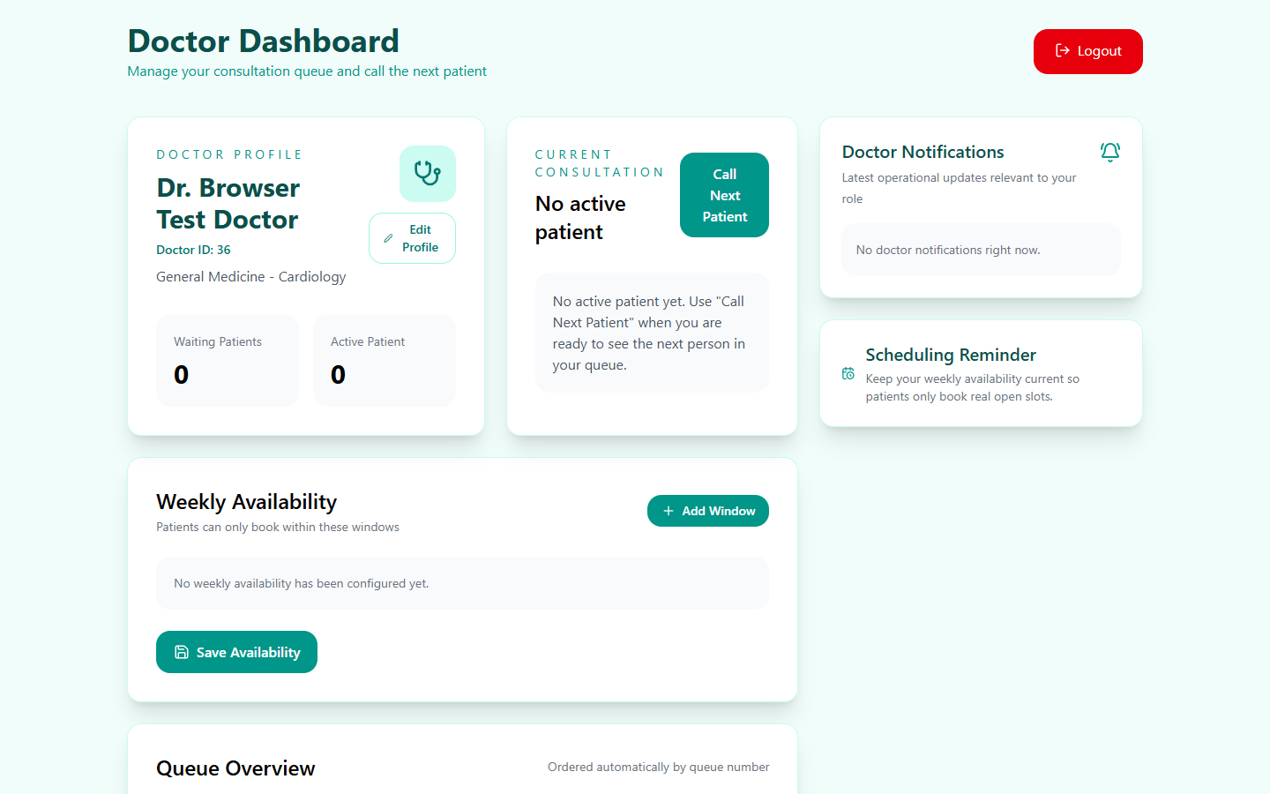
Doctor dashboard: availability, current consultation, notifications, and queue controls.

6. Staff - about 4 minutes
- Sign in. Use staff.demo@clinic.local
- Open Live Queue. Confirm that the called Demo Patient is sent into the consultation room
- Explore operations. Review Appointments, Reports, Doctors, Departments, and Add Walk-in

7. Patient - about 4 minutes
- Sign in. Use patient.demo@clinic.local
- Review Queue Status. See the demonstration queue number and real-time state
- Review Visit History. See the completed sample consultation
- Explore booking. Inspect departments, doctors, dates, and available time slots
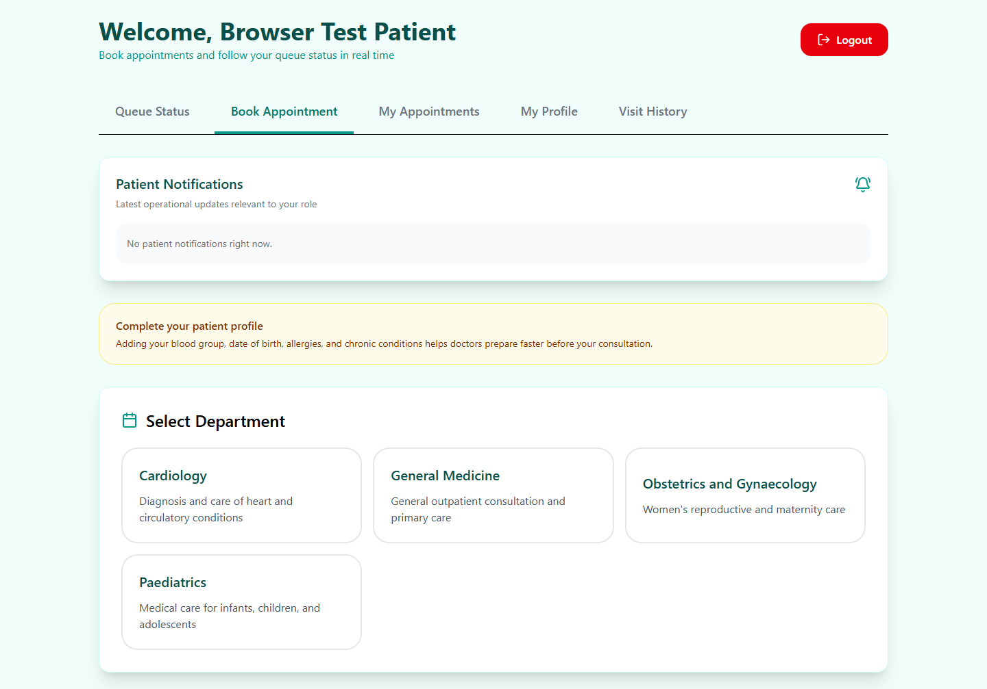
Patient dashboard: booking, appointments, profile, visit history, notifications, and queue status.

8. Restore the original demonstration
- Sign out. Close active demonstration sessions
- Run RESET-DEMO.cmd. Double-click it in deploy\evaluation and wait for success
- Open the clinic. Run OPEN-CLINIC.cmd and reuse DEMO-CREDENTIALS.txt
The reset command is guarded by DEMO_MODE=true and affects only the fixed demonstration account emails.

9. Everyday controls
- OPEN-CLINIC.cmd - open the evaluation system.
- CHECK-CLINIC.cmd - display service status.
- RESET-DEMO.cmd - restore the original sample workflow.
- STOP-CLINIC.cmd - stop evaluation services.

10. Troubleshooting and production handoff
- Docker error: start Docker Desktop manually and wait until it is ready.
- Page does not open: run CHECK-CLINIC.cmd, then OPEN-CLINIC.cmd.
- Workflow is already completed: run RESET-DEMO.cmd.
- Do not convert the evaluation database into the live clinic database. Install the chosen production package with new private passwords and an empty production database.

