**CHAPTER 3**

**DESIGN**

**3.1 Data Flow Diagram**

**3.1.1 Context Level Diagram**

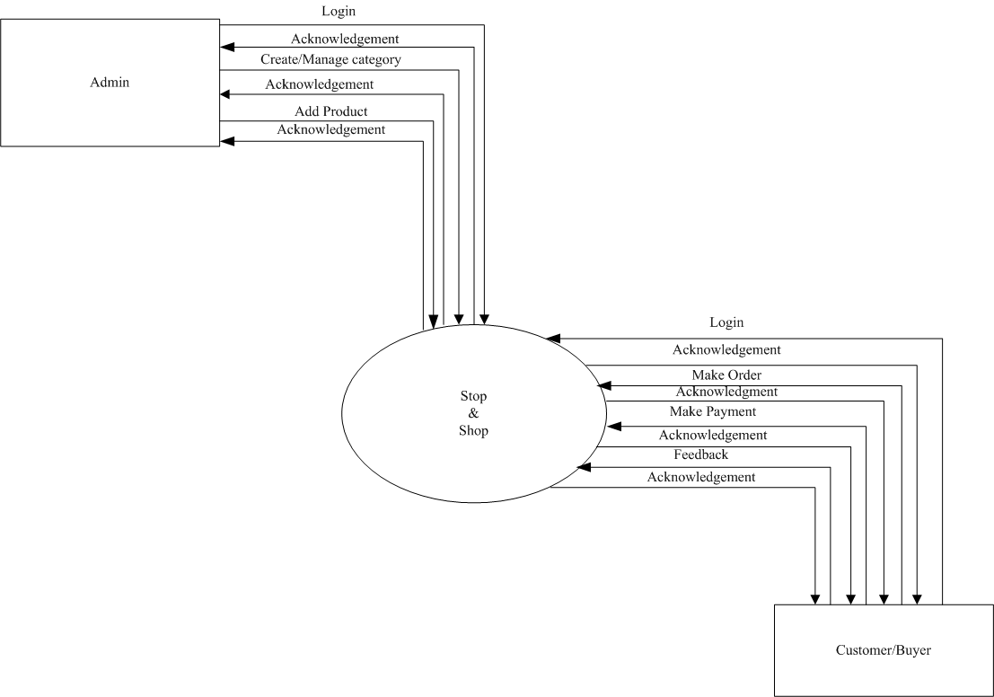

**[Figure 2: Context Level Diagram]**

**3.1.2 Level 1: Admin**

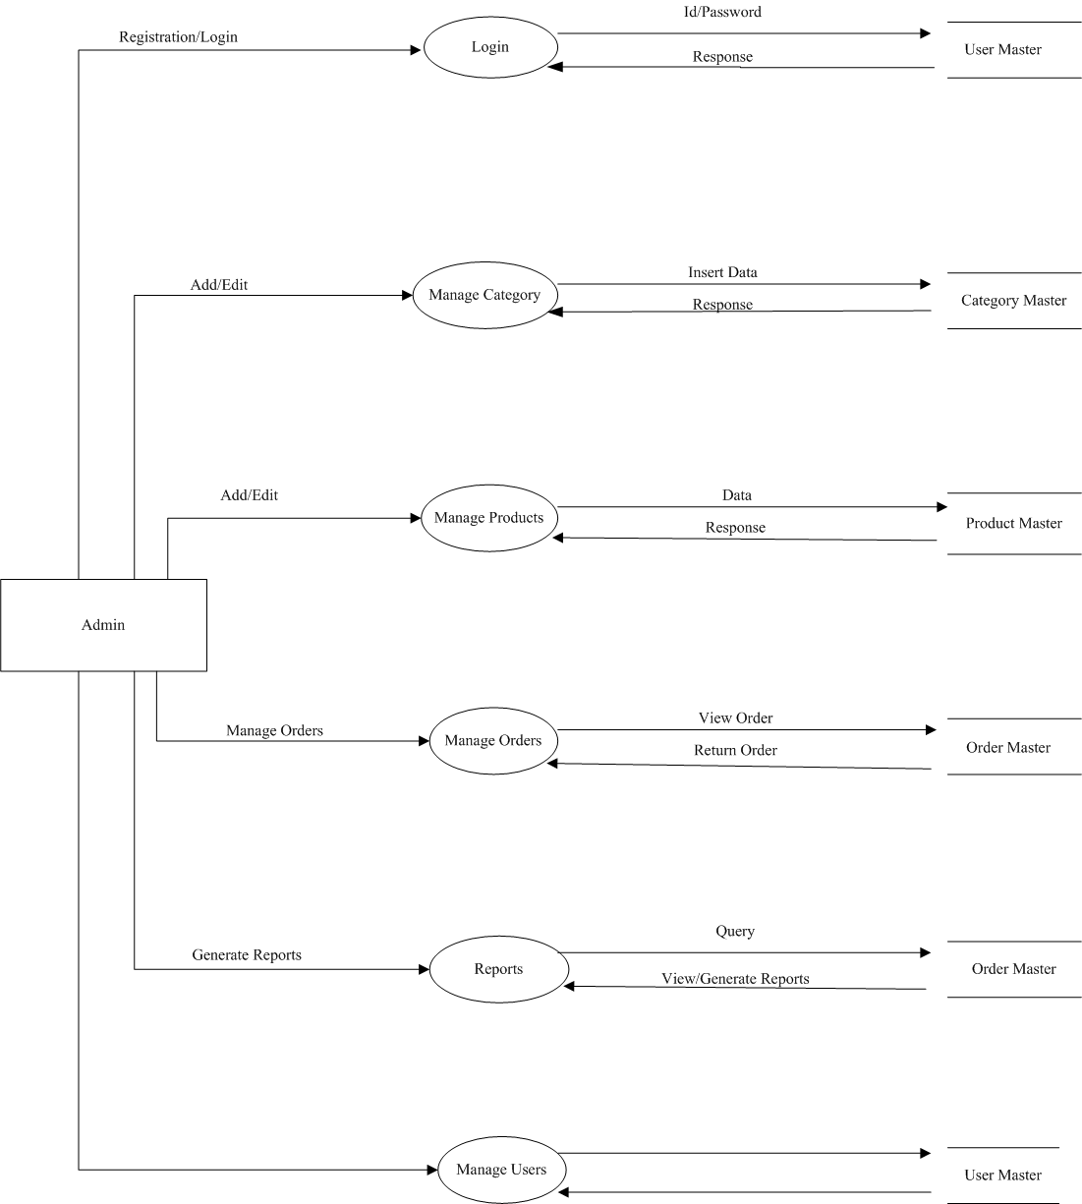

**[Figure 3: Level 1 Admin]**

**3.1.3 Level 1: Customer**

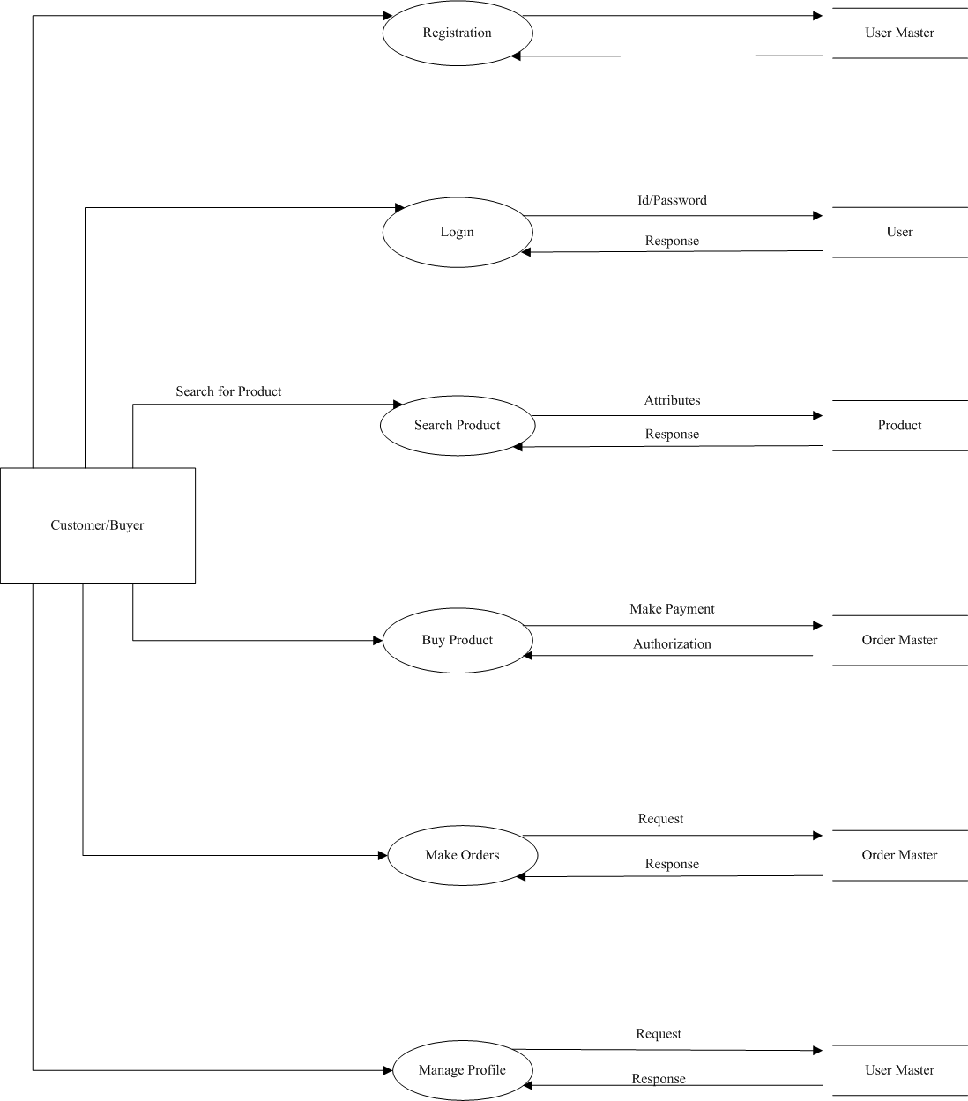

**[Figure 4: Level 1 Customer]**

**3.1.4 Level 2 Admin**

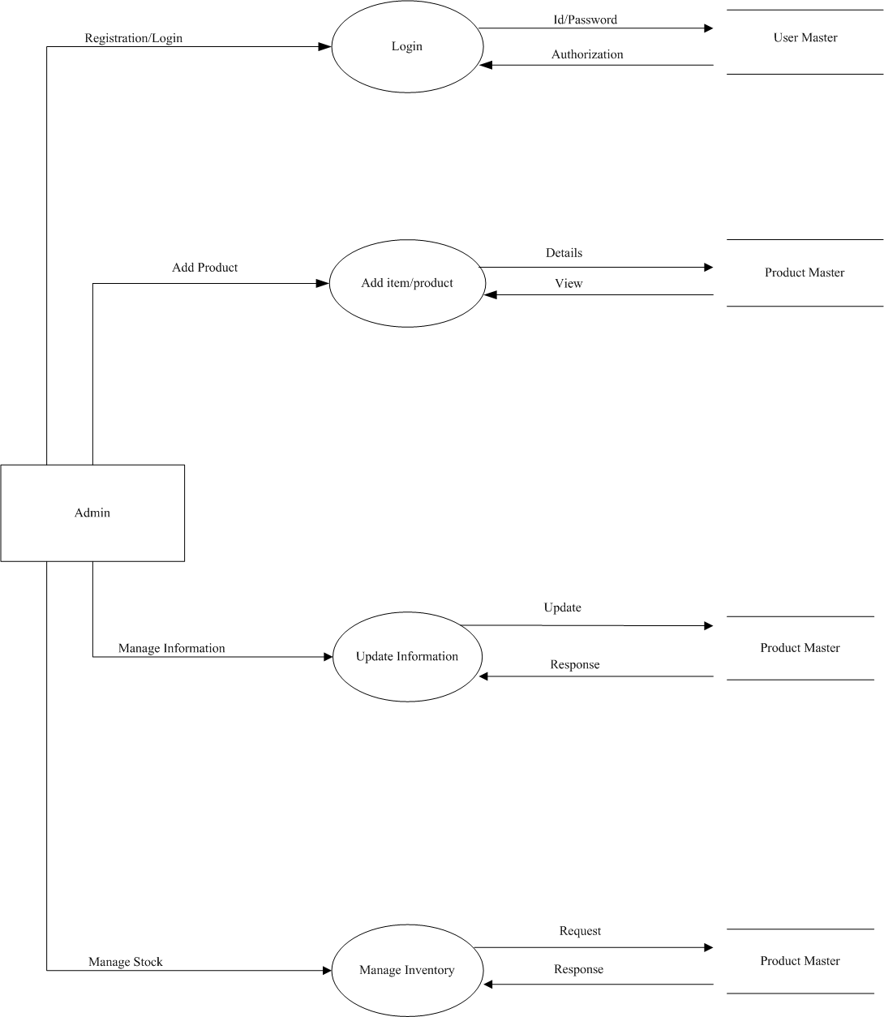

**[Figure 5: Level 2 Admin]**

**3.1.5 Level 2 Customer**

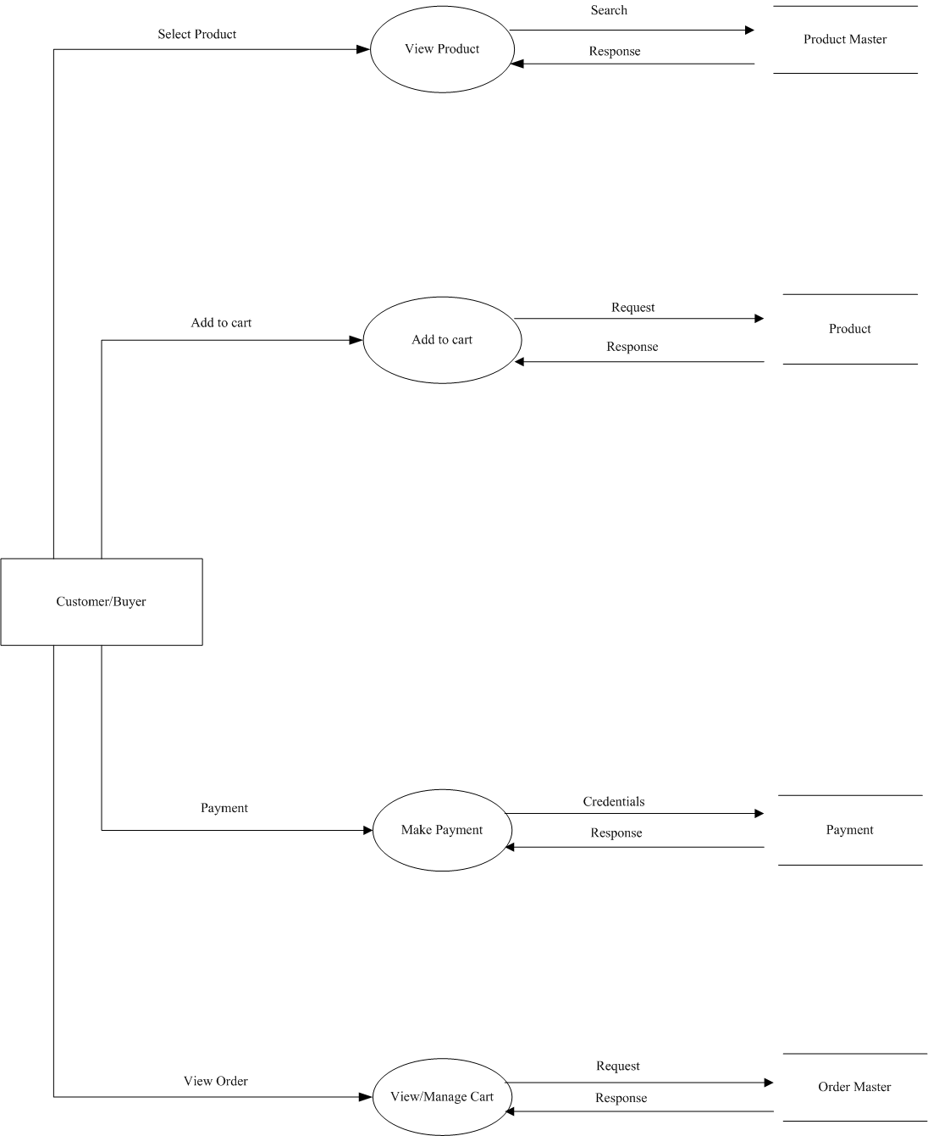

**[Figure 5: Level 2 Customer]**