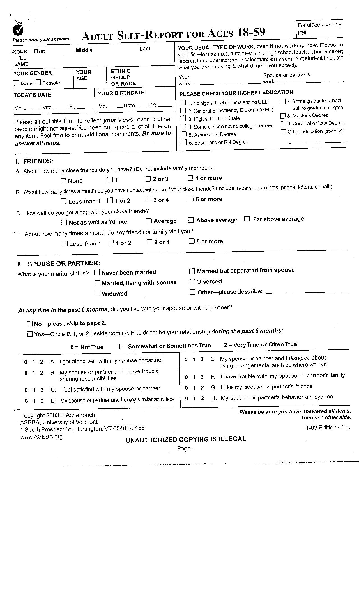
SEX AGE RACE
INT_DATE DOB
INT_ID
WORK WORK_S
EDU
EDU_TXT
FRIENDS
CONTACT
(0,1,2,3)
(0,1,2,3)
(0,1,2,3)
(0,1,2,3)
GET_ALONG
VISIT
(0)
(1)
(2)
(3)
(4)
(5)
MARST
MARST_TXT
LIVE
II_A -- II_H
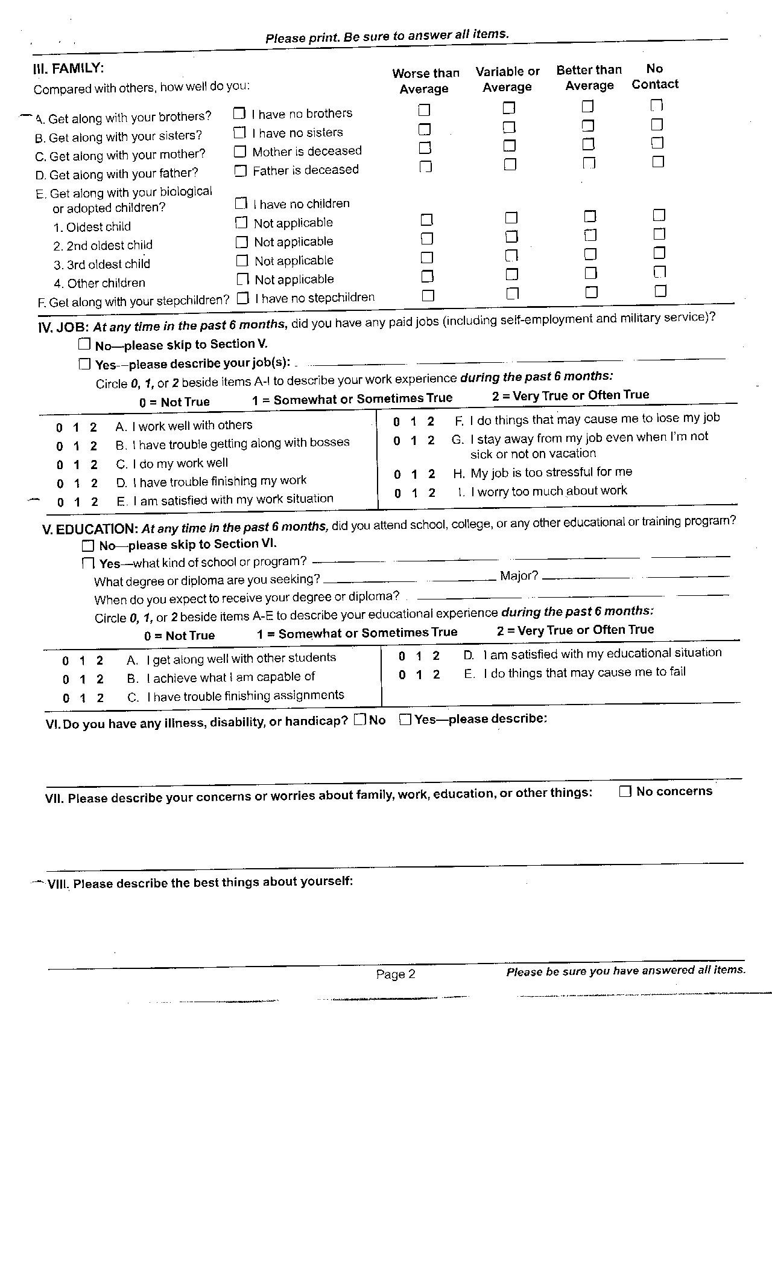

Scoring 4 0 1 2 3

.A 0 1 2 .N
III_A
III_B
III_C
III_D

III_E
III_E_01
III_E_02

III_E_03
III_E_04
III_F

JOB
JOB_TXT
IV_A – IV_I
ATTEND
ATTEND_TXT
DEGREE MAJOR
EXPECT_MN EXPECT_YR
V_A -- V_E
ILLNESS ILLNESS_TXT
NO_CONCERN
CONCERNS
BEST_THINGS
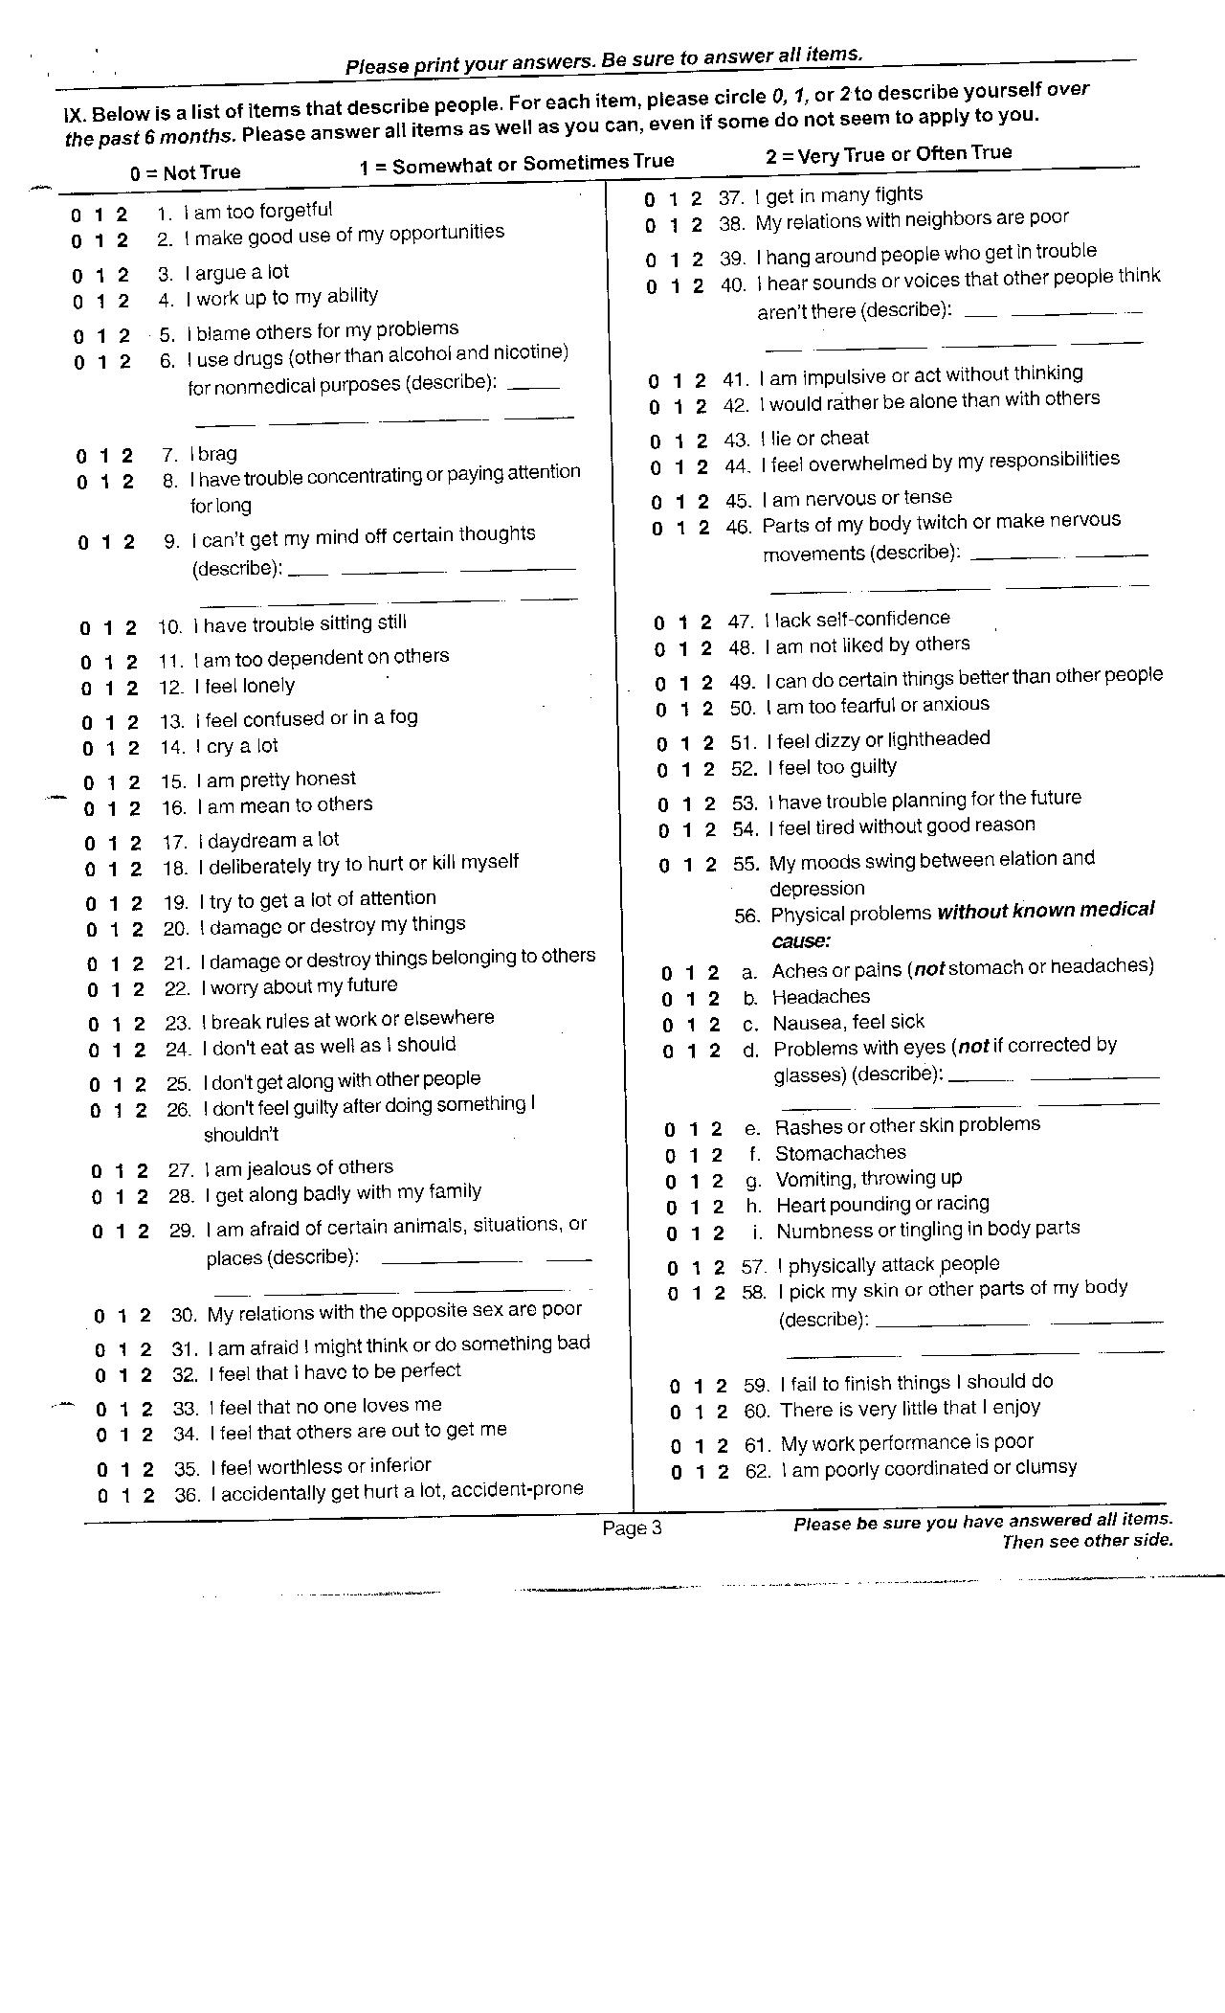
ASR_01 -- ASR_123
ASR_06_TXT
ASR_09_TXT
ASR_29_TXT
ASR_40_TXT
ASR_46_TXT
ASR_56D_TXT
ASR_56A -- ASR_56I
ASR_58_TXT
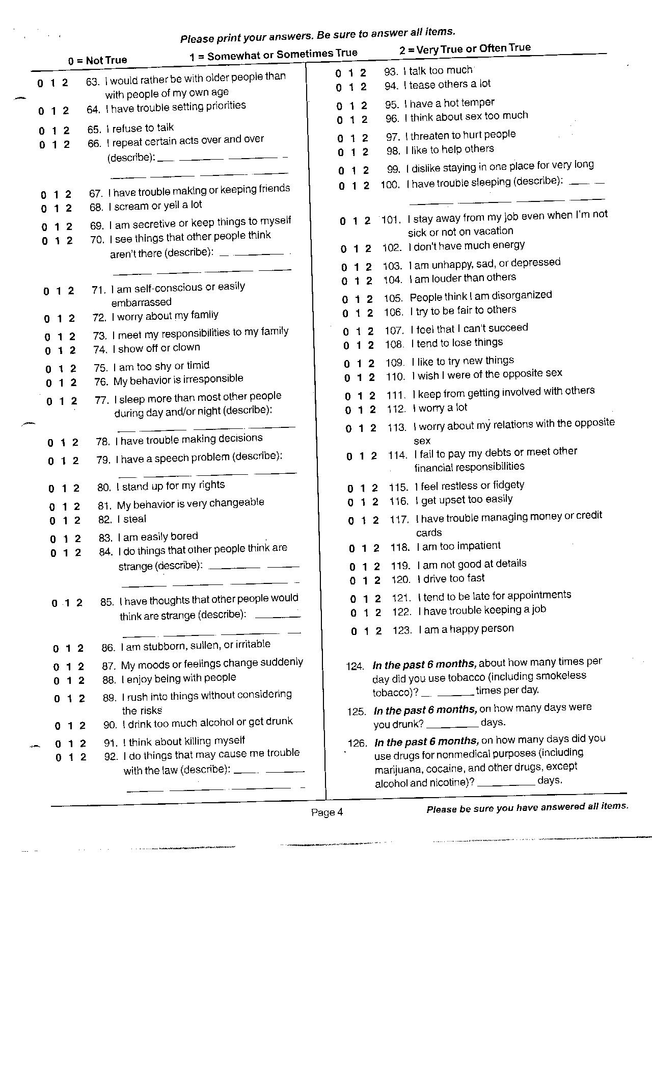
ASR_01 -- ASR_123
ASR_66_TXT
ASR_70_TXT
ASR_77_TXT
ASR_79_TXT
ASR_84_TXT
ASR_85_TXT
ASR_92_TXT
ASR_100_TXT
ASR_124

ASR_125

ASR_126

Summary Scores:
Problem Scales
ANX_RAW, ANX_T, ANX_PCT Problem Scales - Anxious/Depressed Raw Total Score, T Score, Percentile
WITH_RAW, WITH_T, WITH_PCT Problem Scales - Withdrawn Raw Total Score, T Score, Percentile
SOM_RAW, SOM_T, SOM_PCT Problem Scales - Somatic Complaints Raw Total Score, T Score, Percentile
THT_RAW ,THT_T, THT_PCT Problem Scales - Thought Problems Raw Total Score, T Score, Percentile
ATT _RAW, ATT _T, ATT _PCT Problem Scales - Attention Problems Raw Total Score, T Score, Percentile
AGG _RAW, AGG _T, AGG _PCT Problem Scales - Aggressive Behavior Raw Total Score, T Score, Percentile
RULE _RAW, RULE _T, RULE _PCT Problem Scales - Rule Breaking Raw Total Score, T Score, Percentile
INTR _RAW, INTR _T, INTR _PCT Problem Scales - Intrusive Raw Total Score, T Score, Percentile
CRIT _RAW, CRIT _T, CRIT _PCT Problem Scales - Critical Items Raw Total Score, T Score, Percentile
INT _RAW, INT _T, INT _PCT Problem Scales - Internalizing Raw Total Score, T Score, Percentile
EXT _RAW, EXT _T, EXT _PCT Problem Scales - Externalizing Raw Total Score, T Score, Percentile
TOTP _RAW, TOTP _T, TOTP _PCT Problem Scales - Total Problems Raw Total Score, T Score, Percentile

Adaptive Functioning Scales
FRND _RAW, FRND _T, FRND _PCT Adaptive Functioning Scales-Friends Raw Total Score, T Score, Percentile
SP _RAW, SP _T, SP _PCT Adaptive Functioning Scales- Spouse Raw Total Score, T Score, Percentile
FAM _RAW, FAM _T, FAM _PCT Adaptive Functioning Scales- Family Raw Total Score, T Score, Percentile
JOB _RAW, JOB _T, JOB _PCT Adaptive Functioning Scales-Job Raw Total Score, T Score, Percentile
EDU _RAW, EDU _T, EDU _PCT Adaptive Functioning Scales- Education Raw Total Score, T Score, Percentile
MA _RAW, MA _T, MA _PCT Adaptive Functioning Scales- Mean Adaptive Raw Total Score, T Score, Percentile

Substance Use Scale
TOB _RAW, TOB _T, TOB _PCT Substance Use Scales - Tobacco Raw Total Score, T Score, Percentile
ALC _RAW, ALC _T, ALC _PCT Substance Use Scales - Alcohol Raw Total Score, T Score, Percentile
DRUG _RAW, DRUG _T, DRUG _PCT -- Substance Use Scales - Drugs - Raw Total Score, T Score, Percentile
MS _RAW, MS _T, MS _PCT Substance Use Scales - Mean Substance Abuse -Raw Total Score, T Score, Percentile

DSM Scales
DSM_DEP_RAW, DSM_DEP_T, DSM_DEP_PCT DSM Scales - Depressive Problems -Raw Total Score, T Score, Percentile
DSM_ SOM _RAW, DSM_ SOM _T, DSM_ SOM _PCT DSM Scales - Somatic Problems -Raw Total Score, T Score, Percentile
DSM_ AVD _RAW, DSM_ AVD _T, DSM_ AVD _PCT DSM Scales - Avoidant Personality Problems -Raw Total Score, T Score, Percentile
DSM_ ADH _RAW, DSM_ ADH _T, DSM_ ADH _PCT DSM Scales - AD/H Problems -Raw Total Score, T Score
DSM_ ANT _RAW, DSM_ ANT _T, DSM_ ANT _PCT DSM Scales -Antisocial Personality Problems -Raw Total Score,T Score
DSM_ INA _RAW, DSM_ INA _T, DSM_ INA _PCT DSM Scales -Inattention subscale -Raw Total Score, T Score
DSM_ HI _RAW, DSM_ HI _T, DSM_ HI _PCT DSM Scales - Hyperactivity-Impulsivity -Raw Total Score, T Score

