The Wechsler Intelligence Scale for Children (WISC-IV) is an individually administered IQ test used with children aged from 6 to 16.  Younger children are tested using the Wechsler Preschool and Primary Scale of Intelligence (WPPSI).  Older childen and adults are tested using the Wechsler Adult Intelligence Scale (WAIS).

There are 15 subtests on the WISC-IV.   They're not usually all used.  In addition to subtest scores a combined composite score is reported (the IQ).  Composite scores relating to specfic cognitive areas may also be reported.

**Block Design**

**Block Design** measures an individual’s ability to analyze and synthesize an abstract design and reproduce that design from colored plastic blocks. Spatial visualization and analysis, simultaneous processing, visual-motor coordination, dexterity, and nonverbal concept formation are involved.  The students use logic and reasoning to successfully complete the items.

Block Design subtest is a timed core Perceptual Reasoning subtest.

Children are given bi-colored blocks and must arrange them to duplicate a printed image or modelled design.

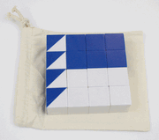          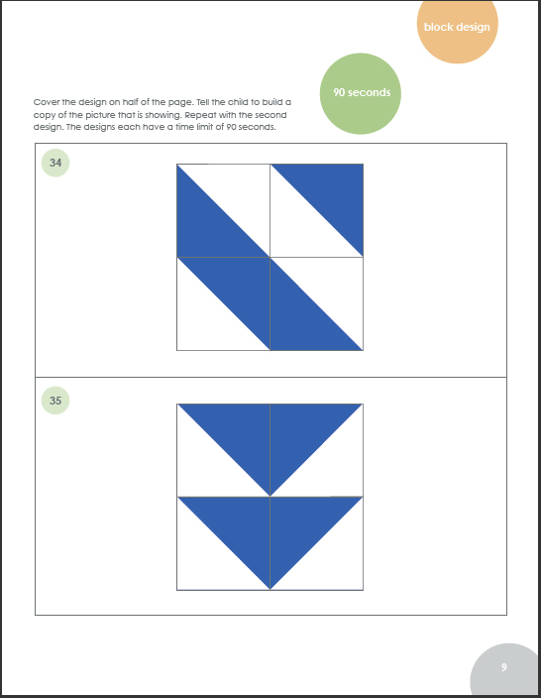

**Suggestions:**

* Pattern Block Activity Pack
* Tangoes
* Building Thinking Skills Figural Activities
* Architecto Games

**Similarities**

**Similarities** measures logical thinking, verbal concept formation and verbal abstract reasoning. Two similar but different objects or concepts are presented, and the student is asked to tell how they are alike or different.

Similarities is an untimed core Verbal Comprehension subtest.

Examples:

How are whales and lions similar?

How are anger and delight similar?

How are boys and girls similar?

**Suggestions:**

* Building Thinking Skills
* Analogies

**Digit Span**

**Digit Span**measures short-term auditory memory and attention. The digits have no logical relationship to each other and are presented in random order by the examiner. The student must then recite the digits correctly by recalling them in the same order.  On the second part of this subtest the student must remember the order in which digits are presented, but recite them in reverse order.

Digit Span is an untimed core Working Memory subtest.

Examples:

For Digit Span forward tester would read numbers like "2, 3, 9, 1"

and child would respond with the same numbers

For Digit Span backward the tester would read numbers like "24, 3, 7, 12"

and child would respond "12, 7, 3, 24"

**Suggestions:**

* Look! Listen! Think!
* Memory Challenge (visualization of numbers as chunks can help memory of auditory information)
* Listening Skills titles (to build attention to the information as it is provided)

**Picture Concepts**

**Picture Concepts**measures categorical, abstract reasoning. Students are asked to look at two (or three) rows of pictured objects and indicate (by pointing) the single picture from each row that shares a characteristic in common with the single picture(s) from the other row(s).

Picture Concepts is an untimed core Perceptual Reasoning Subtest.

Example:

|  |  |
| --- | --- |
| Pick one picture from each  row that go together | https://www.thinktonight.com/v/vspfiles/assets/images/picture%20concepts.jpg |

**Suggestions:**

* Building Thinking Skills
* Analogies
* MiniLUK

**Coding**

**Coding** measures visual-motor dexterity, associative nonverbal learning, and nonverbal short-term memory.  Fine-motor dexterity, speed, accuracy and ability to manipulate a pencil contribute to task success; perceptual organization is also important.

Coding is a timed core Processing Speed subtest.

For children aged 6-7 the test is picture based.  Children are given a worksheet like the example below.  The first line contians the key.  They must place a mark within all the other figures so that they match the key.

For children aged 8-16 the key consists of boxes containing a numeral in the top line and a symbol in the bottom line.  They must write the symbol corresponding to each numeral in the worksheet provided.

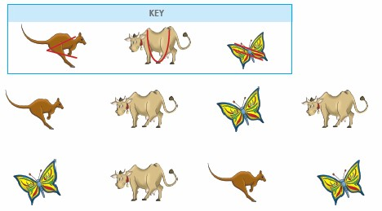  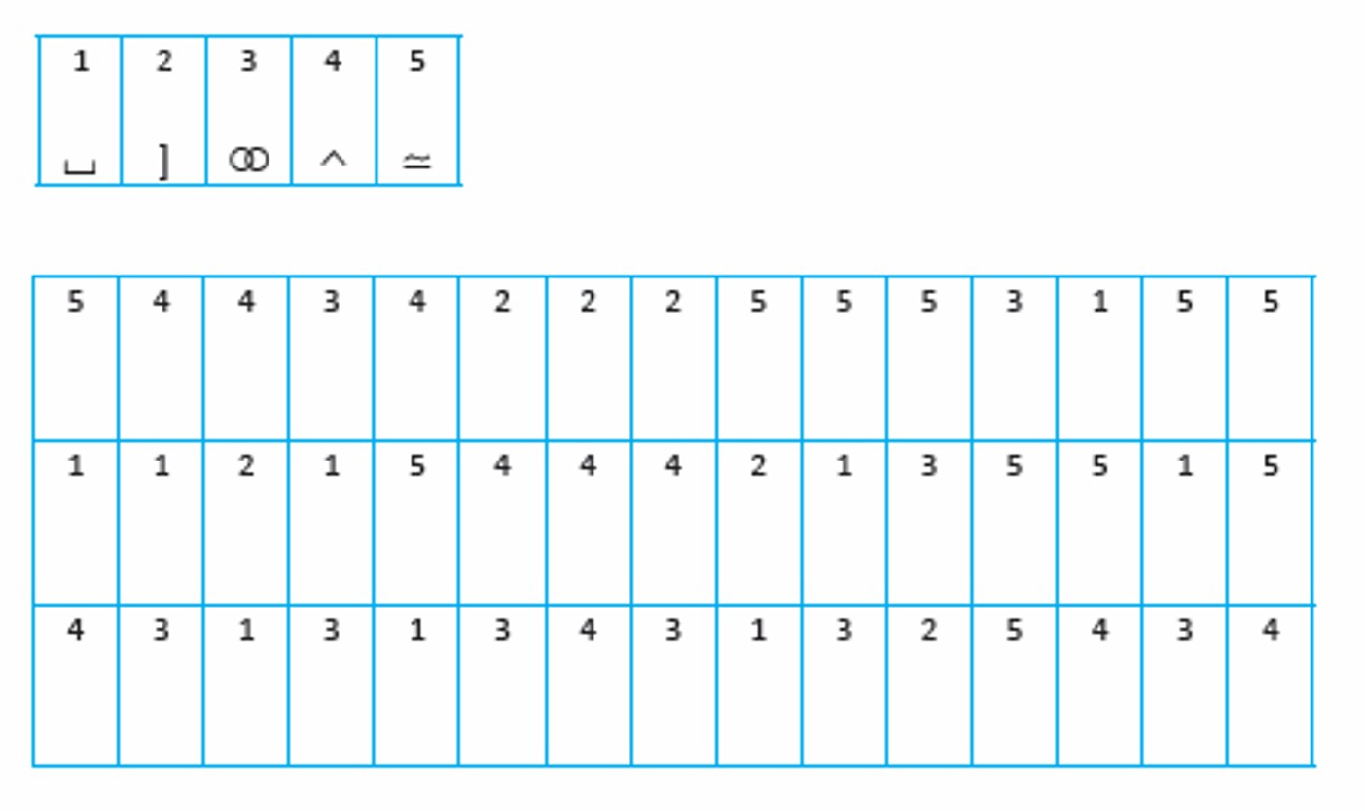

Suggestions:

* Thinker Doodles
* Dot-to-Dot
* Visual Discrimination
* Memory Challenge

**Vocabulary**

**Vocabulary**measures the students’ verbal fluency and concept formation, word knowledge, and word usage.

Vocabulary is an untimed core Verbal subtest

Example:

Children are shown pictures or a word is said aloud.  They are asked to provide the name of the object or to define the word.

|  |  |
| --- | --- |
| What is this? | https://www.thinktonight.com/v/vspfiles/assets/images/carrot.jpg |

What does simple mean?

Suggestions:

* Building Thinking Skills
* Analogies
* Nifty Fifty
* Word Roots
* Vocabulary Cartoons

**Letter-Number Sequencing**

**Letter-Number Sequencing** measures attention span, short-term auditory recall, processing speed and sequencing abilities. The task involves listening to and remembering a string of digits and letters read aloud at a speed of one per second, then recalling the information by repeating the numbers in chronological order, followed by the letters in alphabetical order.

Letter- Number Sequencing is an untimed core Working Memory subtest.

Example:  A - 7 - X - 2 - M - 4

Response: 2, 4, 7, 1, M, X

Suggestions:

• Look! Listen! Think!

• Memory Challenge (visualization the information as it is read can aid recall)

• Number Patterns

**Matrix Reasoning**

**Matrix Reasoning** measures visual processing and abstract, spatial perception and may be influenced by concentration, attention, and persistence.

Matrix Reasoning is an untimed core Perceptual Reasoning subtest.

Children are shown colored matrices or visual patterns with something missing.  The child is asked to select the missing piece from a range of options.

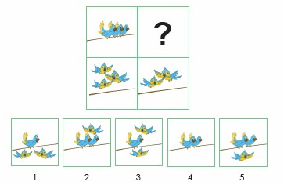

Suggestions:

* Building Thinking Skills
* Math Analogies
* Visual Discrimination
* Look! Listen! Hear!
* Number Patterns
* MiniLUK

**Comprehension**

**Comprehension** measures common-sense social knowledge, practical judgment in social situations, and level of social maturation, along with the extent of development of their moral conscience.  Children are asked to explain situations, actions, or activities that they'd be expected to be familiar with.

Comprehension is a core Verbal Comprehension subtest.

Example:  Why do we turn out lights when we leave a room?

Suggestions:

* What Would You Do?
* Nifty Fifty

**Symbol Search**

**Symbol Search** requires the student to determine whether a target symbol appears among the symbols shown in a search group. Memory is not a primary requirement for success on this task; perception and recognition are the two prime requirements, in addition to speed, accuracy, attention, and concentration. The symbols are geometric forms, rather than familiar letters or numbers.

Symbol Search is a timed core Processing Speed subtest

Suggestions:

* Visual Perceptual Skill Building
* Visual Discrimination
* Look! Listen! Think!

**Picture Completion**

**Picture Completion** measures a student's ability to recognize familiar items and to identify missing parts.  The student's task is to separate essential and nonessential parts from the whole.  It is necessary to observe each item closely and concentrate on picture detail.  Students must name or indicate the missing part by saying the name of the part or by pointing to it.

Picture Completion is a timed supplemental Perceptual Reasoning subtest



Suggestions:

* Thinker Doodles
* Dot-to-Dots
* Visual Discrimination
* Look! Listen! Hear!

**Cancellatio**n

**Cancellation** measures visual vigilance/neglect, selective attention, and speed in processing visual information in accordance with previous attempts along the same line.

Cancellation is a timed supplemental Processing Speed subtest

Children scan a two-page spread of relatively small colorful pictures.  The pictures include animals and objects and the child's task is to identify all the appearances of the target animal.   The illustration below shows a similar type of exercises where the child's role is to identify target letters amongst the clutter.

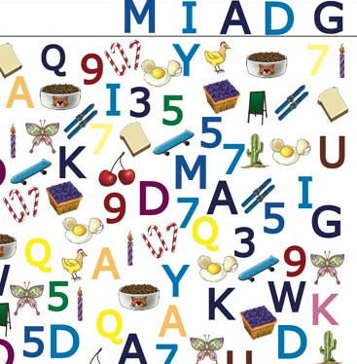

Suggestions:

* Visual Discrimination
* Building Thinking Skills
* Dot-to-Dot

(And look on your home bookshelf for classics like I Spy and Where's Wally?)

**Information**

**Information** measures general cultural knowledge, long-term memory, and acquired facts.   Children are asked questions about different topics like geography, science and historical figures.   The questions shouldn't be difficult for a child with a well rounded education but they do encompass a wide range of knowledge.

Information is a supplemental Verbal Comprehension subtest.

Example:  Who was Queen Elizabeth I

Example:  What do your lungs do?

Example: What is photosynthesis?

Suggestions:  The focus of our store is thinking skills material rather than general knowledge.  We suggest you encourage your child to read quality non-fiction and help them make links between what they're studying at school now and what they've studied in the past so that they retain information.  The titles below can be used to check that your child has the expected grade level knowledge and to build general knowledge:

* Spectrum Test Prep
* Daily Mind Builders

**Arithmetic**

**Arithmetic**measures numerical accuracy, reasoning and mental arithmetic ability. Mental arithmetic and story problems play an important part in the student’s success.

Arithmetic is a supplemental Working Memory subtest.

Example:  How many carrots are there in this picture?

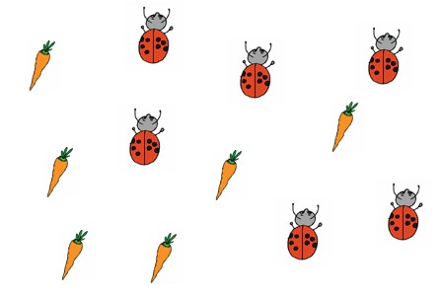

Example: Michelle is 2 years younger than Peter and 5 years older than Sam.  If Sam is 6 how old is Michelle?

Example: Kathy's lunch bill was $22.50.  If she leaves a 15% tip how much money does she need to leave?

Suggestions:

* Primary Grade Challenge Math
* Math Word Problems
* Quick Thinks Math
* Spectrum Test Prep

**Word Reasoning**

**Word Reasoning**measures verbal abstract reasoning requiring analogical and categorical thinking, as well as verbal concept formation and expression.

Word Reasoning is a supplemental Verbal Comprehension subtest.

Children are asked to identify the object described by clues they're given.

Example:  An item of clothing which you sleep in.

Suggestions:

* Building Thinking Skills
* Analogies