Dissertation Submitted for the partial fulfillment of the **M.Sc. as a part of M.Sc. (Integrated) Five Years Program AIML** degree to the Department of AIML & Data Science.

**Project Dissertation**

**Donation-Based Crowdfunding dApp on Polygon**

***submitted to***



***By***

**ZEEL RATHI**

**Semester-IX**

**Under the guidance of**

**Dr. Raval Kamesh**

**Nisarg Pathak,**

**Rashmi Pandey**

**M.Sc. (Integrated) Five Years Program AIML**

## Department of AIML & Data Science.

School of Emerging Science and Technology Gujarat University

**October 2023**

**DECLARATION**

This is to certify that the research work reported in this dissertation entitled “**Donation-Based Crowdfunding dApp on Polygon**” for the partial

fulfilment of M.Sc. as a part of M.Sc. (Integrated) in Artificial Intelligence and Machine Learning degree is the result of investigation done by myself.

|  |  |
| --- | --- |
| Place: Ahmedabad | Name of Student  ZEEL RATHI |
| Date: 13-10-2023 |  |

**ACKNOWLEGEMENT**

I would like to express my sincere gratitude to all those who have supported and assisted me throughout the course of my research and writing of this thesis.

I would like to express my profound gratitude to Dr.Ravi Gor sir, Head of department of AIML/Data science for all his support. He has always supported me and encouraged me to overcome many difficulties. I am extremely grateful to him for his valuable suggestions and guidance that he has provided me during my research work.

I would like to thank my supervisor Dr. Raval Kamesh, Nisarg Pathak, Rashmi Pandey for their invaluable guidance and support throughout this project. Their expertise, encouragement, and constructive criticism have been instrumental in shaping my research and helping me to refine my ideas.

I would also like to thank the staff for their feedback and support in the development of my research. Their insights and suggestions have been incredibly helpful in shaping my arguments and strengthening my analysis.

Furthermore, I would like to thank my friends for their support, encouragement, and assistance throughout this project. Their discussions, feedback, and encouragement have been invaluable in helping me to stay motivated and focused throughout the research and writing process.

Finally, I would like to express my gratitude to my family for their unwavering support and encouragement. Their love, patience, and understanding have been the foundation of my academic journey, and I am incredibly grateful for their continued support.

**~** Zeel Rathi

**Index**

|  |  |  |
| --- | --- | --- |
| **Sr.** | **Content** | **Page** |
| 1 | Abstract & Keywords | 1 |
| 2 | Introduction | 3 |
| 3 | Basic Terminology | 5 |
| 4 | Literature survey | 9 |
| 5 | Methodology | 11 |
| 6 | Result & Discussion | 19 |
| 7 | Conclusion | 23 |
| 8 | Future Scope | 25 |
| 9 | References | 27 |

# Chapter 1 Abstract & Key Words

**Abstract**

The Ethereum blockchain platform's decentralized application (DAPP) called crowdfunding enables users to donate money for causes they care deeply concerned about. It ensures that contributors engage in low-risk backing of emerging ventures and venture capitalists by leveraging blockchain and verifying their transactions and securing the sensitive data. More global supporters can be attracted by creators, which makes it simpler for them to raise significant sums of money quickly. There are a number of projects in the blockchain realm right now. Individuals or small dispersed teams who want to raise funding by issuing tokens have built on this platform to attract the potential contributors. The concept of raising funds through a crowdfunding site is simplified. With the help of global assistance of the public who may be interested to contribute in the campaign for a monetary incentive.

Keywords: Crowd Fund, Blockchain, Ethereum Virtual Machine, Consensus, MetaMask, DAPP.

# Chapter 2 Introduction

Philanthropy has become more open and transparent because of the growth of Internet technology, which has increased the number of avenues via which individuals can obtain information. Numerous issues with philanthropy have been revealed [1]. During a natural or man-made disaster, supplies and money are donated. The everyday administration of philanthropic resources, however, is confusing. Both the willingness to give and the amount given decreased because of these conditions.

Crowdfunding-online has emerged as a new avenue for the netizens to support causes related to public welfare. Raising certain amount of money in required amount from a sizable (manageable) group of netizens known as crowd for supporting a certain cause, project (business), medical emergency, loan or a financial need via chosen platform is CrowdFunding [2]. There are several instances of unknown individuals or businesses receiving funding from others based on social connections on the enabling platforms like: Twitch, Patreon, IndieGoGo, and Kickstarter [3].

However, blockchain technologies have fundamentally altered how we view the Internet. More precisely, the blockchain has fundamentally changed how we think about finances, communication trust, and even revived the idea of digital democracy [4]. Many of the principles in the "hyper-connected and trusted world" vision were already becoming widely accepted notions, but the blockchain has provided the instruments for their quick implementation without the need for a third party (thanks to smart contracts) [3]. Thus, the Blockchain has been enabling technology for the rapid development of decentralized currencies and smart contracts (Digital Contracts – self executing). Also, the Blockchain is the building block for the Smart Property (Intelligent assets those can be managed via Internet).

In this paper, I introduce Coin Kindness, a social networking platform that allows users to fundraise for other users using a straightforward web Dapp created on top of the Ethereum blockchain. Coin Kindness simplifies the process for individuals to raise funds for various purposes such as financial needs, projects, emergencies, and loans. A decentralized online service facilitates the promotion and regulation of diverse fundraising initiatives through its straightforward web Dapp, making it easy for anyone to raise money from the public.

# Chapter 3 Basic Terminology

1. BLOCKCHAIN

The introduction of blockchain was marked by the first crypto currency launched in 2009 by the name of Bit coin. Bitcoin was created by an anonymous person or a group of people going by the name Satoshi Nakamoto and released in the year 2009 as an open-source software [8]. Ten years later, it has become the world’s most widely adopted concept of Distributed Ledger Technology. Bitcoin currently makes 46% of all cryptocurrencies in trade [9]. Blockchain technology is a structure that stores transactional records, also known as the block, of the public in several databases, known as the “chain”, in a network connected through peer-to-peer nodes.

It incorporates characteristics of peer-to-peer decentralization, traceability, data integrity and security. A typical block in a blockchain consists of 3 components:

1. Hash value of current block

2. Data value

3. Hash value of previous block

The first block in a blockchain is referred to as Genesis block. It does not contain any hash value of the previous block. The value of a block that contains the previous block hash value helps connect two blocks together in a linear fashion.

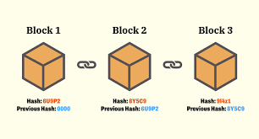

Fig 1- A typical blockchain is shown where the new block is connected to another block and contains its previous block hash. If somehow the previous block changes, the whole network after that will be destroyed. This gives resilience to the blockchain system where you cannot change previous block resulting in immutability and whole network history storage.

1. SMART CONTRACTS

Smart contracts are self-executing contracts with the terms of the agreement directly written into lines of code. These contracts run on blockchain technology, enabling automatic execution of predefined actions when specific conditions are met. Because they are decentralized and secure, smart contracts eliminate the need for intermediaries, ensuring transparency and trust in various transactions. They find applications in finance, real estate, supply chain management, and more, revolutionizing traditional contract processes by offering efficiency, security, and cost-effectiveness.

C. CRYPTOGRAPHY

1. Asymmetric Key Cryptography for Security:

* Blockchain employs asymmetric key cryptography using public and private keys, ensuring data integrity and privacy.
* Senders encrypt transactions with the recipient’s public key, visible to the network, and receivers decrypt using their private key, maintaining transaction confidentiality.

1. Private Key Confidentiality and Prevention of Attacks:

* Private keys must never be disclosed, as they secure data and prevent malicious attacks.
* Unique public-private key pairs for each transaction thwart brute force attacks until data is stored in a block.

1. Public Key Identification and Role of Hash Functions:

* Public keys serve as user IDs without revealing real-world identities, ensuring user anonymity.
* Hash functions generate standardized outputs from variable-sized inputs, connecting data blocks in the blockchain, ensuring data integrity and consistency.

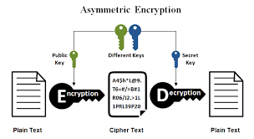

D. PROOF-OF-WORK VS PROOF-OF -STAKE

Blockchain systems require most users to validate a transaction, which can then make an authorized block in a blockchain. This method eliminates the requirement of a trusted third party and projects objectivity of the network for users. Majority consensus means a threshold number of nodes must validate new blocks in a blockchain.

There are two major types of consensus mechanisms:

1) Proof-of-Work (PoW): a probabilistically calculated energy-intensive cryptographic puzzle is created. Miners, also known as nodes compete, to solve this puzzle, higher the computational power of the miner's computer, higher the probability of solving the puzzle. The first miner to solve the puzzle is rewarded with cryptocurrency.

2) Proof-of-Stake (PoS): the chances of the node that publishes a block is determined by the miner’s stake in the blockchain, instead of their mining power.

# Chapter 4 Literature Survey

In the emerging literature on financial technology, several papers have made significant contributions to the understanding of crowdfunding and its intersection with financial inclusion and blockchain technology.

Paper [5] investigates crowdfunding in the context of financial inclusion. It explores the relevance of crowdfunding in promoting financial inclusivity and emphasizes the potential of blockchain technology in advancing crowdfunding practices. This paper represents a pioneering effort in analyzing crowdfunding dynamics. The insights gained from this study suggest potential applications in the field of periodontology dentistry, indicating a promising future for crowdfunding in specialized sectors like dentistry.

Paper [6] delves into the regulatory aspects of blockchain-based crowdfunding. It highlights the unique characteristics of blockchain-based crowdfunding and the need for a nuanced approach to regulations. By reviewing existing literature, the paper identifies key success factors for both traditional and blockchain-based crowdfunding. This analysis provides valuable directions for future research and development efforts, contributing to a deeper understanding of the distinctions and similarities between blockchain-based crowdfunding and its traditional counterpart.

Paper [7] presents an innovative approach by introducing an economical, multimodal, personal oral crowdfunding decentralized application (dApp). This dApp aims to assist new developers and startups in overcoming financial challenges. By leveraging Blockchain technology, this initiative aims to create a supportive digital community where startups and projects can join forces, fostering mutual growth. This collaborative model emphasizes the potential for blockchain-based crowdfunding to create inclusive, self-sustaining ecosystems within the digital realm.

This literature survey reveals a multifaceted landscape where crowdfunding intersects with blockchain technology and financial inclusion. The studies explored crowdfunding's role in financial inclusivity, the regulatory implications of blockchain-based crowdfunding, and innovative applications like the oral crowdfunding dApp. Collectively, these works underline the transformative potential of blockchain technology in reshaping crowdfunding practices. As evidenced by the diverse applications discussed in these papers, the synergy between crowdfunding and blockchain technology holds promise for fostering inclusive, collaborative, and financially sustainable digital communities, transcending traditional barriers in various sectors.

# Chapter 5

# Methodology

Technology Stack

A] Node.js

Node.js is an open-source, server-side JavaScript runtime environment built on Chrome's V8 JavaScript engine. It allows developers to run JavaScript code outside of a web browser, making it ideal for building scalable and high-performance network applications. Node.js uses an event-driven, non-blocking I/O model, which makes it efficient for handling concurrent connections and processing large volumes of data in real-time. Its vast package ecosystem, facilitated by npm (Node Package Manager), provides access to a wide range of libraries and modules, simplifying the development of web servers, APIs, microservices, and other backend applications. Node.js is widely used in web development, enabling the creation of fast, lightweight, and responsive applications across various platforms.

B] Solidity

Solidity is a high-level, statically-typed programming language specifically designed for developing smart contracts on blockchain platforms, primarily Ethereum. It enables developers to define the rules and behaviors of smart contracts, allowing them to create decentralized applications (dApps) for various use cases such as crowdfunding, gaming, and supply chain management. Solidity code is executed on the Ethereum Virtual Machine (EVM), providing the foundation for trustless and secure transactions within the blockchain network.

Tools/Frameworks used:

1. Remix IDE:

Remix IDE is a powerful, user-friendly Integrated Development Environment (IDE) specifically tailored for building Ethereum smart contracts with Solidity. It offers a comprehensive set of tools and features, including a code editor with syntax highlighting and autocompletion, a built-in Solidity compiler, a debugger for testing and troubleshooting contracts, and seamless integration with Ethereum networks for deployment and interaction. Remix IDE simplifies the development process by providing a convenient interface for writing, testing, and deploying smart contracts, making it a popular choice among blockchain developers.

1. Metamask:

Metamask is a chrome browser plugin that acts as a bridge between your browser and Ethereum blockchain by providing a secure identity vault, a user interface to manage multiple Ethereum wallets and sign blockchain transactions. It is one of the best ways to send transactions to Ethereum blockchain because it keeps a track of transaction execution and returns if any error occurs during mining or execution. It supports any ERC20 type token to be added to your wallet and trigger transaction on those ERC20 tokens. It is an Ethereum community open-source project having more than million active users; hence, it is the most popular plugin to interact with blockchain.

1. Next JS:

Next.js is a popular open-source React framework for building dynamic web applications. It simplifies React development by offering server-side rendering, automatic code splitting, and simplified routing, providing developers with a seamless and efficient way to create modern, fast, and SEO-friendly web applications. Next.js supports both static site generation and server-side rendering, allowing developers to choose the most suitable rendering method for their project. With features like hot module reloading and serverless functions, Next.js enhances the development experience, making it a preferred choice for building high-performance React applications and websites.

4. Hardhat:

Hardhat is a robust Ethereum development environment for professionals, offering a flexible and extensible framework for smart contract development and testing. It provides a wide array of features, including built-in tasks, plugins, and testing utilities, making it an ideal choice for Ethereum developers. With its powerful scripting capabilities and integration with popular tools, Hardhat streamlines the process of building and testing smart contracts, facilitating efficient and secure decentralized application (dApp) development on the Ethereum platform.

5. Polygon.technology

Polygon, formerly known as Matic Network, is a Layer 2 scaling solution for Ethereum, designed to enhance its scalability, usability, and user experience. It offers a framework for creating multiple interoperable blockchains, commonly referred to as "sidechains," which are secured by the Ethereum mainnet. Polygon aims to address the limitations of the Ethereum network, including high transaction fees and slow confirmation times, by providing a more efficient and user-friendly environment for decentralized applications (dApps).

6. Infura:

Infura is a popular Ethereum infrastructure provider that offers easy and reliable access to Ethereum and other blockchain networks. It operates Ethereum nodes and provides developers with API endpoints, simplifying the process of interacting with blockchain networks in decentralized applications (dApps) without the need to run a full node. Infura ensures high availability, scalability, and security, making it a go-to solution for developers who want to focus on building their dApps without worrying about managing blockchain infrastructure. It supports various Ethereum networks, including mainnet and testnets, and is widely used for tasks like reading blockchain data, sending transactions, and deploying smart contracts. Infura plays a vital role in accelerating blockchain development by providing seamless access to Ethereum's capabilities.

7. IPFS:

IPFS stands for interplanetary file system. It is a protocol and network used to store and share hypermedia in a distributed file system. It is an open-source project maintained by a huge community of developers. The contents in IPFS are accessed in two ways, via FUSE (in case of Linux) and over HTTP even though IPFS wants to replace HTTP. IPFS can be seen as a BitTorrent swarm, exchanging objects within a single Git repository.

6. Styled-components:

Styled Components is a popular CSS-in-JS library for React and React Native applications. It allows developers to write actual CSS code inside JavaScript files, encapsulating styles within individual components. Styled Components promotes the creation of visually appealing and maintainable user interfaces by enabling developers to style React components dynamically based on props or global themes. Its innovative approach enhances component reusability, readability, and modularity while ensuring a consistent and coherent design system throughout the application. Styled Components simplifies the styling process, making it easier to create responsive and aesthetically pleasing user interfaces in React applications.

Libraries/Packages used:

* 1. `@mui/material`: This is part of the Material-UI library, which is a popular React UI framework. Material-UI provides a set of React components that implement Google's Material Design. `@mui/material` includes a wide range of components like buttons, forms, dialog boxes, navigation, and more. It helps developers create modern, responsive, and visually appealing user interfaces in React applications.
* 2. `@mui/styled-engine-sc`: This package is a styled engine for Material-UI components. It provides a way to style Material-UI components using the `styled-components` library, which is a popular CSS-in-JS solution for React applications. Styled-components allow you to write actual CSS code within your JavaScript files, making it easier to manage component styles.
* 3. `styled-components`: This is a library for styling React components. It allows you to write CSS code as template literals in your JavaScript files, making it possible to scope styles to specific components. Styled-components encourage the use of components to style applications, promoting a modular and maintainable approach to styling in React applications.
* By installing these packages to utilize Material-UI components and styled-components for building visually appealing and customizable user interfaces in your React application.
* Command: npm install @mui/material @mui/styled-engine-sc styled-components
* 4. `ipfs-http-client`: The `ipfs-http-client` package is a JavaScript library that provides a client interface for interacting with the InterPlanetary File System (IPFS) using HTTP. IPFS is a peer-to-peer network designed to make the web faster, safer, and more open by replacing the traditional, centralized model of the internet with a distributed, decentralized one.
* Command: npm install ipfs-http-client

Methodology:

1. SMART CONTRACT DEVELOPMENT:

Campaign.sol: this Solidity code is for a crowdfunding application implemented on the Ethereum blockchain. Let me break down the code for you step by step:

* CampaignFactory Contract:

1. *SPDX-License-Identifier*: This is a SPDX license identifier, indicating that the contract uses the MIT license.

2*. Solidity Version Declaration*: `pragma solidity ^0.8.19; ` specifies that the contract should be compiled using a Solidity compiler version greater than or equal to 0.8.19.

3. *CampaignFactory Contract*: This contract is a factory contract responsible for creating new crowdfunding campaigns.

- `deployedCampaigns`: An array that keeps track of addresses of all deployed campaigns.

- `campaignCreated` Event: This event is emitted whenever a new campaign is created. It contains information such as campaign title, required amount, owner's address, campaign address, image URI, timestamp, and category.

- `createCampaign` Function: This function creates a new campaign. It takes campaign title, required campaign amount, image URI, category, and story URI as parameters. Inside the function:

- A new `Campaign` contract is created with the provided parameters and the sender's (creator's) address.

- The address of the newly created `Campaign` contract is added to the `deployedCampaigns` array.

- The `campaignCreated` event is emitted with the relevant details.

* Campaign Contract:

1*. State Variables*:

- `title`: The title of the crowdfunding campaign.

- `requiredAmount`: The total amount of money required for the campaign.

- `image`: URI for the campaign image.

- `story`: URI for the campaign story or description.

- `owner`: The address of the campaign owner (the person who created the campaign).

- `receivedAmount`: The total amount of money received for the campaign.

2*. Event:*

- `donated`: This event is emitted when someone donates to the campaign. It contains the donor's address, the donated amount, and the timestamp.

3. *Constructor:*

- The constructor initializes the campaign with the provided title, required amount, image URI, story URI, and owner's address.

4. *`donate` Function:*

- This function allows people to donate money to the campaign.

- It checks if the required campaign amount has not been fulfilled yet.

- If the condition is met, the donated amount is transferred to the campaign owner, and the `donated` event is emitted with the sender's address, the donated amount, and the timestamp.

In summary, the `CampaignFactory` contract is used for creating new crowdfunding campaigns, and each campaign is represented by an instance of the `Campaign` contract. People can donate to the campaigns using the `donate` function, and events are emitted to track the creation of new campaigns and donations.

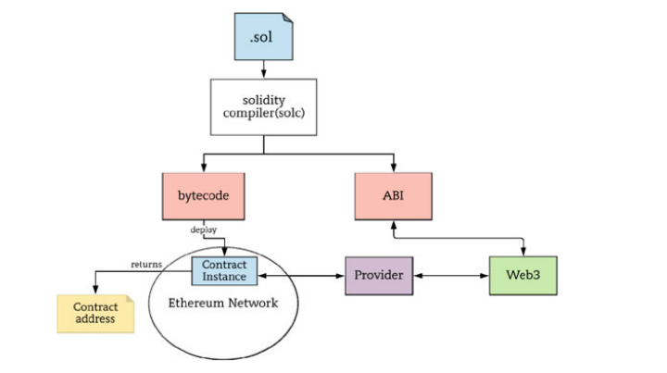

1. Setting up your development environment

* Initialize your Node.js project
* Install necessary packages:

npm install ethers hardhat @nomiclabs/hardhat-waffle @nomiclabs/hardhat-polygon

* Set up hardhat configuration and polygon network in `hardhat.config.ja` file.

1. Frontend Development:

* Created the frontend of your dApp using a framework like Nextt.js.
* Integrated Metamask for wallet interactions using Ether.js for smart contract interactions in my frontend application.
* Designed user interface with 3 forms:

1. Campaign creation
2. Donations
3. Viewing campaign details.
4. Connecting to polygon Network:

* Configured MetaMask to connect to the polygon network.
* Updated frontend to point to the polygon network for contract interactions.

1. Deployment:

* Deployed my smart contract to the polygon testnet for testing.
* Used hardhat tasks for deployment.
* Using command npm hardhat compile
* Verified my contract on Polygon’s block explorer for transparency.

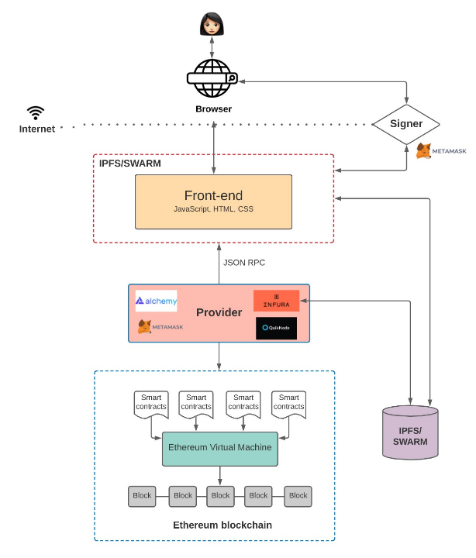

# Chapter 6

# Results & Discussions

* After running the command ’npm run dev’ which is used in Node.js projects to start a development server, our dApp COIN KINDNESS will start running on <http://localhost:3000>.
* There are few functionalities of changing theme and wallet connection.
* You can also view 3 pages:

1. CAMPAIGNS: This is my home page in which we can see the campaigns created in the form of small cards.

* Every card shows us the detail of campaign like title, owner of the campaign, required amount for the campaign, date and time of the campaign started.
* By clicking on the button ‘Go to Campaign’ you will go to detailed page of campaign.
* We can see all the cards of campaigns or we can filter them too on the basis of 3 categories i.e. Education, Health, Animals
* In our detailed page, we will get the image and story from our ipfs of the created campaign,
* There is a functionality to donate our tokens.
* You can view the required amount and the received amount of the campaign.
* You can also view the address, date, time, and the amount donated to a particular campaign, and the recent donations done by other persons.

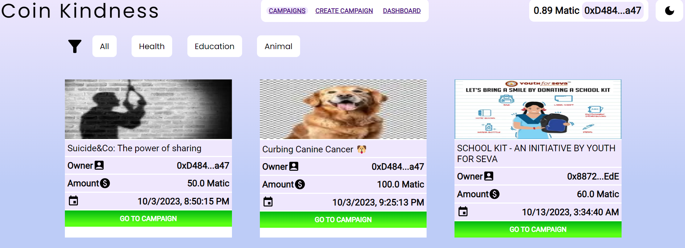

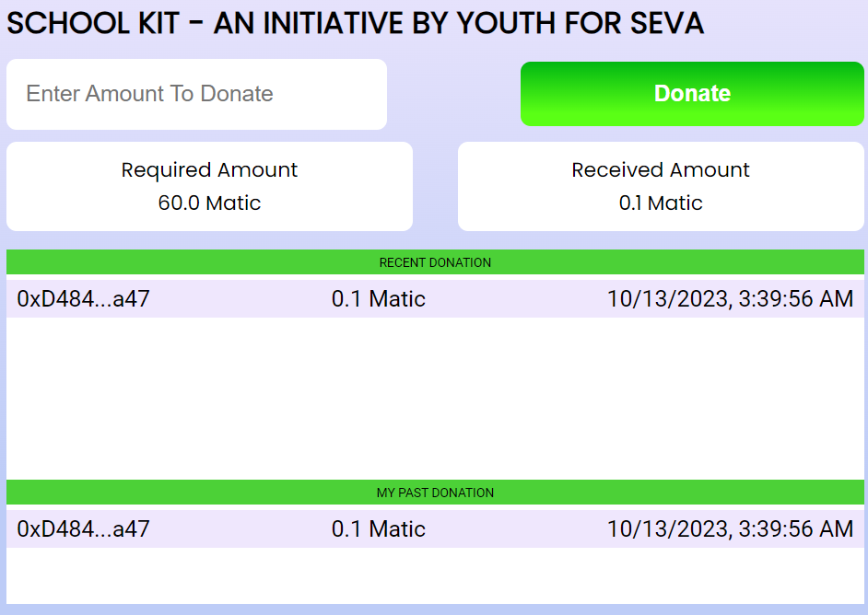

1. CREATE CAMPAIGNS: To create campaigns

* We must fill our required blank form to create campaign for raising funds.
* Details to be added in the form are: campaign title, story (description of the campaign), required amount, category in which we have to create our campaign (Education, Health, Animals), Image.
* Image and story will be uploaded to IPFS, and then we can start the campaign which means our data is stored in blockchain.

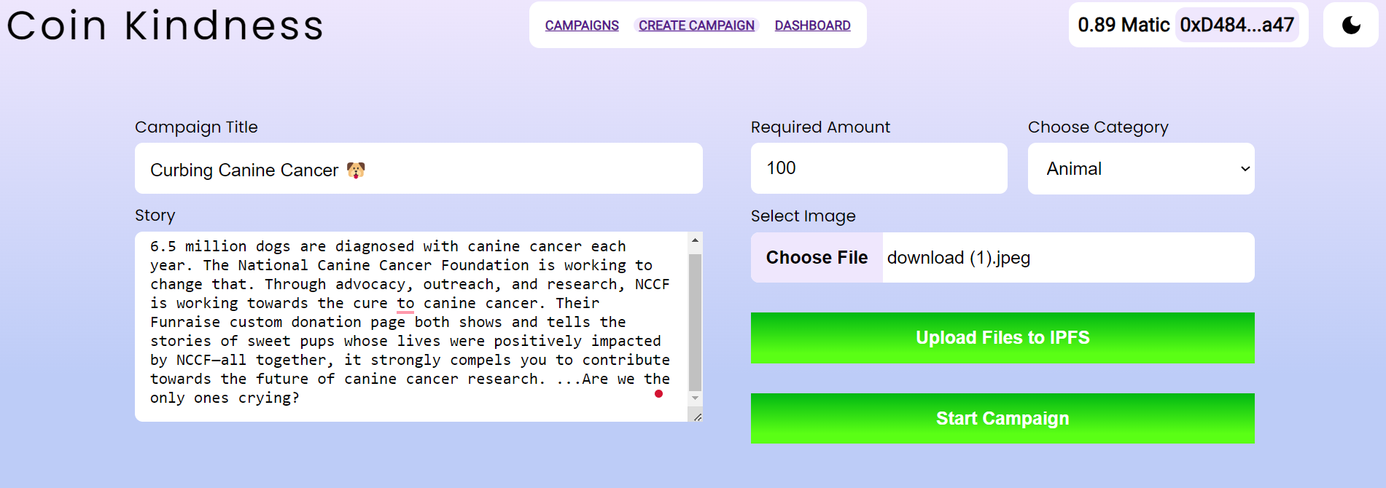

While creating campaign user gets a notification from metamask to confirm the transaction.

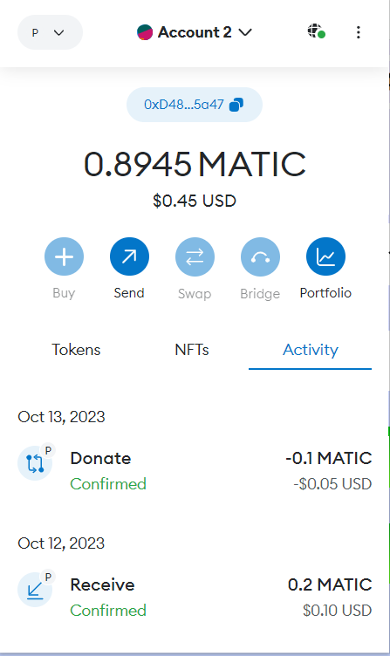

1. DASHBOARD:

* In this page, the user can only see all the campaigns cards which were deployed from their wallet address.

# Chapter 7 Conclusions

Blockchain, despite being a relatively new concept to the community, holds immense potential in bringing benefits to society. Crowdfunding has been playing a significant role in our society and economy, driving innovation, and creating new jobs and employment. Many people use this platform to raise money for different purposes. Even with this growing trend, there are still a couple of drawbacks with the current methods of crowdfunding: Centralization and Single Point-of-Failure - which can be solved by Integrating Crowdfunding and Blockchain.

Nevertheless, the implementation of this concept contains a plethora of loopholes that requires correction for example the Safety of Fund Utilization by a Campaign, Verification of a Particular Campaign or the Community Interest can be solved by Integrating a DAO (Decentralized Autonomous Organization) with this dApp where the user votes whether a particular Campaign should be approved for listing or not.

This paper gives evidence to the scope of reducing the possibility of single point of failure. Integrity can be implemented by realizing the concepts of Layer 2 Blockchain (such as Polygon. Using such elements makes crowdfunding robust and De-centralized.

# Chapter 8

# Future Scope

The future scope of donation-based crowdfunding DApps (decentralized applications) is promising and likely to continue growing. Here are several reasons why:

1. Global Accessibility: Donation-based crowdfunding DApps allow people from all around the world to contribute to causes they care about. This global accessibility ensures a wide pool of potential donors, increasing the chances of successful fundraising.

2. Transparency and Trust: Blockchain technology, upon which most DApps are built, ensures transparency and immutability of transactions. Donors can see exactly where their money is going, which builds trust. Smart contracts can also be used to automate the release of funds, ensuring that the money is used for its intended purpose.

3. Reduced Fees: Traditional crowdfunding platforms often charge significant fees for fundraising campaigns. DApps, being decentralized, can significantly reduce these fees, ensuring that a larger portion of the donated money goes directly to the cause.

4. Smart Contracts: Smart contracts enable programmable donations. For instance, funds can be released only when certain conditions are met or when specific milestones are achieved, ensuring accountability, and preventing misuse of funds.

5. Tokenization: Some DApps utilize tokens as a representation of value. These tokens can be traded, increasing the liquidity of donations. This can attract investors, further increasing the pool of available funds for charitable causes.

6. Incentivizing Donors: DApps can create innovative ways to incentivize donors, such as providing them with tokens or other rewards. This gamification aspect can attract more donors and increase overall engagement.

7. Integration with Other Technologies: Donation-based crowdfunding DApps can integrate with other emerging technologies like AI and IoT. For example, AI algorithms can help match donors with causes they are likely to support, and IoT devices can provide real-time data about the impact of donations.

8. Regulatory Environment: As governments and regulatory bodies adapt to the rise of blockchain and cryptocurrencies, there might be more supportive regulations, making it easier for these platforms to operate legally and gain public trust.

9. Social Impact Investing: The rise of conscious capitalism and social impact investing means more individuals and businesses are looking for ways to make a positive impact on society. Donation-based crowdfunding DApps offer a direct and transparent route for these impact-driven investments.

However, challenges such as regulatory uncertainties, scalability issues, and user adoption hurdles need to be addressed for these DApps to reach their full potential. As the technology matures and public understanding and trust in blockchain increase, the future of donation-based crowdfunding DApps appears bright, with the potential to revolutionize the way charitable donations are made and managed.

# Chapter 9

# References

[1] B. Hu and H. Li, “Research on Charity System Based on Blockchain”, SAMSE, IOP Conference Series: Material Science and Engineering, 2020

[2] H. Baber, “Blockchain-Based Crowdfunding: A ‘Pay-it Forward’ Model of WHIRL”, International Journal of Recent Technology and Engineering (IJRTE), ISSN: 2277-3878, Volume-8 Issue-3, September 2019.

[3] M. Zichichi, M. Contu, S. Ferretti and G. D’Angelo, “LikeStarter: A Smart-contract based Social DAO for Crowdfunding”, arXiv:1905.05560v3 [cs.CY], 6th Nov 2019.

[4] V Buterin, “Ethereum: A next-generation smart contract and decentralized application platform”, White Paper, Vol:3, Issue: 37, 2014.

[5] K. Christidis and M. Devetsikiotis, “Blockchains and smart contracts for the internet of things,” Ieee Access vol. 4, pp. 2292– 2303, 2016.

[6] Y. He, H. Li, X. Cheng, Y. Liu, C. Yang, and L. Sun, “A blockchain based truthful incentive mechanism for distributed p2p applications,” IEEE Access, vol. 6, pp. 27 324–27 335, 2018.

[7] V. Hassija, V. Chamola, S. Garg, N. G. K. Dara, G. Kaddoum, and D. N. K. Jayakody, “A blockchainbased framework for lightweight data sharing and energy trading in v2g network,” IEEE Transactions on Vehicular Technology, 2020.

[8] L.S., "Who is Satoshi Nakamoto?" 2 November 2015. [Online]. Available: https://www. economist.com/the-economist-explains/2015/11 /02/who-is-Satoshi Nakamoto

[9] https://www.coingecko.com/en/coins/bitcoin

[10] Solidity. [Online]. Available: https://solidity. readthedocs.io/en/develop/

[11] G. Hayes, "The Beginners Guide to Using an Ethereum Test Network," 16 February 2018. [Online]. Available: https://medium.com/ compound-finance/the-beginnersguide-to-usingan-ethereum-test-network-95bbbc85fc1d

[11] A. Rosic, “Blockgeeks,”. Available: https:// blockgeeks.com/blockchainc