1. Key Performance Index
2. **Finding the total revenue from pizza sales:**

SELECT SUM(total_price) AS Total_Revenue from pizza_sales  
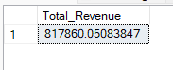

1. **Finding the avg order value:**

SELECT DISTINCT SUM(total_price) AS Total_Revenue FROM pizza_sales

SELECT COUNT(DISTINCT order_id) AS Total_Orders FROM pizza_sales

SELECT DISTINCT SUM(total_price) / COUNT(DISTINCT order_id) AS Avg_Order_Value FROM pizza_sales

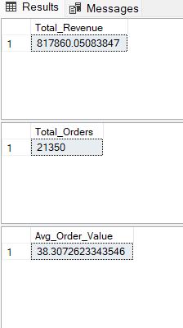

1. Finding the total number of pizzas sold:

SELECT * FROM pizza_sales

SELECT SUM(quantity) AS Total_No_of_Pizzas_Sold FROM pizza_sales

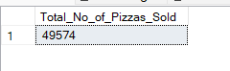

1. Total number of Orders:

SELECT COUNT(DISTINCT order_id) AS Total_orders FROM pizza_sales



1. Average Pizzas per order:

SELECT CAST(CAST(SUM(quantity) AS decimal(10,2)) / CAST(COUNT(DISTINCT order_id) AS decimal(10,2))AS decimal(10,2)) AS Avg_Pizzas_Per_Order from pizza_sales

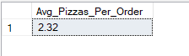

1. Trend for Orders
2. Daily Trend for Total Orders:

SELECT DATENAME(DW, order_date) as order_day, COUNT(DISTINCT order_id) AS Total_orders

from pizza_sales

GROUP BY DATENAME(DW, order_date)

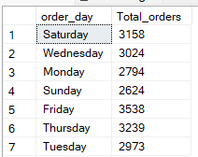

1. Hourly Trend for Total Orders:

SELECT DATEPART(HOUR, order_time) AS order_hours, COUNT(DISTINCT order_id) AS Total_orders

from pizza_sales

GROUP BY DATEPART(HOUR, order_time)

ORDER BY order_hours ASC

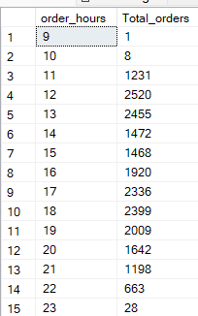

1. Ratio of Pizza Sales category wise:

SELECT pizza_category, SUM(total_price) * 100 / (SELECT SUM(total_price) from pizza_sales) AS Percentage_of_Total_Sales

from pizza_sales

GROUP BY pizza_category

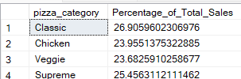

1. Ratio of Pizza Sales size wise:

SELECT pizza_size, CAST(SUM(total_price) * 100 / (SELECT SUM(total_price) from pizza_sales) AS decimal(10,2)) AS Percentage_of_Total_Sales

from pizza_sales

GROUP BY pizza_size

ORDER BY pizza_size ASC

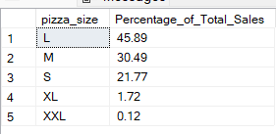

1. Total Pizza Sales Category-wise:

SELECT pizza_category, SUM(quantity) as Total_Pizzas_Sold

FROM pizza_sales

GROUP BY pizza_category

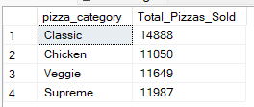

1. Top 5 Bestsellers in Pizza:

SELECT TOP 5 pizza_name, SUM(quantity) as Total_Pizzas_Sold

FROM pizza_sales

GROUP BY pizza_name

ORDER BY Total_Pizzas_Sold DESC

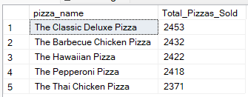

1. Top 5 Worstsellers in Pizza:

SELECT TOP 5 pizza_name, SUM(quantity) as Total_Pizzas_Sold

FROM pizza_sales

GROUP BY pizza_name

ORDER BY Total_Pizzas_Sold ASC

