SLE-3: ARCHITECTURAL DESIGN USING FULL C4 MODEL
Course: Introduction to Artificial Intelligence (02AML204)
Name: Jeenat Faiyaz Gaiban
PRN: 25UAM121
Program / Semester: SY B.Tech. CSE (AI & ML) / SEM-VI

1. System Title and Short Description
System Title: BFS vs DFS – 26-Node (A–Z) Empirical Performance Analysis System
Description:
The BFS vs DFS Empirical Performance Analysis System provides an architectural and benchmarking framework to evaluate the traversal performance of Breadth-First Search (BFS) and Depth-First Search (DFS) over a defined 26-node graph (A to Z) starting from node A. The system measures real execution times using Python's time.perf_counter(), records the number of nodes expanded across Best Case (goal B), Average Case (goal M), and Worst Case (goal Z), and integrates with py-spy to sample the CPython call stack and export flame graph profiles (profile.svg). The architecture is documented across all four levels of the C4 model: Context, Container, Component, and Code.

2. Level 1 – System Context Diagram
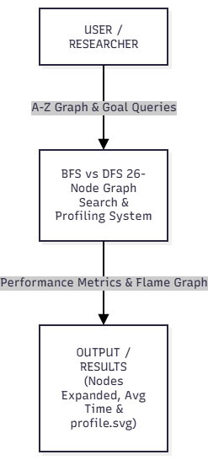

Context Explanation:
The Level 1 Context diagram outlines the system boundary with respect to external entities. The researcher/user provides the 26-node graph topology and configures the target goal queries (Best, Average, and Worst cases). The system executes the search routines, profiles stack activity via an external profiler (py-spy), and returns node expansion counts, average execution times in milliseconds, and flame graph visual profiles.

3. Level 2 – Container Diagram
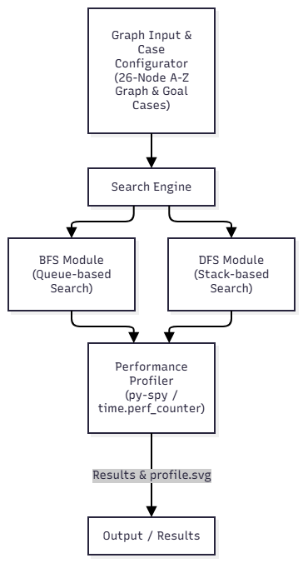
Container Breakdown:
- Graph Input & Case Configurator: Defines the 26-node adjacency list (keys A through Z) and configures target goal nodes for Best ($A→B$), Average ($A→M$), and Worst ($A→Z$) cases.
- Search Engine: Orchestrates traversal execution by calling BFS and DFS algorithms for each goal scenario.
- BFS Module: Implements queue-based Breadth-First Search exploring nodes level by level using collections.deque.
- DFS Module: Implements stack-based Depth-First Search exploring deep branches before backtracking.
- Performance Profiler: Executes 3 iterations per case using time.perf_counter() to compute average runtime and interfaces with py-spy to generate profile.svg.
- Output / Results: Formats console output detailing the path found, total nodes expanded, and execution duration.

4. Level 3 – Component Diagram
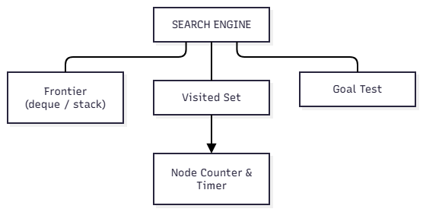

Component Breakdown:
Inside the Search Engine Container, four core functional units interact:
- Frontier: Stores active candidate paths (collections.deque for FIFO breadth exploration; standard Python list stack for LIFO depth exploration).
- Visited Set: Python set data structure providing $O\left(1\right)$ lookup checks to eliminate cyclic loops and duplicate node visits.
- Goal Test: Evaluates whether the currently popped node matches the target goal node (B, M, or Z).
- Node Counter & Timer: Increments total node expansions and tracks elapsed execution time using time.perf_counter()

5. Level 4 – Code Level Overview
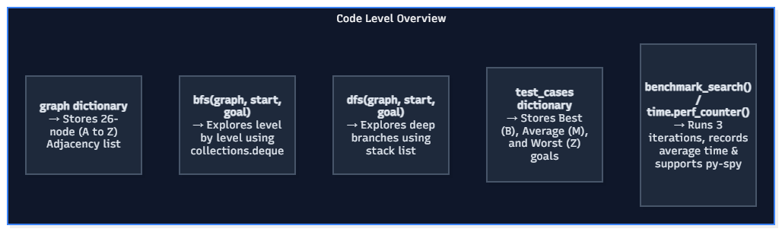
Code Responsibilities:
- bfs(graph, start, goal): Level-by-level queue traversal returning the complete path and nodes expanded.
- dfs(graph, start, goal): Branch-first stack traversal returning the complete path and nodes expanded.
- graph: Python dictionary storing the 26-node adjacency list (A to Z).
- test_cases: Scenario mapping linking Best ($B$), Average ($M$), and Worst ($Z$) goal cases.
- benchmark_search(): Driver function that executes 3 runs using time.perf_counter() and outputs average metrics.

6. Design Decisions
- Adjacency List Structure: Represented as a Python dictionary of lists for clean $O\left(1\right)$ key lookups and minimal memory overhead.
- Procedural Architecture Over OOP: Standalone functions (def bfs(), def dfs()) were preferred over complex OOP class hierarchies to eliminate object-instantiation overhead and keep stack sampling clean during py-spy execution.
- Dual Metric Evaluation: Because execution times on a 26-node graph are sub-millisecond ($<0.02\text{ ms}$), counting the actual number of nodes expanded provides an essential, hardware-independent metric to compare BFS and DFS effort.

7. AI Contribution Note
AI tools were utilized to format the system architecture across the four standard C4 levels (Context, Container, Component, and Code), generate draw.io-ready Mermaid diagrams, and align the report layout with the course submission guidelines. All code implementation, empirical execution, node counting, and py-spy profiling runs were performed independently by the student.

8. Conclusion
Applying the Full C4 Model to the empirical search system clarifies the connection between high-level benchmarking requirements and low-level code routines. Decomposing the system down to component frontiers and time.perf_counter() hooks shows how queue versus stack data structures directly shape traversal effort and execution performance.

