**E-commerce Application on IBM Cloud Foundry**

**Abstract:**

This abstract introduces a cutting-edge e-commerce website based on cloud technology, poised to transform the world of online shopping. As businesses and consumers increasingly rely on the internet for their retail needs, the need for a scalable, reliable, and flexible e-commerce platform has become paramount. Leveraging the power of cloud computing, our innovative e-commerce website is designed to meet these demands and offer an unparalleled shopping experience.

1. **Scalability:**

The cloud-based architecture allows our e-commerce platform to seamlessly scale up or down to accommodate changing workloads, ensuring consistent performance even during peak shopping seasons.

1. **Reliability:**

With redundant data storage, automated backups, and disaster recovery capabilities, our e-commerce website ensures 24/7 availability, minimizing downtime and data loss.

1. **Security:**

Robust security measures, including data encryption, regular security audits, and compliance with industry standards, safeguard customer and business data from potential threats.

1. **Flexibility:**

The cloud-based infrastructure enables businesses to customize their online stores, add or remove features, and integrate third-party applications with ease.

1. **Cost Efficiency:**

By paying only for the resources used, businesses can reduce infrastructure costs and allocate more resources to growth and innovation.

1. **Global Reach:**

Cloud technology facilitates fast content delivery and global reach, ensuring that customers from different parts of the world experience fast loading times and responsive websites.

1. **Mobile Responsiveness:**

Our e-commerce platform is optimized for mobile devices, ensuring a seamless shopping experience on smartphones and tablets.

1. **Personalization:**

Utilizing machine learning and AI algorithms, our platform offers personalized product recommendations, enhancing user engagement and driving sales.

1. **Analytics and Insights:**

Advanced data analytics tools provide businesses with valuable insights into customer behavior, helping them make informed decisions to improve their products and services.

**Algorithms:**

**Search Algorithms:**

* + **Keyword-based Search:** Algorithms like TF-IDF (Term Frequency-Inverse Document Frequency) are used to implement keyword-based product search.
  + **Relevance Ranking:** Algorithms like Elasticsearch, Solr, and machine learning-based recommendation systems help in ranking search results by relevance.

**Recommendation Algorithms:**

* + **Collaborative Filtering:** This includes user-based and item-based recommendation systems to suggest products based on user behavior and preferences.
  + **Content-Based Filtering:** Recommends products based on the attributes and characteristics of items the user has interacted with or shown interest in.
  + **Hybrid Recommendation:** Combining collaborative and content-based filtering for more accurate recommendations.
  + **Sort by Price:** Algorithms like Quick Sort or Merge Sort are commonly used for sorting products by price.

**Sorting Algorithms:**

**Sort by Popularity:** Algorithms that track user interactions to sort products based on popularity.

**Shopping Cart Algorithms:**

* + Algorithms to manage and optimize shopping cart operations, including adding, removing, and updating items in the cart.

**Payment Processing Algorithms:**

* + Algorithms for secure payment processing, encryption, and fraud detection.

**Inventory Management Algorithms:**

* + Algorithms to manage and track inventory levels, automate restocking, and prevent overselling.

**Recommendation Engine Algorithms:**

* + Machine learning algorithms for real-time personalized product recommendations.

**Image Processing Algorithms:**

* + Algorithms for image recognition, resizing, and optimization for product images.

**Security Algorithms:**

* + Encryption algorithms (e.g., SSL/TLS) for securing data in transit.
  + Hashing and salting algorithms for securely storing and managing user passwords.

**User Authentication Algorithms:**

* + Algorithms for user authentication and authorization, including OAuth, JWT (JSON Web Tokens), and various authentication protocols.

**Data Mining Algorithms:**

* + Analyzing user behavior data to identify patterns and trends in customer preferences.

**Feedback and Review Algorithms:**

* + Sentiment analysis and natural language processing (NLP) algorithms to analyze and rank customer reviews and feedback.

**Shipping and Logistics Algorithms:**

* + Route optimization algorithms for shipping and delivery, real-time tracking, and delivery time estimations.

**Fraud Detection Algorithms:**

* + Machine learning models for identifying and preventing fraudulent activities, such as payment fraud and fake accounts.

**Personalization Algorithms:**

Algorithms for tailoring the user experience, content, and product recommendations based on individual user preferences and behavior

**Flowchart:**

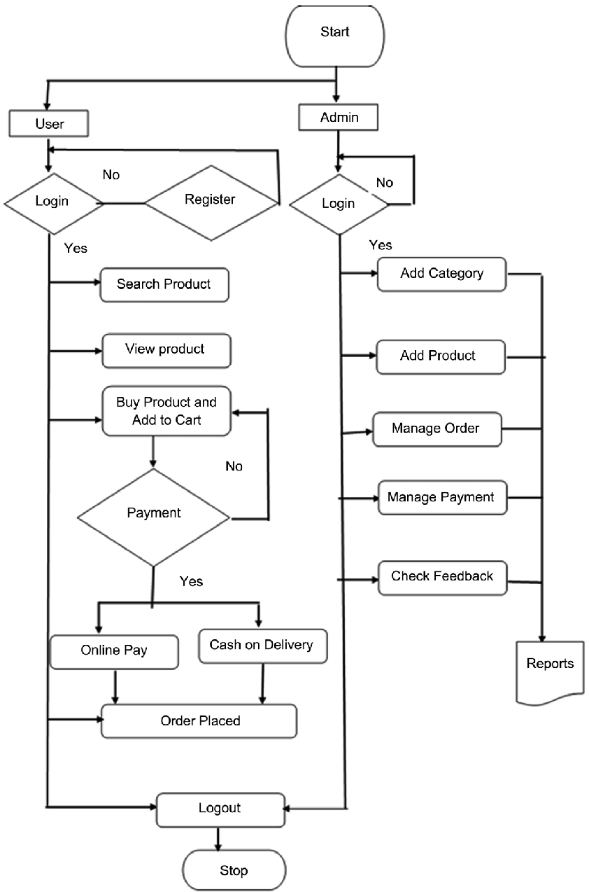

**Augmented Reality (AR) Product Try-On**

Augmented Reality (AR) can significantly enhance the performance of an e-commerce website by providing an immersive and interactive shopping experience. This idea involves integrating AR technology to allow customers to virtually try on products before making a purchase. Here's how it works:

**Implementation:**

1. **AR Try-On for Apparel:** Implement an AR feature that allows users to see how clothing items, such as dresses, shirts, and shoes, will look on them. Customers can use their smartphone cameras or webcams to see a real-time overlay of the product on their body.
2. **AR Virtual Fitting Rooms:** Create virtual fitting rooms where users can select clothing items and see how they fit and look from different angles. They can change sizes, colors, and styles on the virtual model to make informed decisions.
3. **AR Home Decor Try-Out:** For home decor and furniture e-commerce websites, allow customers to use AR to visualize how furniture and decor items will look in their homes. This can include virtually placing a new sofa in their living room or hanging a piece of art on their wall.
4. **AR Makeup and Accessories:** Implement AR for trying on makeup products, eyeglasses, jewelry, and accessories. Users can see how different makeup shades or accessories complement their appearance in real-time.

**Benefits:**

1. **Improved Customer Engagement:** AR adds an interactive and engaging element to the shopping experience, keeping customers on the site for longer durations.
2. **Increased Confidence in Purchases:** Customers can make more informed decisions, reducing the likelihood of returns and increasing overall satisfaction.
3. **Reduced Product Returns:** By allowing customers to virtually try on products, the website can reduce the number of returns due to incorrect sizing or dissatisfaction with the product's appearance.
4. **Differentiation and Competitive Edge:** Implementing AR sets the e-commerce website apart from competitors, demonstrating a commitment to innovation and customer satisfaction.
5. **Enhanced Mobile Shopping:** With the increasing use of mobile devices for online shopping, AR can be particularly effective as it leverages the capabilities of smartphones and tablets.
6. **Data Insights:** AR features can collect data on customer preferences and behavior, providing valuable insights for product recommendations and inventory management.

**Conclusion:**

this cloud-based e-commerce website represents the future of online retail, offering businesses the tools they need to succeed in the digital age. With its scalability, reliability, security, and flexibility, it empowers businesses to adapt to ever-changing market demands, while providing customers with a convenient, personalized, and efficient shopping experience. The cloud is the backbone of this innovative platform, ensuring it remains at the forefront of e-commerce technology.